Table 1. Characteristics of Included Studies
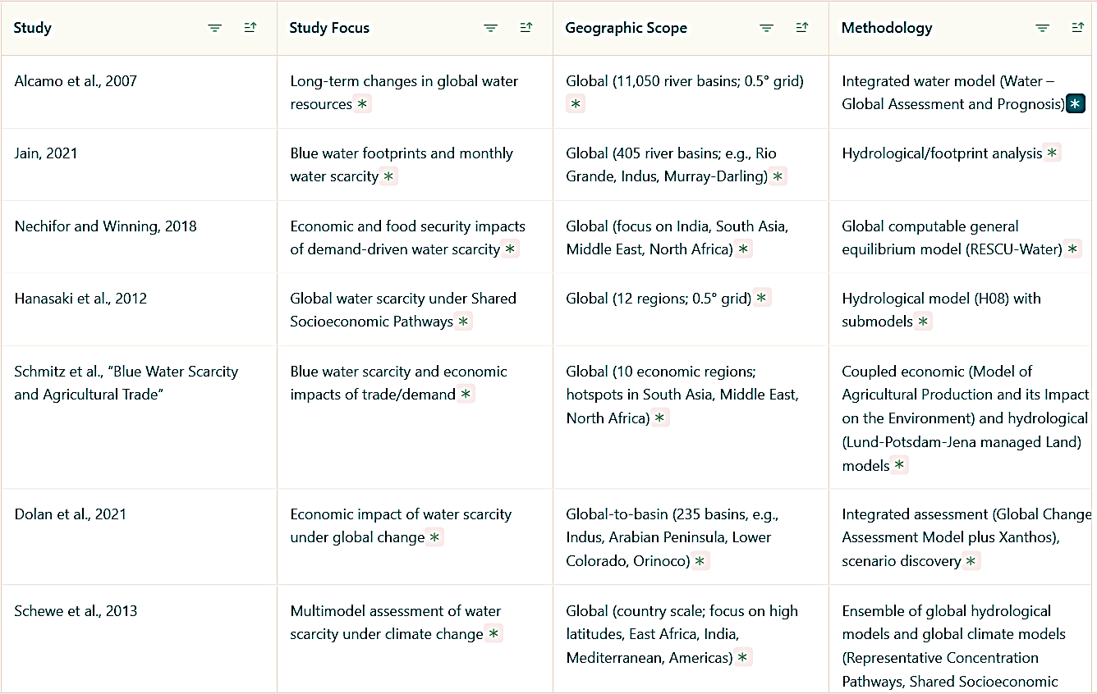

Table 2. Conceptual Framework for Analyzing Freshwater Scarcity
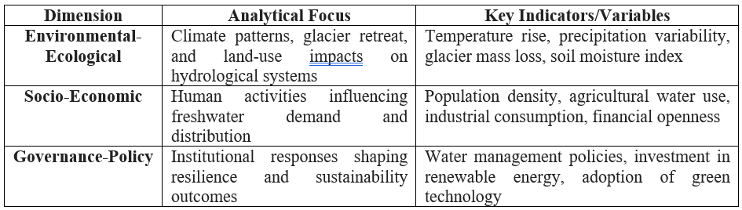

Table 3. Conceptual Framework for Environmental Impacts
