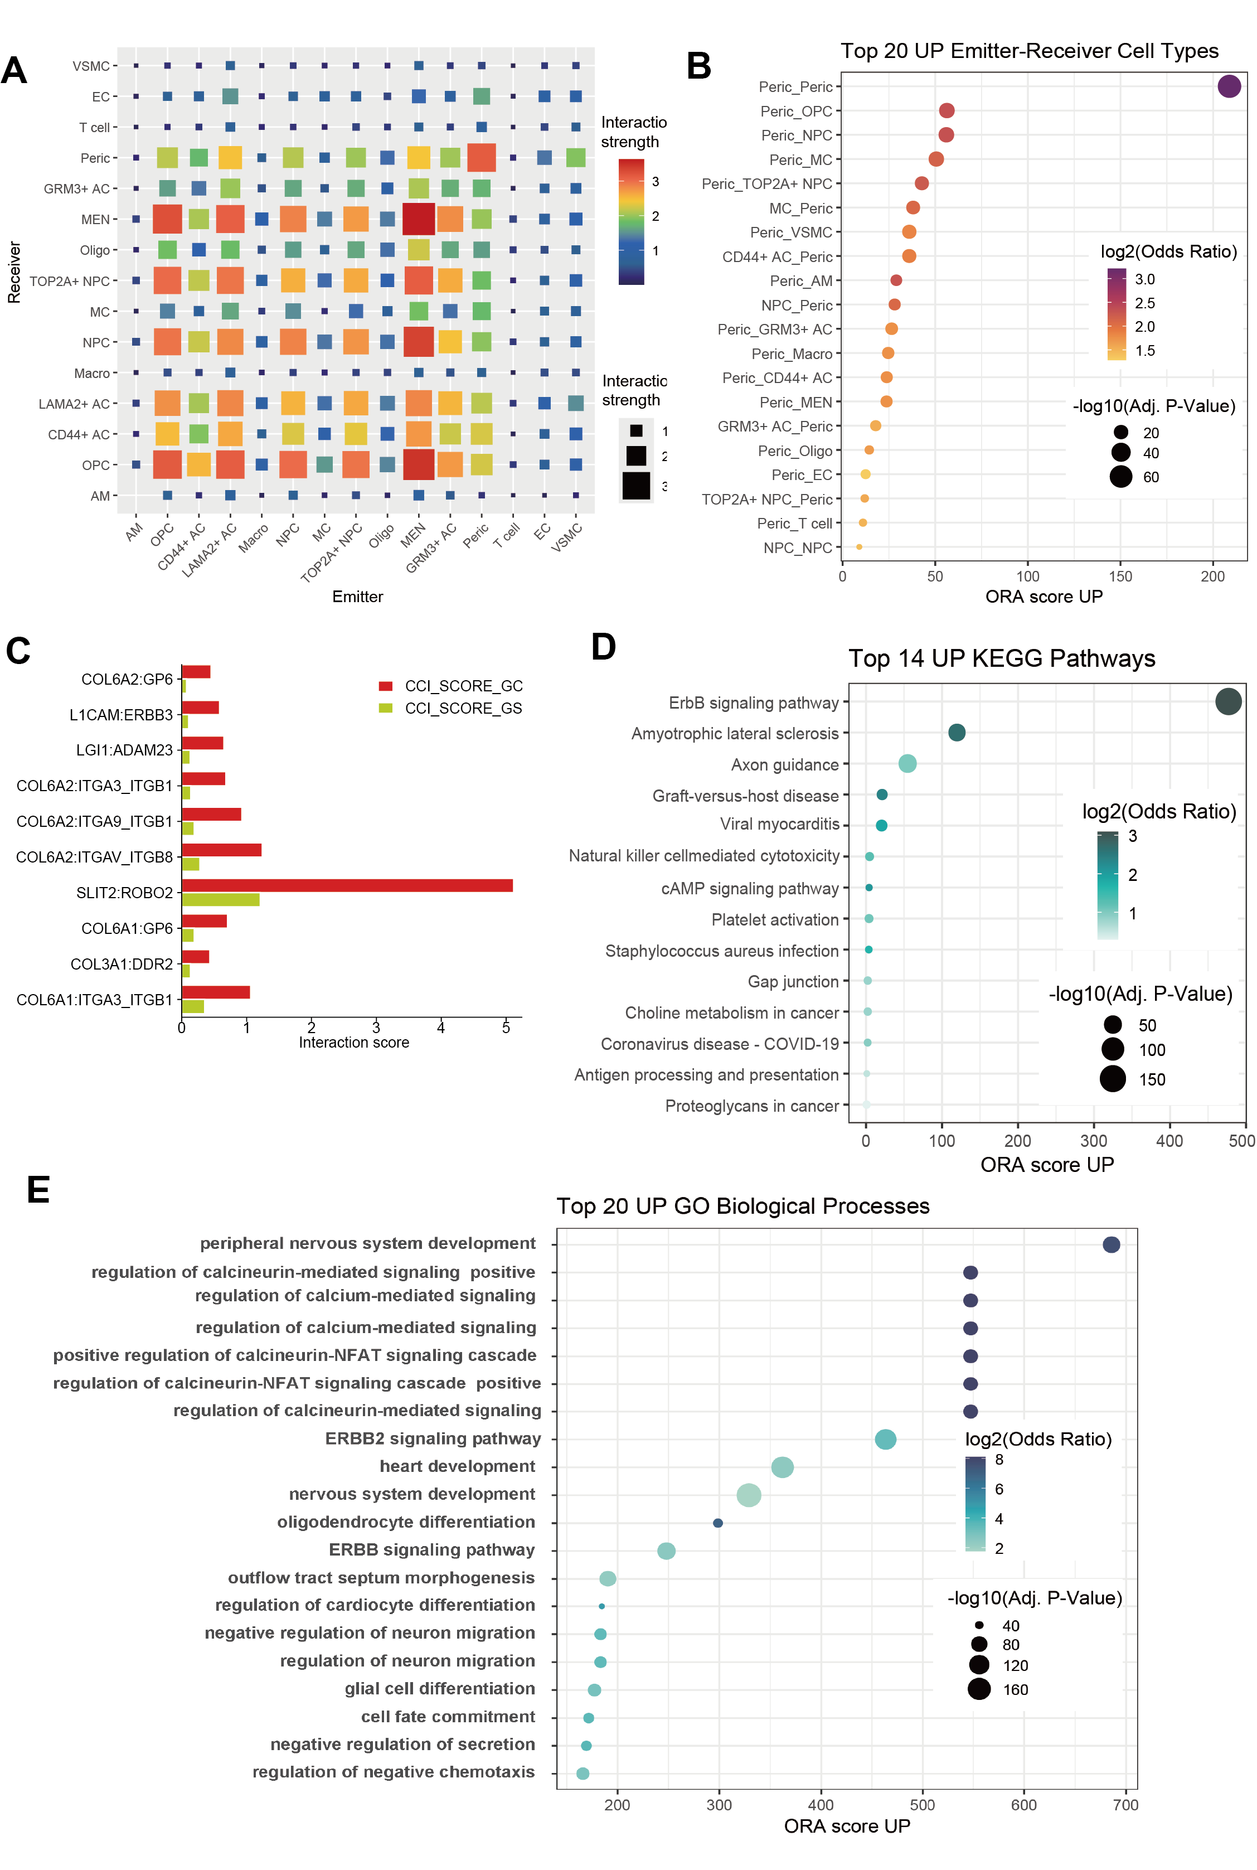
Supplementary Figure 1. Intercellular communication analysis reveals key signaling networks in tumor microenvironment.
(A) Heatmap of interaction intensity between different cell types, with x-axis representing signal sending and y-axis representing signal receiving. (B) Bubble plot of top 20 upregulated sender-receiver cell type pairs. (C) Key ligand-receptor pair interaction scores for intercellular interactions between pericytes and mature excitatory neurons. (D) KEGG pathway enrichment analysis of upregulated intercellular communication. (E) GO biological process enrichment analysis of upregulated intercellular communication. ORA scores represent the enrichment degree of corresponding processes in differential cellular communication. (www.kegg.jp/kegg/kegg1.html). © Kanehisa Laboratories.)

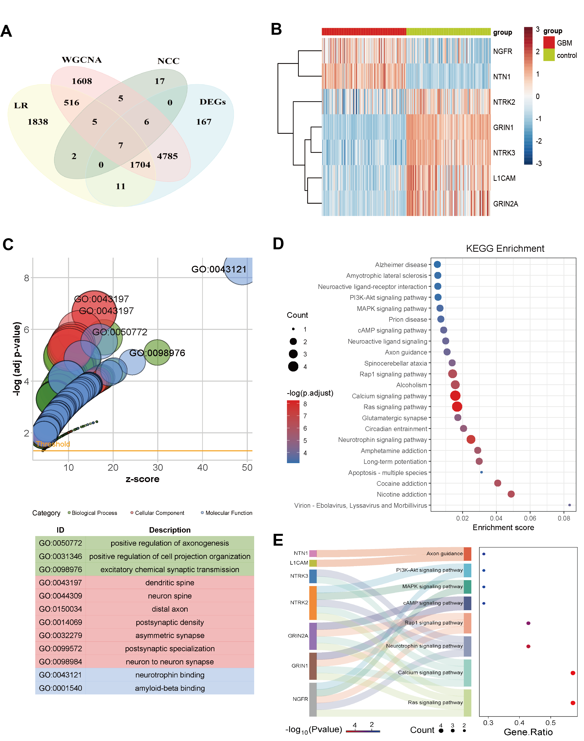
Supplementary Figure 2. Integrated analysis identifies key genes related to neuro-cancer crosstalk.
(A) Venn diagram showing overlaps between genes identified by different analysis methods. Key cell type marker genes and cellular communication differential genes (LR), differentially expressed genes (DEGs), WGCNA hub genes, and neuro-cancer crosstalk related genes (NCC). (B) Expression heatmap of 7 candidate genes in GBM and control groups. (C) GO functional enrichment analysis bubble plot of candidate genes. X-axis shows z-score representing enrichment degree, Y-axis shows -log10(adjusted P value). Bubble size represents the number of genes in each GO term, color represents category type (green: biological process, pink: cellular component, blue: molecular function), horizontal orange line marks significance threshold. (D) KEGG pathway enrichment analysis of candidate genes. X-axis shows enrichment score representing enrichment degree, bubble size represents the number of genes enriched in each pathway, bubble color represents -log10(adjusted P value). (E) Sankey diagram showing associations between 7 key genes and major signaling pathways from pathway enrichment analysis. (www.kegg.jp/kegg/kegg1.html). © Kanehisa Laboratories.)

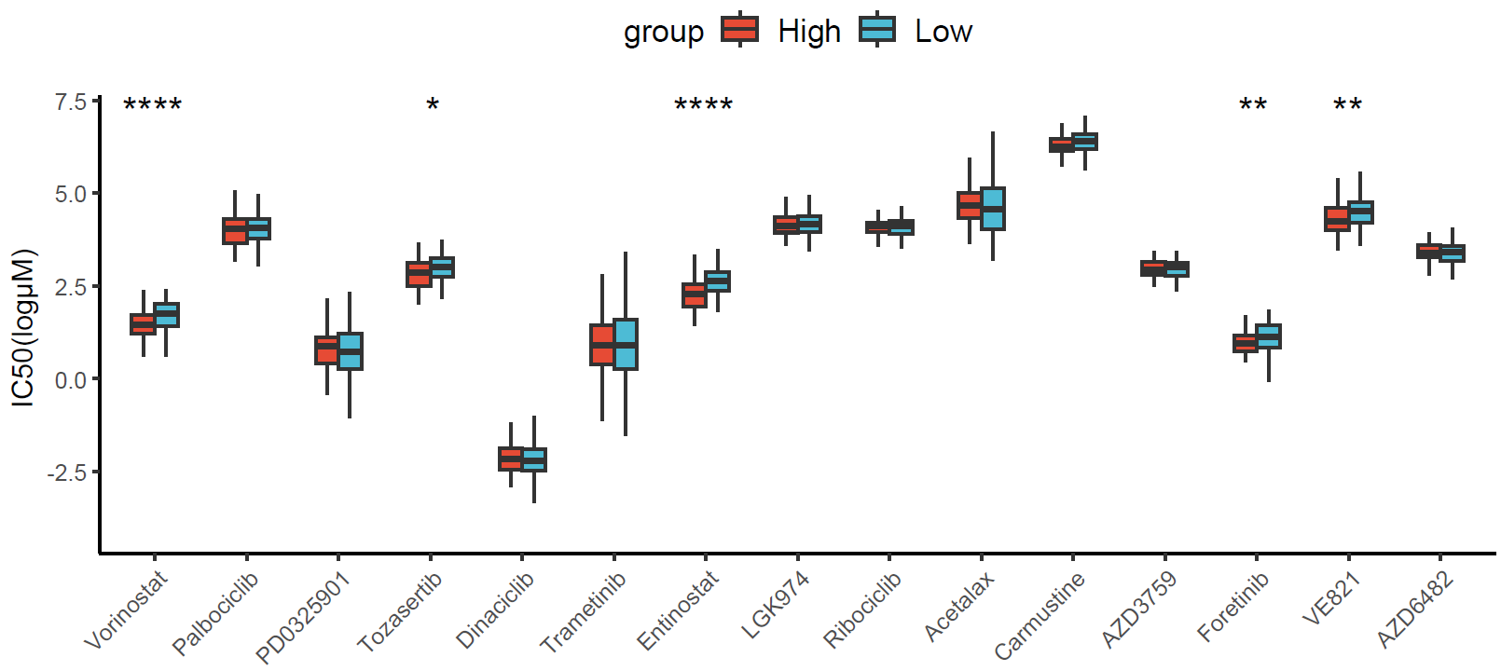
Supplementary Figure 3. Comparison of IC₅₀ values of different chemotherapy drugs in high-risk and low-risk groups.
Statistical significance was determined by Wilcoxon rank sum test, *P < 0.05, **P < 0.01, ***P < 0.001, ****P < 0.0001.

Supplementary Table 2. Connectivity Scores and Binding Free Energies of Small Molecule Candidate Drugs Corresponding to Key Target Genes
Compound | Target | Connectivity score | Binding free energies (-kcal/mol)
betamethasone-acetate | L1CAM | -1.6 | -8
TAK-733 | L1CAM | -1.6 | -6.9
U-54494A | L1CAM | -1.6 | -6.7
betamethasone-acetate | NGFR | -1.6 | -7.3
TAK-733 | NGFR | -1.6 | -6.1
U-54494A | NGFR | -1.6 | -5.7

