Supporting Information

A novel TMTP1-modified theranostic nanoplatform for targeted in vivo NIR-II fluorescence imaging-guided chemotherapy of cervical cancer
Nuernisha Alifu¹†, Rong Ma²†, Lijun Zhu¹, Zhong Du², Shuang Chen², Ting Yan¹, Gulinigaer Alimu¹, Linxue Zhang¹, Cailing Ma², Xueliang Zhang¹*
*Correspondence: shuxue2456@126.com
†Nuernisha Alifu and Rong Ma contributed equally to this work.
¹State Key Laboratory of Pathogenesis, Prevention and Treatment of High Incidence Diseases in Central Asia School of Medical Engineering and Technology, Xinjiang Medical University, Urumqi, 830011, China
²State Key Laboratory of Pathogenesis, Prevention, and Treatment of High Incidence Diseases in Central Asia, Department of Gynecology, The First Affiliated Hospital of Xinjiang Medical University, Urumqi 830054, China

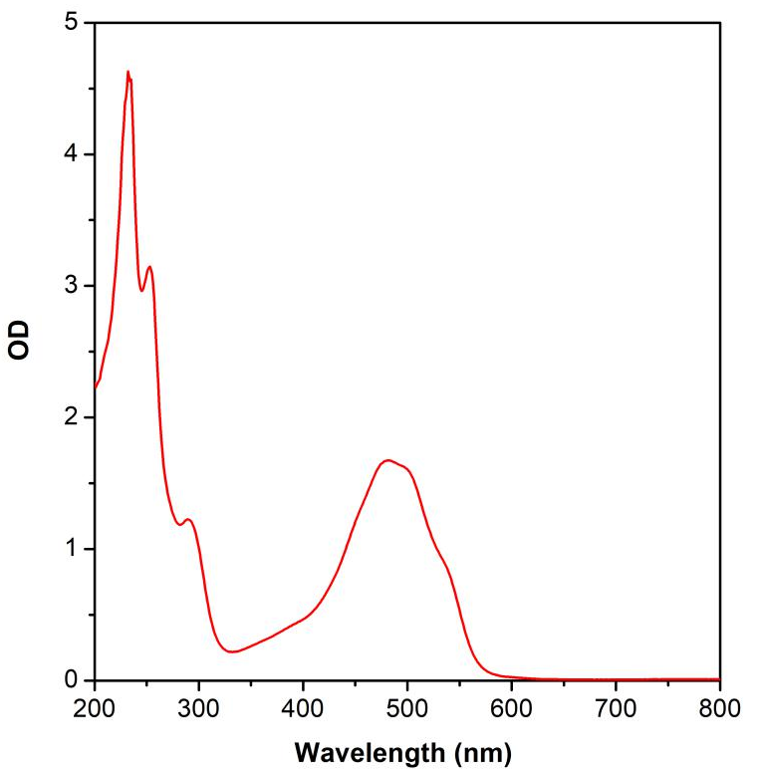
Fig. S1 Absorption spectrum of DOX in aqueous solution.

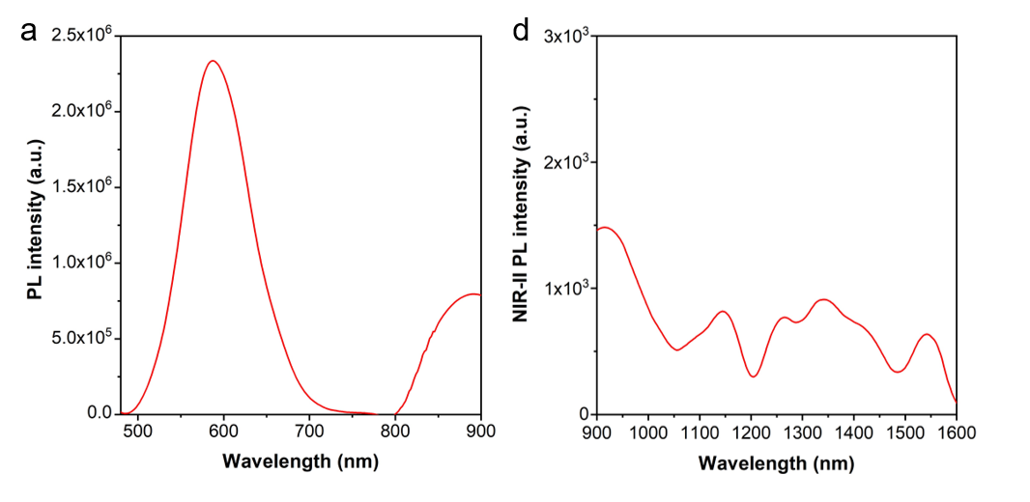
Fig. S2 Fluorescence spectrum of IR-783-DOX-TMTP1 nanoparticles (NPs) in aqueous dispersion.

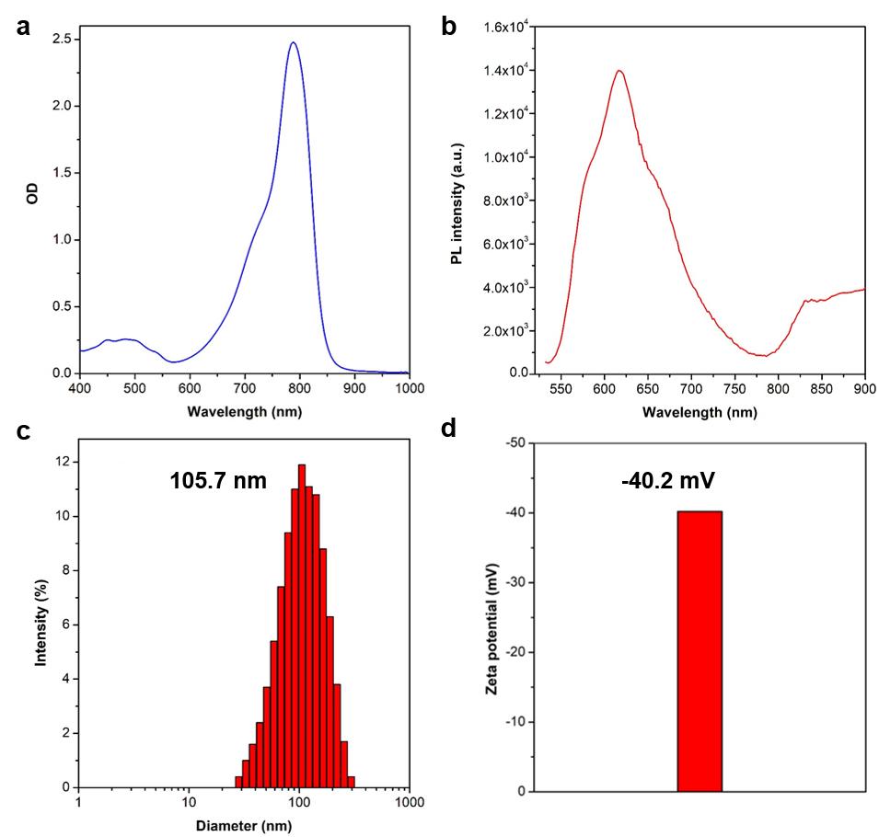
Fig. S3 a Absorption, b fluorescence spectra, c dynamic light scattering (DLS) and d Zeta potential of IR-783-DOX NPs in aqueous dispersion.

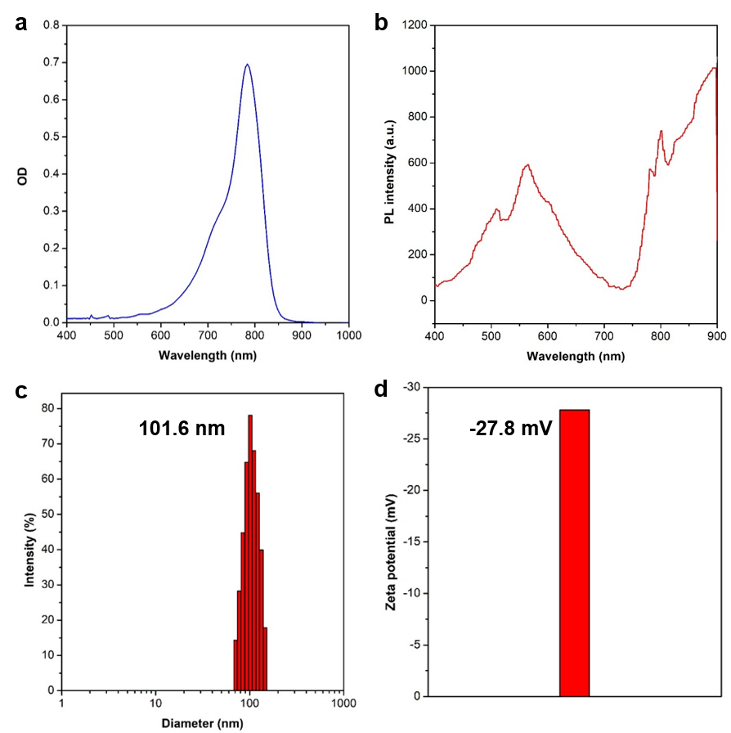
Fig. S4 a Absorption, b fluorescence spectra, c DLS and d Zeta potential of IR-783-TMTP1 NPs in aqueous dispersion.

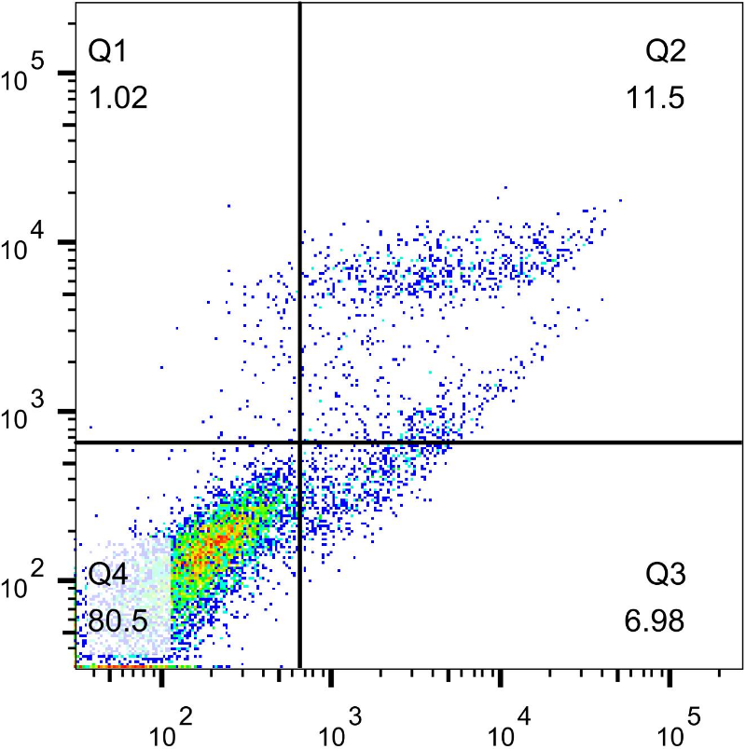
Fig. S5 Flow cytometric detection results of HeLa cells (control group).
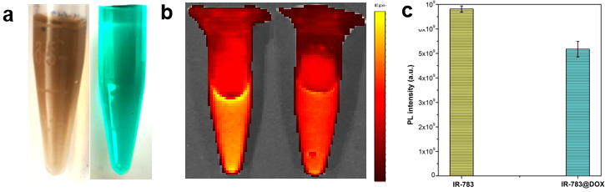
Fig. S6 a IR-783-DOX-TMTP1 NPs and IR-783 in aqueous dispersion; b Corresponding near-infrared-I (NIR-I) images; c NIR-I fluorescence intensity analysis.

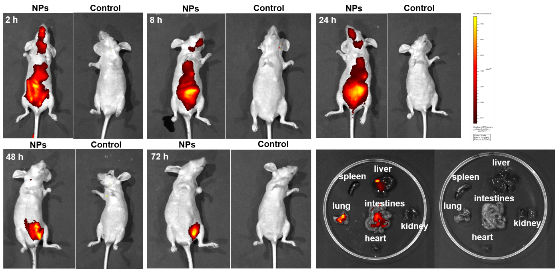
Fig. S7 In vivo NIR-I fluorescence images of nude mouse injected with 1×PBS and IR-783-TMTP1 NPs in aqueous dispersion at various time points, and corresponding ex vivo NIR-I fluorescence images of major organs (liver, lung, spleen, heart, intestines and kidney) at 48 h of post-injection. λ_{ex}=745 nm, λ_{em}=840 nm.
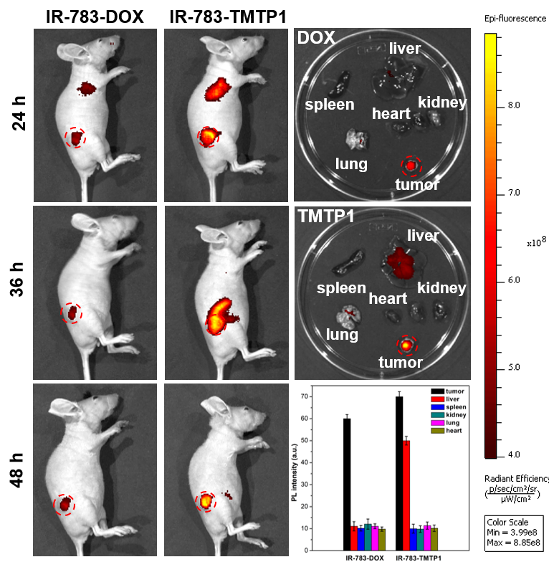
Fig. S8 In vivo NIR fluorescence images tumor-bearing mouse injected with IR-783-DOX NPs and IR-783-TMTP1 NPs in aqueous dispersion. λ_{ex}=745 nm, λ_{em}=840 nm.
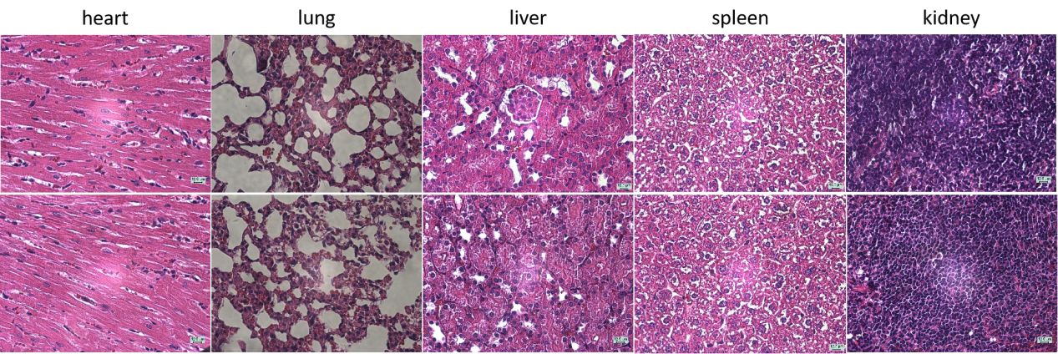
Fig. S9 Microscopic images of tissue sections from the mice intravenously injected with 1×PBS (down line, 200 μL) and IR-783-DOX-TMTP1 NPs (upper line, 1 mg/mL, 200 μL) for 24 hours.
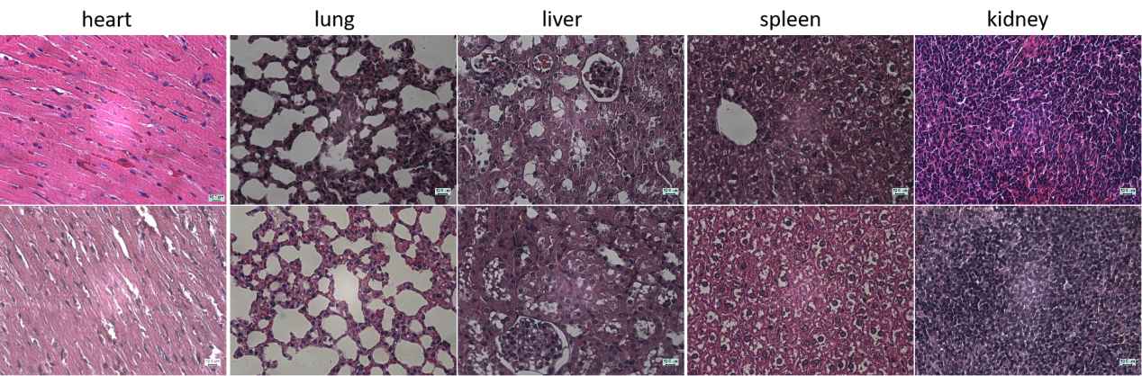
Fig. S10 Microscopic images of tissue sections from the mice intravenously injected with 1×PBS (down line, 200 μL) and IR-783-DOX-TMTP1 NPs (upper line, 1 mg/mL, 200 μL) for 7 days

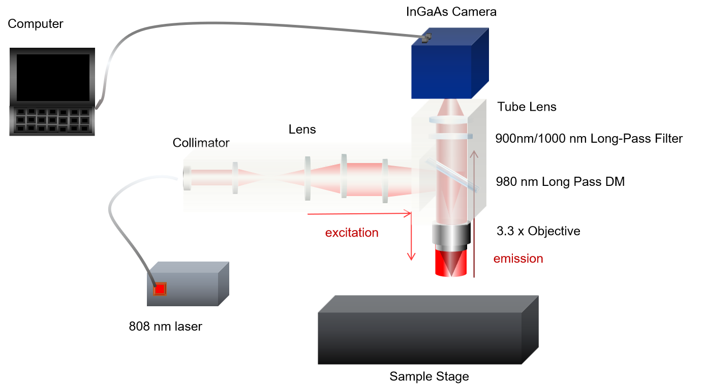
Fig. S11 Schemetic illustration of NIR-II fluorescence microscopic imaging system.

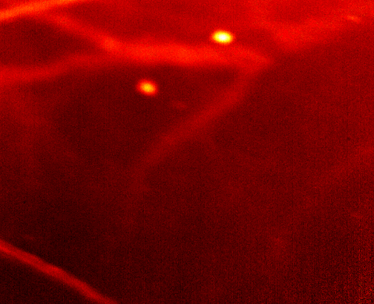
Fig. S12 NIR-II fluorescence miroscopic images of ear blood vessels treated with PBS.
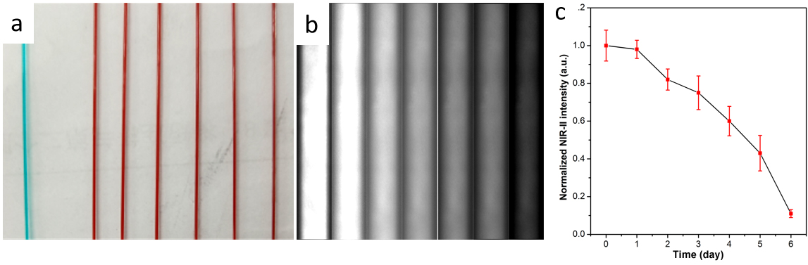
Fig. S13 In vivo blood circulation analysis of IR-783-DOX-TMTP1 NPs.
Fig. S14 NIR-II fluorescence miroscopic images of tumour blood vessels treated with PBS under 808 nm laser excitation.

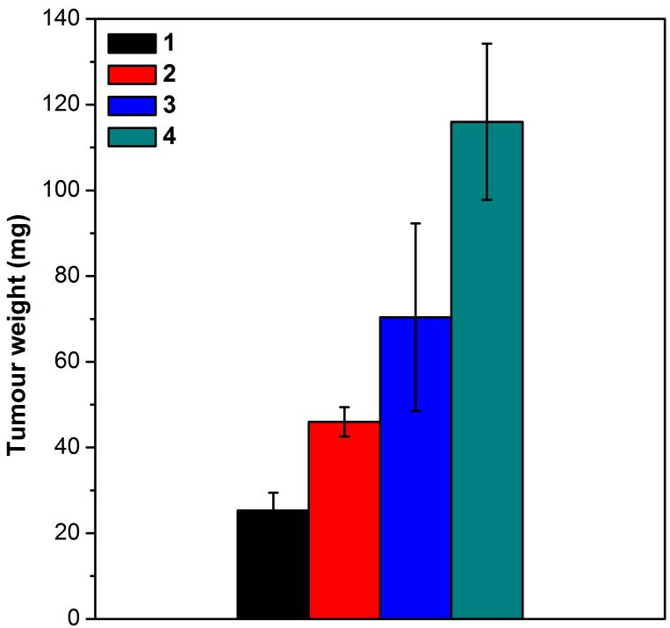
Fig. S15 Body weight of therapeutic agents did not cause any significant loss of mouse body weight during the entire treatment process. Data were displayed as the mean ± SD (n =4).

