Supplemental Data
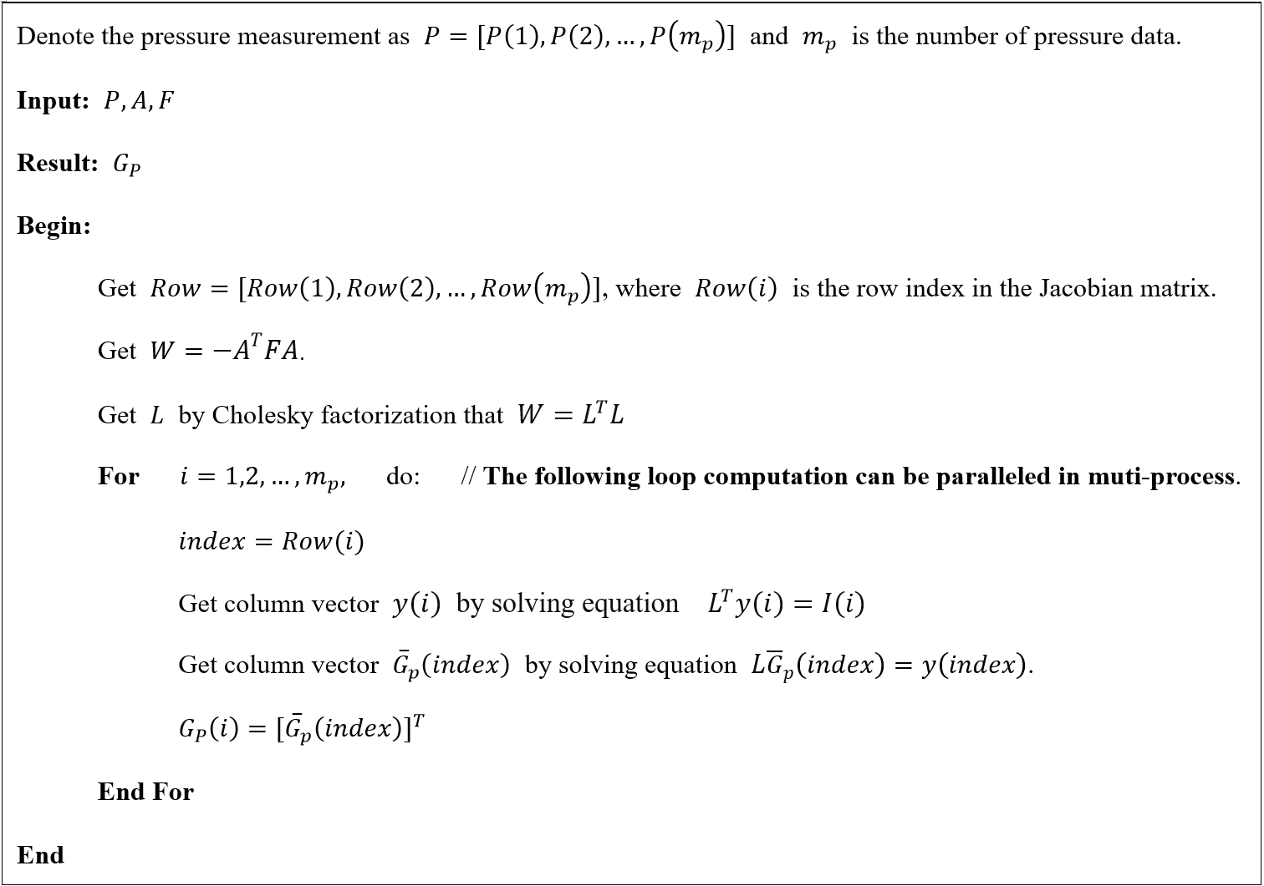
Figure S1 The pseudo-code for the solution of pressure data Jacobian matrix.
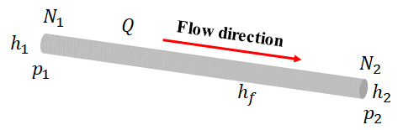
Figure S2 Schematic diagram of a pipe

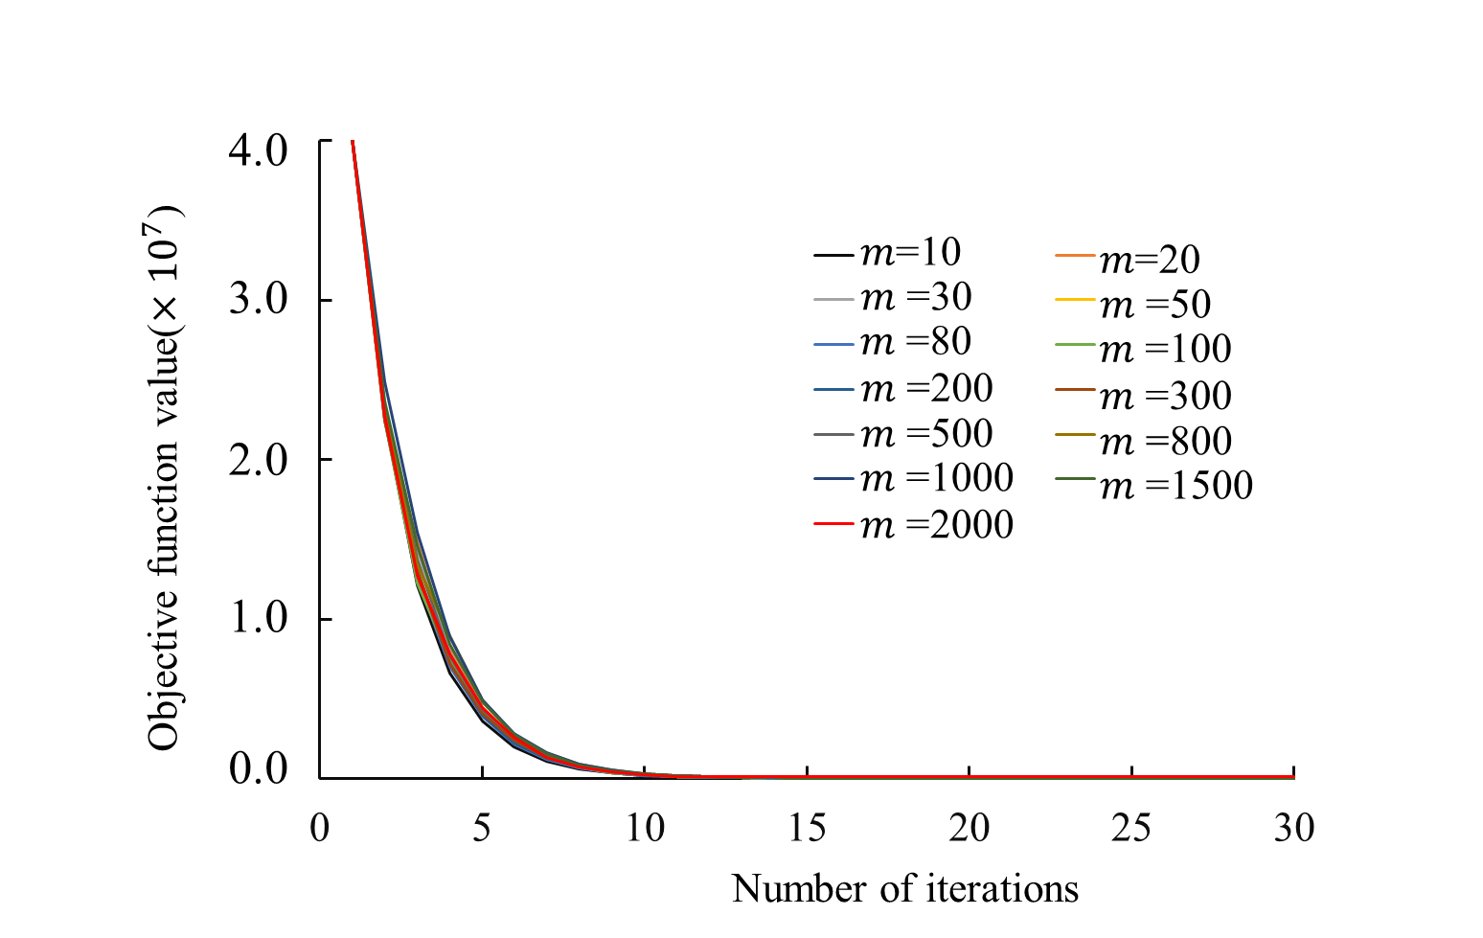
Figure S3 Objective function value versus number of iterations
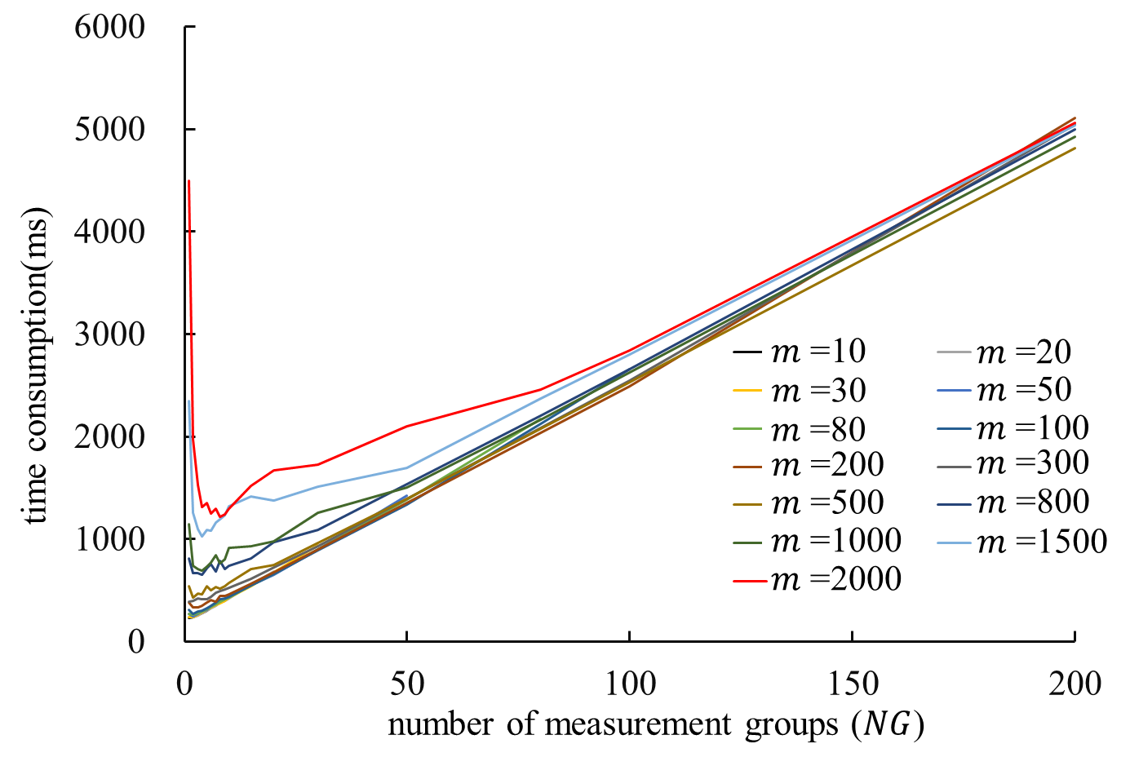
Figure S4 The time consumption of the Hessian matrix inversion for different number of measurement groups

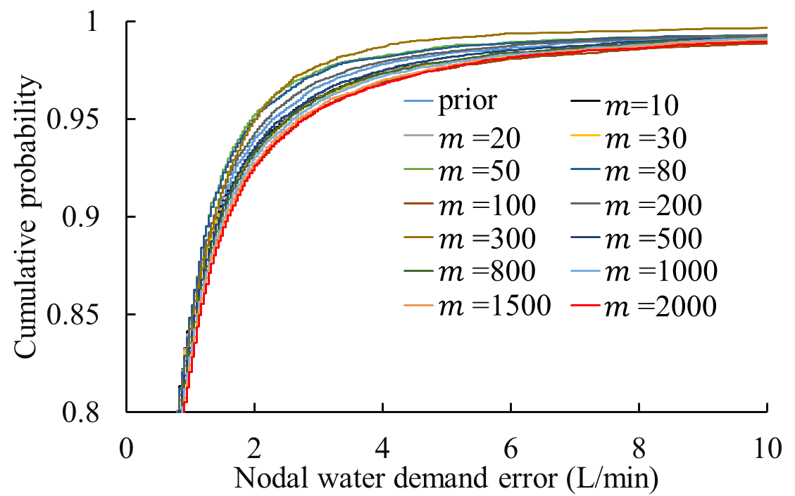
Figure S5 Cumulative probability of absolute errors of nodal demand
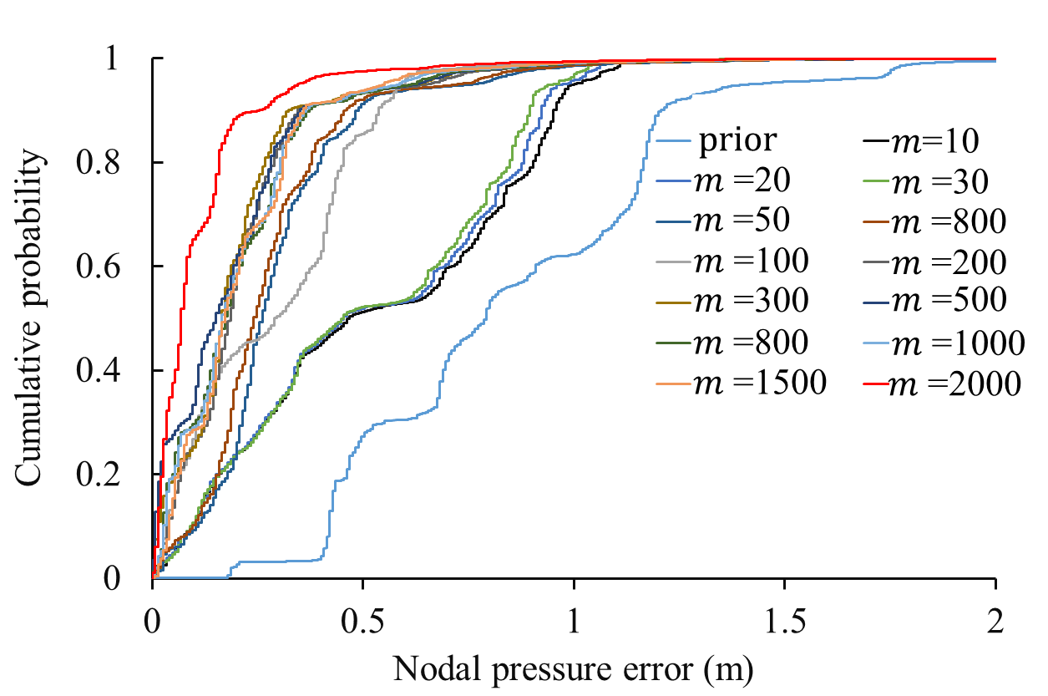
Figure S6 Cumulative probability of absolute errors of nodal pressure

