Supplementary Material
Outline
Supplementary Material 1
Supplementary methods 2
Methods S1. Subject Information 2
Table S1. Demographic and neuropsychological data for all dataset 2
Table S2. Demographic and neuropsychological data for tACS dataset 7
Method S2: Prediction of clinical status based on functional topography 9
Method S3: Regression Analysis of Group Differences in Cortical Thickness 9
Supplementary figures 10
Figure S1. IFN improves the inner network homogeneity and acts as a fingerprint for individual identification. 10
Figure S2. Clinical relevance of IFN in Alzheimer’s disease. 11
Figure S3. The correlations of areas between functional networks in three datasets. 12
Figure S4. The performance of classification and cognitive prediction in ADNI. 13
Figure S5. Across-subject variability of functional topography changed in Alzheimer’s disease. 14
Figure S6. Deviation of IFN associated with the atrophy in Alzheimer’s disease. 15
Figure S7. The normative range derived from the distribution of functional topography in MCAD. 16
Figure S8. Alterations of area of functional networks in AD in three datasets. 17
Figure S9. Deviation patterns of IFN topography in AD. 18
Figure S10. Three-month follow-up after tACS stimulation revealed a gradual return to the original trajectory of AD progression. 19
Figure S11. Effect declines 3 months post-stimulation 21
References 22

Supplementary methods

Methods S1. Subject Information

Table S1. Demographic and neuropsychological data for all dataset
Site | Group | Number | Age | P | Sex  (M/F) | P | MMSE | P
MCAD  site 1  HH_Z | NC | 23 | 65.4±6.3 | 0.53 | 9/14 | 0.37 | 28.8±1.2 | P<0.001
MCAD  site 1  HH_Z | MCI | 29 | 65.1±8.6 | 0.53 | 10/19 | 0.37 | 26.1±2.5 | P<0.001
MCAD  site 1  HH_Z | AD | 35 | 67.2±8.2 | 0.53 | 18/17 | 0.37 | 15.9±5.7 | P<0.001
MCAD  site 2  PL_G | NC | 17 | 67.8±4.6 | 0.11 | 9/8 | 0.26 | 28.9±1.0 | P<0.001
MCAD  site 2  PL_G | MCI | 22 | 72.9±8.3 | 0.11 | 11/11 | 0.26 | 27.0±1.9 | P<0.001
MCAD  site 2  PL_G | AD | 15 | 71.5±8.4 | 0.11 | 4/11 | 0.26 | 20.2±3.3 | P<0.001
MCAD  site 3  PL_S1 | NC | 37 | 68.2±6.7 | 0.80 | 16/21 | 0.54 | 28.6±1.5 | P<0.001
MCAD  site 3  PL_S1 | MCI | 31 | 68.5±8.5 | 0.80 | 11/20 | 0.54 | 26.8±2.5 | P<0.001
MCAD  site 3  PL_S1 | AD | 39 | 69.4±9.3 | 0.80 | 19/20 | 0.54 | 17.7±6.8 | P<0.001
MCAD  site 4  QL_W | NC | 41 | 65.4±6.8 | 0.13 | 12/29 | 0.15 | 28.5±1.7 | P<0.001
MCAD  site 4  QL_W | MCI | 15 | 66.5±7.5 | 0.13 | 8/7 | 0.15 | 24.9±1.6 | P<0.001
MCAD  site 4  QL_W | AD | 57 | 68.2±7.1 | 0.13 | 26/31 | 0.15 | 19.1±3.3 | P<0.001
MCAD  site 5  XW_H | NC | 53 | 66.4±6.1 | 0.61 | 21/32 | 0.15 | 28.5±1.9 | P<0.001
MCAD  site 5  XW_H | MCI | 79 | 67.4±9.9 | 0.61 | 43/36 | 0.15 | 24.3±3.3 | P<0.001
MCAD  site 5  XW_H | AD | 38 | 68.2±8.7 | 0.61 | 15/23 | 0.15 | 17.3±6.2 | P<0.001
MCAD  site 6  XW_Z | NC | 21 | 65.0±8.2 | 0.17 | 7/14 | 0.37 | 28.5±1.4 | P<0.001
MCAD  site 6  XW_Z | MCI | 16 | 69.9±8.4 | 0.17 | 9/7 | 0.37 | 21.6±5.2 | P<0.001
MCAD  site 6  XW_Z | AD | 28 | 65.4±8.8 | 0.17 | 13/15 | 0.37 | 11.0±6.5 | P<0.001
MCAD  site 7  PL_S2 | NC | 40 | 68.2±8.3 | 0.45 | 20/20 | 0.33 | 28.8±1.2 | P<0.001
MCAD  site 7  PL_S2 | MCI | 35 | 70.1±7.0 | 0.45 | 12/23 | 0.33 | 26.2±2.6 | P<0.001
MCAD  site 7  PL_S2 | AD | 40 | 70.3±8.8 | 0.45 | 15/25 | 0.33 | 15.9±5.8 | P<0.001
ADNI | NC | 340 | 72.3±7.2 | 2.7e-03 | 138/202 | 3.6e-03 | 29.1±1.1 | P<0.001
ADNI | MCI | 213 | 73.3±9.5 | 2.7e-03 | 115/98 | 3.6e-03 | 27.8±2.1 | P<0.001
ADNI | AD | 68 | 76.0±7.6 | 2.7e-03 | 37/31 | 3.6e-03 | 22.8±3.9 | P<0.001
OASIS | NC | 421 | 69.2±9.2 | P<0.001 | 175/246 | P<0.001 | 29.1±1.2 | P<0.001
OASIS | AD | 85 | 76.7±7.9 | P<0.001 | 54/31 | P<0.001 | 24.3±4.0 | P<0.001
These datasets were used in our previous studies to evaluate altered spontaneous activity in Alzheimer’s disease (AD) ^{1,2}. To minimize the variation in multicenter data, we included the following quality controls: (1) exclusion of subjects with poor fMRI data quality, subjects without complete demographic information, and subjects without Mini-Mental State Examination (MMSE) scores; (2) removal of subjects with large head motion in any direction corresponding to >3 mm or any rotation >3°; and (3) matching the age and gender of the subjects at each center. Here, with permission, we have rewritten the information to maintain the integrity of the present study.

PL_G and PL_S
This study was approved by the Medical Ethics Committee of PLA General Hospital. Written informed consent was obtained from each enrolled subject or his/her authorized guardian. All of the participants were recruited by an advertisement (http://www.301ad.com.cn, Chinese version). Prior to selection for this study, all of the participants were given free physical, psychological and laboratory examinations. All patients received professional suggestions for further treatment.
All of the subjects were right-handed and underwent a battery of neuropsychological tests, including the Mini-Mental State Examination (MMSE), the auditory verbal learning test (AVLT), Geriatric Depression Scale (GDS) ³, Clinical Dementia Rating (CDR) ⁴ and Activities of Daily Living (ADL) Scale. In brief, the AVLT consisted of 1 learning trial in which a list of 10 Chinese double-character words was read, and the subject was asked to immediately recall as many items as possible. The trial was repeated twice, and the immediate recall score was the average of 3 accurate recalls. After a 5-minute delay, each subject was asked to recall the words from the initial list (AVLT-delayed recall). The subjects were then told to identify the 10 studied words that were inter-mixed with 10 novel words (AVLT-recognition).
The recruited AD patients fulfilled the following inclusion criteria: (1) diagnosed using the National Institute of Neurological and Communicative Disorders and Stroke and the Alzheimer Disease’s and Related Disorders Association criteria for probable AD; (2) CDR = 1 or 2; (3) currently receiving no tropic drugs, such as cholinesterase inhibitors; and (4) able to perform the neuropsychological test and tolerate MR scanning.
The diagnostic criteria for MCI were determined as previously described ⁵ and included the following: (1) memory complaints lasting at least 6 months; (2) CDR = 0.5; (3) intact functional status and ADL< 26; and (4) lack of dementia. The criteria for NC included the following: (1) normal physical status; (2) CDR = 0; and (3) without memory complaints.
The following exclusion criteria were used in this study: (1) metabolic conditions such as hypothyroidism or vitamin B12/folic acid deficiencies; (2) psychiatric disorders such as schizophrenia or depression; (3) infarction or brain hemorrhaging, as indicated by MR/CT imaging; and (4) Parkinsonian syndrome, epilepsy and other nervous system diseases that can influence cognitive function. In addition, patients with a metallic foreign body, such as a cochlear implant, heart stent or other relevant MR scanning contraindications, were excluded from the study.
Related publications can be found elsewhere ⁶⁻¹⁵.

HH_Z
The dataset followed the same protocol as PL_G and PL_S. This study was approved by the Medical Ethics Committee of Tianjin Huanhu Hospital. The patients were recruited from the memory clinic of the Neurology Department of Tianjin Huanhu Hospital, Tianjin, China. The control subjects were recruited from the local community using advertisements. Written informed consent was obtained from each enrolled subject or his/her authorized guardian. The participants underwent general physical, psychological and laboratory examinations prior to enrollment in the formal study. The participants didn’t undergo the auditory verbal learning test. The participants did not take medications that might have influenced cognition during the scans, and all patients received professional suggestions for further treatment.

QL_W
The dataset followed the same protocol as PL_G and PL_S. This study was approved by the Medical Ethics Committee of Qilu Hospital of Shandong University. The patients were recruited from the memory clinic of the Department of Neurology and Radiology, Qilu Hospital of Shandong University, Ji’nan, China. The control subjects were recruited from the local community using advertisements. Written informed consent was obtained from each enrolled subject or his/her authorized guardian. The participants underwent general physical, psychological and laboratory examinations prior to enrollment in the formal study. The participants did not take medications that might have influenced cognition during the scans, and all patients received professional suggestions for further treatment.

XW_H
The study was approved by the Medical Research Ethics Committee and Institutional Review Board of Xuanwu Hospital (ClinicalTrials.gov identifiers: NCT02353884 and NCT02225964). Part of the data have been used in several previous studies, and detail information can be found elsewhere ^{16,17}.
All subjects underwent a series of standardized clinical evaluations, including a medical history interview, neurologic examination, and a battery of neuropsychological tests. The neuropsychological tests included the Chinese version of the MMSE, the Beijing version of MoCA ¹⁸, the CDR ⁴, the AVLT ¹⁹, an ADL assessment, the Hachinski Ischemic Scale, the Hamilton Depression Rating Scale (HAMD) ²⁰, and The Center for Epidemiologic Studies Depression Scale ²¹. Confirmation of diagnosis for all subjects was made by the consensus of at least two experienced neurologists in the Neurology Department of Xuanwu Hospital. The diagnoses were based on the available data from the neuropsychological assessment evaluation, a battery of general neurological examinations, and subject symptoms as well as functional capacity reports.
The inclusion criteria for aMCI diagnosis included the following ²²: (a) memory complaints, confirmed by an informant; (b) objectively impaired memory confirmed by neuropsychological tests; (c) a definite history of cognitive decline; (d) not meeting the criteria for dementia according to the Diagnostic and Statistical Manual of Mental Disorders, Fourth Edition, Revised (DSM-IV-R); and (e) a CDR score of 0.5.
AD subjects were diagnosed according to the National Institute of Aging-Alzheimer’s Association (NIA-AA) criteria for clinically probable AD ^{23,24}: (a) meeting the criteria for dementia; (b) insidious and gradual onset (not sudden) over more than 6 months; (c) definite history of declining cognition; (d) initial and most prominent cognitive deficits evident in amnestic or non-amnestic performance; and (e) hippocampal atrophy confirmed by structural MRI.

XW_Z
The NC patients were required to meet the following research criteria: (a) no memory concerns; (b) MMSE and MoCA scores within the normal range (adjusted for age, sex, and education); and (c) a CDR score of 0.
The exclusion criteria applied to all subjects included the following: (a) vascular cognitive impairment (Hachinski Ischemic Scale score > 4 points); (b) severe depression (HAMD score > 24 points or The Center for Epidemiological Studies Depression Scale score > 21 points); (c) other central nervous system diseases that could cause cognitive decline (e.g., epilepsy, brain tumors, Parkinson’s disease, or encephalitis); (d) systemic diseases that could cause cognitive impairments (e.g., anthracemia, syphilis, thyroid dysfunctions, severe anemia, or HIV); (e) a history of psychosis or congenital mental growth retardation; (f) severe hypopsia or dysacusis; (g) cognitive decline caused by traumatic brain injury; (h) severe end-stage disease or severe diseases in acute stages; (i) a history of stroke; or (j) unable to complete neuropsychological tests or with a contraindication for MRI.
All the participants were recruited by advertisement and supported throughout the testing procedures in a specialist neuropsychological research facility at Xuanwu Hospital, Beijing, China. Patients and informants (usually a family member) were interviewed clinically by a senior psychiatrist (X. Zhang). Written consent forms were obtained from all subjects or their legal guardians (usually a family member). The study was approved by the Ethics Committee of Xuanwu Hospital. AD subjects were diagnosed using standard operationalized criteria (DSM-IVR [American Psychiatric Association, 1994] and NINCDS-ADRDA ²³]).
The inclusion criteria for AD diagnosis included the following: severity of dementia was assessed using the Clinical Dementia Rating (CDR) scale ⁴. Patients with a diagnosis of AD and CDR score of 1 were classified as mild AD; patients with a CDR score of 2 or 3 were diagnosed as severe AD.
Mild cognitive impairment (MCI) was diagnosed according to standard criteria ^{5,25,26}, which included subjective memory loss with objective evidence of memory impairment in the context of normal or near-normal performance on other domains of cognitive functioning; minimal impairment of activities of daily living; and a CDR score of 0.5. Normal volunteers have a CDR score of 0.
All participants satisfied the following inclusion criteria: (1) no history of an affective disorder within one month prior to assessment; (2) normal vision and audition; (3) able to cooperate with cognitive testing; (4) aged between 50 and 90 years; (5) no clinical history of stroke or other severe cerebrovascular disease; and (6) no more than one lacunar infarction, without patchy or diffuse leukoaraiosis, on neuroradiological assessment of conventional MR images.
The exclusion criteria included the following: (1) severe general medical disorders of cardiovascular, endocrine, renal or hepatic systems; neurological disorders associated with potential cognitive dysfunction, including local brain lesions, traumatic brain injury with loss of consciousness or confusion, and dementia associated with neurosyphilis, Parkinsonism or Lewy body disease; psychiatric disorders including depression, alcohol or drug abuse; (2) concomitant use of psychotropic medication in a large quantity; and (3) insufficient cognitive capacity to understand and cooperate with study procedures.
All patients underwent a complete physical and neurological examination, an extensive battery of neuropsychological assessments, and standard laboratory tests. Healthy volunteers underwent a brief clinical interview and MMSE to confirm that they satisfied the exclusion criteria for cognitive deficits, psychoactive drug use, and clinical disorders.

ADNI
The replication dataset was obtained from the ADNI database (http://adni.loni.usc.edu ). The Alzheimer’s Disease Neuroimaging Initiative (ADNI), launched in 2003 as a public-private partnership and is a longitudinal natural history study whose primary purpose is to inform the design of therapeutic trials in Alzheimer’s disease (AD).
Briefly, the NC patients were required to meet the following inclusion criteria: 1) No memory complaints; 2) Normal memory documented by scoring below education-adjusted cutoffs on the Logical Memory II subscale (Delayed Paragraph Recall, Paragraph A only) from the Wechsler Memory Scale-Revised; 3) MMSE score between 24 and 30 inclusive (Exceptions may be made for participants with less than 8 years of education at the discretion of the Project Director); 4) Clinical Dementia Rating = 0. Memory Box score must be at least 0. Inclusion of MCI in ADNI was mainly included: 1) Participant must express a subjective memory concern; 2) Abnormal memory function documented by scoring below education-adjusted cutoffs on the Logical Memory II subscale (Delayed Paragraph Recall, Paragraph A only) from the Wechsler Memory Scale-Revised; 3) MMSE score between 24 and 30 inclusive (Exceptions may be made for participants with less than 8 years of education at the discretion of the Project Director); 4) Clinical Dementia Rating = 0.5. Memory Box score must be at least 0.5; 5) General cognition and functional performance sufficiently preserved such that a diagnosis of Alzheimer’s disease cannot be made by the site physician at the time of the Screening Visit. Inclusion of AD in ADNI was mainly included: 1) Participant must express a subjective memory concern; 2) Abnormal memory function documented by scoring below education-adjusted cutoffs on the Logical Memory II subscale (Delayed Paragraph Recall, Paragraph A only) from the Wechsler Memory Scale-Revised; 3) MMSE score between 20 and 24 inclusive (Exceptions for scores of 24 and 25 may be made for participants with less than 8 years of education at the discretion of the Project Director); 4) Clinical Dementia Rating = 0.5 or 1.0; 5) NINCDS/ADRDA criteria for probable AD.
The exclusion criteria in ADNI mainly included: 1) Any significant neurologic disease other than Alzheimer’s disease; 2) Screening/Baseline MRI brain scan with evidence of infection, infarction, or other focal lesions or multiple lacunes or lacunes in a critical memory structure; 3) Subjects that have any contraindications for MRI studies, including the presence of cardiac pacemakers, or metal fragments or foreign objects in the eyes, skin or body; 4) Major depression, bipolar disorder as described in DSM-IV within the past 1 year. Psychotic features, agitation, or behavioral problems within the last 3 months that could lead to difficulty complying with the protocol. The completed inclusion and exclusion criteria can be found in the Clinical Protocols in ADNI (adni.loni.usc.edu/methods/documents/).
The fMRI images were acquired on a 3.0-Tesla scanner. Resting-state functional images were obtained by using echo-planar imaging (EPI) sequence. This detailed information can be found in MRI Protocols in ADNI (adni.loni.usc.edu/methods/documents/) elsewhere in our previous studies ^{1,2,27-31}.

OASIS
We utilized the OASIS-3 dataset ³², a longitudinal neuroimaging, clinical and cognitive dataset of 1,378 participants aged 42–95 years, including cognitively normal individuals (CDR = 0) and individuals at various stages of cognitive decline (CDR = 0.5–1). Subjects were recruited through several studies at the Knight Alzheimer Disease Research Center, Washington University in St. Louis, and underwent multi-modal MRI/PET imaging, biomarker, and cognitive assessments. Participants with major neurological or systemic disorders precluding imaging or accurate cognitive evaluation were excluded.

Table S2. Demographic and neuropsychological data for tACS dataset
Characteristics | Active Group (n = 23) | Sham Group (n = 21) | P Value
Age | 66.17 ± 5.72 (56 - 74) | 62.67 ± 6.19 (51 - 73) | 0.21
Sex, Female | 6 (26.1%) | 10 (47.6%) | 0.06
Education | 10.61 ± 2.95 (5 - 16) | 10.05 ± 3.47 (4 - 17) | 0.53
MMSE | 20.26 ± 3.58 (13 - 27) | 21.14 ± 3.24 (16 - 28) | 0.49
MoCA | 15.39 ± 3.58 (11 - 27) | 16.38 ± 4.12 (10 - 25) | 0.24
ADAS-cog | 17.52 ± 5.32 (5 - 29) | 16.95 ± 5.58 (8 - 27) | 0.68
AVLT-IR | 15.26 ± 7.58 (2 - 35) | 15.43 ± 4.04 (7 - 21) | 0.68
AVLT-DR | 2.22 ± 3.13 (0 - 10) | 0.76 ± 1.26 (0 - 4) | 0.11
AVLT-R-R | 5.96 ± 3.44 (0 - 13) | 7.00 ± 6.24 (1-32) | 0.95
TMT-A | 99.43 ± 36.06 (50 - 150) | 84.00 ± 46.40 (29 - 150) | 0.20
TMT-B | 207.74 ± 84.76 (68 - 300) | 145.71 ± 95.62 (40 - 300) | 0.02
BNT | 21.78 ± 2.58 (18 - 26) | 21.90 ± 5.42 (7 - 29) | 0.55
Data are n (%) or mean ± SD (range). Categorical data were compared between groups using the Chi-square test, and continuous data were compared between groups using Mann Whitney U test. ADAS-cog = Alzheimer Disease Assessment Scale–cognitive subscale, AVLT = Auditory Verbal Learning Test, BNT = Boston Naming Test, DR = delay recall, IR = immediate recall, MMSE = Mini-Mental State Examination, MoCA = Montreal Cognitive Assessment, R-R = recognition recall, TMT-A = Trail Making Test part A, TMT-B = Trail Making Test part B.

tACS dataset description
Participant Eligibility Criteria
Patients aged 45–75 years with mild AD were recruited according to the following inclusion criteria: right-handed, Chinese, with a minimum of 6 years of education; met the diagnostic criteria of AD according to the National Institute on Aging and the Alzheimer’s Association guidelines; clinical dementia rating scale score of 1.0 at baseline; amyloid-β–positive findings at PET imaging or cerebrospinal fluid testing; and were administered a fixed dose of a cholinesterase inhibitor, such as rivastigmine or donepezil, consistently for a minimum duration of 6 weeks, with the dose remained unchanged throughout the intervention and follow-up period. The exclusion criteria were as follows: current or history of other neurologic diseases that may affect cognition (eg, epilepsy, stroke, hemorrhage, and mass), other neurodegenerative
diseases (eg, Parkinson disease and frontotemporal dementia), severe psychiatric disorders, MRI and tACS contraindications, and patients who were unable to complete cognitive tests.
Imaging Acquisition
All patients underwent a safety screening before undergoing MRI scanning procedure. They were instructed to remain relaxed and physically still without falling asleep throughout the examination. The data was acquired using a 3.0 T MR scanner (SIGNA Premier, GE Healthcare, USA) using a 48-channel coil. The following is a description of the acquisition parameters. Structural T1-weighted images were obtained using a sagittal three-dimensional magnetization prepared rapid gradient echo sequence: repetition time /echo time = 2476 ms / 2.7 ms, slice thickness = 1.0 mm, flip angle = 8°, field of view = 256 mm × 256 mm, matrix = 256 × 256, voxel size = 1.0 × 1.0 × 1.0 mm3, slice number = 166. The fMRI data was acquired using a multiband imaging (multiband acceleration factor = 2) with echo-planar imaging sequence: repetition time /echo time = 2000 ms / 30 ms, slice thickness = 3.0 mm, flip angle = 90°, field of view = 224 mm × 224 mm, matrix = 74 × 74, voxel size = 3.0 × 3.0 × 3.0 mm3, slice number = 40. A total of 240 volumes were obtained.
Cognitive tests
Mini-Mental State Examination (MMSE), Montreal Cognitive Assessment (MoCA), AD Assessment Scale-cognitive subscale (ADAS-cog), World Health Organization-University of California Los Angeles Auditory Verbal Learning Test (AVLT) consisting of immediate recall (IR), delay recall (DR), and recognition recall (RR), Trail Making Test (TMT), consisting of A and B parts, Boston Naming Test (BNT) was collected. The raters who conducted the cognitive tests were blinded to the intervention group allocation for each patient.

Method S2: Prediction of clinical status based on functional topography
The weights of functional networks were used as features to construct a prediction model, the clinical states (NC, AD) serving as the group label in classification, and the MMSE score of AD patients serving as the measure of cognitive ability in regression. Support vector machine (SVM) and Support vector regression (SVR) were employed as the foundational model, using a linear kernel function for the classification and regression respectively. In the classification, due to the evident sample imbalance in the dataset, the data generated through random sampling in each cycle consisted of 90% of the sample size from the category with the smaller sample size. AD patients and NC samples were sampled in equal numbers. In the regression, we used all the samples of AD to validate the performance of cognitive prediction.
Subsequently, the model's performance was evaluated using a randomly divided 5-fold cross-validation approach, and nested cross-validation was applied to verify the performance after parameter optimization in each fold of training. After completing the prediction, the performance of classification was assessed by the accuracy and the performance of cognitive prediction was assessed by calculating the Spearman correlation between the predicted and true values. To determine the significance of the model's predictive effect, the sample labels were randomly shuffled, and the distribution of prediction performance in a random state was constructed using 100 random permutation tests.
Additionally, to determine the contribution of different functional networks to the model, separate experiments were conducted on the topographic features of each functional network individually. Finally, the prediction tasks were conducted using the functional network topography of all networks to assess the overall predictive performance.

Method S3: Regression Analysis of Group Differences in Cortical Thickness
After extracting cortical thickness values for each voxel in the fsaverage4 space for each subject, we performed vertex-wise multiple linear regression to examine group differences. Covariates included sex, age, estimated total intracranial volume (eTIV), and center. To enhance the robustness of the results, the cross-subject variability difference map was randomly rotated 1000 times on the spherical surface, and Spearman correlation coefficients between each rotated map and the cortical thickness difference map were computed. This procedure generated a null distribution for significance testing.

Supplementary figures

Figure S1. IFN improves the inner network homogeneity and acts as a fingerprint for individual identification.
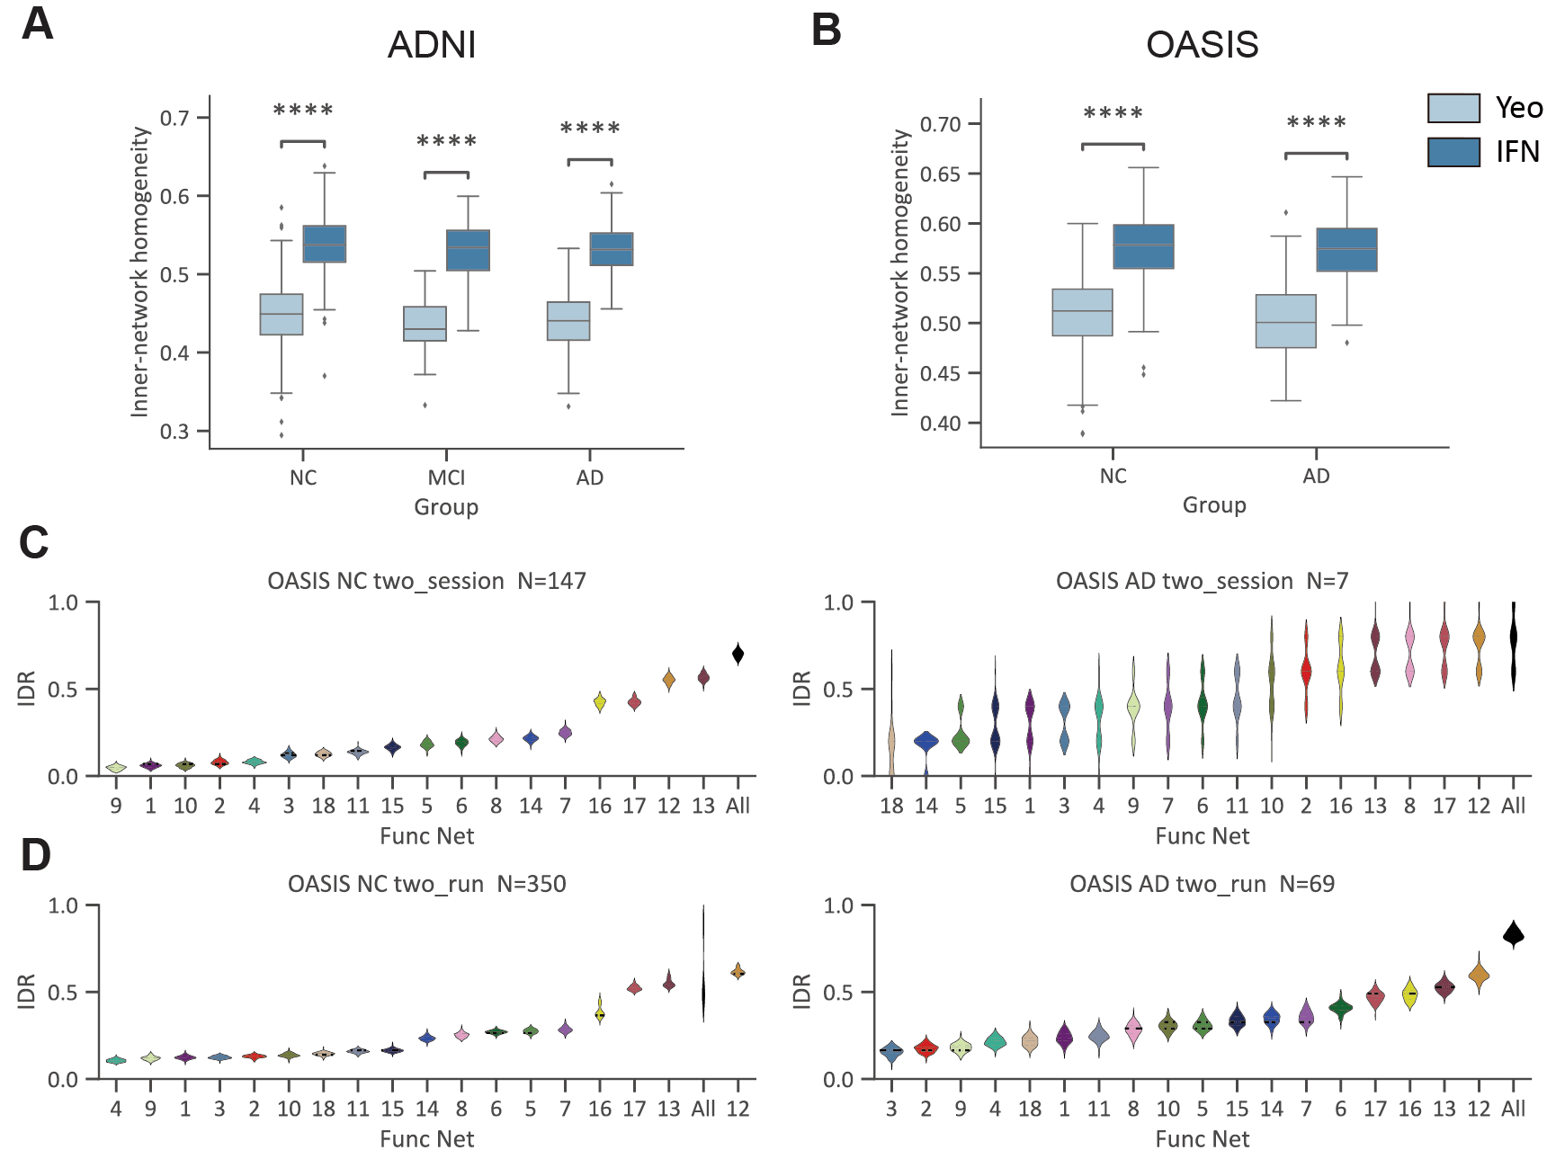
Figure S1. IFN improves the inner network homogeneity and acts as a fingerprint for individual identification. (A-B) The activity homogeneity inside each functional network. ****P < 0.0001. (C-D) The performance of network topography in individual recognition. The network topography achieved a mean identification rate (IDR) of 0.70 (N = 147) for NC and 0.78 (N = 7) for AD between follow-up scans. Across all networks, the mean IDR was 0.58 (N = 350) for NC and 0.82 (N = 69) for AD, indicating that IFN-derived topography retains high individual specificity over time, particularly in AD.

Figure S2. Clinical relevance of IFN in Alzheimer’s disease.
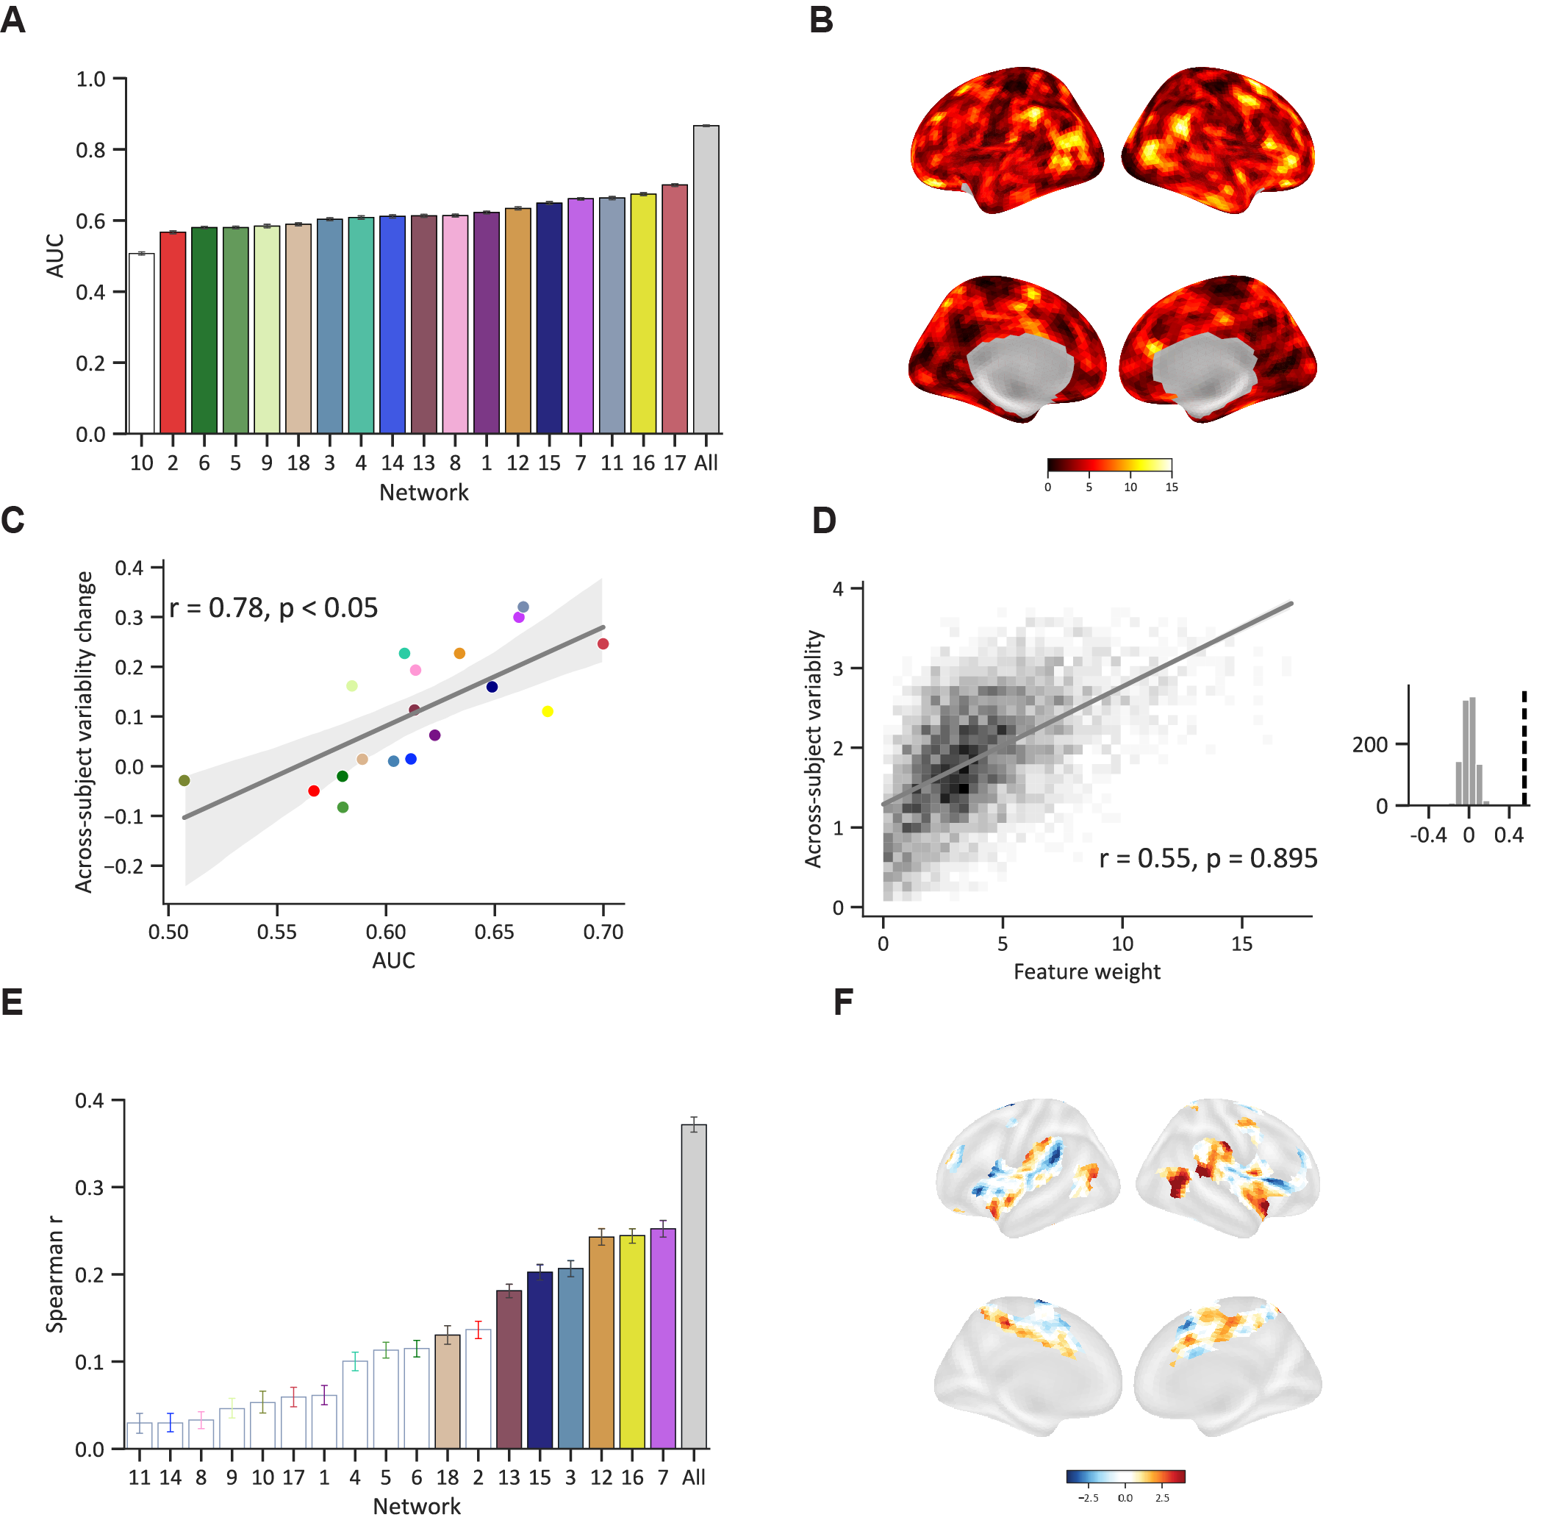
Figure S2. Clinical relevance of IFN in Alzheimer’s disease. (A) The performance (AUC) of each network and all networks for AD diagnosis was assessed using SVM and SVR with 1,000 iterations of 5-fold cross-validation. (B) The feature weights of all networks in classification, highlight that regions with higher inter-subject variability significantly contribute to classification performance. (C) The classification performance is correlated with the across-subject variability. (D) The feature weight of all networks is correlated with the across-subject variability. Higher network contributions are correlated with greater inter-subject heterogeneity (E) The performance (Spearman r) of each network for AD diagnosis, assessed through 1,000 iterations of 5-fold cross-validation. (F) The feature weight of the ventral attention in cognitive prediction, revealed that the association cortex contributed the most to the cognitive decline.

Figure S3. The correlations of areas between functional networks in three datasets.
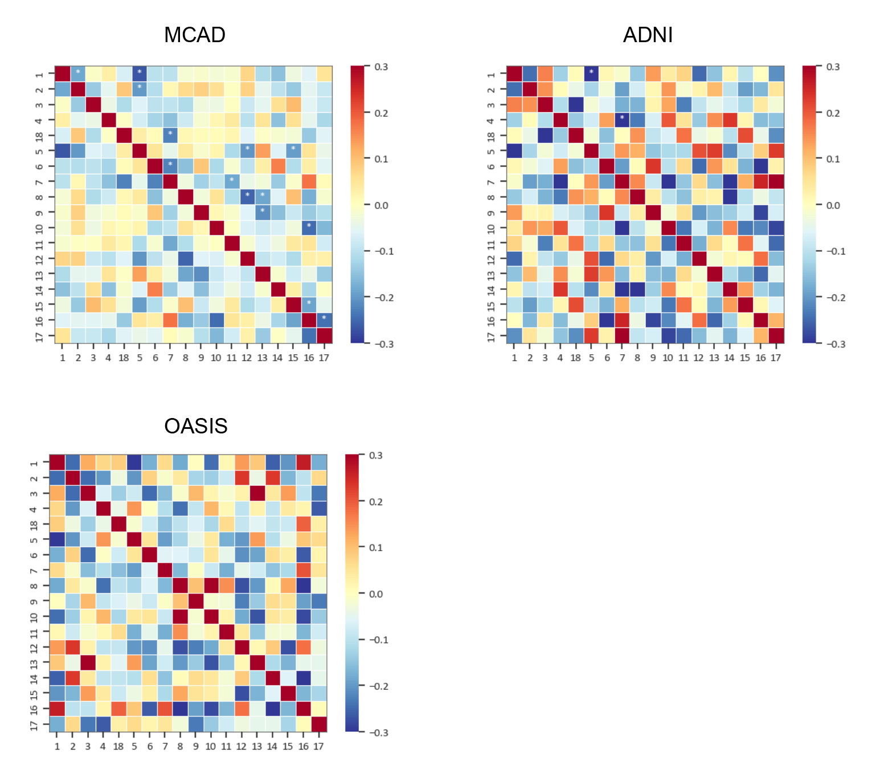
Figure S3. The correlations of areas between functional networks in three datasets. The results in MCAD were significantly correlated with those in ADNI (r = 0.29, p < 0.05) and in OASIS (r = 0.42, p < 0.05).

Figure S4. The performance of classification and cognitive prediction in ADNI.
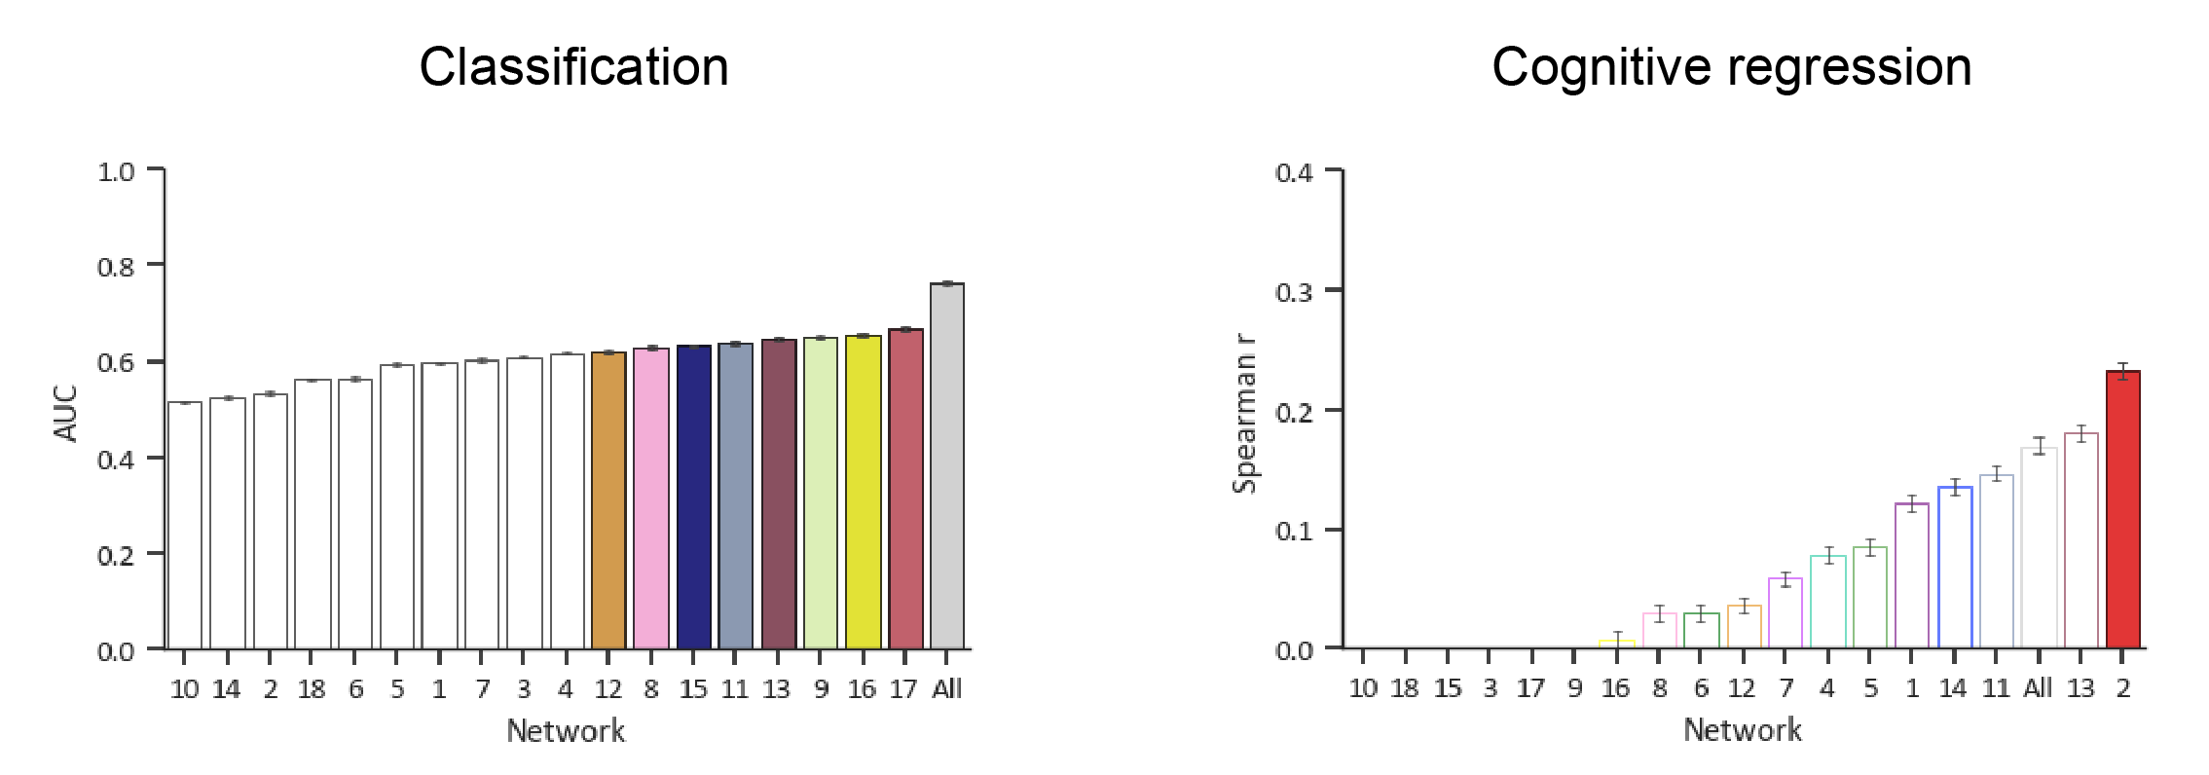
Figure S4. The performance of classification and cognitive prediction in ADNI.

Figure S5. Across-subject variability of functional topography changed in Alzheimer’s disease.
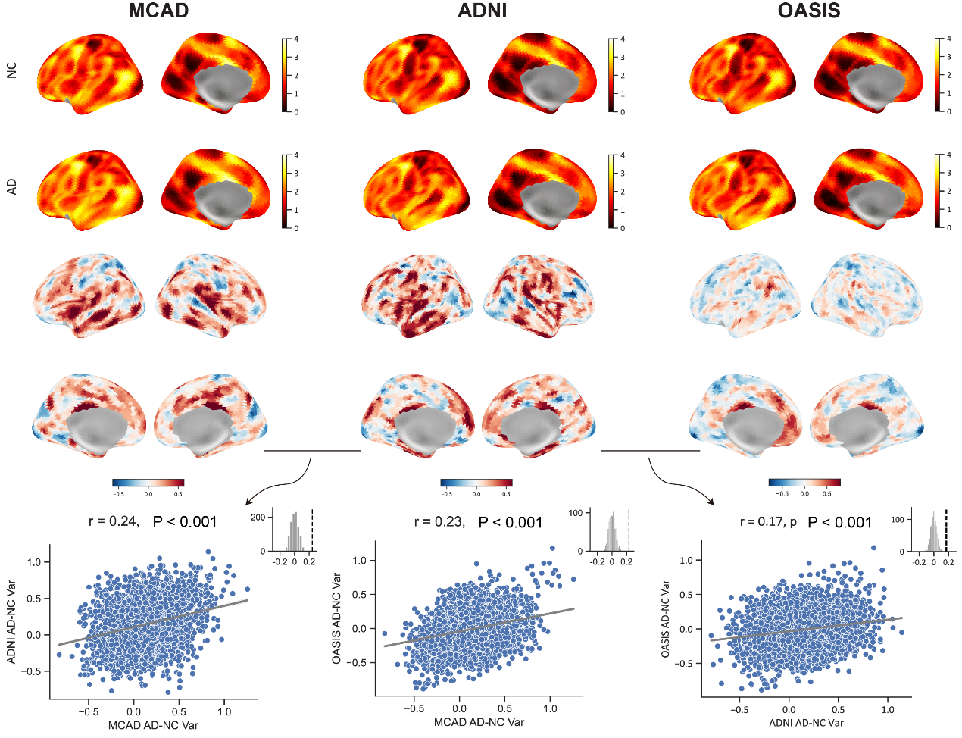
Figure S5. Across-subject variability of functional topography changed in Alzheimer’s disease. The results showed that there was a significant spatial correlation between the MCAD dataset and the ADNI dataset in across-subject variability alteration (R = 0.24, Pspin < 0.001). Additionally, the spatial distribution of variability alterations in the OASIS dataset exhibited a significant correlation with that observed in the MCAD dataset (R = 0.23, Pspin < 0.001) and in the ADNI dataset (R = 0.17, Pspin < 0.001).

Figure S6. Deviation of IFN associated with the atrophy in Alzheimer’s disease.
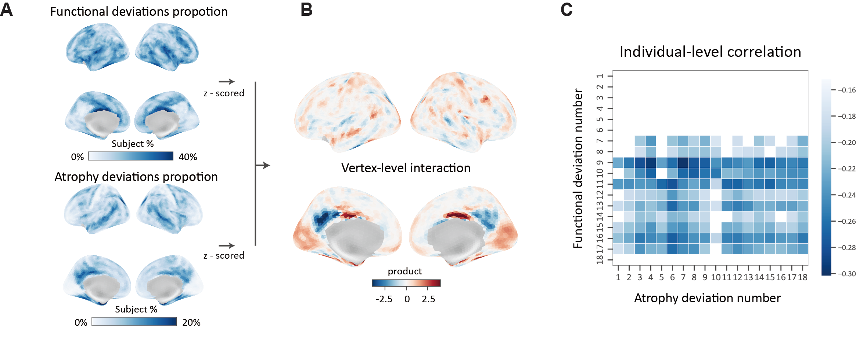
Figure S6. Deviation of IFN associated with the atrophy in Alzheimer’s disease. (A) The deviation proportion map of functional network topography and the deviation proportion map of cortical thickness in AD. (B) The products between the z-scored functional deviation map and the z-scored atrophy deviation map in AD. Positive values mean the functional deviation and atrophy deviation have positive relationships, while negative values mean the relationships are negative. (C) Correlation heatmap of atrophy voxel counts and functional deviation counts between 18 functional brain networks in AD patients. Each cell in the heatmap represents the correlation coefficient between two networks, calculated from the voxel counts of atrophy and functional deviations within each network. The heatmap demonstrates the inter-network relationships and highlights patterns of atrophy and network dysfunction in the AD patient population.

Figure S7. The normative range derived from the distribution of functional topography in MCAD.
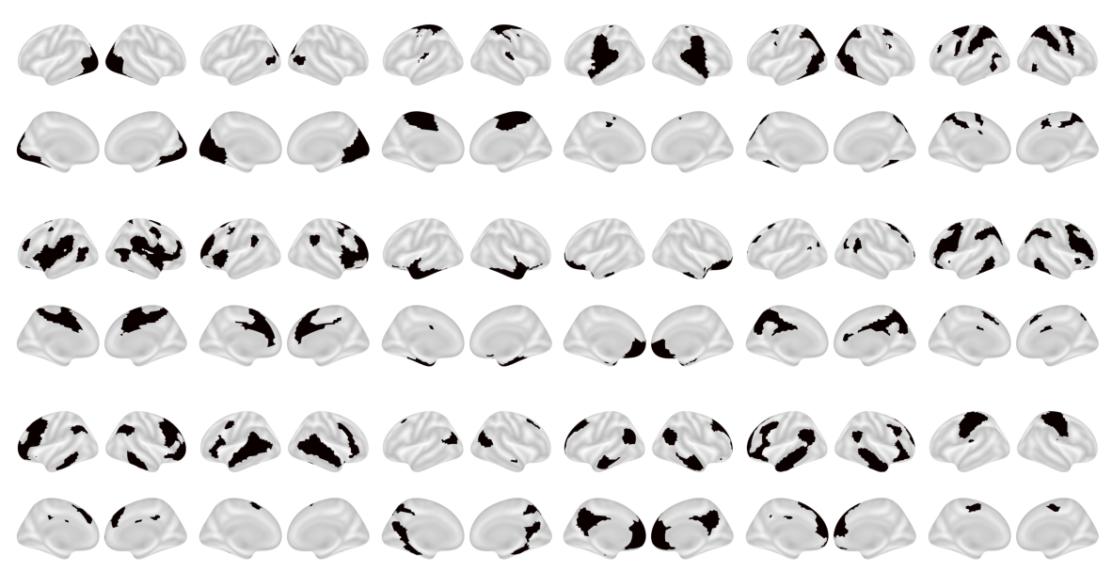
Figure S7. The normative range derived from the distribution of functional topography in MCAD.

Figure S8. Alterations of area of functional networks in AD in three datasets.
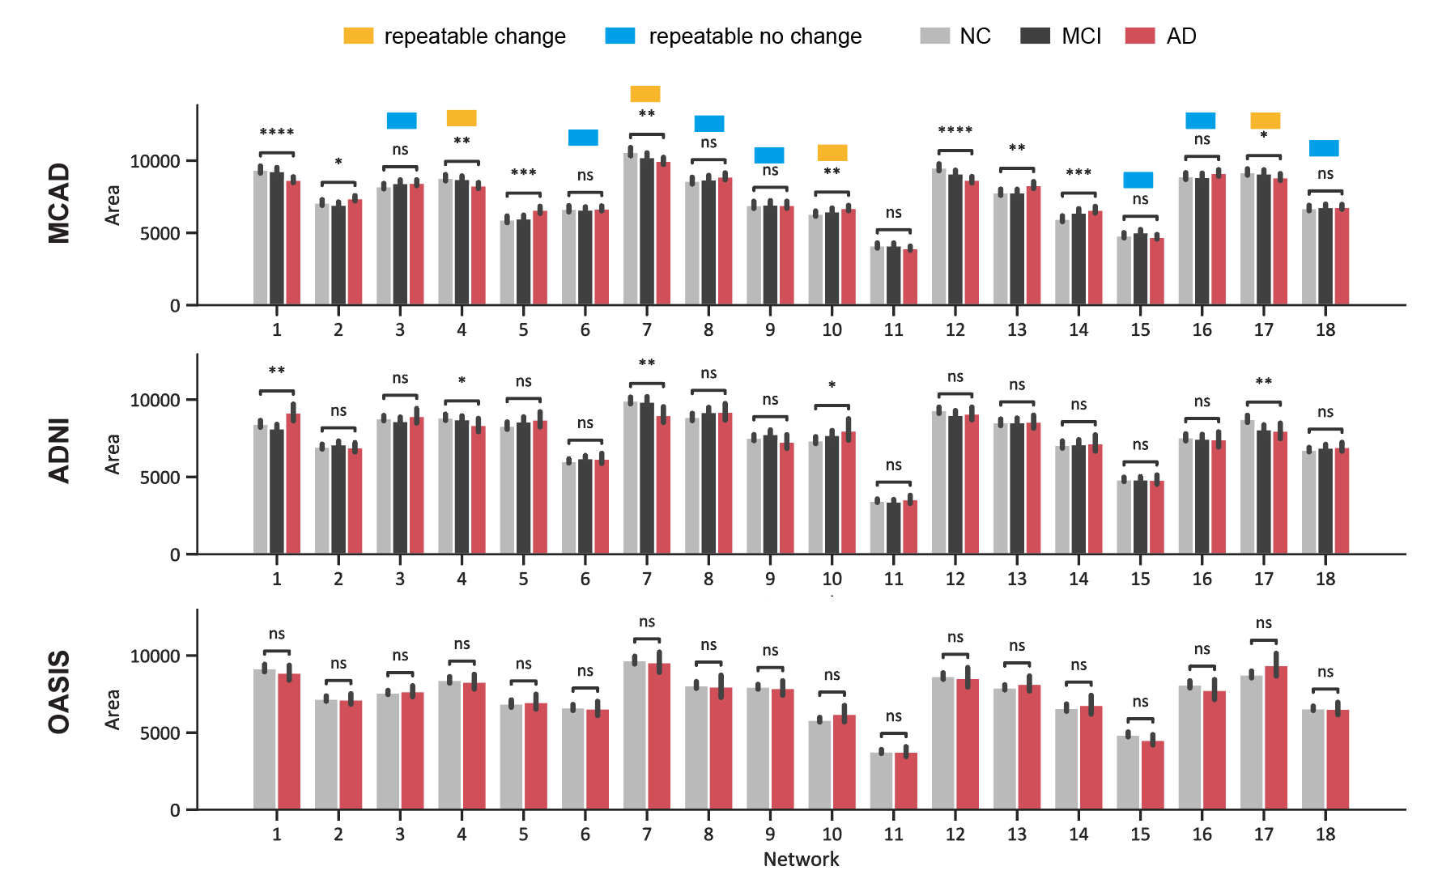
Figure S8. Alterations of area of functional networks in AD in three datasets.

Figure S9. Deviation patterns of IFN topography in AD.
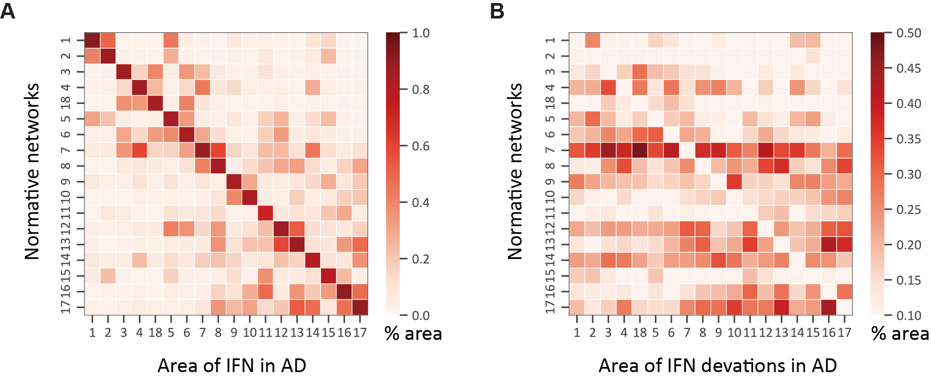
Figure S9. Deviation patterns of IFN topography in AD. (A) Deviations of individualized functional network parcellation in AD. The left panel shows the differences in functional network topography between the AD and NC, illustrating the proportion of deviations in each functional network. (B) The right panel further details the sources of functional network deviations and topographical changes in the AD group.

Figure S10. Three-month follow-up after tACS stimulation revealed a gradual return to the original trajectory of AD progression.
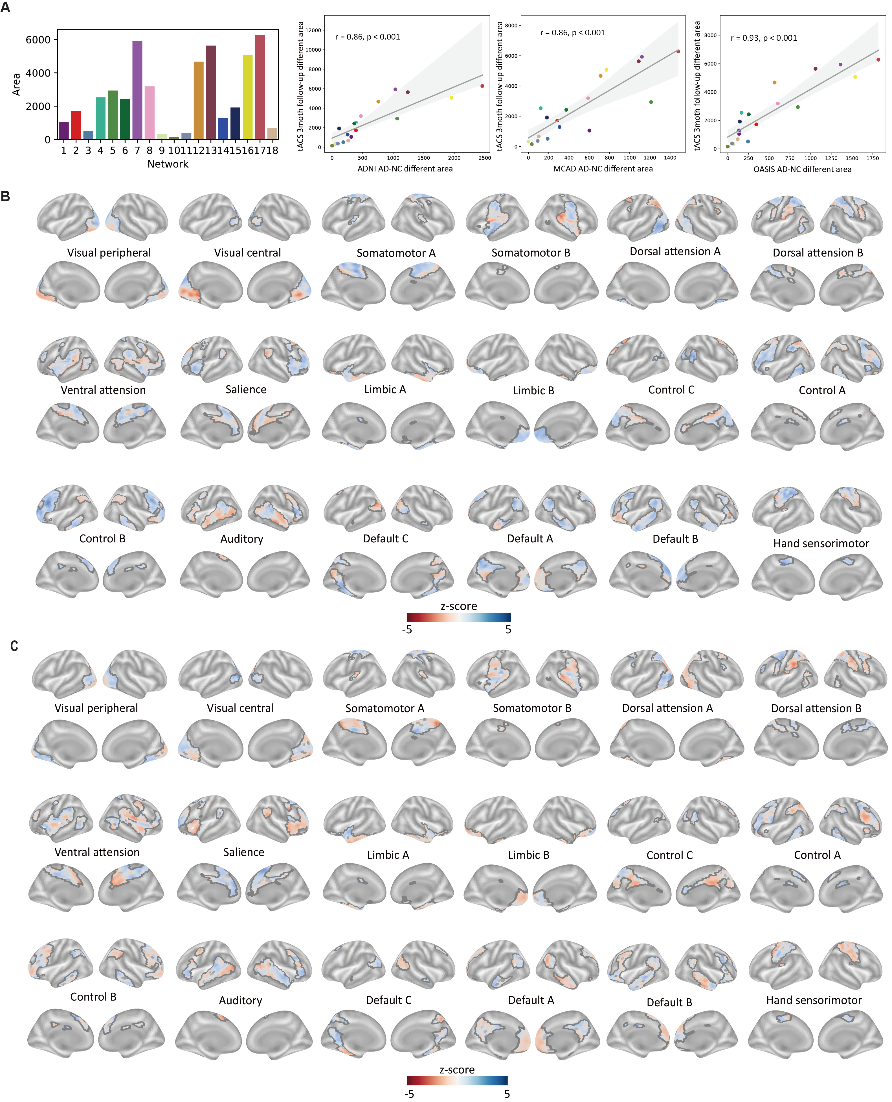
Figure S10. Three-month follow-up after tACS stimulation revealed a gradual return to the original trajectory of AD progression. (A) The consistency between the follow-up area results and the AD-HC pattern was reduced. (B) Alterations in brain network patterns were observed following three weeks of consecutive stimulation. (C) The pattern of network alterations was found to gradually weaken three months after stimulation.

Figure S11. Effect declines 3 months post-stimulation
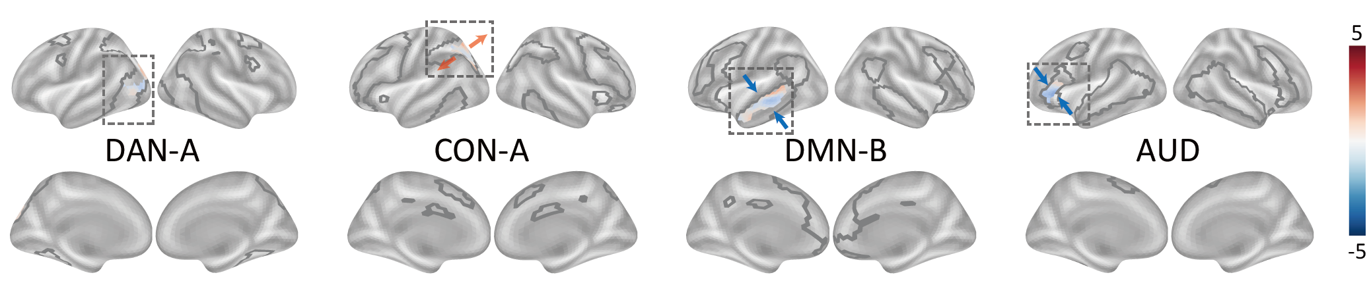
Figure S11. Effect declines 3 months post-stimulation. Differences between the active groups at the three-week and three-month time points, where no significant effects were observed. Colored regions indicate z-value changes falling within the range of deviations identified in the MCADI dataset.

References
1. Li, J., Jin, D., Li, A., Liu, B., Song, C., Wang, P., Wang, D., Xu, K., Yang, H., Yao, H., et al. (2019). ASAF: altered spontaneous activity fingerprinting in Alzheimer’s disease based on multisite fMRI. Science Bulletin. 10.1016/j.scib.2019.04.034.
2. Jin, D., Wang, P., Zalesky, A., Liu, B., Song, C., Wang, D., Xu, K., Yang, H., Zhang, Z., Yao, H., et al. (2020). Grab-AD: Generalizability and reproducibility of altered brain activity and diagnostic classification in Alzheimer's Disease. Hum Brain Mapp 41, 3379-3391. 10.1002/hbm.25023.
3. Yesavage, J.A., Brink, T.L., Rose, T.L., Lum, O., Huang, V., Adey, M., and Leirer, V.O. (1982). Development and validation of a geriatric depression screening scale: a preliminary report. J Psychiatr Res 17, 37-49. 10.1016/0022-3956(82)90033-4.
4. Morris, J.C. (1993). The Clinical Dementia Rating (CDR): current version and scoring rules. Neurology 43, 2412-2414. 10.1212/wnl.43.11.2412-a.
5. Petersen, R.C., Smith, G.E., Waring, S.C., Ivnik, R.J., Tangalos, E.G., and Kokmen, E. (1999). Mild cognitive impairment: clinical characterization and outcome. Archives of neurology 56, 303-308. 10.1001/archneur.56.3.303.
6. Feng, F., Wang, P., Zhao, K., Zhou, B., Yao, H., Meng, Q., Wang, L., Zhang, Z., Ding, Y., Wang, L., et al. (2018). Radiomic Features of Hippocampal Subregions in Alzheimer's Disease and Amnestic Mild Cognitive Impairment. Front Aging Neurosci 10, 290. 10.3389/fnagi.2018.00290.
7. Zhou, B., Yao, H., Wang, P., Zhang, Z., Zhan, Y., Ma, J., Xu, K., Wang, L., An, N., Liu, Y., and Zhang, X. (2015). Aberrant Functional Connectivity Architecture in Alzheimer's Disease and Mild Cognitive Impairment: A Whole-Brain, Data-Driven Analysis. Biomed Res Int 2015, 495375. 10.1155/2015/495375.
8. Wang, P., Zhou, B., Yao, H., Zhan, Y., Zhang, Z., Cui, Y., Xu, K., Ma, J., Wang, L., An, N., et al. (2015). Aberrant intra- and inter-network connectivity architectures in Alzheimer's disease and mild cognitive impairment. Sci Rep 5, 14824. 10.1038/srep14824.
9. Zhang, Z., Liu, Y., Zhou, B., Zheng, J., Yao, H., An, N., Wang, P., Guo, Y., Dai, H., Wang, L., et al. (2014). Altered functional connectivity of the marginal division in Alzheimer's disease. Current Alzheimer research 11, 145-155. 10.2174/1567205011666140110112608.
10. Yao, H., Zhou, B., Zhang, Z., Wang, P., Guo, Y., Shang, Y., Wang, L., Zhang, X., An, N., Liu, Y., and Alzheimer's Disease Neuroimaging, I. (2014). Longitudinal alteration of amygdalar functional connectivity in mild cognitive impairment subjects revealed by resting-state FMRI. Brain Connect 4, 361-370. 10.1089/brain.2014.0223.
11. Guo, Y., Zhang, Z., Zhou, B., Wang, P., Yao, H., Yuan, M., An, N., Dai, H., Wang, L., Zhang, X., and Liu, Y. (2014). Grey-matter volume as a potential feature for the classification of Alzheimer's disease and mild cognitive impairment: an exploratory study. Neurosci Bull 30, 477-489. 10.1007/s12264-013-1432-x.
12. Zhou, B., Liu, Y., Zhang, Z., An, N., Yao, H., Wang, P., Wang, L., Zhang, X., and Jiang, T. (2013). Impaired functional connectivity of the thalamus in Alzheimer's disease and mild cognitive impairment: a resting-state fMRI study. Current Alzheimer research 10, 754-766. 10.2174/15672050113109990146.
13. Yao, H., Liu, Y., Zhou, B., Zhang, Z., An, N., Wang, P., Wang, L., Zhang, X., and Jiang, T. (2013). Decreased functional connectivity of the amygdala in Alzheimer's disease revealed by resting-state fMRI. European journal of radiology 82, 1531-1538. 10.1016/j.ejrad.2013.03.019.
14. Wang, P., Zhang, X., Liu, Y., Liu, S., Zhou, B., Zhang, Z., Yao, H., Zhang, X., and Jiang, T. (2013). Perceptual and response interference in Alzheimer's disease and mild cognitive impairment. Clin Neurophysiol 124, 2389-2396. 10.1016/j.clinph.2013.05.014.
15. Zhang, Z., Liu, Y., Jiang, T., Zhou, B., An, N., Dai, H., Wang, P., Niu, Y., Wang, L., and Zhang, X. (2012). Altered spontaneous activity in Alzheimer's disease and mild cognitive impairment revealed by Regional Homogeneity. NeuroImage 59, 1429-1440. 10.1016/j.neuroimage.2011.08.049.
16. Yan, T., Wang, W., Yang, L., Chen, K., Chen, R., and Han, Y. (2018). Rich club disturbances of the human connectome from subjective cognitive decline to Alzheimer's disease. Theranostics 8, 3237-3255. 10.7150/thno.23772.
17. Li, S., Yuan, X., Pu, F., Li, D., Fan, Y., Wu, L., Chao, W., Chen, N., He, Y., and Han, Y. (2014). Abnormal changes of multidimensional surface features using multivariate pattern classification in amnestic mild cognitive impairment patients. J Neurosci 34, 10541-10553. 10.1523/JNEUROSCI.4356-13.2014.
18. Lu, J., Li, D., Li, F., Zhou, A., Wang, F., Zuo, X., Jia, X.F., Song, H., and Jia, J. (2011). Montreal cognitive assessment in detecting cognitive impairment in Chinese elderly individuals: a population-based study. J Geriatr Psychiatry Neurol 24, 184-190. 10.1177/0891988711422528.
19. Guo, Q., Sun, Y., Yu, P., Hong, Z., and Lu, C. (2007). Norm of Auditory Verbal Learning Test in the Normal Aged in China Community. Chinese Journal of Clinical Psychology 15, 132-134.
20. Hamilton, M. (1960). A rating scale for depression. Journal of neurology, neurosurgery, and psychiatry 23, 56-62. 10.1136/jnnp.23.1.56.
21. Dozeman, E., van Schaik, D.J., van Marwijk, H.W., Stek, M.L., van der Horst, H.E., and Beekman, A.T. (2011). The center for epidemiological studies depression scale (CES-D) is an adequate screening instrument for depressive and anxiety disorders in a very old population living in residential homes. Int J Geriatr Psychiatry 26, 239-246. 10.1002/gps.2519.
22. Petersen, R.C. (2004). Mild cognitive impairment as a diagnostic entity. Journal of internal medicine 256, 183-194. 10.1111/j.1365-2796.2004.01388.x.
23. McKhann, G., Drachman, D., Folstein, M., Katzman, R., Price, D., and Stadlan, E.M. (1984). Clinical diagnosis of Alzheimer's disease: report of the NINCDS-ADRDA Work Group under the auspices of Department of Health and Human Services Task Force on Alzheimer's Disease. Neurology 34, 939-944. 10.1212/wnl.34.7.939.
24. McKhann, G.M., Knopman, D.S., Chertkow, H., Hyman, B.T., Jack, C.R., Jr., Kawas, C.H., Klunk, W.E., Koroshetz, W.J., Manly, J.J., Mayeux, R., et al. (2011). The diagnosis of dementia due to Alzheimer's disease: recommendations from the National Institute on Aging-Alzheimer's Association workgroups on diagnostic guidelines for Alzheimer's disease. Alzheimers Dement 7, 263-269. 10.1016/j.jalz.2011.03.005.
25. Petersen, R.C., Doody, R., Kurz, A., Mohs, R.C., Morris, J.C., Rabins, P.V., Ritchie, K., Rossor, M., Thal, L., and Winblad, B. (2001). Current concepts in mild cognitive impairment. Archives of neurology 58, 1985-1992. 10.1001/archneur.58.12.1985.
26. Choo, I.H., Lee, D.Y., Youn, J.C., Jhoo, J.H., Kim, K.W., Lee, D.S., Lee, J.S., and Woo, J.I. (2007). Topographic patterns of brain functional impairment progression according to clinical severity staging in 116 Alzheimer disease patients: FDG-PET study. Alzheimer Dis Assoc Disord 21, 77-84. 10.1097/WAD.0b013e3180687418.
27. Wu, Y., Zhang, Y., Liu, Y., Liu, J., Duan, Y., Wei, X., Zhuo, J., Li, K., Zhang, X., Yu, C., et al. (2016). Distinct Changes in Functional Connectivity in Posteromedial Cortex Subregions during the Progress of Alzheimer's Disease. Front Neuroanat 10, 41. 10.3389/fnana.2016.00041.
28. Liu, J., Zhang, X., Yu, C., Duan, Y., Zhuo, J., Cui, Y., Liu, B., Li, K., Jiang, T., and Liu, Y. (2016). Impaired Parahippocampus Connectivity in Mild Cognitive Impairment and Alzheimer's Disease. J Alzheimers Dis 49, 1051-1064. 10.3233/JAD-150727.
29. Liu, Y., Yu, C., Zhang, X., Liu, J., Duan, Y., Alexander-Bloch, A.F., Liu, B., Jiang, T., and Bullmore, E. (2014). Impaired long distance functional connectivity and weighted network architecture in Alzheimer's disease. Cereb Cortex 24, 1422-1435. 10.1093/cercor/bhs410.
30. He, X., Qin, W., Liu, Y., Zhang, X., Duan, Y., Song, J., Li, K., Jiang, T., and Yu, C. (2014). Abnormal salience network in normal aging and in amnestic mild cognitive impairment and Alzheimer's disease. Hum Brain Mapp 35, 3446-3464. 10.1002/hbm.22414.
31. Song, J., Qin, W., Liu, Y., Duan, Y., Liu, J., He, X., Li, K., Zhang, X., Jiang, T., and Yu, C. (2013). Aberrant functional organization within and between resting-state networks in AD. PLoS One 8, e63727. 10.1371/journal.pone.0063727.
32. LaMontagne, P.J., Benzinger, T.L., Morris, J.C., Keefe, S., Hornbeck, R., Xiong, C., Grant, E., Hassenstab, J., Moulder, K., Vlassenko, A.G., et al. (2019). OASIS-3: Longitudinal Neuroimaging, Clinical, and Cognitive Dataset for Normal Aging and Alzheimer Disease. medRxiv, 2019.2012.2013.19014902. 10.1101/2019.12.13.19014902.

