Supplementary Information for
Layer-by-Layer Shear Densification for Multiscale Hierarchical Alignment in Bulk Hydrogels
Sen Wang^{1, 2†}, Senxuan Tang^{1†}, Tianqi Fu¹, Yirong Jiang¹, Yun Lin¹, Lianlian Fu³, Ronghui Wu^{2*} and Youhui Lin^{1*}

¹Department of Physics, Research Institute for Biomimetics and Soft Matter, Fujian Provincial Key Laboratory for Soft Functional Materials Research, Xiamen University, Xiamen 361005, P. R. China
²School of Materials Science and Engineering, Nanyang Technological University, 50 Nanyang Avenue, Singapore, 639798 Singapore
³College of Material Science and Engineering, Huaqiao University, Xiamen, 361021, P. R. China

Correspondence to: ronghui.wu@ntu.edu.sg, linyouhui@xmu.edu.cn
This PDF file includes:
Supplementary Figs. 1 to 21
Supplementary Table 1 to 4
References

Supplementary Fig. 1 | Comparison of strategies for fabricating hydrogels with hierarchical structures. (a) Freeze-casting: Creates anisotropic structures but typically results in a loose arrangement and weak interlayer bonding. (b) Strain Alignment: Achieves partial ordering, but the alignment is often nonuniform. (c) Flow Field-induced: Effective for high orientation in films, but fails to maintain uniform alignment in bulk materials, resulting in a dense skin and a loose core. (d) Layer-by-Layer Shear Densification (LBSD) (This Work): A novel method utilizing repeated rolling to construct hydrogels with high orientation, uniform structure, and compact arrangement throughout the bulk volume. LBSD overcomes the inherent limitations of conventional methods.

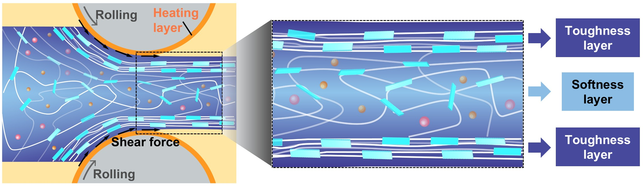
Supplementary Fig. 2 | Schematic illustration of the structural evolution of FFR hydrogels during the rolling-pressure process. The diagram illustrates the formation of oriented “toughness layers” and disordered “softness layers” within the hydrogel. During the rolling process, the outer regions are exposed to stronger shear forces and higher temperatures, leading to the development of densely packed and highly aligned lamellar networks that form the toughness layers. In contrast, the inner regions experience weaker shear and lower temperatures, retaining a relatively disordered polymer network that constitutes the softness layers.

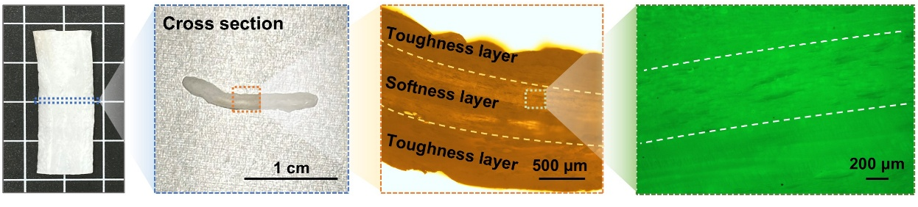
Supplementary Fig. 3 | Macroscopic and microscopic observations of the FFR hydrogel. From left to right: (i) digital photograph of the as-prepared hydrogel; (ii) digital photograph of its cross section; (iii) optical microscopy image revealing alternating toughness and softness layers; and (iv) fluorescence microscopy image clearly distinguishing the sparsely porous softness layers from the densely packed toughness layers.

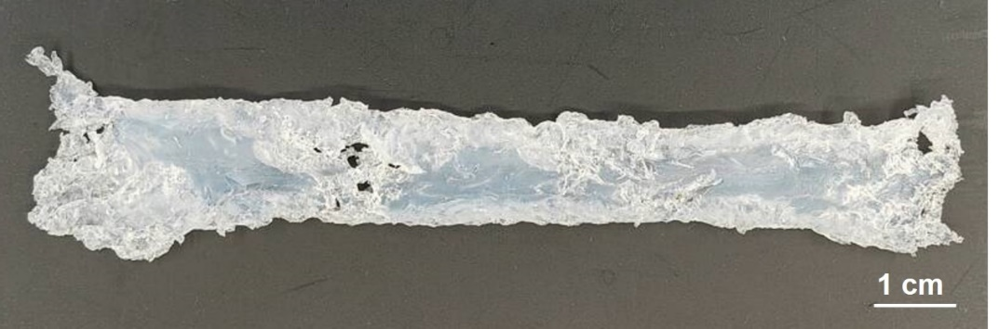
Supplementary Fig. 4 | Photos of the samples prepared by freezing-rolling pressure.

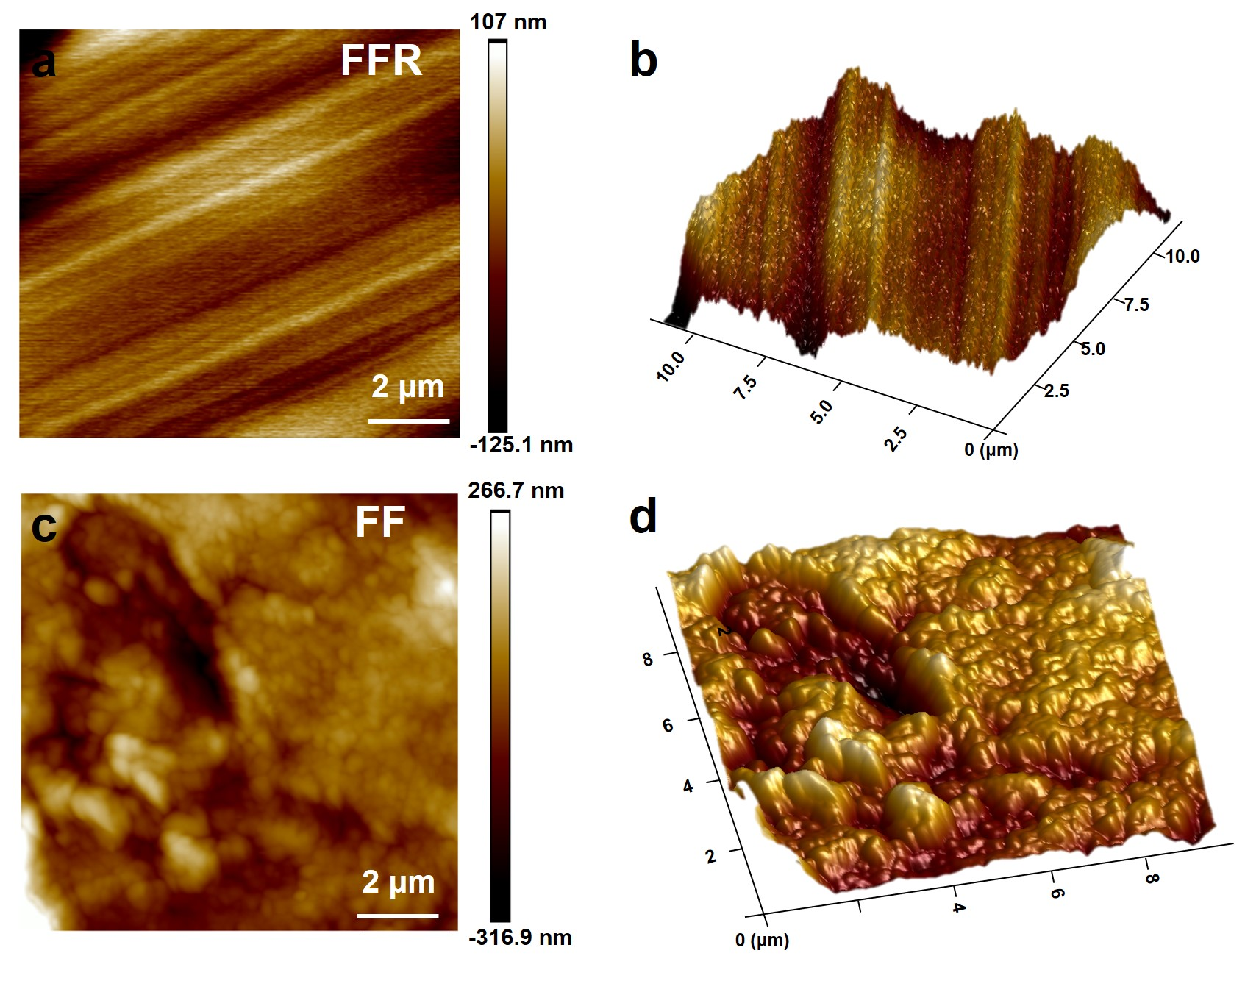
Supplementary Fig. 5 | AFM characterization of the surface morphologies of FFR and FF hydrogels. a, Two-dimensional AFM height image of the FFR hydrogel showing well-aligned hierarchical lamellar structures. b, Three-dimensional AFM topography of the FFR hydrogel highlighting the orderly layered alignment. c, Two-dimensional AFM height image of the FF hydrogel exhibiting a randomly oriented and rough surface morphology. d, Three-dimensional AFM topography of the FF hydrogel further confirming the disordered surface structure.

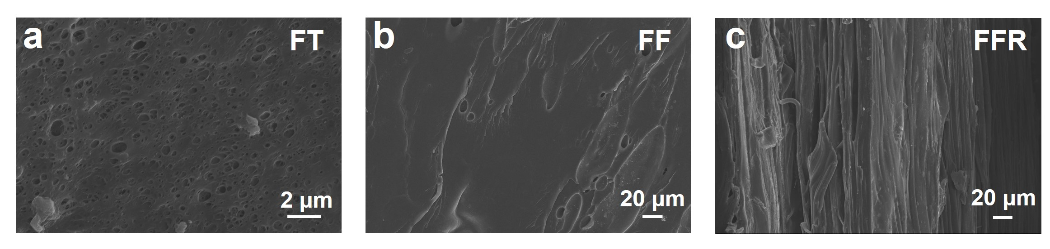
Supplementary Fig. 6 | SEM images of FT, FF, and FFR hydrogels. a, SEM image of the FT hydrogel showing a uniform and disordered porous morphology. b, SEM image of the FF hydrogel exhibiting a similarly disordered structure without apparent orientation. c, SEM image of the FFR hydrogel displaying a well-defined, highly aligned architecture.

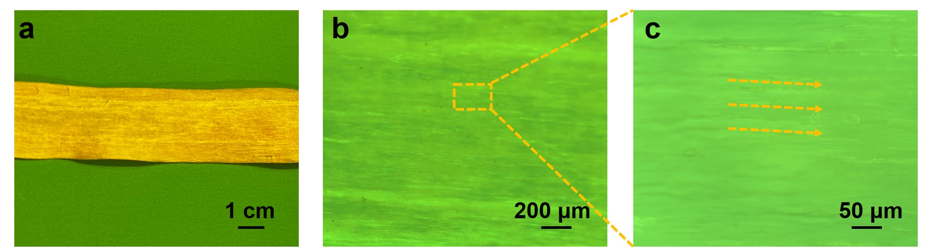
Supplementary Fig. 7 | Optical and confocal fluorescence images of the FFR hydrogel. a, Optical image of the FFR hydrogel treated with sodium fluorescein to enhance structural visualization. b-c, Confocal fluorescence images clearly revealing the aligned hierarchical structure of the FFR hydrogel along the rolling direction.

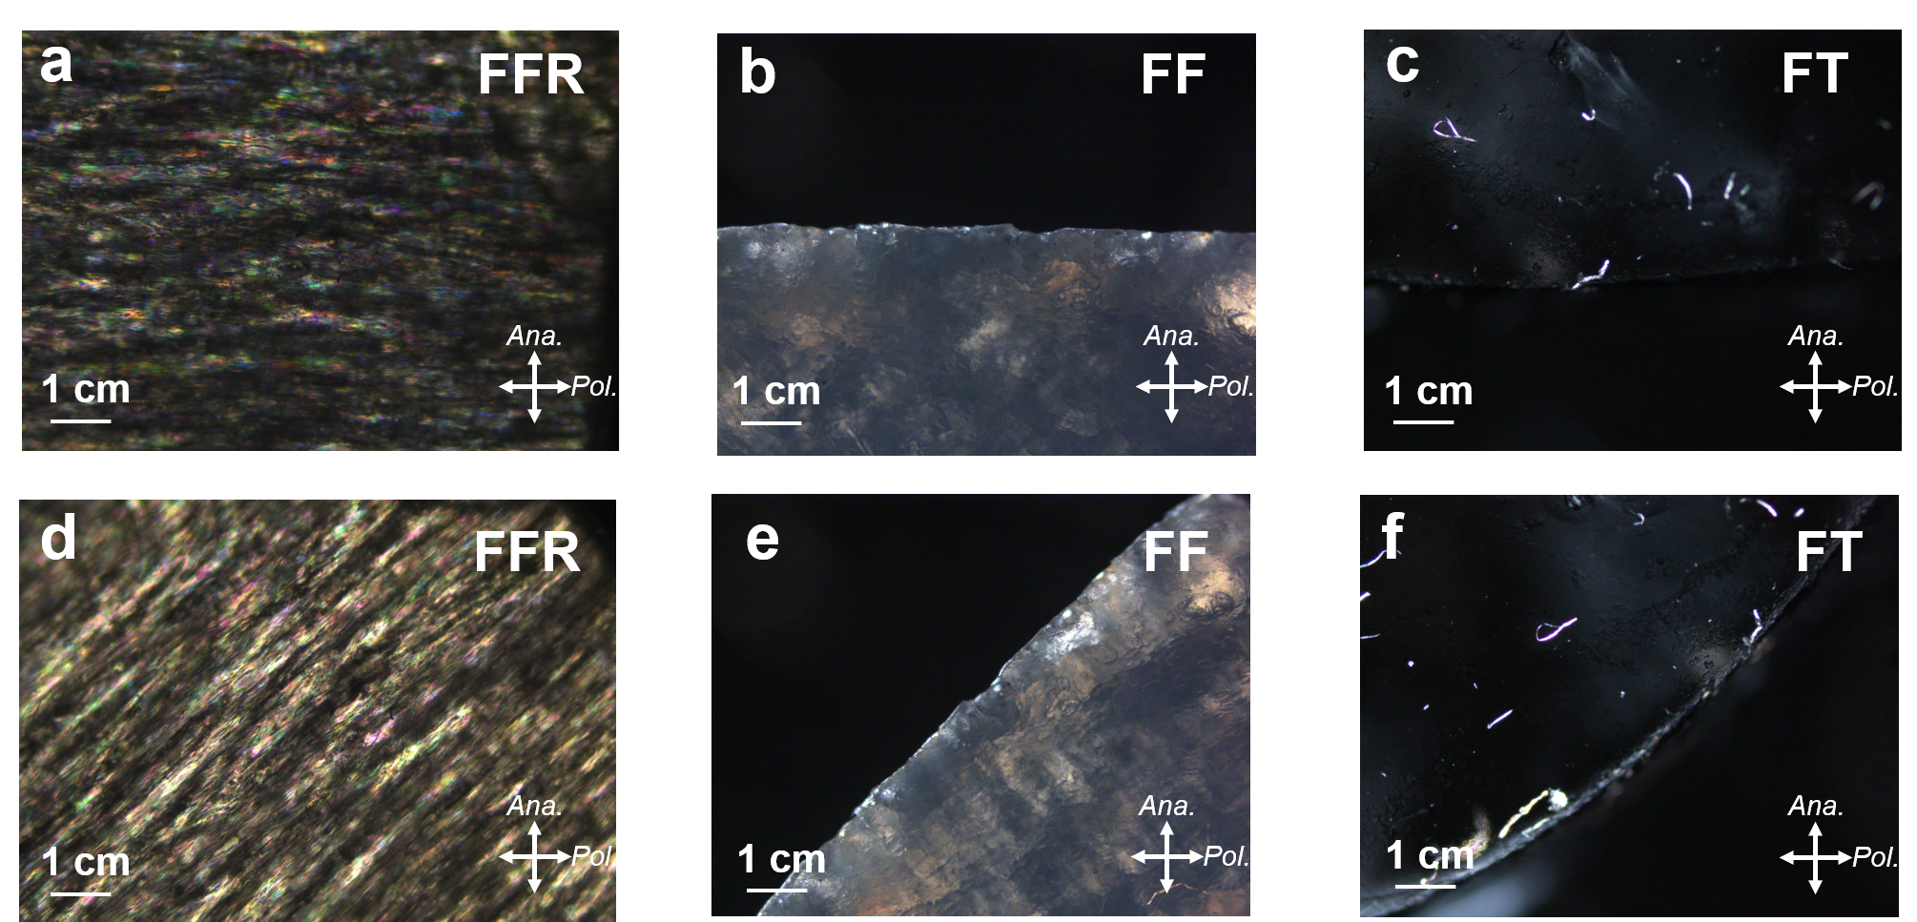
Supplementary Fig. 8 | Polarized optical images of FFR, FF, and FT hydrogels. (a, d) Polarized optical images of the FFR hydrogel showing strong birefringence, with maximum brightness observed at 45° and minimal brightness at 90° relative to the analyzer. (b, e) Polarized optical images of the FF hydrogel, and (c, f) images of the FT hydrogel, both exhibiting negligible brightness variation, indicating the absence of optical anisotropy.

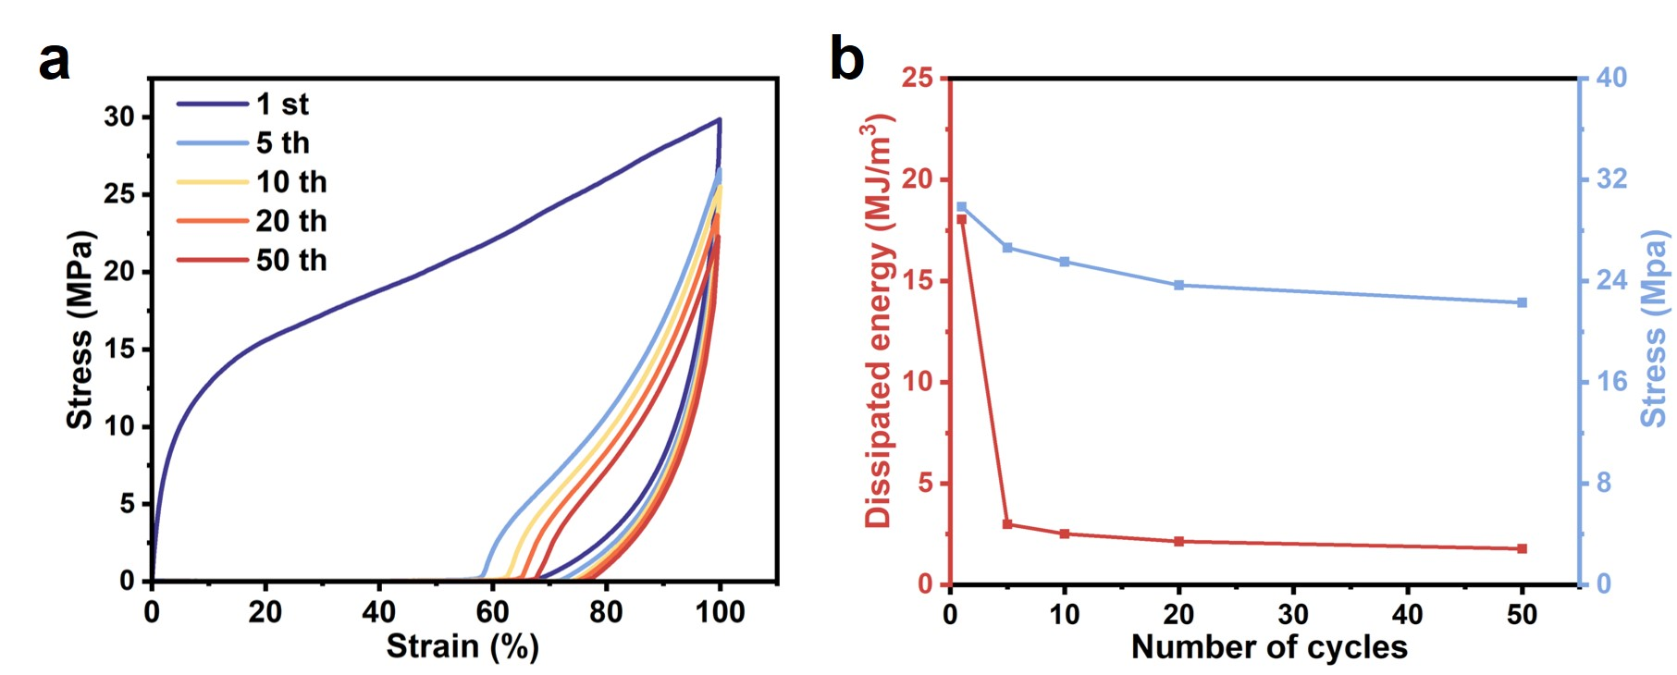
Supplementary Fig. 9 | Cyclic tensile behavior of the FFR hydrogel under 100% strain. a, Cyclic stress-strain curves of the FFR hydrogel over fifty loading-unloading cycles at a fixed strain of 100%. b, Corresponding variations in tensile strength and dissipated energy with the number of cycles. The nearly constant dissipated energy demonstrates the reversibility of the sacrificial hydrogen bonds within the FFR hydrogel.

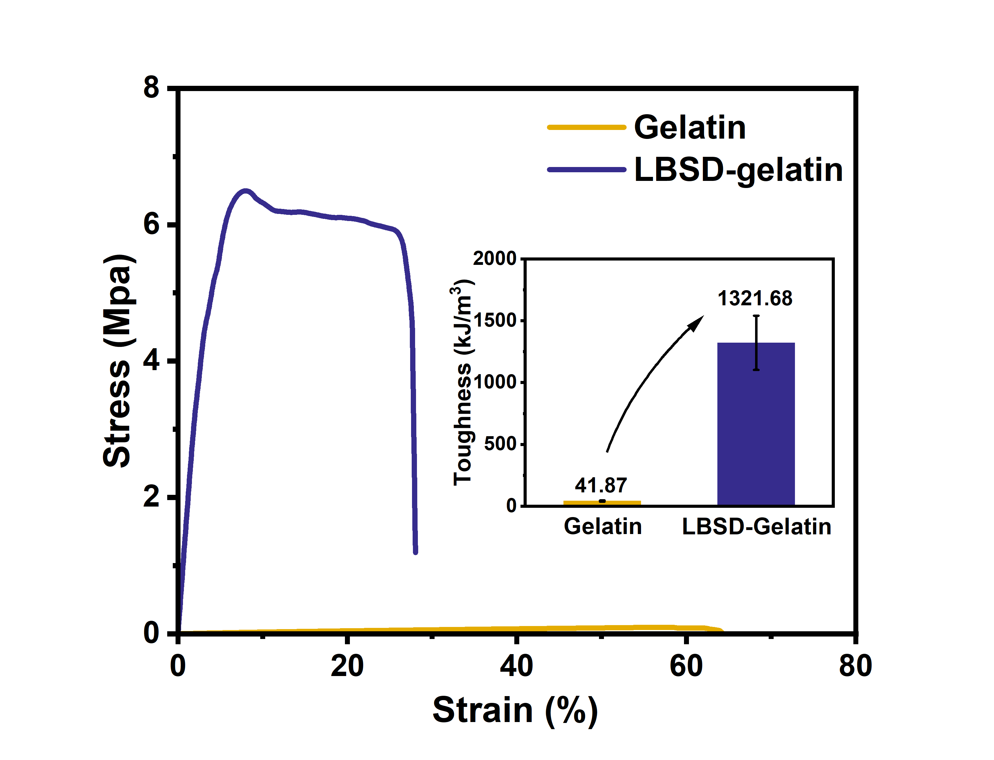
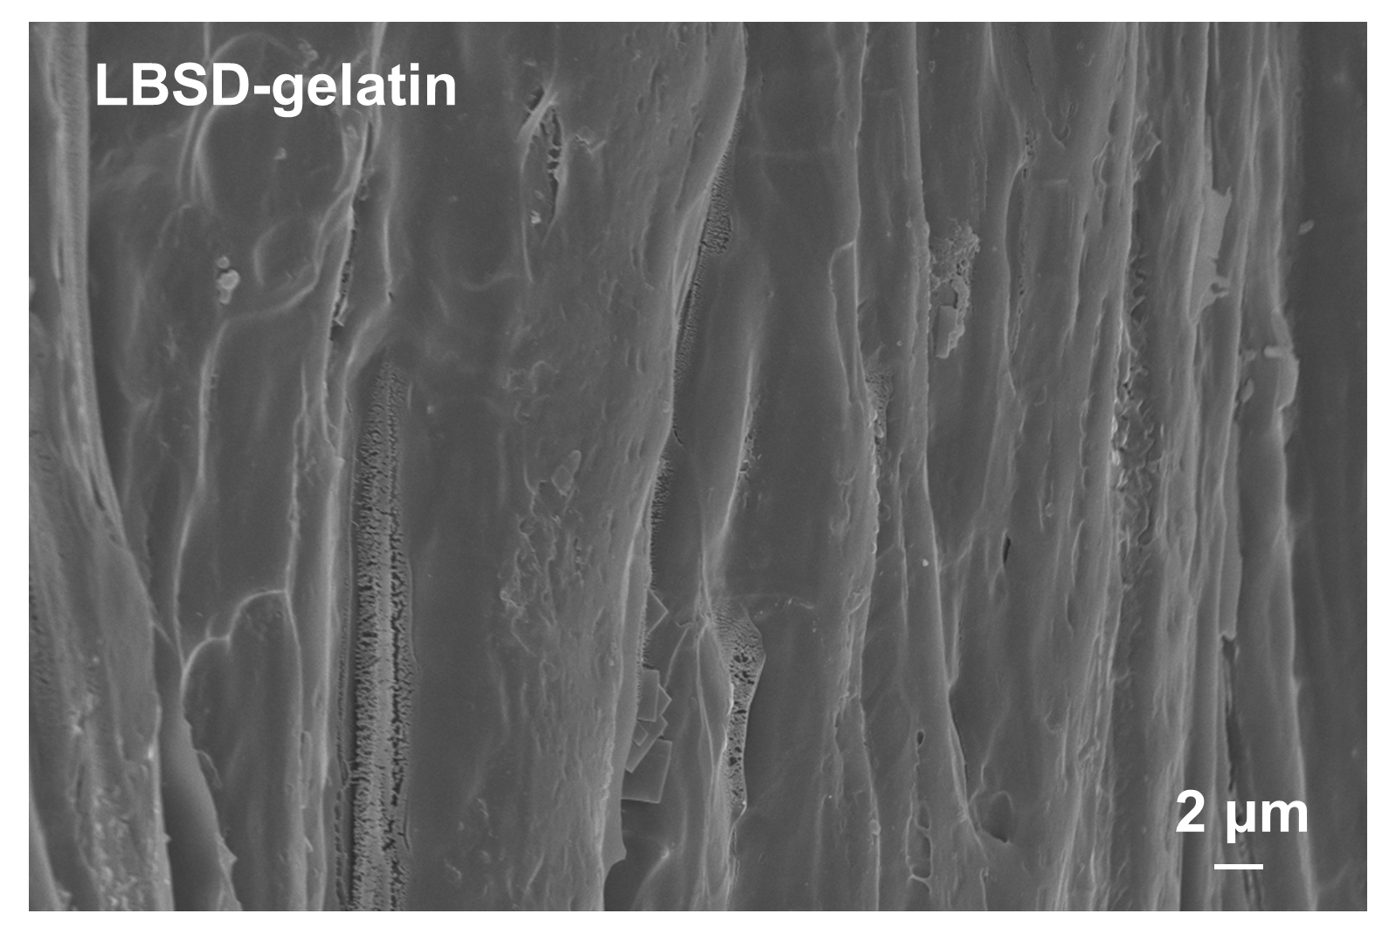
Supplementary Fig. 10 | Microstructural characterization and mechanical performance of LBSD-gelatin hydrogels. SEM imaging reveals that LBSD treatment induces a compact and aligned architecture within the gelatin network (left). The stress–strain curves show that LBSD-gelatin hydrogels exhibit markedly improved tensile strength and toughness compared with untreated gelatin (right). This result demonstrates the broad compatibility of the LBSD strategy across diverse polymer systems.

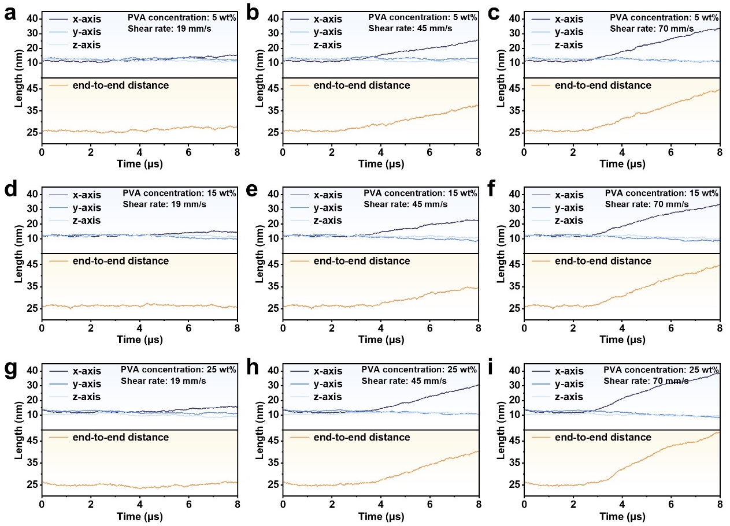
Supplementary Fig. 11 | Molecular dynamics simulations of the effects of shear rate and polymer concentration on PVA chain alignment. a-c, End-to-end distances of PVA chains under different shear rates (19, 45, and 70 mm·s⁻¹) at a polymer concentration of 5 wt%. d-f, Corresponding results at a polymer concentration of 15 wt%. g-i, Corresponding results at a polymer concentration of 25 wt%.
The above simulated data indicate that at a fixed shear rate, higher polymer concentrations lead to greater chain alignment within the same simulation time. However, the variation in concentration has a relatively minor influence on chain conformational changes during shear, while the shear rate exerts a more pronounced effect on molecular orientation.

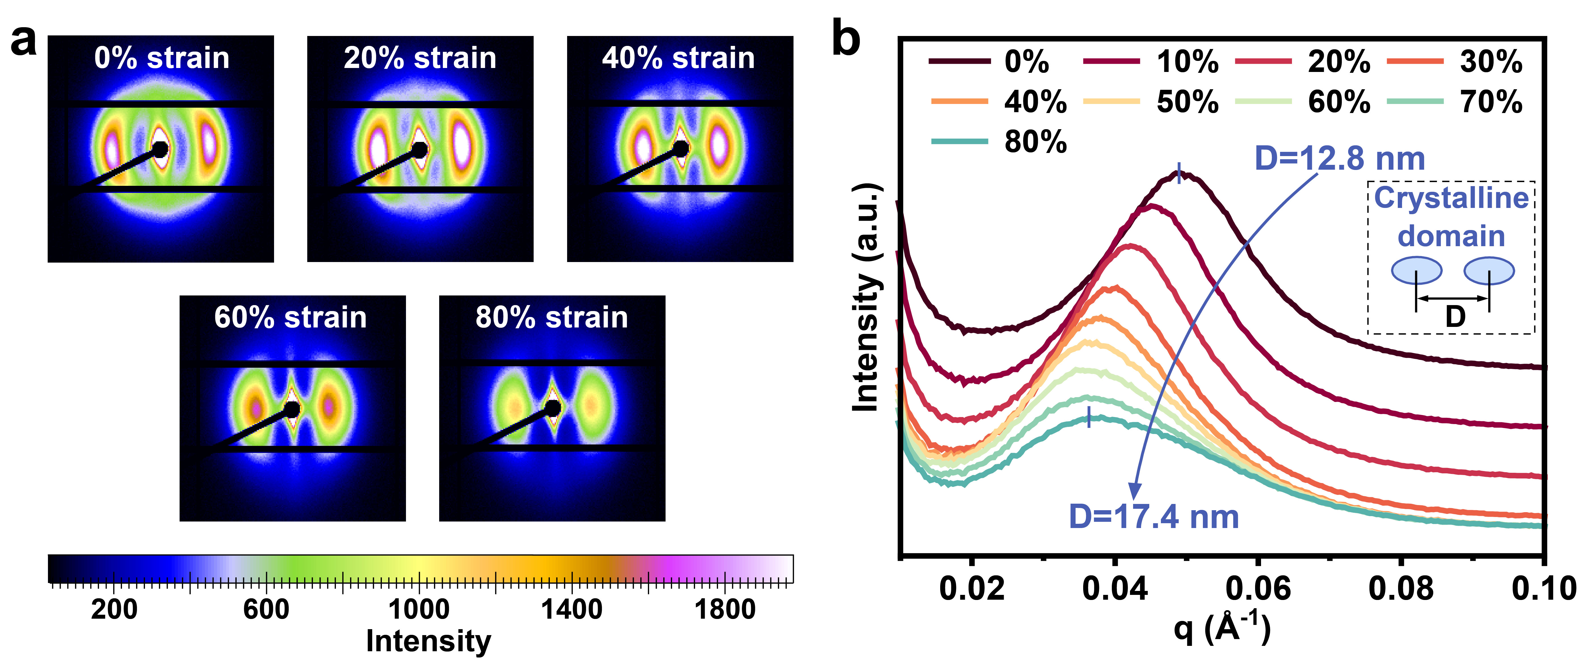
Supplementary Fig. 12 | In situ SAXS analysis of the FFR hydrogel under tensile deformation. a, 2D SAXS patterns of the FFR hydrogel at different tensile strains (0%, 20%, 40%, 60%, and 80%), showing progressively intensified horizontal scattering arcs that indicate enhanced chain alignment upon stretching. b, 1D SAXS profiles corresponding to different tensile strains, revealing an increase in the average crystalline domain spacing (D) from 12.8 nm in the unstressed state to 17.4 nm at 80% strain.

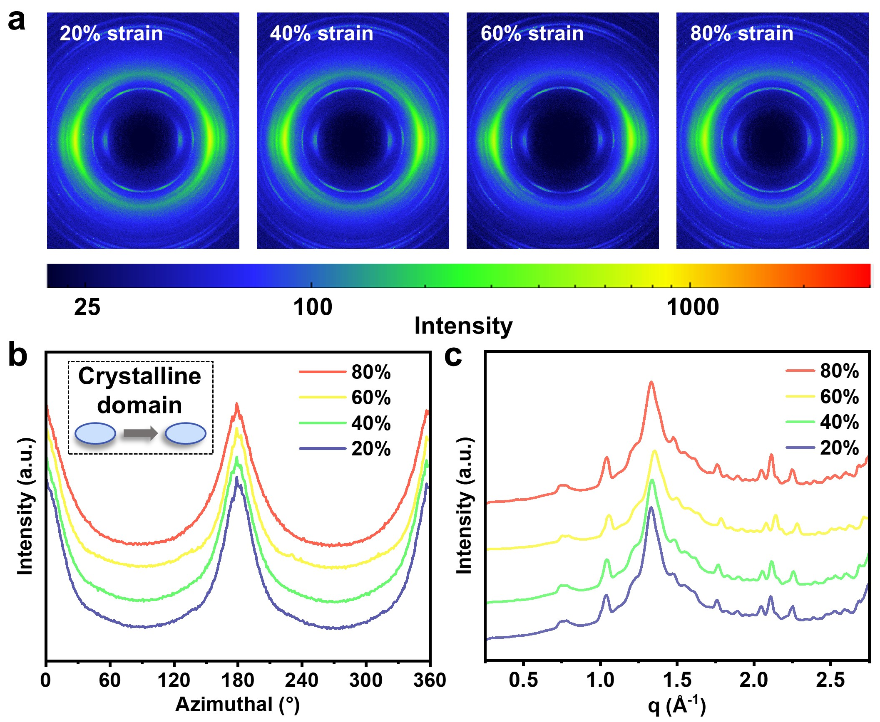
Supplementary Fig. 13 | In situ WAXS analysis of the FFR hydrogel under different tensile strains. a, 2D WAXS patterns of the FFR hydrogel at tensile strains of 20%, 40%, 60%, and 80%, showing negligible changes in scattering intensity and pattern shape with increasing strain. b-c, Corresponding 1D WAXS profiles at different strain levels. The absence of noticeable variation is attributed to the already high degree of crystalline orientation in the pristine FFR hydrogel (f = 0.91), indicating that the domains are densely packed and highly aligned from the initial state.

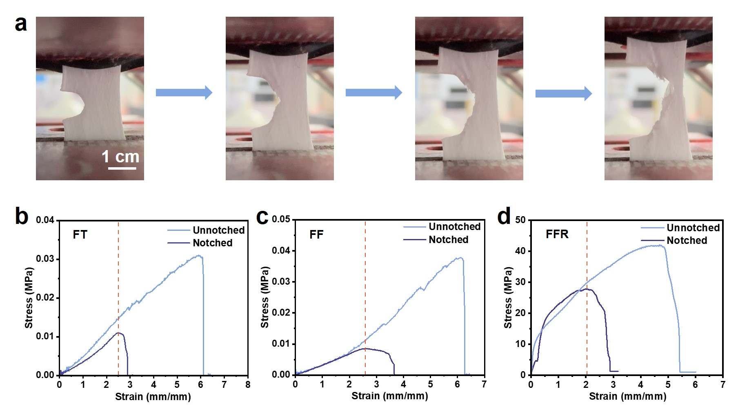
Supplementary Fig. 14 | Crack propagation and fracture resistance of different hydrogels. a, Sequential images showing the stretching process of the FFR hydrogel containing a pre-made crack. b-d, Stress–strain curves of unnotched and notched FT, FF, and FFR hydrogels, respectively. These curves were used to evaluate the fracture resistance of the hydrogels according to the pure shear test.

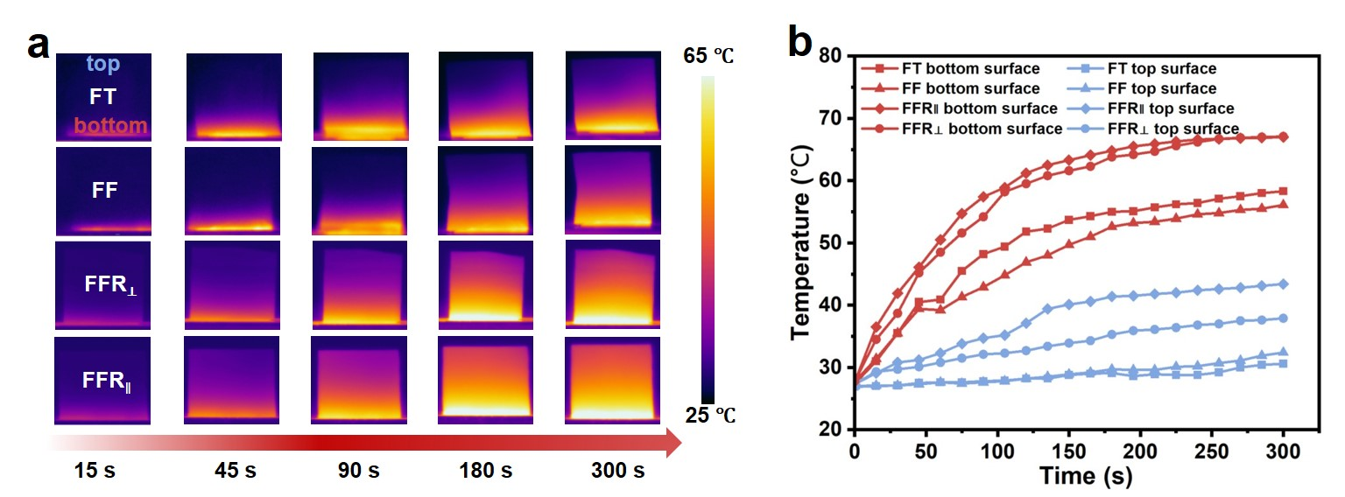
Supplementary Fig. 15 | Infrared thermal imaging and temperature evolution of different hydrogels during the heating process. a, Infrared images of FT, FF, FFR⊥, and FFR∥ hydrogels recorded at different heating durations (15-300 s). b, Temporal evolution of surface and bottom temperatures of the corresponding samples. The FFR hydrogel along the longitudinal direction (∥) exhibits a markedly faster heat transfer rate compared with other samples.

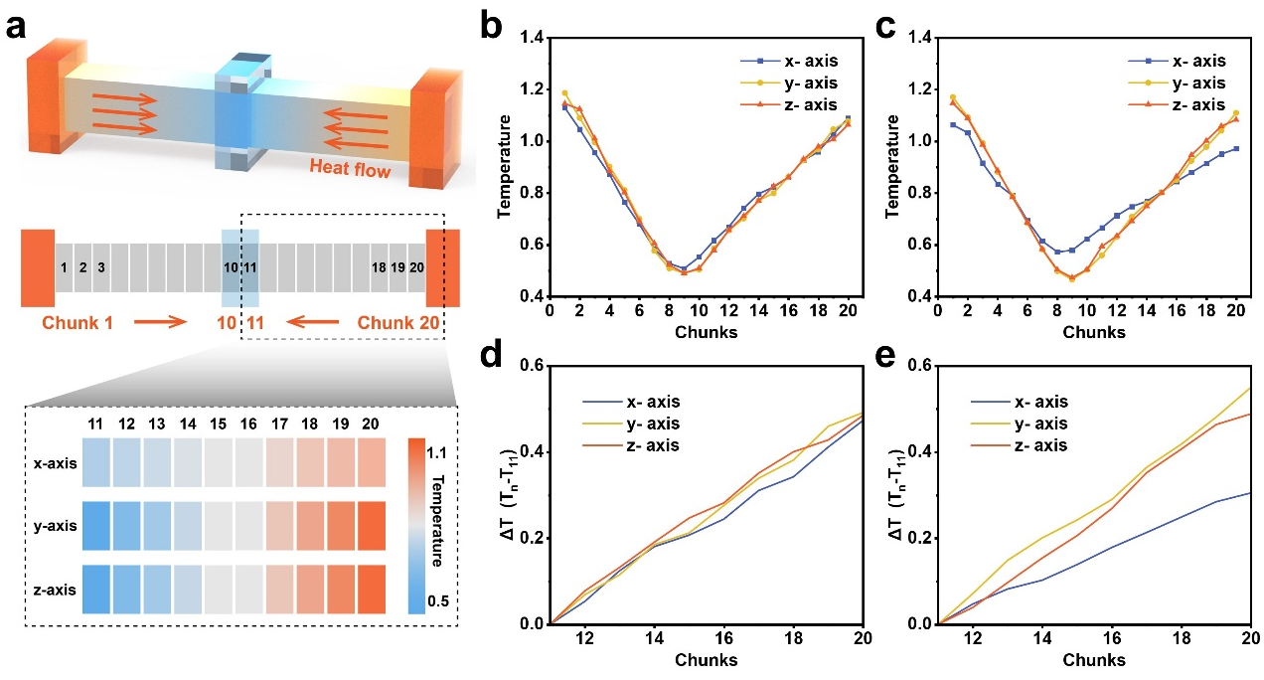
Supplementary Fig. 16 | Non-equilibrium molecular dynamics (NEMD) simulations of thermal conduction. a, Schematic of the simulation box divided into parallel slices, where heat is extracted from the central region and injected into the boundary regions to establish a temperature gradient. b-c, Temperature profiles across different regions along the x, y, and z axes before and after shear, respectively. d, Temperature differences (ΔT = Tₙ − T₁₁) among various chunks before shear, where Tₙ represents the average temperature of the n-th chunk along the heat-transfer direction and T₁₁ denotes the average temperature of the eleventh chunk. e, Temperature differences among various chunks after shear, which are used to evaluate the thermal conductivities along the three orthogonal directions. A smaller ΔT under the same heat flux indicates a higher thermal conductivity, as it corresponds to a reduced temperature gradient during heat transfer. The detailed thermal conductivity values before and after shear are summarized in Supplementary Table 3.

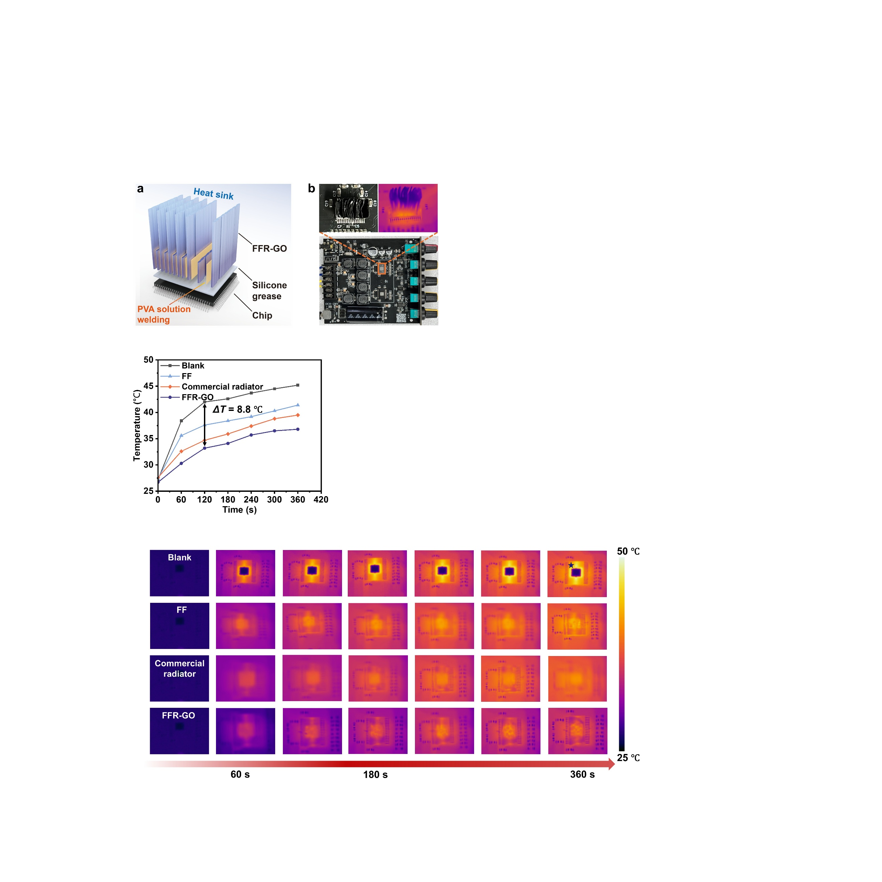
Supplementary Fig. 17 | Setup for thermal management testing using the FFR-GO hydrogel heat sink. a, Schematic illustration of the FFR-GO hydrogel-based heat sink bonded to a chip using PVA solution welding for thermal management testing. b, Optical and infrared thermal images of the audio amplifier system equipped with the FFR-GO heat sink during heat-dissipation tests.

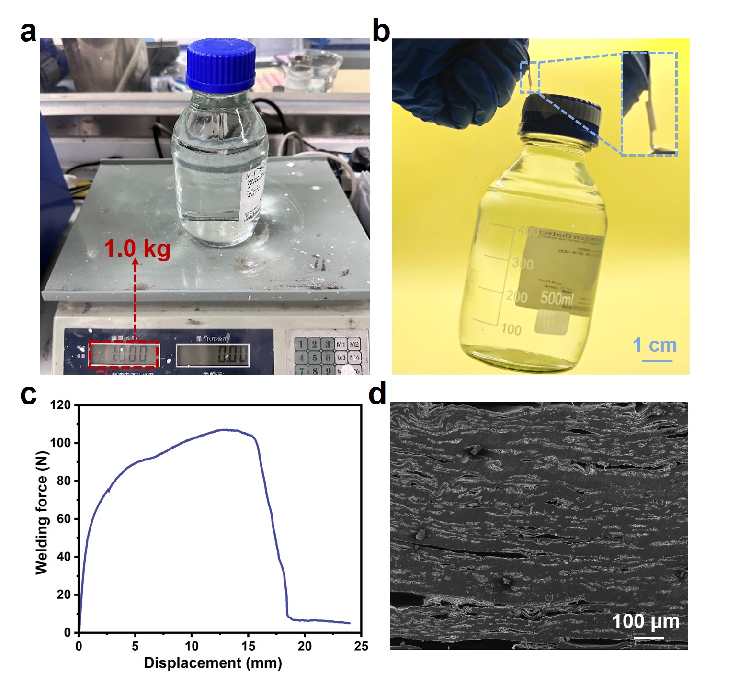
Supplementary Fig. 18 | Adhesion and interfacial welding performance of the FFR hydrogel using PVA solution as the adhesive. a-b, Photographs of two FFR hydrogel samples welded with the PVA solution, capable of lifting a 1 kg weight. c, Welding force–displacement curve of the bonded FFR hydrogel samples, demonstrating strong interfacial adhesion. d, SEM image of the welded cross-section, revealing a compact and continuous joint between the two FFR hydrogels.

Supplementary Fig. 19 | Infrared thermographic images showing surface temperature evolution of the chip under different heat dissipation conditions (blank, commercial radiator, FFR hydrogel) over 360 s.

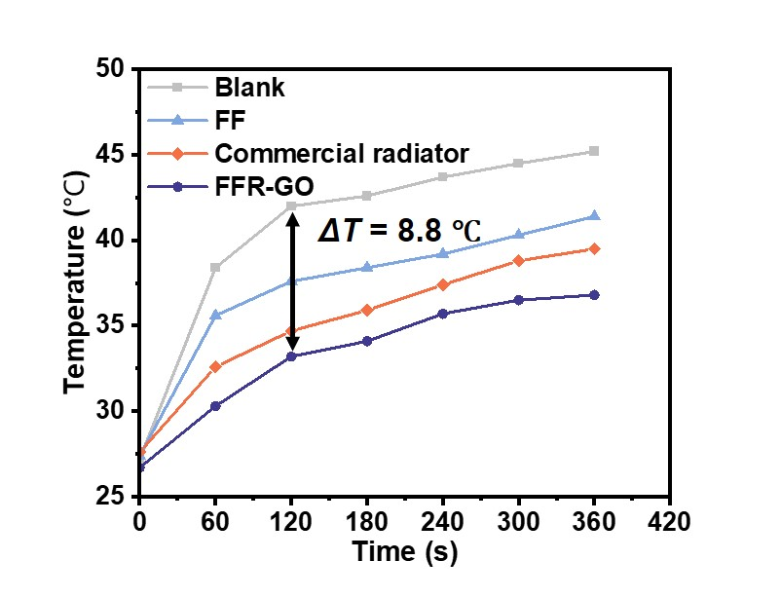
Supplementary Fig. 20 | Temperature profiles of the chip surface during operation with blank (no heat spreader), commercial radiator, FF, and FFR hydrogel as heat spreaders.

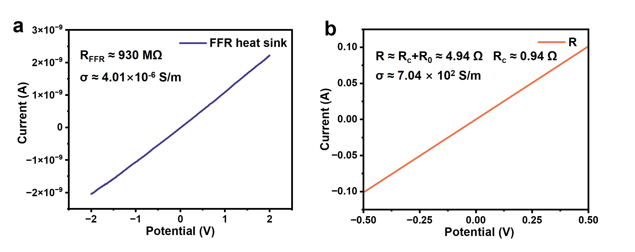
Supplementary Fig. 21 | Electrical conductivity comparison between the FFR hydrogel heat sink and a commercial metallic heat sink. a, Current-voltage (I-V) curve of the FFR hydrogel heat sink, showing extremely low electrical conductivity (σ = 4.01 × 10⁻⁶ S·m⁻¹). b, I-V curve of the commercial metallic heat sink connected in series with a fixed resistor (R₀ = 4 Ω), exhibiting a much higher conductivity (σ = 7.04 × 10² S·m⁻¹).

Supplementary Table 1 Comparison of FFR hydrogel to those of other representative tough PVA gels and artificial materials
Materials | Stress (MPa) | Strain (%) | Young’s modulus (MPa) | Toughness (MJ/m³) | Fracture energy (kJ/m²) | Ref.
This work | 41.29 | 468.2 | 73.61 | 159.37 | 97.94
DESs-PVA  (Adv. Fun. Mater.) | 20.2 | 550 | 16.1 | 62.7 | N/A | ¹
SEWA hydrogels (Adv. Mater.) | 11.2 | 1879 | N/A | 82.3 | 25.39 | ²
D-hydrogel-AAc/AAm  (Adv. Mater.) | 5.9 | ~800 | ~3 | ~28 | N/A | ³
FC-EtFe  (Sci. Adv.) | 6.5 | 1710 | 1.7 | 58.9 | 73.4 | ⁴
Gel-SALT hydrogel  (Adv. Mater.) | ~10.12 | ~140 | ~34.26 | ~14.28 | N/A | ⁵
AFH  (Nat. Commun.) | ~14 | ~800 | 4.38 | ~154 | ~153 | ⁶
FC-A PVA  (Adv. Mater.) | ~17 | ~500 | ~8 | ~1.05 | N/A | ⁷
DCC-hydrogels  (Adv. Mater.) | ~20 | ~51 | ~367 | ~7 | N/A | ⁸
PVA-S-LS  (ACS Nano) | ~23 | ~350 | ~17 | ~47 | ~42 | ⁹
HA-5PVA  (Nature) | ~11.5 | 2900 | N/A | 175 | 131.14 | ¹⁰
PCNA  (Chem. Eng. J.) | 25.9 | 556 | 422.6 | 90.9 | N/A | ¹¹
PVA/CNF  (ACS Nano) | ~40 | ~250 | 30 | ~60 | N/A | ¹²

Supplementary Table 2 Comparison of the Herman’s orientation factor (f) obtained by different preparation techniques.

Materials | Preparation technology | Method | Herman’s orientation factor (f) | Ref.
This work | Flocculating-freezing-rolling pressure | layer-by-layer shear densification | 0.91
SS-GO/CA (Nature) | Superspreading | Shear-flow-induced | 0.89 | ¹³
CP fibers  (Sci. Adv.) | Flow-enhanced crystallization | Extensional and shear flows and post-stretching | 0.67 | ¹⁴
V-BN/SG  (Nano-Micro Lett.) | Expansion-flow-assisted alignment | Shear-induced | 0.43 | ¹⁵
CSNF-TA-PVA (Nat. Commun.) | Bottom-up nanofiber assembly | Stretch-induced | 0.64 | ¹⁶
Gel-300  (Adv. Mater.) | Salting out-alignment-locking | Stretch-induced | 0.52 | ¹⁷
Concentric-RA (Sci. Adv.) | Ice-templating | Ice crystal-induced | 0.27 | ¹⁸
DF-PVA/CNF  (Nat. Commun.) | Directional freezing-induced assembly and prestretch-assisted salting out | Ice crystal-induced and stretch-induced | 0.24 | ¹⁹
PFeDAC  (Carbohydr. Polym.) | Magnetic field orientation | Magnetic field-induced | 0.76 | ²⁰
GCFs  (Adv. Funct. Mater.) | Hydrogel-controllable carbonization | Asymmetric shrinkage | 0.38 | ²¹
Random materials | - | - | -0.01 | ¹⁸

Supplementary Table 3 Thermal transport parameters of different hydrogels. Thermal diffusivity (α), density (ρ), and specific heat capacity (C_{p}) were measured and used to calculate the thermal conductivity (κ = α × ρ × C_{p}) of FFR hydrogels (in-plane and cross-plane), FF hydrogels. The thermal conductivity of neat PVA matrix was obtained from the literature.
Materials | Thermal diffusivity  α (mm² ·s⁻¹) | Density  ρ (g·cm⁻³) | Specific heat capacity  C_{p} (J·g⁻¹·K⁻¹) | Thermal conductivity  κ (W·m⁻¹·K⁻¹)
FFR (In-plane) | ~0.641 | ~1.428 | ~2.378 | ~2.18
FFR (Cross-plane) | ~0.178 | ~1.428 | ~2.378 | ~0.60
FF | ~0.174 | ~0.989 | ~1.486 | ~0.26
PVA matrix²² | - | - | - | ~0.19

Supplementary Table 4 Thermal conductivities of the simulated system along the three orthogonal directions before and after shear.
 | Before shear | After shear
X-axis | 2.99 | 4.15
Y-axis | 3.04 | 2.86
Z-axis | 3.07 | 2.91

Reference
1. Zhang H, Tang N, Yu X, Li MH, Hu J. Strong and Tough Physical Eutectogels Regulated by the Spatiotemporal Expression of Non‐Covalent Interactions. Adv. Funct. Mater. 2022, 32(41), 2206305.

2. Wu Y, Zhang Y, Wu H, Wen J, Zhang S, Xing W, et al. Solvent‐Exchange‐Assisted Wet Annealing: A New Strategy for Superstrong, Tough, Stretchable, and Anti‐Fatigue Hydrogels. Adv. Mater. 2023, 35(15), 2210624.

3. Lin P, Ma S, Wang X, Zhou F. Molecularly Engineered Dual‐Crosslinked Hydrogel with Ultrahigh Mechanical Strength, Toughness, and Good Self‐Recovery. Adv. Mater. 2015, 27(12), 2054-2059.

4. Guo X, Dong X, Zou G, Gao H, Zhai W. Strong and tough fibrous hydrogels reinforced by multiscale hierarchical structures with multimechanisms. Sci. Adv. 2023, 9(2), eadf7075.

5. Sun X, Mao Y, Yu Z, Yang P, Jiang F. A Biomimetic “Salting Out—Alignment—Locking” Tactic to Design Strong and Tough Hydrogel. Adv. Mater. 2024, 36(25), 2400084.

6. Zhu S, Wang S, Huang Y, Tang Q, Fu T, Su R, et al. Bioinspired structural hydrogels with highly ordered hierarchical orientations by flow-induced alignment of nanofibrils. Nat. Commun. 2024, 15, 118.

7. Liang X, Chen G, Lin S, Zhang J, Wang L, Zhang P, et al. Anisotropically Fatigue‐Resistant Hydrogels. Adv. Mater. 2021, 33(30), 2102011.

8. Mredha MTI, Guo YZ, Nonoyama T, Nakajima T, Kurokawa T, Gong JP. A Facile Method to Fabricate Anisotropic Hydrogels with Perfectly Aligned Hierarchical Fibrous Structures. Adv. Mater. 2018, 30(9), 1704937.

9. Pan X, Li X, Wang Z, Ni Y, Wang Q. Nanolignin-Facilitated Robust Hydrogels. ACS Nano 2024, 18(35), 24095-24104.

10. Hua M, Wu S, Ma Y, Zhao Y, Chen Z, Frenkel I, et al. Strong tough hydrogels via the synergy of freeze-casting and salting out. Nature 2021, 590(7847), 594-599.

11. Zhang L, Wang K, Weng S, Jiang X. Super strong and tough anisotropic hydrogels through synergy of directional freeze-casting, metal complexation and salting out. Chem. Eng. J. 2023, 463, 142414.

12. Wu L, Kang Y, Shi X, Yuezhen B, Qu M, Li J, et al. Natural-Wood-Inspired Ultrastrong Anisotropic Hybrid Hydrogels Targeting Artificial Tendons or Ligaments. ACS Nano 2023, 17(14), 13522-13532.

13. Zhao C, Zhang P, Zhou J, Qi S, Yamauchi Y, Shi R, et al. Layered nanocomposites by shear-flow-induced alignment of nanosheets. Nature 2020, 580(7802), 210-215.

14. Zhang Z, Li P, Xiong M, Zhang L, Chen J, Lei X, et al. Continuous production of ultratough semiconducting polymer fibers with high electronic performance. Sci. Adv. 2024, 10(14), eadk0647.

15. Niu H, Guo H, Kang L, Ren L, Lv R, Bai S. Vertical Alignment of Anisotropic Fillers Assisted by Expansion Flow in Polymer Composites. Nano-Micro Lett. 2022, 14(1), 153.

16. Zhuo H, Dong X, Liu Q, Hong L, Zhang Z, Long S, et al. Bamboo-inspired ultra-strong nanofiber-reinforced composite hydrogels. Nat. Commun. 2025, 16, 980.

17. Sun X, Mao Y, Yu Z, Yang P, Jiang F. A Biomimetic “Salting Out—Alignment—Locking” Tactic to Design Strong and Tough Hydrogel. Adv. Mater. 2024, 36(25), 2400084.

18. Gu W, Yang S, Zhao D, Zou Y, Chen C, Niu P, et al. Concentric ice-templating of ultracompressible tough hydrogels with bioinspired circumferentially aligned architecture. Sci. Adv. 2025, 11(25), eadv7786.

19. Xu Z, Chen H, Yang H-B, Yao X, Qin H, Cong H-P, et al. Hierarchically aligned heterogeneous core-sheath hydrogels. Nat. Commun. 2025, 16, 400.

20. Yan G, He S, Chen G, Tang X, Sun Y, Xu F, et al. Anisotropic, strong, self-adhesive and strain-sensitive hydrogels enabled by magnetically-oriented cellulose/polydopamine nanocomposites. Carbohydr. Polym. 2022, 276, 118783.

21. Tan M, Chen D, Cheng Y, Sun H, Chen G, Dong S, et al. Anisotropically Oriented Carbon Films with Dual-Function of Efficient Heat Dissipation and Excellent Electromagnetic Interference Shielding Performances. Adv. Funct. Mater. 2022, 32(31), 2202057.

22. Yan Q, Dai W, Gao J, Tan X, Lv L, Ying J, et al. Ultrahigh-Aspect-Ratio Boron Nitride Nanosheets Leading to Superhigh In-Plane Thermal Conductivity of Foldable Heat Spreader. ACS Nano 2021, 15(4), 6489-6498.

