Questionnaire.
INSTRUCTIONS. Please Tick (✔) the box against the preferred choice.
SECTION A
SOCIO-DEMOGRAPHIC INFORMATION
- What is your gender?
☐ Male ☐ Female
- What is your age (in years)?
☐ 18 - 23 ☐ 24 - 28 ☐ 29 - 35
- Level of education?
☐ No formal education ☐ Primary education ☐ Secondary education
☐ Technical/Vocational Training ☐ Other (specify) ……………………
- Years of welding experience (in years)?
☐ Less than 2 ☐ 3–5 ☐ 6 or over
- What is your employment status
☐ Business owner ☐ Fully employed ☐ Partially employed ☐ Casual/Temporary
- How many hours on average do you work per day?
☐ Less than 6 hours ☐ 6–8 hours ☐ 9–12 hours ☐ More than 12 hours
- Do you sometimes do work for more hours/overtime?
☐ Yes ☐ No
- Is there enough space to move freely around the workstation?
☐ Yes ☐ No

SECTION B
NORDIC MUSCULOSKELETAL QUESTIONNAIRE (NMQ)
- Have you experienced body pain/discomfort or numbness in the last 12 months or in the past 7 days? ☐ Yes ☐ No
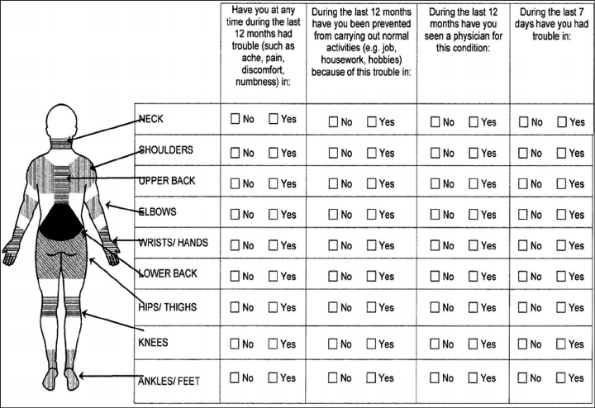
If yes, please fill the below Nordic Musculoskeletal Questionnaire (NMQ) to the best of your knowledge. (Tick (√) where appropriate)
- In your opinion, are the body pains related to your daily work activities?
☐ Yes ☐ No.

SECTON C
ORGANISATIONAL FACTORS
- a) Do you take breaks at work, apart from lunch hour?
☐ Yes ☐ No
b) If yes, how frequently are breaks observed?
☐ Every hour ☐ Every 2–3 hours ☐ Once per shift
c) What is the approximate break duration?
☐ Less than 5 min ☐ 5–15 min ☐ more than 15 min
- Are Personal Protective Equipment (PPE) available at your workplace?
☐ Yes ☐ No
- Which PPE do you use?
☐ Gloves ☐ Goggles ☐ Safety boots ☐ Face shield/welding helmet ☐ Apron/Overalls
☐ Earplugs
- How often do you wear PPE while performing your tasks?
☐ Never ☐ Rarely ☐ Occasionally ☐ Frequently ☐ Always
- Have you received any training on occupational health and safety?
☐ Yes ☐ No
If Yes, how often do you receive safety training?
☐ Once a month
☐ Once every 3 months
☐ Once a year
☐ Never
- Are there safety policies at your workplace?
☐ Yes ☐ No ☐ Not sure
- What improvements would you recommend for a safer workplace?

Thank You

