Chondroitin Sulphate and Gas Foaming Concurrently Improve Articular Cartilage Regeneration in Electrospun Poly(L-lactide-co-ε-caprolactone)/Silk Fibroin Based Scaffolds

Yujie Chen^{a,1}, Wei Xu^{b,c,d,1}, Muhammad Shafiq^{a,}*, Daiying Song^{b,c,d}, Xianrui Xieª, Zhengchao Yuanª, Mohamed EL-Newehy^{e}, Hany EL-Hamshary^{e}, Yosry Morsi^{f}, Yu Liu^{b,c,d,}*, Xiumei Mo^{a,}*
ª Shanghai Engineering Research Center of Nano-Biomaterials and Regenerative Medicine, State Key Laboratory for Modification of Chemical Fibers and Polymer Materials, College of Chemistry, Chemical Engineering and Biotechnology, Donghua University, Songjiang, Shanghai 201600, China
^{b} Research Institute of Plastic Surgery, Wei Fang Medical College, Weifang 261000, China
^{c} National Tissue Engineering Center of China, Minhang, Shanghai 201100, China
^{d} Shanghai Key Laboratory of Tissue Engineering, Department of Plastic and Reconstructive Surgery, Shanghai 9th People’s Hospital, Shanghai Stem Cell Institute, Shanghai Jiao Tong University School of Medicine, Huangpu, Shanghai 200001, China
^{e} Department of Chemistry, College of Science, King Saud University, P.O. Box 2455, Riyadh 11451, Saudi Arabia
^{f} Faculty of Engineering and Industrial Sciences, Swinburne University of Technology, Boroondara, VIC 3122, Australia
* Corresponding author: Dr. Xiumei Mo, Email: xmm@dhu.edu.cn; Dr. Yu Liu, Email: yuliu1211@163.com; Dr. Muhammad Shafiq, Email: shafiqdr786@yahoo.com
¹These authors contributed equally to this work.

1. Preparation of regenerated Silk Fibroin
Cocoons were degummed in Na₂CO₃ (0.02 M) solution at 100 °C for three times to remove the sericin protein. After that, the dried silk was dissolved in a 9.3 M LiBr solution in a water bath at 45 °C for 30 min. Then, the homogeneous solution was dialyzed (dialysis bag: MWCO = 1.4 kD) against deionized water for up to 3 days. Finally, the regenerated SF was obtained by filtering and lyophilizing the silk solution.
2. Pore area distribution
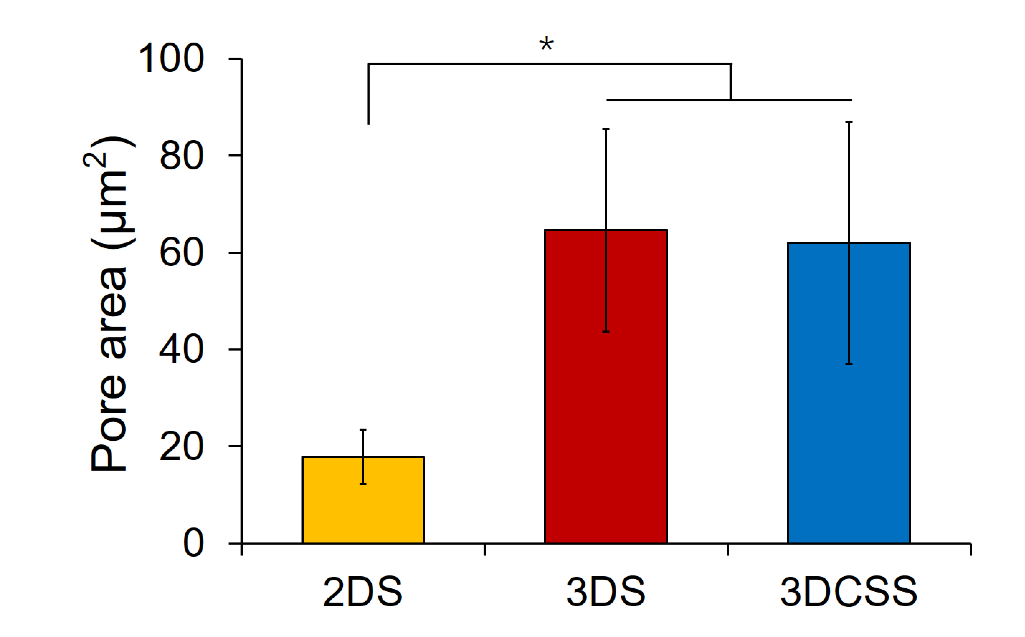
Fig. S1. Pore area of 2DS, 3DS, and 3DCSS (*p < 0.05, n = 20).
3. Water absorption
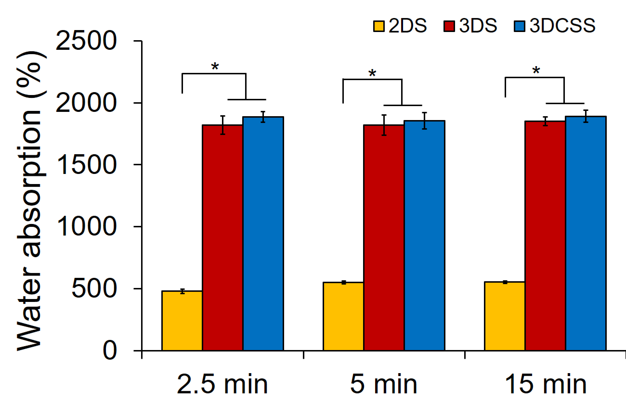
Fig. S2. Water absorption rate of 2DS, 3DS and 3DCSS (*p < 0.05, n = 3).
4. Collagen type II staining of cell−scaffold constructs in vitro
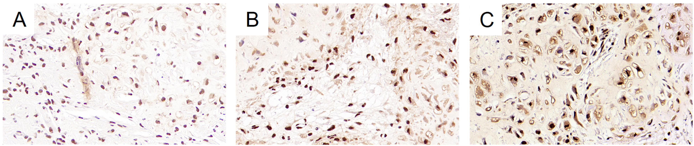
Fig. S3. Collagen type II staining of cell-scaffold constructs implanted subcutaneously in nude mice for up to 8 weeks of 2DS(A), 3DS (B) and 3DCSS (C).
5. Collage type I staining of articular cartilage
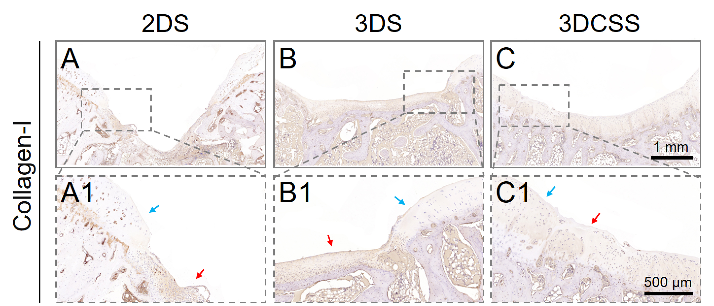
Fig. S4. Collagen Type I immunohistochemical staining images of the repaired cartilage defects in different groups 12 weeks after surgery. Blue arrows indicate the intact cartilage area, and the red arrows indicate the cartilage defect area.

Table S1.
Primers of target genes in RT-PCR.
Gene | Forward primers (5’-3’) | Reverse primers (5’-3’)
IL-1β | TCTCTGGACCCAAAGGAGGG | ACGGCTGCTTTCAGGGGTGA
TNF-α | AGCTGGTGGTGCCGACAGAT | TGCGATGCGGCTGATGGTGT
MMP13 | CCTGTGCTCCTGCCATTTGG | GAATGGGCAGCTCCATGGCT
GADPH | TCAGCTGCTGGGGAGTGACA | CCTAAGCCCCTCCCCTTCTT

Table S2. ICRS macroscopic evaluation of cartilage repair
Cartilage repair assessment ICRS | Score
I. Degree of defect repair | 12
In level with surrounding cartilage | 4
75% repair of defect depth | 3
50% repair of defect depth | 2
25% repair of defect depth | 1
0% repair of defect depth | 0
II. Integration to border zone
Complete integration with surrounding cartilage | 4
Demarcating border < 1 mm | 3
3/4th of graft integrated, 1/4th with a notable border > 1 mm width | 2
1/2 of graft integrated with surrounding cartilage, 1/2 with a notable border > 1 mm | 1
From no contact to 1/4th of graft integrated with surrounding cartilage | 0
III. Macroscopic appearance
Intact smooth surface | 4
Fibrillated surface | 3
Small, scattered fissures or cracs | 2
Several, small or few but large fissures | 1
Total degeneration of grafted area | 0
Overall repair assessment
Grade I: normal | 12
Grade II: nearly normal | 11-8
Grade III: abnormal | 7-4
Grade IV: severely abnormal | 3-1

Table S3. Modified O’Driscoll histological evaluation of cartilage repair O’Driscoll category
 | Score
Nature of the predominant tissue
Cellular morphology
Hyaline articular cartilage | 4
Incompletely differentiated mesenchyme | 2
Fibrous tissue or bone | 0
Safranin-O staining of the matrix
Normal or nearly normal | 3
Moderate | 2
Slight | 1
None | 0
Structural characteristics
Surface regularity
Smooth and intact | 3
Superficial horizontal lamination | 2
Fissures: 25–100% of thickness | 1
Severe disruption, including fibrillation | 0
Structural integrity
Normal | 2
Slight disruption, including cysts | 1
Severe disintegration | 0
Thickness  100% of normal adjacent cartilage | 2
50–100% of normal cartilage | 1
0–50% of normal cartilage  Bonding to the adjacent cartilage | 0
Bonded at both ends of the graft | 2
Bonded at one end, or partially at both ends | 1
Not bonded | 0
Freedom from cellular changes of degeneration
Hypocellularity
Normal cellularity | 3
Slight hypocellularity | 2
Moderate hypocellularity | 1
Severe hypocellularity | 0
Chondrocyte clustering
No clusters | 2
< 25% of the cells | 1
25–100% of the cells | 0
Adjacent cartilage degenerative joint disease
Normal, no clusters, normal staining | 3
Normal cell, mild clusters, mod staining | 2
Mild/moderate hypocellularity, slight staining | 1
Severe hypocellularity | 0

Table S4. Modified Mankin score
 | Score
I. Structure
Normal | 0
Irregular surface, including fissures into the radial layer | 1
Pannus | 2
Superficial cartilage layers (≥6) absent | 3
Slight disorganization (cellular rows absent, some small superficial clusters)  Fissures into calcified cartilage layer  Disorganization (chaotic structure, clusters, osteoclast activity) | 4  5  6
II. Cellular abnormalities
Normal  Hypercellularity, including small superficial clusters | 0  1
Clusters | 2
Hypocellularity | 3
III. Matrix staining
Normal/slight reduction | 0
Staining reduced in radial layer | 1
Reduced in interterritorial matrix | 2
Only present in pencellular matrix | 3
Absent | 4

