Supplementary Methods
Determination of type 2 diabetes
To determine T2DM status, results from the oral glucose tolerance test (OGTT) with a 75 g glucose solution were used in the ASAS cohort. According to the American Diabetes Association criteria, patients with 1) a fasting glucose level ≥ 126 mg/dl or 2) a 2-hour glucose level ≥ 200 mg/dl were determined to have T2DM. In addition, treatment history was used to identify patients with T2DM. The participants of the HEXA and CAVAS cohorts received no OGTTs, so the fasting glucose levels (≥ 126 mg/dl) and treatment histories were used for the determination of T2DM status.

Simulation data analysis
Simulation analyses were applied to test the performance of the MERG compared with conventional methods. Using a logistic regression model, we generated the simulated data using the following equation (Equation (1)):
(1)
We randomly assigned ages from 20 to 70 years and normalized the simulated age with the transformation of (age – mean(age))/sd(age), where sd indicates standard deviation. We generated covariates x₁ and x₂ by multiplying the predefined constants by the simulated age. This correlates with the covariates and reflects the effect of the change in age on the covariates, which changed during the development of the disease. Genotype information was generated using a binomial distribution. Under a fixed minor allele frequency (MAF), genotypes coded 0, 1, and 2, which represent the number of risk alleles, were simulated. An arbitrary intercept value was assigned to set the proportion of disease to the extent that the proportion of disease at the most recent follow-up would be less than half of all participants. All simulated values of the covariates, genotypes, and intercepts were summed according to Equation (6), and the summed value was applied to the logistic function. The final value from the logistic function was applied to a binomial distribution to simulate disease status.
Follow-up data were simulated by modifying the initially simulated data. We conducted regular follow-ups for all participants. At the i-th follow-up, follow-up age was set by summing (i-1) × predefined interval to the initial age. Then, the covariates of the i-th follow-up were generated by multiplying the predefined value and the linear predictive value for the i-th state using Equation (1). The resulting step was the same as that of the initial simulation. In the simulation of the follow-up data, participants who were assigned to the disease group once were continuously assigned to the disease group during the rest of the follow-ups. This is because disease status is often irreversible, even with a change in covariates. Finally, participant loss was simulated by removing a fixed proportion of participants who were randomly selected at each follow-up.

Supplementary Results
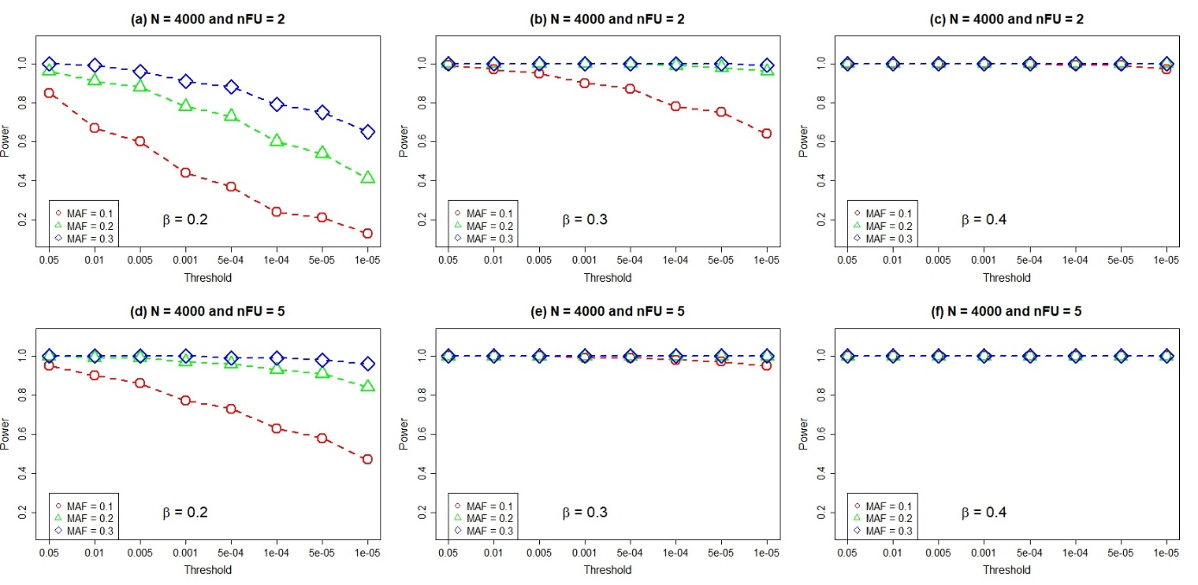

Supplementary Fig. 1. Power analysis result of MERG. For different combinations of parameters that were used in the generation of simulation data, powers are determined with different P-value thresholds. In a fixed sample size, powers are dependent on the MAF and the number of follow-ups when the effect size is small. However, the other parameters have no significant effect on powers when the effect size becomes larger. As shown in (c) and (d), powers are saturated to 1 with a beta coefficient (effect size) of 0.4 in all combinations of the other parameters. MERG, meta-analysis of repeat genome-wide association study; MAF, minor allele frequency.

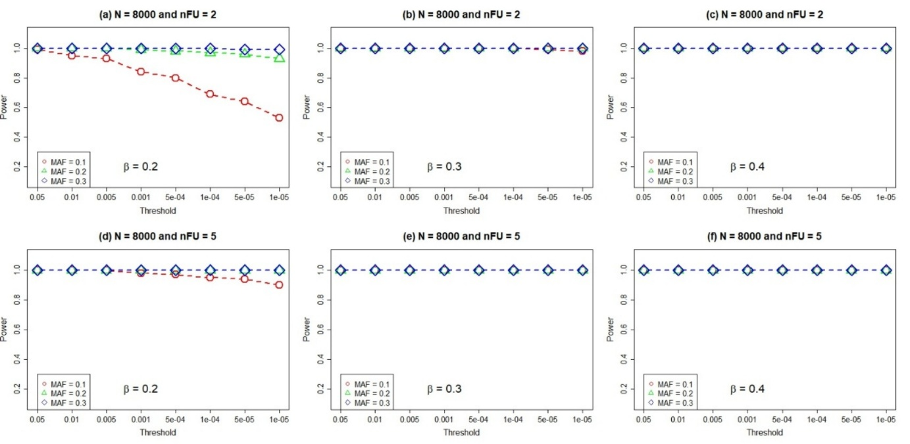

Supplementary Fig. 2. Power analysis result of MERG. For different combinations of parameters that were used in the generation of simulation data, powers are determined with different P-value thresholds. In a fixed sample size, powers are dependent on the MAF and the number of follow-ups when the effect size is small. However, the other parameters have no significant effect on powers when the effect size becomes larger. As shown in (c) and (d), powers are saturated to 1 with a beta coefficient (effect size) of 0.4 in all combinations of the other parameters. MERG, meta-analysis of repeat genome-wide association study; MAF, minor allele frequency.

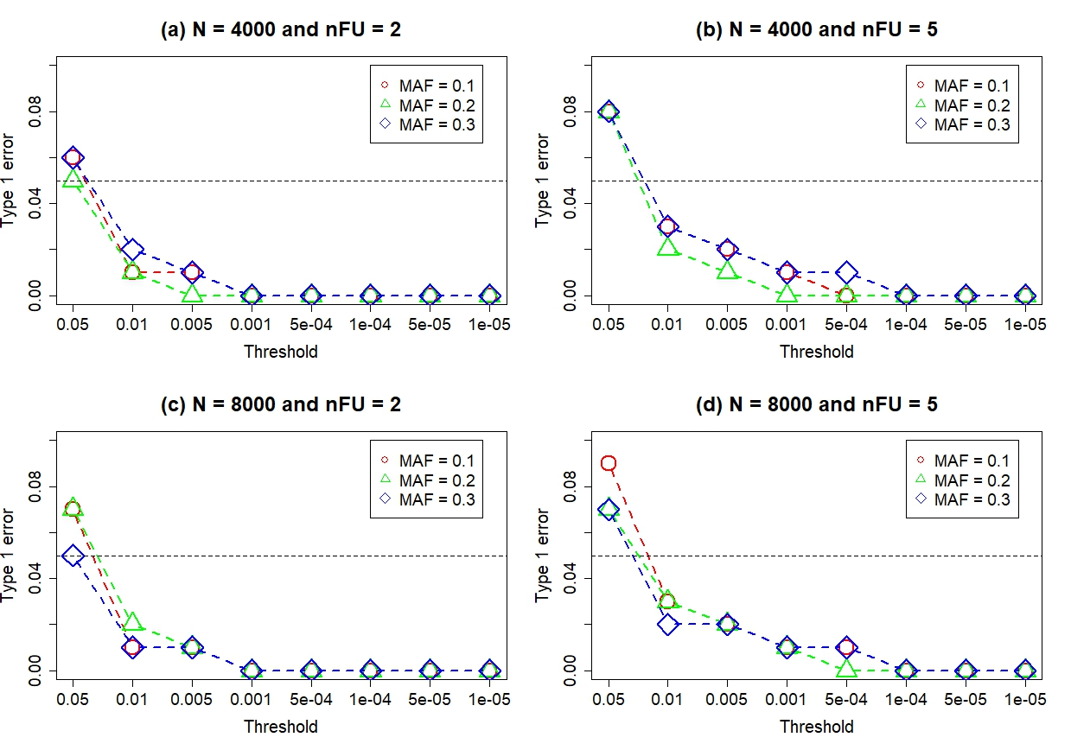

Supplementary Fig. 3. Result of type 1 error analysis for MERG. With different combinations of minor allele frequencies (MAFs), number of follow-ups, and samples, the type 1 errors of the MERG are presented. In general, type 1 errors of MERG are acceptable (< 0.05) when the P-value thresholds are ≤ 0.01. Clearly, the overall type 1 error becomes greater when the number of samples changes from 4000 to 8000. The MAF of 0.1 tends to show greater type 1 errors, especially when the number of samples and follow-ups is 8000 and 5, respectively. The number of follow-ups also shows a tendency to increase type 1 errors as they become greater. nFU, number of follow-up; MERG, meta-analysis of repeat genome-wide association study.

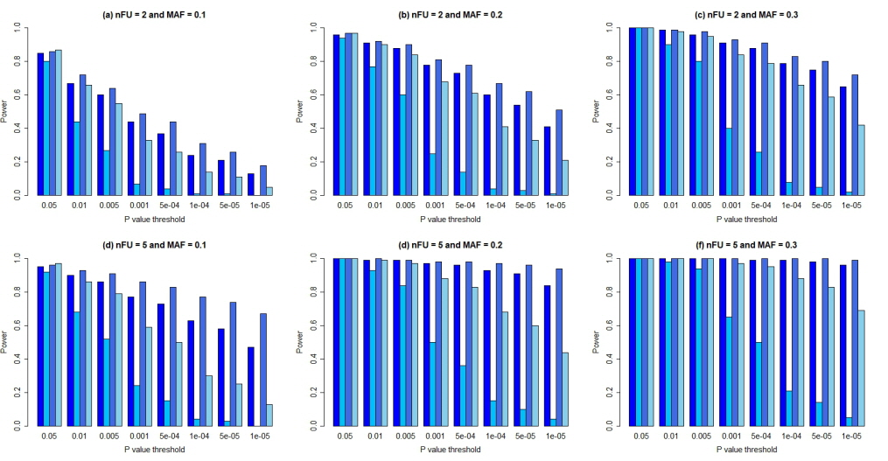

Supplementary Fig. 4. Power analysis of MERG and comparison methods with effect size (beta value) = 0.2 and sample = 4000. Note that the upper three figures correspond to the number of follow-ups (nFU) = 2, and the lower three correspond to the nFU = 5. The placement of the figures is the same in the Supplementary Figures (from Supplementary Fig. 4 to 9). As the nFU and the minor allele frequency increased, MERG and Fisher’s method tended to show equivalent power. However, MERG.cov and LR showed lower performance. nFU = number of follow-ups, MAF: minor allele frequency.

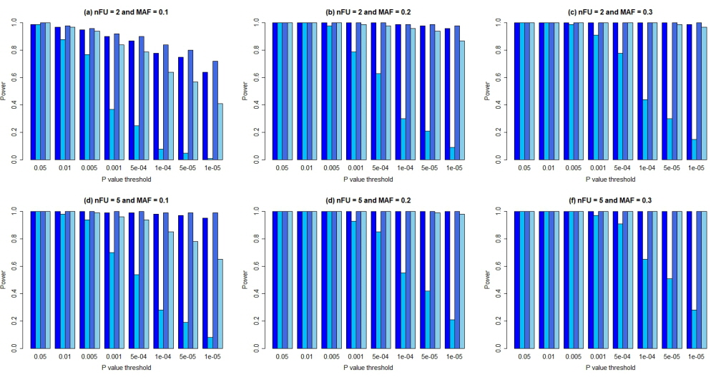

Supplementary Fig. 5. Power analysis of MERG and comparison methods with effect size (beta value) = 0.3 and sample = 4000. All methods show an overall increase in power with an increase in the effect size. However, MERG.cov shows relatively poor performance. The power is almost saturated, even with a minor allele frequency of 0.2, except for that of MERG.cov. nFU= number of follow-ups, MAF: minor allele frequency.

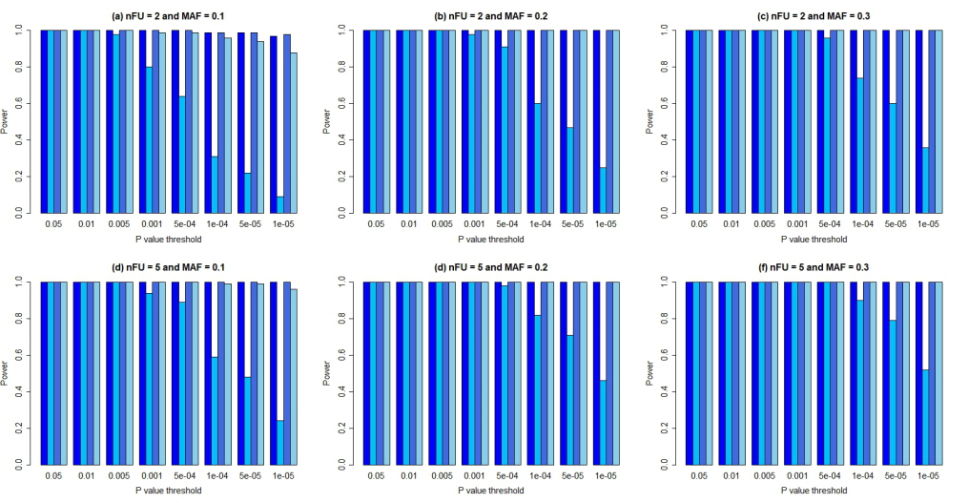

Supplementary Fig. 6. Power analysis of MERG and comparison methods with effect size (beta value) = 0.4 and sample = 4000. As shown in the figure, all methods show almost perfect performances. However, MERG.cov shows poor performance, especially under stringent P-value thresholds. nFU= number of follow-ups, MAF: minor allele frequency.

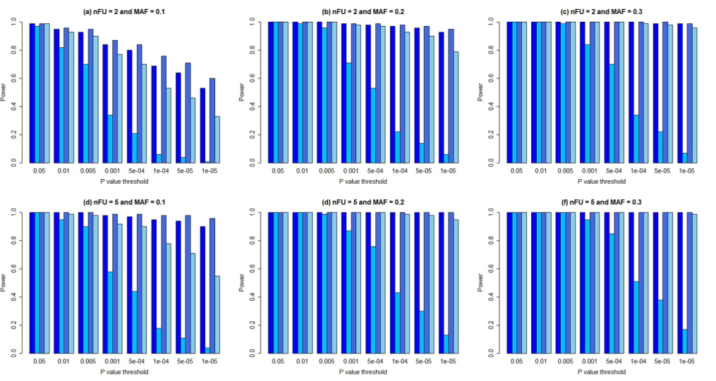

Supplementary Fig. 7. Power analysis of MERG and comparison methods with effect size (beta value) = 0.2 and sample = 8000. MREG and Fisher's method outperform the other two methods (MERG.cov and logistic regression) when the minor allele frequency (MAF) is set to 0.1. When the MAF is set to 0.2, MERG, Fisher's method, and LR show excellent power. However, MERG.cov shows poor performance with stringent P-value thresholds. nFU= number of follow-ups.

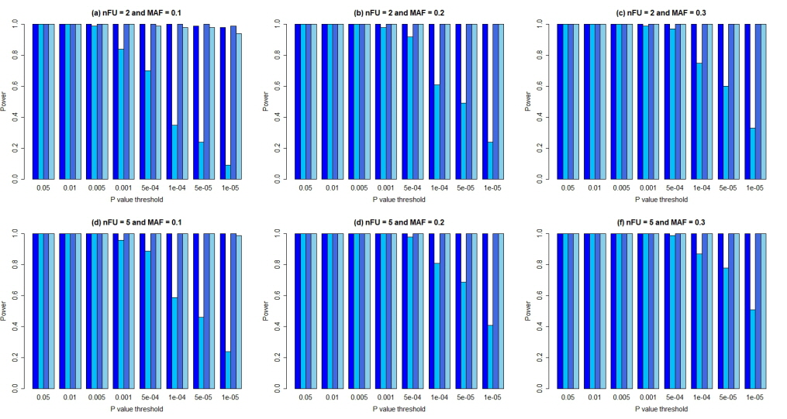

Supplementary Fig. 8. Power analysis of MERG and comparison methods with effect size (beta value) = 0.3 and sample = 8000. MERG, Fisher’s method, and logistic regression show strong power with the minimal parameters. However, MERG.cov still has poor performance under stringent P-value thresholds. nFU= number of follow-ups, MAF: minor allele frequency.

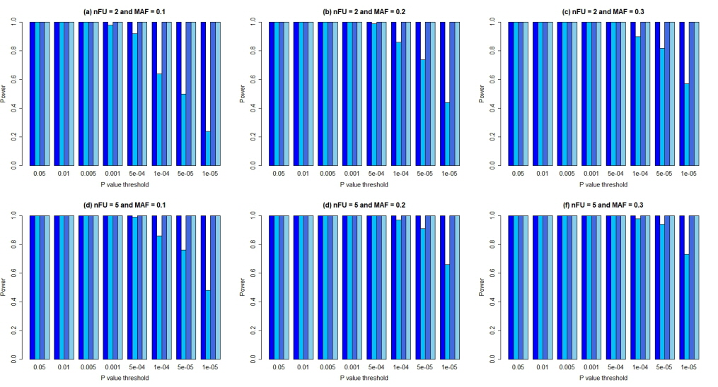

Supplementary Fig. 9 Power analysis of MERG and comparison methods with effect size (beta value) = 0.4 and sample = 8000. While three methods (MERG, Fisher's method, and logistic regression) have perfect performance with minimal parameters, MERG.cov shows less power than the others. (nFU = number of follow-ups, MAF = minor allele frequency).

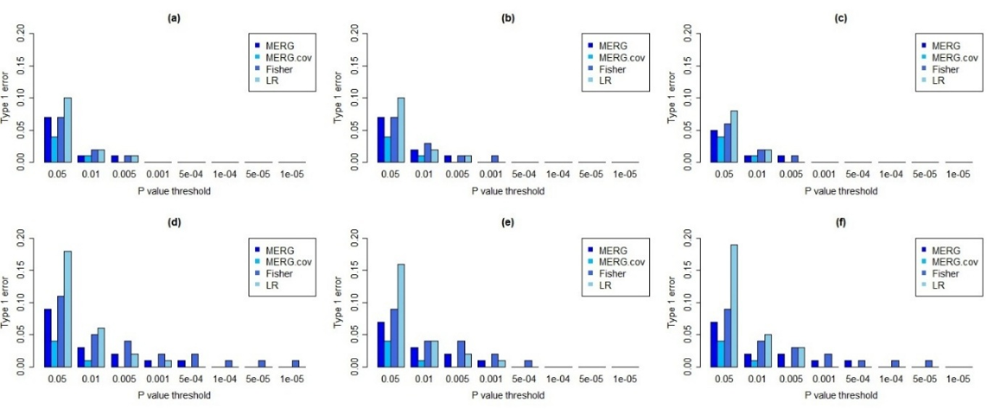
Supplementary Fig. 10. Type 1 errors of MERG, Fisher’s method and logistic regression with 8000 samples. As in Fig. 3, all methods showed almost zero type 1 error with stringent P value threshold (P = 5.00E-4). Except the case with P value threshold of 0.05, MERG and MERG.cov showed acceptable type 1 errors, while Fisher’s method and logistic regression showed greater type 1 error than the other methods. MERG: meta-analysis of repeat GWAS, MERG.cov: MERG with covariance, Fisher: Fisher’s method, LR: logistic regression.

