Supplementary material.
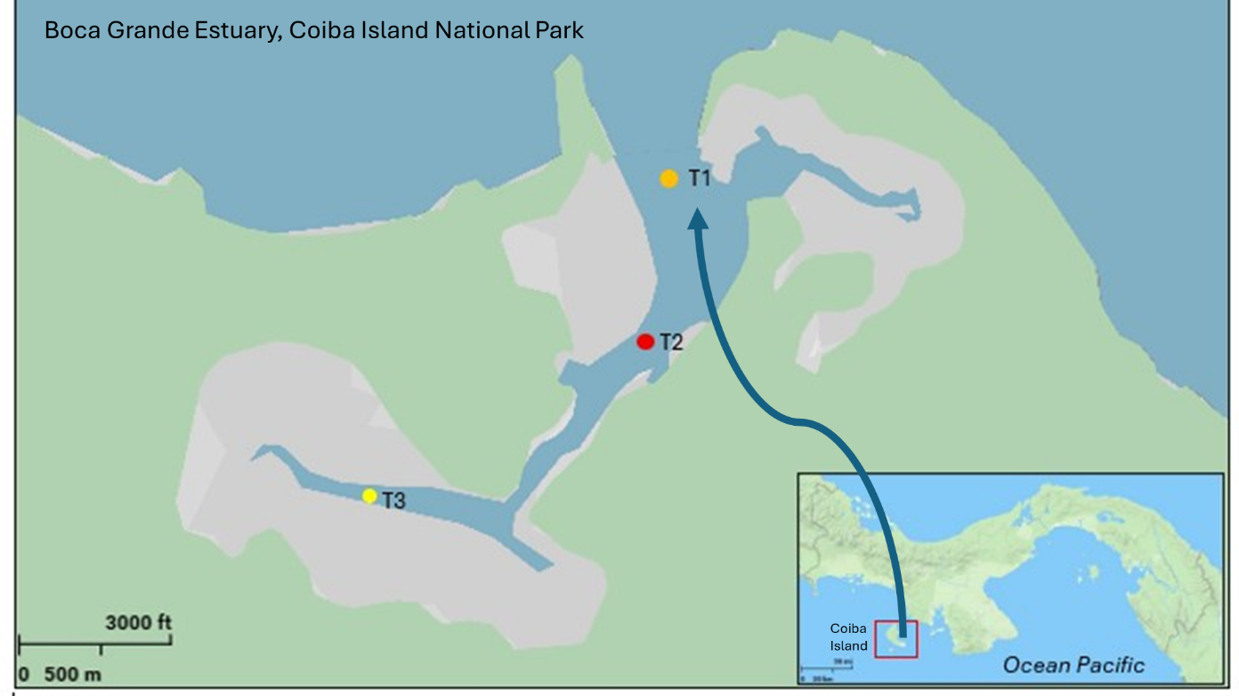
Figure 1. Boca Grande Estuary at Coiba National Park, Panama. Color dots indicate the studied transects for determining fish composition. The blue arrow points out to transect T1 that showed intermediate to high salinities 16 to 29ppt and where all N. brevirostris were collected.

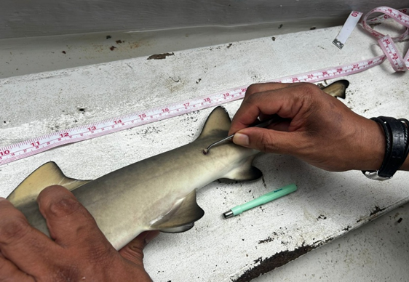

Figure 2. Tissue biopsy for DNA conducted on N. brevirostris individuals.

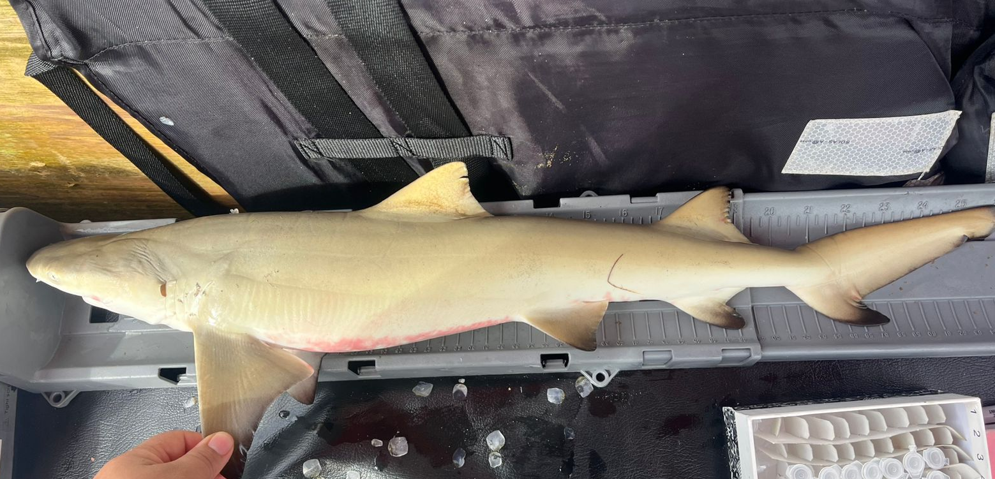
Figure 3. Young of the Year (YOY) of N. brevirostris collected in Boca Grande estuary, Coiba National Park.
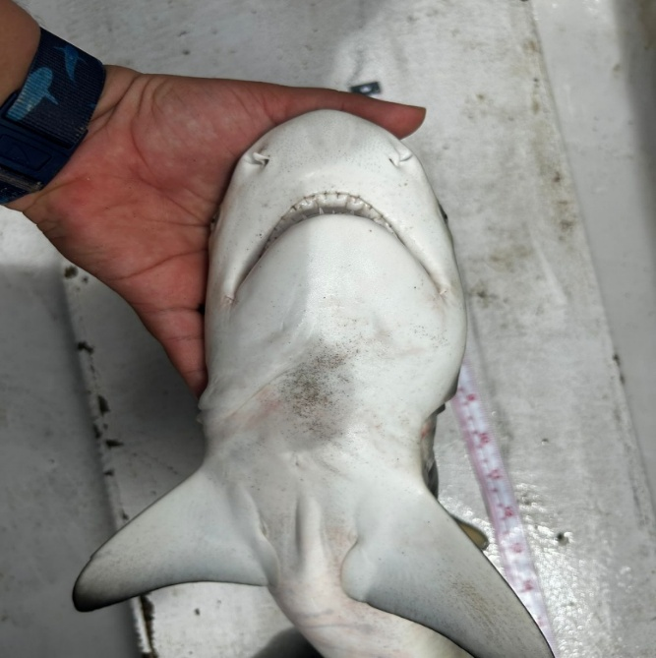
Figure 4. Ventral features of mouth, teeth and open umbilical scar of N. brevirostris.

