Supplementary Figures
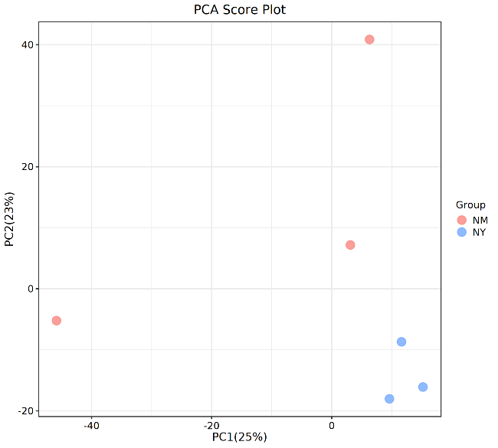
Supplementary.Figure.1 PCA analysis of the EC (blue) and NC (orange) groups in 16s rRNA-seq.
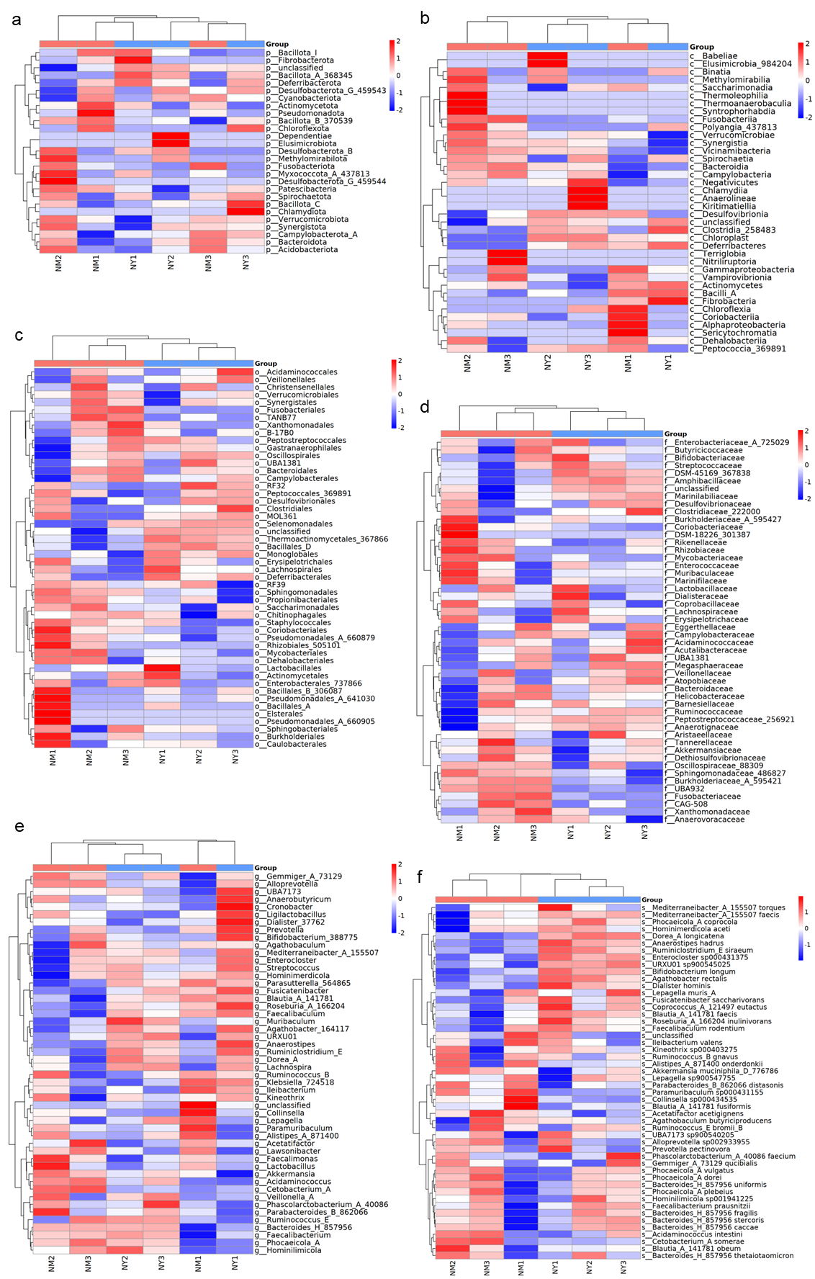
Supplementary.Figure.2 a-f) Heatmaps displaying the expression levels of Phylum (a), Class (b), Order (c), Family (d), Genus (e) and Species (f) of the EC (blue) and NC (orange) groups in 16s rRNA-seq.
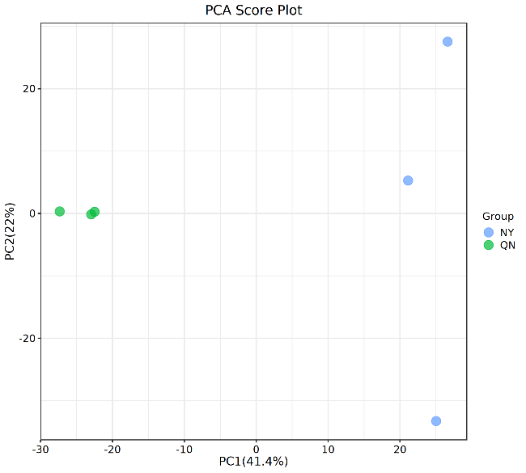
Supplementary.Figure.3 PCA analysis of the EC (blue) and NCF (green) groups in 16s rRNA-seq.
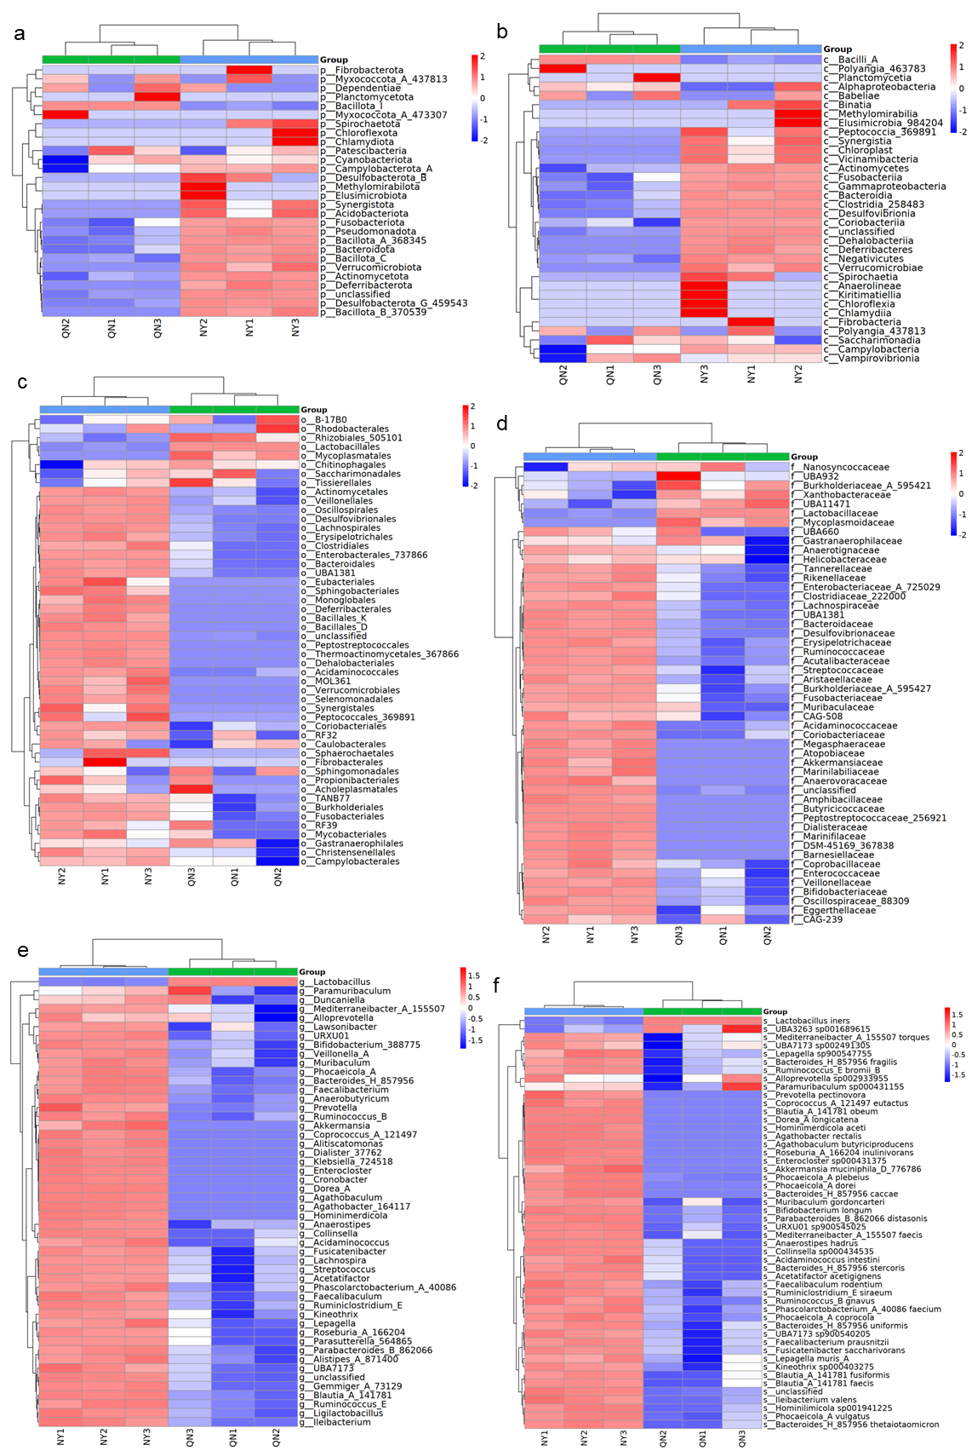
Supplementary.Figure.4 a-f) Heatmaps displaying the expression levels of Phylum (a), Class (b), Order (c), Family (d), Genus (e) and Species (f) of the EC (blue) and NCF (green) groups in 16s rRNA-seq.
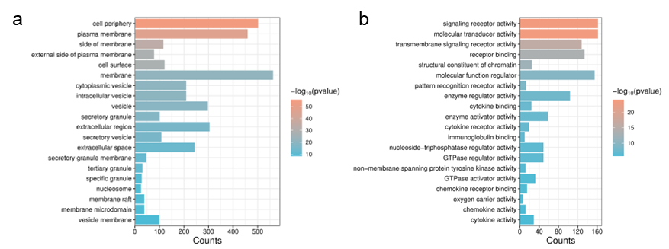
Supplementary.Figure.5 a-b) GO Cellular Component (CC) (a) and GO Molecular Function (MF) (b) enrichment analysis of the EC relative to the NC group.
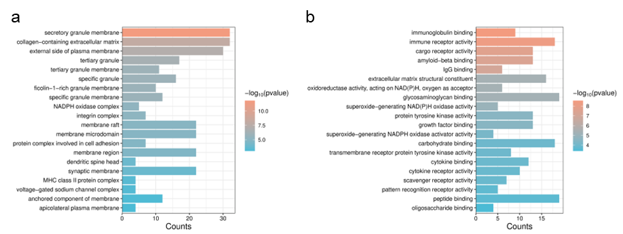
Supplementary.Figure.6 a-b) GO Cellular Component (CC) (a) and GO Molecular Function (MF) (b) enrichment analysis of the EC relative to the NC group in the GEO database.
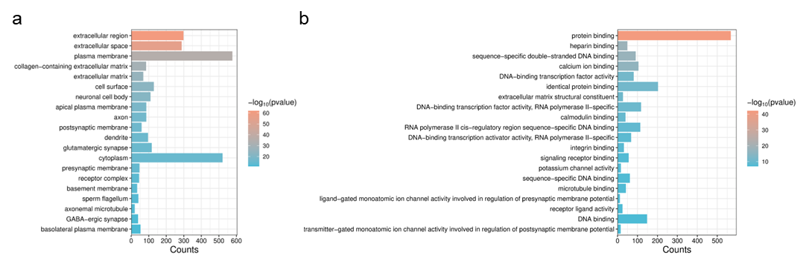
Supplementary.Figure.7 a-b) GO Cellular Component (CC) (a) and GO Molecular Function (MF) (b) enrichment analysis of the EE relative to the EC group.
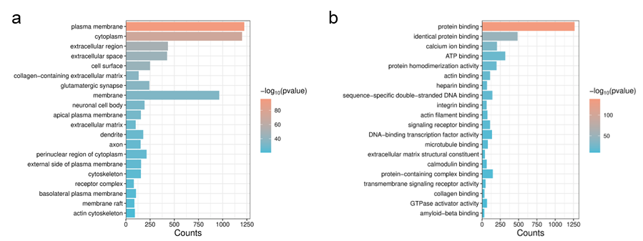
Supplementary.Figure.8 a-b) GO Cellular Component (CC) (a) and GO Molecular Function (MF) (b) enrichment analysis of the EE relative to the NC group.
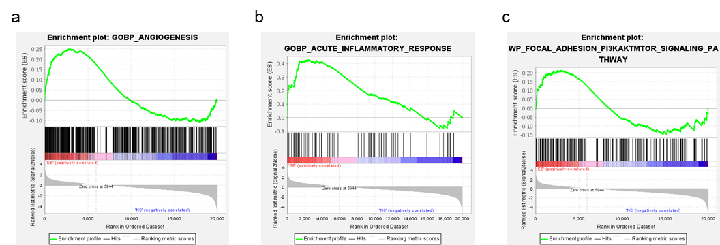
Supplementary.Figure.9 a-c) GSEA enrichment analysis of angiogenesis (a), acute inflammatory response (b) and adhesion PI3K-AKT-mTOR signaling pathway (c) between the EE and NC groups.
Supplementary.Figure.10 Representative fluorescence images of the endometrium (n=3) with MPO (violet), Ly6G (green), and DAPI (blue) (bar = 50 μm).
Supplementary.Figure.11 Representative white-light images of the endometrium (n=3) with CD31 (bar = 50 μm).
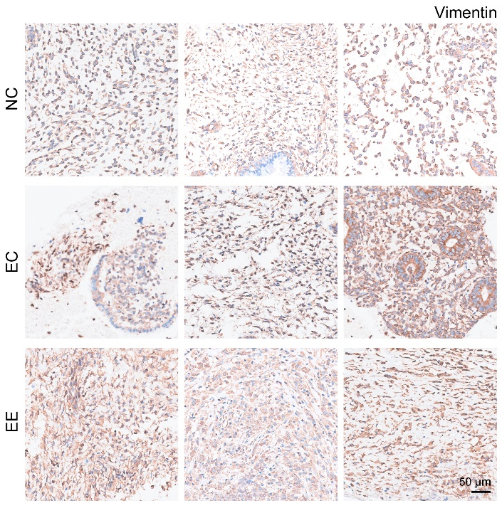
Supplementary.Figure.12 Representative white-light images of the endometrium (n=3) with vimentin (bar = 50 μm).
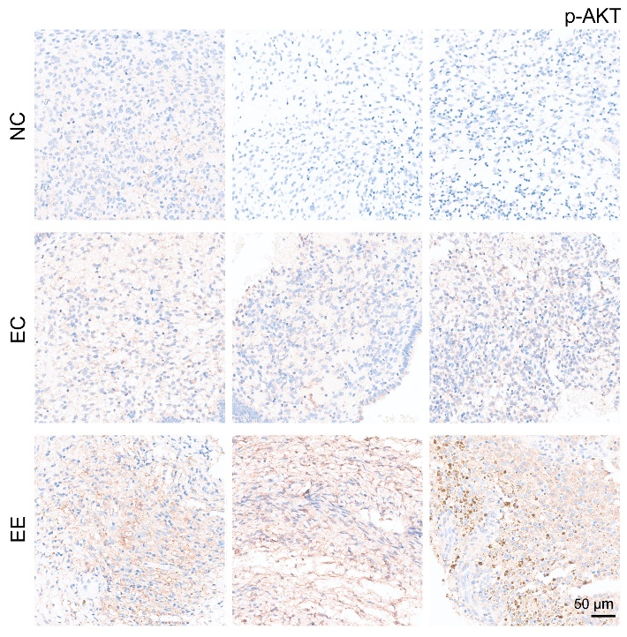
Supplementary.Figure.13 Representative white-light images of the endometrium (n=3) with p-AKT (bar = 50 μm).
Supplementary.Figure.14 Representative white-light images of the endometrium (n=3) with p-mTPR (bar = 50 μm).

