Appendix A: Statistical Significance

 | Overall Storm Count |  |  | ET Complete Cases |  | ET Completion Rate
 | Climo | RCP4.5 | RCP8.5 | RCP4.5 | RCP8.5 | RCP4.5 | RCP8.5
Jan | 0.000 | 0.092 | 0.308 | 0.541 | 0.943 | 0.672 | 0.523
Feb | 0.000 | 0.100 | 0.236 | 0.939 | 0.650 | 0.141 | 0.595
Mar | 0.000 | 0.286 | 0.979 | 0.509 | 0.262 | 0.903 | 0.164
Apr | 0.000 | 0.953 | 0.251 | 0.389 | 0.745 | 0.266 | 0.516
May | 0.177 | 0.077 | 0.762 | 0.043 | 0.758 | 0.241 | 0.898
Jun | 0.004 | 0.005 | 0.046 | 0.146 | 0.303 | 0.199 | 0.428
Jul | 0.000 | 0.000 | 0.000 | 0.000 | 0.001 | 0.121 | 0.877
Aug | 0.000 | 0.000 | 0.000 | 0.002 | 0.000 | 0.740 | 0.947
Sep | 0.000 | 0.000 | 0.000 | 0.000 | 0.000 | 0.500 | 0.676
Oct | 0.000 | 0.245 | 0.001 | 0.696 | 0.535 | 0.598 | 0.005
Nov | 0.174 | 0.977 | 0.531 | 0.403 | 0.208 | 0.278 | 0.260
Dec | 0.047 | 0.174 | 0.454 | 0.713 | 0.404 | 0.553 | 0.635
Total | 0.000 | 0.000 | 0.000 | 0.000 | 0.000 | 0.458 | 0.085
Table A1: P values for statistical significance tests for Table 2, comparing with the control. The chi-square test is used for overall storm count and number of ET complete cases. The z-test is used for the ET completion rate. Red bolded indicates statistically significant at 99% confidence. Red non-bolded statistically significant at 95% confidence. Black bolded statistically significant at 90% confidence. Otherwise statistically insignificant.
Variable | Unit | Phase | Percentile | Control | RCP4.5 | RCP8.5
Sea Level Pressure | hPa | All | 25% | 978.9 | 977.9 | 977.5
Sea Level Pressure | hPa | All | Median | 995.0 | 993.4 | 993.4
Sea Level Pressure | hPa | All | 75% | 1002.4 | 1001.4 | 1001.6
Sea Level Pressure | hPa | All | P Value |  | 0.000 | 0.000
Sea Level Pressure | hPa | Tropical | 25% | 977.8 | 977.3 | 976.9
Sea Level Pressure | hPa | Tropical | Median | 995.6 | 993.8 | 993.6
Sea Level Pressure | hPa | Tropical | 75% | 1002.8 | 1001.6 | 1002
Sea Level Pressure | hPa | Tropical | P Value |  | 0.000 | 0.000
Sea Level Pressure | hPa | Transitioning | 25% | 967.2 | 970.1 | 966.5
Sea Level Pressure | hPa | Transitioning | Median | 987.0 | 987.4 | 986.3
Sea Level Pressure | hPa | Transitioning | 75% | 997.6 | 997.6 | 997.0
Sea Level Pressure | hPa | Transitioning | P Value |  | 0.511 | 0.147
Sea Level Pressure | hPa | Extratropical | 25% | 990.0 | 986.0 | 987.2
Sea Level Pressure | hPa | Extratropical | Median | 997.4 | 996.5 | 995.8
Sea Level Pressure | hPa | Extratropical | 75% | 1003.1 | 1002.6 | 1002.5
Sea Level Pressure | hPa | Extratropical | P Value |  | 0.000 | 0.000
Longitude | °W | All | 25% | -72.8 | -68.1 | -70.2
Longitude | °W | All | Median | -57.9 | -51.2 | -54.6
Longitude | °W | All | 75% | -40.4 | -37.9 | -38.8
Longitude | °W | All | P Value |  | 0.000 | 0.000
Longitude | °W | Tropical | 25% | -74.4 | -70.2 | -73.1
Longitude | °W | Tropical | Median | -60.5 | -53.9 | -56.5
Longitude | °W | Tropical | 75% | -42.6 | -40.2 | -40.5
Longitude | °W | Tropical | P Value |  | 0.000 | 0.000
Longitude | °W | Transitioning | 25% | -67.8 | -65.5 | -67.3
Longitude | °W | Transitioning | Median | -56.2 | -49.1 | -54.7
Longitude | °W | Transitioning | 75% | -42.3 | -37.2 | -42.1
Longitude | °W | Transitioning | P Value |  | 0.000 | 0.214
Longitude | °W | Extratropical | 25% | -62.7 | -55.5 | -61.1
Longitude | °W | Extratropical | Median | -45.0 | -41.0 | -41.8
Longitude | °W | Extratropical | 75% | -27.3 | -26.6 | -26.6
Longitude | °W | Extratropical | P Value |  | 0.000 | 0.014
Latitude | °N | All | 25% | 22.7 | 25.3 | 25
Latitude | °N | All | Median | 30.8 | 33.4 | 33.4
Latitude | °N | All | 75% | 38.5 | 39.9 | 39.6
Latitude | °N | All | P Value |  | 0.000 | 0.000
Latitude | °N | Tropical | 25% | 19.9 | 22.1 | 21.9
Latitude | °N | Tropical | Median | 27.2 | 30.4 | 30.1
Latitude | °N | Tropical | 75% | 34.0 | 36.2 | 35.8
Latitude | °N | Tropical | P Value |  | 0.000 | 0.000
Latitude | °N | Transitioning | 25% | 33.6 | 34.7 | 35.8
Latitude | °N | Transitioning | Median | 38.8 | 39.9 | 40.0
Latitude | °N | Transitioning | 75% | 43.4 | 43.6 | 43.4
Latitude | °N | Transitioning | P Value |  | 0.014 | 0.000
Latitude | °N | Extratropical | 25% | 41.2 | 39.4 | 38.8
Latitude | °N | Extratropical | Median | 46.2 | 45.4 | 44.9
Latitude | °N | Extratropical | 75% | 49.8 | 49.8 | 49.6
Latitude | °N | Extratropical | P Value |  | 0.004 | 0.000
Table A2: Median, first quartile, third quartile and P values for Figures 7, B3 and B4. Red bolded indicates statistically significant at 99% confidence. Red non-bolded statistically significant at 95% confidence. Black bolded statistically significant at 90% confidence. Otherwise statistically insignificant.
Variable | Unit | Point | Percentile | Control | RCP4.5 | RCP8.5
Max 850hPa Windspeed | $$m/s$$ | Tropical  Peak | 25% | 46.1 | 48.2 | 51.5
Max 850hPa Windspeed | $$m/s$$ | Tropical  Peak | Median | 56.6 | 57.9 | 59.5
Max 850hPa Windspeed | $$m/s$$ | Tropical  Peak | 75% | 65.0 | 68.1 | 67.8
Max 850hPa Windspeed | $$m/s$$ | Tropical  Peak | P Value |  | 0.762 | 0.347
Max 850hPa Windspeed | $$m/s$$ | ET Initiation | 25% | 38.5 | 42.7 | 37.2
Max 850hPa Windspeed | $$m/s$$ | ET Initiation | Median | 48.1 | 51.2 | 50.2
Max 850hPa Windspeed | $$m/s$$ | ET Initiation | 75% | 58.6 | 61.6 | 61.4
Max 850hPa Windspeed | $$m/s$$ | ET Initiation | P Value |  | 0.503 | 0.375
Max 850hPa Windspeed | $$m/s$$ | ET Completion | 25% | 33.3 | 33.6 | 35.1
Max 850hPa Windspeed | $$m/s$$ | ET Completion | Median | 38.3 | 39.3 | 40.1
Max 850hPa Windspeed | $$m/s$$ | ET Completion | 75% | 42.5 | 42.8 | 46.2
Max 850hPa Windspeed | $$m/s$$ | ET Completion | P Value |  | 0.379 | 0.162
850hPa  18m/s Wind Field Size | $${10}^{3}{km}^{2}$$ | Tropical  Peak | 25% | 277.7 | 345.5 | 327.9
850hPa  18m/s Wind Field Size | $${10}^{3}{km}^{2}$$ | Tropical  Peak | Median | 432.7 | 498.5 | 547.6
850hPa  18m/s Wind Field Size | $${10}^{3}{km}^{2}$$ | Tropical  Peak | 75% | 604.5 | 726.3 | 1001.0
850hPa  18m/s Wind Field Size | $${10}^{3}{km}^{2}$$ | Tropical  Peak | P Value |  | 0.185 | 0.051
850hPa  18m/s Wind Field Size | $${10}^{3}{km}^{2}$$ | ET Initiation | 25% | 391.5 | 574.4 | 508.0
850hPa  18m/s Wind Field Size | $${10}^{3}{km}^{2}$$ | ET Initiation | Median | 630.1 | 772.3 | 793.0
850hPa  18m/s Wind Field Size | $${10}^{3}{km}^{2}$$ | ET Initiation | 75% | 977.0 | 1079.9 | 1332.2
850hPa  18m/s Wind Field Size | $${10}^{3}{km}^{2}$$ | ET Initiation | P Value |  | 0.070 | 0.116
850hPa  18m/s Wind Field Size | $${10}^{3}{km}^{2}$$ | ET Completion | 25% | 700.4 | 714.9 | 864.4
850hPa  18m/s Wind Field Size | $${10}^{3}{km}^{2}$$ | ET Completion | Median | 1120.8 | 1077.9 | 1219.0
850hPa  18m/s Wind Field Size | $${10}^{3}{km}^{2}$$ | ET Completion | 75% | 1588.2 | 1710.6 | 1870.9
850hPa  18m/s Wind Field Size | $${10}^{3}{km}^{2}$$ | ET Completion | P Value |  | 0.685 | 0.282
850hPa  33m/s Wind Field Size | $${10}^{3}{km}^{2}$$ | Tropical  Peak | 25% | 34.6 | 36.5 | 64.1
850hPa  33m/s Wind Field Size | $${10}^{3}{km}^{2}$$ | Tropical  Peak | Median | 65.8 | 79.2 | 103.7
850hPa  33m/s Wind Field Size | $${10}^{3}{km}^{2}$$ | Tropical  Peak | 75% | 107.1 | 114.0 | 145.5
850hPa  33m/s Wind Field Size | $${10}^{3}{km}^{2}$$ | Tropical  Peak | P Value |  | 0.555 | 0.017
850hPa  33m/s Wind Field Size | $${10}^{3}{km}^{2}$$ | ET Initiation | 25% | 22.3 | 40.2 | 14.5
850hPa  33m/s Wind Field Size | $${10}^{3}{km}^{2}$$ | ET Initiation | Median | 61.3 | 91.5 | 104.8
850hPa  33m/s Wind Field Size | $${10}^{3}{km}^{2}$$ | ET Initiation | 75% | 135 | 184.6 | 187.9
850hPa  33m/s Wind Field Size | $${10}^{3}{km}^{2}$$ | ET Initiation | P Value |  | 0.224 | 0.089
850hPa  33m/s Wind Field Size | $${10}^{3}{km}^{2}$$ | ET Completion | 25% | 2.2 | 3.3 | 16.2
850hPa  33m/s Wind Field Size | $${10}^{3}{km}^{2}$$ | ET Completion | Median | 44.6 | 53.5 | 74.7
850hPa  33m/s Wind Field Size | $${10}^{3}{km}^{2}$$ | ET Completion | 75% | 131.6 | 136.6 | 216.4
850hPa  33m/s Wind Field Size | $${10}^{3}{km}^{2}$$ | ET Completion | P Value |  | 0.934 | 0.364
Table A3: Same as Table A2, but for variables relating to Figure 3.10. Red bolded indicates statistically significant at 99% confidence. Red non-bolded statistically significant at 95% confidence. Black bolded statistically significant at 90% confidence. Otherwise statistically insignificant.
Variable | Unit | Point | Percentile | Control | RCP4.5 | RCP8.5
5mm/hr Precip Field Size | $${10}^{3}{km}^{2}$$ | Tropical  Peak | 25% | 34.6 | 34.3 | 37.4
5mm/hr Precip Field Size | $${10}^{3}{km}^{2}$$ | Tropical  Peak | Median | 44.6 | 48.5 | 53.5
5mm/hr Precip Field Size | $${10}^{3}{km}^{2}$$ | Tropical  Peak | 75% | 61.3 | 60.2 | 79.2
5mm/hr Precip Field Size | $${10}^{3}{km}^{2}$$ | Tropical  Peak | P Value |  | 0.263 | 0.124
5mm/hr Precip Field Size | $${10}^{3}{km}^{2}$$ | ET Initiation | 25% | 35.7 | 48 | 50.7
5mm/hr Precip Field Size | $${10}^{3}{km}^{2}$$ | ET Initiation | Median | 54.6 | 63.6 | 63.6
5mm/hr Precip Field Size | $${10}^{3}{km}^{2}$$ | ET Initiation | 75% | 74.7 | 88.4 | 97.6
5mm/hr Precip Field Size | $${10}^{3}{km}^{2}$$ | ET Initiation | P Value |  | 0.101 | 0.026
5mm/hr Precip Field Size | $${10}^{3}{km}^{2}$$ | ET Completion | 25% | 20.1 | 20.1 | 42.9
5mm/hr Precip Field Size | $${10}^{3}{km}^{2}$$ | ET Completion | Median | 44.6 | 40.2 | 66.9
5mm/hr Precip Field Size | $${10}^{3}{km}^{2}$$ | ET Completion | 75% | 60.2 | 62.2 | 88.1
5mm/hr Precip Field Size | $${10}^{3}{km}^{2}$$ | ET Completion | P Value |  | 0.694 | 0.000
Max Precip Rate | $$mm/hr$$ | Tropical  Peak | 25% | 32.3 | 28.7 | 38.2
Max Precip Rate | $$mm/hr$$ | Tropical  Peak | Median | 43.3 | 47.1 | 50.8
Max Precip Rate | $$mm/hr$$ | Tropical  Peak | 75% | 49.4 | 61.1 | 66.2
Max Precip Rate | $$mm/hr$$ | Tropical  Peak | P Value |  | 0.074 | 0.001
Max Precip Rate | $$mm/hr$$ | ET Initiation | 25% | 17.3 | 22.3 | 19.1
Max Precip Rate | $$mm/hr$$ | ET Initiation | Median | 28.3 | 30.5 | 33.9
Max Precip Rate | $$mm/hr$$ | ET Initiation | 75% | 40.0 | 47.6 | 57.8
Max Precip Rate | $$mm/hr$$ | ET Initiation | P Value |  | 0.255 | 0.147
Max Precip Rate | $$mm/hr$$ | ET Completion | 25% | 9.8 | 11.1 | 13.7
Max Precip Rate | $$mm/hr$$ | ET Completion | Median | 13.9 | 14.3 | 20.2
Max Precip Rate | $$mm/hr$$ | ET Completion | 75% | 18.4 | 19.8 | 25.2
Max Precip Rate | $$mm/hr$$ | ET Completion | P Value |  | 0.422 | 0.000
Max Precipitable Water | $$mm$$ | Tropical  Peak | 25% | 78.7 | 81.9 | 90.7
Max Precipitable Water | $$mm$$ | Tropical  Peak | Median | 83.4 | 93.7 | 104.0
Max Precipitable Water | $$mm$$ | Tropical  Peak | 75% | 88.0 | 99.4 | 112.2
Max Precipitable Water | $$mm$$ | Tropical  Peak | P Value |  | 0.000 | 0.000
Max Precipitable Water | $$mm$$ | ET Initiation | 25% | 63.5 | 66.7 | 69.8
Max Precipitable Water | $$mm$$ | ET Initiation | Median | 75.7 | 80.1 | 84.4
Max Precipitable Water | $$mm$$ | ET Initiation | 75% | 80.8 | 92.2 | 100.8
Max Precipitable Water | $$mm$$ | ET Initiation | P Value |  | 0.017 | 0.000
Max Precipitable Water | $$mm$$ | ET Completion | 25% | 50.7 | 54.4 | 60.9
Max Precipitable Water | $$mm$$ | ET Completion | Median | 55.7 | 59.3 | 67.2
Max Precipitable Water | $$mm$$ | ET Completion | 75% | 59.1 | 62.8 | 69.5
Max Precipitable Water | $$mm$$ | ET Completion | P Value |  | 0.005 | 0.000
Table A4: Same as Table A3, but for variables relating to Figures 3.11-3.12. Red bolded indicates statistically significant at 99% confidence. Red non-bolded statistically significant at 95% confidence. Black bolded statistically significant at 90% confidence. Otherwise statistically insignificant.
Appendix B: Additional Figures
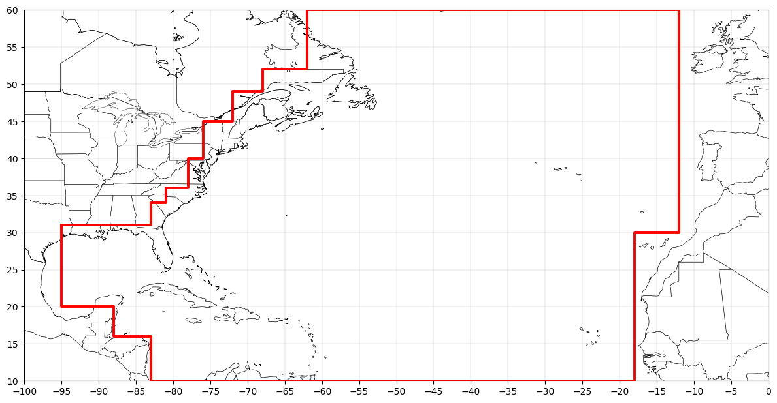
Figure B1: Geographical bounds for ET initiation and ET completion in Subset C.
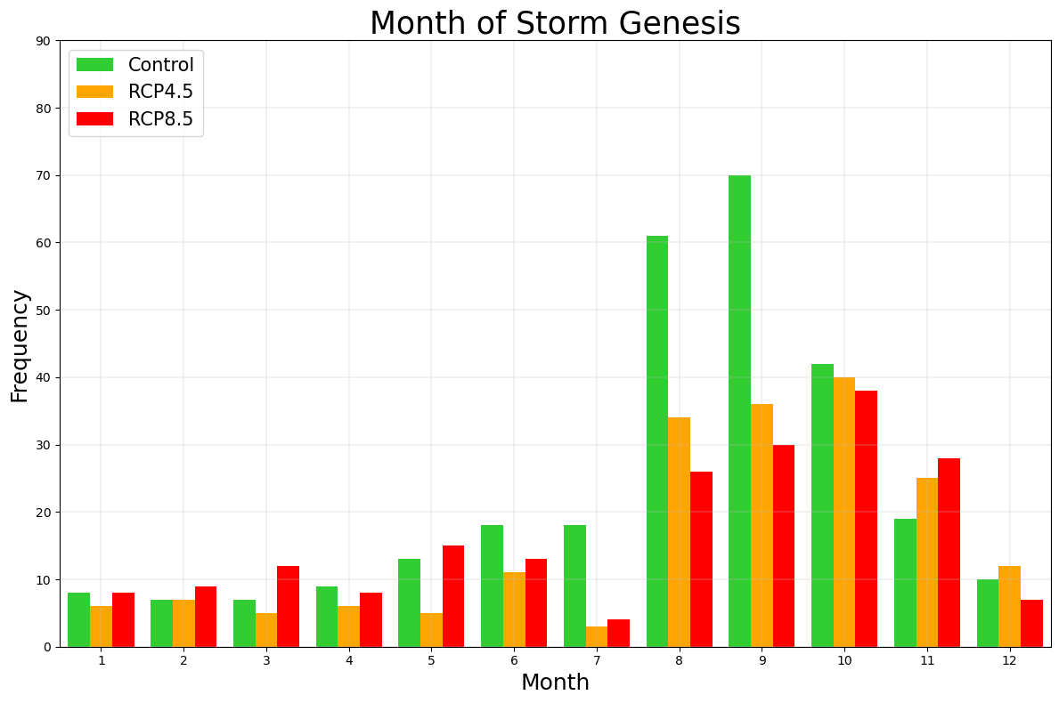
Figure B2: Monthly frequencies of genesis of storms with a complete extratropical transition (Subset B). Green bars represent the frequency in the control ensemble, orange bars represent RCP4.5, and red bars represent RCP8.5.
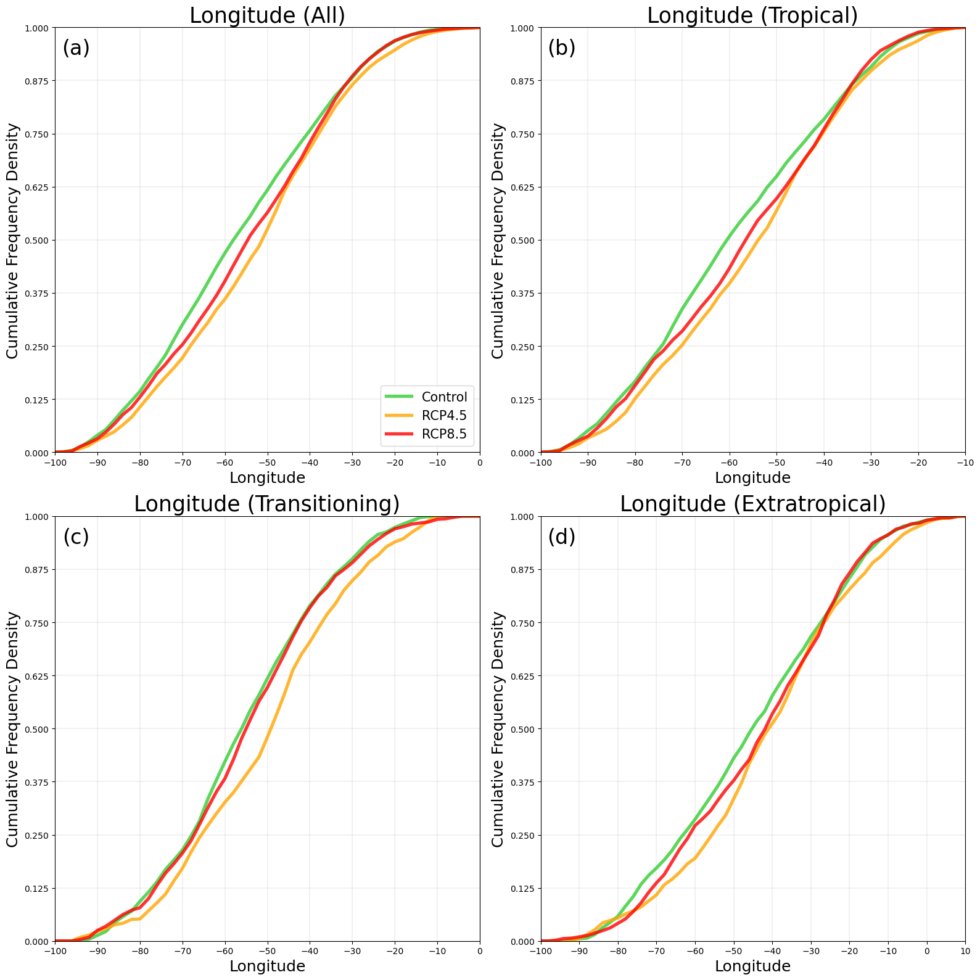
Figure B3: Cumulative frequency density plot of longitude at each six-hourly datapoint, for (a) any, (b) tropical, (c) transitioning, and (d) extratropical phase. Only datapoints with sea level pressure ≤ 1008hPa within Subset B (storms with a complete ET) are considered.
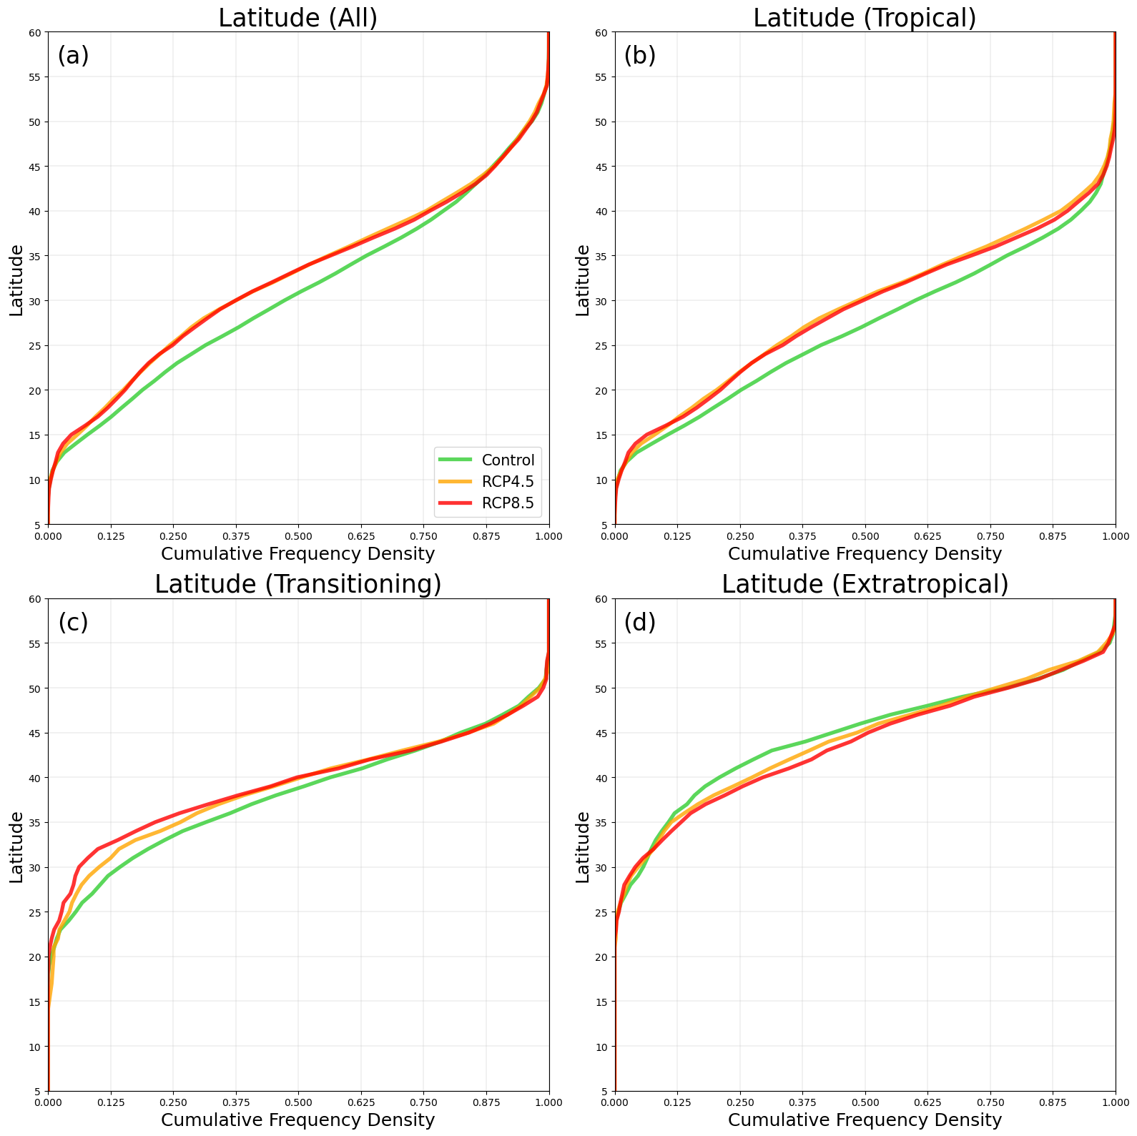
Figure B4: Same as Figure B3, but for latitude at each six-hourly datapoint.
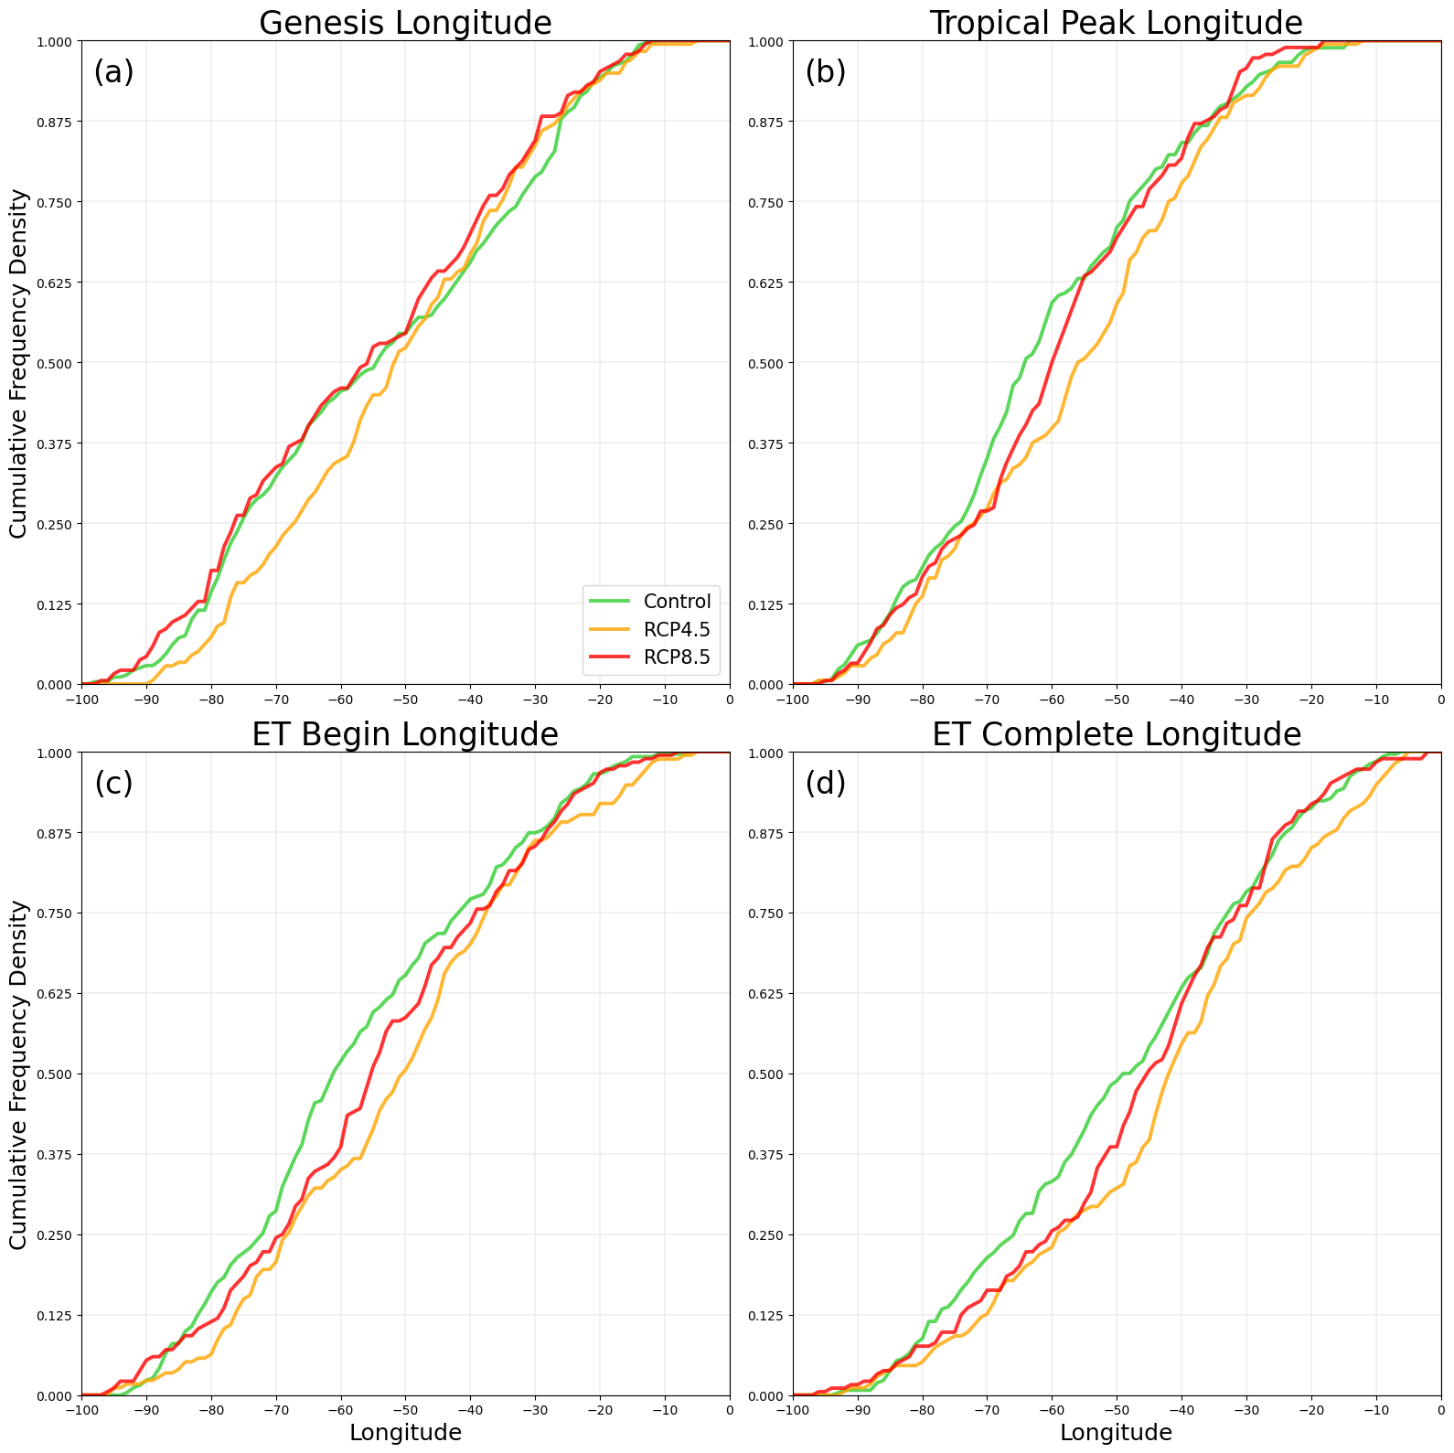
Figure B5: Cumulative frequency density plot of longitude at (a) genesis, (b) tropical peak, (c) ET initiation, and (d) ET completion. Only datapoints within Subset B (storms with a complete ET) are considered.
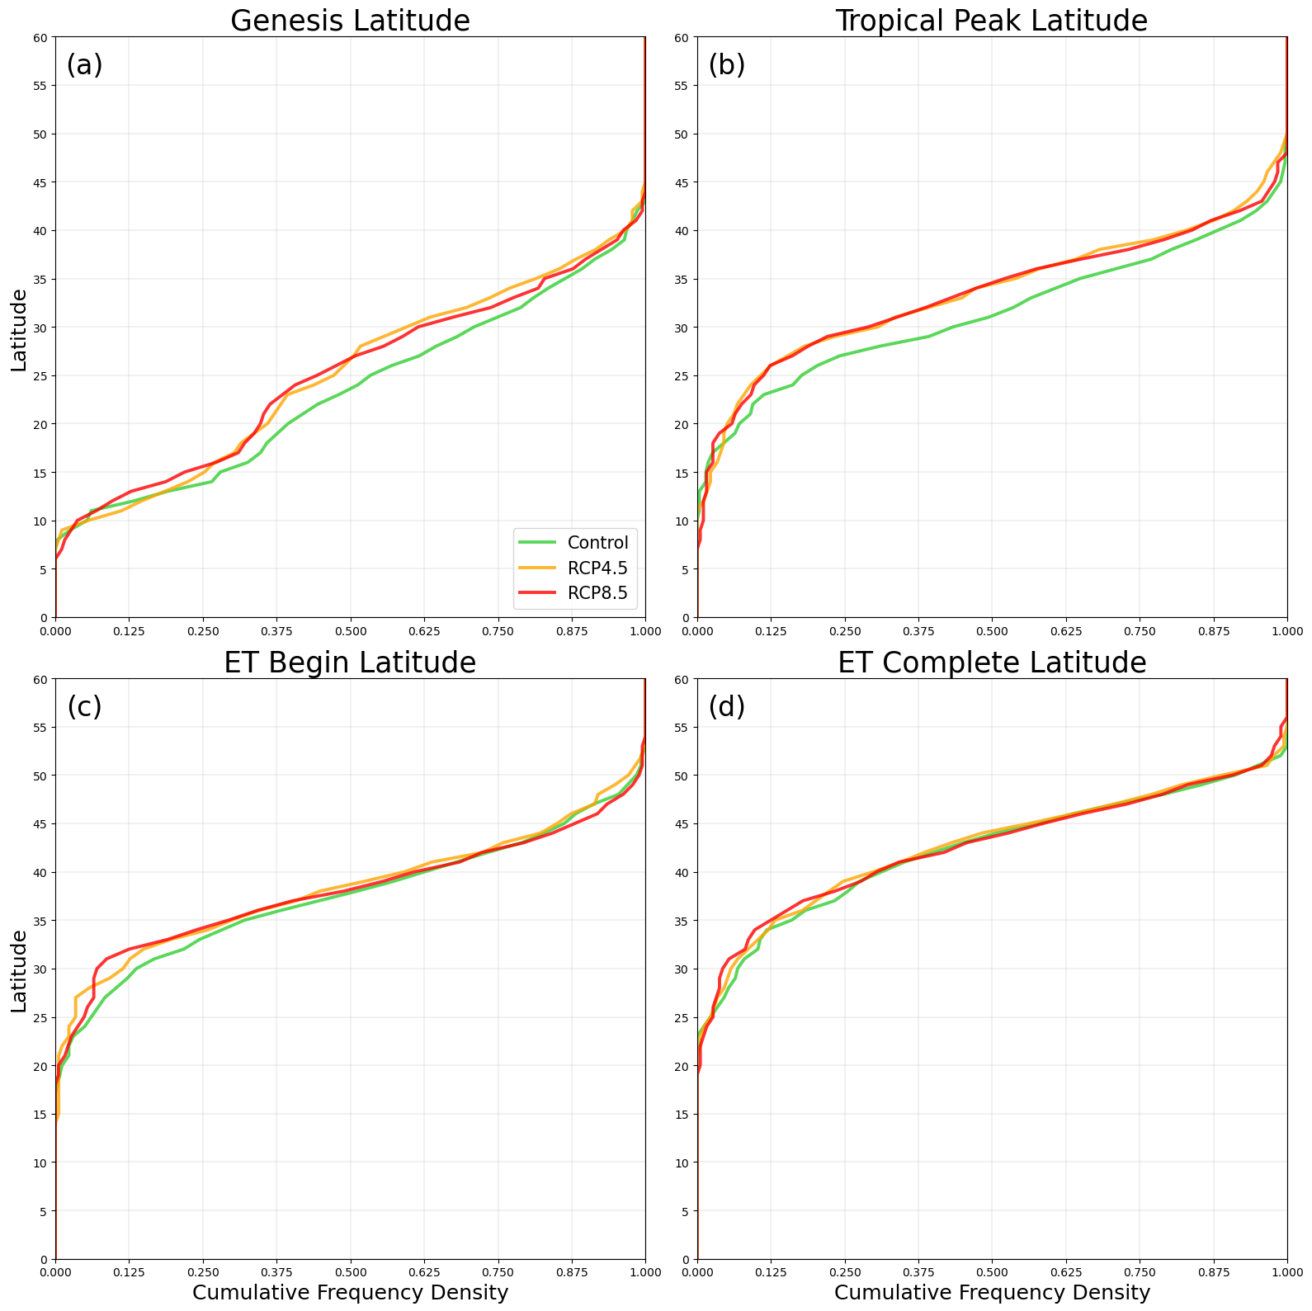
Figure B6: Same as Figure B5, but for latitude at (a) genesis, (b) tropical peak, (c) ET initiation, and (d) ET completion.
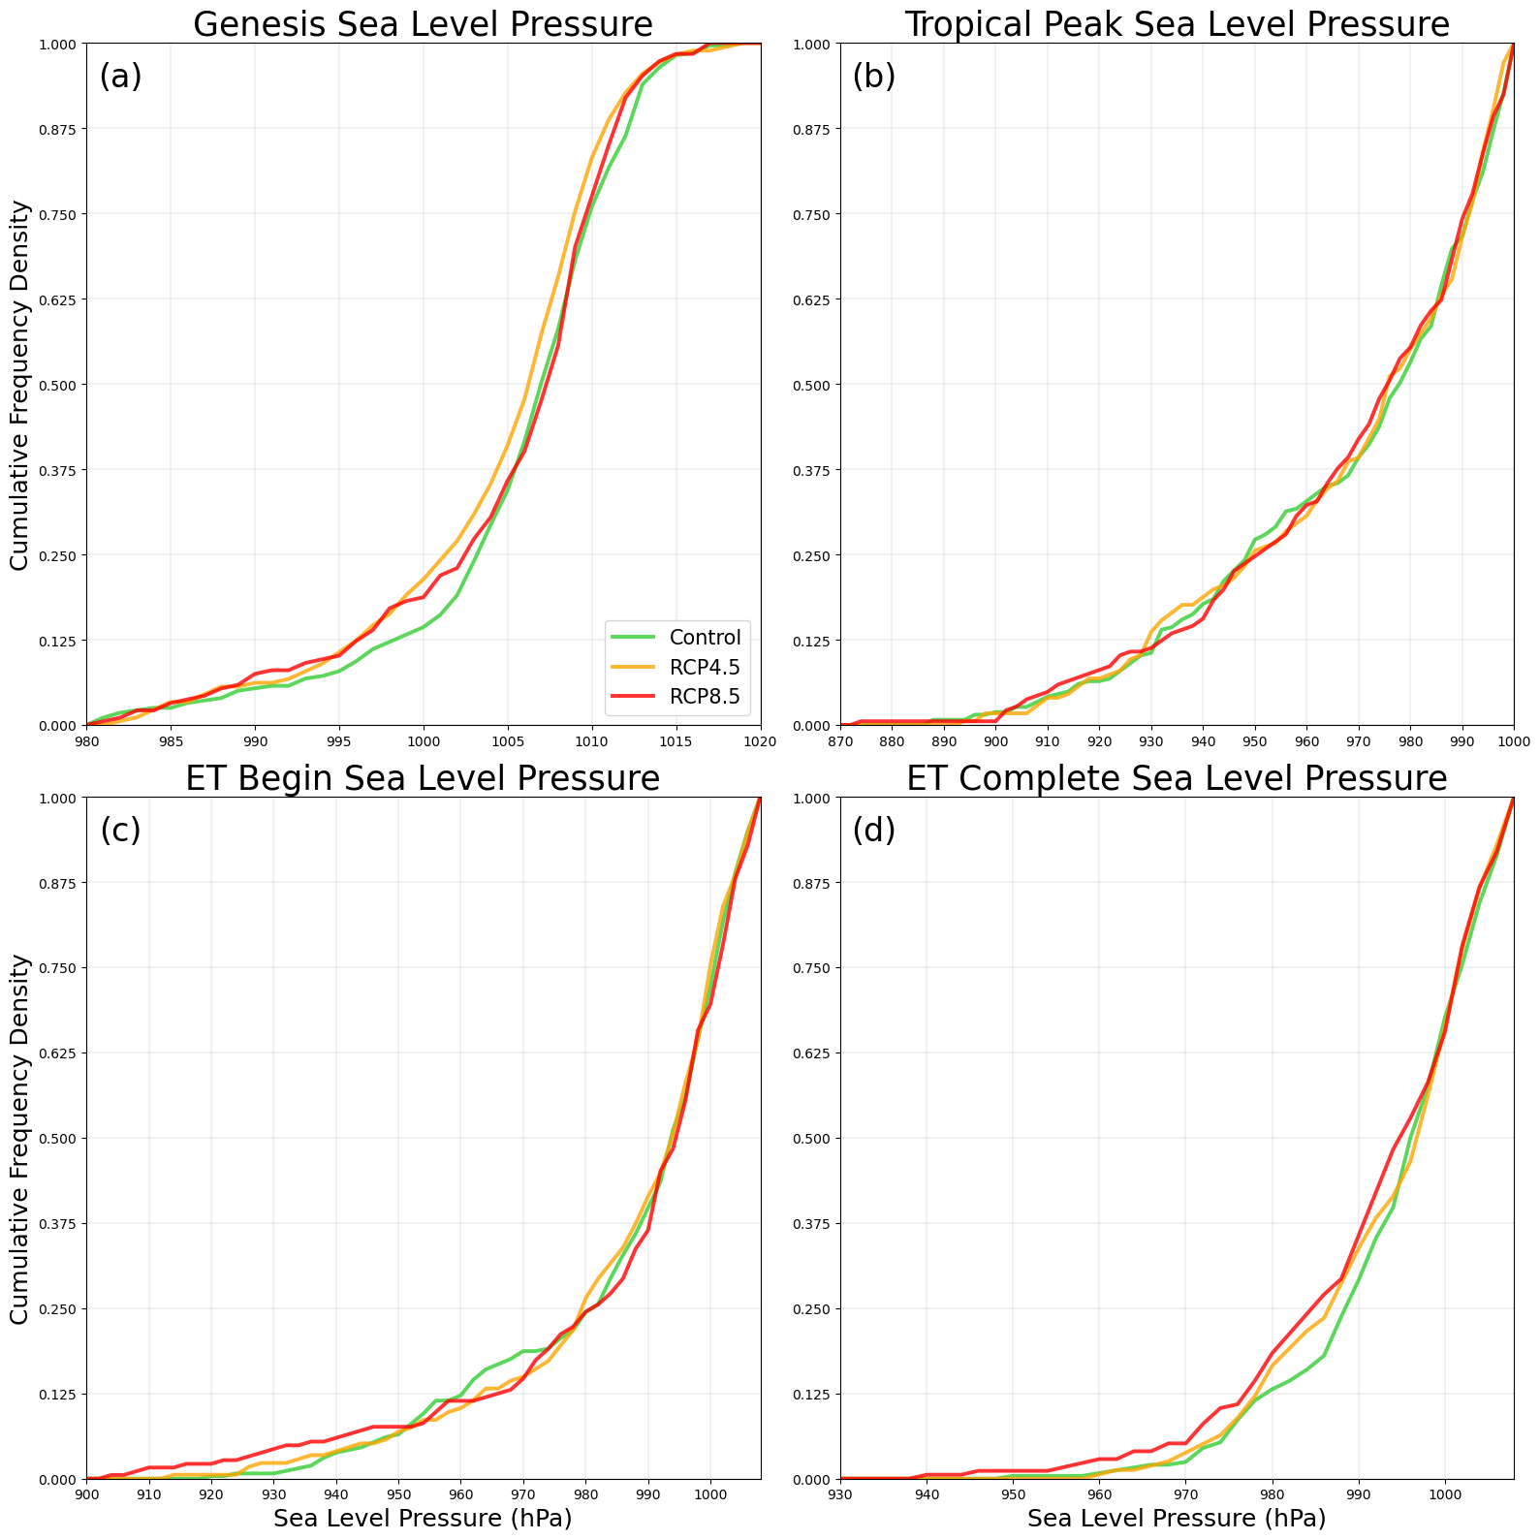
Figure B7: Same as Figure B6, but for sea level pressure at (a) genesis, (b) tropical peak, (c) ET initiation, and (d) ET completion.

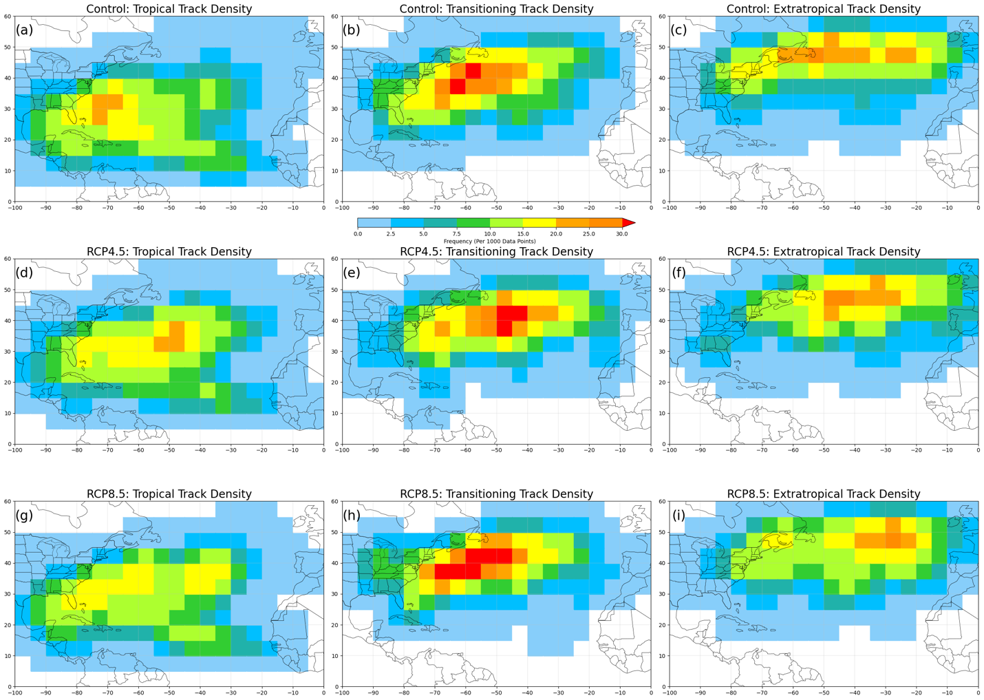
Figure B8: (a-c) Track density of datapoints of (a) tropical, (b) transitioning, (c) extratropical phase in the control ensemble. (d-f) Same as a-c, but for RCP4.5 ensemble. (g-i) Same as a-c, but for RCP8.5 ensemble.
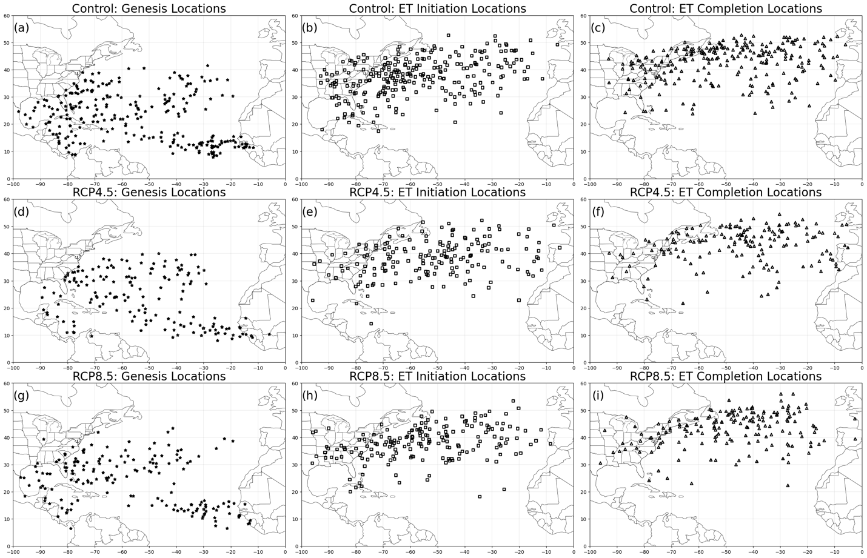
Figure B9: Map of (a) genesis locations, (b) extratropical transition initiation locations, and (c) extratropical transition completion locations of storms in the control ensemble within Subset B. (d-f) Same as a-c, but for storms in the RCP4.5 run. (g-i) Same as a-c, but for storms in the RCP8.5 run.
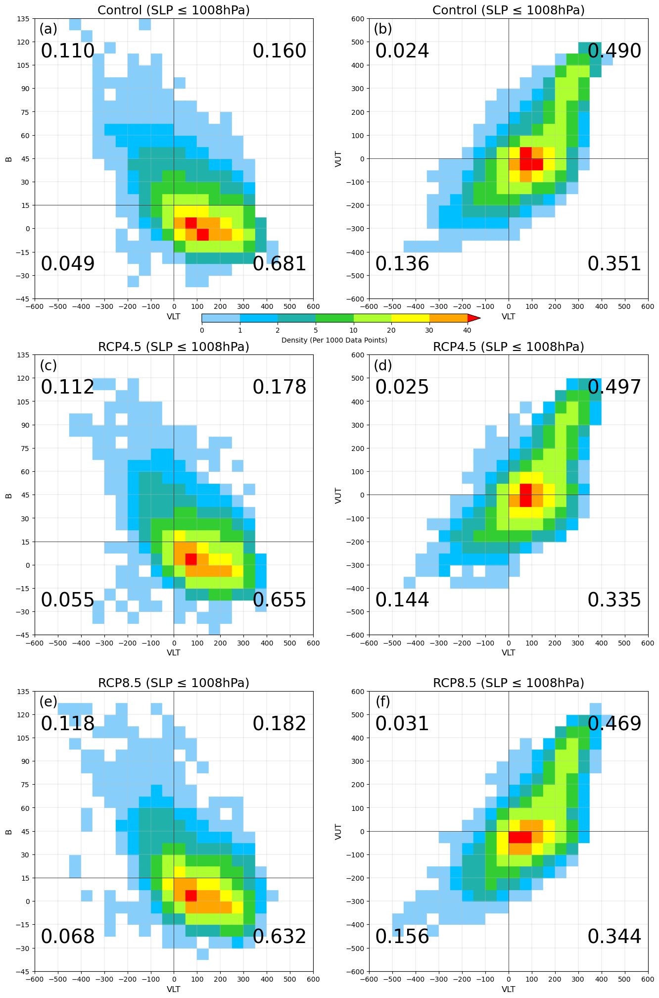
Figure B10: (a-b) Distribution of datapoints with sea level pressure ≤ 1008hPa on the cyclone phase space diagram in the control. (c-d) Same as a-b, but for RCP4.5 ensemble. (e-f) Same as c-d, but for RCP8.5 ensemble.
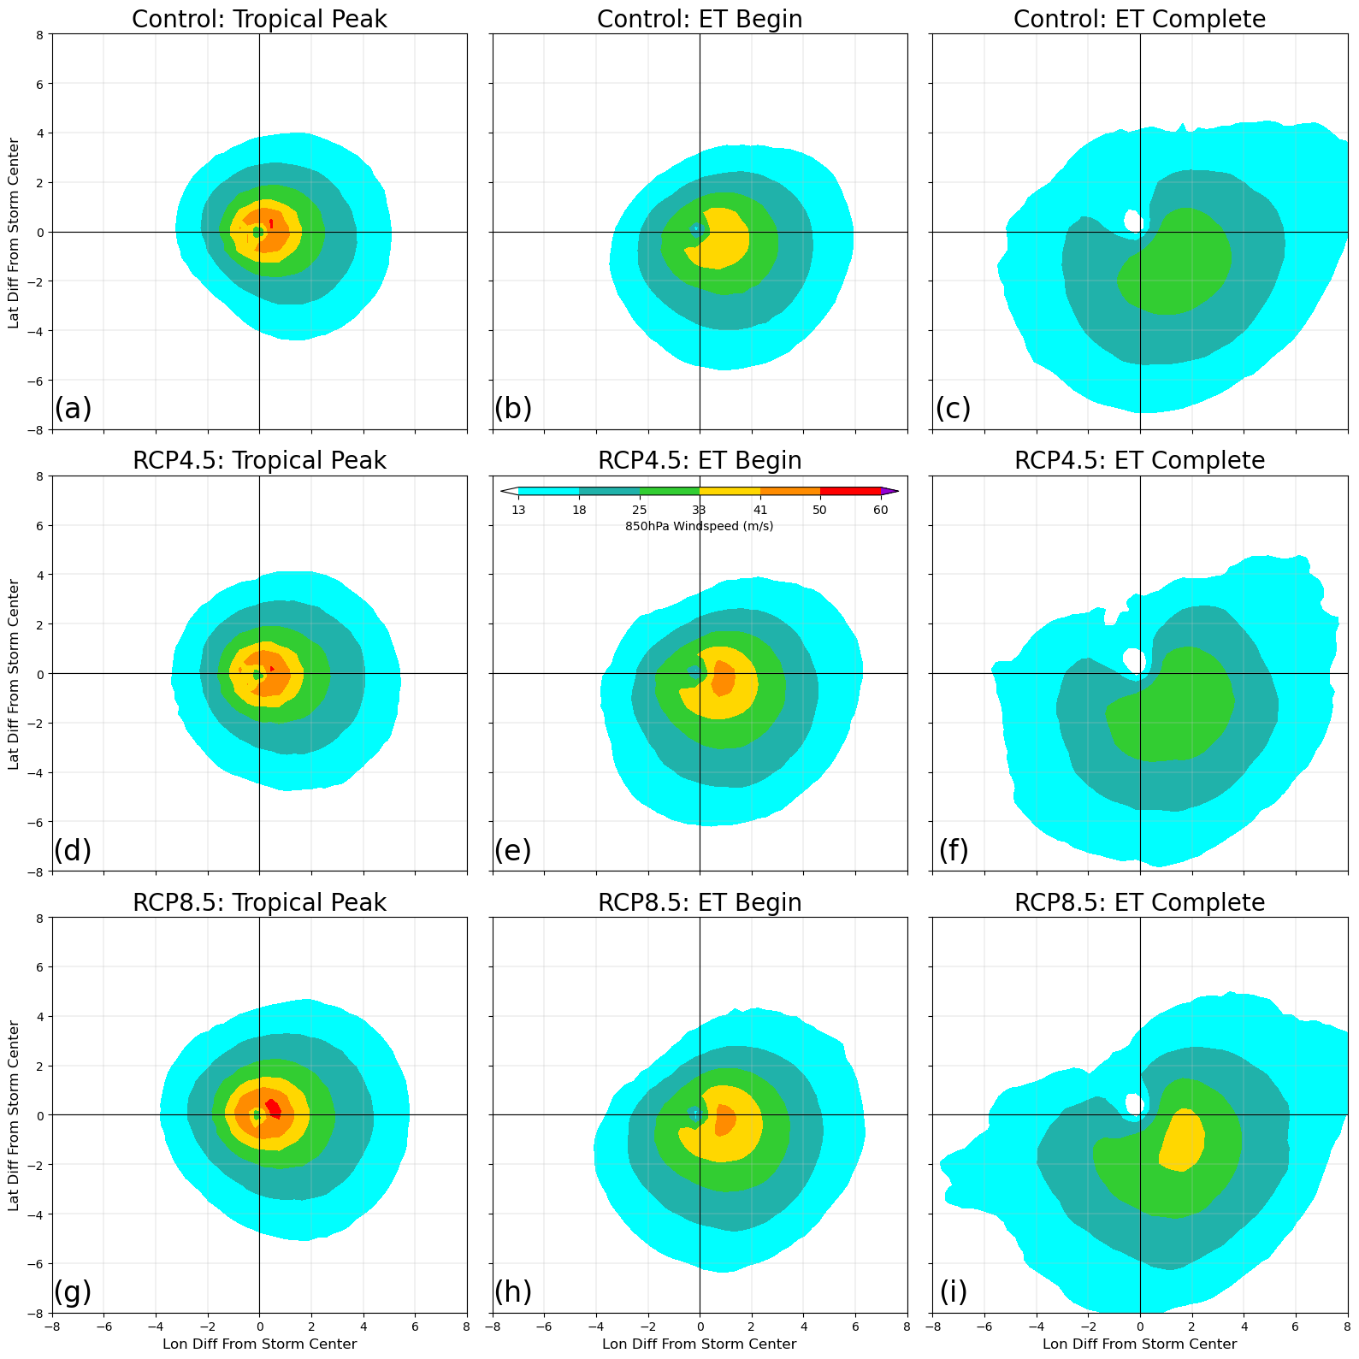
Figure B11: (a-c) Composites of 850hPa windspeed ($m/s$) for the control ensemble, at (a) tropical peak, (b) ET initiation, and (c) ET completion points. (d-f) Same as a-c, but for RCP4.5 ensemble. (g-i) Same as a-c, but for RCP8.5 ensemble.
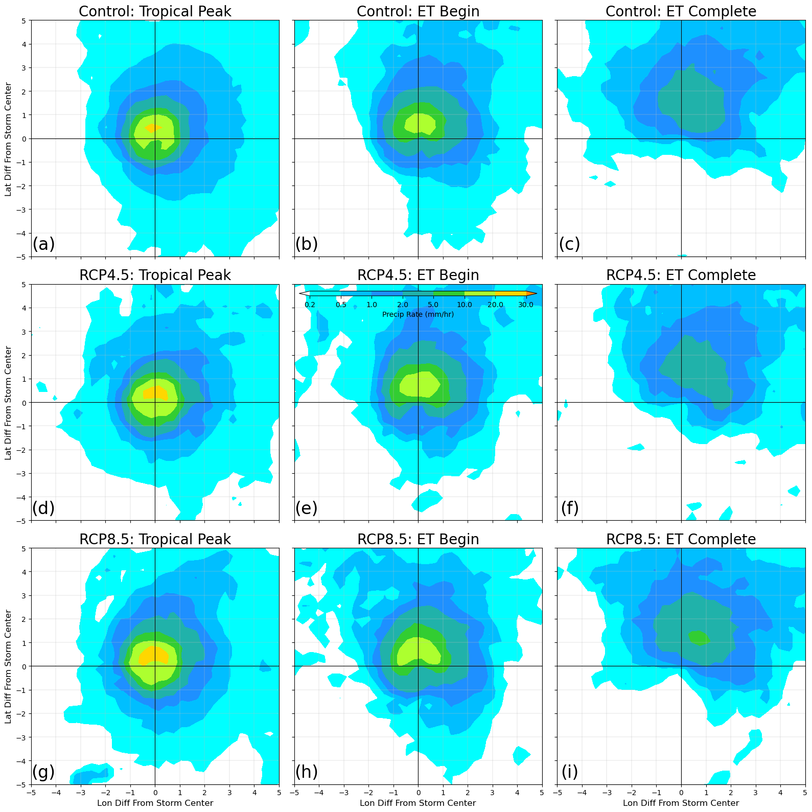
Figure B12: (a-c) Composites of precipitation rate ($mm/hr$) for the control ensemble, at (a) tropical peak, (b) ET initiation, and (c) ET completion points. (d-f) Same as a-c, but for RCP4.5 ensemble. (g-i) Same as a-c, but for RCP8.5 ensemble.
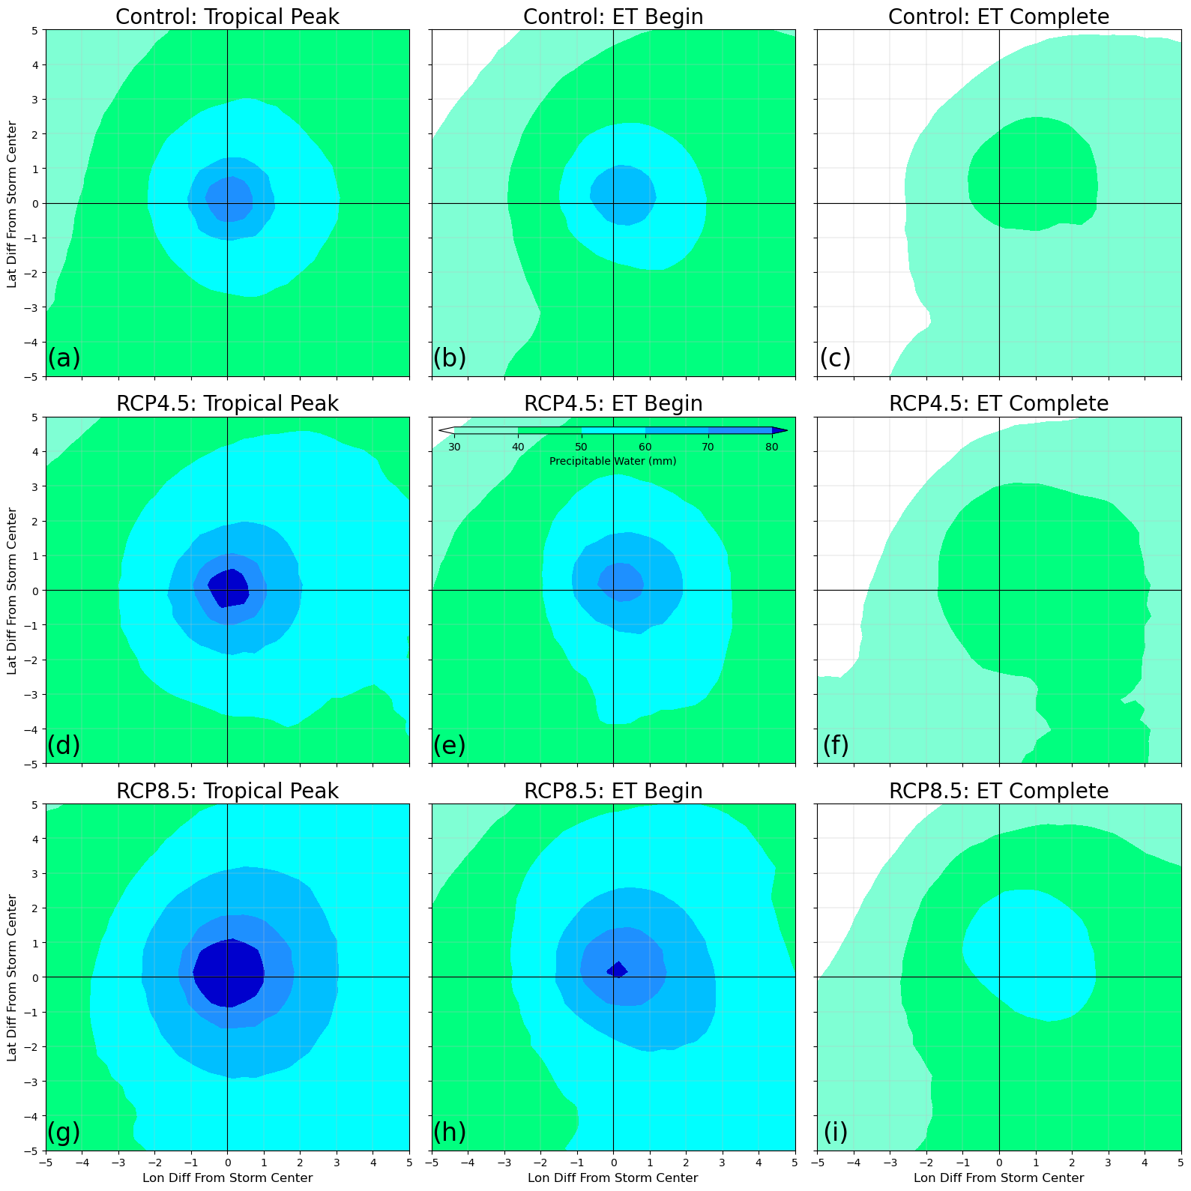
Figure B13: (a-c) Composites of precipitable water ($mm/hr$) for the control ensemble, at (a) tropical peak, (b) ET initiation, and (c) ET completion points. (d-f) Same as a-c, but for RCP4.5 ensemble. (g-i) Same as a-c, but for RCP8.5 ensemble.
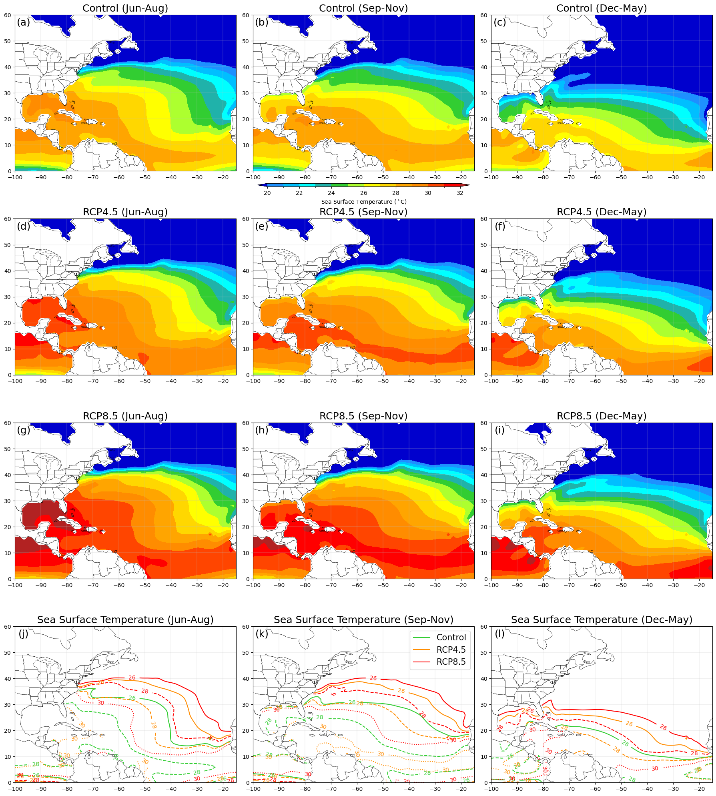
Figure B14: (a-c) Shaded contours of sea surface temperature ($℃$) for the control ensemble, averaged across the months of (a) June to August, (b) September to November, and (c) December to May. (d-f) Same as a-c, but for RCP4.5 ensemble. (g-i) Same as d-f, but for RCP8.5 ensemble. (j-l) Contour lines of $26℃$ (solid), $28℃$ (dashed), and $30℃$ (dotted) sea surface temperatures for each simulation, averaged across the months of (j) June to August, (k) September to November, and (l) December to May.
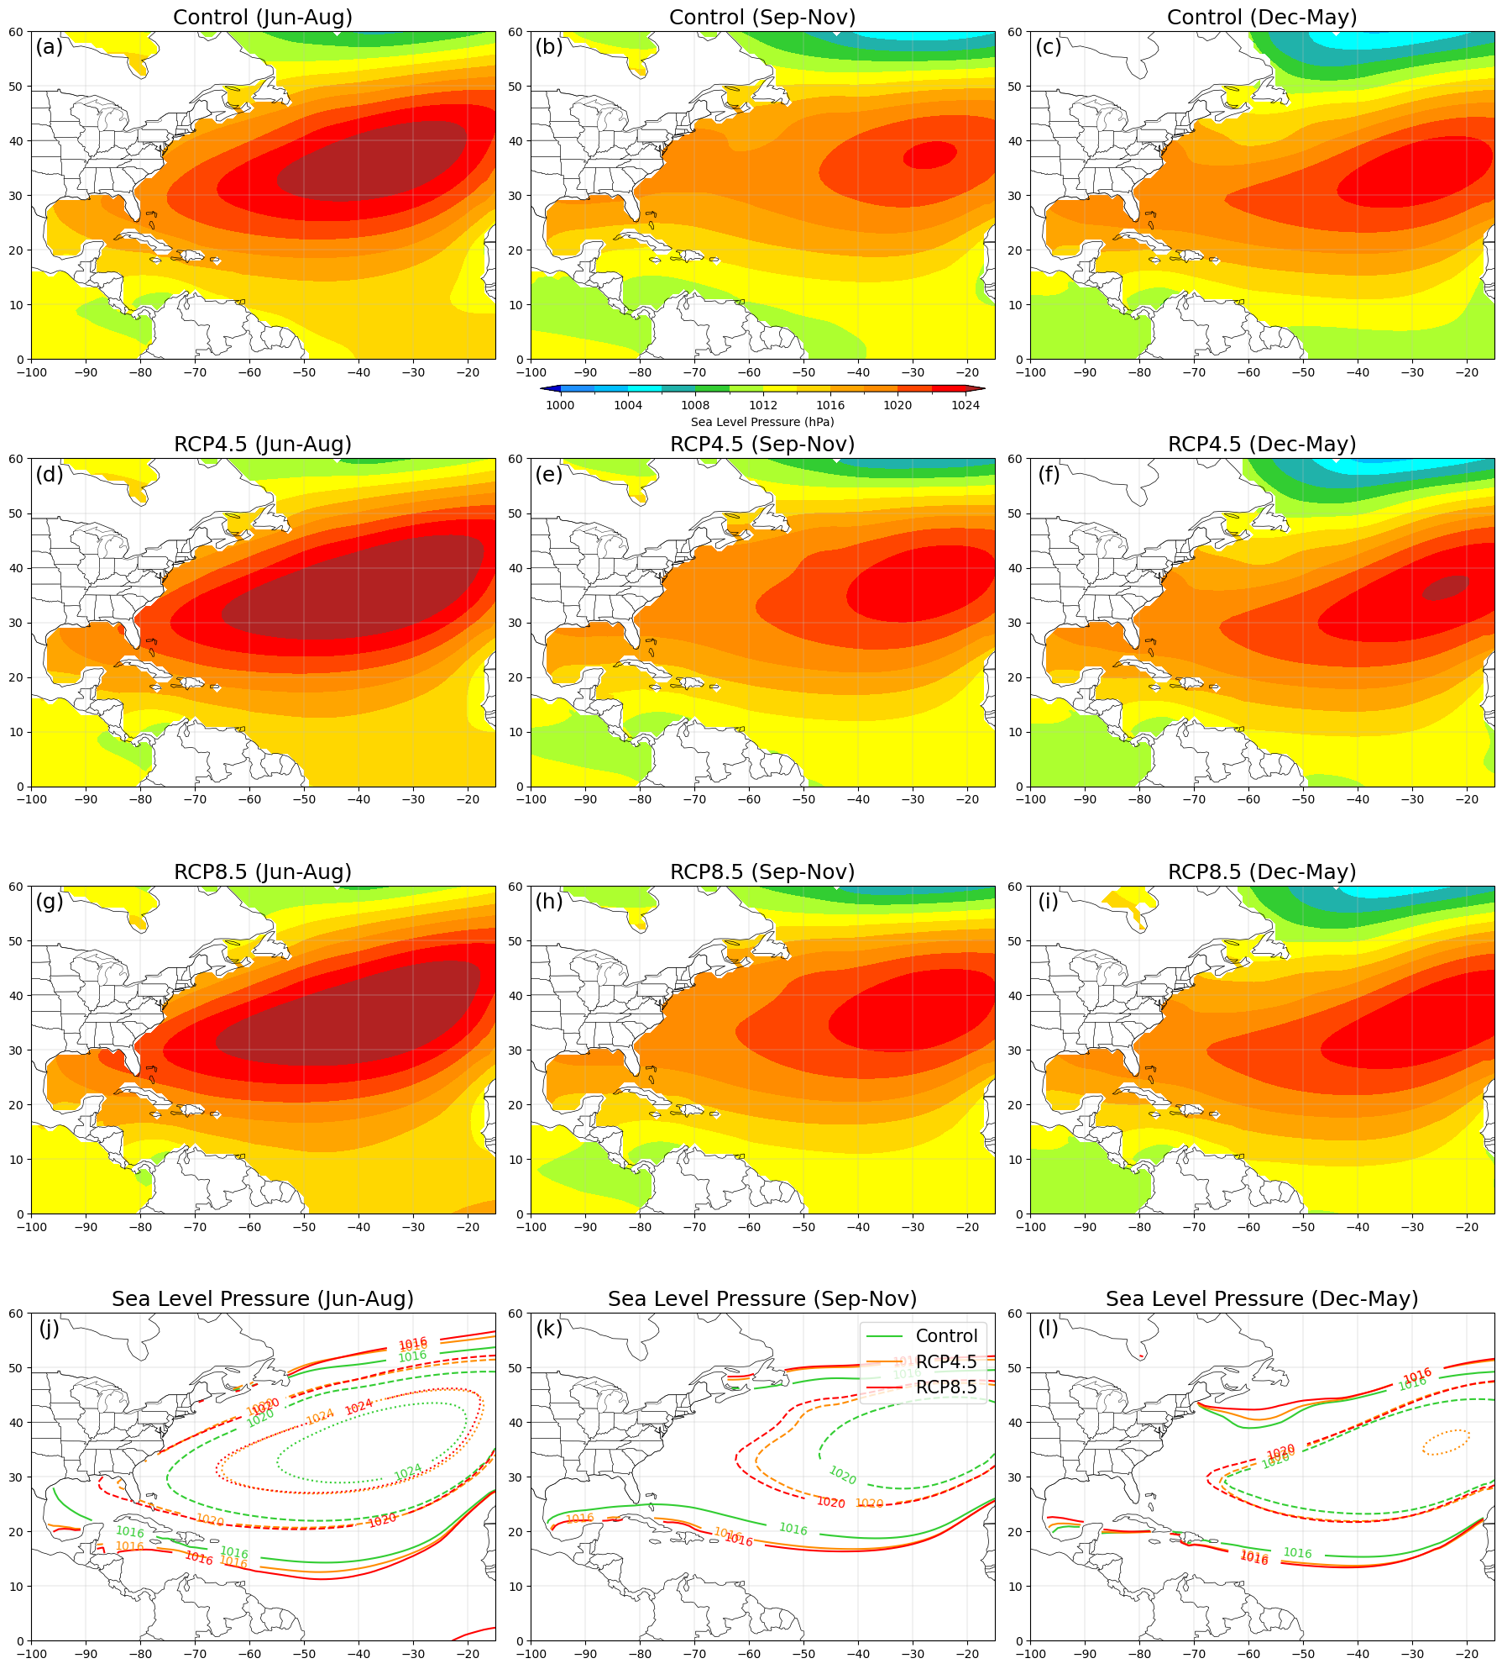
Figure B15: (a-c) Shaded contours of sea level pressure ($hPa$) for the control ensemble, averaged across the months of (a) June to August, (b) September to November, and (c) December to May. (d-f) Same as a-c, but for RCP4.5 ensemble (g-i) Same as d-f, but for RCP8.5 ensemble. (j-l) Contour lines of $1016hPa$ (solid), $1020hPa$ (dashed), and $1024hPa$ (dotted) sea level pressures for each simulation, averaged across the months of (j) June to August, (k) September to November, and (l) December to May.
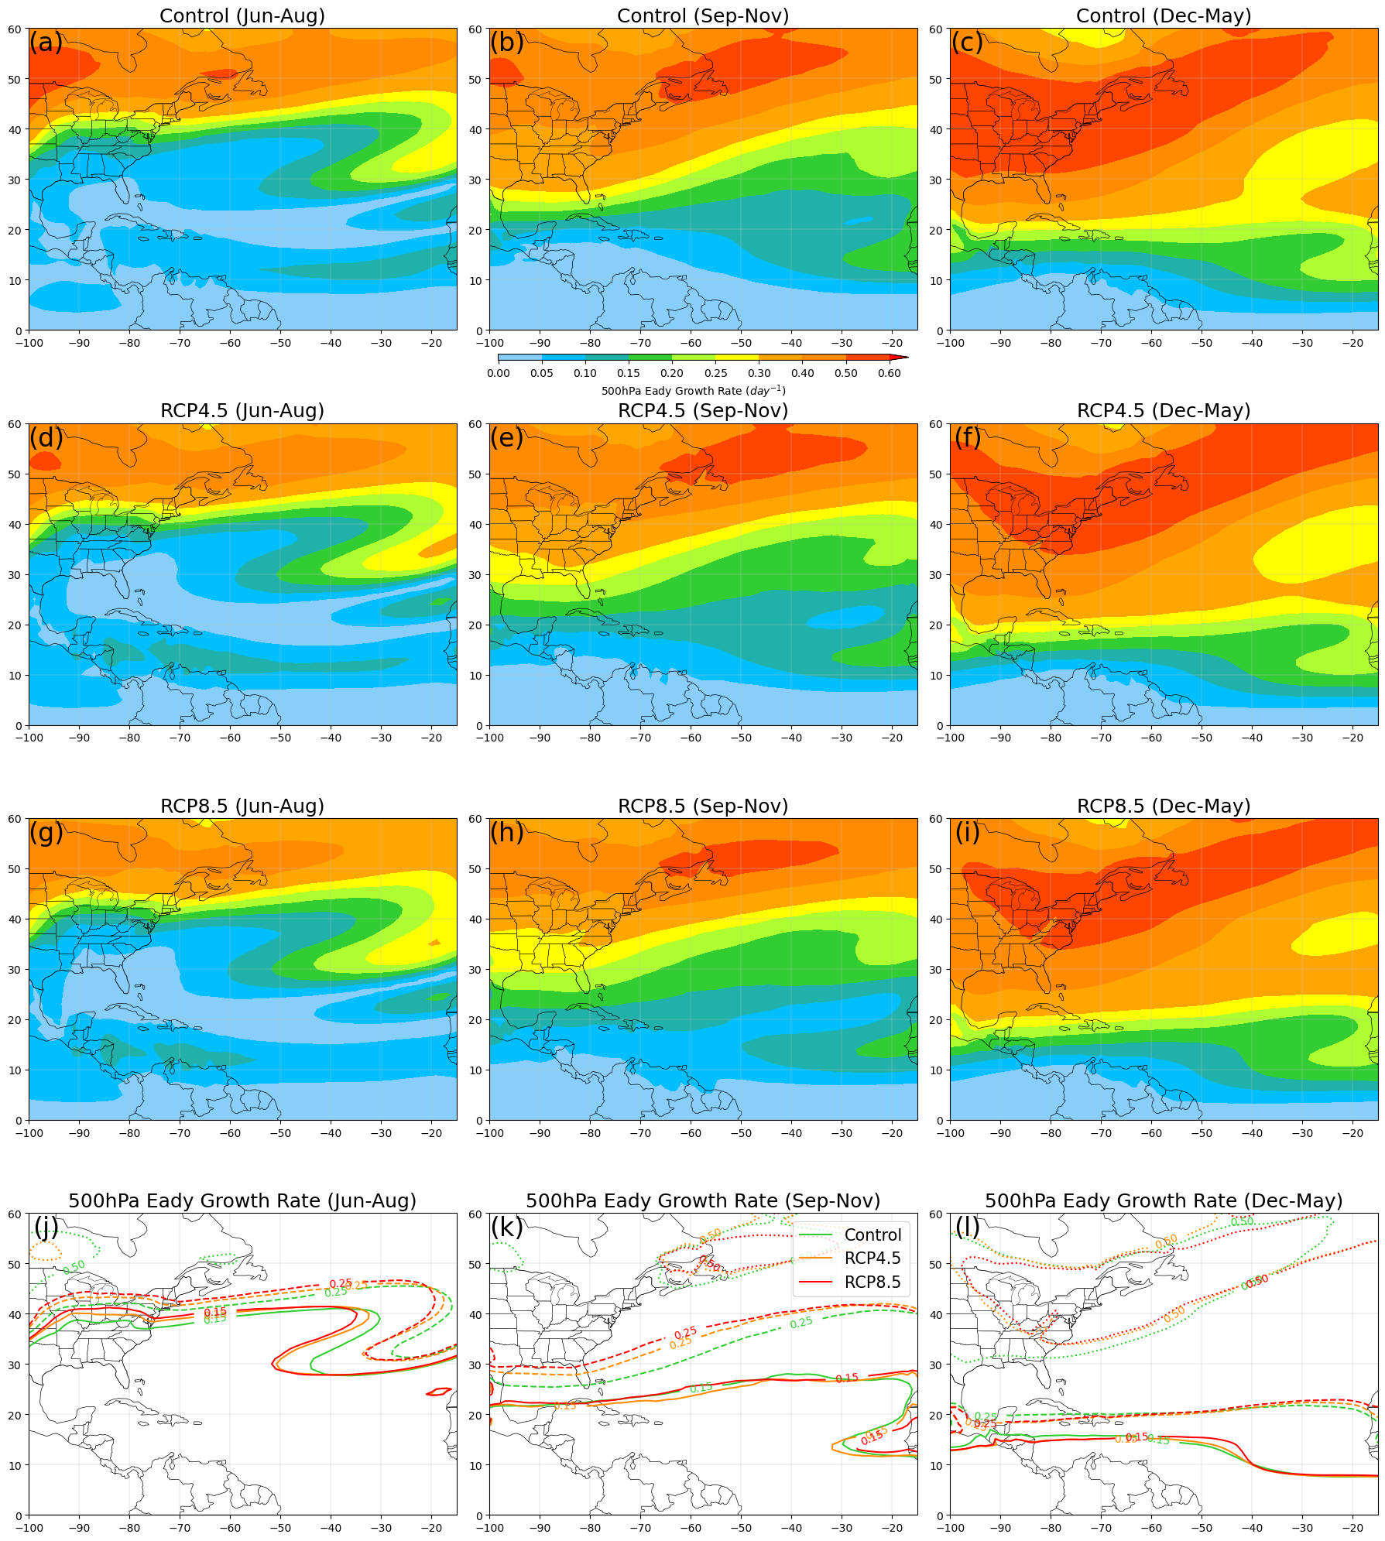
Figure B16: (a-c) Shaded contours of 500hPa Eady Growth Rate (${day}^{-1}$) for the control ensemble, averaged across the months of (a) June to August, (b) September to November, and (c) December to May. (d-f) Same as a-c, but for RCP4.5 ensemble (g-i) Same as d-f, but for RCP8.5 ensemble. (j-l) Contour lines of $0.15{day}^{-1}$ (solid), $0.25{day}^{-1}$ (dashed), and $0.50{day}^{-1}$ (dotted) Eady Growth Rates for each simulation, averaged across the months of (j) June to August, (k) September to November, and (l) December to May.

