Residency time and other risk factors for large bovine tuberculosis breakdowns in Irish cattle herds: Supplementary results part 1
Miriam Casey-Bryars ¹, Jamie A. Tratalos ², Andrew Byrne ³, Simon More ², Damien Barrett ³, Jamie M. Madden *² and Andrew Conlan *⁴
- School of Veterinary Medicine, University College Dublin, Belfield, Dublin 4, Ireland
- Centre for Veterinary Epidemiology and Risk Analysis, School of Veterinary Medicine, University College Dublin, Belfield, Dublin 4, Dublin Ireland.
- ﻿ Department of Agriculture, Food and the Marine, Kildare Street, Dublin, Ireland.
- Disease Dynamics Unit, Department of Veterinary Medicine, University of Cambridge, Cambridge, UK.
* These authors contributed equally.
Correspondence to: Miriam Casey-Bryars; miriam.casey@ucd.ie, School of Veterinary Medicine, University College Dublin, Belfield, Dublin D04 W6F6, Ireland

Descriptive summary figures

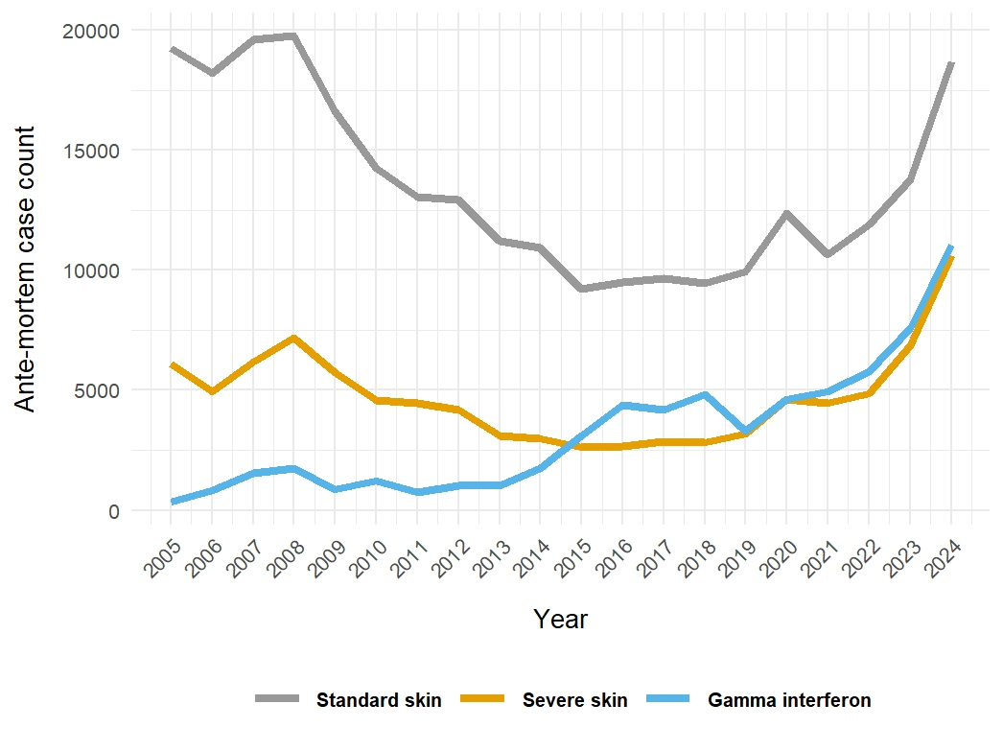
Supplementary Figure 1.1: Count of ante-mortem bTB cases detected by standard interpretation skin testing, severe interpretation skin testing skin testing and gamma interferon testing, by year, between 2005 and 2024.Madden. 2025 describes slaughterhouse cases over time and also provide extra detail on ante-mortem case counts.

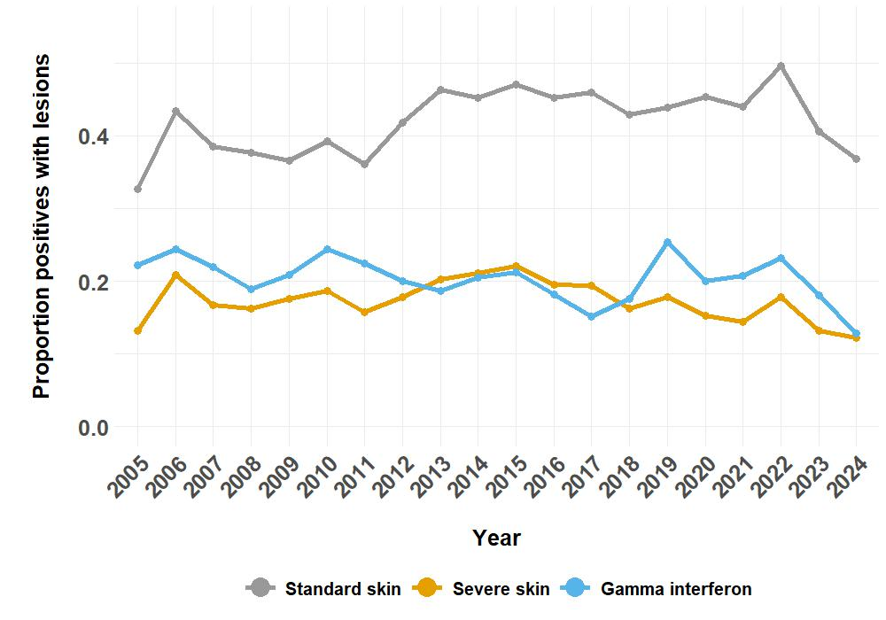
Supplementary Figure 1.2: Proportion of ante-mortem test reactors with lesions detected at slaughter in standard interpretation skin, severe interpretation skin and gamma interferon cases, by year, between 2005 and 2024.

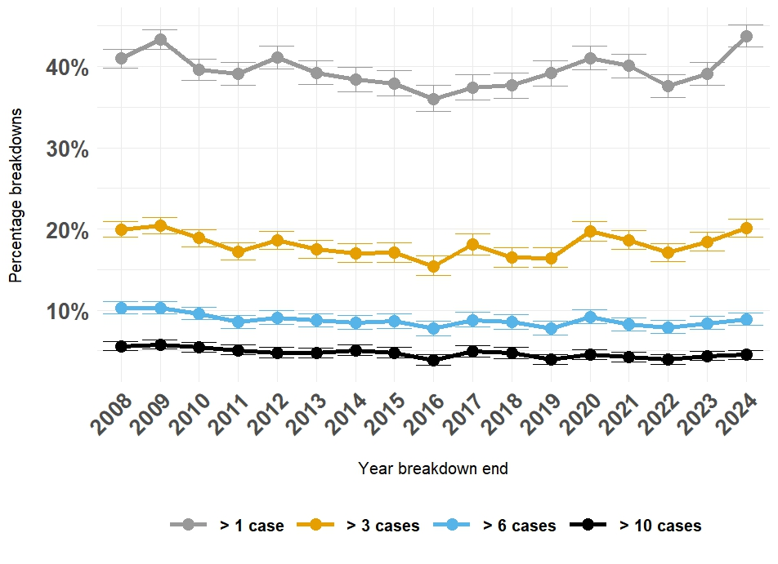
Supplementary figure 1.3: Proportions of breakdowns with count of standard skin or slaughterhouse cases greater than 1, 3, 6 and 10, by year, between 2008 and 2024.

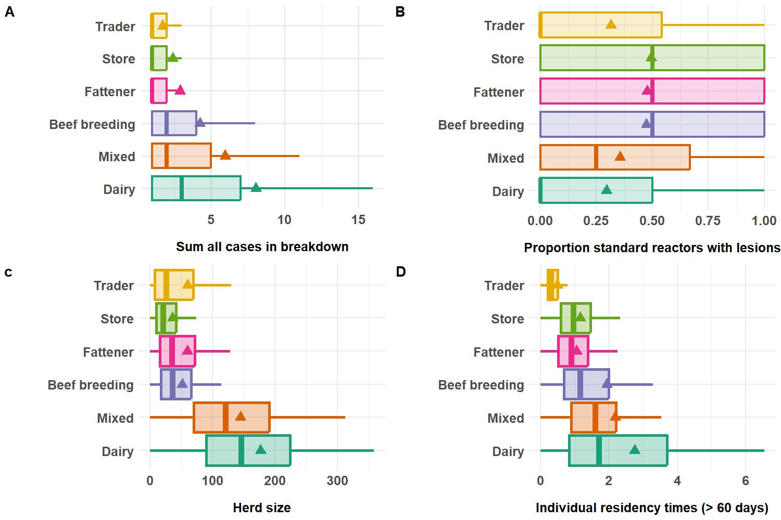
Figure 1.4: A summary of case count (A), proportion standard skin reactors with lesions (B), herd size (C) and individual residency times > 60 days, ending between 2008 and 2023 (D) in each herd management type. Triangles represent the mean and boxplots represent median and interquartile range. Plots A and B are based on the study population for the regression models (Full population A : total cases). Plots C and D are based on all available data for the same time window for the different management types (that is all herds, not only herds with bovine tuberculosis breakdowns).

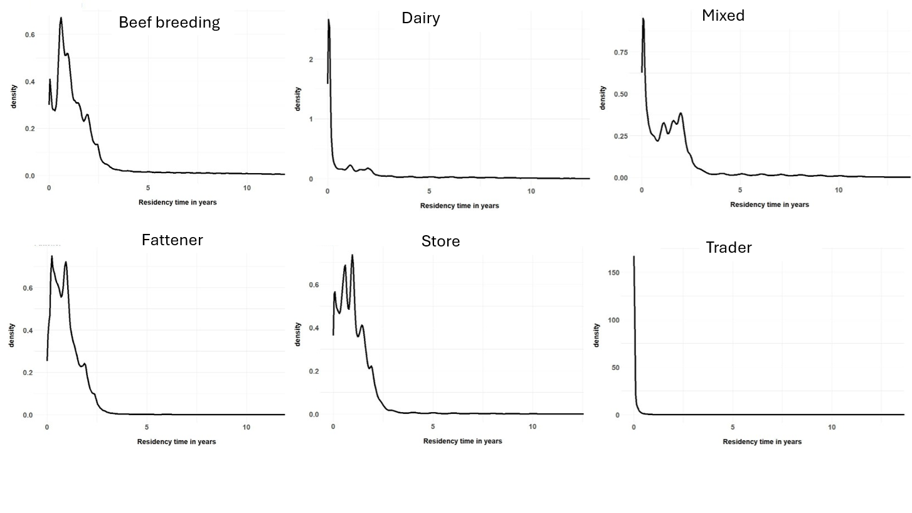
Supplementary figure 1.5: All residency time distributions in years, stratified by herd management type. These plots based on all available (that is all herds, not only herds with bovine tuberculosis breakdowns) for residency times ending between 2008 and 2023.
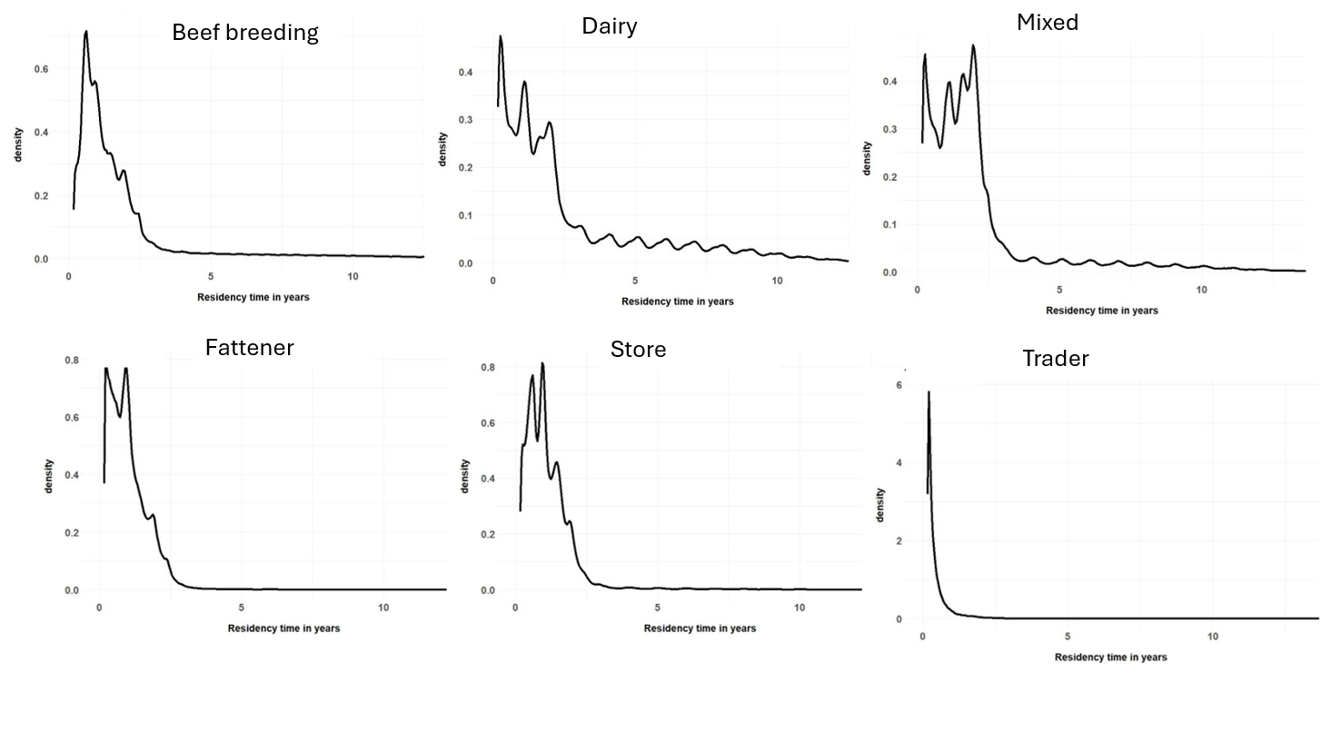
Supplementary figure 1.6: Residency times greater than 60 days, in years, stratified by herd management type. These plots based on all available (that is all herds, not only herds with bovine tuberculosis breakdowns) for residency times ending between 2008 and 2023.

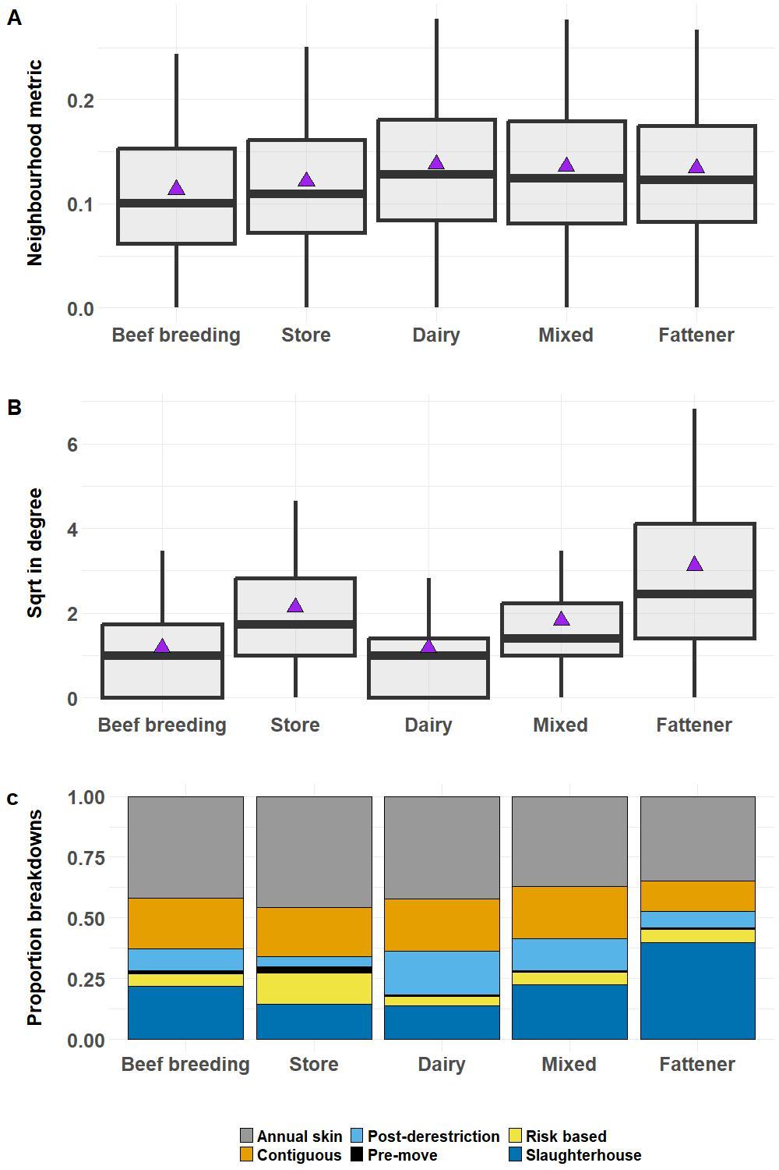
Supplementary Figure 1.7: Boxplots summarising A) neighbourhood burden metric (proportion of herds within 6km of herd centroids which had breakdown status in the previous three years) and B) square root of in degree, stratified by herd management. Traders are excluded to allow visualisation of differences in in degree between the other herd types. Panel C shows the proportion of breakdowns in each management type initiated by different test types. Triangles represent the mean and boxplots represent median and interquartile range.

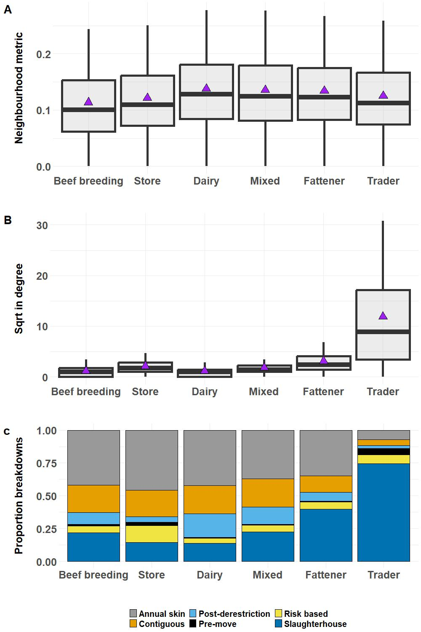
Supplementary Figure 1.8: This is the same as Supplementary figure 6 but with trader herds included. Boxplots summarising A) neighbourhood burden metric (proportion of herds within 6km of herd centroids which had breakdown status in the previous three years) and B) square root of in degree, stratified by herd management. Panel C shows the proportion of breakdowns in each management type initiated by different test types. Triangles represent the mean and boxplots represent median and interquartile range.

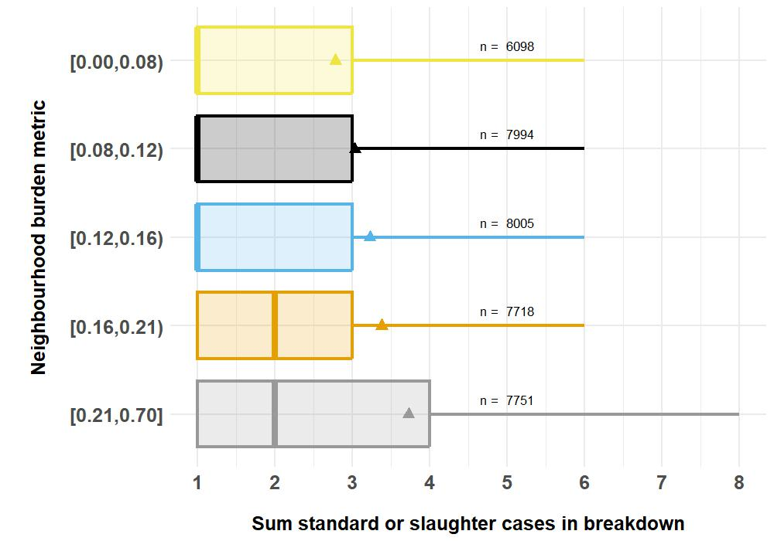
Supplementary Figure 1.9: Case count stratified by neighbourhood burden categories. Triangles represent the mean and boxplots represent median and interquartile range.

.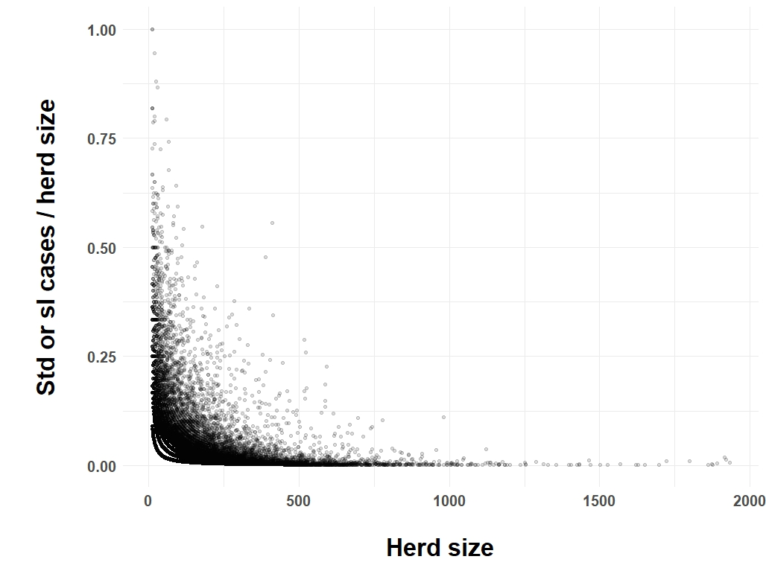
Supplementary Figure 1.10: Proportion of standard skin or slaughterhouse cases with herd size.

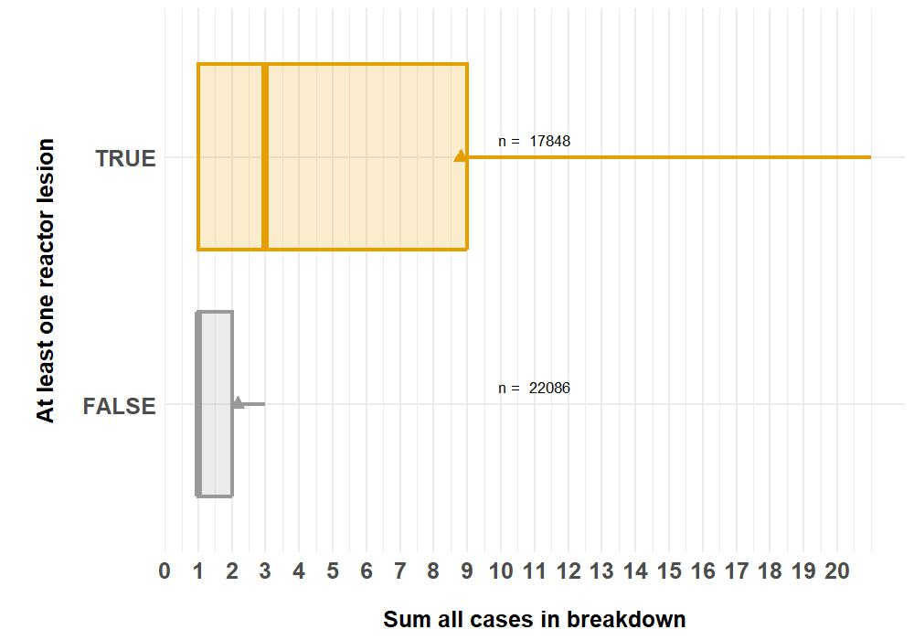
Supplementary Figure 1.11: Count of all cases in breakdowns with at least one lesioned reactor compared to no lesioned reactors. Breakdowns with at least one ante-mortem reactor were included.

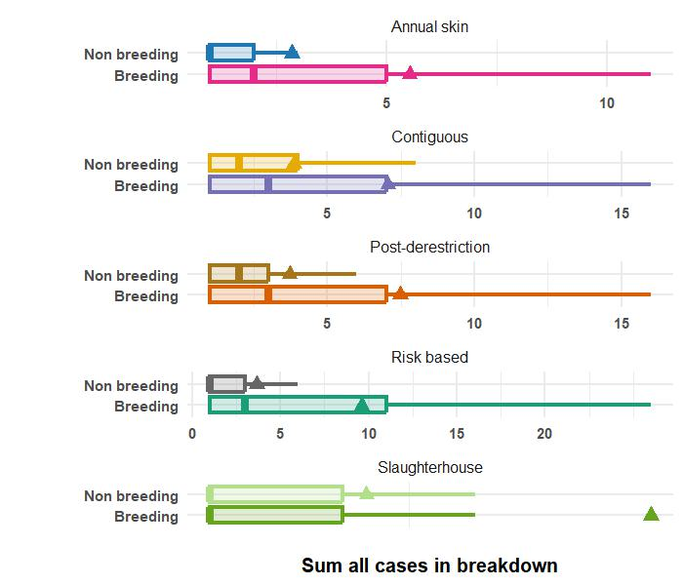
Supplementary Figure 1.12: Case count stratified by initiating test type and breeding herd (Beef breeding, Mixed or Dairy) or not.

