Residency time and other risk factors for large bovine tuberculosis breakdowns in Irish cattle herds : Supplementary Methods
Miriam Casey-Bryars ¹, Jamie A. Tratalos ², Andrew Byrne ³, Simon More ², Damien Barrett ³, Jamie M. Madden *² and Andrew Conlan *⁴
- School of Veterinary Medicine, University College Dublin, Belfield, Dublin 4, Ireland
- Centre for Veterinary Epidemiology and Risk Analysis, School of Veterinary Medicine, University College Dublin, Belfield, Dublin 4, Dublin Ireland.
- ﻿ Department of Agriculture, Food and the Marine, Kildare Street, Dublin, Ireland.
- Disease Dynamics Unit, Department of Veterinary Medicine, University of Cambridge, Cambridge, UK.
* These authors contributed equally.
Correspondence to: Miriam Casey-Bryars; miriam.casey@ucd.ie, School of Veterinary Medicine, University College Dublin, Belfield, Dublin D04 W6F6, Ireland

Contents
Data generation and processing 3
The Irish bovine tuberculosis surveillance system 3
Data 6
Data processing 7
References for supplementary methods 10

Data generation and processing

The Irish bovine tuberculosis surveillance system

Skin testing
Bovine tuberculosis cases are diagnosed in Irish cattle using the comparative intradermal tuberculin test (CITT, skin test hereafter) . Herds must undergo annual skin testing of every bovine aged older than 42 days (1). Two interpretations of the skin test are used in Ireland (2). An animal is defined as positive under the standard interpretation if the bovine reaction exceeds the avian reaction by more than 4 mm or if there are clinical signs of bTB. An animal is positive under the severe interpretation if the bovine reaction is either positive (≥ 4 mm) or inconclusive (> 2 mm) and exceeds the avian reaction. Standard interpretation is routinely used in herds with a bTB-free history. Severe interpretation may be used in herds at higher risk of bTB. Under the testing protocol used in Ireland, testing veterinarians are advised to change to the severe interpretation when one animal in a herd is positive to the standard interpretation in a previously clear herd. Prior to June 2020, the threshold for switching to severe skin test interpretation was two positive bTB cases. Severe interpretation is also used from the outset in herd-level tests as part of the contiguous skin testing programme. This comprises enhanced risk-based bTB surveillance in herds located adjacent to high risk breakdowns (with two or more bTB cases). Contiguous herds are tested at four-month intervals under severe interpretation until at least four-months after the last bTB reactor was removed the index breakdown. Additional risk-based herd and animal-level skin tests may be applied in addition to the annual and contiguous whole-herd testing regimes (3,4). Test type categories used in this study are explained in Supplementary Table 1.
Supplementary Methods Table 1: Simplification of test types for summary and modelling purposes. “N” refers to the number of initiating tests in the original breakdown dataset. IC = inconclusive. SCT = special check test. Misc = miscellaneous. depop = depopulation.
Original initiating test type | N | Simplified first test type
Annual skin | 16060 | Annual skin
Slaughterhouse | 9290 | Slaughterhouse
Contiguous | 7222 | Contiguous
1st post derestriction check | 2465 | Post-derestriction
2nd/3rd post derestriction check | 2031 | Post-derestriction
IC reactor retest | 1691 | IC reactor retest (excluded)
Backward trace SCT herd | 1205 | Risk based
Forward trace SCT animal | 667 | Risk based
High incidence area SCT herd | 502 | Contiguous
Private/pre movement test animal | 406 | Pre-move (merged with annual skin tests)
Regain status after sus eg lab IC | 127 | Risk based
Reactor retest | 56 | Reactor retest
Misc SCT | 42 | Risk based
Associated with reactor herd SCT | 36 | Risk based
Post depop CT | 3 | Post depop CT (excluded)
Balance of herd test after single dx | 2 | Risk based

Slaughterhouse surveillance
All cattle sent to slaughter for human consumption are inspected post-mortem for bTB lesions. If a suspect bTB lesion is detected in an attested animal from a bTB clear herd, lesion material is sent for laboratory confirmation of bovine tuberculosis based on histopathological examination, RT-PCR testing for the presence of M. bovis, or bacterial culture.
If bTB cases are diagnosed ante-mortem by skin or gamma-interferon testing, they are sent to slaughter and examined for gross bTB lesions PM, and these are reported. Suspect bTB lesions from ante-mortem reactors are not routinely sent for laboratory confirmation, as unlike in the United Kingdom, confirmation does not influence the follow up testing regime in Irish bTB breakdowns.

Gamma interferon testing
Diagnostic interferon-gamma testing is used in parallel with the skin test, in herds with relatively higher counts of skin cases already detected, allows for the detection of additional infected cattle (5–7). Its usage increased substantially in Ireland from 2015 onwards. Policy advice, in breakdowns with four or more cases already detected, is that interferon-gamma testing be implemented in cohorts of cattle within the herd deemed at high risk of exposure to infection (Good and Duignan, 2016). In December 2019, the threshold for implementing interferon-gamma testing was updated. State veterinarians were instructed to implement interferon gamma testing in breakdowns with five or more TB positive animals in herds of size up to and including 100 cattle, or 5% or more of the herd is TB positive in herds of size >100 cattle, any herd with 10 or more TB positive animals, regardless of herd size. Finally, policy advises interferon-gamma testing to be implemented upon disclosure of further skin reactors, and/or factory lesions at a third, and/or any subsequent reactor retest.

Trade restrictions and enhanced surveillance associated bTB breakdowns
If cases are detected with the skin test, or if bTB lesions are confirmed at slaughter, a movement restriction is applied to the herd of origin until it has undergone two consecutive herd level tests (termed “reactor retests” in Ireland and similar to “short interval tests” in United Kingdom) with negative results, at least 60 days apart. This period of movement restriction related to bTB case detection is termed a breakdown. If only a single case is diagnosed with the skin test, and the herd fulfils a range of criteria associated with low risk of bTB, the case may be classified with a “singleton” low risk status and, after the removal of the singleton reactor, only a single clear herd-level follow-up test is required to regain free trading status. After the removal of breakdown restrictions, enhanced follow up testing is implemented. Singleton breakdowns (~7% of all breakdowns) have no extra follow-up. Other single case breakdowns go through the usual two reactor retests and then have a single extra follow up test between 3 and 7 months after the end of the breakdown. After this initial follow-up breakdowns which had two or more cases have two further whole-herd follow up tests at six monthly intervals (Supplementary Methods Figure 1).
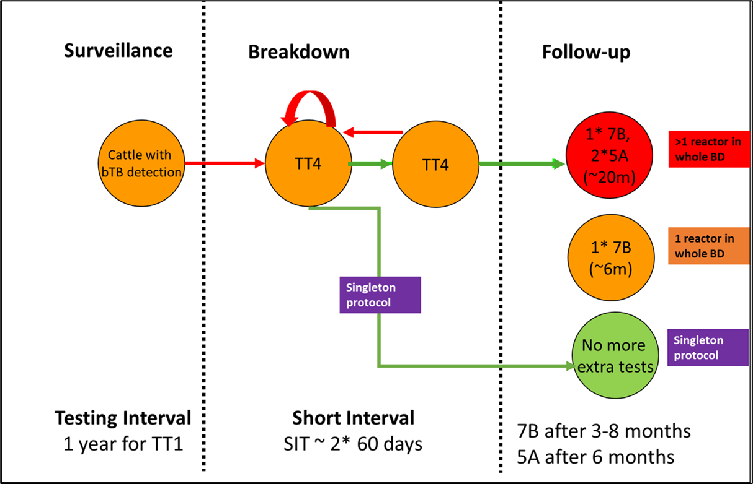
Supplementary Methods Figure 1: An overview of the Irish national annual skin testing process. TT1 = Annual skin test. TT4 / SIT = short interval reactor retests, after the initial detection of a positive case. 7B = initial follow up test after the end of a breakdown. 5A = second and third follow up tests after the end of a breakdown. Approximately 7 per cent of Irish breakdowns follow the singleton protocol (3).

Data

Animal Identification and Movements (AIM) database
All birth, death and movement records for Irish cattle herds were obtained from DAFM’s Animal Identification and Movements (AIM) database. Movement data were available from 2000 to 2023 inclusive.

Animal Health Computer System (AHCS) and laboratory data
Skin test and PM inspection results were available at individual animal level from January 2005 to March 2024 on the Animal Health Computer System (AHCS) of the Department of Agriculture Food and the Marine (DAFM). Animal level interferon-gamma test results were also available from this database from May 2019 onwards. For interferon-gamma tests conducted prior to 2019, test result data were not available on AHCS and were obtained directly from the Tuberculosis Diagnostics and Immunology Research Laboratory at University College Dublin and the Cork Regional Veterinary Laboratory.

Land Parcel Identification System
DAFM’s Land-Parcels Identification System (LPIS) (8) was used to delineate the extent of the land occupied by each cattle herd. Following (9) centroid coordinates for each herd were also derived from these data, with the exception of approximately 5 per cent of herds not recorded in the LPIS system. These latter herds were mapped by randomly assigning a location within the electoral division they were located in.

Data processing

Case count (outcome variable)
Bovine tuberculosis case detection data were obtained from AHCS and laboratory databases. Total case count comprised any bovine culled for bTB control purposes due to diagnosis of TB with a skin or gamma interferon test, and in addition cases detected amongst attested cattle undergoing routine post-mortem examination at slaughter. Standard and severe reactor counts were based on individual animal skin measurements and the official interpretation applied in the test, based on policy. Gamma interferon test reactor counts were based on individual animal optical density measurements and application of the relevant cut-off values for the date of interpretation. In a small minority of cases where the total cattle culled for bTB control purposes was greater than that which would be accounted for by individual test results, we interpreted this as additional cattle culled within the breakdown being deemed to be reactors due to disease risk or welfare considerations. For example, in some cases, suckling calves of reactor cows may be deemed to be reactors. We cross-checked a subset of these with individual herd reports on the AHCS interface for state veterinarians, to assess that categorisation of deemed reactors was correct.

Herd size and management
AHCS and AIM data were accessed, managed and processed as previously described (9,10). Herd profiles from the 1st January, May and September for each year were acquired from the AIM database, using data from 2008 onwards. Herd sizes were taken to be the average from these three profiled dates throughout each year. Animal movement and demographic data were also used to create categories of herd management types based on the methodology of Brock et al. (2021) (11), from 2008 onwards.

Residency time calculations
Animal level movement records on the AIM database from between the beginning of 2000 and the end of 2023 were accessed. Records were ordered by animal unique identifier and date. “Moves in” included births and live moves into a herd. “Moves out” included death on farm, and moves out from the herd to other herds and to slaughter. The residency time of each animal in each herd was the “move in” date subtracted from the “move out” date. Datapoints missing “move in” or “move out” dates for a herd-animal combination, reflecting left or right censoring, were excluded. We considered herds to be active in years which they had at least a single animal present, based on the herd profile calculations described above. We included herds active each year between 2008 and 2023 in our residency time analyses. To generate summary statistics at herd and year level, we considered the residency times of all cattle moving out of the herd during the year in question.

In degree calculations
Based on the work of Tratalos et al. (2020; 2023) (9,12), we considered in degree to be the inward movement metric most strongly associated with bTB risk. Using the AIM data described above, calculated this metric for each year and each herd by counting the number of unique herds from which cattle were sourced per herd per annum. Herd profile and movement data were merged to identify herds with cattle present but no inward movements in a given year.
To generate an in degree explanatory variable for our regression models we averaged in degree for the year breakdown start, and for the two years preceding this.

Metric of neighbourhood burden of bTB
Our metric of neighbourhood burden was the proportion of herds within a six kilometre radius of the herd of interest which had a bTB breakdown restriction status in the three years prior to the year of interest. Using centroid coordinates and bTB breakdown history for every herd and every year between 2008 and 2024, an algorithm was written in C++ to calculate the neighbourhood burden metric. The work of Tratalos et al. (2023) (12) justified our selection of a 6km radius. In their risk-factor analysis to explain bTB breakdown occurrence in Ireland, they compared model fits using radii between 2km and 10 km of herd centroids and found that a radius of 6km was associated with the best fit. We compared incorporation of five year and three year breakdown history in the locale as explainers of breakdown risk and found that three year breakdown history was associated with a lower AIC score. Therefore, we used “proportion of herds within 6km of herd of interest with bTB breakdown history in the three years prior to the start year of the breakdown,” as our neighbourhood burden metric in this study.
For the purposes of comparison with previous work, and to address the question of whether animal- rather than herd- based metrics of neighbourhood burden would make a difference to or results, we also calculated two further metrics of neighbourhood burden as previously described (13,14). These were based on district electoral division (DED) units (mean area 20.6km² (12)). The first was, for the year before the breakdown start, standard skin test reactors per 1000 cattle skin tested within the DED, and the second was standard skin test reactors per km²within the DED.

Temporal window and study population
For initial descriptive analyses, we used all available breakdown data available from between 2005 and 2024, and movement data between 2008 and 2023. Allowing for our average three year in degree metric meant excluding breakdowns beginning before 2010. To avoid selection of only shorter breakdowns in early years, we excluded breakdowns ending in 2010 and 2011. This was based on the finding that only 0.5% of our full breakdown population was longer than two years in duration. We used year of breakdown end for our analyses to avoid right censoring issues. This left a study population of breakdowns ending between 2012 and 2023, and starting after 2009. Our residency time calculations required herds which comprised at least a single animal each year between 2008 and 2023. We also excluded the 2% of breakdowns in herds which comprised ten cattle or fewer, as these were likely to reflect atypical management systems, for example hobby farms, in contrast to the general population.
Because of the increased bTB risk associated with animals with previous inconclusive skin test results (15), inconclusive reactor policy changed in 2020 to promote the removal of inconclusive skin test reactors as early as possible rather than allowing them follow up skin testing. Due to this major policy change and its impact on case counts in inconclusive reactor initiated breakdowns, we excluded these. Controlled finishing units, due to the allowance for long term breakdown status and reduced testing requirements, were also excluded. This left a dataset for analysis of 37,176 breakdowns.
Supplementary Methods Table 2: Example temporal windows for data processing to generate explanatory variables relating to a single hypothetical breakdown beginning in 2015 and ending in 2016.
Year | 2010 | 2011 | 2012 | 2013 | 2014 | 2015 | 2016
Breakdown status
Breakdown end year
In degree years
Residency time end year
Neighbourhood breakdowns (herd level)
Neighbourhood burden (animal level)
Herd breakdown history

References for supplementary methods
1. Animal Health and Welfare (Bovine Tuberculosis) Regulations SI 58 of 2015 [Internet]. 2015. Available from: https://www.irishstatutebook.ie/eli/2015/si/58/made/en/print?q=58&years=2015
2. Gormley E, Doyle M, Duignan A, Good M, More SJ, Clegg TA. Identification of risk factors associated with disclosure of false positive bovine tuberculosis reactors using the gamma-interferon (IFNγ) assay. Vet Res. 2013;44(1):1–8.
3. Good M, Duignan A. Veterinary Handbook for Herd Management in the TB eradication programme [Internet]. Dublin; 2016. 23–25 p. Available from: https://www.researchgate.net/publication/323402319_Veterinary_Handbook_for_herd_management_in_the_bovine_TB_Eradication_Programme
4. More SJ, Good M. Understanding and managing bTB risk: Perspectives from Ireland. Vet Microbiol. 2015;176(3–4):209–18.
5. Clegg TA, Doyle M, Ryan E, More SJ, Gormley E. Characteristics of Mycobacterium bovis infected herds tested with the interferon-gamma assay. Prev Vet Med [Internet]. 2019;168(April):52–9. Available from: https://doi.org/10.1016/j.prevetmed.2019.04.004
6. Clegg TA, Good M, Doyle M, Duignan A, More SJ, Gormley E. The performance of the interferon gamma assay when used as a diagnostic or quality assurance test in Mycobacterium bovis infected herds. Prev Vet Med [Internet]. 2017;140:116–21. Available from: http://dx.doi.org/10.1016/j.prevetmed.2017.03.007
7. Gormley E, Doyle MB, Fitzsimons T, McGill K, Collins JD. Diagnosis of Mycobacterium bovis infection in cattle by use of the gamma-interferon (Bovigam®) assay. Vet Microbiol. 2006;112(2-4 SPEC. ISS.):171–9.
8. Zimmermann J, Fealy RM, Lydon K, Mockler EM, O’Brien P, Packham I, et al. The Irish land-parcels identification system (LPIS) – experiences in ongoing and recent environmental research and land cover mapping. Biol Environ. 2016;116B(1):53–62.
9. Tratalos J, Madden J, McGrath G, Graham D, Áine Collins, More S. Spatial and network characteristics of Irish cattle movements. Prev Vet Med. 2020;183.
10. Madden JM, Casey-Bryars M, More SJ, Barrett D, Gormley E, Ryan E. Investigation of the association between the Enferplex bovine tuberculosis antibody test and the future risk of bovine tuberculosis in irish cattle in infected herds: a pilot field study. Vet Res Commun. 2024;48(1):555–61.
11. Brock J, Lange M, Tratalos JA, More SJ, Graham DA, Guelbenzu-Gonzalo M, et al. Combining expert knowledge and machine-learning to classify herd types in livestock systems. Sci Rep [Internet]. 2021 Dec 4 [cited 2021 Feb 8];11(1):2989. Available from: http://www.nature.com/articles/s41598-021-82373-3
12. Tratalos JA, Fielding HR, Madden JM, Casey M, More SJ. Can Ingoing Contact Chains and other cattle movement network metrics help predict herd-level bovine tuberculosis in Irish cattle herds? Prev Vet Med [Internet]. 2023;211(April 2022):105816. Available from: https://doi.org/10.1016/j.prevetmed.2022.105816
13. Clegg TA, Good M, Hayes M, Duignan A, McGrath G, More SJ. Trends and predictors of large tuberculosis episodes in cattle herds in Ireland. Front Vet Sci. 2018;5(MAY):1–12.
14. Houtsma E, Clegg TA, Good M, More SJ. Further improvement in the control of bovine tuberculosis recurrence in Ireland. Vet Rec. 2018;183(20):622.
15. Clegg TA, Good M, Duignan A, Doyle R, More SJ. Shorter-term risk of Mycobacterium bovis in Irish cattle following an inconclusive diagnosis to the single intradermal comparative tuberculin test. Prev Vet Med [Internet]. 2011;102(4):255–64. Available from: http://dx.doi.org/10.1016/j.prevetmed.2011.07.014

