Residency time and other risk factors for large bovine tuberculosis breakdowns in Irish cattle herds : Supplementary results part 2
Miriam Casey-Bryars ¹, Jamie A. Tratalos ², Andrew Byrne ³, Simon More ², Damien Barrett ³, Jamie M. Madden *² and Andrew Conlan *⁴
- School of Veterinary Medicine, University College Dublin, Belfield, Dublin 4, Ireland
- Centre for Veterinary Epidemiology and Risk Analysis, School of Veterinary Medicine, University College Dublin, Belfield, Dublin 4, Dublin Ireland.
- ﻿ Department of Agriculture, Food and the Marine, Kildare Street, Dublin, Ireland.
- Disease Dynamics Unit, Department of Veterinary Medicine, University of Cambridge, Cambridge, UK.
* These authors contributed equally.
Correspondence to: Miriam Casey-Bryars; miriam.casey@ucd.ie, School of Veterinary Medicine, University College Dublin, Belfield, Dublin D04 W6F6, Ireland

Contents
Detailed results from model assessments 2
Alternative multivariable regression results 3
Marginal effects plots from model reported in main text 3
Likelihood ratio testing results for models reported in the main text 18

Detailed results from model assessments
Initial candidate variables for multivariable models included those described in Table 1 in the main text, and year of breakdown end. Herd breakdown history category had a variance inflation factor of between 4 and 6 depending on the model. Furthermore, it was not retained after likelihood ratio testing in initial model screening. Smaller herds were more likely to have a clear breakdown history (mean herd size with five or more years clear surveillance was 116 cattle compared to 170 cattle in herds with more recent breakdown history and 188 in herds with a breakdown within the previous year). Also, test type, for example, follow-up testing after a breakdown, is correlated with breakdown history. Based on these findings, we excluded breakdown history from our candidate models, relying instead on “follow-up test” initiating status as indicative of a previous breakdown ending within the last 18 months.
Table 1 in the main text and Supplementary Figure 1.11 show that having at least one ante-mortem reactor subsequently confirmed by lesion detection at post-mortem examination at slaughter, is strongly associated with total case count. However, because lesioned skin reactors could arguably be a consequence of increased numbers of skin test reactors being examined at slaughter, rather than a cause, we opted not to include them in our main analyses. Instead, we report multivariable analysis including lesioned skin reactors in Supplementary Figure 2.1, which shows results for the other variables which are consistent with those presented in the main text.
Although in-degree and residency time were negatively correlated (Figure 1A main text), variance inflation factor analysis did not suggest any evidence for multicollinearity in the multivariable models. When in degree metrics were included in candidate models, increasing in degree had a weak non-linear effect on case counts (Supplementary Figures 2.2 and 3.3). The highest in-degree category had a negative effect on case count which may be consistent with a negative correlation with residency time, which was positively associated with case count. Inclusion of in-degree did not substantially change results relating to residency time in the multivariable models (Supplementary Figures 2.2 and 2.3). Therefore, for the purposes of biological interpretation, we restrict reporting of “in-degree” containing multivariable models to our Supplementary Results. Based on this rationale, our final set of candidate explanatory variables for multivariable regressions reported in the main text comprised herd size, herd type, test type which initiated the breakdown, residency time, neighbourhood burden metric and year the breakdown ended. We also considered interactions between herd size and neighbourhood burden, and herd size and residency time, but their retention was not justified by AIC comparison or likelihood ratio testing.

Alternative multivariable regression results
The figures below provide supplementary results on alternative models. Supplementary Figure 2.1 includes lesioned reactors as an explanatory variable in regressions to explain binned case counts in “Full population A : total cases”. Supplementary Figures 2.2 and 2.3 include “In Degree” in explaining binned case counts in “Full population A : total cases”, and case count in “Sub-population B : standard skin cases”. Supplementary Figures 2.4 and 2.5 exclude initiating test type as an explanatory variable to highlight that the effects associated with neighbourhood do not change substantially even in absence of contiguous tests as explanatory variables.

Marginal effects plots from model reported in main text
Supplementary Figures 2.6 and 2.7 show the marginal effects of herd size and residency time, respectively, based on the zero-truncated negative binomial regression analysis of “Sub-population B : standard skin cases” reported in the main text.
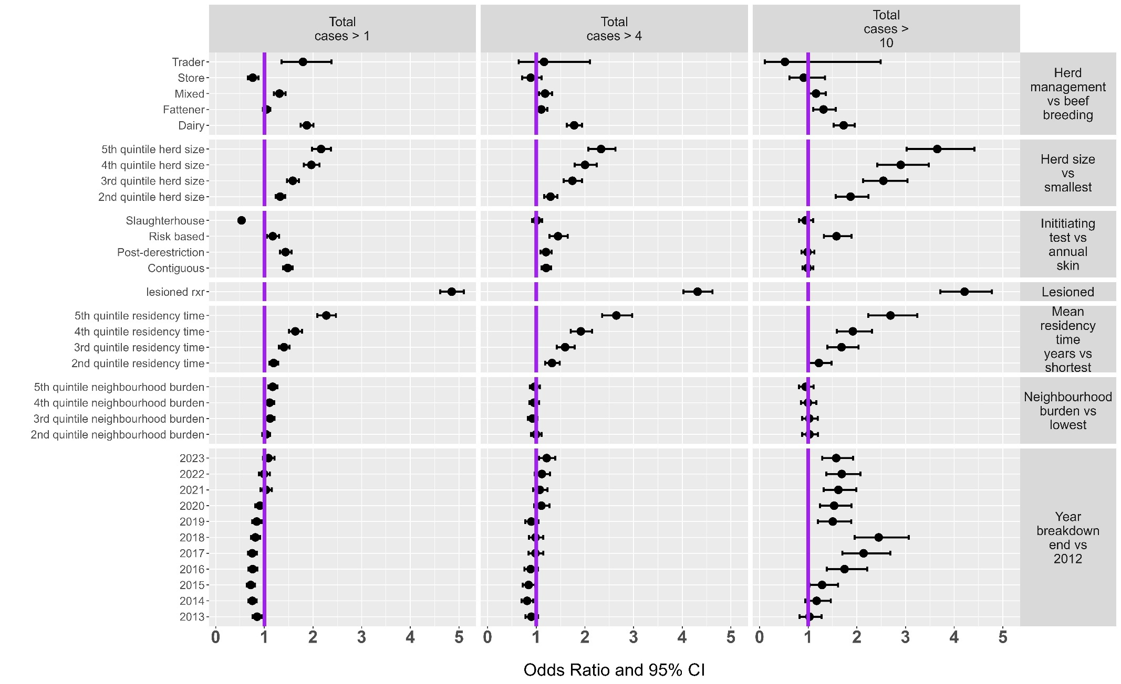
Supplementary Figure 2.1: Results from multivariable logistic regression, with a herd level random effect on the intercept, to explain (left) total case counts greater than one in all breakdowns (n = 37,176); (centre) amongst breakdowns with greater than one case (n = 20,029) , total case counts greater than four; (right) amongst breakdowns with greater than four cases (n= 9,104), total case counts greater than ten. These outputs are based on Full population A : total cases, breakdowns ending between 2012 and 2023. In contrast to the main text, these logistic regressions include the presence of at least one lesioned ante-mortem reactor (“lesioned rxr” on y axis labels) as an explanatory variable.

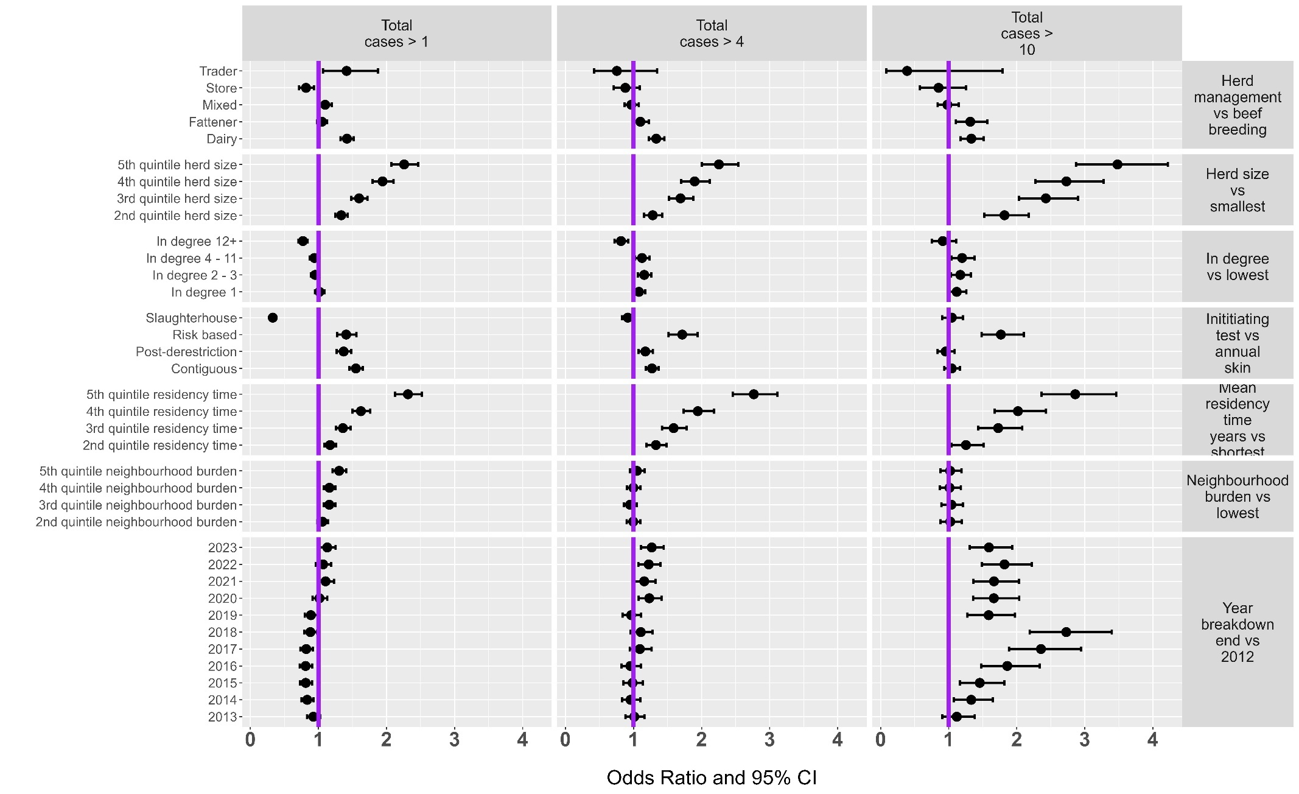
Supplementary Figure 2.2: Results from multivariable logistic regression to explain (left) total case counts greater than one in all breakdowns (n = 37,176); (centre) amongst breakdowns with greater than one case (n = 20,029) , total case counts greater than four; (right) amongst breakdowns with greater than four cases (n= 9,104), total case counts greater than ten. These outputs are based on Full population A : total cases, breakdowns ending between 2012 and 2023. In contrast to the main text, these logistic regressions include “in degree” (average count of unique source herds for inward moving cattle for the year of breakdown start and the two preceding years) as an explanatory variable.
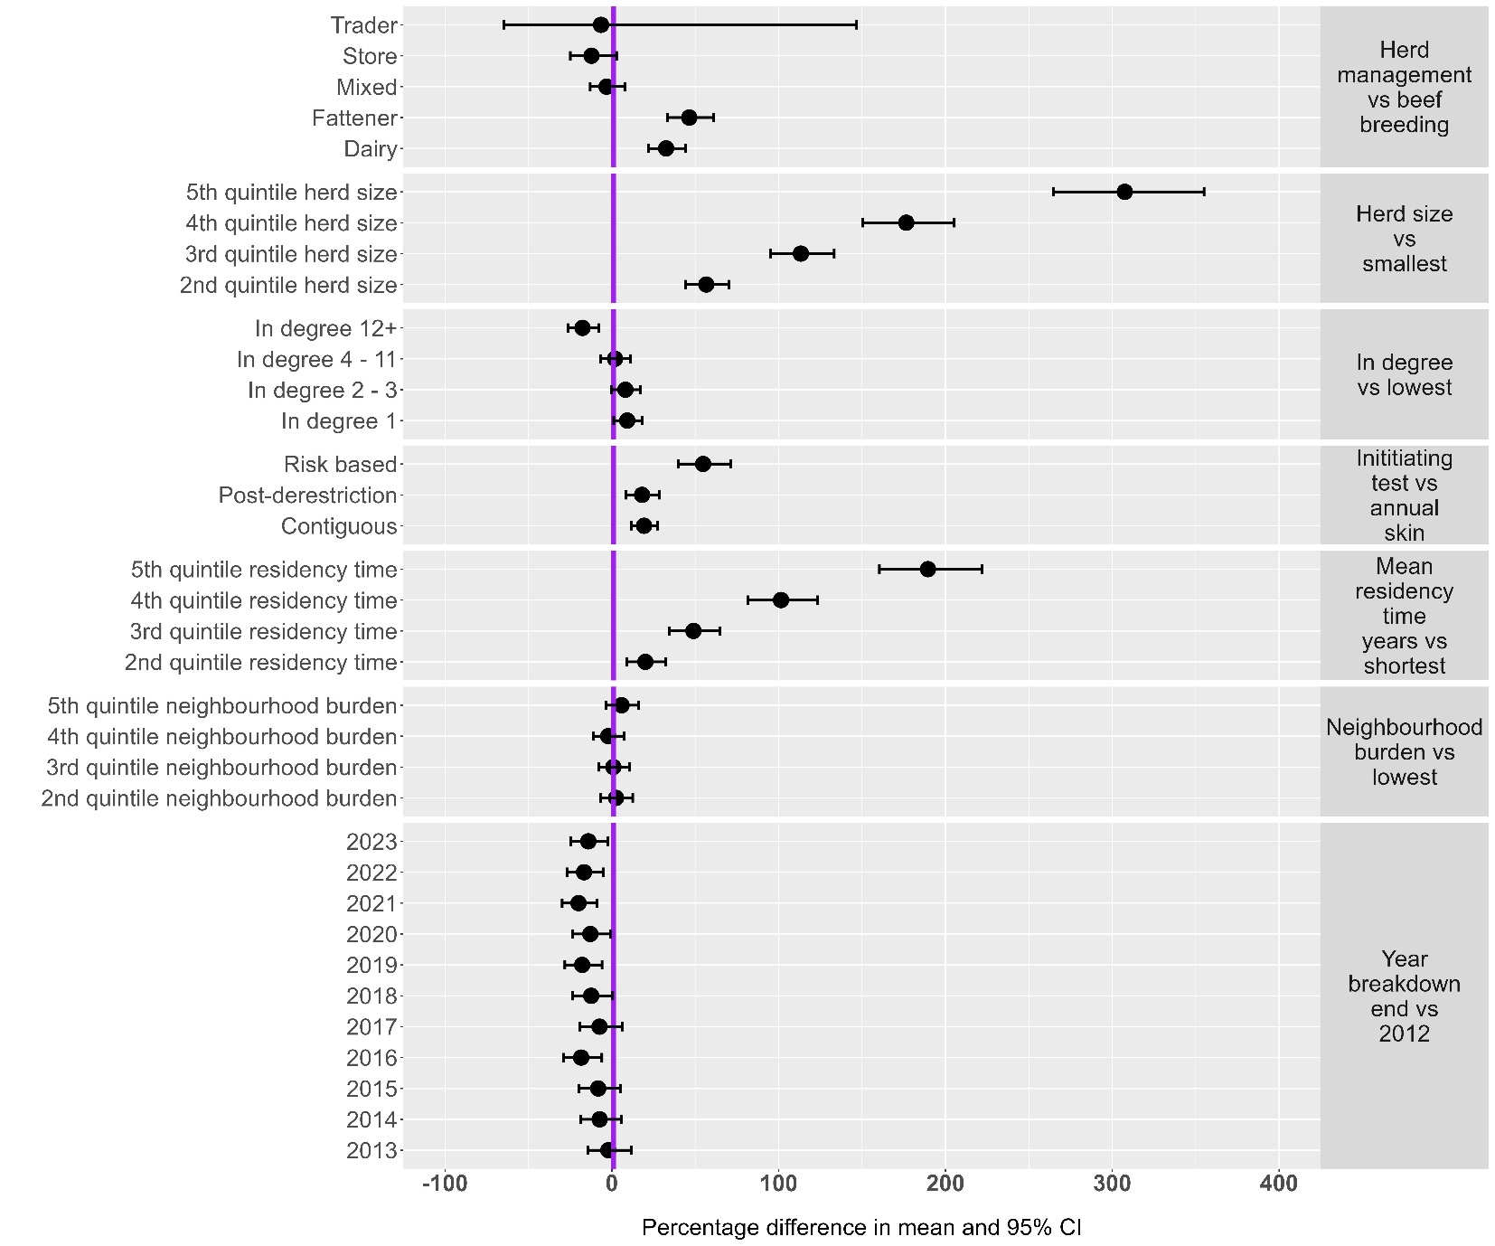
Supplementary Figure 2.3: Negative binomial regression results including in degree categories in the sub-population (Skin test initiated breakdowns with at last one lesioned ante-mortem reactor). The response variable is count of standard interpretation skin test reactors. This is based on “Sub-population B : standard skin cases”. In contrast to the main text, this regression includes “in degree” (average count of unique source herds for inward moving cattle for the year of breakdown start and the two preceding years) as an explanatory variable
.
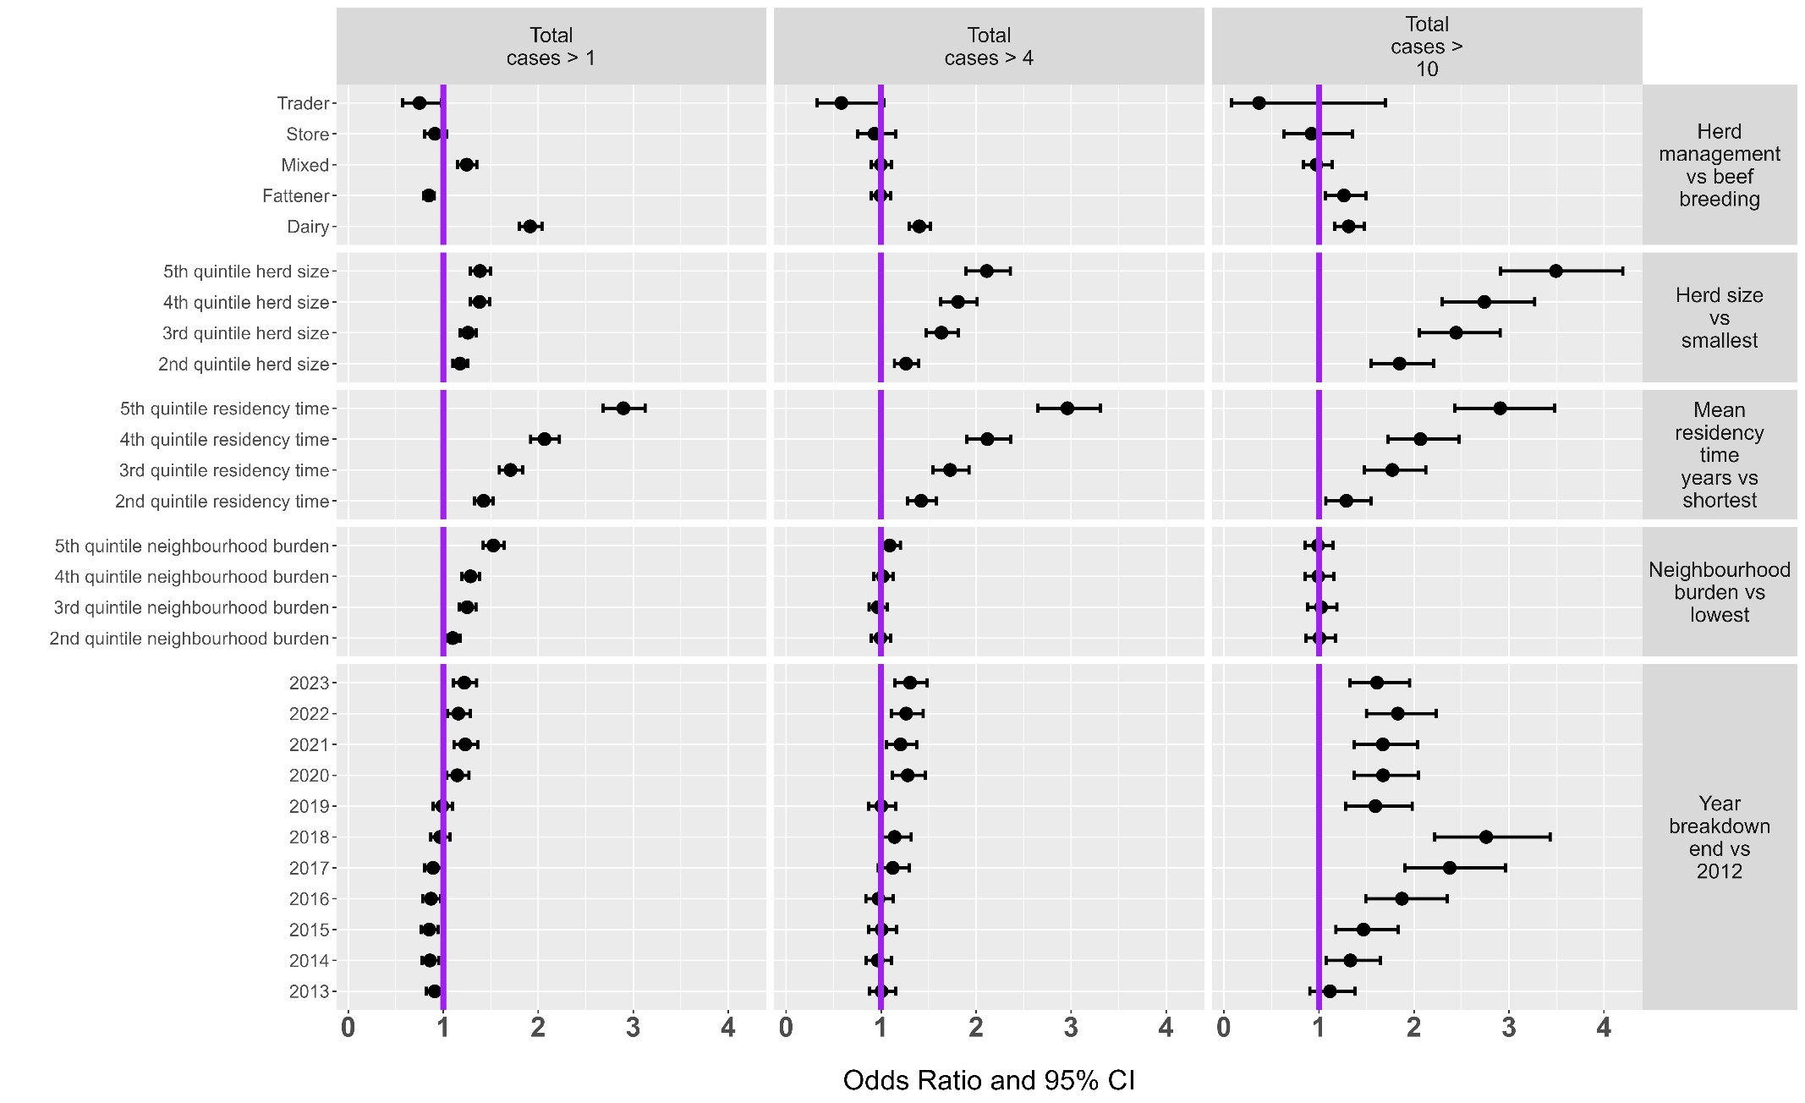
Supplementary Figure 2.4: Results from multivariable logistic regression to explain (left) total case counts greater than one in all breakdowns (n = 37,176); (centre) amongst breakdowns with greater than one case (n = 20,029) , total case counts greater than four; (right) amongst breakdowns with greater than four cases (n= 9,104), total case counts greater than ten. These outputs are based on Full population A : total cases, breakdowns ending between 2012 and 2023. In contrast to the main text, this regression excludes “initiating test type” as an explanatory variable to investigate whether this makes a difference to the effect of “neighbourhood burden.”
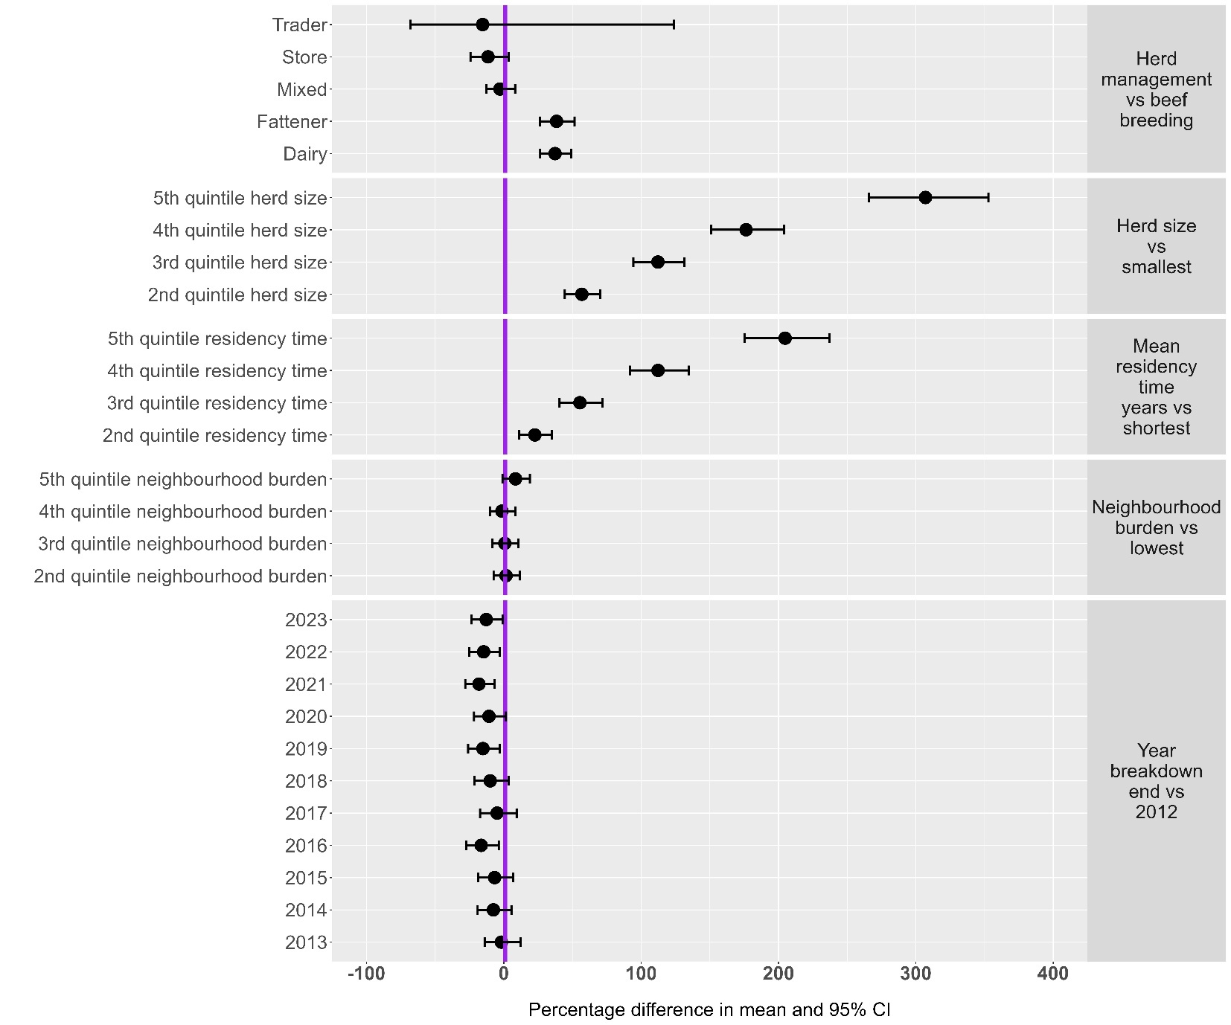
Supplementary Figure 2.5: Negative binomial regression results including in degree categories in the sub-population (Skin test initiated breakdowns with at last one lesioned ante-mortem reactor). The response variable is count of standard interpretation skin test reactors. This is based on “Sub-population B : standard skin cases”. In contrast to the main text, this regression excludes “initiating test type” as an explanatory variable to investigate whether this makes a difference to the effect of “neighbourhood burden.”
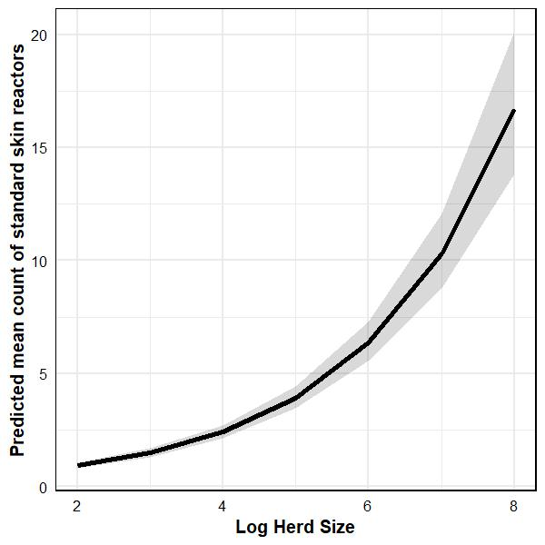
Supplementary Figure 2.6: Marginal effects plots showing the effect of log herd size (not categorised) on the mean count of standard skin reactors, as modelled by the zero-truncated negative binomial regression (which uses a log-transform on the mean count outcome variable). This is based on “Sub-population B : standard skin cases”.

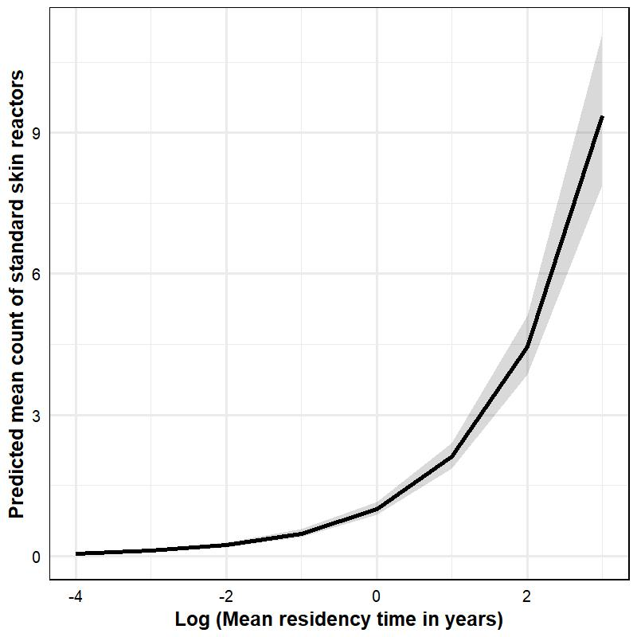
Supplementary Figure 2.7 Marginal effects plots showing the effect of log of mean residency time (not categorised) on the mean count of standard skin reactors, as modelled by the zero-truncated negative binomial regression (which uses a log-transform on the mean count outcome variable). This is based on “Sub-population B : standard skin cases”.

Likelihood ratio testing results for models reported in the main text
Supplementary tables 2.1 to 2.4 below summarise likelihood ratio testing (LRT) results for the multivariable regression models in the main text. For each of the fixed effects, and also for the herd level random effect on the intercept, the likelihood of the data, given models with and without the explanatory variable / random effect, are compared with the LRT. I the table legends, we also report the variance and standard deviation of the random effects, and for the zero-truncated negative binomial regression (Supplementary Table 2.4), the dispersion parameter.
The inclusion of the herd level random effect on the intercept significantly improved model fits, based on likelihood ratio testing, for explaining case counts > 1 and > 4 but did not assist explaining > 10 cases (even though 19.7% of herds in the dataset informing the > 10 case model contributed greater than one breakdown). The explanatory capacity of the logistic regression set was modest, with total variance explained and fixed effects only variance explained, measured through Nakagawa's R2 for mixed models (respectively) being 22% and 18.3% for the > 1 case model; 13.3% and 8.5% for the > 4 case model and 10.4% and 10.1% for the >10 case model. “Area Under Curve” (AUC) estimates were 72% for “cases > 1”, 73% for “cases > 4” and 66% for “cases > 10”.
Supplementary Results Table 2.1: Logistic regression for > 1 case (Population A, N = 37,176 breakdowns; 24,730 herds). Herd level random effect on intercept variance was 0.16 and standard deviation was 0.40. APT DED = positive cattle per 1000 tested in the district electoral division.
Term | DF (Reduced) | DF (Full) | AIC (Reduced) | AIC (Full) | Chi-Sq | Chi DF | p-value
Year breakdown end | 22 | 33 | 45,841.89 | 45,743.55 | 120.338 | 11 | 1.55e-20
Herd management | 28 | 33 | 45,928.20 | 45,743.55 | 194.652 | 5 | 3.96e-40
Initiating test | 29 | 33 | 48,240.08 | 45,743.55 | 2,504.524 | 4 | p < 2.2e-16
Mean residency time | 29 | 33 | 46,379.74 | 45,743.55 | 644.188 | 4 | 4.22e-138
Neighbourhood burden (APT DED) | 30 | 33 | 45,801.35 | 45,743.55 | 63.794 | 3 | 9.08e-14
Herd size | 29 | 33 | 46,132.61 | 45,743.55 | 397.059 | 4 | 1.20e-84
Herd level random effect | 32 | 33 | 45,771.49 | 45,743.55 | 29.934 | 1 | 4.47e-08

Supplementary Results Table 2.2: Logistic regression for > 4 cases (Population A: Breakdowns with > 1 case, N = 20,029 breakdowns; 14,776 herds). Herd level random effect on intercept variance was 0.18 and standard deviation was 0.43. APT DED = positive cattle per 1000 tested in the district electoral division.
Term | DF (Reduced) | DF (Full) | AIC (Reduced) | AIC (Full) | Chi-Sq | Chi DF | p-value
Year breakdown end | 22 | 33 | 26,326.45 | 26,297.03 | 51.413 | 11 | 3.48e-07
Herd management | 28 | 33 | 26,374.59 | 26,297.03 | 87.562 | 5 | 2.18e-17
Initiating test | 29 | 33 | 26,407.06 | 26,297.03 | 118.032 | 4 | 1.41e-24
Mean residency time | 29 | 33 | 26,741.47 | 26,297.03 | 452.440 | 4 | 1.29e-96
Neighbourhood burden (APT DED) | 30 | 33 | 26,302.73 | 26,297.03 | 11.697 | 3 | 8.50e-03
Herd size | 29 | 33 | 26,501.61 | 26,297.03 | 212.579 | 4 | 7.41e-45
Herd level random effect | 32 | 33 | 26,319.64 | 26,297.03 | 24.604 | 1 | 7.04e-07

Supplementary Results Table 2.3: Logistic regression for > 10 cases (Population A: Breakdowns with > 4 cases, N = 9,104 breakdowns; 7,347 herds). Herd level random effect on intercept variance was 0.009 and standard deviation was 0.095. APT DED = positive cattle per 1000 tested in the district electoral division.
Term | DF (Reduced) | DF (Full) | AIC (Reduced) | AIC (Full) | Chi-Sq | Chi DF | p-value
Year breakdown end | 22 | 33 | 12,057.16 | 11,940.87 | 138.287 | 11 | 3.63e-24
Herd management | 28 | 33 | 11,970.10 | 11,940.87 | 39.232 | 5 | 2.13e-07
Initiating test | 29 | 33 | 11,979.13 | 11,940.87 | 46.264 | 4 | 2.17e-09
Mean residency time | 29 | 33 | 12,133.09 | 11,940.87 | 200.222 | 4 | 3.37e-42
Neighbourhood burden (APT DED) | 30 | 33 | 11,936.76 | 11,940.87 | 1.890 | 3 | 5.96e-01
Herd size | 29 | 33 | 12,125.81 | 11,940.87 | 192.945 | 4 | 1.23e-40
Herd level random effect | 32 | 33 | 11,938.90 | 11,940.87 | 0.027 | 1 | 8.70e-01

Supplementary Results Table 2.4: Zero truncated negative binomial regression (Population B, N = 15,834 cases; 12,705 herds). Herd level random effect on intercept variance was 0.37 and standard deviation was 0.60. The dispersion parameter for the truncated negative binomial distribution was 0.494 based on the truncated_”nbinom2” family in the “GlmmTMB” R package. APT DED = positive cattle per 1000 tested in the district electoral division.
Term | DF (Reduced) | DF (Full) | AIC (Reduced) | AIC (Full) | Chi-Sq | Chi DF | p-value
Year breakdown end | 22 | 33 | 71,496.91 | 71,499.08 | 19.828 | 11 | 4.78e-02
Herd management | 28 | 33 | 71,601.54 | 71,499.08 | 112.457 | 5 | 1.24e-22
Initiating test | 30 | 33 | 71,579.80 | 71,499.08 | 86.723 | 3 | 1.11e-18
Mean residency time | 29 | 33 | 72,210.10 | 71,499.08 | 719.022 | 4 | 2.65e-154
Neighbourhood burden (APT DED) | 30 | 33 | 71,497.53 | 71,499.08 | 4.450 | 3 | 2.17e-01
Herd size | 29 | 33 | 72,010.75 | 71,499.08 | 519.666 | 4 | 3.74e-111
Herd level random effect | 33 | 34 | 71,749.70 | 71,502.45 | 249.246 | 1 | 3.79e-56

