Supplementary Information
Ultralow wear and superlubricity under high current density with single crystalline graphite
Weijia Feng^{1,2,3}, Yiran Wang^{1,2,3}, Jing Xu³, Yisheng Huang³, Yuhan Gong³, Lanxing Gao³, Ying Liu³, Minxing Lu³, Jinhui Nie^{3*} & Ming Ma^{1,2,3*}

¹ State Key Laboratory of Tribology in Advanced Equipment & Department of Mechanical Engineering, Tsinghua University, Beijing 100084, China.
² Center for Nano and Micro Mechanics, Tsinghua University, Beijing 100084, China
³ Institute of Superlubricity Technology, Research Institute of Tsinghua University in Shenzhen, Shenzhen 518057, China

Contents
1. AFM topography of Au rod surface 2
2. XPS characterization of freshly exfoliated SCG. 2
3. Calculation of contact area between SCG and Au rod 3
4. Wear performance comparison between SCG, HOPG and Cu60 graphite 4
5. Two-axis force sensor used in friction testing 5
6. SCG mesa bonding process 5
7. Steps to obtain minimally-tilted SCG mesa contact state 7
8. Lateral and depth resolution of our optical interferometry system 7
9. SCG in-plane fracture analysis 10
10. Two-beam interferometry approach for calculation of contact state 10
11. Au counter-pair AFM topography in current-carrying friction test 12
12. Transfer film tribological performance under different humidity 12
13. Tribological performance comparison between SCG and HOPG mesa 13
References 14

AFM topography of Au rod surface
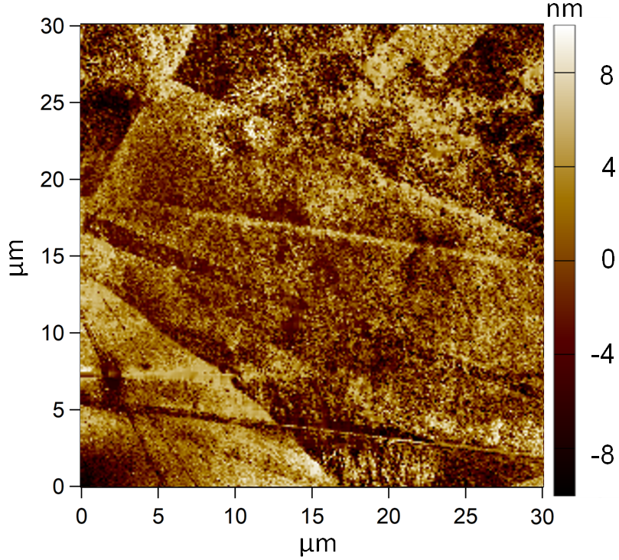
Supplementary Fig. 1: AFM topography of 30 μm×30 μm region on Au rod surface, with SA ~ 3 nm and asperity height up to 8 nm.

XPS characterization of freshly exfoliated SCG.
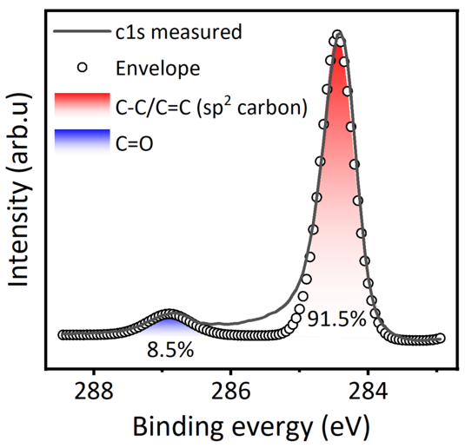
Supplementary Fig. 2: XPS characterization of freshly exfoliated SCG, where the existence mild of C=O functional group may be result of slight surface oxidation when exposed to ambient environment after exfoliation.

Calculation of contact area between SCG and Au rod
Since both tribo-pairs in the wear rate testing in Figure 1 is oblique, optical interferometry method cannot be used for true contact area calculation. Hence Hertz contact is utilized to obtain an approximate contact area between SCG and cylindrical Au surface.

$\frac{1}{E^{*}}=\frac{1-v_{1}^{2}}{E_{1}}+{\frac{1-v_{2}^{2}}{E_{2}}}$ (1)
$P={\frac{F}{L}}$ (2)
$a={\sqrt{\frac{4PR}{πE^{*}}}}$ (3)
$A=2aL$ (4)

In formula (1), $E_{1}$(36.5GPa), $E_{2}$(75GPa) are the measured Young’s modulus of SCG and Au curved surface, $v_{1}$(0.19) $v_{2}$(0.3) are the referenced Poisson’s ratio of SCG and Au. In formula (2), $P$is the load per unit length which is obtained from $F$ (normal load, 59 mN) and effective contact length along the cylinder axis $L$ (0.7 mm). In formula (3), $a$ is contact half-width, $R$ (1 mm) is cylinder rod radius. In formula (4), $A$ is the calculated contact area that between the two atomically smooth tribo-pairs, which yields 2850 μm².

Wear performance comparison between SCG, HOPG and Cu60 graphite
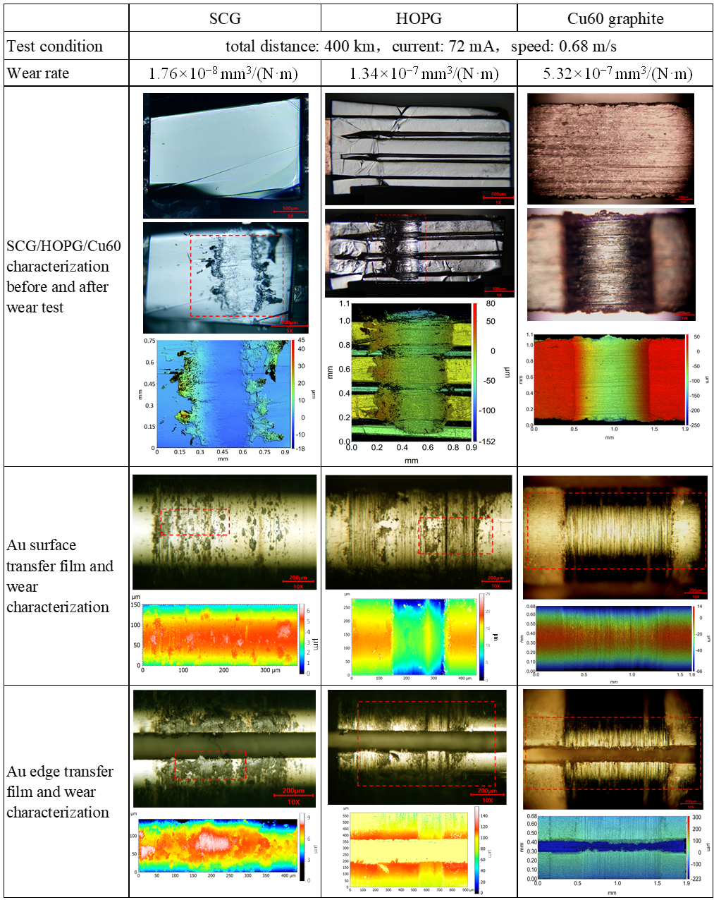
Supplementary Fig. 3: Wear rate comparison between SCG, HOPG and Cu60 under same current, rotating speed and rotating distance.
For SCG, wear depth is 3 μm and wear volume is 4.16×10⁵ μm³. The Au counter-pair surface has hardly any wear track, and the Au edge is covered with SCG’s transfer film with thickness of a few μm.
For HOPG, much less transfer film is present on Au surface and edge where instead obvious grooves are present. The HOPG is substantially worn with wear depth 14 μm and wear volume 3.16×10⁶ μm³. HOPG sample fabrication is similar to SCG sample fabrication as described in Section 4, except the first step where mechanical exfoliation is used to obtain standalone HOPG thin film, which usually have maximum thickness around 30 μm. Hence after bonding HOPG sample to copper alloy substrate, thin HOPG film conformed to copper alloy surface and topography of the three tooths is visible on the HOPG sample before and after wear test as shown in Figure S3.
For Cu60 graphite, the wear depth is ~ 105 μm on Cu60 graphite surface and ~ 8 μm on the Au surface and edge. Minimum flake-like transfer film is observed.

Two-axis force sensor used in friction testing
Illustration of the two-axis force sensor used in our in-situ friction test is shown in Supplementary Fig. 4a It has working principal based on piezoelectric ceramic actuator together with optical encoder which provides large range, nanoscale resolution location feedback, thus rendering the high-speed positioner with outstanding motion repeatability. Supplementary Fig. 4b provides the lateral and normal force resolution, which is measured under zero normal and lateral load in ambient environment (temperature 25 ℃, relative humidity 60%). Both axis force sensors have resolution of ±0.1 μN, which yields high accuracy friction force measurement for mesoscale tribo-pairs such as SCG where normal load applied is usually above 2 mN and lateral force measured is usually above 2 μN.
Supplementary Fig. 4: Illustration of force sensor used in friction force testing and its lateral and normal force resolution.

SCG mesa bonding process
Bonding process is the critical step to fabricate upward facing and fully exposed SCG mesa, which enables in-situ observation of transfer film formation under flat-on-flat contact between SCG and transparent counter-pair. Due to the μm scale lateral and horizontal size of SCG mesa, precise alignment with bonding substrate and control of bonding force are of critical importance. In addition, to ensure effective tribological testing with flat-plane counter-pair, SCG surface has to be substantially higher than (usually 1 μm or more) the bonding substrate so that the counter-pair will not be in contact with asperities on the bonding substrate. Last but not least, the SCG surface after bonding has to be free of defects and contaminants to ensure intrinsic contact and friction measurement.
Inspired by micro-LED assembly and chip packaging technology [1-3], we have developed a high precision flip-chip bonding machine and bonding process (Supplementary Fig. 5a) to fabricate SCG mesa. Step 1 is to align the SCG array with bonding substrate using the spectroscope on the bonding machine and apply a pre-set temperature and bonding pressure. In Step 2, the bonding machine automatically bonds the SCG mesa cap with bonding substrate under the bonding pressure and temperature given in Step 1 and automatically detaches the SCG array when finished bonding. In Step 3, the leftover SCG array is removed and the bonded SCG mesa is detached from the chip pick-up component onto a cleanroom wipe. In Step 4, the bonded SCG mesa is brought under optical microscope for quality check which is shown in Supplementary Fig. 5b where the SCG surface is free from defects, steps or contaminants.
Subsequently, white light interferometry and AFM scanning of bonded SCG mesa are also performed as shown in Figure Supplementary Fig. 5c and Supplementary Fig. 5d respectively. In Supplementary Fig. 5c, it is evident that SCG surface is at least 1 μm higher than the bonding substrate, which effectively prevents undesired contact between bonding substrate and transparent counter-pair. Supplementary Fig. 5d provides the AFM amplitude retrace topography of bonded SCG mesa surface. Comparing to height retrace, amplitude retrace offers more nuanced information about atomic steps, surface contamination and defects on the SCG surface. Minimal steps and contaminants are observed on the SCG surface even under amplitude retrace channel, hence confirming the excellent quality of SCG mesa that our bonding process fabricates.
Supplementary Fig. 5: SCG mesa fabrication process and result. a illustration of SCG mesa bonding process using flip chip bonding. b optical microscope characterization of SCG mesa surface after bonding. c white light interferometry characterization of SCG mesa surface height after bonding. d AFM amplitude retrace topography of SCG mesa surface after bonding.

Steps to obtain minimally-tilted SCG mesa contact state
Since the resolution of the pitch adjustment stage is 0.01°, minor tilt is inevitable. Nevertheless, minor tilt can be reflected by the magnitude of lateral force when transparent counter-pair is in static contact with SCG mesa, as lateral force should ideally be averaged to zero if the static contact is perfectly un-tilted.
Supplementary Fig. 6: Steps to obtain minimally-tilted SCG mesa contact state.

Lateral and depth resolution of our optical interferometry system
Lateral resolution: Since the lateral resolution of optical microscope is limited by the diffraction limit of light, standard gratings with width of 1mm/1000, 1mm/1200 and 1mm/1800 are examined under our optical microscope and the images are shown in Figure S7. The 1mm/1000 gratings can be clearly discerned, 1mm/1200 grating can be vaguely discerned and that of 1mm/1800 is not discernable at all. Hence the lateral resolution of our optical microscope is approximately 830 nm. This means that contact state observed through our optical microscope interferometry image cannot laterally discern most of the transparent counter-pair’s sub-μm asperity contact with SCG mesa. Electron microscopes have much higher lateral resolution and some even have “quasi-real-time” observation of samples. However, integration of meso-scale friction testing with electron microscope is extremely challenging and beyond the scope of this work.
Supplementary Fig. 7: Optical microscope lateral resolution measurement by standard grating.

Depth resolution: To understand the depth resolution of our optical microscope in analyzing contact state between SCG and transparent counter-pair, a 40 μm lateral size SCG mesa with mild surface undulation is chosen, whose AFM height topography is shown in right-hand-side of Figure S8. Since the SCG mesa surface is locally continuous with tens of nm level height protrusion in the center and one of the edge regions, two adjacent regions (each region has roughly lateral size of 830 nm, which is lateral resolution limit as described above) with the smallest height difference in the AFM topography is chosen, as shown in point 1 and 2 in Figure S8 right-hand side. Meanwhile, the optical interference image (left-hand side of Figure S8) is obtained by contact between the same SCG mesa and a minimally tilted transparent counter-pair. The air gap value of point 1 and 2 on the optical interference image is obtained using algorithm in Figure S8. Consequently, the height difference between point 1 and 2 obtained from the optical interference image is 0.34 nm, while that obtained from AFM topography is 0.29 nm, demonstrating that the depth resolution of our optical interferometry system is at sub-nm level. Considering the tens of nm protrusion on tens of μm SCG mesa surface, it seems that lateral resolution limit is the more critical factor in hindering the depth resolution of SCG’s contact state measurement.
Supplementary Fig. 8: Optical microscope interferometry depth resolution analysis by choosing two adjacent 830 nm × 830 nm region, applying optical interferometry calculation as illustrated in Figure S10 and comparing to “ground truth” AFM surface topography.

SCG in-plane fracture analysis
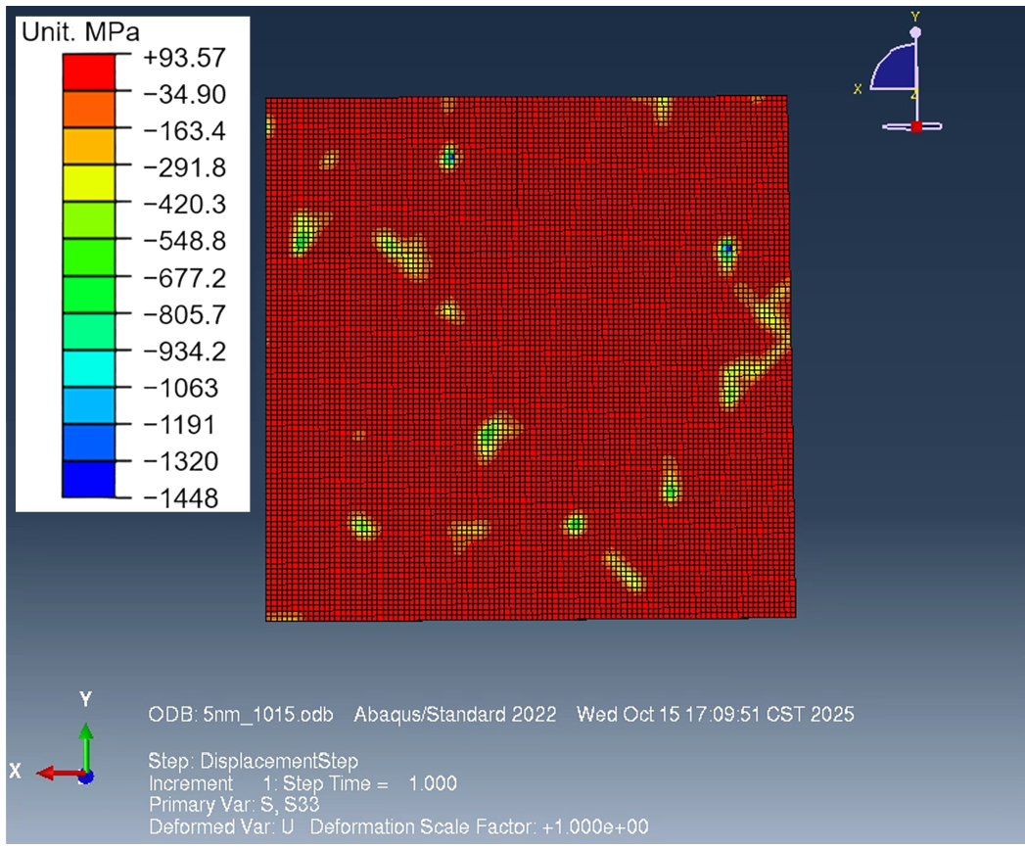
Supplementary Fig. 9: $σ_{3}$ stress distribution on the 2 μm × 2 μm SCG surface at 5 nm displacement load.

Two-beam interferometry approach for calculation of contact state
An algorithm for obtaining optical pixel-wise distance between tribo-pairs is provided in Figure S10. The sets of equations in Figure S10 are referenced from the principle of colorimetric light interferometry [4-7], where the total interference luminance I equals the sum of reflected light intensity from transparent counter-pair (R_{f}), reflected light intensity from SCG surface (R_{b}) and the interference intensity due to optical path difference between light reflected from the transparent counter-pair and SCG surface $2\sqrt{R_{f}R_{b}}\cos{(\frac{4πt}{λ}+φ)}$. In our case, the total interference luminance I_{n,λ} is obtained from the optical interference image captured by the CCD of the optical microscope, which is divided into n optical regions according to the lateral resolution of our optical microscope (calibrated in SI Section 8) and λ refers to the wavelength of incident light. R_{f}, R_{b} are obtained by multiplying incident light from the microscope light source (which is normalized to 1 in our case) with the reflectance property of transparent counter-pair and SCG respectively. Inside the cosine term, t_{n} is the distance between the two tribo-pairs in region n, the value of which can reflect the contact state between the two tribo-pairs. Air gap variable t is the only unknown variable in the equation. λ refers to the wavelength of incident light and φ is the phase change when light enters SCG surface from air.
In our in-situ observation system, the incident light is white light, which is difficult to prevent deterioration in accuracy due to diffuse reflection, hence the RGB values from optical interference CCD image, as well as the calculated total luminance values are converted to hue value by the equation on the right-hand side of Figure S10.
Supplementary Fig. 10: Algorithm for pixel-based calculation of air gap (true distance between the two contacting tribo-pair) t₁, t₂…, t_{n} for pixel 1 to n in the optical interferometry image. $I_{n,λ}$ and $\tan{H}$ are known values from the optical interferometry image, R_{f}, R_{b}, φ are known values from the material properties of the two contacting tribo-pair where incident light from optical microscope is normalized to 1. Air gap t₁, t₂…, t_{n} are the only unknown variables in this algorithm.

11. Au counter-pair AFM topography in current-carrying friction test
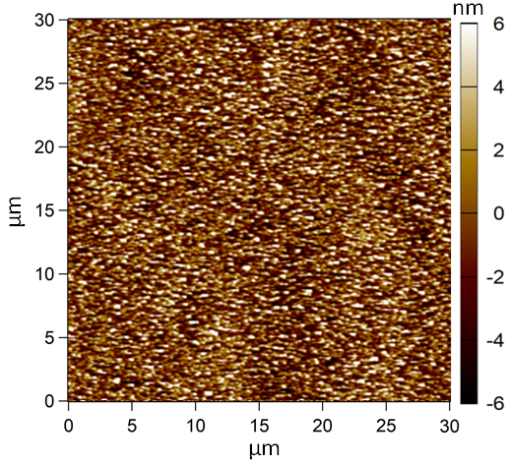
Supplementary Fig. 11: AFM topography of Au counter-pair surface with asperity height of ~ 6 nm and SA of ~ 3 nm.

12. Transfer film tribological performance under different humidity
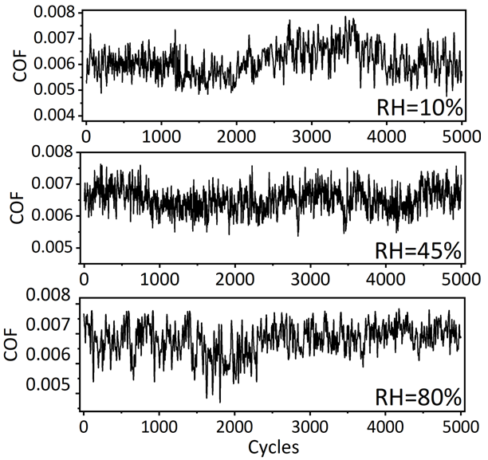
Supplementary Fig. 12: Friction test of transfer film sliding against SCG under relative humidity of 10%, 45% and 80%.

13. Tribological performance comparison between SCG and HOPG mesa
Supplementary Fig. 13: Transfer film morphology and tribological performance comparison between SCG and HOPG: both mesa size is set to 20 μm × 20 μm.

References
1. X. Ji, F. Wang, P. Lin, et al., Fabrication and mechanical properties improvement of micro bumps for high-resolution micro-LED display application. IEEE Transactions on Electron Devices, 2022. 69(7): p. 3737-3741.
2. S. Zhang, H. Zheng, L. Zhou, et al., Research progress of micro-LED display technology. Crystals, 2023. 13(7): p. 1001.
3. C. An, M. Wu, Y. Huang, et al., Study on flip chip assembly of high density micro-LED array, in 2011 6th International Microsystems, Packaging, Assembly and Circuits Technology Conference (IMPACT), 2011: IEEE.
4. T. Tomota, M. Tohyama, and K. Yagi, Elucidation of contact state on various rough surfaces via highly robust colorimetric optical interferometry. Scientific reports, 2022. 12(1): p. 178.
5. O. Marklund and L. Gustafsson, Interferometry-based measurements of oil-film thickness. Proceedings of the Institution of Mechanical Engineers, Part J: Journal of Engineering Tribology, 2001. 215(3): p. 243-259.
6. M. Hartl, I. Krupka, R. Poliscuk, et al., Thin film colorimetric interferometry. Tribology Transactions, 2001. 44(2): p. 270-276.
7. J. Luo, S. Wen, and P. Huang, Thin film lubrication. Part I. Study on the transition between EHL and thin film lubrication using a relative optical interference intensity technique. Wear, 1996. 194(1-2): p. 107-115.

