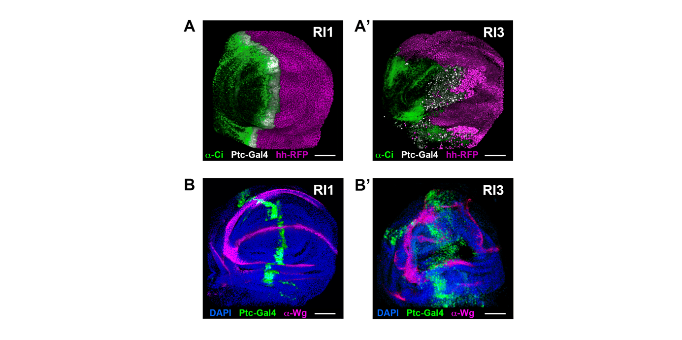Figure S1. Patterning defects in wing imaginal discs after repetitive induction of Rpr
A and A’) Anterior (Ci) (green) and posterior (Hh-RFP) (magenta) compartment expression in RI1 (A) and RI3 (A’) wing discs. Ptc expression is shown in white. Scale bar is 30 µm.
B and B’) Wingless (Wg) wing pouch expression (magenta) in RI1 (B) and RI3 (B’) wing discs. Ptc expression is shown in green and DAPI in blue. Scale bar is 30 µm.

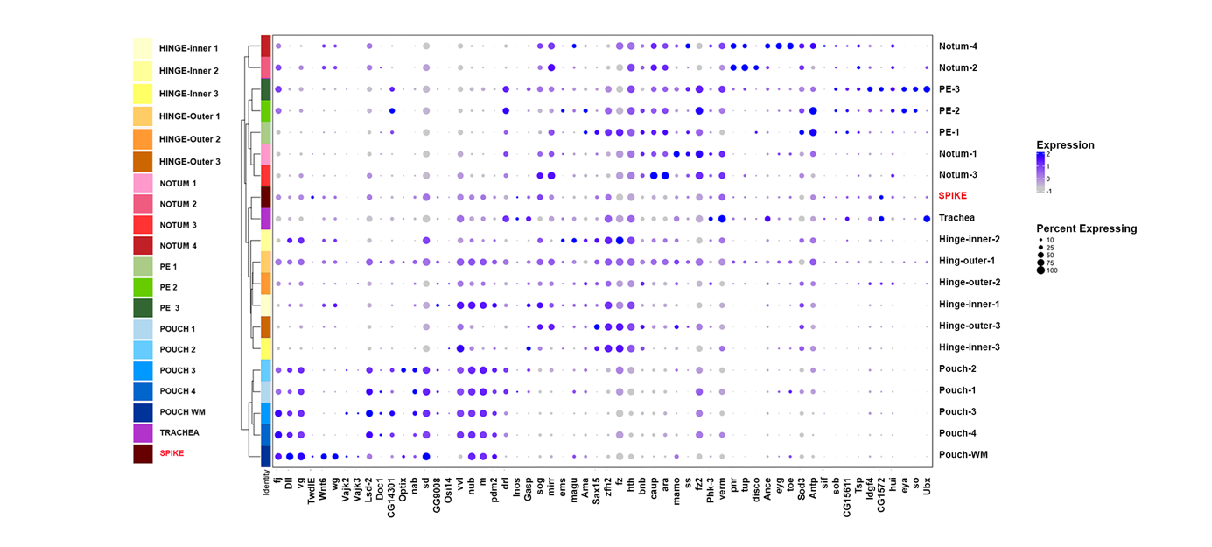Figure S2. Patterns of expression of landmark genes
58 landmark genes (expression level and expression percentage) define 30 subclusters within the overall snRNA Seq data. 19 of these clusters are represented (all except indirect and direct muscles subclusters). The new SPIKE subcluster is highlighted in red.
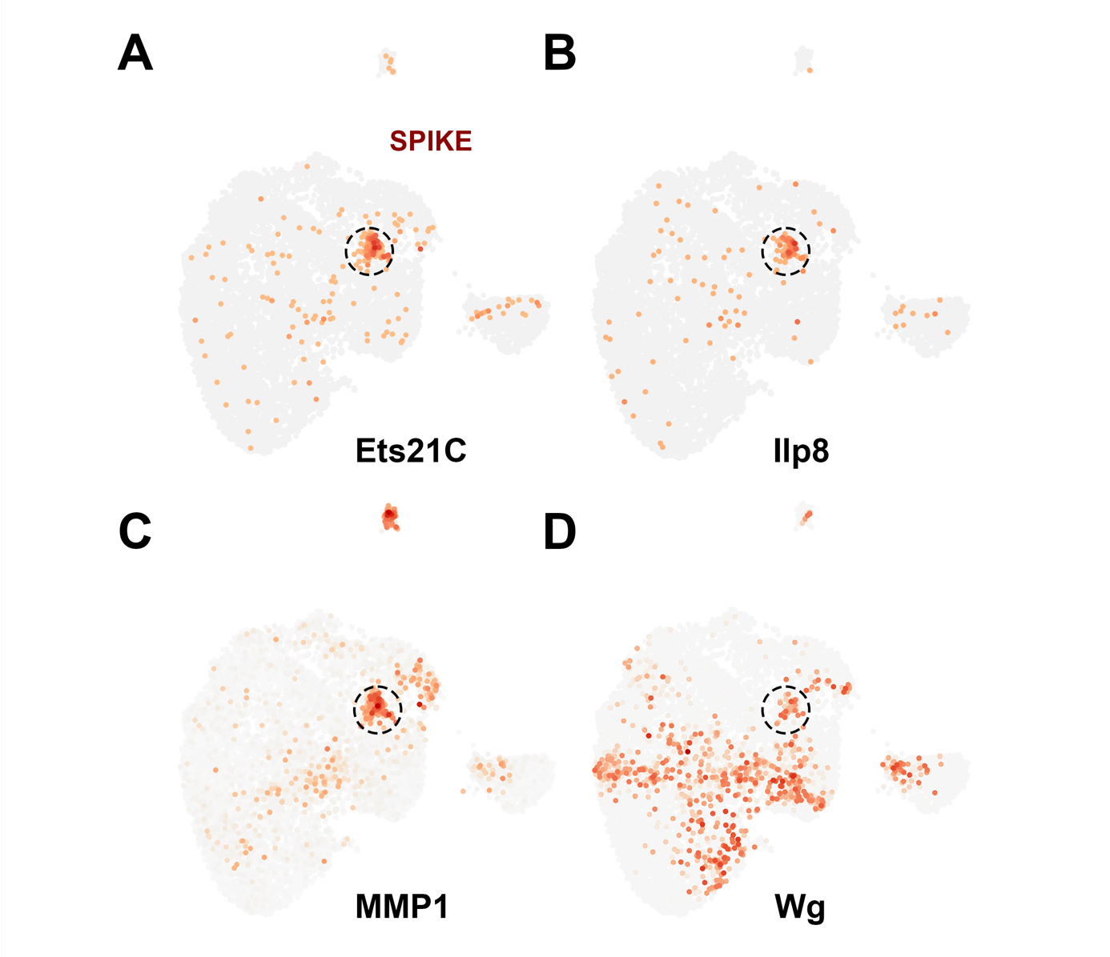
Figure S3. Feature plots highlighting expression of blastema enriched genes
A) Ets21C. B) Ilp8. C) MMP1. D) Wg. The SPIKE domain is encircled by a discontinued circumference.
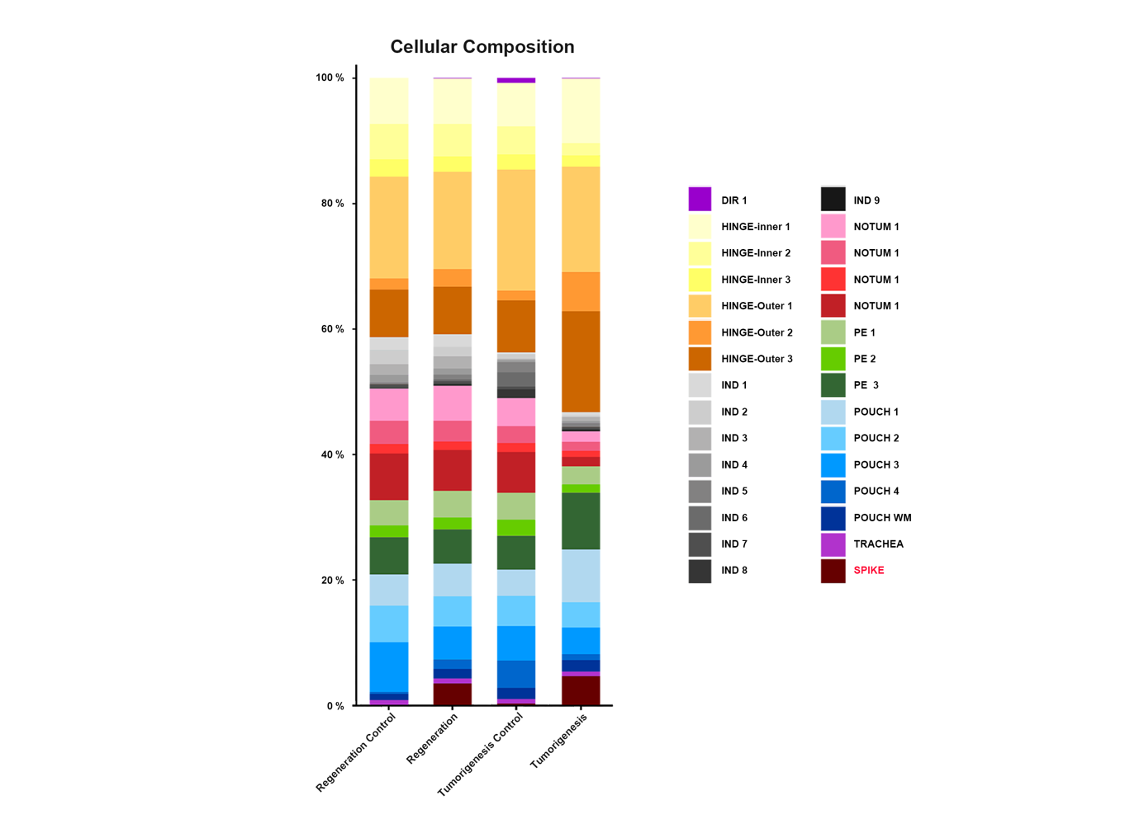Figure S4. Percent subclusters composition of wing imaginal disc
Color coded marking of the different subcluster identified in the snRNAseq analysis for regeneration control, regeneration, tumorigenesis control and tumorigenesis wing discs. The SPIKE subcluster is shown in red.

