Figure S10. Gene Ontology (GO) functional enrichment analysis of differentially expressed miRNA with their target genes in group D4 vs. D0 (a), D8 vs. D0 (b), and D8 vs. D4 (c).
a.
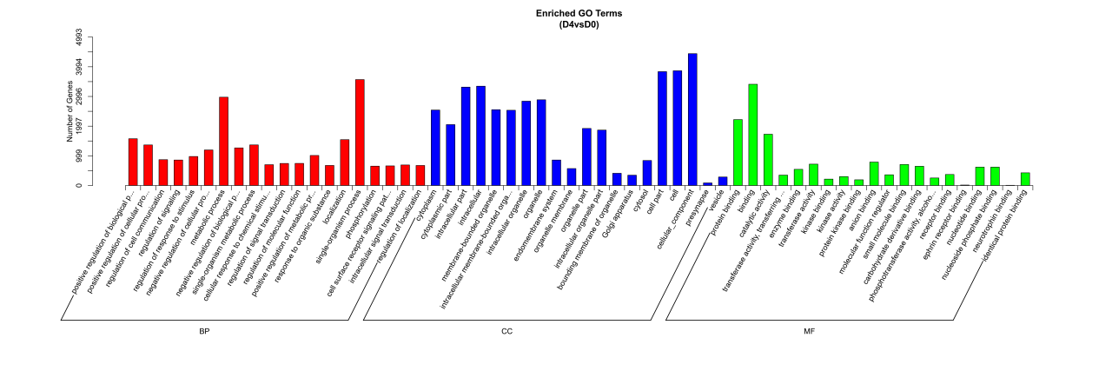
b.
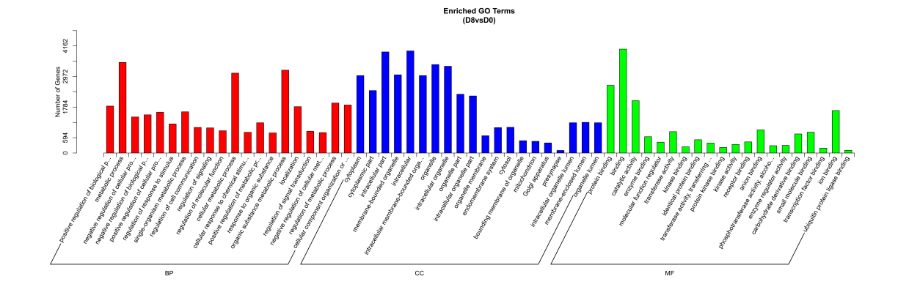
c.
