Table 3: Groundnut landraces and released varieties cultivated in East Hararghe (EH) and East Wellega (EW) zones, their distinguishing features according to local producers interviewed in 2016.

Image of seed | Local name (in Oromiffa) | Meaning of the name | Habit and agronomic features | Culinary and economic features
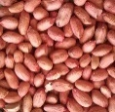 | oldhale or ejja | Prefix ol means ‘up’ and dhale means giving birth; oldhale means pods on the upper surface of the soil | Relatively high yield under optimal and drought conditions because pod does not remain in the soil and is confined to the base of the plant. | Less tasty, not preferred for food. Low nutrient content. Less weight resulting in low market value.
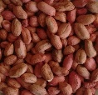 | sartu or sara | sartu and sara both refer to having more vegetative branches. | Traditional, spreading landrace collected from EH zone. Difficult to harvest since it produces pods along all branches and requires more digging. Relatively low yields; some pods lost in soil at harvest, especially under drought condition. Does not tolerate excessive rain (flooding). | Tasty and preferred for food. High nutrient content.  High market value. Highly vegetative and preferred for fodder.
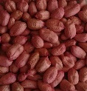 | roba | Named by Haramaya University Research Center. | Early maturing and erect released variety collected from EH Zone. Tolerates drought and is easy to harvest, but sometimes germinates before harvesting, resulting in yield losses. | Less tasty, not preferred for food.  Low market demand and low prices.
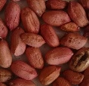 | jambo or yambo | jambo refers to the relatively large size of the pod and seed | Traditional, neglected erect landrace collected from EH zone. Low yield, producing a large number of vegetative branches and few pods. Does not tolerate drought but is easy to harvest. | Less tasty, not preferred for food. No market demand and low prices.
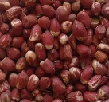 | bure | bure means having multiple of colors, referring to the variegated color of the seed. | Traditional, erect landrace collected from EW zone. Easy to harvest. Sharing many features with oldhale landrace (see above). | Less tasty than dima but used as food.  Low market demand and low prices.
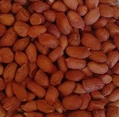 | Dima | ‘Dima’ means a state of having red colors  So groundnut variety with red colored seed | Traditional, spreading landrace collected from EW zone. Does not tolerate drougt. Late (long) maturing. | Tasty and preferred for food. High market demand and high prices.

