Extended Data Figures:

Extended Data Fig.1: Mitochondrial respiration capabilities in LRRK2 BAC-hR1441G mice at 3 months and 6 months of age.

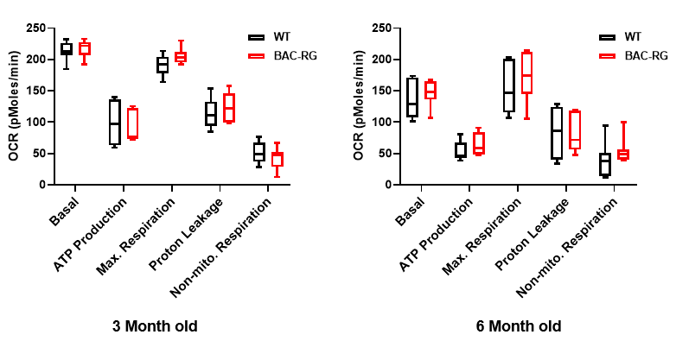

Extended Data Fig.2: Spectrum of roEGFP expressed in SNc dopaminergic neurons under physiological conditions (a) and after treatments with DTT and Ald, respectively (b).

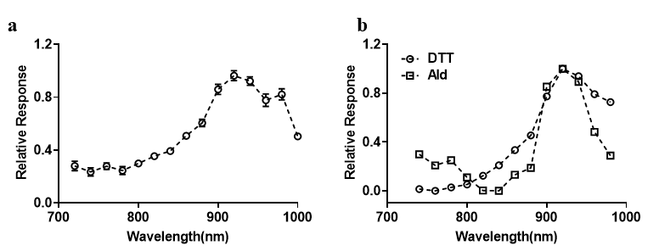

Extended Data Fig.3: Sensitivity of roEGFP to sequential DTT and Ald treatments

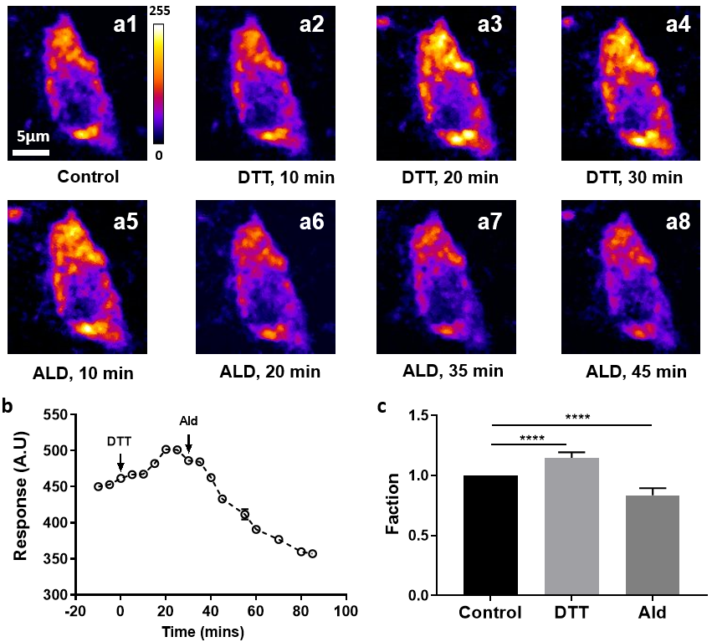

a1–a8, Representative images of SNc dopaminergic neurons at different time points following DTT and Ald treatments. b, Quantification of roEGFP fluorescence response to DTT and Ald treatments. c, Statistical analysis of roEGFP responses to sequential DTT and Ald treatments (N = 4, n = 6).

Extended Data Fig.4: Validation of the ratiometric measuring oxidative levels

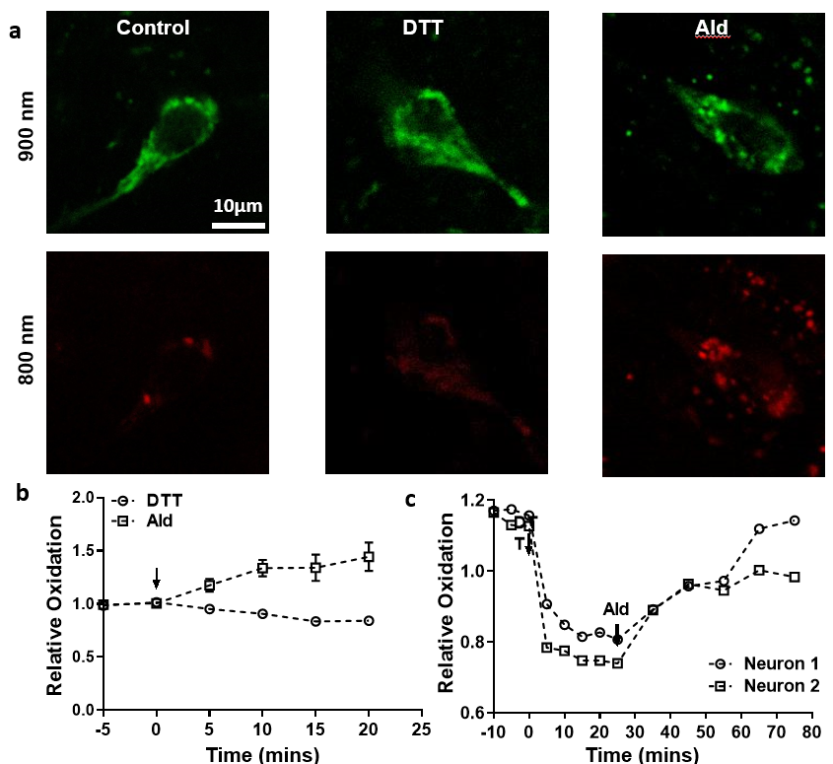

a, Representative roEGFP images under different conditions (left: physiological; middle: fully reduced with DTT; right: fully oxidized with Ald) captured at two excitation wavelengths (900 nm and 800 nm). b, Validation of the ratiometric method for measuring roEGFP response to DTT and Ald treatments individually. c, Validation of the ratiometric method for assessing roEGFP response to sequential DTT and Ald treatments.

Extended Data Fig.5: Oxidative levels in SNc DA neurons in R1441G WT and BAC-hR1441G mice at three different ages

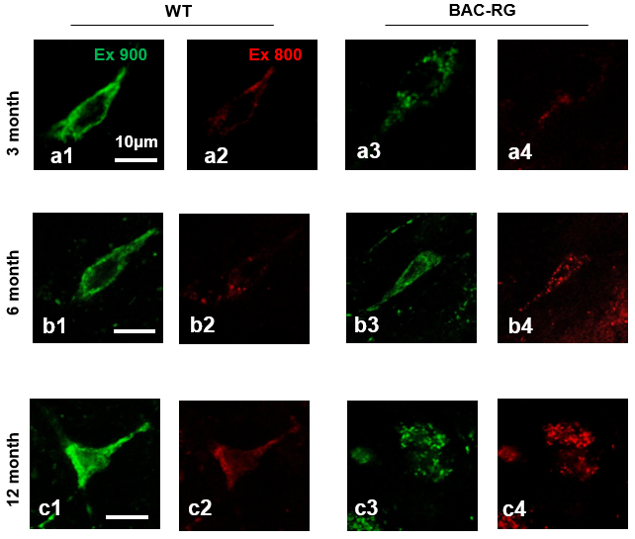
a1-a4, b1-b4, c1-c4, Representative images of roEGFP expressed in SNc dopaminergic (DA) neurons in LRRK2 wild-type (WT) and BAC-RG animal models, excited by two different wavelengths (900 nm and 800 nm), across three age groups: 3 months, 6 months, and 12 months, respectively.

Extended Data Fig.6: Oxidative levels of dSTR DA terminals in LRRK2 WT and BAC-hR1441G mice at three different ages
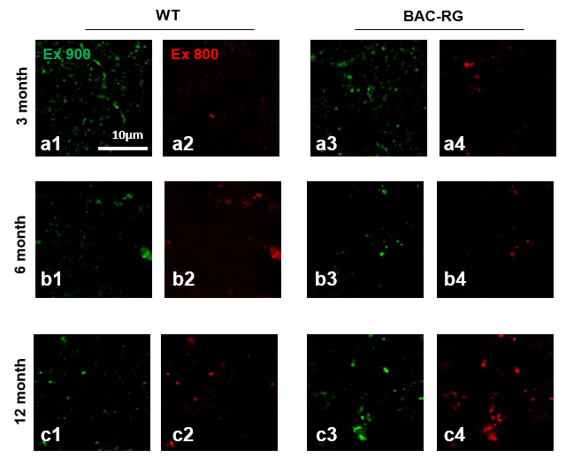
a1-a4, b1-b4, c1-c4, Representative images of roEGFP expression in the striatum of LRRK2 wild-type (WT) and BAC-RG animal models, excited by two distinct wavelengths (900 nm and 800 nm), across three age groups: 3 months, 6 months, and 12 months.

Extended Data Fig.7: Oxidative levels of VTA DA neuron in LRRK2 WT and BAC-hR1441G mice at two different ages
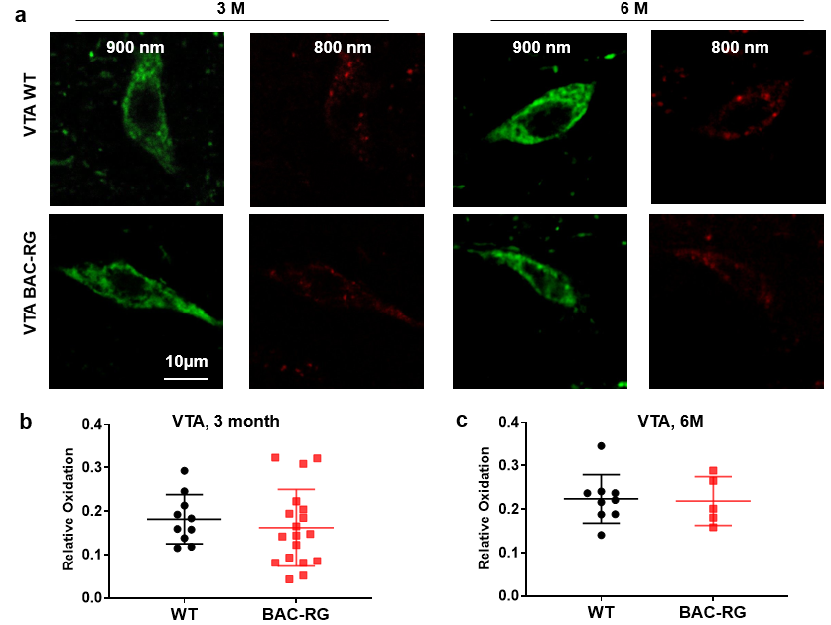

a, Representative roGFP images of DA neurons within VTA area at the excitation of laser beam: 900nm (Green) and 800nm (Red), between WT and BAC-RG at the different ages (3m and 6m). b, quantitation analysis of relative oxidation at 3-month-old animals. (3 pairs, DA neurons: WT, n = 10, BAC-RG, n = 18). c, quantitation analysis of relative oxidation at 6-month-old animal (3 pair, DA neurons: WT, n = 10, BAC-RG, n = 6).

Extended Data Fig.8: Identification of TMRM-labeled SNc DA neurons based on TH-GFP expression
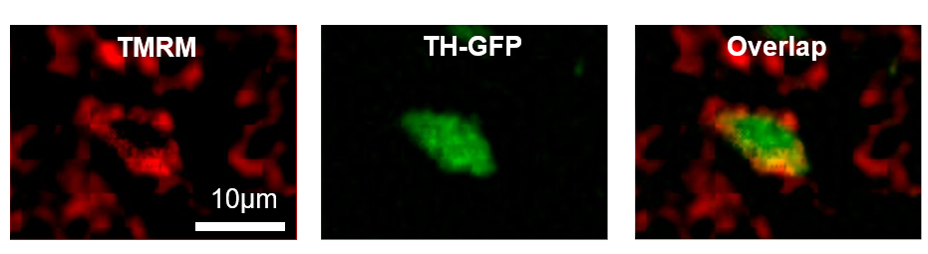

Extended Data Fig.9: hR1441G mutation decreased the aged-dependent flickering events in SNc DA neurons

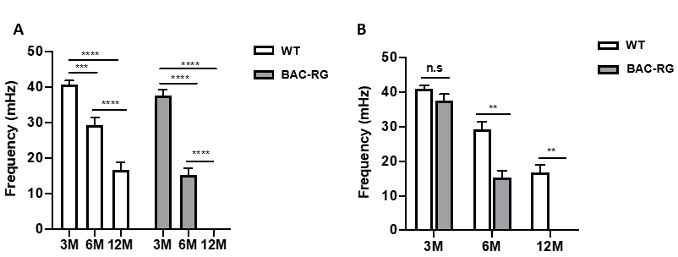

a, MMP flickering events are age dependent. b, MMP flickering frequency decreased in BAC-RG (3-month mice: 3 pair, DA neuron, WT 6, BAC-RG, 6; 6-month mice: 4 pair, DA neurons: WT n = 8, BAC-RG, n = 8; 12-month mice: 3 pair, DA neurons: WT, n = 7, BAC-RG, n = 6).

Extended Data Fig.10: Enrichment analysis of differentially expressed gene (DEG) between LRRK2 BAC-hR1441G and Wildtype in KEGG gene set
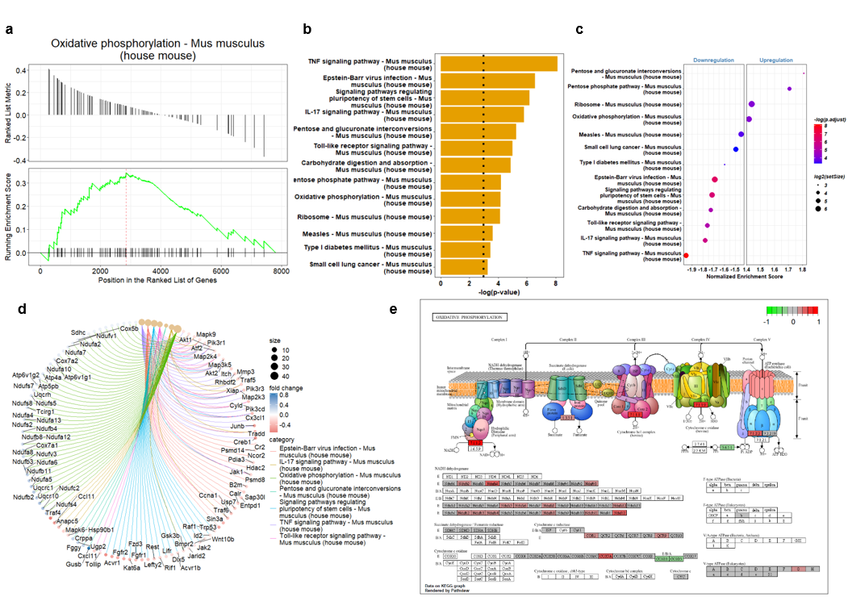

a, Enrichment plot comparing LRRK2 BAC-hR1441G to Wildtype in the KEGG gene set. The peak in the plot reflects the upregulation of gene sets associated with the enrichment term: Oxidative phosphorylation – Mus musculus (house mouse). b, Reactome pathway analysis of differentially expressed genes (DEGs) between LRRK2 BAC-RG and Wildtype. c, Gene set enrichment analysis (GSEA) of the Reactome gene set based on DEGs from LRRK2 BAC-R1441G versus Wildtype, represented as a hierarchically clustered heatmap. The color scale corresponds to the -Log₁₀ of the p-value for the enrichment score, and the size of the circles corresponds to the number of leading genes in each enriched term. d, CNET plot from gene set enrichment analysis, illustrating the complex associations between genes and significantly enriched terms. Node size is proportional to the significance of the enrichment (adjusted p-value), while the color of the gene nodes represents fold change values. Edges indicate the associations between genes and the enriched terms. e, Visualization of the Oxidative phosphorylation enrichment term, highlighting upregulated and downregulated genes.

Extended Data Video Legends

Extended Data Video 1: Representative movies of mitochondrial membrane potential of SNc DA neuron between WT (A) and BAC-RG (B).
Extended Data Video 2: MPG treatment reduced the MMP flickering frequency of SNc DA neurons.
Extended Data Video 3: L-type calcium channel blocker, Isradipine, reduced the MMP flickering frequency of SNc DA neurons.

