Electronic Supplementary Material

Pharmacokinetic modeling of hepatospecific MRI contrast agent flux in large animal models by dynamic contrast-enhanced MRI
Journal: Molecular Imaging and Biology

Matthew T. Latourette^{1,6}, Jeremy M.-L. Hix^{1,6}, Jie Huang¹, Christiane L. Mallett^{1,6}, Kirk A. Muñoz^{5$}, Erik M. Shapiro^{1,2,3,4,6}*
- Department of Radiology, Michigan State University, East Lansing, MI, USA
- Department of Physiology, Michigan State University, East Lansing, MI, USA
- Department of Chemical Engineering and Material Science, Michigan State University, East Lansing, MI, USA
- Department of Biomedical Engineering, Michigan State University, East Lansing, MI, USA
- Department of Small Animal Clinical Sciences, Michigan State University, East Lansing, MI, USA
- Institute for Quantitative Health Science and Engineering, Michigan State University, East Lansing, MI, USA⁶
$. Current Address: Department of Veterinary Clinical Sciences, The Ohio State University, Columbus, OH, USA

Corresponding author:
Erik M. Shapiro, PhD
Department of Radiology
Michigan State University
846 Service Rd
East Lansing, MI, USA, 48824
Tel: +1-(517)-884-3270
Email: shapir86@msu.edu

Results
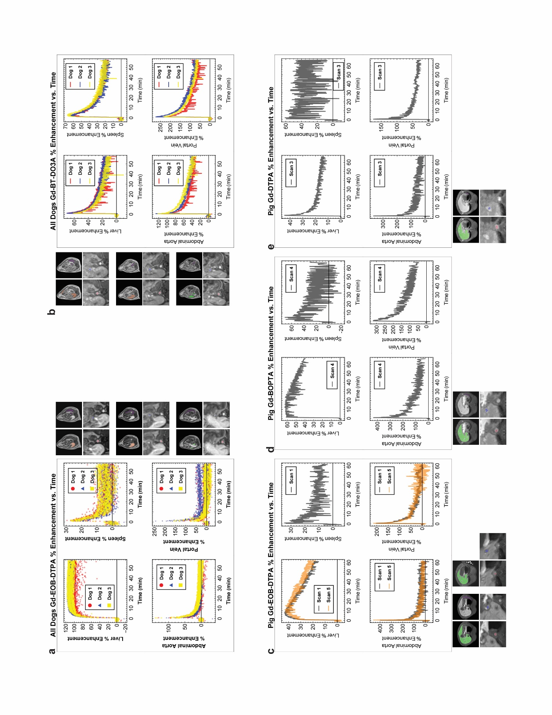
Supplementary Figure 1. Percent Enhancement — Unfiltered Data
This figure presents the same data as Figure 3 in the main text but without applying any noise filtering to the mean ROI signal time series. Single slice examples of the ROIs as well as plots of the percent enhancement are shown. (a,b) Display plots for Gd-EOB-DTPA and Gd-BT-DO3A, respectively, in dogs. (c,d,e) Display plots for Gd-EOB-DTPA, Gd-BOPTA, and Gd-DTPA, respectively, in the pig.

