Supplemental Figures
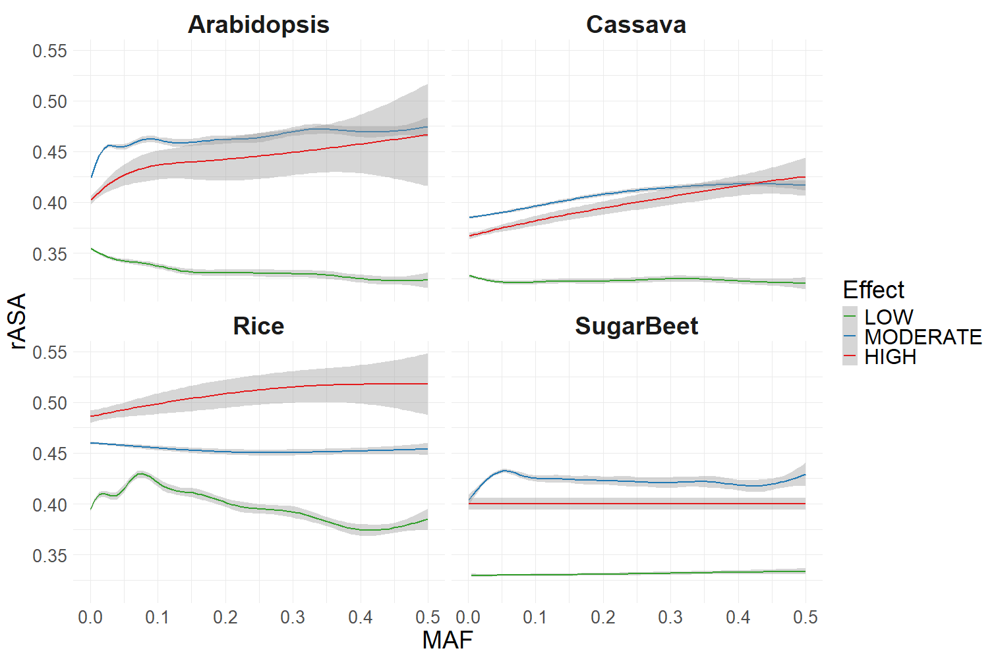
Figure S1. snpEFF Mutation Classes Across Protein Structures (5% tails excluded). The relationship between minor allele frequency (MAF) and relative available surface area (rASA) at mutation positions in protein coding genes is plotted with the geom_smooth function in ggplot2. Mutation effects are classified as low (synonymous), moderate (nonsynonymous or in-frame small indels), and high (frameshift, splice site variants, start-codon loss, etc). Amino acids that fell into the first and last 5% of the protein sequence were excluded.

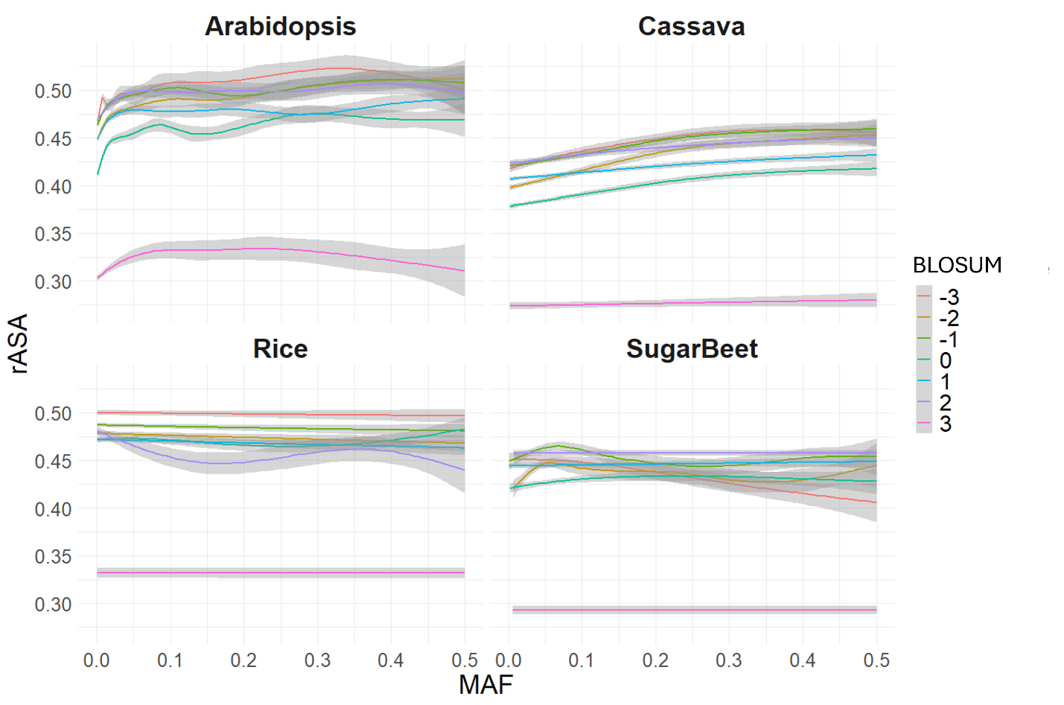
Figure S2. Amino Acid Substitution BLOSUM Scores Across Protein Structures. The relationship between minor allele frequency (MAF) and relative available surface area (rASA) at nonsynonymous mutation positions is plotted with the geom_smooth function in ggplot2. The BLOSUM score given by the BLOSUM62 matrix are shown for nonsynonymous mutations.
BLOSUM

