Supplementary File 2 (Figures and Legends)
(Choroid Plexus Modulates Subventricular Zone Adult Neurogenesis… by Liu L et al)

Figure S1. CP expresses high level of sEV markers.
A | B | C

D |  | E | 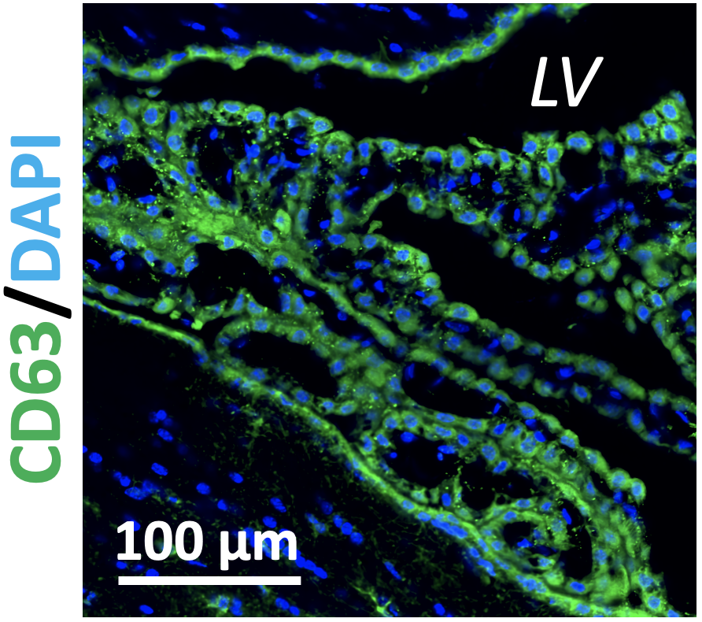 | F | 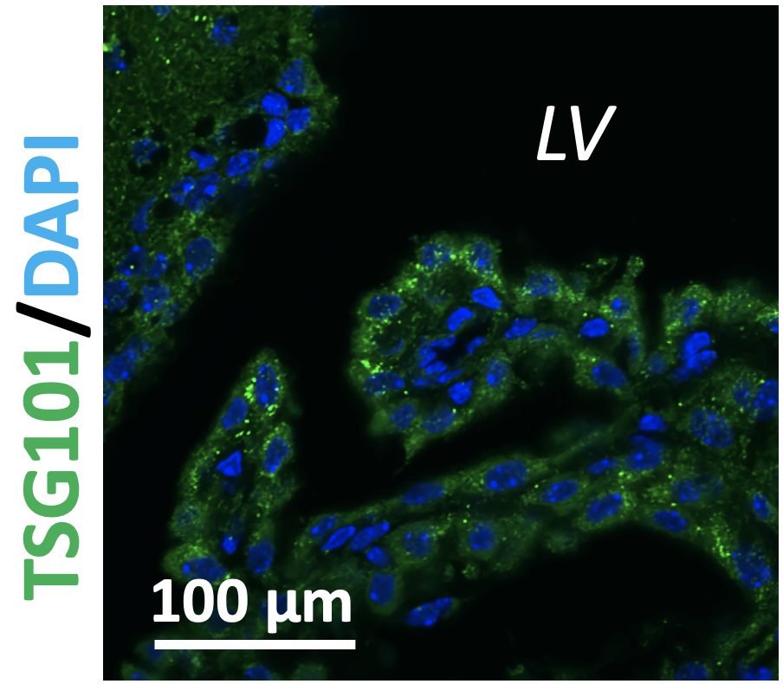

G

(A-D). qPCR analyses for relative expressions of sEV markers across brain regions. Data of Cd9, Cd63, Cd81, and Tsg101 were provided in (A), (B), (C), and (D), respectively (n = 4). ST: striatum; HP: hippocampus; CB: cerebellum.
(E). IHC staining of CD63 in the CP.
(F). IHC staining of TSG101 in the CP.
(G). Effects of storage duration under 37°C on concentration of sEVs (n = 3).

Figure S2. AAV5 does not evidently impact SVZ adult neurogenesis.
A | B | 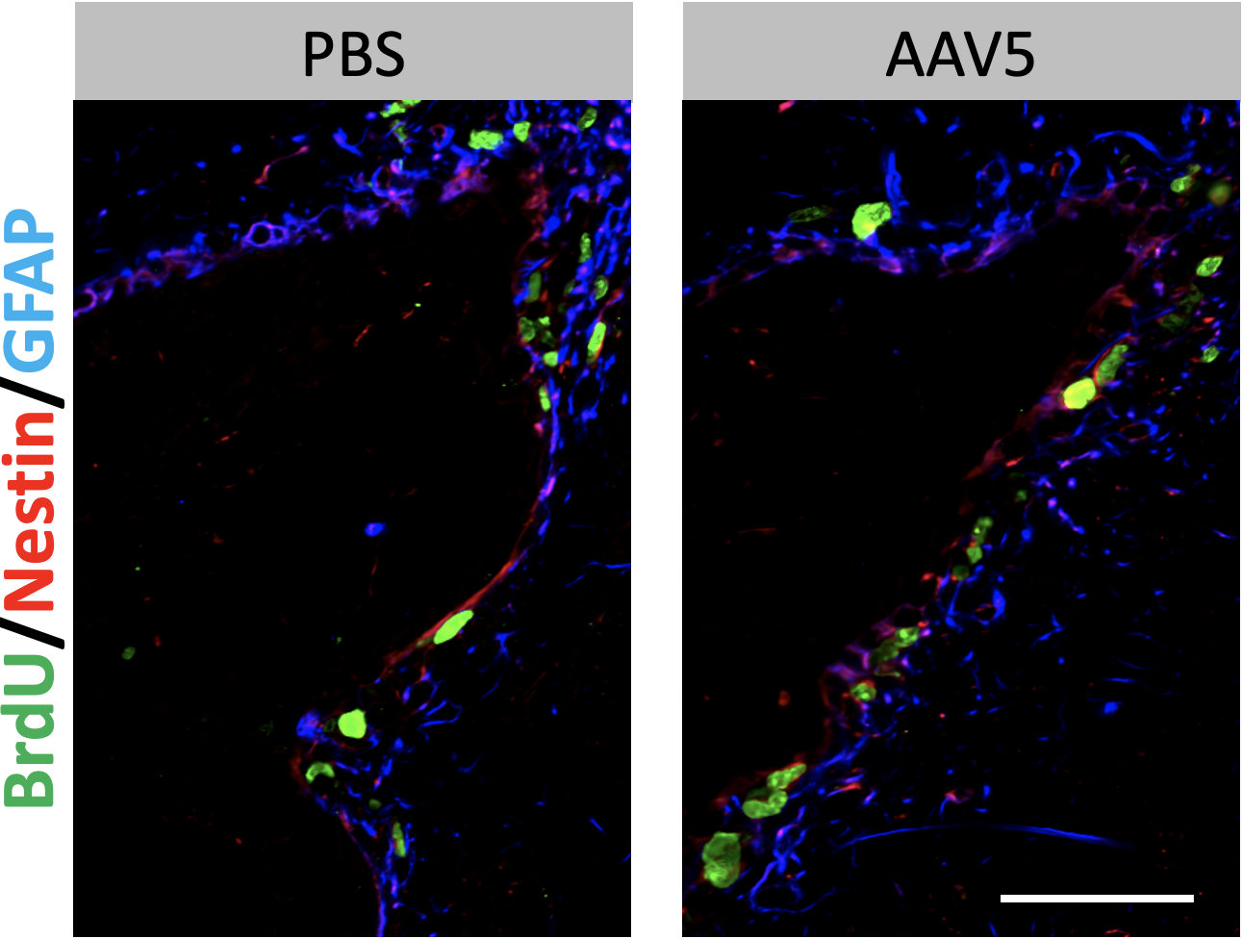 | C
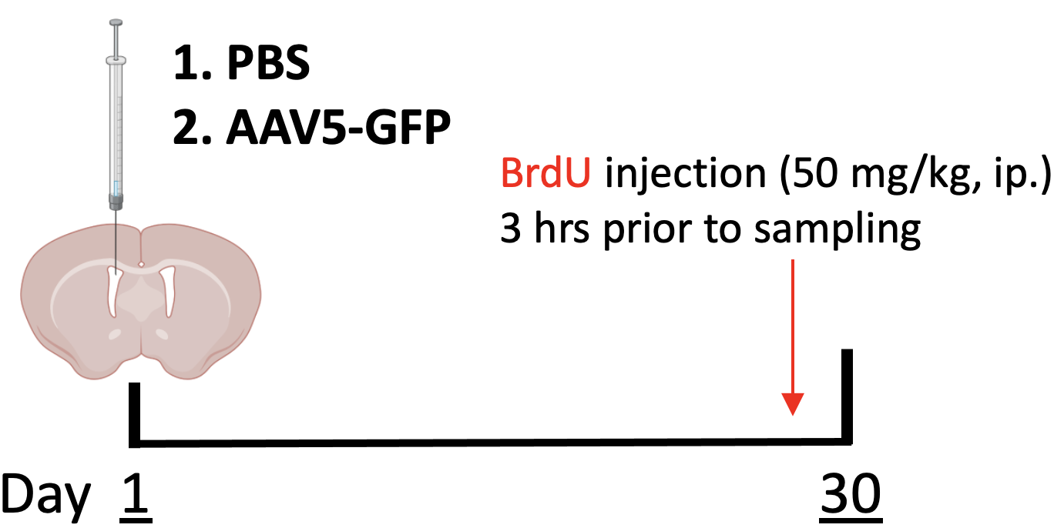

D | 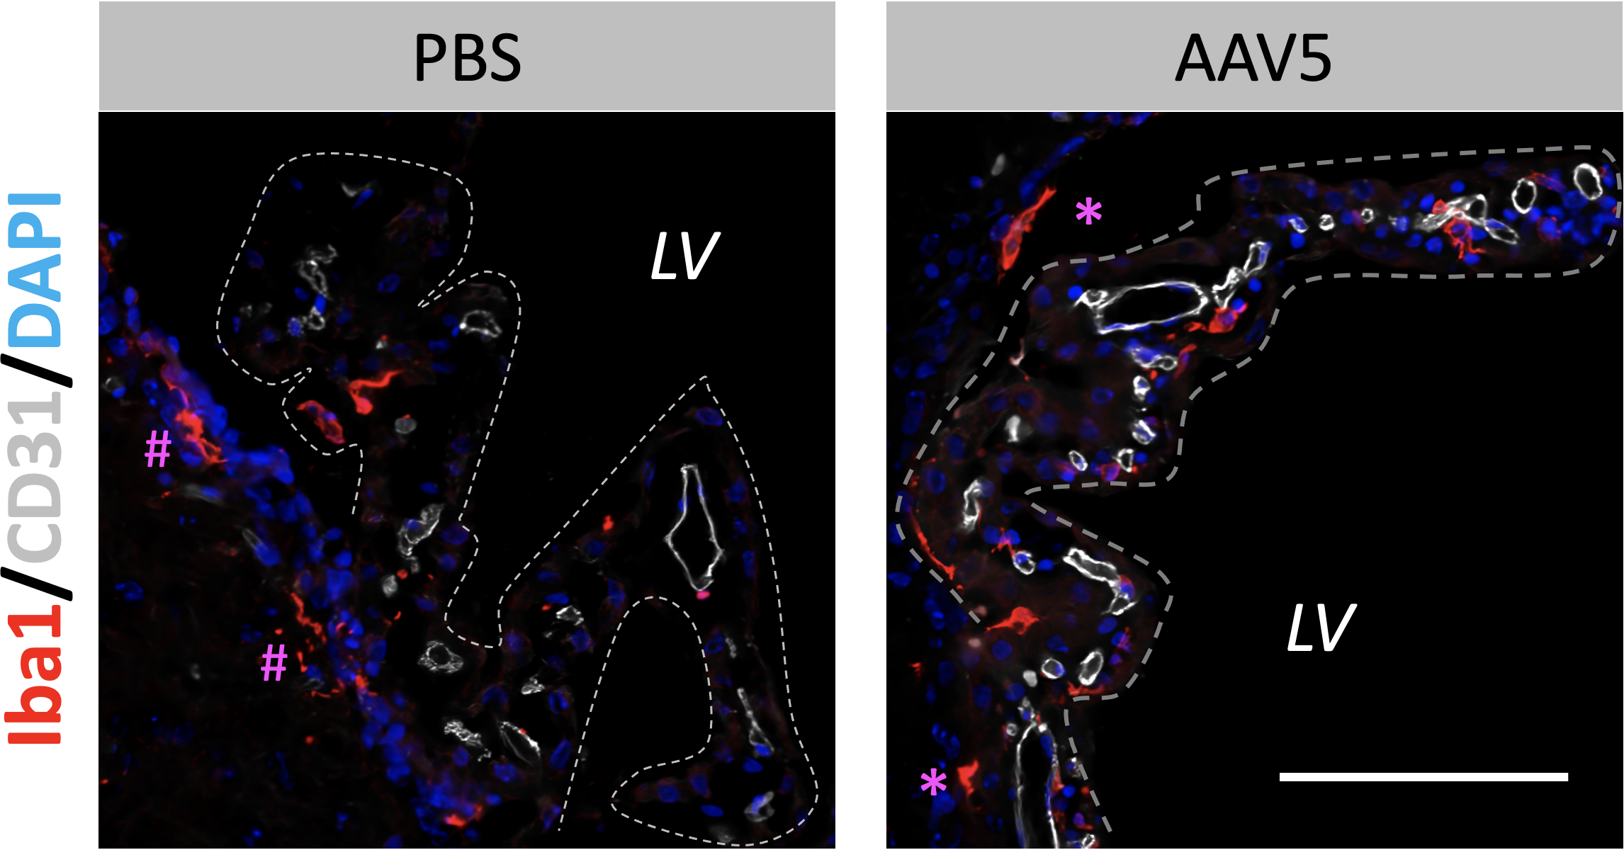 | E |  | F

G |  | 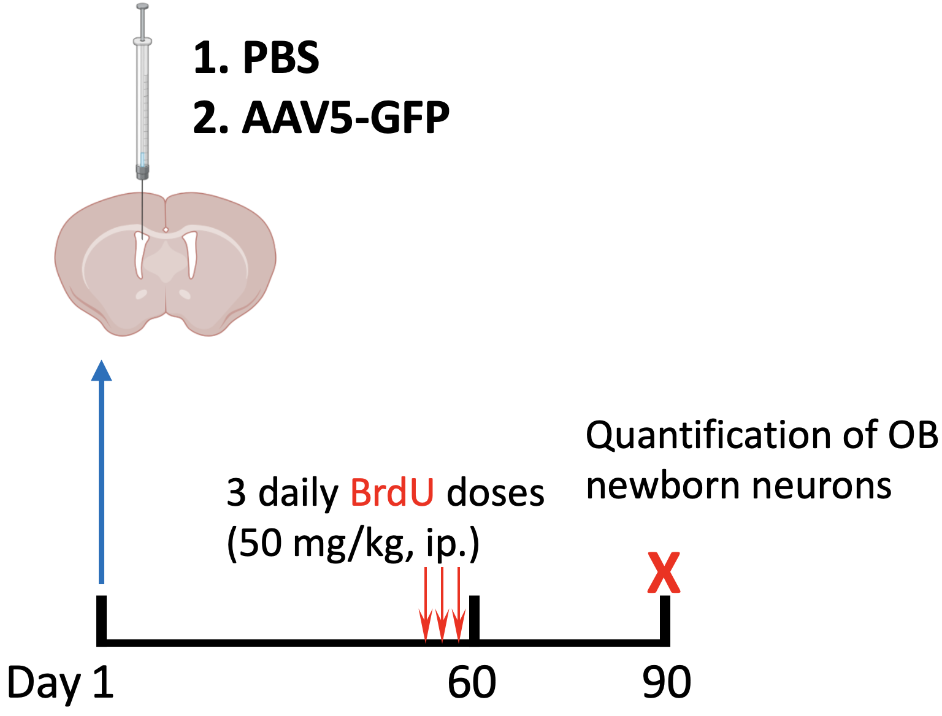 | H |  | 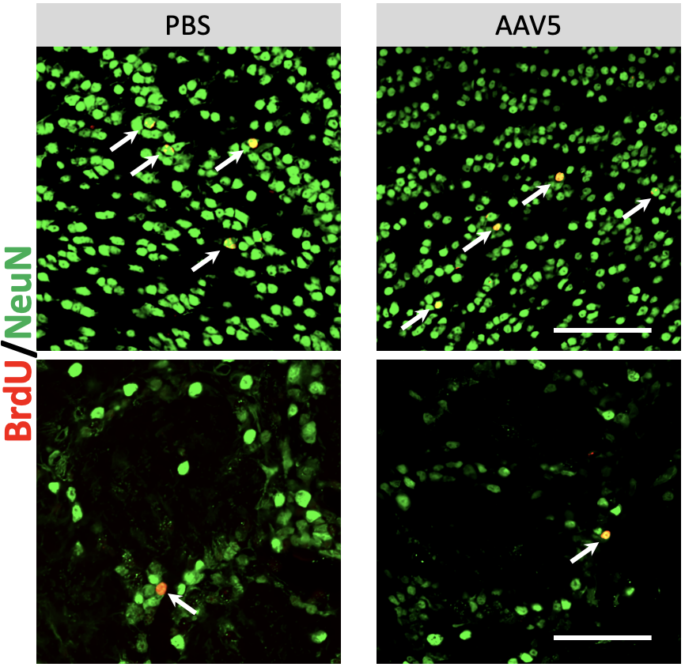
I
J
(A). Experimental timeline assessing the effects of AAV5 ICV injection on proliferation of SVZ NSCs.
(B and C). Representative images and quantification of proliferating SVZ NSCs 30 days post ICV injection of AAV5. Of note, mice used in this experiment were 5-month-old. n =4; scale bar = 100 µm.
(D-F). Representative images and quantification of Iba1(+) cells in the CP and SVZ 30 days post ICV injection of AAV5. Relative Iba1(+) cell density in the CP and SVZ were provided in (E) and (F), representatively. n =3; scale bar = 50 µm.
(G). Experimental timeline assessing the effects of AAV5 ICV injection on SVZ adult neurogenesis to the OB.
(H and I). Representative images and quantification of BrdU(+)/NeuN(+) newborn neurons in the OB. In (H), the upper panel shows newborn neurons in the GCL, and the lower represents newborn neurons in the GL. n =4; scale bar = 50 µm.
(J). Body weight monitor post ICV injections (n = 5).

Figure S3. Glial population in the OB 6 months post CP-targeted SMPD3 knockdown.
A |  | B
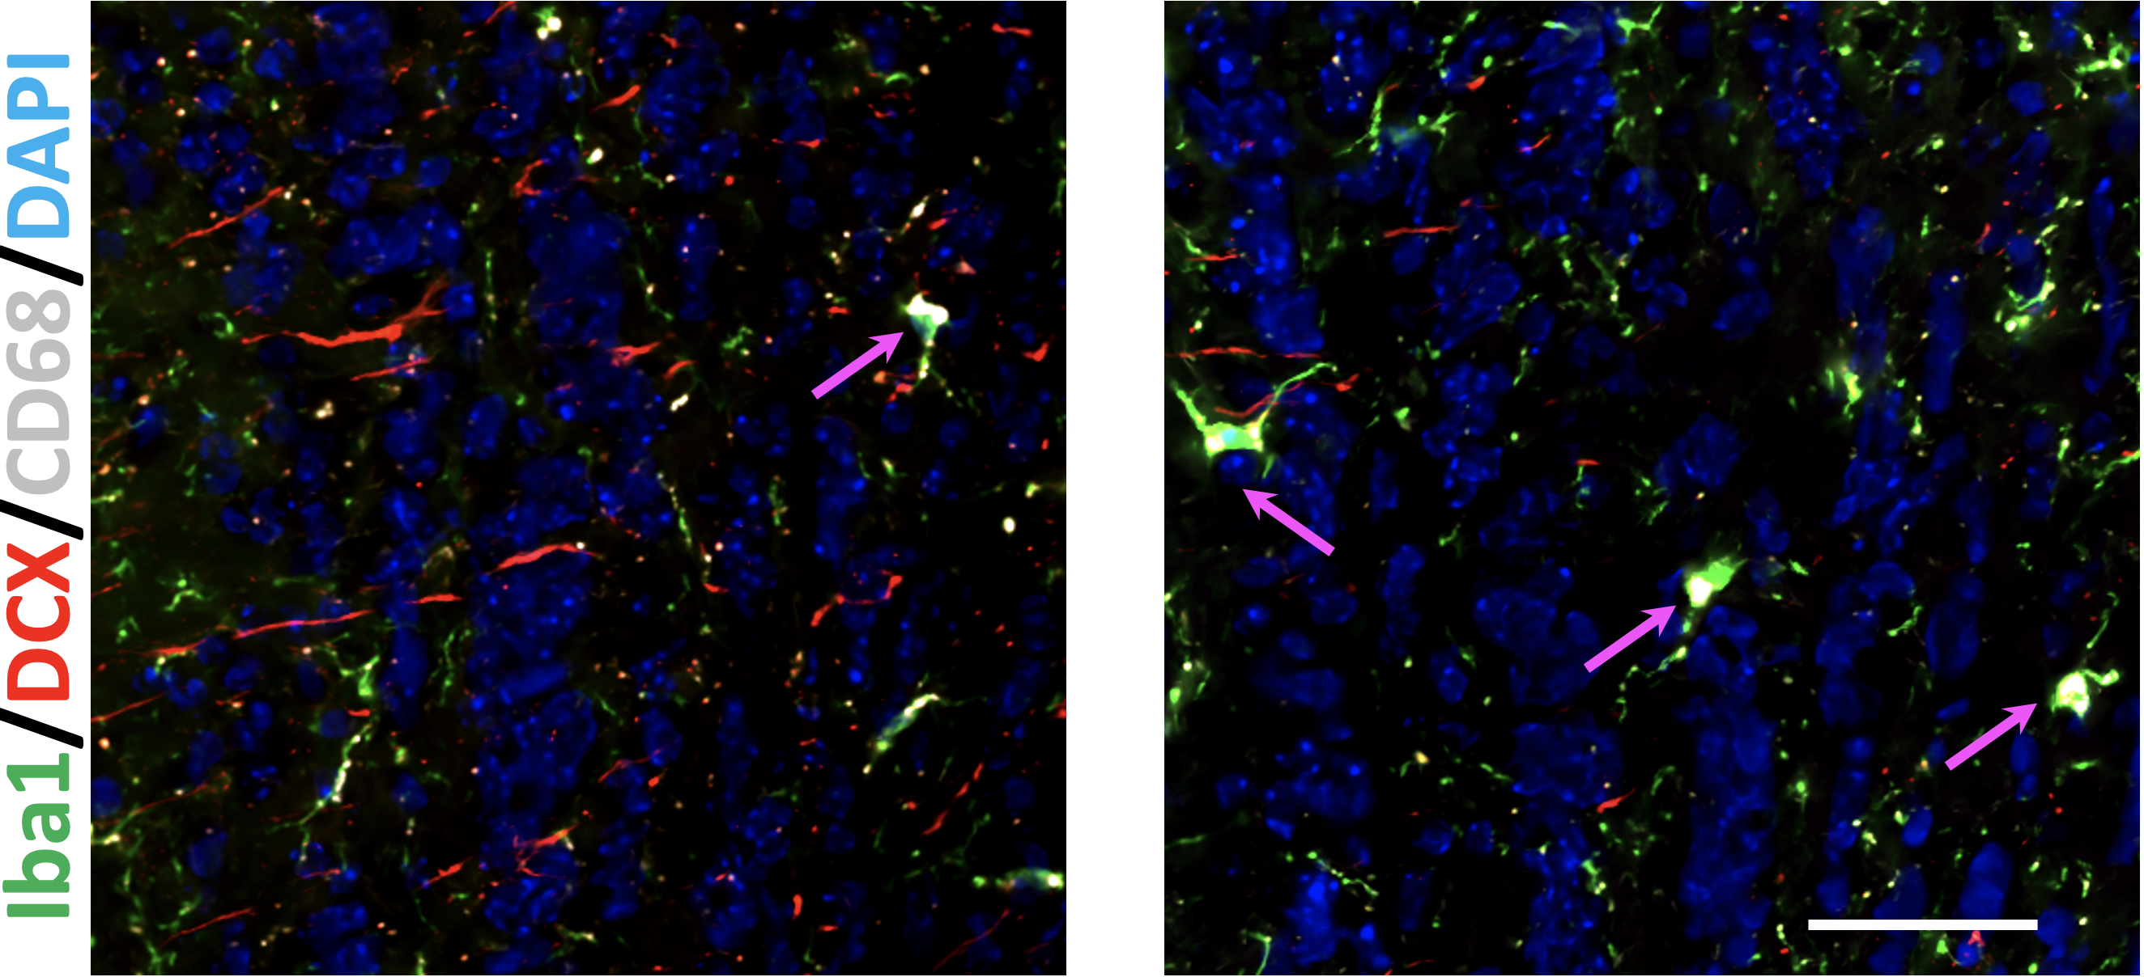
C |  | D
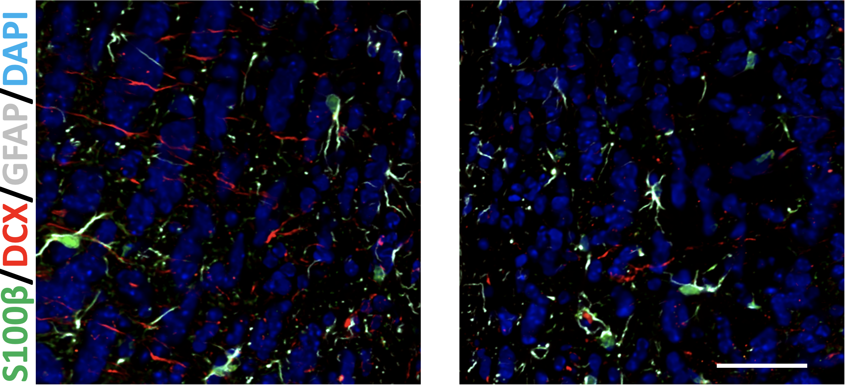
E |  | F
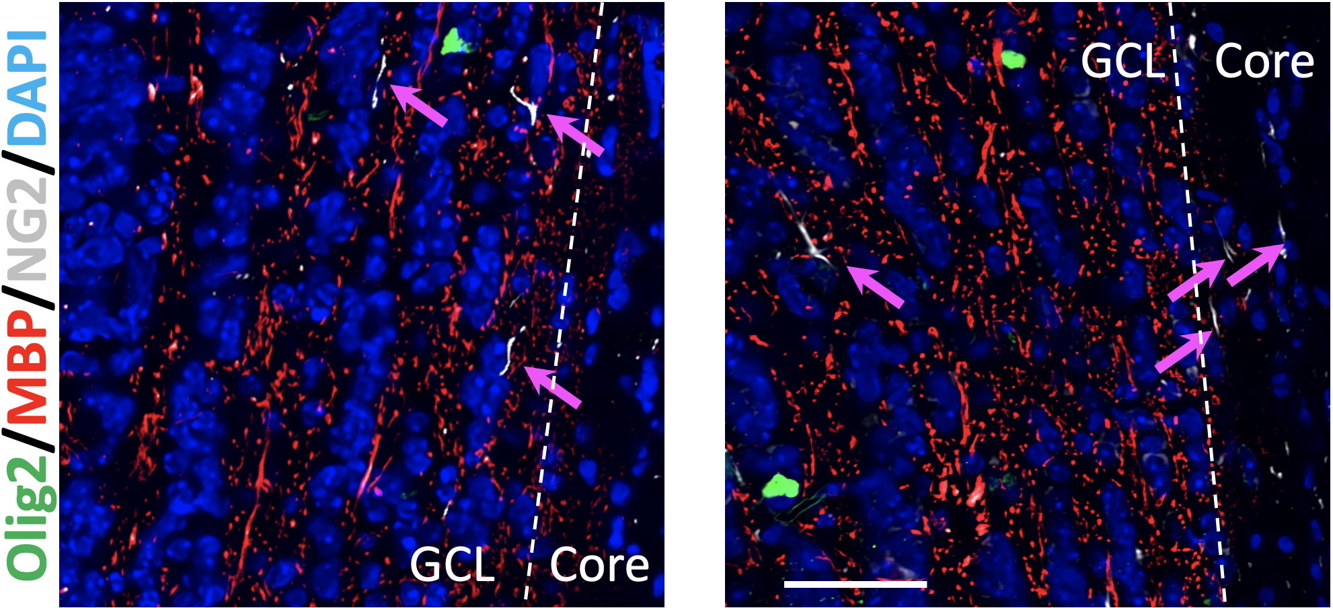
G | H
(A and B). Representative images and quantification of Iba1(+) microglial cells and the CD68(+) activated phenotypes in the OB. n =4; scale bar = 50 µm. Arrows in pink mark enlarged Iba1(+)/CD68(+) cells.
(C and D). Representative images and quantification of GFAP(+)/S100β astrocytes in the OB. n =4; scale bar = 50 µm.
(E). Representative images of oligodendrocyte lineage cells in the OB. Scale bar = 50 µm. Arrows in pink mark bipolar NG2(+) cells.
(F-H). Quantification of MBP fluorescent intensity, Olig2(+) cell density, and NG2(+) cell density in the OB. n =4.

