Supplementary Material

Source code and data explanation
The file all_result_validation.csv includes the results of predicted probabilities of all models for validation set.
The file yangjiang_independent_result.csv includes the results of predicted probabilities of all models for internal test set.
The file external_test.csv includes the results of predicted probabilities of all models for external test set.
The file custom_feature.csv includes all the features required by the CIPR model (only for internal test set).
All above files are obtained by uAI Research Portal system.

The files all_stat_independent.py and all_stat.py performed metrics computing and statistical test analysis on all datasets.
The files plot_figure3.py and plot_figure4.py plot the Figure 3 and Figure 4 of this study.
The files shap_analysis1.py, shap_dependence.py and shap_interaction.py plot the Figure 5d-f, while Figure 5a-c are obtained by uAI Research Portal system.

Identification of PVC
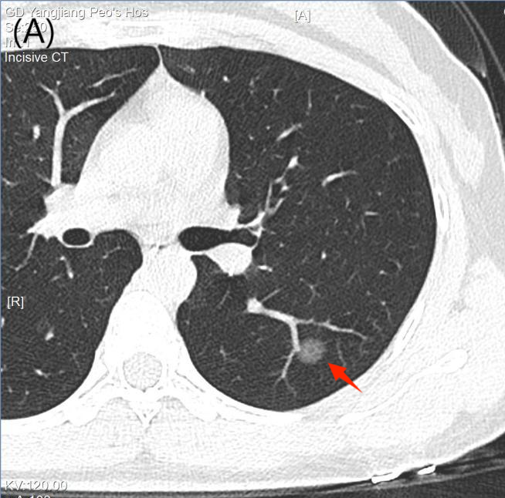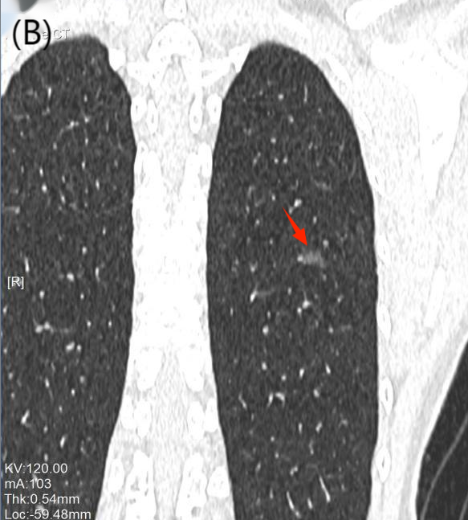
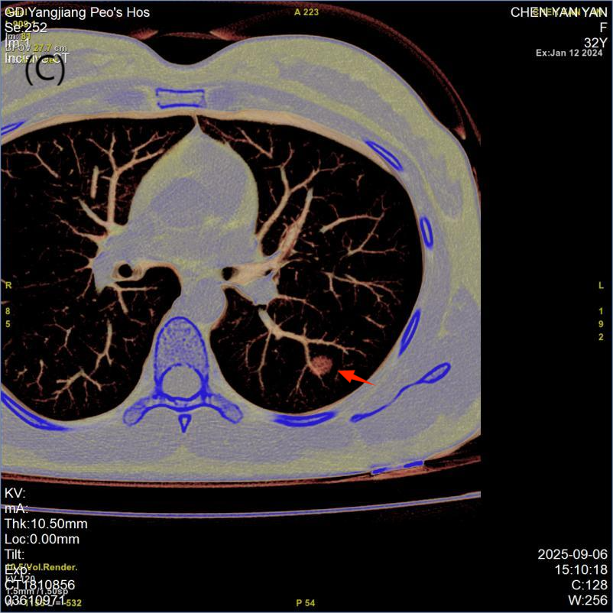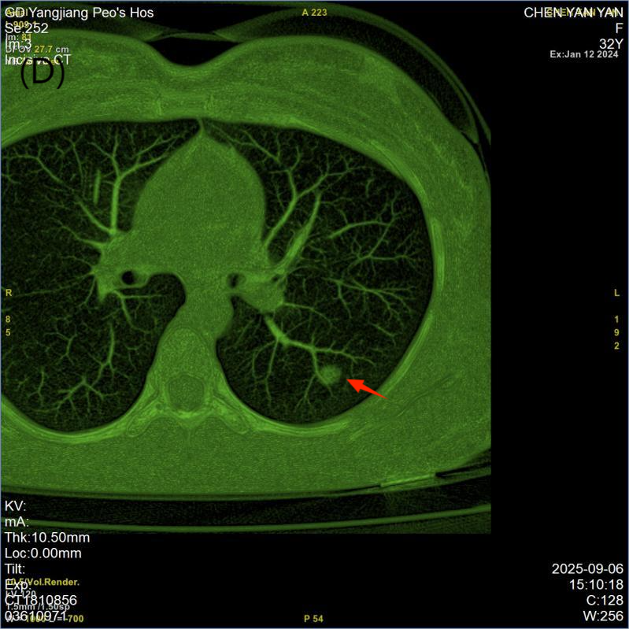
Figure S1. A 32-year-old female with (left upper lobe) adenocarcinoma in situ: the tumor was adjacent to the visceral pleura, with no cancerous invasion of the visceral pleura. The marginal vascular sign was positive.(A) Axial view; (B) Coronal view; (C, D) Volume-rendered images showing a round nodule with a smooth margin and uniform density, accompanied by one proximal blood vessel (thick arrow).
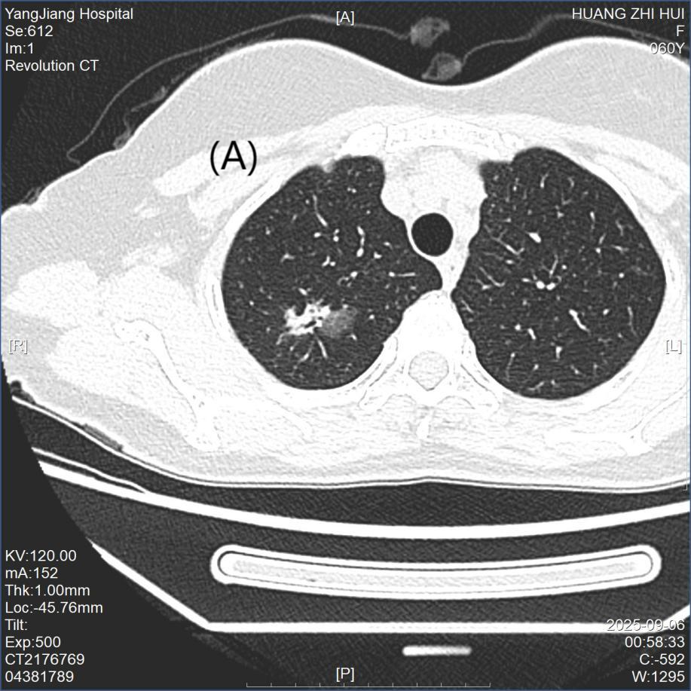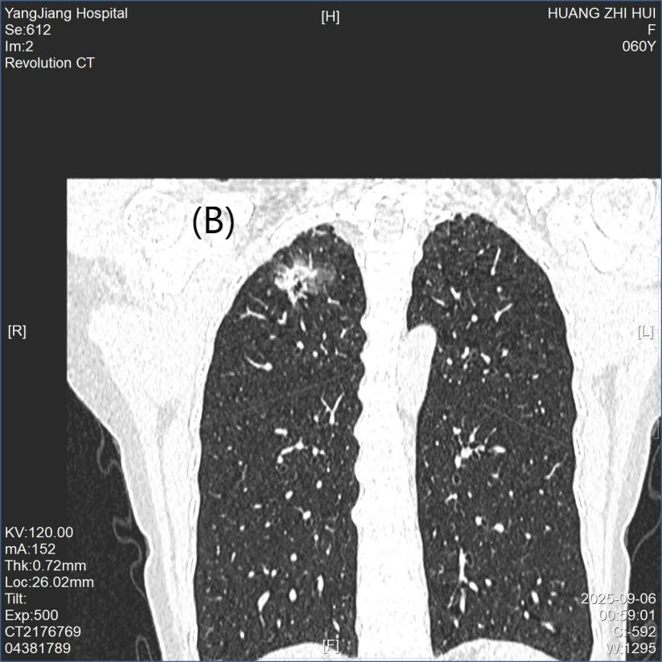
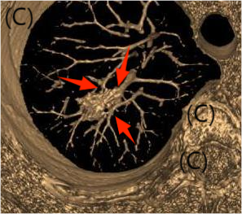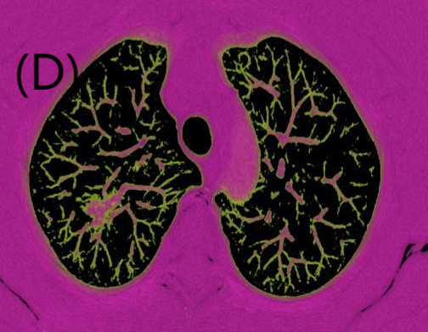
Figure S2. A 60-year-old female with (right upper lobe) invasive adenocarcinoma, acinar-predominant subtype: the marginal vascular sign was positive. (A) Axial view; (B) Coronal view; (C, D) Volume-rendered images showing an irregularly shaped part-solid nodule with heterogeneous density, accompanied by three proximal blood vessels (thick arrows).

