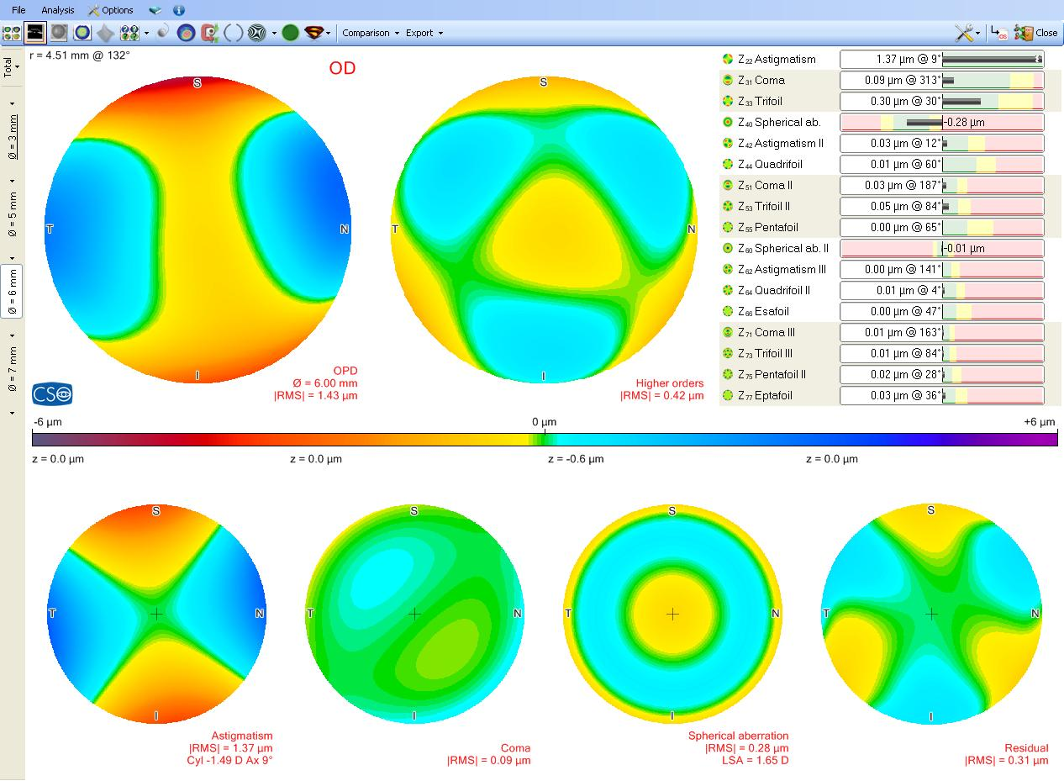
Image1. Sample Sirius corneal aberrometry

