Supplementary data
Figure S1 Venn diagram of genera differences between the FFz group and the CK group on day 5 of the 5th instar stage.
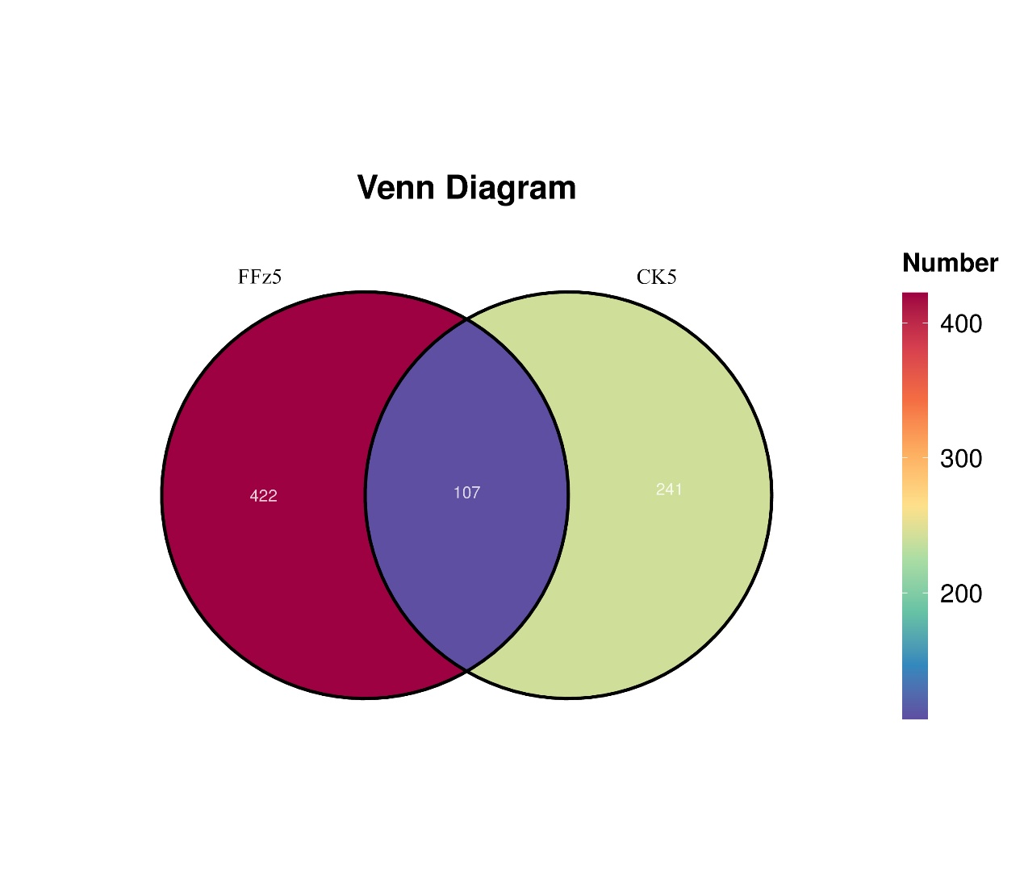

Figure S2 Use LDA and LefSe to analyze the differential flora in the CK group and the FFz group on days 1, 2, 3, and 5. On the left are the differentially abundant genera within the CK group on days 1, 2, 3, and 5. On the right are the differentially abundant genera within the FFz group on days 1, 2, 3, and 5.
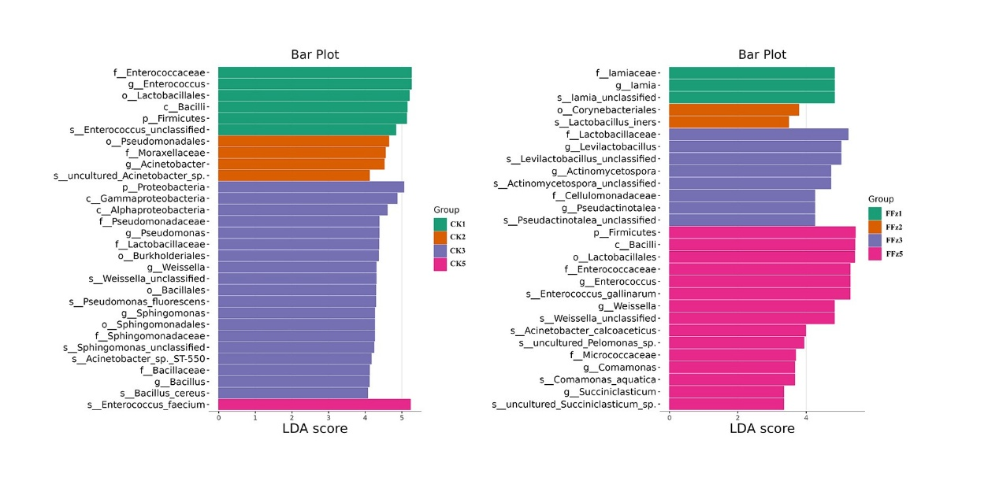

Figure S3 Use LDA and LefSe to analyze the differential flora in the FFy group on days 1, 2, 3, and 5.
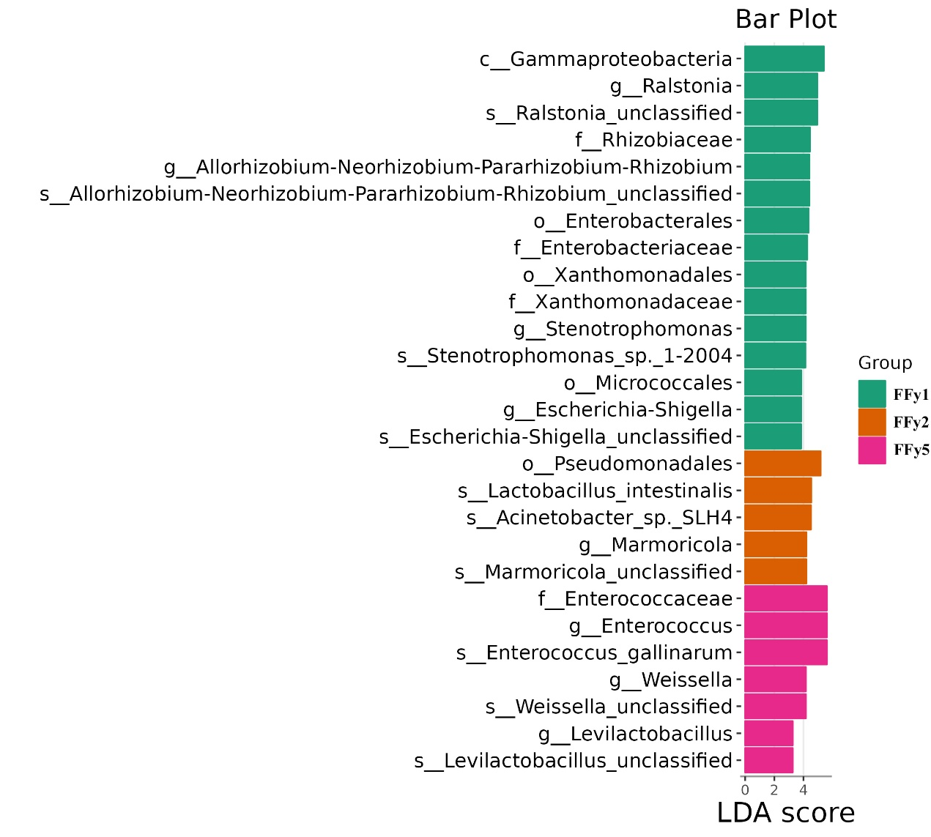

Figure S4 Venn diagram of genera differences between the CY group and the CK group on day 5 of the 5th instar stage.

