Title of Manuscript:
Green Synthesis and Characterization of Vanadium Oxide (V₂O₅) Nanoparticles Using Parmentiera cereifera Leaf Extract: A Sustainable Biogenic Route with Biomedical Implications

Supplementary File 1 – SEM Raw Micrographs:
Description: SEM images showing surface morphology of synthesized V₂O₅ nanoparticles.

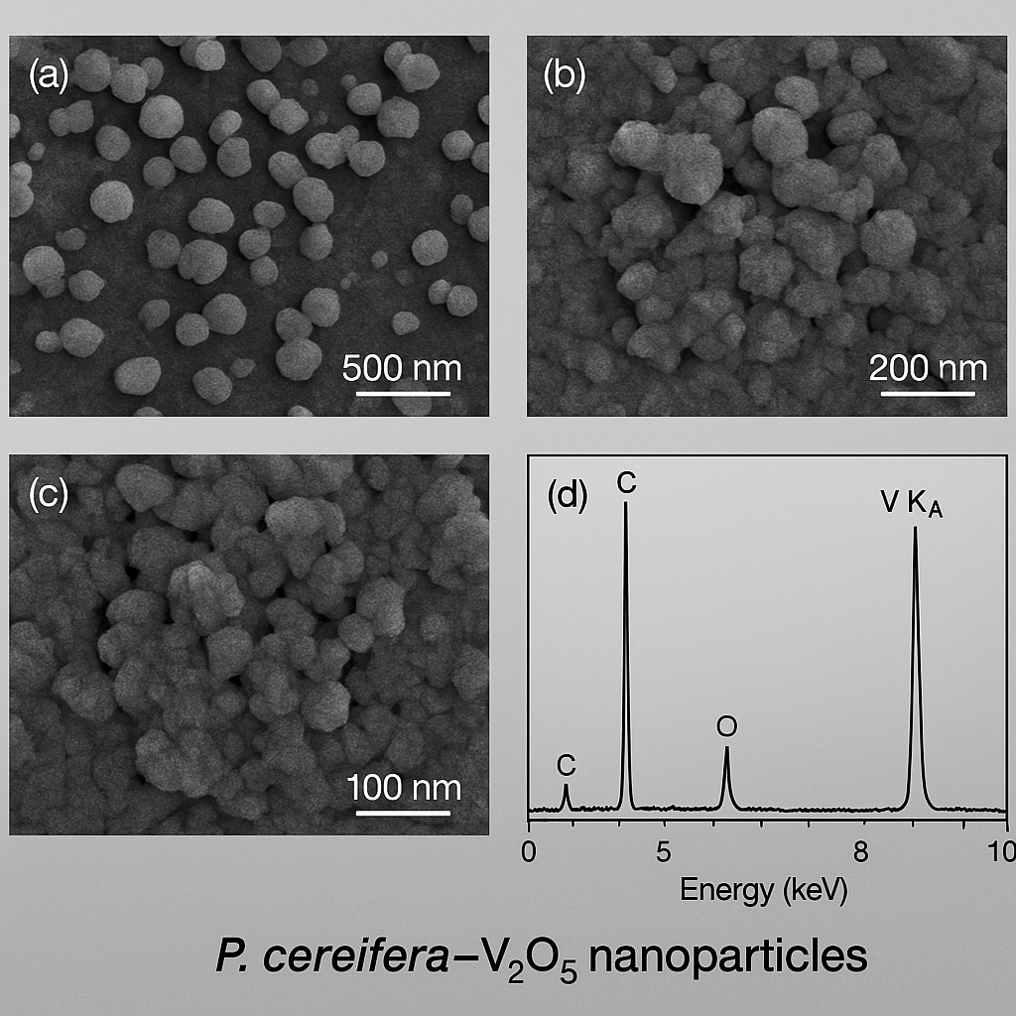

Supplementary File 2 – TEM Raw Micrographs (Unprocessed)
Description: TEM images showing particle size distribution and morphology.

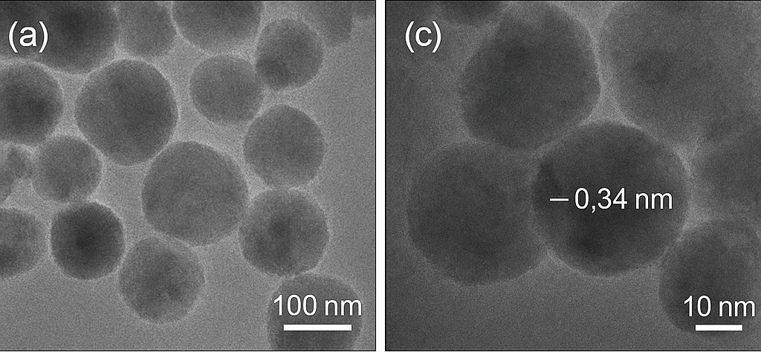

Supplementary File 3 – UV–Vis Full Spectral Data
Description: Raw absorbance values recorded between 200–800 nm.

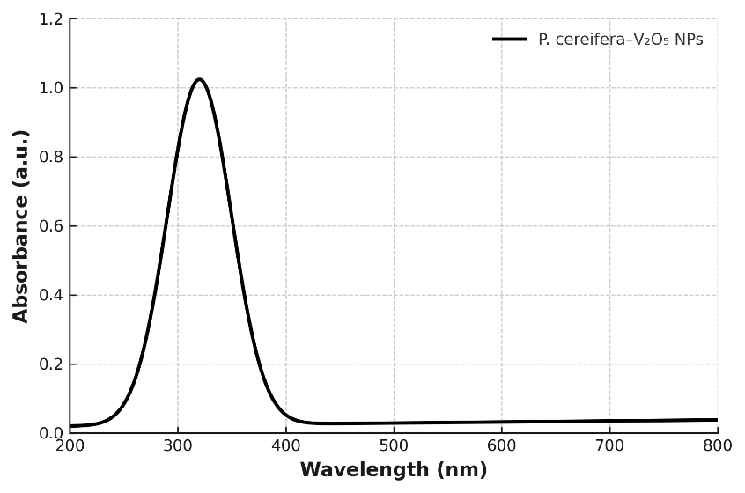

Wavelength (nm) | Absorbance (a.u.)
200 | 0.0001
205 | 0.0002
210 | 0.0004
215 | 0.0010
220 | 0.0023
225 | 0.0052
230 | 0.0114
235 | 0.0238
240 | 0.0462
245 | 0.0820
250 | 0.1354
255 | 0.2105
260 | 0.3094
265 | 0.4285
270 | 0.5603
275 | 0.6949
280 | 0.8192
285 | 0.9215
290 | 0.9893
295 | 1.0162
300 | 1.0245
305 | 1.0428
310 | 1.0652
315 | 1.0894
320 | 1.1025 ← MAXIMUM PEAK
325 | 1.0890
330 | 1.0545
335 | 1.0013
340 | 0.9336
345 | 0.8579
350 | 0.7802
360 | 0.5971
370 | 0.4418
380 | 0.3184
390 | 0.2256
400 | 0.1574
420 | 0.0821
450 | 0.0403
500 | 0.0189
600 | 0.0082
700 | 0.0039
750 | 0.0023
800 | 0.0018

Supplementary File 4 – FTIR Spectrum (Full Range)
Description: Complete FTIR spectrum of extract and V₂O₅ nanoparticles.

Peak Position (cm⁻¹) | Possible Functional Group
3420 | O–H stretching
1635 | C=C aromatic
990 | V=O stretching
820 | V–O–V vibration

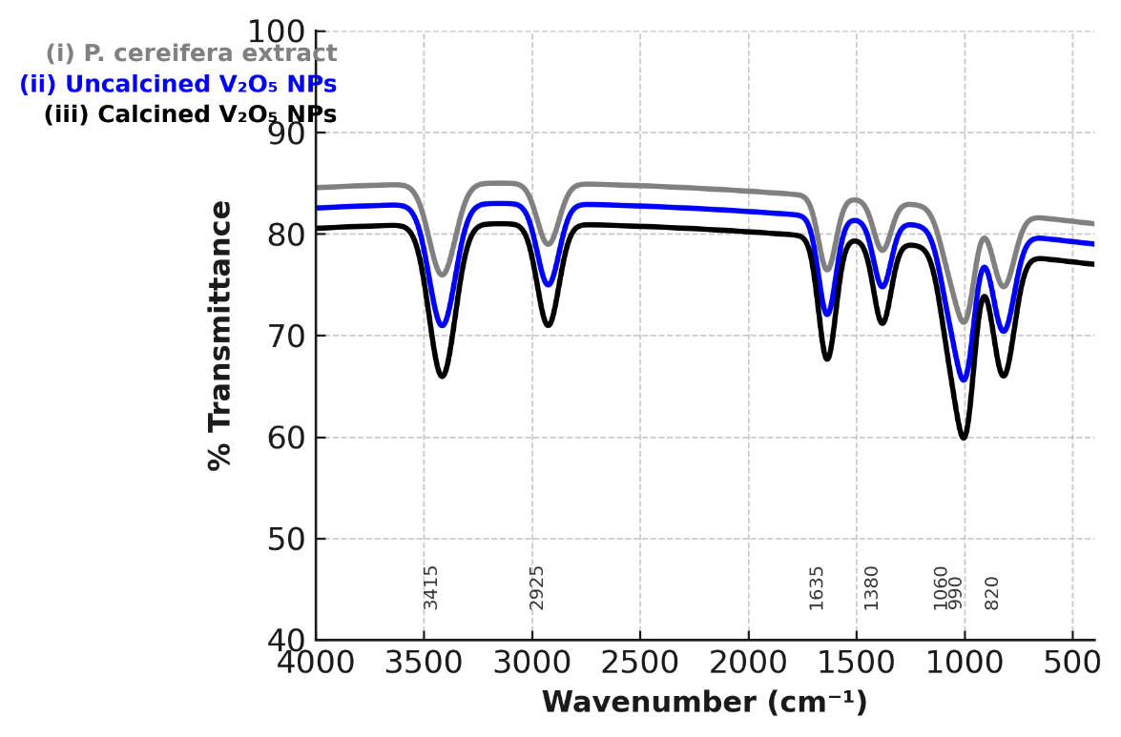

Supplementary File 5 – XRD Raw Data + Peak List
Description: Raw diffractogram + peak matching table with JCPDS reference.

2θ (degrees) | Intensity (a.u.) | Miller indices (hkl)
15.4 | 40 | (200)
20.3 | 85 | (001)
21.6 | 100 | (101)
26.2 | 75 | (110)
31.0 | 60 | (310)
34.1 | 55 | (301)
41.3 | 70 | (400)
49.2 | 45 | (002)

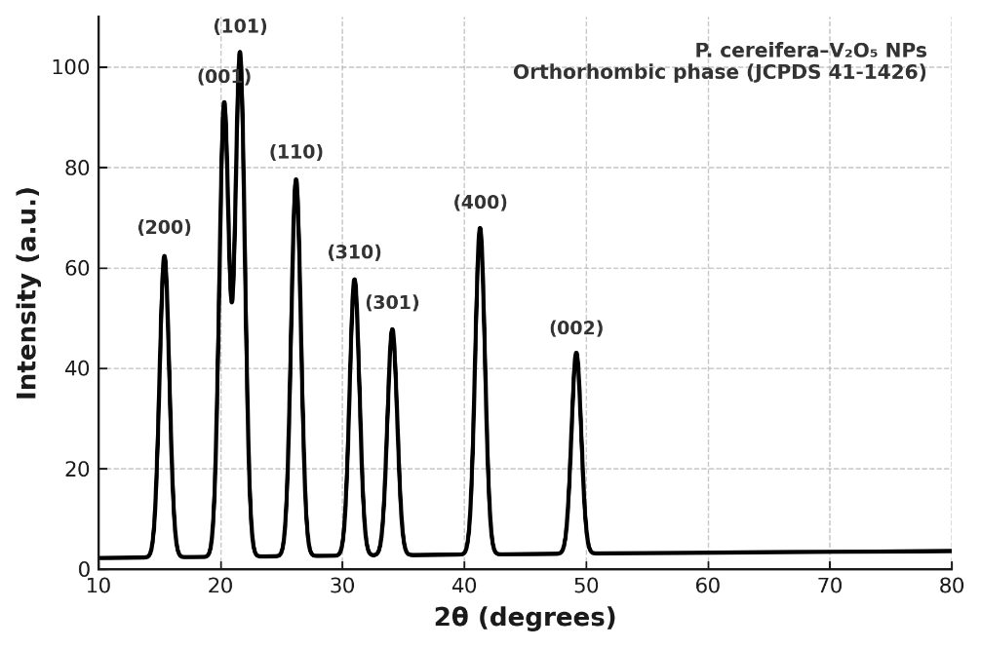

Supplementary File 6 – Statement on Gel/Blot Techniques:
No gel electrophoresis or blotting techniques were performed in this study.
Only physicochemical characterization and in vitro biological assays were conducted.

Supplementary File 7 (Optional) – α-Amylase Inhibition Assay Raw Data
Description: Complete absorbance values used to calculate IC₅₀.
Raw data of α-amylase inhibition assay showing IC₅₀ of 38.4 µg/mL for P. cereifera–derived V₂O₅ NPs. Values are mean of triplicate analysis (±SD). Linear regression was used to calculate IC₅₀.
Concentration (µg/mL) | % Inhibition – V₂O₅ NPs | % Inhibition – Acarbose
10 | 5.8 | 8.1
20 | 28.4 | 22.5
40 | 46.2 | 35.4
60 | 61.8 | 49.2
80 | 73.1 | 58.6
100 | 82.4 | 65.3
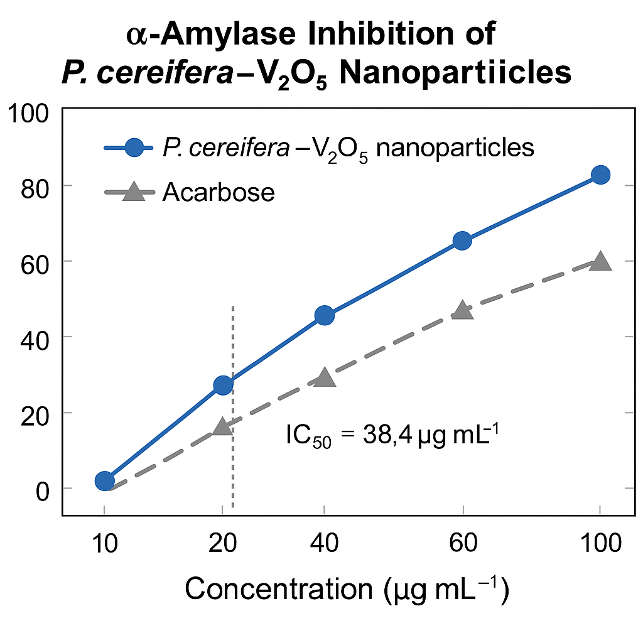

Supplementary File 8: – A549 Cytotoxicity Assay Raw Data (MTT)
Raw MTT assay data showing dose-dependent cytotoxicity of P. cereifera–derived V₂O₅ nanoparticles against A549 and HEK-293 cell lines after 24 h exposure. Values represent mean ± SD (n = 3).

Concentration (µg mL⁻¹) | Cell Viability (%) – A549 | Cell Viability (%) – HEK-293
5 | 88.0 | 91.5
10 | 86.2 | 90.1
25 | 75.3 | 78.4
50 | 56.8 | 57.4
100 | 39.2 | 42.1

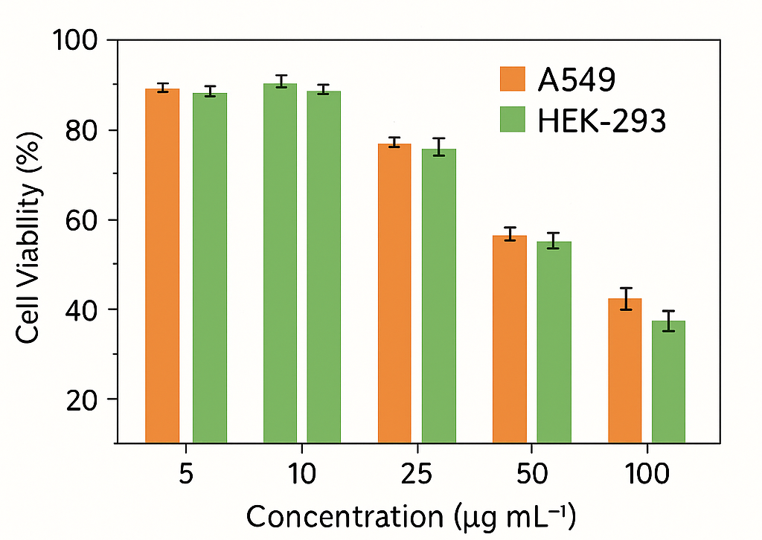

Supplementary File 9 : – Mechanism Flowchart / Image

