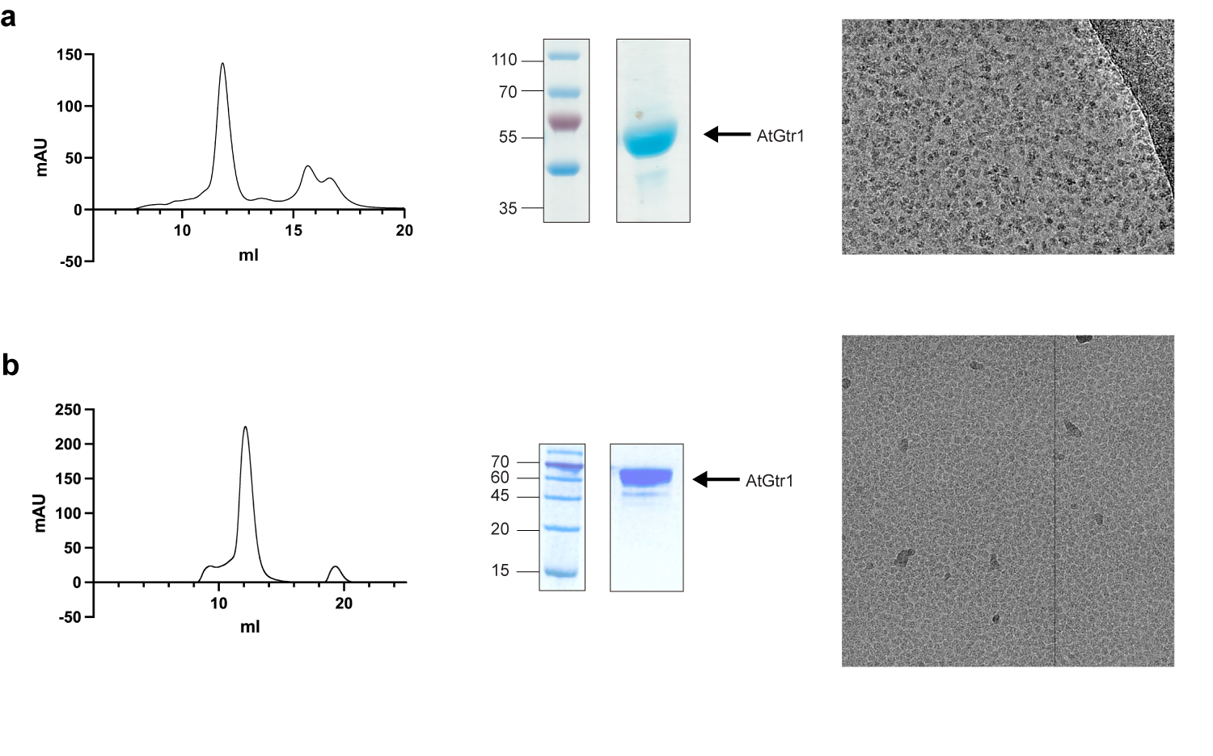
Supplementary Fig. 1 Purification and cryo-EM micrograph of GTR1. a-b Representative size-exclusion chromatography (SEC) profile of the detergent-purified GTR1 expressed in yeast (a) or Sf9 cells (b). Pooled peak fractions used for cryo-EM grid preparation are shown by Coomassie blue-stained SDS-PAGE. Representative motion-corrected EM micrograph of apo GTR1 at pH 8.0 (a) and pH 6.0 (b).

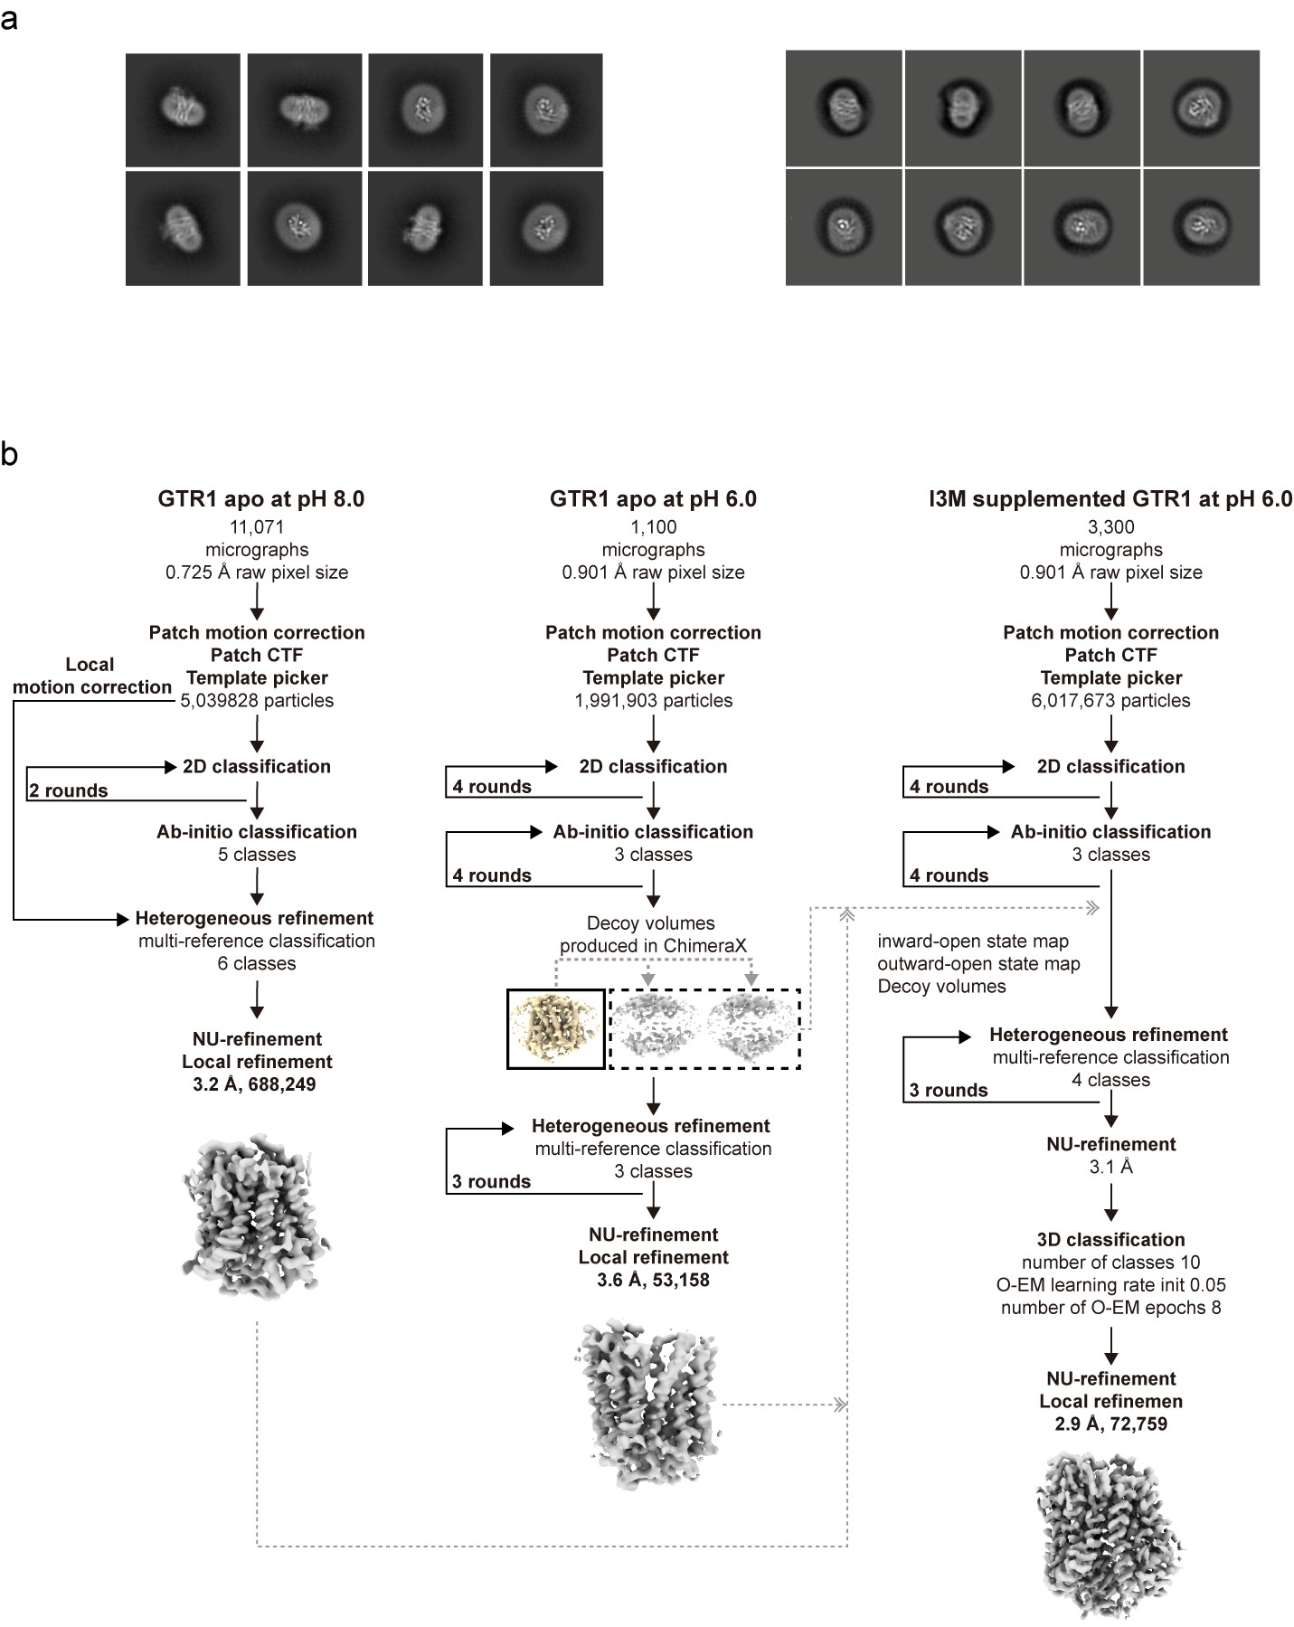
Supplementary Fig. 2 cryo-EM image processing of GTR1. a Representative reference-free 2D class averages of GTR1. b Flowchart for cryo-EM data processing for GTR1 at pH 8.0, GTR1 at pH 6.0, and I3M-supplemented GTR1 at pH 6.0.
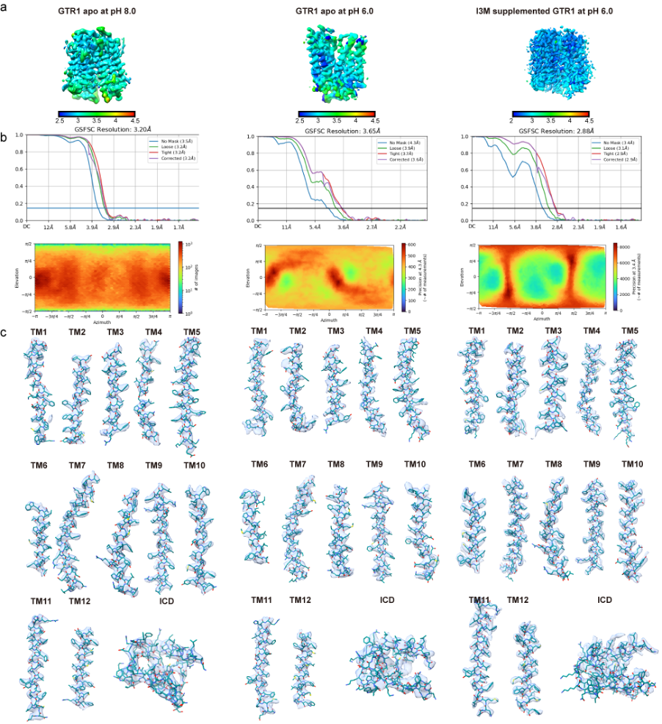Supplementary Fig. 3 cryo-EM data validations. a Local Resolution estimation of final cryo-EM reconstructions. b Fourier-shell correlation and projection orientation distribution map for the final reconstruction generated from cryoSPARC. c cryo-EM maps for secondary structure segments. From left to right are cryo-EM data validations for GTR1 inward-open at pH 8.0, outward-open at pH 6.0, and inward-open I3M-bound structures.

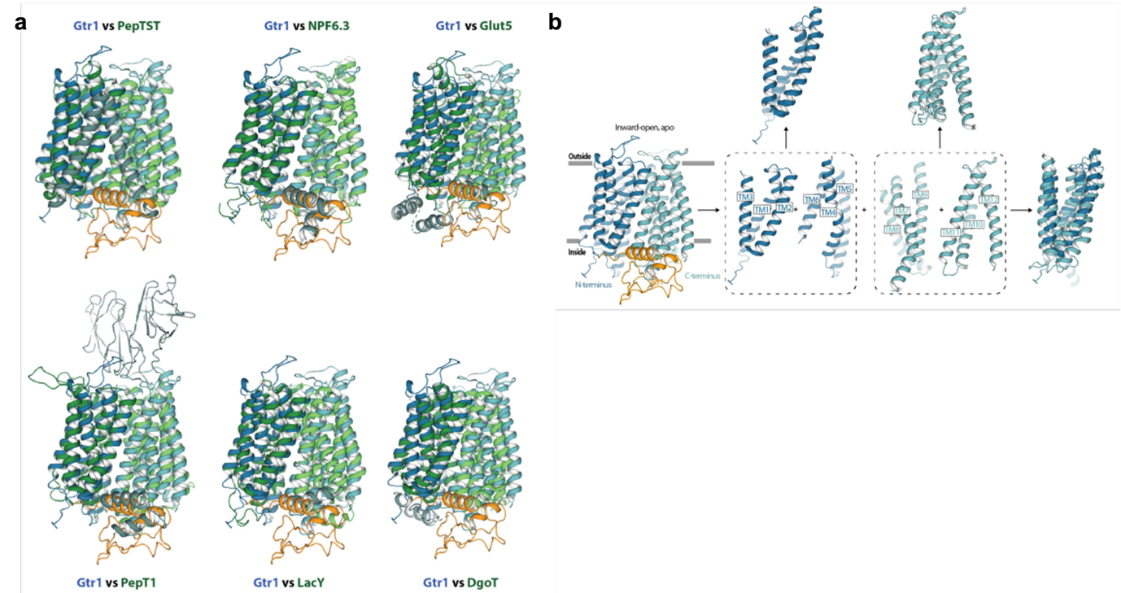
Supplementary Fig. 4 Canonical MFS fold and inverted repeats. a Super position of inward-open apo GTR1 to MFS transporters (N- and CTD are shown in dark and light green, respectively). The employed PDB-IDs were 6FMR (PepTSt), 5A2O (NPF6.3), 4YB9 (Glut5), 7S8U (PepT1), 1PV6 (LacY) and 6E9N (DgoT). b The N- and CTDs each consist of a pair of inverted repeats, establishing a (3+3)+(3+3) TM fold, by rotating each 3-TM bundle 180 degrees relative to an axis roughly parallel to the putative membrane plane.

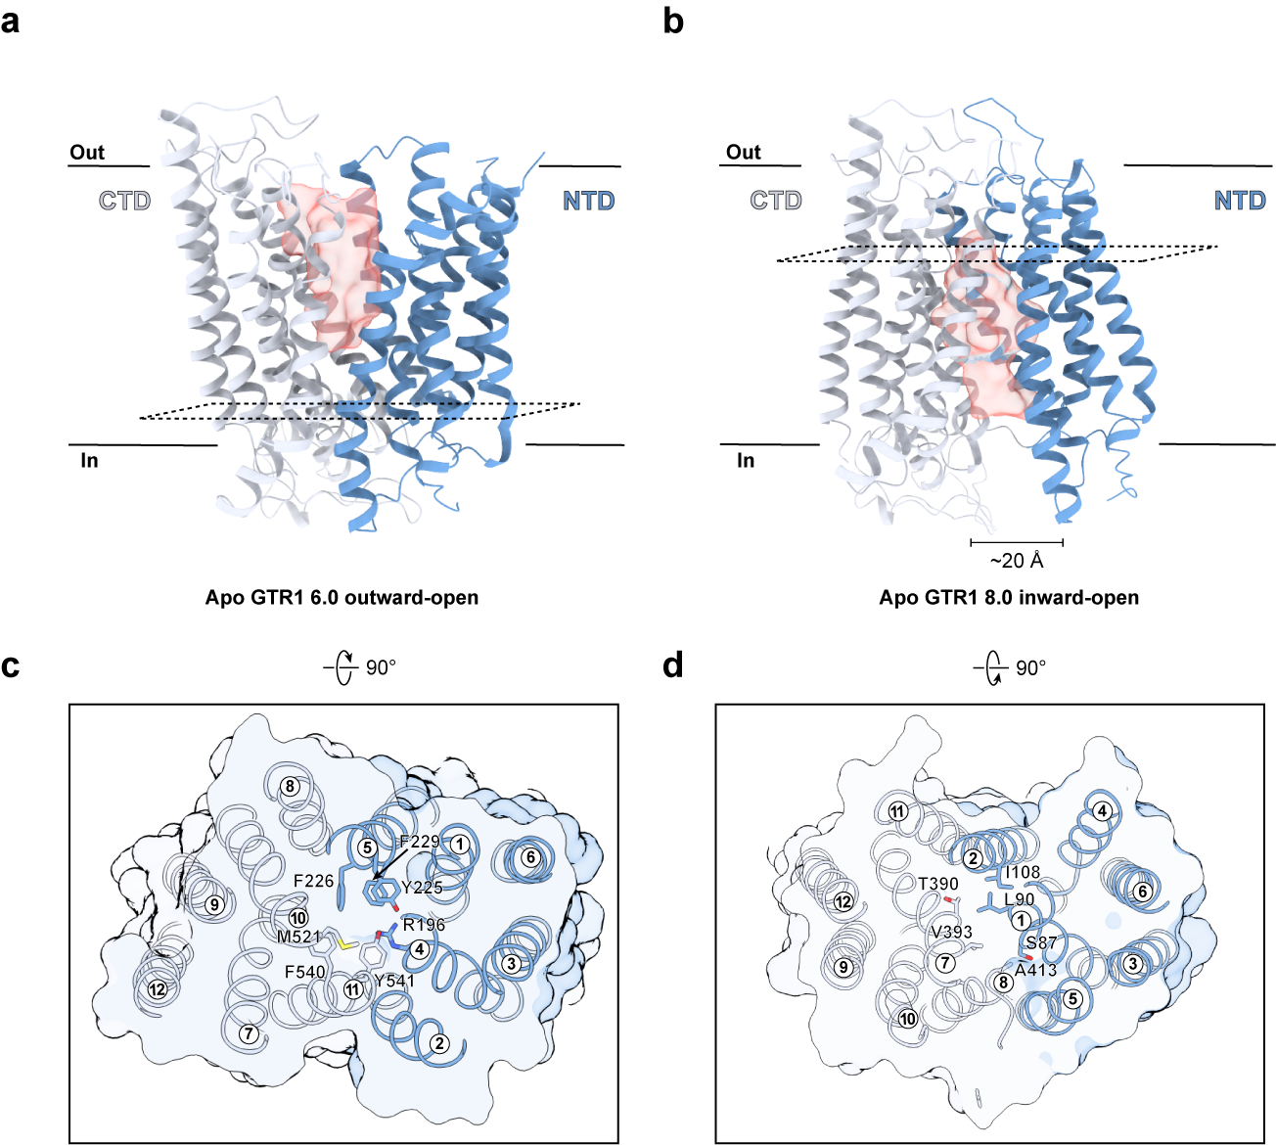
Supplementary Fig. 5 Solvent accessibility profiles of the central cavity and gating helixes. a Structures of AtGTR1 in the outward-open and inward-open state, with HOLLOW-computed cavities, showing solvent-accessible pathways. c-d Residues that seal the cavity from either the cytoplasm (c) or the extracellular (d) sides are shown, revealing state-dependent gating elements that regulate alternate-access.

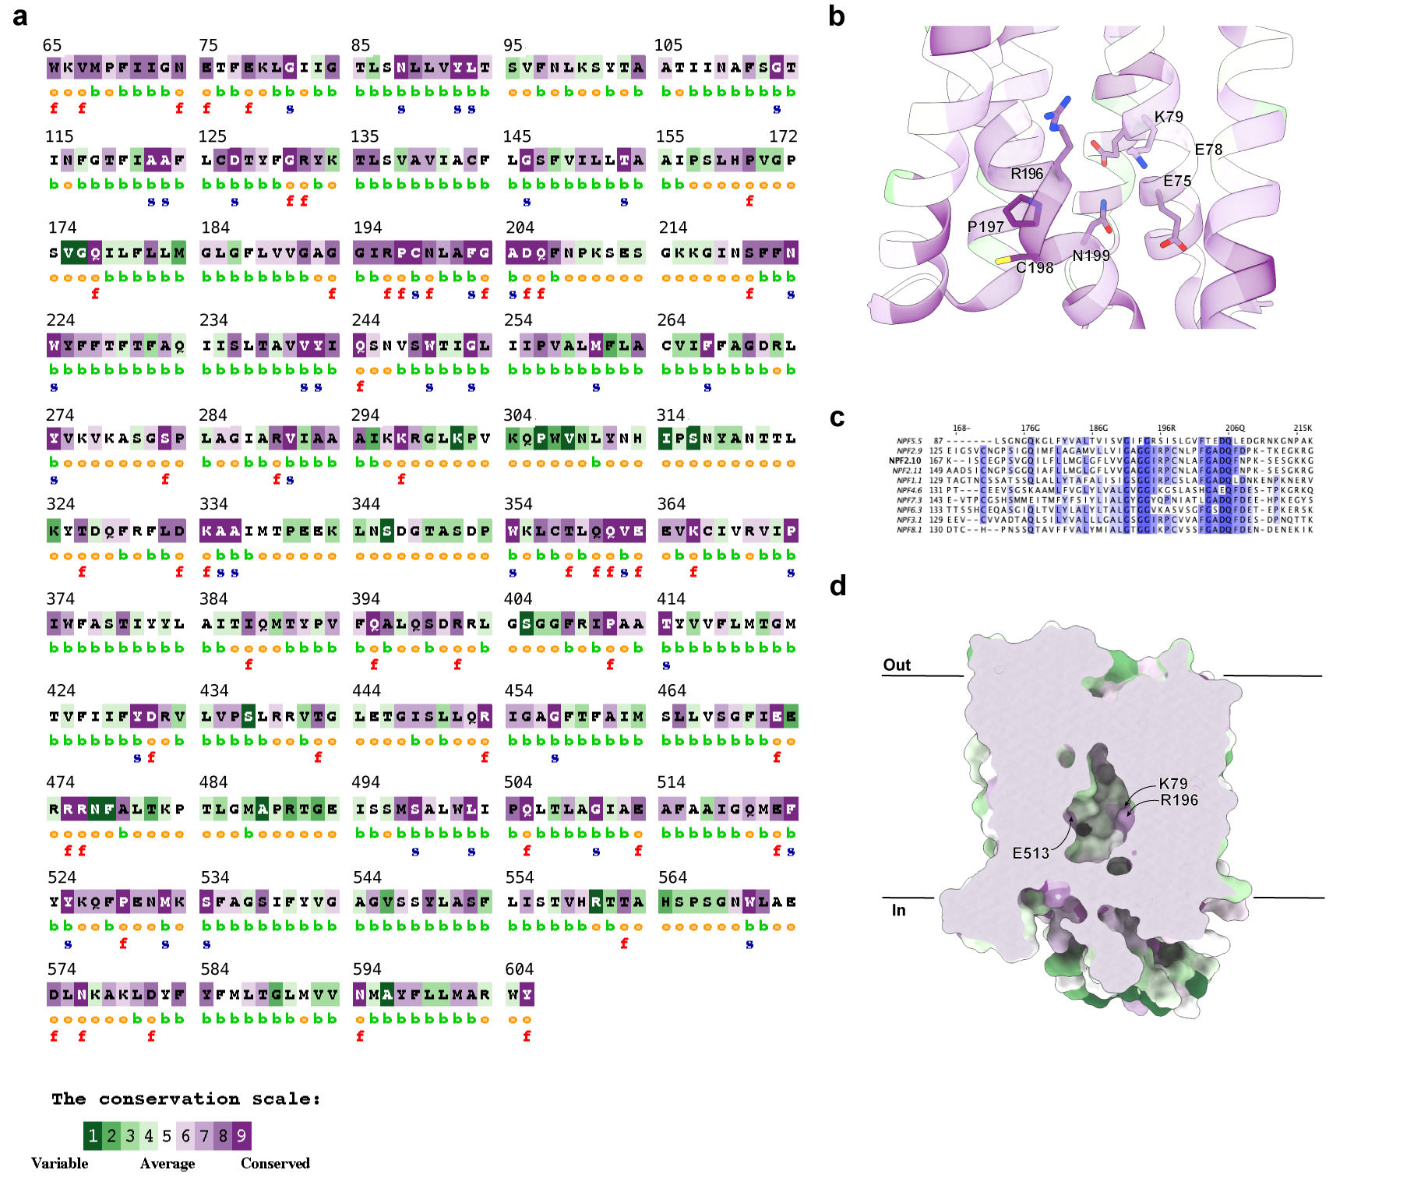
Supplementary Fig. 6 Evolutionary conservation of GTR1 and mapping of conserved motifs using Consurf analysis a Sequence conservation analysis of GTR1 orthologues generated by multiple sequence alignment, with residue conservation scores ranging from variable (green) to highly conserved (purple). b Close-up view of conserved residues surrounding the ExxE motif (E75,E78) and R196 within the inward-open structure. c Sequence logo representation highlighting conserved positions across the GTR1 family. d Surface rendering of inward-open GTR1 with conserved residues mapped on the central cavity and gating regions, illustrating conserved structural features lining the transport pathway.

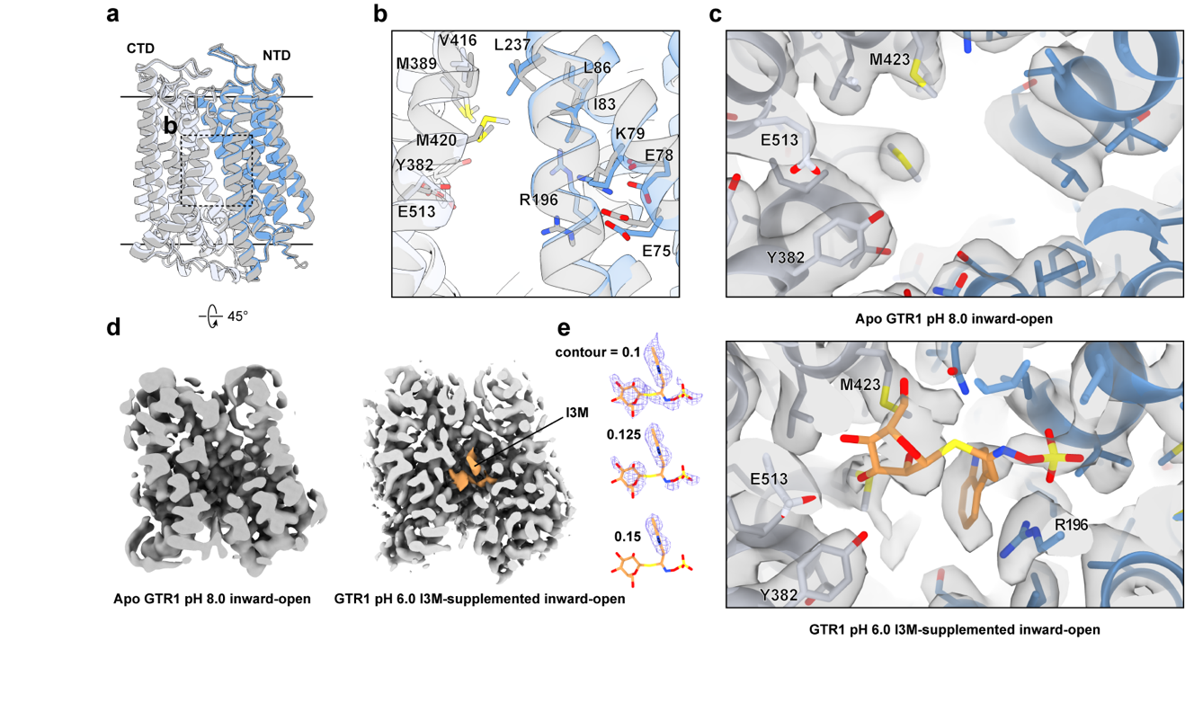
Supplementary Fig. 7 cryo-EM peaks in central binding pocket of the GTR1 I3M-supplemented inward-open state. a Structural superimposition of the inward-open GTR1 in the apo (gray) and I3M-bound (blue) states. b Local conformational adjustment sof residues involved in substrate recognition are highlighted for the apo and I3M-bound structures. c Cryo-EM map of the inward-open GTR1 at pH 8.0 showing no discernible density in the central cavity (top). Upon I3M supplementation, additional well-defined densities emerge adjacent to key coordinating residues, including R196, E513 and Y382, consistent with ligand occupancy under I3M-supplemented conditions (bottom). d Comparison of cryo-EM density maps at the identical contour for the apo inward-open GTR1 and the inward-open I3M-bound state. GTR1 is colored in silver and I3M is colored in orange. e I3M densities are displayed at multiple contour levels.

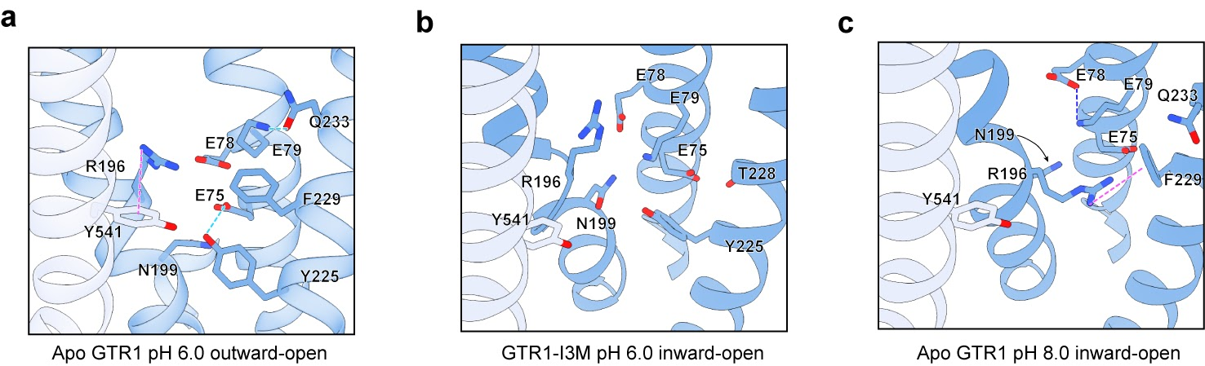

Supplementary Fig. 8 Interaction network around RPCN-ExxEK motif across conformational states. a Outward-open state at pH 6.0. b I3M-supplemeted inward-open state at pH 6.0. c Inward-open state at pH 8.0. Key residues are shown as sticks and hydrogen bonds (light blue), electrostatic (dark blue) and cation-π interaction (magenta) are represented as dashed lines.

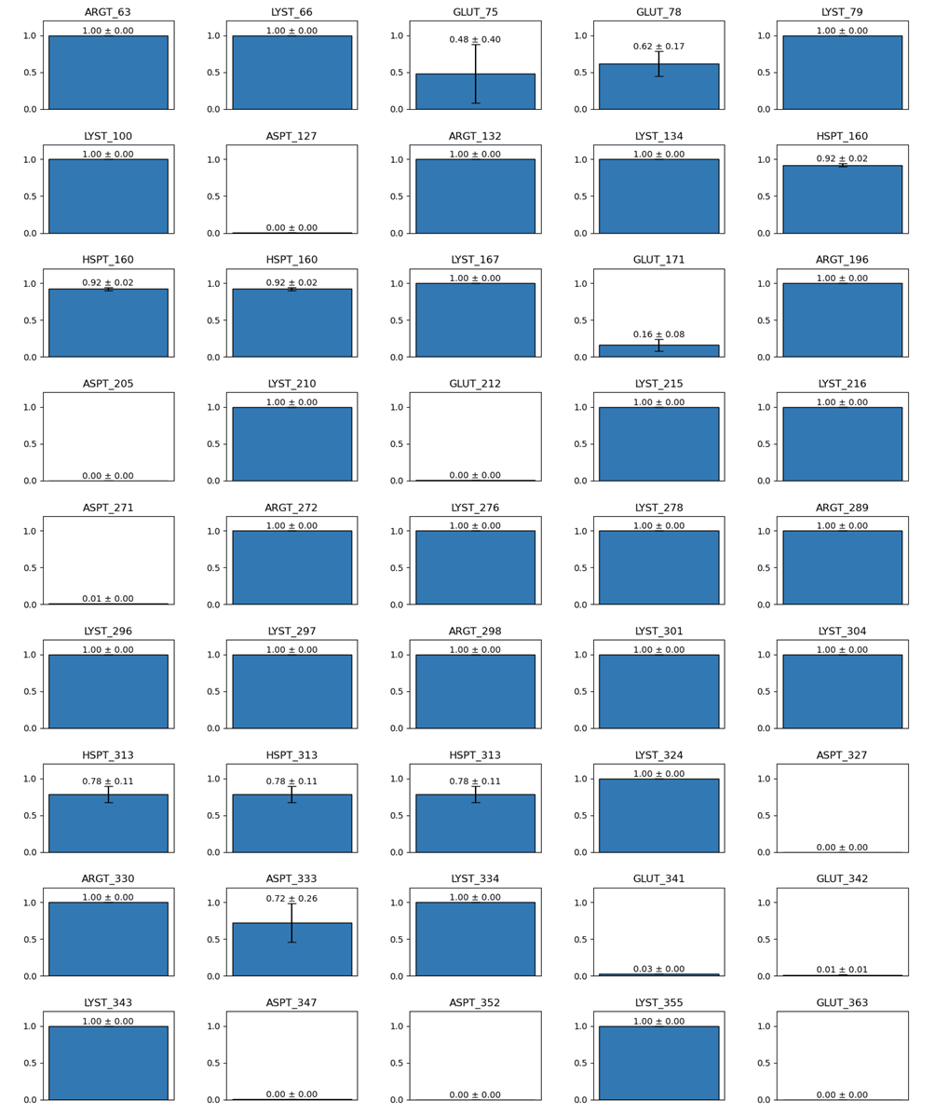

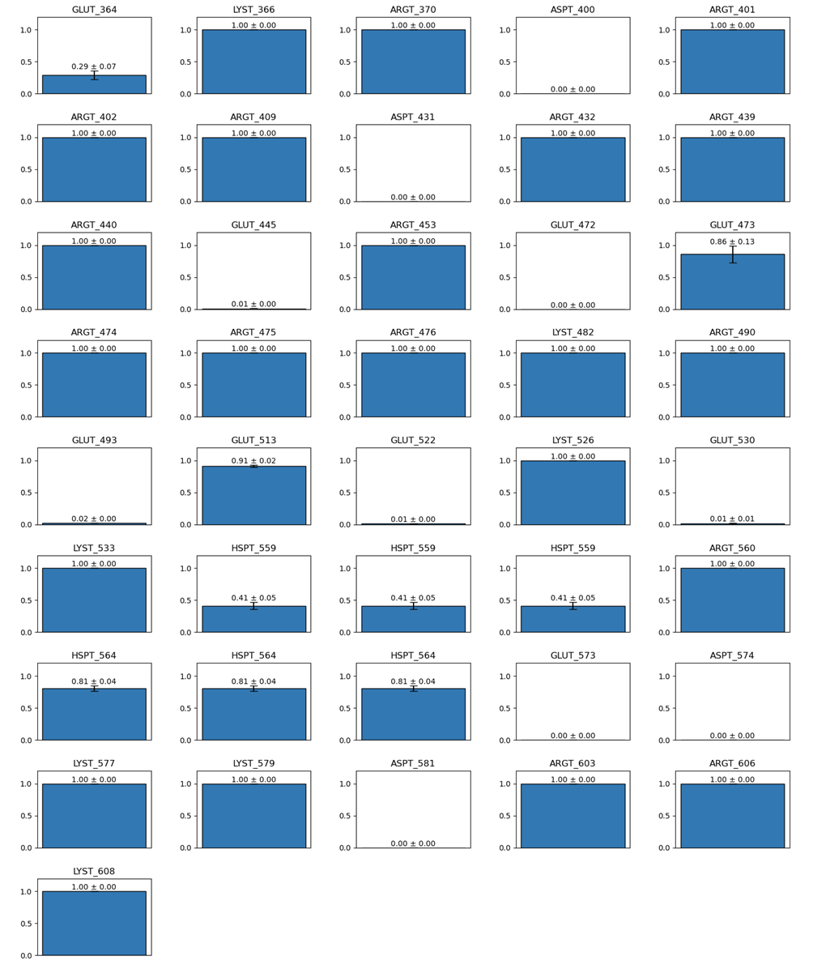
Supplementary Fig. 9 Constant-pH simulations of GTR1 apo outward-open at pH 5.5
Residues protonation fractions averaged between two CpHMD replicas of GTR1 apo outward-open at pH 5.5. Error bars represent the standard error.

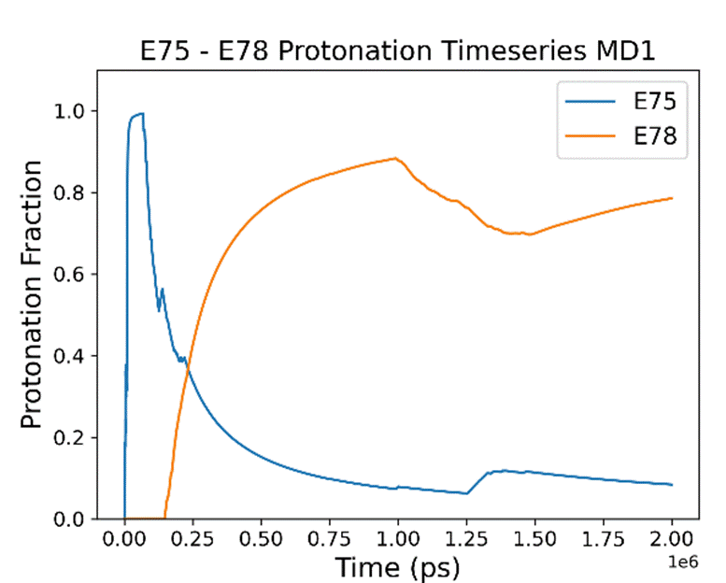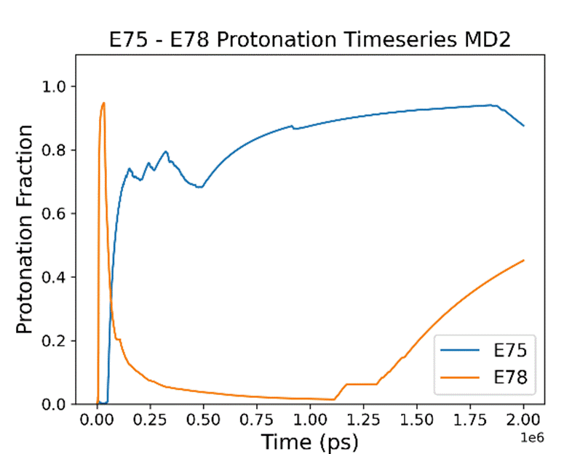
Supplementary Fig. 10 E75 and E78 compete for protonation during Constant-pH simulations of GTR1 apo outward-open at pH 5.5.
Time evolution of E75 and E78 protonation fractions in two replicas (MD1, left; MD2, right).

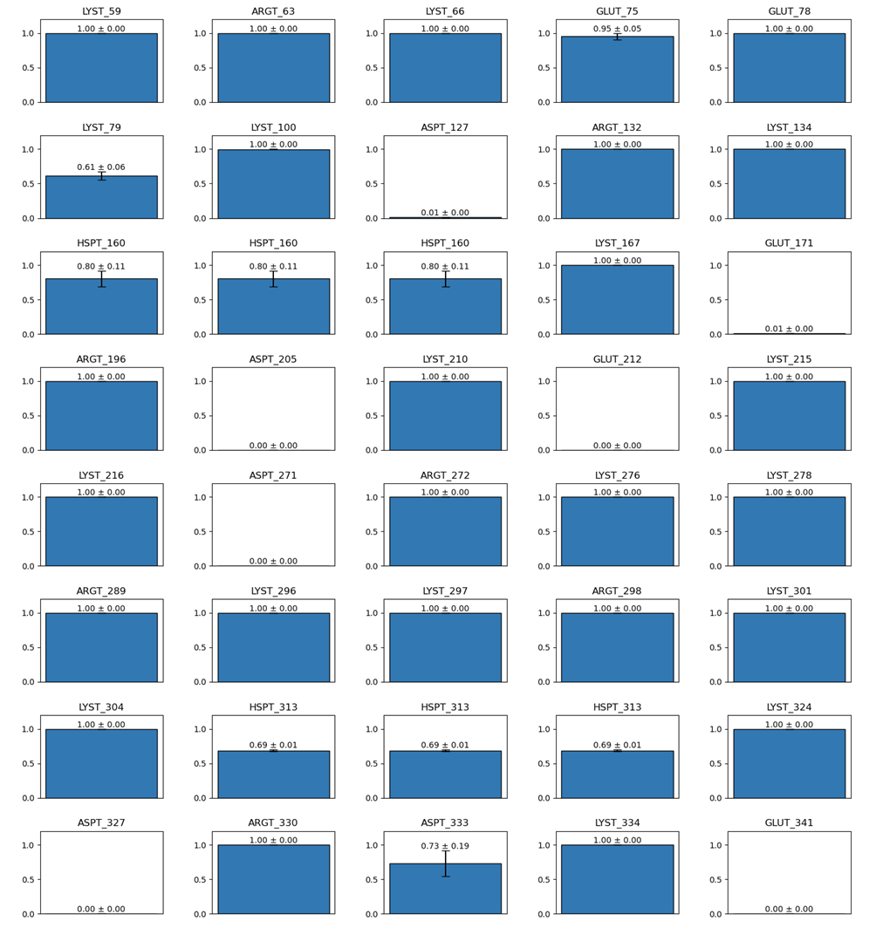

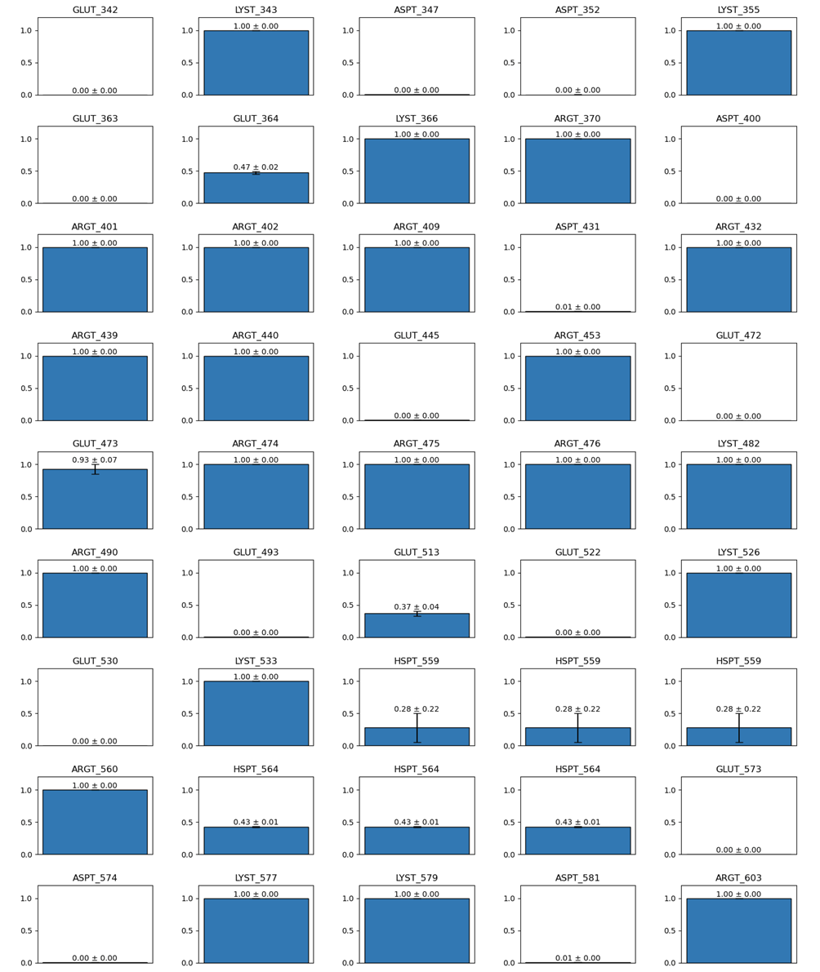

Supplementary Fig. 11 Constant-pH simulations of GTR1 apo inward-open at pH 6.0
Residues protonation fractions averaged between two CpHMD replicas of GTR1 apo inward-open at pH 6.0. Error bars represent the standard error.

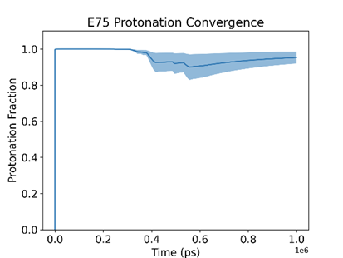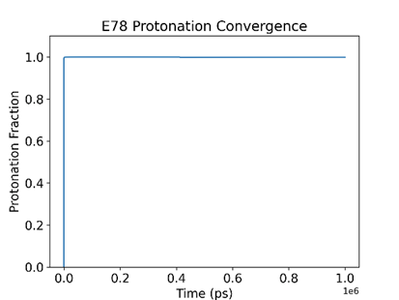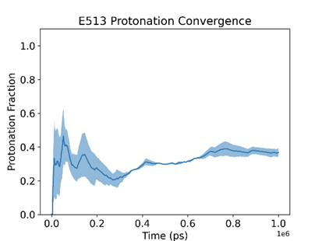
Supplementary Fig. 12 Time-series convergence during Constant-pH simulations of GTR1 apo inward-open at pH 6.0
Time evolution of E75, E78 and E513 protonation fractions averaged between the two CpHMD replicas of GTR1 apo inward-open at pH 6.0. The shades correspond to the standard error measured between the two replicas.

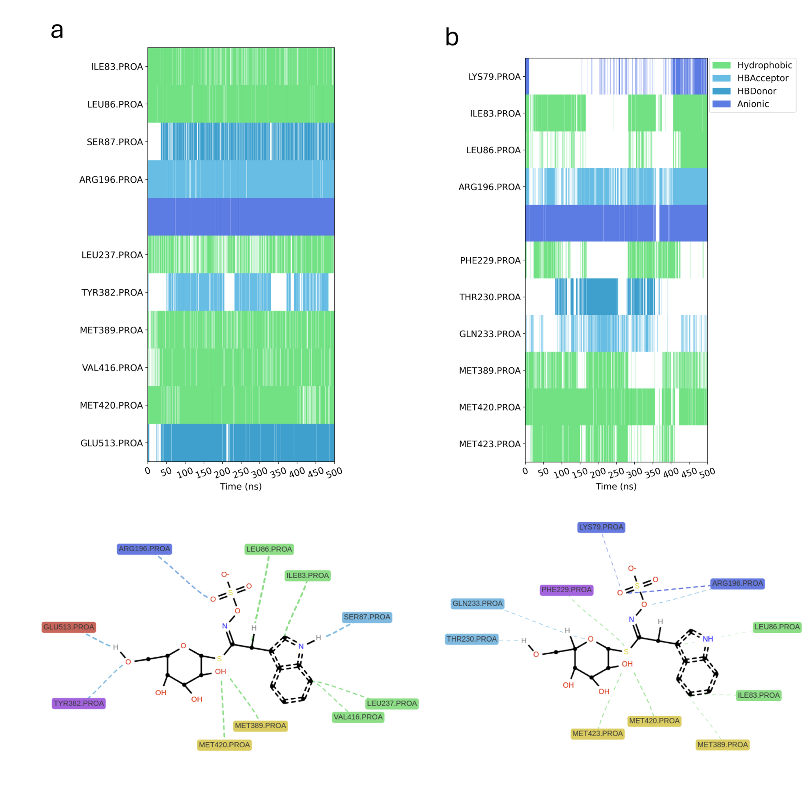
Supplementary Fig. 13 GTR1 inward-open I3M-bound MD simulations with E513 deprotonated.
Interaction time-series (top) and 2D network (bottom) plots of the complex GTR1-I3M during MD simulations in two replicas (a) and (b). The 2D network plot in panel a corresponds to the one shown in Figure 4g. Hydrophobic interactions are represented in green, hydrogen bond acceptors in light blue, hydrogen bond donors in cyan, anionic salt bridges in dark blue. In the 2D network plot, only residues interacting for more than 30% of the simulation time are shown.

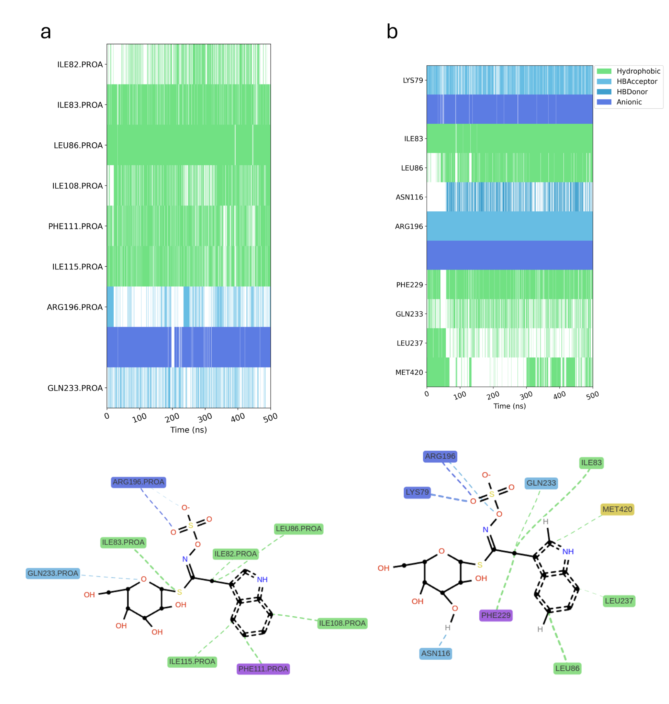
Supplementary Fig. 14 GTR1 inward-open I3M-bound MD simulations with E513 protonated.
Interaction time-series (top) and 2D network (bottom) plots of the complex GTR1-I3M during MD simulations in two replicas (a) and (b). The 2D network plot in panel b corresponds to the one shown in Figure 4f. Hydrophobic interactions are represented in green, hydrogen bond acceptors in light blue, hydrogen bond donors in cyan, anionic salt bridges in dark blue. In the 2D network plot, only residues interacting for more than 30% of the simulation time are shown.

Supplementary table 1. One-Way ANOVA for each compound
4MTB~Transporter
 | Df | Sum sq | Mean Sq | F value | Pr(>F)
RNA | 13 | 5026524 | 386656 | 47.77 | <2e-16 | ***
Residuals | 199 | 1610819 | 8095

I3M~Transporter
 | Df | Sum sq | Mean Sq | F value | Pr(>F)
RNA | 13 | 2498477 | 192191 | 70.85 | <2e-16 | ***
Residuals | 199 | 539811 | 2713

pOHB~Transporter
 | Df | Sum sq | Mean Sq | F value | Pr(>F)
RNA | 13 | 3732205 | 287093 | 32.12 | <2e-16 | ***
Residuals | 199 | 1778989 | 8940

Supplementary table 2. GTR1 constructs used in study.
No | Plasmid | Organism | Mutation
1 | pFastBac | Insect cells | -
2 | P426H7-U | Saccharomyces cerevisiae | -
3* | pNB1 | Xenopus laevis oocytes | -
4 | pNB1 | Xenopus laevis oocytes | I83A (ATA -> gcA)
5 | pNB1 | Xenopus laevis oocytes | L86A (TTA -> gcA)
6 | pNB1 | Xenopus laevis oocytes | N199A (AAT -> gcT)
7 | pNB1 | Xenopus laevis oocytes | Y225A (TAT -> gcT)
8 | pNB1 | Xenopus laevis oocytes | Q233A (CAG -> gct)
9 | pNB1 | Xenopus laevis oocytes | Y382A (TAC -> gct)
10 | pNB1 | Xenopus laevis oocytes | M389A (ATG -> gca)
11 | pNB1 | Xenopus laevis oocytes | F540A (TTT -> gcT)
12 | pNB1 | Xenopus laevis oocytes | Y541A (TAT -> gcT)
* published¹¹

Supplementary table 3. Cryo-EM data collection and refinement statistics.

 | AtGTR1  ’inward’-open  Apo | AtGTR1  ‘outward’-open  Apo | AtGTR1  ‘inward’-open  I3M added
Data collection
EM equipment | Titan Krios™ G2 | Titan Krios™ G4 | Titan Krios™ G4
Voltage (kV) | 300 | 300 | 300
Magnification | 165,000 | 130,000 | 165,000
Detector | Falcon 4i | Falcon 4i | Falcon 4i
Data collection mode | Counting | Counting | Counting
Pixel size (Å) | 0.725 | 0.901 | 0.705
Energy filter width (eV) | 10 | 10 | 10
Total exposure dose (e⁻/Å²) | 40 | 60 | 50
Defocus range (µm) | -2.4 ~ -0.8 | -2.0 ~ -0.6 | -1.8 ~ -0.8
Data processing
Software | cryoSPARC | cryoSPARC | cryoSPARC
Number of initial micrographs | 11,071 | 1,100 | 3,300
Number of initial particles | 5,039,828 | 1,991,903 | 6,017,673
Number of final particles used | 688,249 | 53,158 | 72,759
Symmetry | C1 | C1 | C1
Map resolution (Å) | 3.2 | 3.6 | 2.9
FSC threshold | 0.143 | 0.143 | 0.143
Model refinement statistics
Initial model used | AF-Q944G5-F1 | AF-Q944G5-F1 | AF-Q944G5-F1
Number of protein residues | 551 | 546 | 546
Nonhydrogen atoms | 4314 | 4262 | 4291
Model-map Q-score | 0.61
Model-map-fit CC (mask) | 0.87 | 0.70 | 0.86
Mean CC for ligands | - | - | 0.61
R.m.s.d
bonds (Å) | 0.003 | 0.004 | 0.004
angles (°) | 0.565 | 0.818 | 0.640
Average B-factor (Å²) | 158 | 109 | 36
Validation
Molprobity score | 1.52 | 2.26 | 1.71
Clash score | 8.83 | 27.50 | 13.65
Rotamer outliers (%) | 0.22 | 0.66 | 0.88
Ramachandran plot
Favored (%) | 97.81 | 95.22 | 97.98
Allowed (%) | 2.19 | 4.78 | 2.02
Rotamer outliers (%) | 0.00 | 0.00 | 0.00

Supplementary table 4. MRM transitions for glucosinolates quantified by LC-MS/MS. Qt = quantifier ion, additional transitions were used for identification. Q = quadrupole. CE = collision energy. IS = internal standard
Analyte | Retention Time  [min] | Q1  [m/z] | Q3 [m/z] | Fragmentor  [V] | CE  [V]
2-propenyl GLS (IS) | 1.72 | 358.0 | 97.0^{Qt} | 98 | 20
(Sinigrin) |  | 358.0 | 259.0 | 98 | 16
[M-H]⁻ |  | 358.0 | 75.0 | 98 | 36
p-hydroxybenzyl GLS | 2.69 | 447.0 | 97.0^{Qt} | 112 | 24
(pOHB) |  | 447.0 | 259.0 | 112 | 24
[M-H]⁻ |  | 447.0 | 205.0 | 112 | 20
4-methylthiobutyl GLS | 2.56 | 420.0 | 97.0^{Qt} | 107 | 24
(4MTB) |  | 420.0 | 259.0 | 107 | 20
[M-H]⁻ |  | 420.0 | 75.0 | 107 | 40
Indol-3-ylmethyl GLS | 2.69 | 447.0 | 97.0^{Qt} | 112 | 24
(I3M) |  | 447.0 | 259.0 | 112 | 24
[M-H]⁻ |  | 447.0 | 205.0 | 112 | 20

