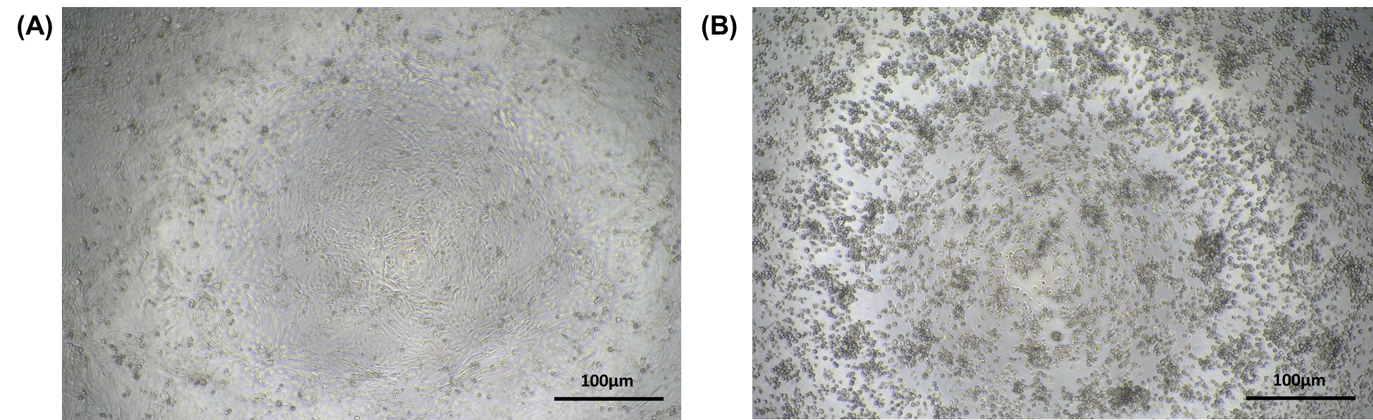
Figure S1. Cytopathic effect (CPE) observed in influenza virus infected Madin-Darby canine kidney (MDCK) cells.
(A) Normal, uninfected MDCK cells. (B) CPE such as rounding formation, cell destruction, and detachment, were observed in influenza virus infected MDCK cells.

