Traits and the City: functional trait space in urban bird and bat assemblages
Marina Querejeta¹, Élie Morin², Axel Jame¹, Simon Chapenoire³, Alice Chéron⁴, Hélène Paulhac¹, Mohamed Said Ramdani¹, Yvonnick Guinard⁵, Thibaut Preux⁶, Romain Michenaud⁷, Jean-Louis Yengue⁶, Dominique Royoux⁶, Thomas Rodier⁷, Nicolas Bech^{1*}, Sophie Beltran-Bech^{1*}
¹ Laboratory of Ecologie et Biologie des Interactions (EBI), UMR CNRS 7267, University of Poitiers, Bâtiment B31, 3 Rue Jacques Fort, TSA 51106, 86073 Poitiers Cedex 9, France
² PICTAMAP, 4 B rue du moulin 86130, Jaunay-Marigny, France
³ LPO, DT Poitou-Charentes, 25 rue Victor Grignard, Poitiers
⁴Vienne Nature, 14 rue Jean Moulin, 86240, Fontaine-le-Comte, France
⁵Agence Régionale de la Biodiversité Nouvelle Aquitaine, 86962, Futuroscope Chasseneuil Cedex, France
⁶Laboratory of RURALITES, UR13823, University of Poitiers, MSHS, Bâtiment A5, 5, rue Théodore-Lefèbvre, TSA 21103, 86073 Poitiers Cedex 9, France
⁷Grand Poitiers Communauté Urbaine, 86000 Poitiers, France
*Co-last authors contributed equally to this study
Corresponding author: Marina Querejeta. ORCID : 0000-0003-1803-5239. E-mail: marina.querejeta@univ-poitiers.fr

Supporting Information A

Figure S1. Boxplots representing two functional alpha diversity metrics, Functional Richness (FRic) and Mean Functional Distance (MFD), between the two types of urban points, Urban Heat Islands (UHIs) and Urban Cool Islands (UCIs) in urban A) bird and B) bat assemblages. Signification according to Generalized Linear Models (GLMs) are placed over each plot when significant.
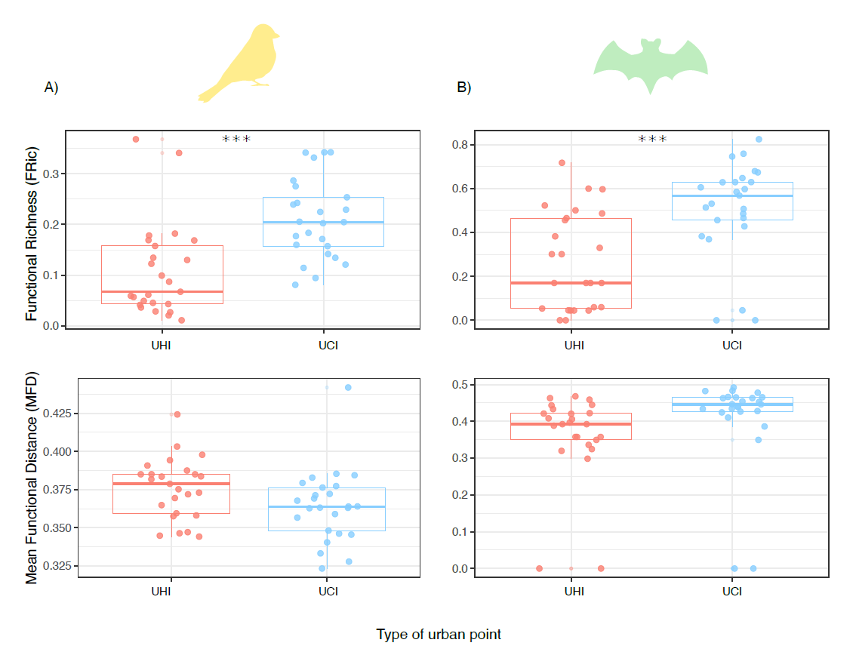

Figure S2. Boxplots representing the Standardised Effect Sizes (ses) of the functional alpha diversity metrics used in this study, Functional Richness (FRic), Mean Functional Distance (MFD) and Functional Redundancy (FRed) between the two types of urban points, Urban Heat Islands (UHIs) and Urban Cool Islands (UCIs) in urban A) bird and B) bat assemblages. Signification according to Generalized Linear Models (GLMs) are placed over each plot when significant. Asterisks indicate statistical significance ( p < 0.05; ** p < 0.01; *** p < 0.001).
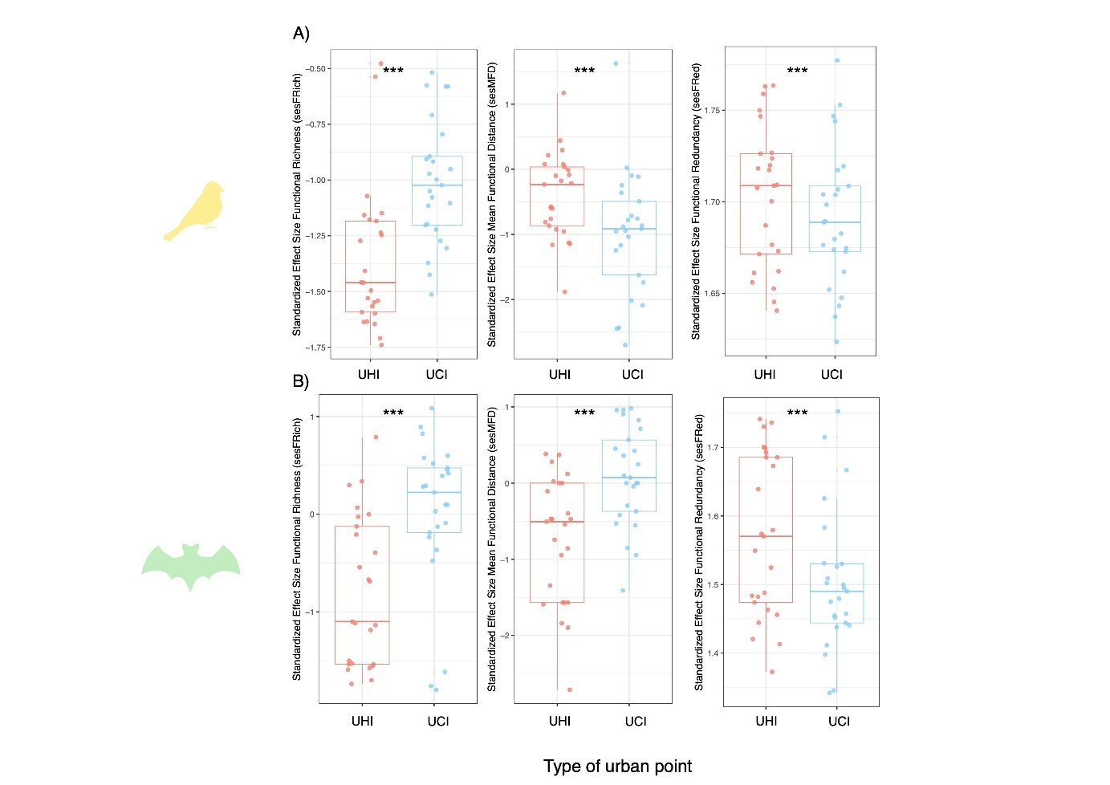

Figure S3. Correlations between the First Component (PC1) of the urban landscape variables Principal Components Analysis (PCA) or “Rate of Artificialisation” with Functional Richness (FRic) and Mean Functional Distance (MFD) for A) birds and B) bats. Points are coloured by type of urban point, Urban Heat Island (UHI) or Urban Cool Island (UCI).
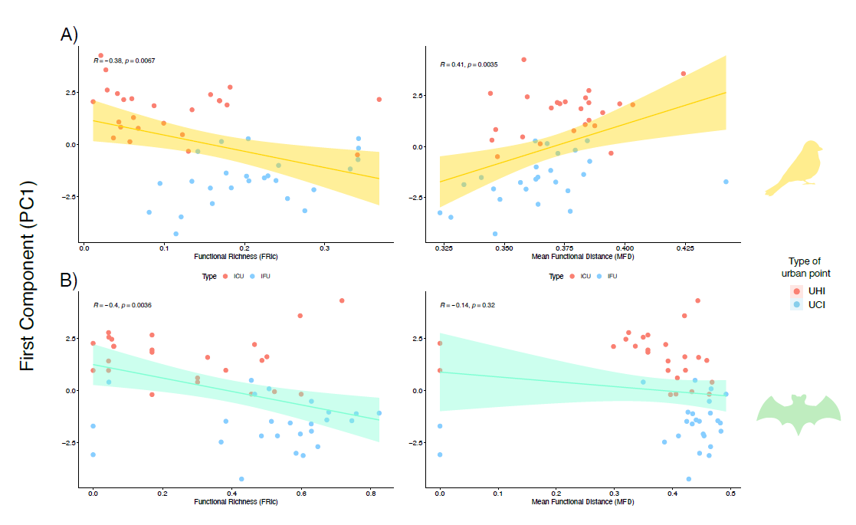
Figure S4. Boxplots representing Community Weighted Means (CWMs) of continuous functional traits between the two types of urban points, Urban Heat Islands (UHIs) and Urban Cool Islands (UCIs) for urban A) bird and B) bat assemblages. In the case of birds, beak length, tarsus length, Hand-Wing Index (HWI), body mass, geographical range size, egg number, lifespan, Species Temperature Index (STI) and Species Specialization Index (SSI) represent continuous functional traits. In the case of bats, those traits included call duration, call peak frequency, forearm length, lifespan, body mass, geographical range size, Species Temperature Index (STI) and Species Specialization Index (SSI).
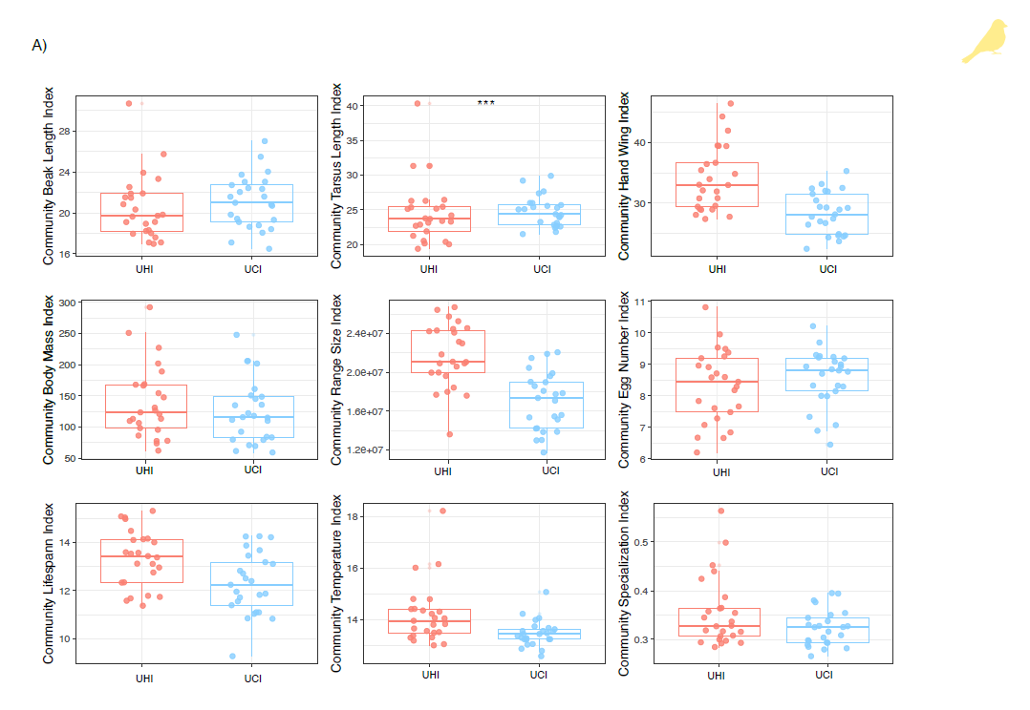
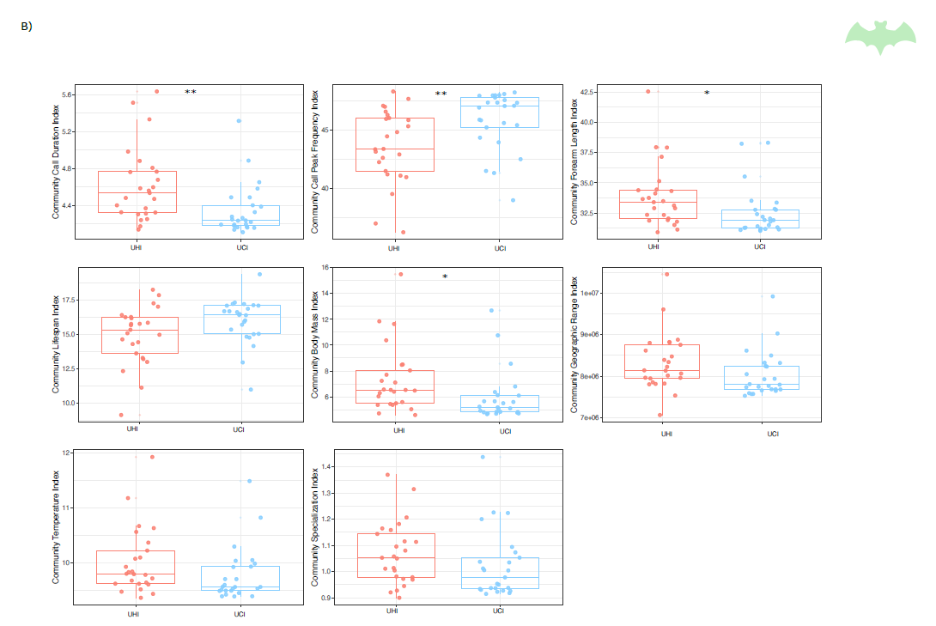

Figure S5. Correlations between the First Component (PC1) of the urban landscape variables Principal Components Analysis (PCA) or “Rate of Artificialisation” with urban A) bird and B) bat assemblages.
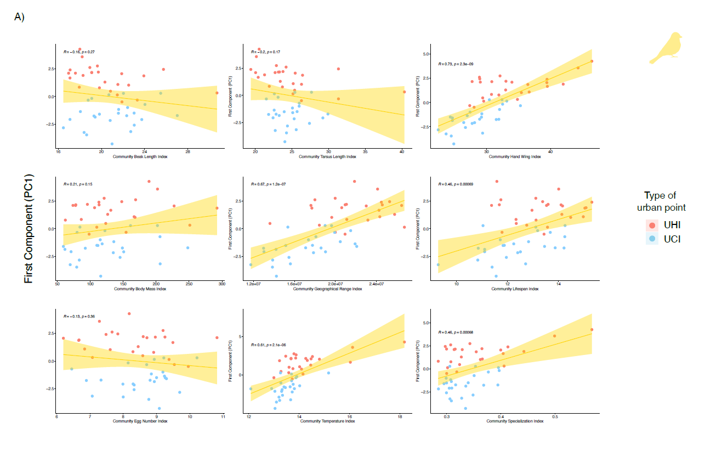
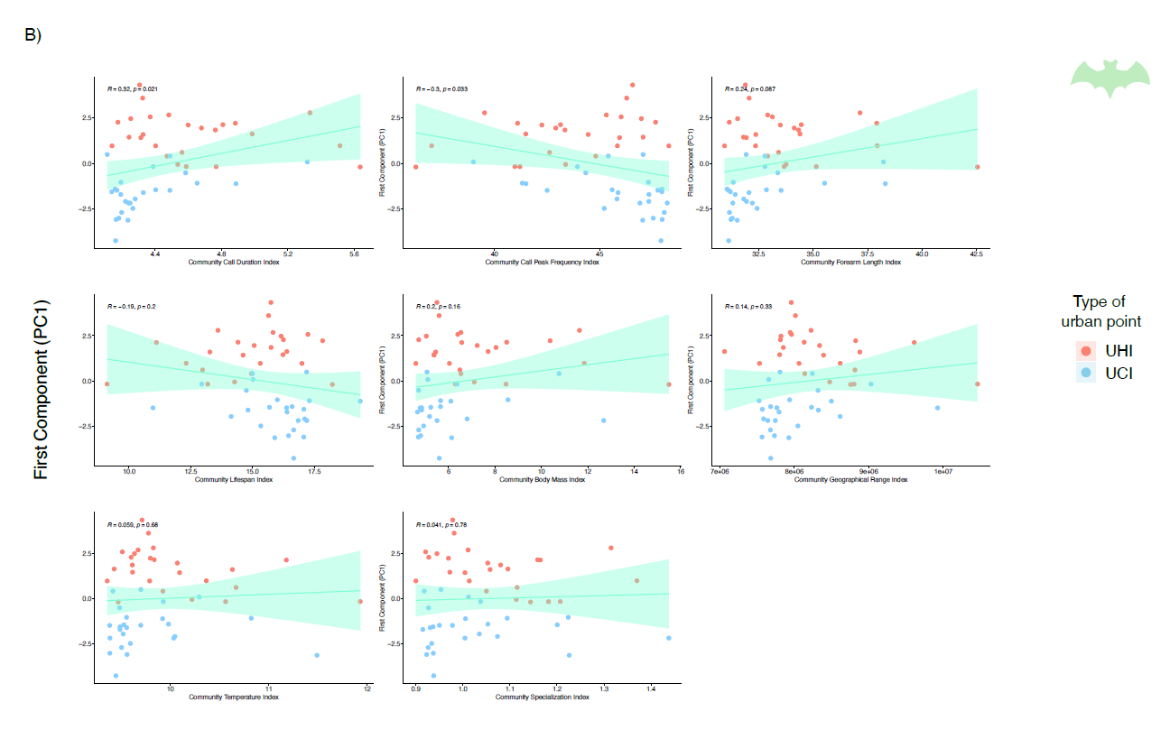
Figure S6. Bar plots representing the distribution of the relative abundance of each nominal functional trait used in this study along the urban points, Urban Heat Islands (UHIs) and Urban Cool Islands (UCIs) for urban A) bird and B) bat assemblages. In the case of birds, nominal functional traits include habitat type, trophic level, trophic niche, primary lifestyle and migratory status. In the case of bats, traits are call type, main prey, main hibernation and main maternity roost.
