Table 1 Summary of the status of provincial historic districts in Liaoning province
No. | City | District Name |  | District Type | Historical Period | Architectural Style | Protection Scope (hm²) | Historically & Culturally Famous City | State of the District
1 | Chaoyang | Chaoyang Old City |  | Mixed-use  (Commercial & Residential) | Eastern Jin Dynasty | Chinese Style | 114 | Provincial-level | 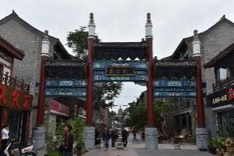
2 | Chaoyang | Water Pump Factory |  | Industrial | Contemporary | Soviet Style | — | Provincial-level | 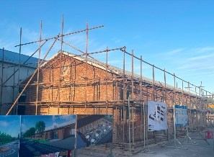
3 | Shenyang | Zhongshan Road |  | Commercial | Modern Era | European Style | 93.7 | National-level | 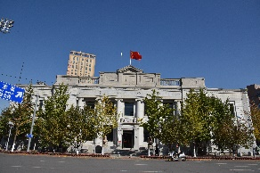
4 | Shenyang |  | Tiexi Worker's Village | Residential | Contemporary | Modern Red-Brick Style | 13.6 | National-level | 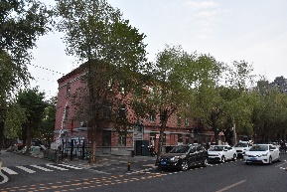
5 | Shenyang |  | Shengjing Royal City | Mixed-use  (Commercial & Residential) | Later Jin to Modern Era | Chinese Style | 166 | National-level | 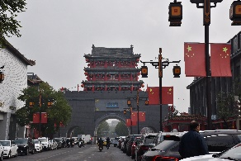
6 | Liaoyang |  | Baita Park | Landscape | Liao Dynasty | Chinese Style | 24.26 | National-level | 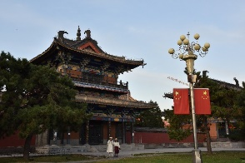
7 | Liaoyang |  | Tanghu Village | Residential | Modern Era | Japanese Style | 21.77 | National-level | 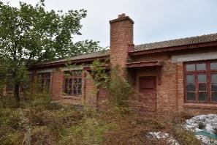
8 | Liaoyang |  | Dongjing Mausoleum | Landscape | Later Jin | Ancient Chinese Architecture | 19.45 | National-level | 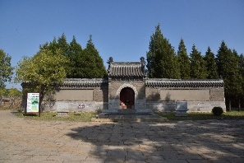
9 | Liaoyang |  | Taizi Gully | Residential | Modern Era | Soviet Style | 8.95 | National-level | 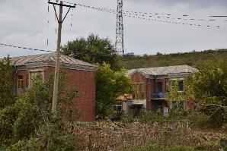
10 | Anshan |  | Taiding | Residential | Modern Era | Japanese Style | 76.23 | — | 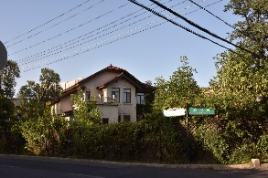
11 | Yingkou |  | Liaohelaojie | Commercial | Modern Era | Chinese-Western Fusion | 12.93 | — | 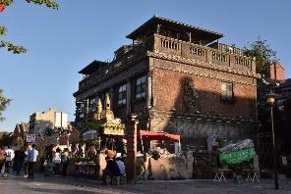
12 | Anshan |  | Cuoshishan Park | Landscape | Neolithic | Chinese Style | 25 | — | 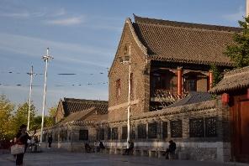
13 | Dalian |  | Lüshun Taiyanggou | Mixed-use (commercial/residential) | Modern Era | Japanese-Russian | 84.96 | Provincial-level | 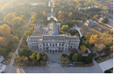
14 | Dalian |  | Dongguan Street | Mixed-use (commercial/residential) | Modern Era | Japanese-Russian | 8.13 | Provincial-level | 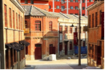
15 | Dalian |  | Shengli Bridge North | Mixed-use (commercial/residential) | Modern Era | Russian-style | 40.47 | Provincial-level | 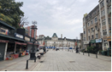
16 | Dalian |  | Zhongshan Square | Commercial | Modern Era | European-style | 16 | Provincial-level | 