SUPPLEMENTARY MATERIAL

Host–Microbiome Archetypes Differentiate Infection from
Pathogen Carriage in the Human Lower Airway

1. SUPPLEMENTARY FIGURES
2. SUPPLEMENTARY TABLES
3. SUPPLEMENTARY DATA FILES

SUPPLEMENTARY FIGURES
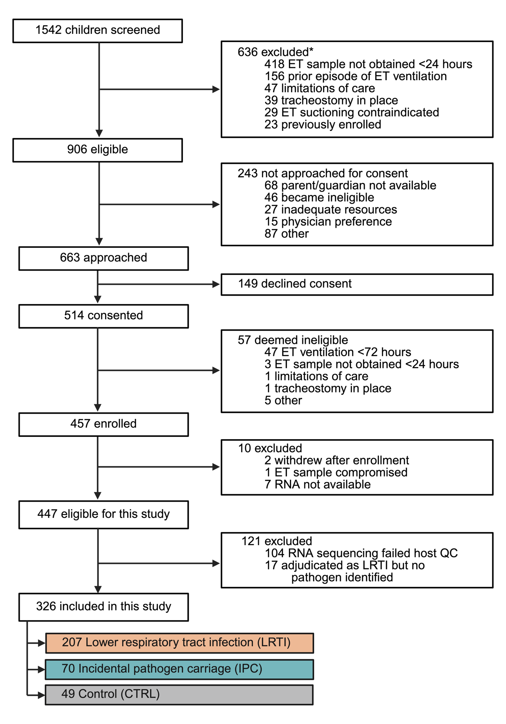
Figure S1. Study flow diagram. Asterisk indicates that some children had multiple reasons for exclusion. ET, endotracheal tube; QC, quality control.

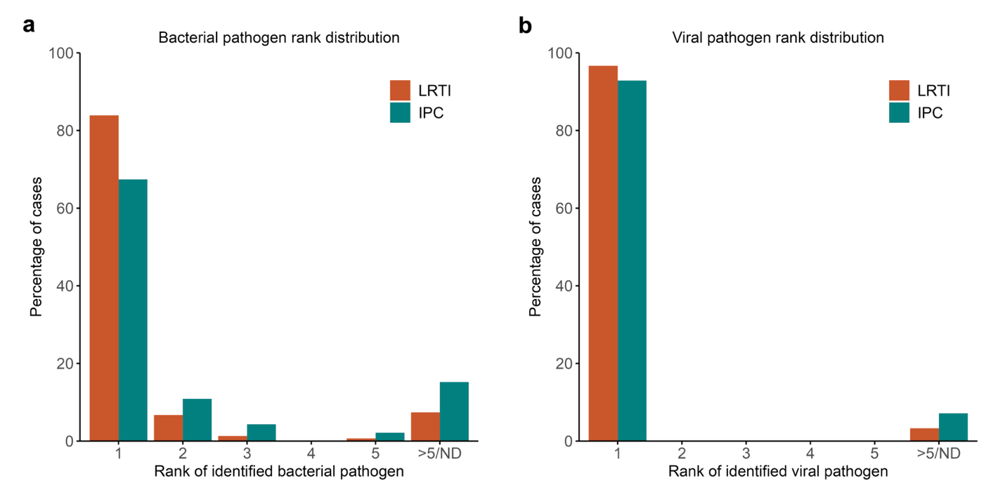
Figure S2. Ranks plots of detected bacterial and viral pathogens. a. Bar plot showing the distribution of pathogen ranks in patients who had a bacterial pathogen identified, stratified by LRTI and IPC groups. Rank was determined based on reads per million (RPM) of the detected pathogen in the metatranscriptomics data. If more than one bacterial pathogen was detected in a sample, the rank of the higher ranking pathogen was plotted. Ranks >5 and cases where the implicated pathogen was not identified in the metatranscriptomics data were grouped together as >5/ND. b. Bar plot showing the distribution of pathogen ranks in patients who had a viral pathogen identified, using the same methodology.

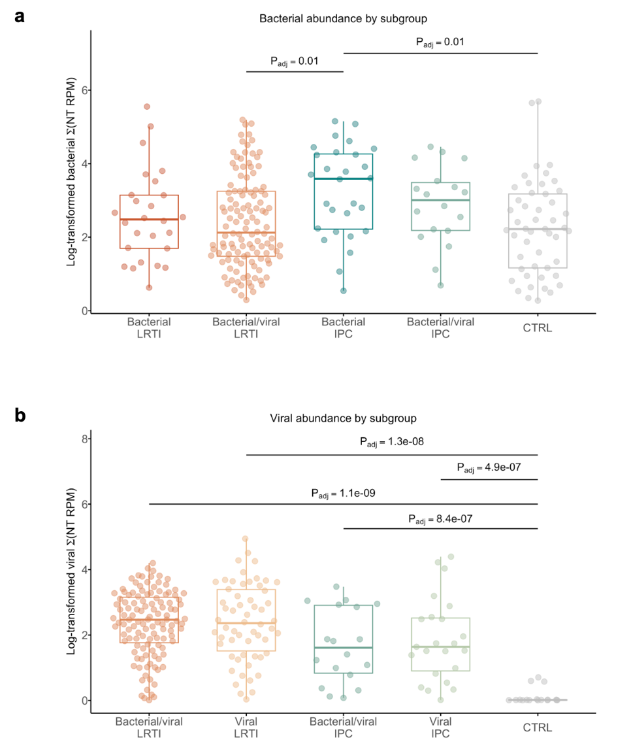

Figure S3. Microbial load by infection subclass. a. Total bacterial abundance measured in reads per million (RPM) across bacterial subclasses and controls. b. Total viral abundance across viral subclasses and controls. P values determined by Wilcoxon rank-sum tests and adjusted for multiple comparisons.

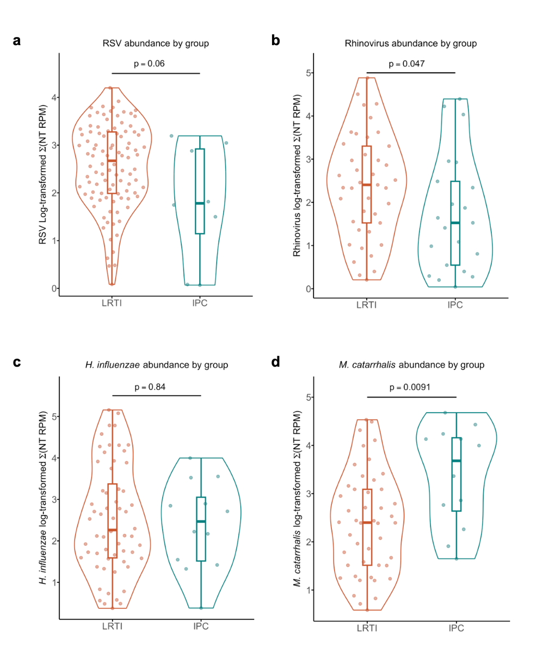

Figure S4. Abundance differences of the most prevalent bacterial and viral pathogens in LRTI versus IPC groups. a. Abundance of RSV, defined as sum of NT RPM, for patients who had RSV detected as a pathogen. b. Rhinovirus. c. Haemophilus influenzae d. Moraxella catarrhalis. NT RPM, nucleotide reads per million.

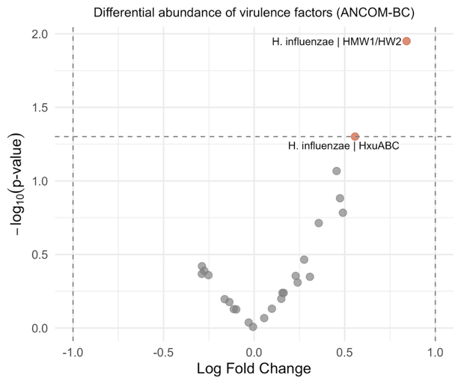

Figure S5. Exploratory analysis of virulence factors in LRTI and IPC groups. Differential abundance of all virulence factors, annotated by VFDB 2.0, between LRTI and IPC groups, using ANCOM-BC. Positive log fold change indicates upregulation with LRTI and negative log fold change indicates upregulation with IPC. Unadjusted P values shown.

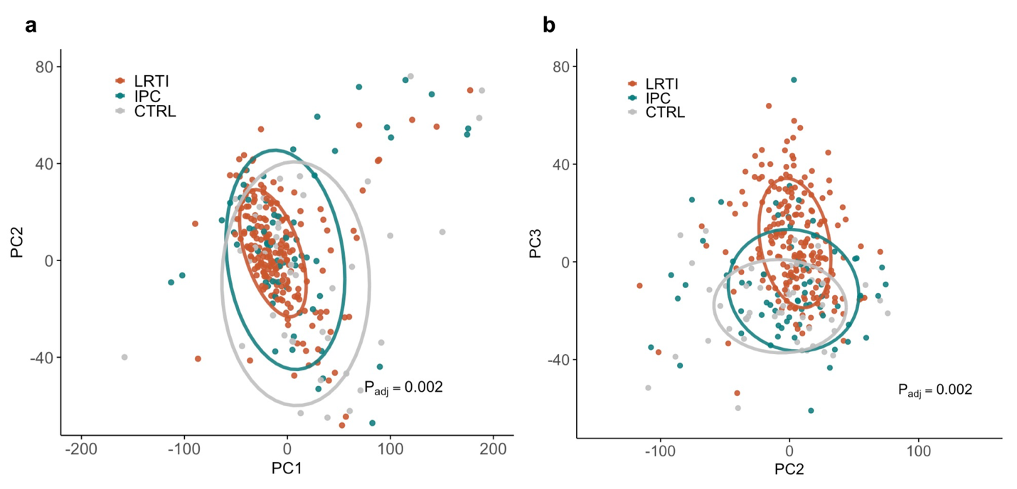
Figure S6. Additional principal components of the lower respiratory tract transcriptome. a. PC1 versus PC2. b. PC2 versus PC3. Orange indicates LRTI, teal indicates IPC, and gray indicates CTRL. Adjusted P values calculated by PERMANOVA between LRTI and non-LRTI groups.

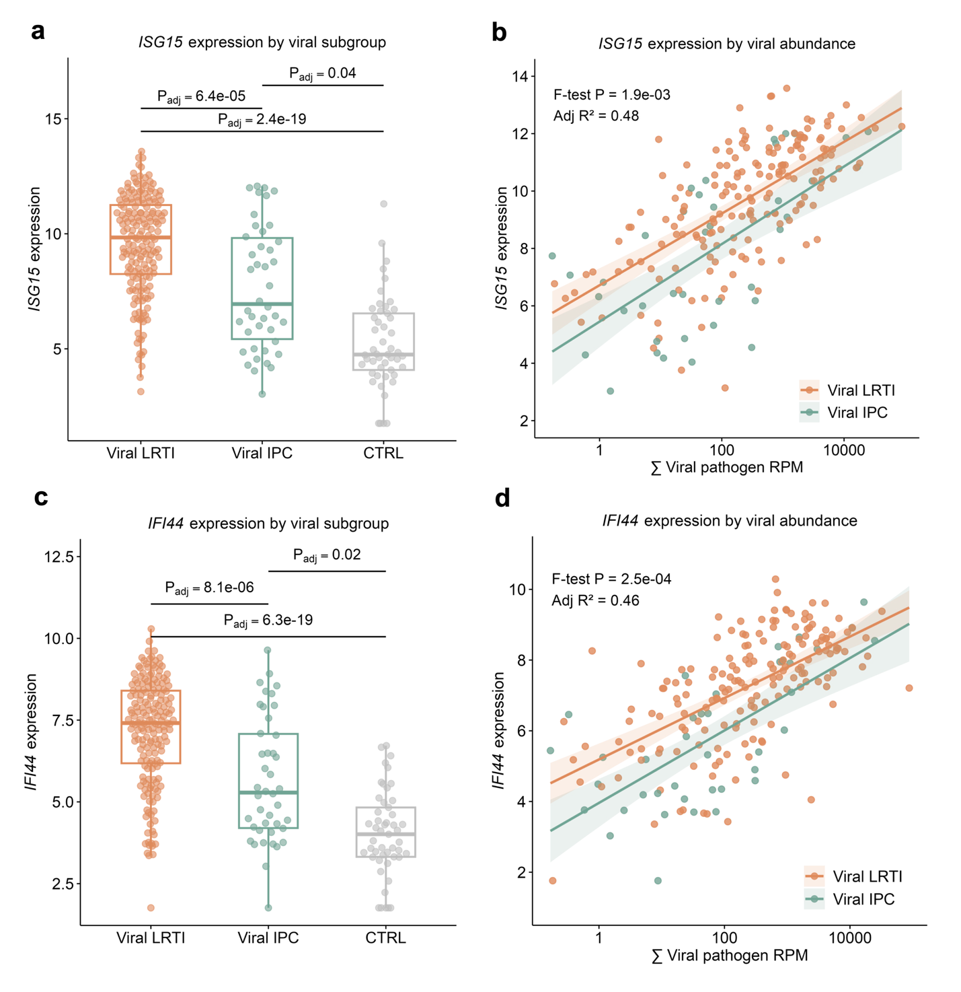Figure S7. Integrated host-microbial analyses for additional interferon-related genes among viral cases. a. Boxplot of normalized ISG15 expression by group. Benjamini-Hochberg (BH) adjusted P values, based on differential expression (DE) analyses, shown. b. Linear regression of viral abundance (reads per million, RPM), against normalized ISG15 expression for viral LRTI and IPC. c. Boxplot of normalized IFI44 expression by group. d. Linear regression of viral abundance against normalized IFI44 expression for viral LRTI and IPC.

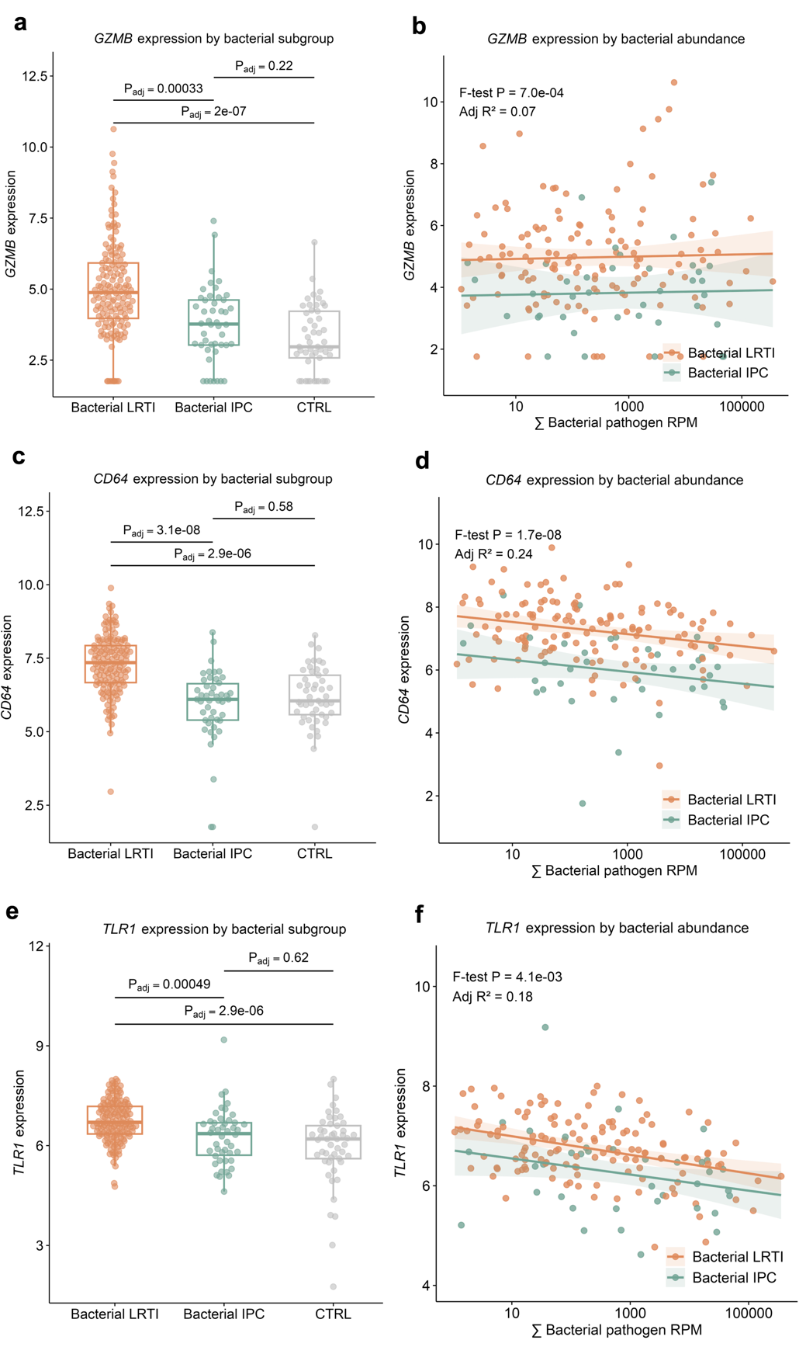
Figure S8. Integrated host-microbial analyses for classic anti-bacterial defense genes among bacterial cases. a. Boxplot of normalized GZMB expression. Benjamini-Hochberg (BH) adjusted P values, based on differential expression (DE) analyses, shown. b. Linear regression of bacterial pathogen abundance (reads per million, RPM), against normalized GZMB expression for bacterial LRTI and IPC. c. Boxplot of normalized CD64 expression. d. Linear regression of bacterial abundance against normalized CD64 expression for bacterial LRTI and IPC. e. Boxplot of normalized TLR1 expression by group. f. Linear regression of bacterial abundance against normalized TLR1 expression for bacterial LRTI and IPC.
SUPPLEMENTARY TABLE

Model Feature | ENSEMBL ID | Fold 1 | Fold 2 | Fold 3 | Fold 4 | Fold 5
Shannon Diversity Index | N/A | -0.151 | -0.241 | -0.234 | -0.252 | -0.231
ZNF12 | ENSG00000164631 | -0.053 | - | - | - | -
WBP2 | ENSG00000132471 | - | - | - | - | -0.173
VCPIP1 | ENSG00000175073 | - | - | - | 0.229 | -
TAP1 | ENSG00000168394 | - | 0.031 | - | - | -
SNHG19 | ENSG00000260260 | - | - | - | - | -0.054
SAP30L | ENSG00000164576 | - | - | - | - | 0.060
RSAD2 | ENSG00000134321 | 0.099 | - | - | - | -
RPS6KA1 | ENSG00000117676 | - | - | - | - | -0.227
RBP4 | ENSG00000138207 | -0.225 | -0.198 | -0.202 | -0.085 | -0.220
PSMB8 | ENSG00000204264 | - | - | 0.030 | - | -
PRKDC | ENSG00000253729 | -0.281 | - | -0.057 | - | -0.207
PPP1R14B | ENSG00000173457 | - | - | - | - | -0.151
PIK3CA | ENSG00000121879 | 0.236 | - | - | - | -
PARP9 | ENSG00000138496 | - | 0.059 | - | 0.122 | 0.122
NMI | ENSG00000123609 | - | - | - | - | 0.049
MUC2 | ENSG00000198788 | 0.021 | - | - | - | -
MED14 | ENSG00000180182 | 0.063 | - | - | - | 0.212
MARCO | ENSG00000019169 | -0.009 | - | - | - | -0.160
IRF7 | ENSG00000185507 | - | 0.198 | 0.102 | 0.137 | 0.166
IRF1 | ENSG00000125347 | - | 0.110 | 0.118 | - | -
IL3RA | ENSG00000185291 | 0.024 | - | - | - | 0.075
IFITM1 | ENSG00000185885 | 0.045 | - | - | - | -
IFIT2 | ENSG00000119922 | - | - | 0.015 | 0.009 | -
H2BC12 | ENSG00000197903 | 0.031 | - | 0.003 | - | -
H2AC14 | ENSG00000276368 | 0.016 | - | - | - | -
GZMB | ENSG00000100453 | - | - | 0.020 | - | -
GNLY | ENSG00000115523 | 0.121 | - | - | - | -
FFAR3 | ENSG00000185897 | 0.285 | 0.019 | 0.110 | 0.131 | -
FCGR1A | ENSG00000150337 | - | - | - | - | 0.050
FABP4 | ENSG00000170323 | -0.137 | -0.094 | -0.146 | -0.138 | -0.070
ERGIC1 | ENSG00000113719 | -0.217 | - | - | - | -
CYBB | ENSG00000165168 | - | - | - | - | 0.021
CES1 | ENSG00000198848 | - | -0.010 | - | -0.081 | -0.108
CDHR3 | ENSG00000128536 | - | - | - | - | -0.013
CCR1 | ENSG00000163823 | - | - | - | - | 0.040
CASC3 | ENSG00000108349 | -0.115 | - | - | - | -
C5AR2 | ENSG00000134830 | - | - | - | - | -0.005
C10orf55 | ENSG00000222047 | - | - | - | - | -0.057
BATF | ENSG00000156127 | - | - | - | - | 0.144
AP003170.3 | ENSG00000256452 | - | - | - | - | -0.015
AP000442.1 | ENSG00000255139 | - | - | - | - | -0.002
AOC3 | ENSG00000131471 | -0.046 | - | - | -0.026 | -
AL731567.1 | ENSG00000231964 | - | - | - | - | 0.015
AL627230.1 | ENSG00000275493 | - | - | - | - | -0.013
ADAMDEC1 | ENSG00000134028 | 0.057 | - | - | - | -

Table S1. Integrated multi-gene and Shannon Diversity Index classifier coefficients. Model coefficients for each of the features included in the five folds are shown. If a gene was not included in that fold, its absence is indicated by a dash. Shannon diversity index, FABP4, and RBP4, were selected as model parameters in all folds.

SUPPLEMENTARY DATA FILES

Supplementary Data File 1: ANCOM-BC of differential taxonomic abundance between LRTI and IPC, adjusted for age and sex. Legend: lfc = log fold change; se = standard error of log fold change; W = W test statistic; p = unadjusted P values; q = Benjamini-Hochberg adjusted P values; diff= denotes whether or not a given taxon is differentially abundant (TRUE/FALSE); passed_ss = denotes whether or not a given taxon passed structural zero screening (TRUE/FALSE).

Supplementary Data File 2: ANCOM-BC of differential virulence factor abundance between LRTI and IPC, adjusted for age and sex. Legend: lfc = log fold change; se = standard error of log fold change; W = W test statistic; p = unadjusted P values; q = Benjamini-Hochberg adjusted P values; diff= denotes whether or not a given taxon is differentially abundant (TRUE/FALSE); passed_ss = denotes whether or not a given taxon passed structural zero screening (TRUE/FALSE).

Supplementary Data File 3: Metabolic pathway differences between LRTI and IPC generated using HUMAnN3 and MaAsLin2. Legend: coef = effect size; stderr = standard error; N = number of samples; N.not.0 = number of samples with a value > 0; pval = unadjusted P values; qval = Benjamini-Hochberg adjusted P values.

Supplementary Data File 4: a. Genes differentially (DE) expressed between LRTI and CTRL, adjusted for age and sex. b. Genes DE between LRTI and IPC, adjusted for age and sex. c. Genes DE between IPC and CTRL, adjusted for age and sex. Legend: logFC = log₂ fold change; P_{adj} = Benjamini-Hochberg adjusted P values, t = T statistic, B = B statistic.

Supplementary Data File 5: a. Gene set enrichment analyses (GSEA) of DE genes between LRTI and IPC. b. GSEA of DE genes between IPC and CTRL. Legend: NES = normalized enrichment score, p.adjust = Benjamini-Hochberg adjusted P value, setSize = size of REACTOME pathway.

Supplementary Data File 6: a. Genes DE between viral LRTI and CTRL, adjusted for age and sex. b. Genes DE between bacterial LRTI and CTRL, adjusted for age and sex. c. Genes DE between viral LRTI and viral IPC, adjusted for age and sex. d. Genes DE between bacterial LRTI and bacterial IPC, adjusted for age and sex. e. Genes DE between viral IPC and CTRL, adjusted for age and sex. f. Genes DE between bacterial IPC and CTRL, adjusted for age and sex. Legend: logFC = log₂ fold change; P_{adj} = Benjamini-Hochberg adjusted P values, t = T statistic, B = B statistic.

Supplementary Data File 7: a. Genes differentially (DE) expressed between LRTI and CTRL, adjusted for age, sex, and Shannon Diversity Index (SDI). b. Genes DE between LRTI and IPC, adjusted for age, sex, and SDI. c. Genes DE between IPC and CTRL, adjusted for age, sex, and SDI. Legend: logFC = log₂ fold change; P_{adj} = Benjamini-Hochberg adjusted P values, t = T statistic, B = B statistic.

