Supporting Information
On-site decoking of Ca-looping process achieves 1000 cycles of stable thermochemical energy storage
Han Li^{1,2‡}, Ke Tang^{1,2‡}, Jiashun Wang^{1,2‡}, Jinfeng Lin^{1,2}, Xianfeng Qiao^{1,2}, Junwei Li³, Hangbing Zheng^{1,2}, Yan Zhuang^{1,2}, Zhengxin Ding^{1.2*}, Mingkai Fu^{4*}, Pengzhao Wang⁵, Jinjia Wei⁶, Jinlin Long^{1,2*}
¹ State Key Laboratory of Chemistry for NBC Hazards Protection, College of Chemistry, Fuzhou University, Fuzhou 350116, P. R. China
² State Key Laboratory of Photocatalysis on Energy and Environment, College of Chemistry, Fuzhou University, Fuzhou 350116, P. R. China
³ Department of Chemical Engineering, KU Leuven, Celestijnenlaan 200F, B-3001 Leuven, Belgium
⁴ Institute of Electrical Engineering, Chinese Academy of Sciences, Beijing, 100190, China
⁵ College of Chemical Engineering, Fuzhou University, Fuzhou 350108, P. R. China
⁶ School of Chemical Engineering and Technology, Xi’an Jiaotong University, Xi’an, Shaanxi 710049, China
*Corresponding Author. E-mail: zxding@fzu.edu.cn; fumingkai@mail.iee.ac.cn; jllong@fzu.edu.cn
‡These authors contributed equally to this work

Table of Contents:
Supplementary Figure S1-22
Supplementary Tables S1-8
Supplementary References

Figure S1 to 21

Figure S1. Preparation procedure of ternary component-doped CaO nanomaterials

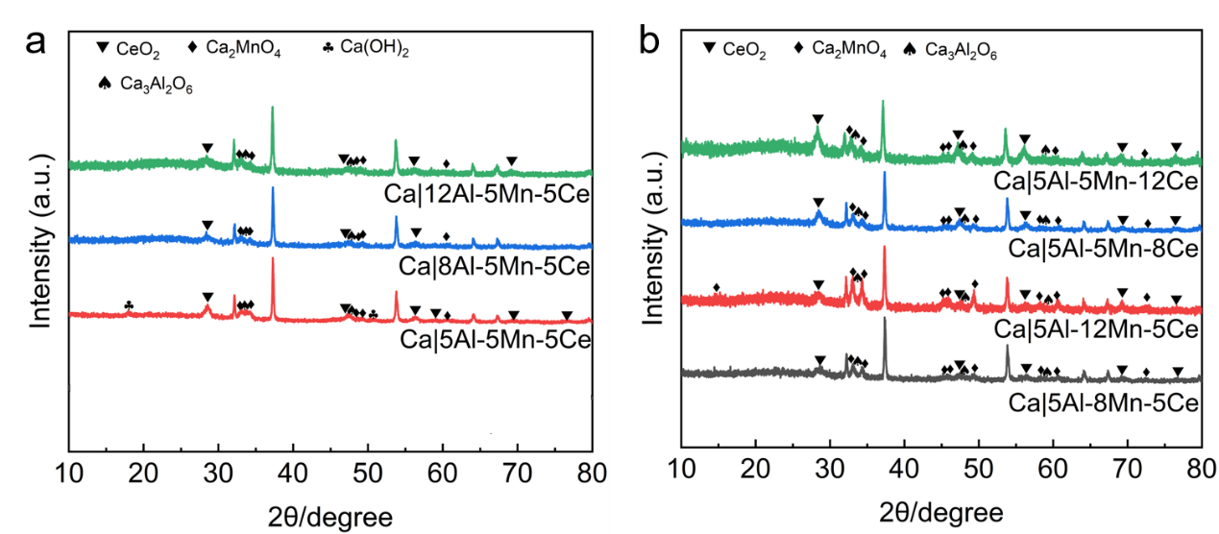
Figure S2. XRD pattern. (a) Ca|5Al-5Mn-5Ce, Ca|8Al-5Mn-5Ce, and Ca|12Al-5Mn-5Ce nanocarriers; (b) Ca|5Al-8Mn-5Ce, Ca|5Al-12Mn-5Ce, Ca|5Al-5Mn-8Ce, and Ca|5Al-5Mn-12Ce nanocarriers.

Figure S3. The cell volume of CaCA, Ca|4Al-4Mn-2Ce, Ca|8Al-8Mn-Ce and Ca|10Al-10Mn-5Ce.

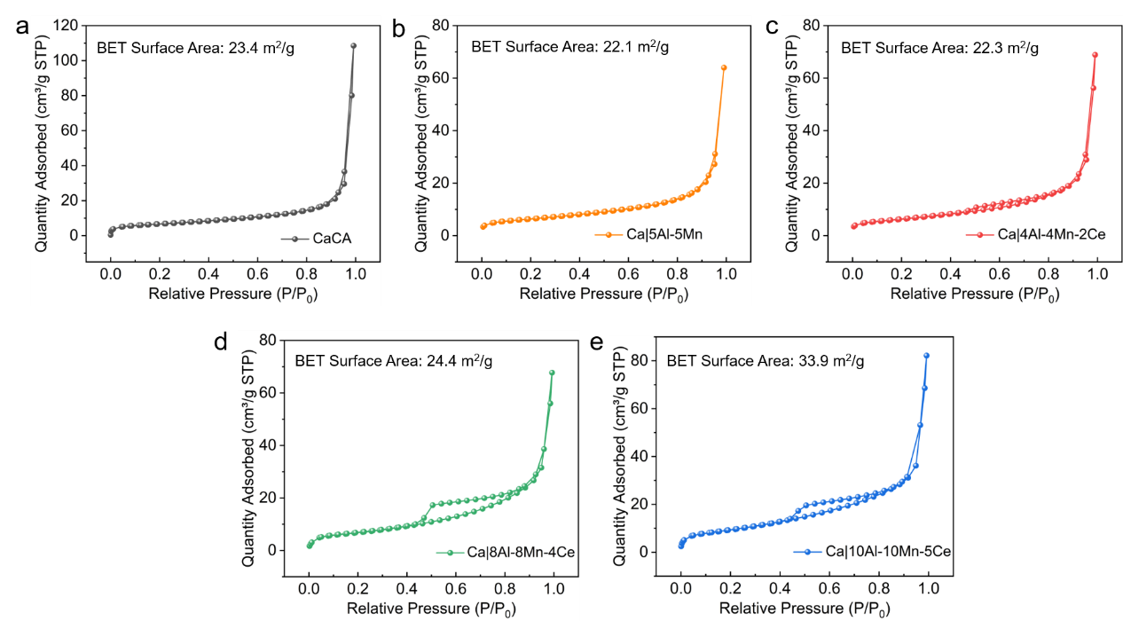
Figure S4. Nitrogen adsorption and desorption curves and BET surface area of (a) CaCA, (b) Ca|5Al-5Mn, (c) Ca|4Al-4Mn-2Ce, (d) Ca|8Al-8Mn-4Ce and (e) Ca|10Al-10Mn-5Ce.

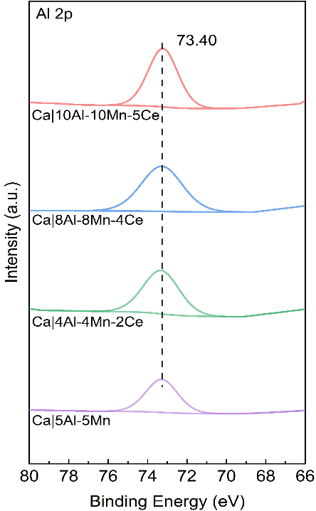
Figure S5 Al 2p XPS spectra of Al-doped CaO samples.

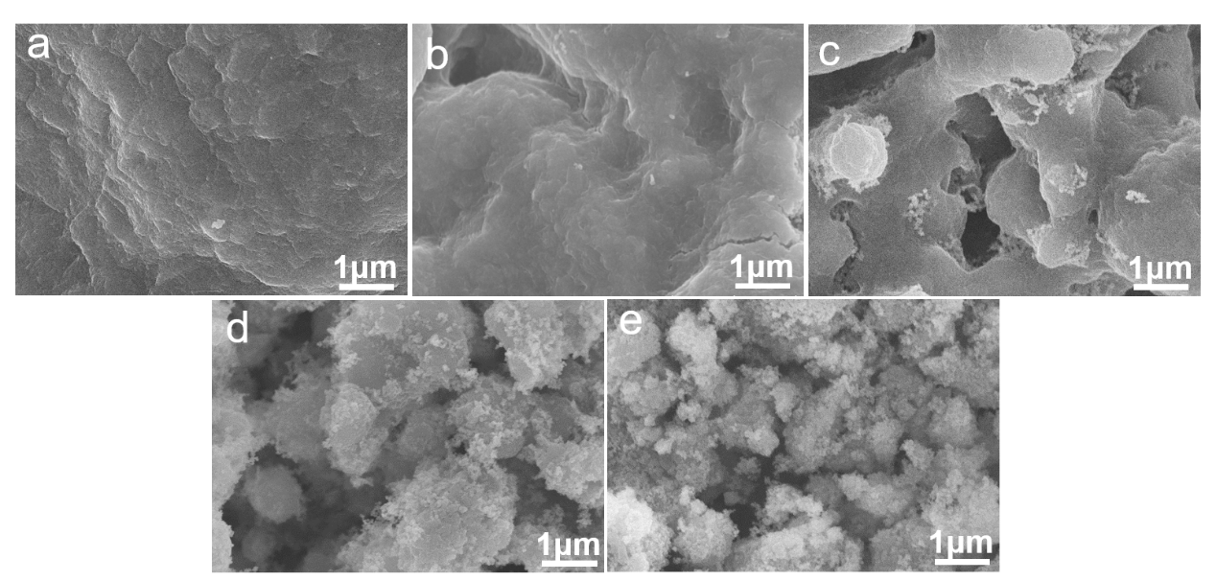
Figure S6. SEM images of Al/Mn/Ce composite CaO nanocarriers after 50 cycles (a) CaCA; (b) Ca|5Al-5Mn; (c) Ca|4Al-4Mn-2Ce; (d) Ca|8Al-8Mn-4Ce; (e) Ca|10Al-10Mn-5Ce.

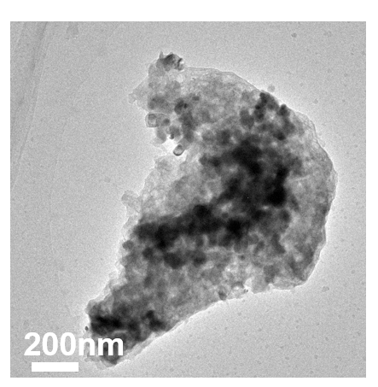
Figure S7. (a, b) TEM image of the Ca|10Al-10Mn-5Ce nanocarrier after 500 cycles

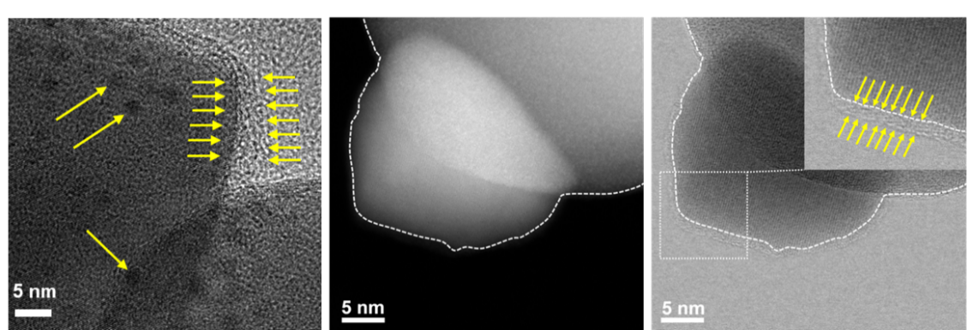
Figure S8. STEM image of the Ca|10Al-10Mn-5Ce after 500 cycles, it can be clearly observed that the surface of the nanoparticles is covered with a translucent film.

Figure S9. Optimized structures of (a) the CaO (100) with adsorbed CaO nanoclusters, (b) the Al/CaO(100) with adsorbed CaO nanoclusters, (c) the Mn/CaO(100) with adsorbed CaO nanoclusters, (d) the Al,Mn/CaO(100) with adsorbed CaO nanoclusters, (e) the Ce/CaO(100) with adsorbed CaO nanoclusters, (f) the Ca₂MnO₄(100) with adsorbed CaO nanoclusters, (g) the Ce/Ca₂MnO₄(100) with adsorbed CaO nanoclusters, (h) the Ca₃Al₂O₆(011) with adsorbed CaO nanoclusters and (i) the Ce/Ca₃Al₂O₆(011) with adsorbed CaO nanoclusters.

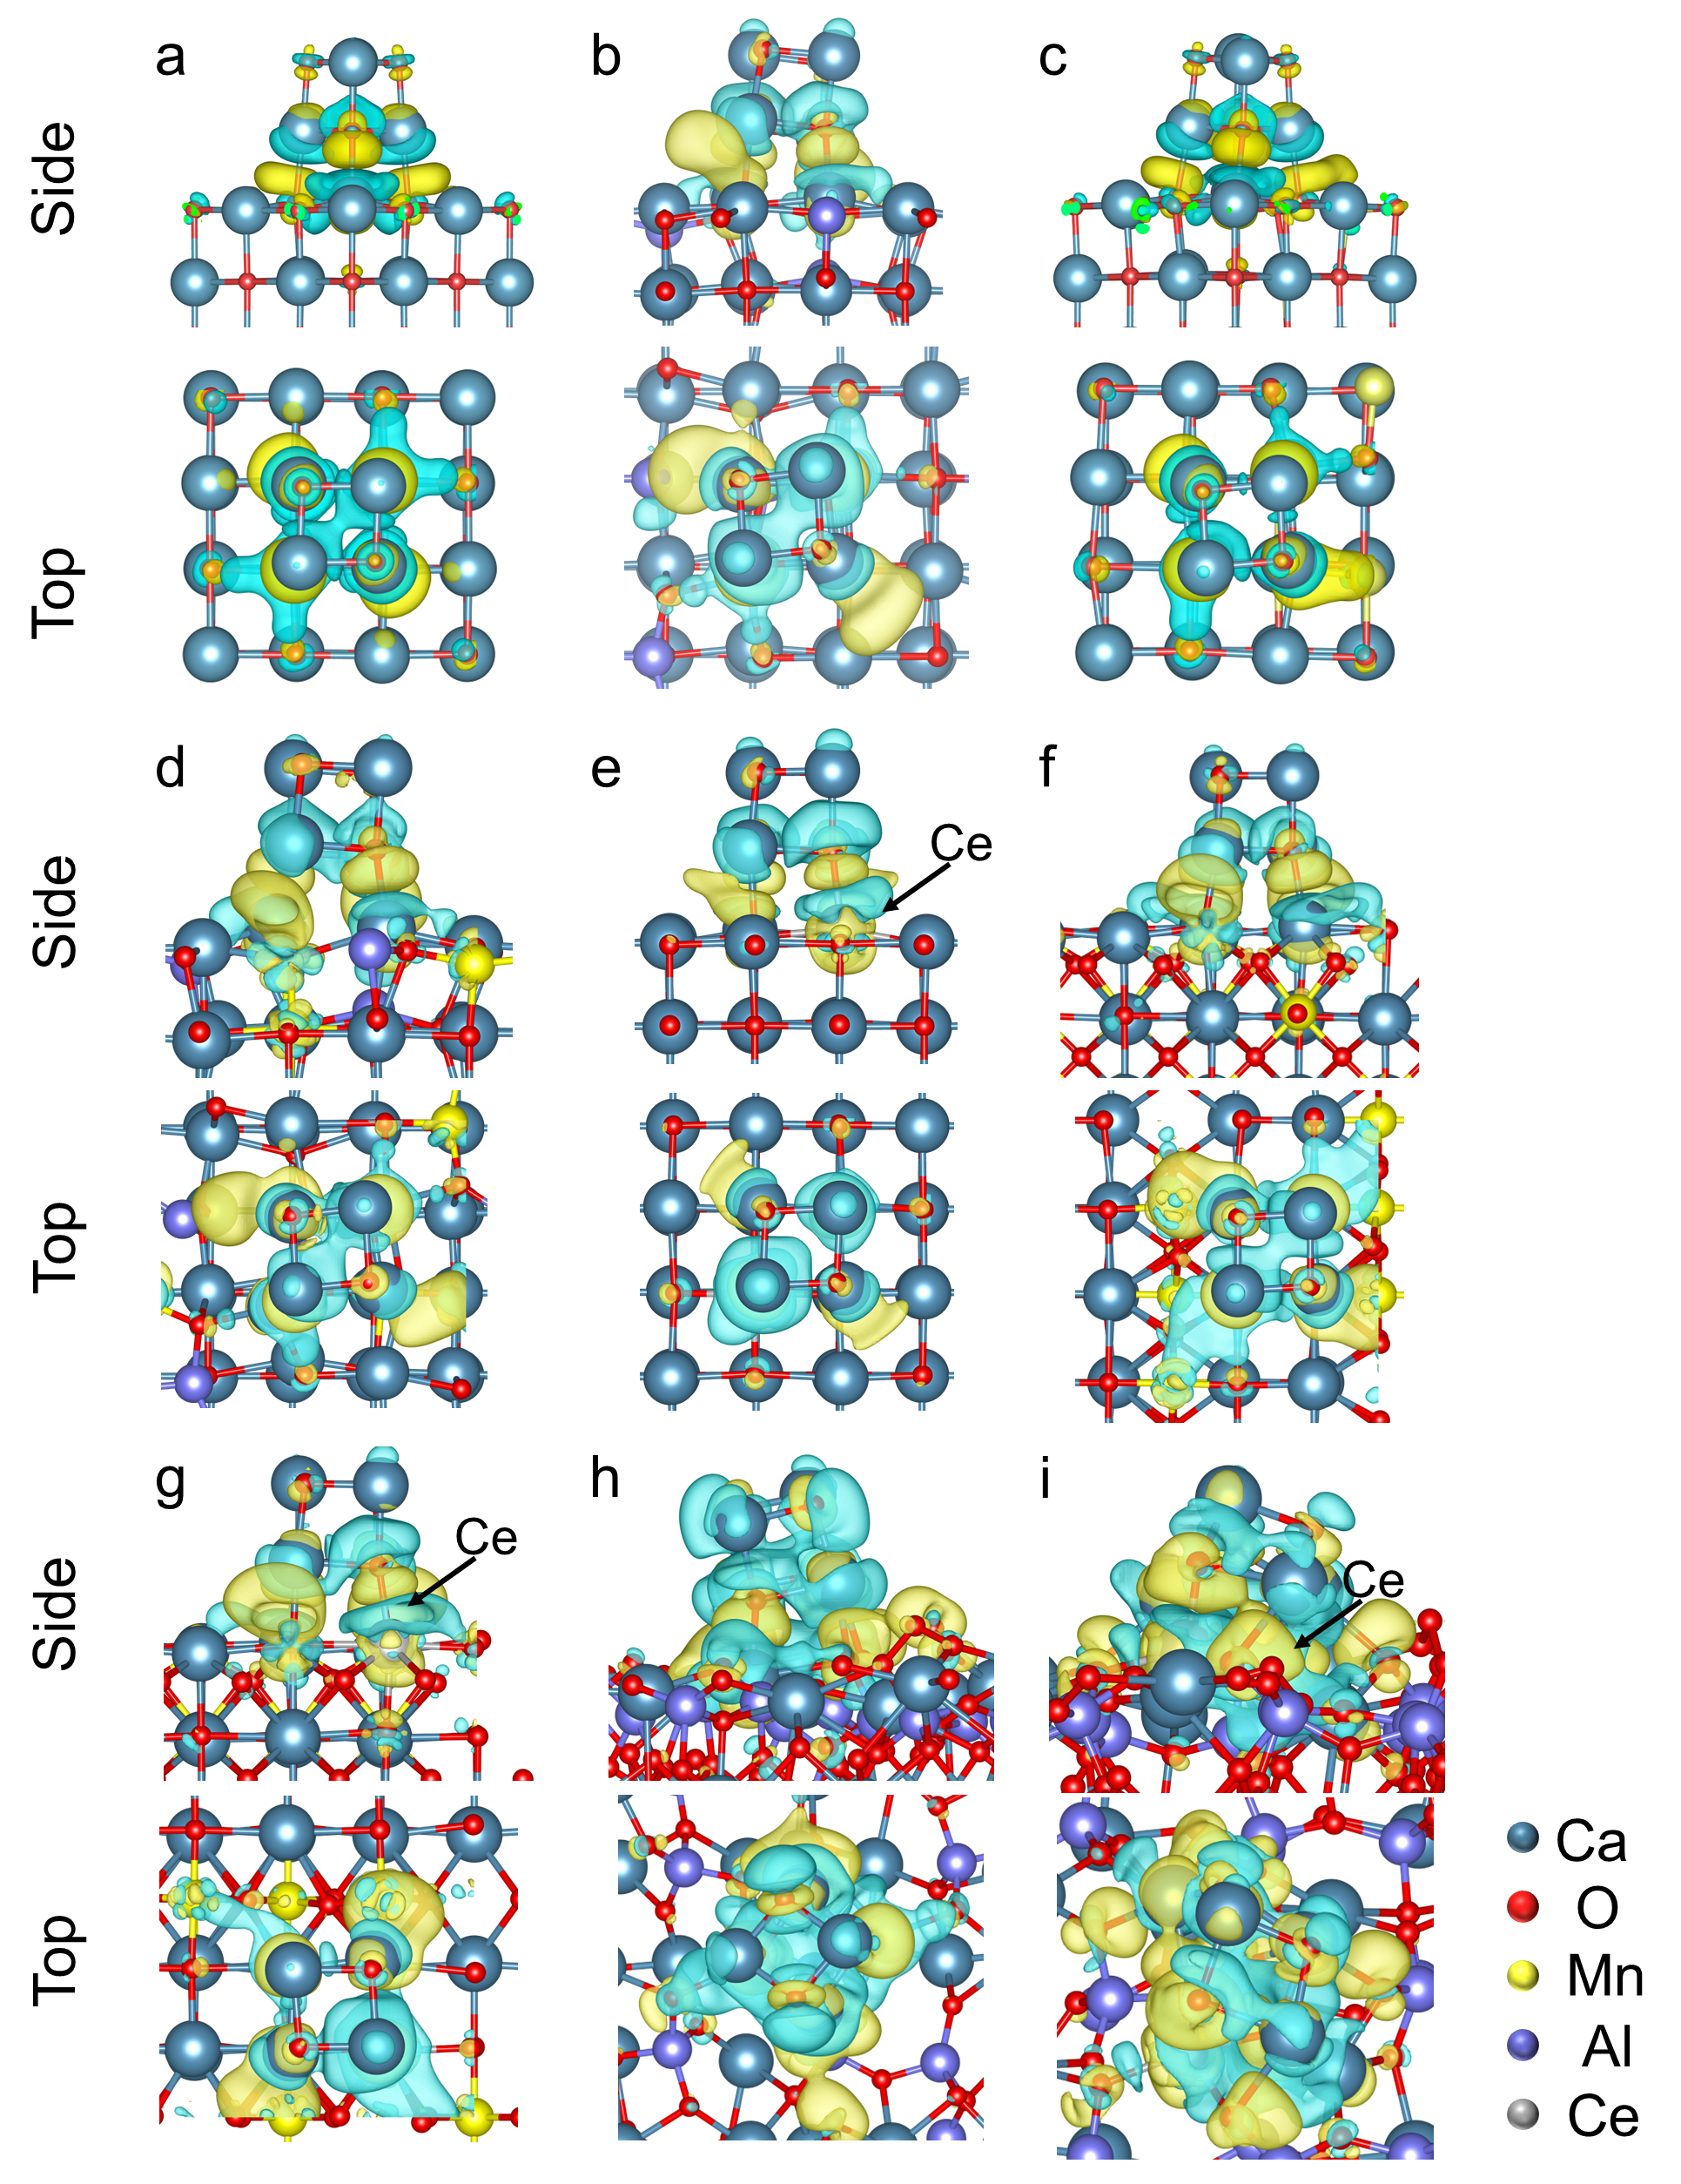
Figure S10. The differential charge density profile of (a) the CaO (100) with adsorbed CaO nanoclusters, (b) the Al/CaO(100) with adsorbed CaO nanoclusters, (c) the Mn/CaO(100) with adsorbed CaO nanoclusters, (d) the Al,Mn/CaO(100) with adsorbed CaO nanoclusters, (e) the Ce/CaO(100) with adsorbed CaO nanoclusters, (f) the Ca₂MnO₄(100) with adsorbed CaO nanoclusters, (g) the Ce/Ca₂MnO₄(100) with adsorbed CaO nanoclusters, (h) the Ca₃Al₂O₆(100) with adsorbed CaO nanoclusters and (i) the Ce/Ca₃Al₂O₆(100) with adsorbed CaO nanoclusters. Yellow and cyan represent electron accumulation and depletion region, respectively.

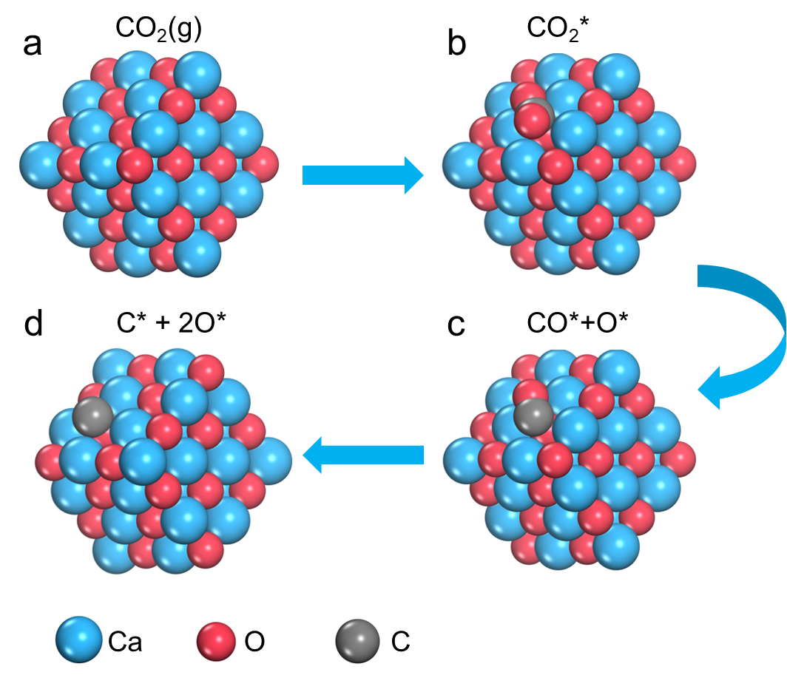
Figure S11. Optimized structures of reaction intermediates on CaO(100).

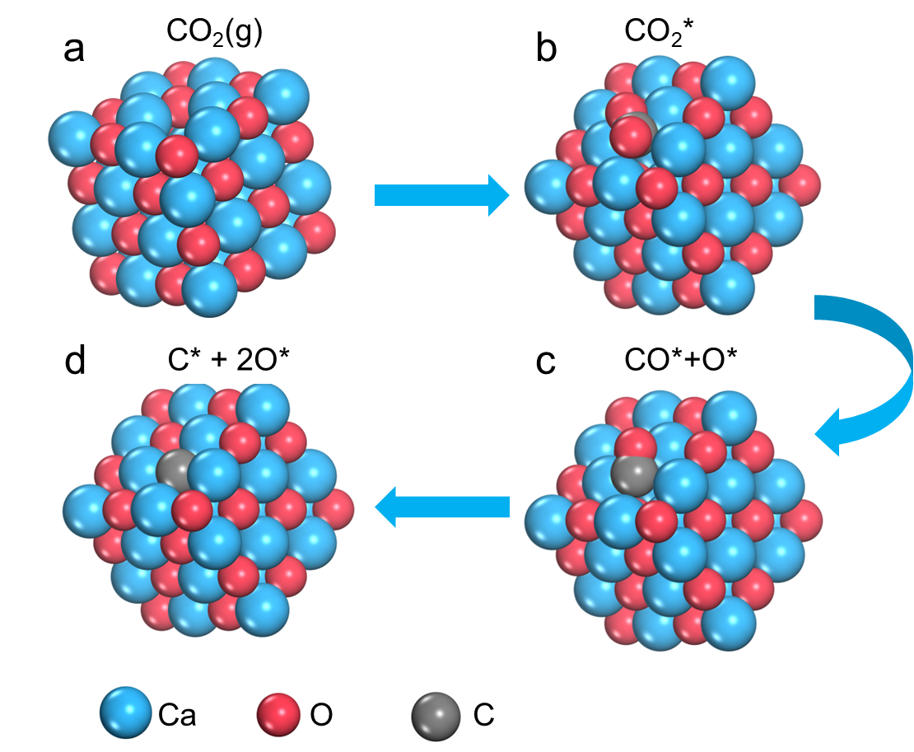
Figure S12. Optimized structures of reaction intermediates on CaO(100)/V (the V represents oxygen vacancy)

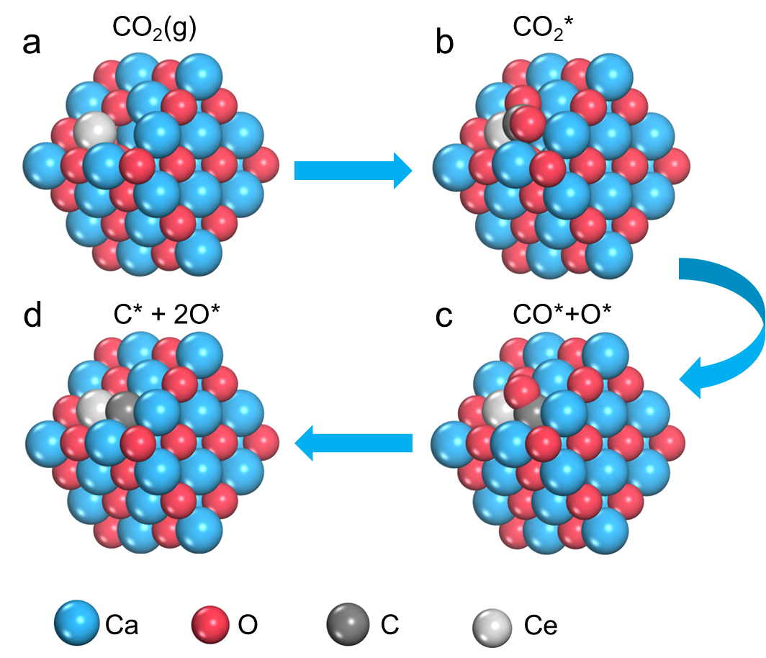
Figure S13. Optimized structures of reaction intermediates on Ce-CaO(100)/V (the V represents oxygen vacancy)

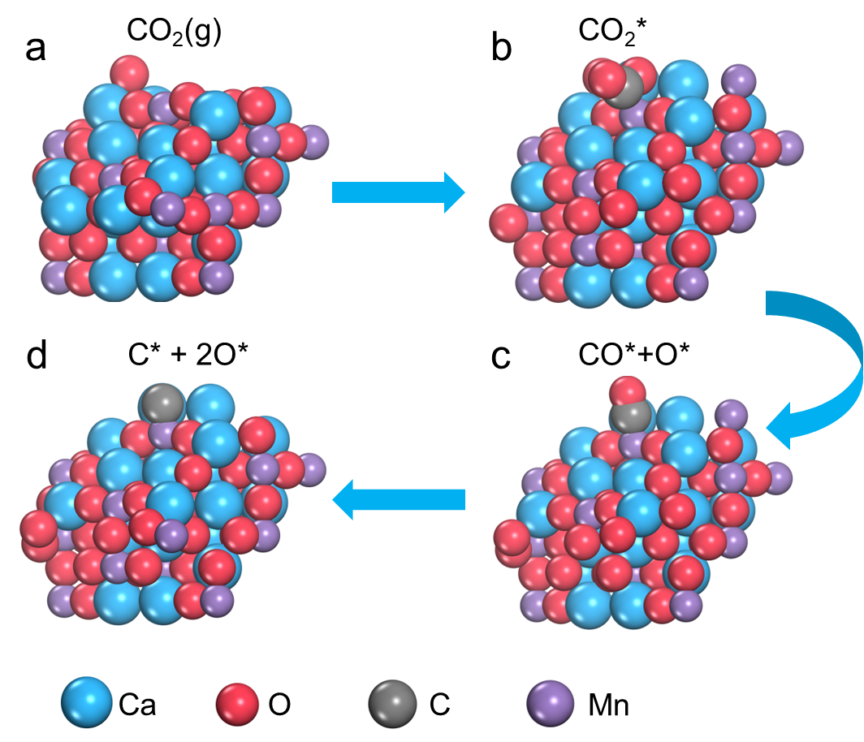
Figure S14. Optimized structures of reaction intermediates on Ca₂MnO₄(100) (the V represents oxygen vacancy)
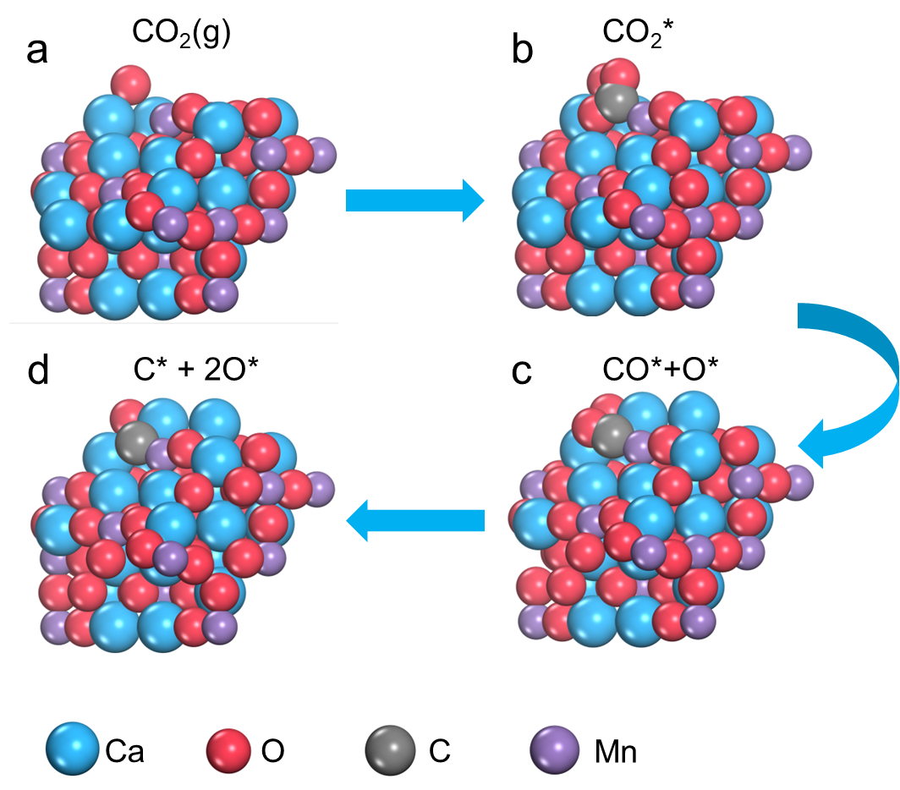
Figure S15. Optimized structures of reaction intermediates on Ca₂MnO₄(100)/V (the V represents oxygen vacancy)
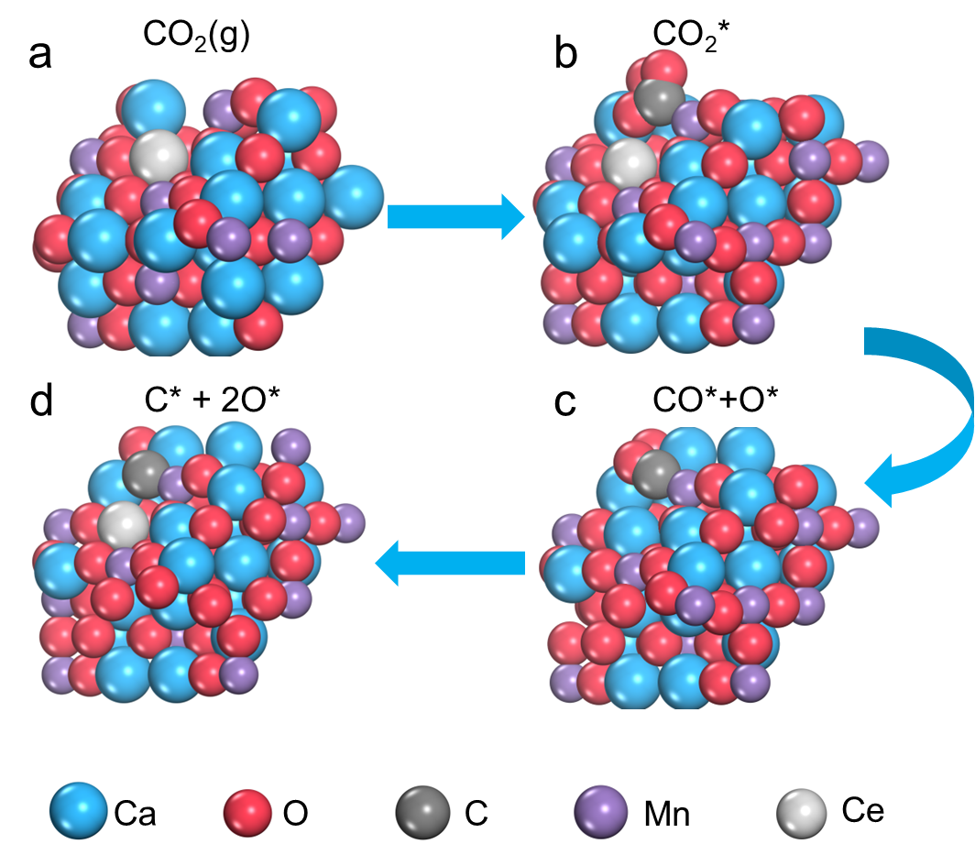
Figure S16. Optimized structures of reaction intermediates on Ce-Ca₂MnO₄(100)/V (the V represents oxygen vacancy)
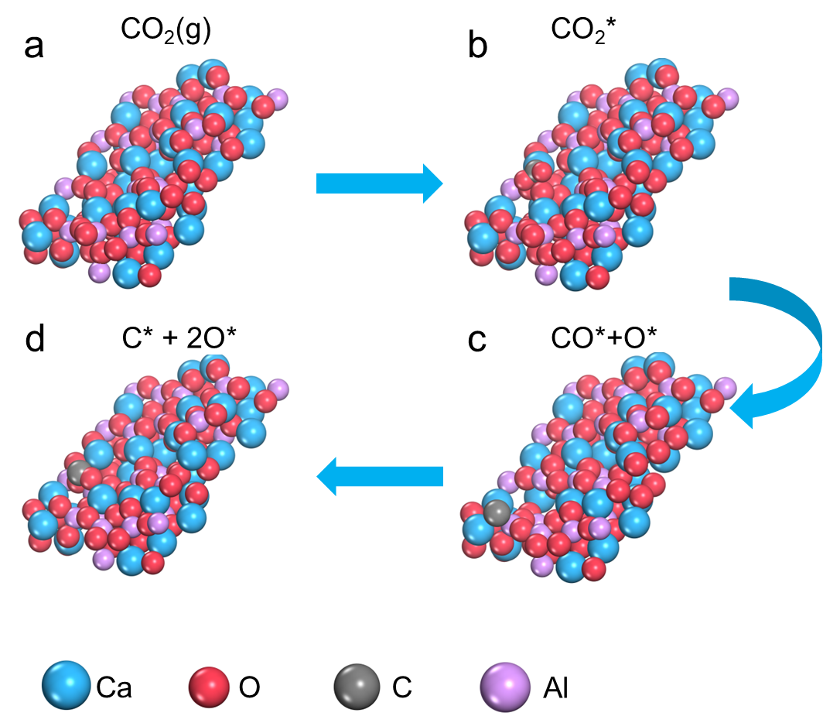
Figure S17. Optimized structures of reaction intermediates on Ca₃Al₂O₆(100). (the V represents oxygen vacancy)
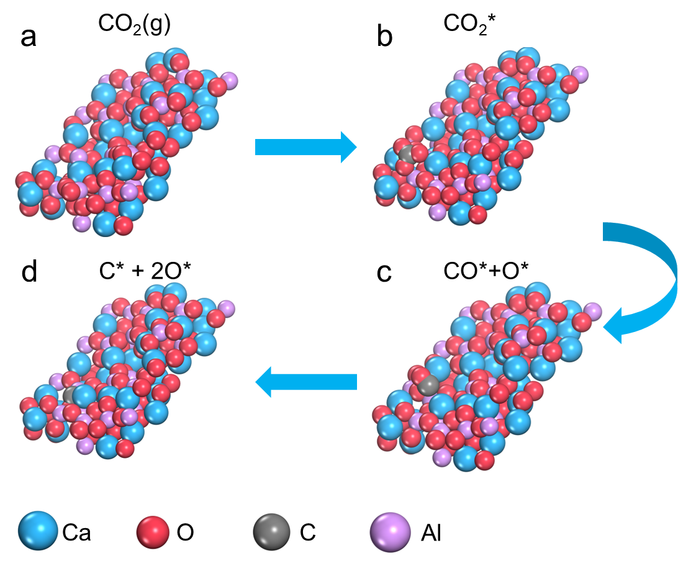
Figure S18. Optimized structures of reaction intermediates on Ca₃Al₂O₆(100)/V. (the V represents oxygen vacancy)

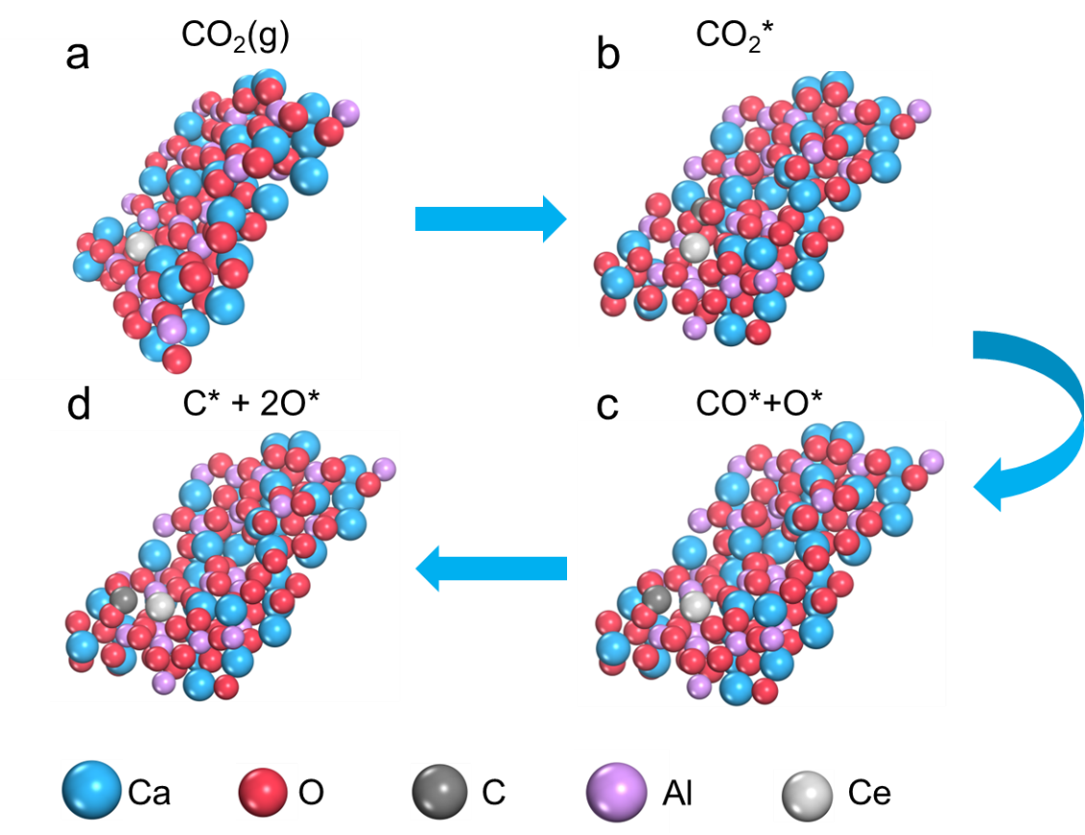
Figure S19. Optimized structures of reaction intermediates on Ce-Ca₃Al₂O₆(100)/V. (the V represents oxygen vacancy)

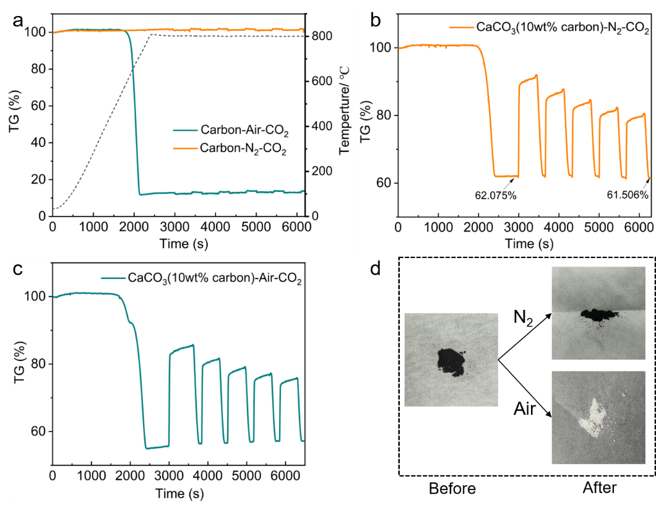
Figure S20. (a) TG diagram of carbon black tested in N₂ and air calcination atmosphere for 5 cycles respectively; (b) TG diagram of 5 cycles of CaCO₃(10wt% carbon) under N₂ calcination atmosphere; (c) TG diagram of 5 cycles of CaCO₃(10wt% carbon) under air calcination atmosphere; (d) Macroscopic appearance of CaCO₃(10wt% carbon) before and after cycles under different calcining atmospheres.

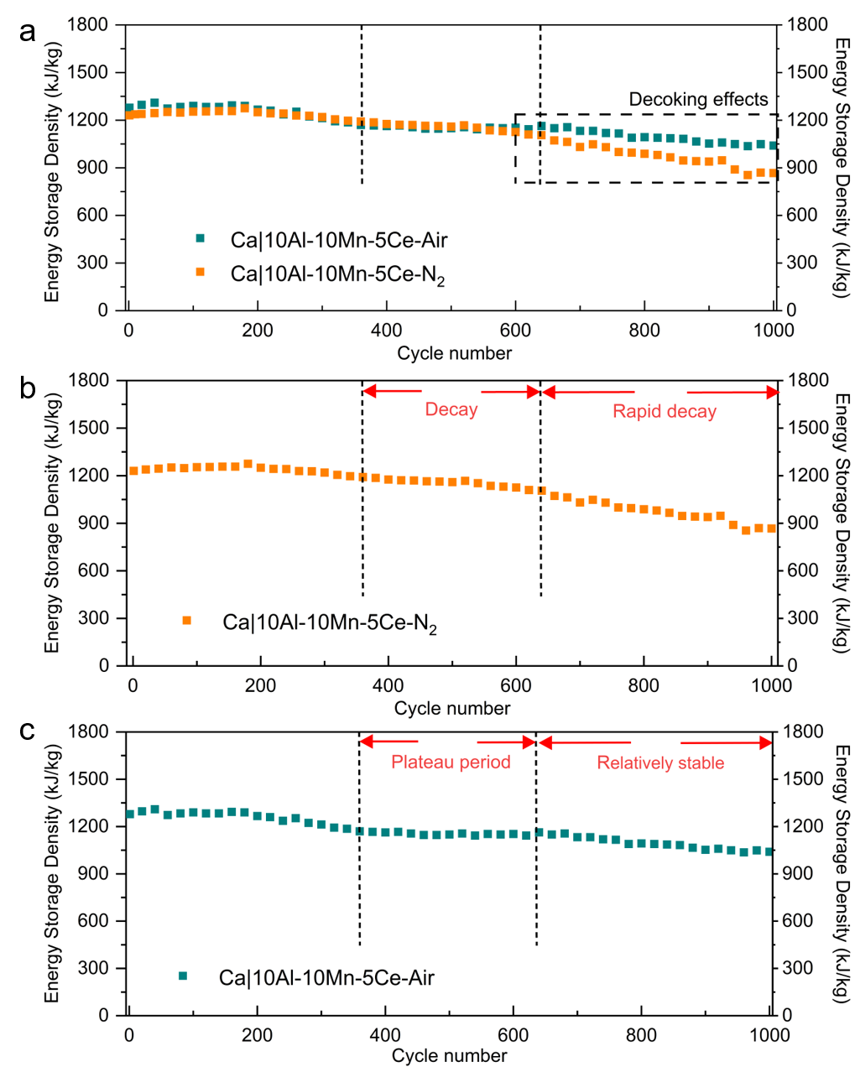
Figure S21. Stability of Ca|10Al-10Mn-5Ce after 1000 cycles under different calcination atmospheres, (a) N₂-Air comparison, (b) N₂ atmosphere, (c) Air atmosphere.

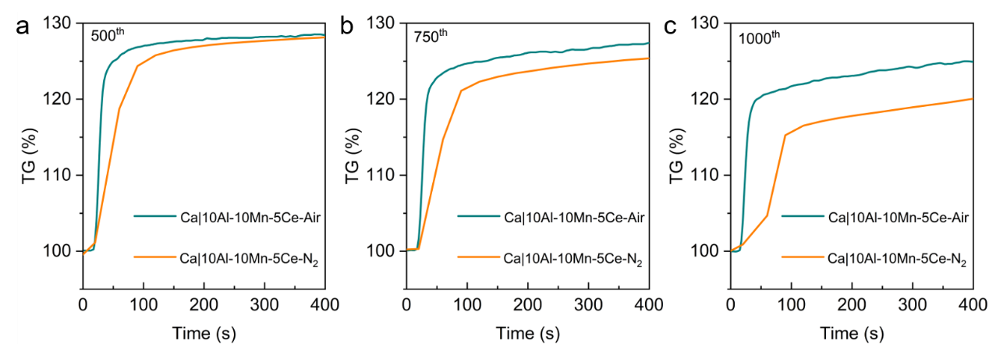
Figure S22. TG curve of Ca|10Al-10Mn-5Ce carbonation under calcination atmosphere of Air and N₂, (a) 500th cycle; (b) 750th cycle; (c) 1000th cycle.

Tabl S1 to 8

Table S1. The crystal cell parameters of as-synthesized metal doping CaO samples. (Space group: Fm-3m)

Samples | a[Å] | d₍₂₀₀₎ [Å] | V[Å³]
CaCA | 4.8252 | 2.4126 | 112.3430
Ca|5Al-5Mn | 4.8287 | 2.4143 | 112.5876
Ca|4Al-4Mn-2Ce | 4.8225 | 2.4112 | 112.1545
Ca|8Al-8Mn-4Ce | 4.8224 | 2.4112 | 112.1475
Ca|10Al-10Mn-5Ce | 4.8194 | 2.4097 | 111.9384
Ca|5Al-5Mn-5Ce | 4.8200 | 2.4100 | 111.9802
Ca|8Al-5Mn-5Ce | 4.8200 | 2.4100 | 111.9802
Ca|12Al-5Mn-5Ce | 4.8277 | 2.4139 | 112.5177
Ca|5Al-8Mn-5Ce | 4.8094 | 2.4047 | 111.2430
Ca|5Al-12Mn-5Ce | 4.8179 | 2.4090 | 111.8339
Ca|5Al-5Mn-8Ce | 4.8150 | 2.4075 | 111.6320
Ca|5Al-5Mn-12Ce | 4.8422 | 2.4211 | 113.5346

Table S2. The BET surface area and pore volume of Al/Mn/Ce composite energy carriers.
Sample | BET Surface Area (m² g⁻¹) | Pore volume of pores (cm³ g⁻¹) | Average pore diameter  (nm)
CaCA | 23.4 | 0.0465 | 8.0
Ca|5Al-5Mn | 22.1 | 0.0434 | 7.8
Ca|4Al-4Mn-2Ce | 22.3 | 0.0468 | 18.3
Ca||8Al-8Mn-4Ce | 24.4 | 0.0503 | 11.8
Ca|10Al-10Mn-5Ce | 33.9 | 0.0616 | 12.5

Table S3. The CaO grain size of different nanocarrier was calculated by Debye-Scherrer formula
Sample | Grain Size (nm)
CaCA | 23.4
Ca|5Al-5Mn | 22.1
Ca|4Al-4Mn-2Ce | 22.3
Ca||8Al-8Mn-4Ce | 24.4
Ca|10Al-10Mn-5Ce | 33.9

Table S4. Binding energies of Ce 3d XPS peaks of Al/Mn/Ce composite energy carriers.
Sample | Binding energies of Ce 3d XPS peaks (eV)
Sample | v⁰ | v | v' | v'' | v''' | u⁰ | u | u' | u'' | u'''
Ca|4Al-4Mn-2Ce | 881.7 | 833.1 | 885.9 | 888.8 | 897.5 | 899.2 | 900.6 | 903.2 | 906.8 | 916.1
Ca|8Al-8Mn-4Ce | 881.8 | 883.0 | 885.9 | 888.8 | 897.7 | 899.2 | 900.6 | 903.3 | 906.9 | 916.2
Ca|10Al-10Mn-5Ce | 881.8 | 883.2 | 886.1 | 888.9 | 897.6 | 899.3 | 900.7 | 903.2 | 906.9 | 916.1

Table S5. Ce³⁺ relative amount (%) of Al/Mn/Ce co-doping energy carriers.
Sample | relative amount (%)
Ca|4Al-4Mn-2Ce | 28.2
Ca|8Al-8Mn-4Ce | 29.1
Ca|10Al-10Mn-5Ce | 31.6

Table S6. Representative works on Ca-based thermochemical energy storage.

Samples | Initial energy storage density  [kJ kg⁻¹] | Cycle number | Energy storage density after cycle  [kJ kg⁻¹] | Attenuation | Conditions  (carbonation/  calcination)
This work | 1230.0 | 1000 | 1039.6 | 15.5% | 800 ℃, 7.5 min/800 ℃, 6 min
Mg/CaO¹ | 2034.0 | 30 | 1907 | 6.3 | 650 ℃, 20 min/900 ℃, 5 min
Al/CaO² | 2002 | 30 | 1748 | 12.7% | 650 ℃, 20 min/900 ℃, 10 min
Na/CaO³ | 2161 | 50 | 1112 | 48.5% | 650 ℃, 20 min/800 ℃, 10 min
Ti, Ni/CaO⁴ | 1296 | 20 | 1267 | 2.2% | 750 ℃, 10 min/850 ℃, 5 min
Mn, Zr/CaCO3⁵ | 1706 | 125 | 1604 | 6.0% | 800 ℃, 7 min/800 ℃, 4 min
Mn, Fe/CaO⁶ | 636 | 100 | 556 | 12.5% | 750 ℃, 60 min/750 ℃, 60 min
Ce, La, Nd, Yb, Zr/CaO⁷ | 1748 | 20 | 1653 | 5.4% | 650 ℃, 30 min/850 ℃, 5 min
SiC/CaO | 1120 | 40 | 482 | 57.0% | 884 ℃, 10 min/884 ℃, 20 min
Mn, Mg/CaO⁸ | 1520 | 100 | 1460 | 4.0% | 800 ℃, 10 min/800 ℃, 8 min
Ni, Zr/CaO⁹ | 2100 | 60 | 2000 | 4.8% | 850 ℃, 10 min/750 ℃, 15 min
Mn, Ce/CaO¹⁰ | 2480 | 20 | 2385 | 3.8% | 850 ℃, 10 min/850 ℃, 10 min
SiO_{2/}CaO¹¹ | 2542 | 50 | 1176 | 53.7% | 850 ℃, 35 min/650 ℃, 40 min

Table S7. Adsorption energy of CaO clusters on different substrates.
Name | The adsorption energy (eV)
CaO(100) | -2.92
Mn/CaO(100) | -3.78
Al/CaO(100) | -3.94
AlMn/CaO(100) | -3.69
Ce/CaO(100) | -3.73
Ca₂MnO₄(110) | -4.18
Ce/Ca₂MnO₄(110) | -4.47
Ca₃Al₂O₆(011) | -5.76
Ce/Ca₃Al₂O₆(011) | -6.48

Table S8. Carbon content of Ca|10Al-10Mn-5Ce before and after 500 cycles.
sample | C (%)
Ca|10Al-10Mn-5Ce | 0.84
Ca|10Al-10Mn-5Ce -500th | 1.31

References:
- Naeem MA, et al. Optimization of the structural characteristics of CaO and its effective stabilization yield high-capacity CO₂ sorbents. Nat. Commun. 9, 2408 (2018).
- Armutlulu A, et al. Multishelled CaO Microspheres Stabilized by Atomic Layer Deposition of Al₂O₃ for Enhanced CO₂ Capture Performance. Adv. Mater. 29, 1702896 (2017).
- Krödel M, et al. Structure of Na Species in Promoted CaO‐Based Sorbents and Their Effect on the Rate and Extent of the CO₂ Uptake. Adv. Funct. Mater. 33, 2302916 (2023).
- Guo SJ, Tian XK, Yan J, Ju SH, Zhao CY. Performance enhancement mechanisms of calcium-based thermochemical energy storage compounds: insights from first-principles and experimental investigations. J. Mater. Chem. A 12, 14129-14147 (2024).
- Li H, et al. 3D Ordered Macroporous Mn, Zr‐Doped CaCO₃ Nanomaterials for Stable Thermochemical Energy Storage. Adv. Sci. 12, 2412082 (2024).
- Desage L, Humphries TD, Paskevicius M, Buckley CE. Reversible sorption of carbon dioxide in Ca–Mg–Fe systems for thermochemical energy storage applications. J. Mater. Chem. A 12, 14721-14733 (2024).
- Long Y, et al. High‐Entropy Fluorite Oxide‐Modified CaO‐Based Sorbent Pellets for Enhanced High‐Temperature CO₂ Capture. Small 20, 2406165 (2024).
- Liu H, Li Y, Wei J. High performance Mn/Mg co-modified calcium-based material via EDTA chelating agent for effective solar energy storage. Chem. Eng. J. 480, 147892 (2024).
- Li Z-y, et al. Ni/Zr co-doping strategy to promote cyclic performance of CaO-based materials for thermochemical energy storage: Experimental and first-principles insights. Chem. Eng. J. 523, 168897 (2025).
- Zhang Y, et al. Screening dual variable-valence metal oxides doped calcium-based material for calcium looping thermochemical energy storage and CO₂ capture with DFT calculation. J. Energy Chem. 107, 170-182 (2025)
- Li C-C, Wu U-T, Lin H-P. Cyclic performance of CaCO₃@mSiO₂ for CO₂ capture in a calcium looping cycle. J. Mater. Chem. A 2, 8252-8257 (2014).

