Supplementary Information

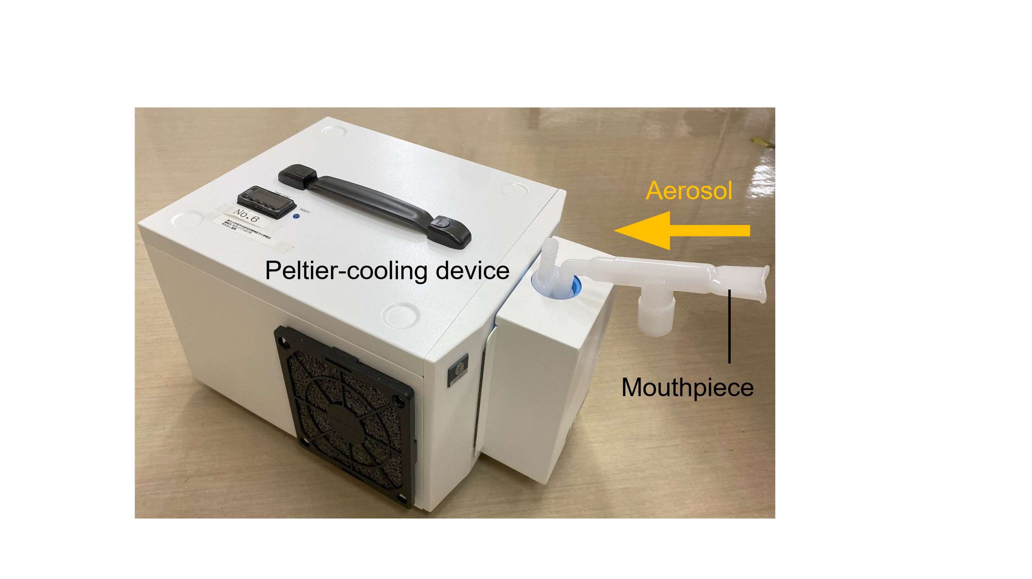
Supplementary Fig. 1 Collection of EBC
EBC was collected by applying a nose clip while the subject was seated and breathing normally at rest for 5 min. Using the Peltier-cooling device, the exhaled breath was rapidly cooled to −20 ℃.
Abbreviations: EBC, exhaled breath condensate

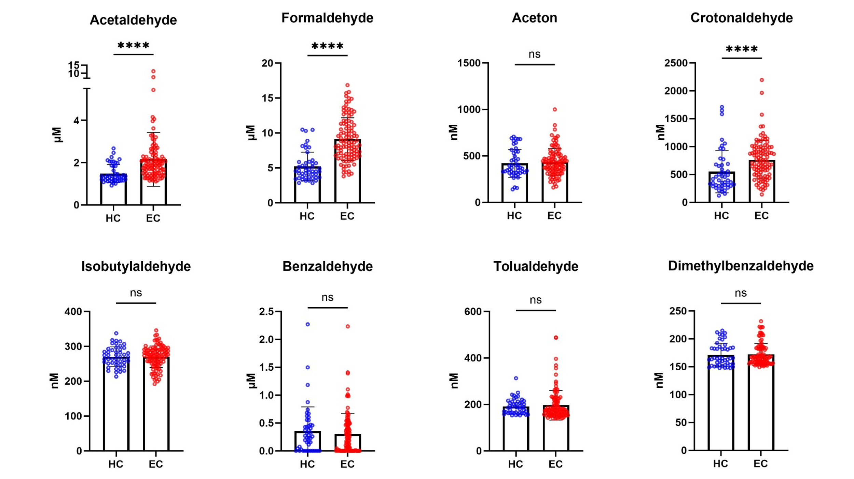
Supplementary Fig. 2 Results of all aldehyde analyses
All aldehydes in EBC could be quantitatively detected using LC-ESI-MS/MS. Each data point represents an individual patient with EC (n = 106) or an HC (n = 47). Data are presented as the mean ± standard deviation. **** P < 0.0001.
Abbreviations: EC, esophageal cancer; HC, healthy controls; LC-ESI-MS/MS, liquid chromatography–electrospray ionization–tandem mass spectrometry; Ns, not significant

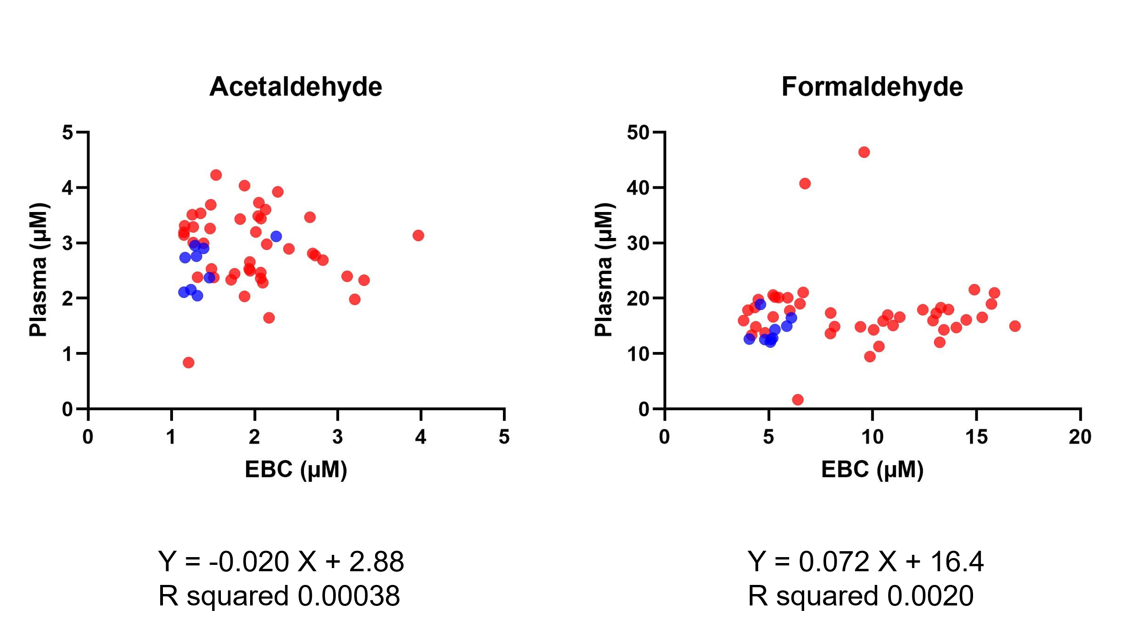

Supplementary Fig. 3 Correlation between acetaldehyde and formaldehyde concentrations in both EBC and plasma
Red and blue filled circles represent patients with EC and HC, respectively.
Abbreviations: EBC, exhaled breath condensate; EC, esophageal cancer; HC, healthy controls

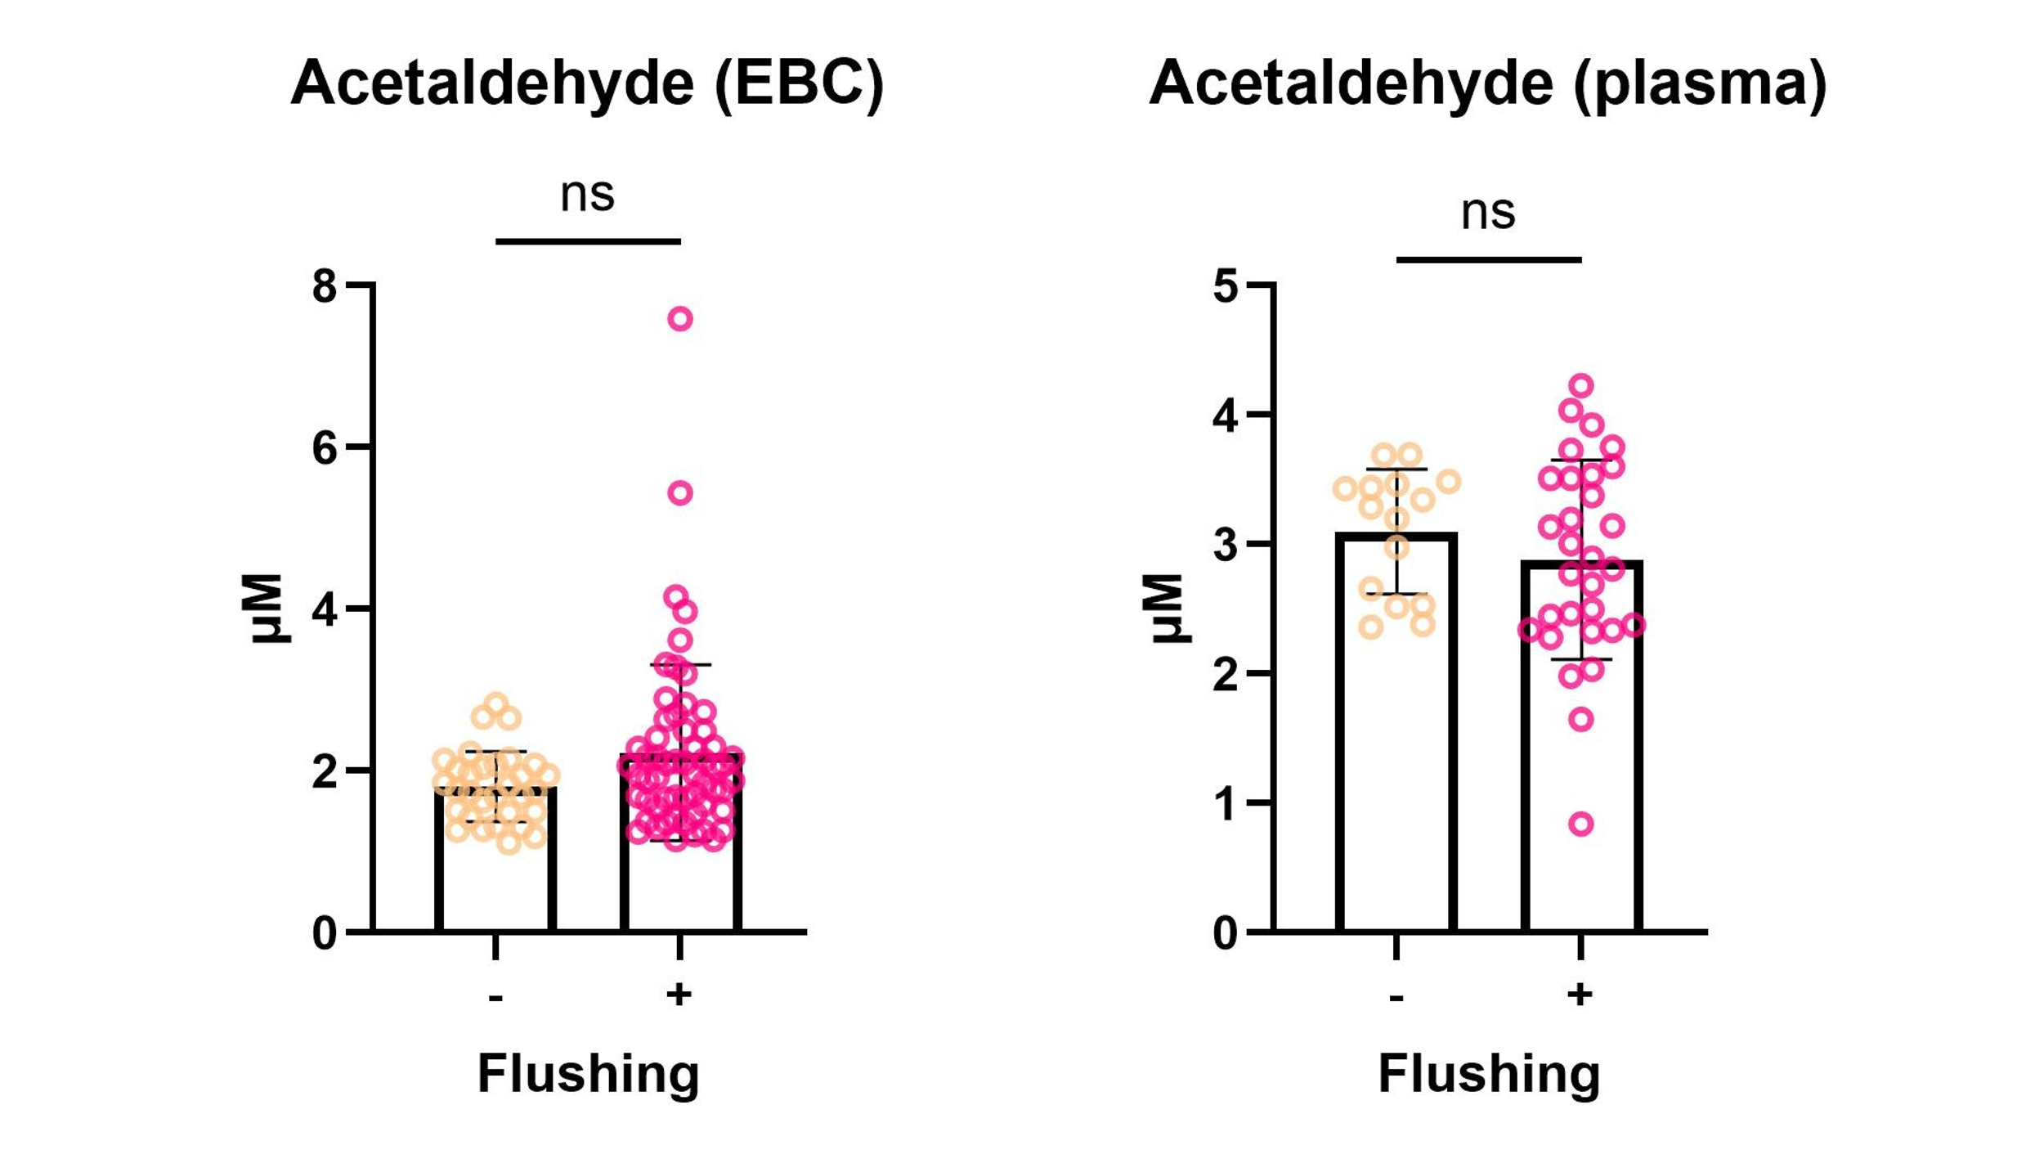
Supplementary Fig. 4 Relationship between flushing and acetaldehyde concentration in both EBC and plasma
Acetaldehyde concentration in the EBC was classified according to the presence or absence of flushing. Each data point represents an individual subject: the absence of flushing (n = 31) and the presence of flushing (n = 58) in the EBC; the absence of flushing (n = 15) and the presence of flushing (n = 30) in the plasma. Data are presented as the mean ± standard deviation.
Abbreviations: EBC, exhaled breath condensate; EC, esophageal cancer; HC, healthy controls; Ns, not significant

Supplementary Table 1. Multiple reaction monitoring parameters of various carbonyl compounds used for LC-ESI-MS/MS
Analyte | Polarity | Precursor ion (m/z) | Product ion (m/z) | Collision energy (V)
Formaldehyde-DNPH | − | 209.10 | 46.00 | 24
Acetaldehyde-DNPH | − | 223.10 | 46.00 | 23
Acrolein-DNPH | − | 235.10 | 199.95 | 14
Valeraldehyde-DNPH | − | 265.20 | 96.95 | 25
Acetone-DNPH | − | 237.10 | 191.05 | 10
Crotonaldehyde-DNPH | − | 249.20 | 203.00 | 10
Isobutylaldehyde-DNPH | − | 251.10 | 205.05 | 11
Benzaldedehy-DNPH | − | 285.20 | 240.90 | 10
o,m,p-Tolualdehyde-DNPH | − | 299.20 | 162.95 | 15
Dimethylbenzaldehyde-DNPH | − | 313.30 | 267.05 | 15
Abbreviations: LC-ESI-MS/MS, liquid chromatography–electrospray ionization-tandem mass spectrometry; DNPH, 2,4-dinitrophenylhydrazine.

