Zinc-Imidazole Metal-Organic Nanocomposite for High-Efficiency Crystal Violet Removal and Antibacterial Applications for Environmental Remediation
Sibani Sahu¹, Soumyaranjan Senapati², Madhusmita Pradhan³, Satya Narayan Sahu³, Kapilas Das⁴, Sanjoy Kumar Maji⁴, Dusmant Maharana⁵, Biswajit Mishra^{6*} Saismrutiranjan Mohanty^{6*} Abhishek Maurya^{7*}
¹Department of Chemistry, School of Applied Sciences, Centurion University of Technology and Management (CUTM), Bhubaneswar, 752050,
²Department of Chemistry, Mangalayatan University, Jabalpur 483001, Madhya Pradesh, India
³School of Biotechnology, Centurion University of Technology and Management (CUTM), Bhubaneswar, 752050, India
⁴Department of Chemistry, School of Applied Sciences, KIIT, DU, Bhubaneswar, 751024, Odisha, India
⁵Department of Environmental Science, Parul Institute of Applied Sciences, Parul University, Vadodara-391760, Gujarat, India
⁶Department of Environmental Sciences, School of Applied Sciences, Centurion University of Technology and Management, Bhubaneswar, 752050, Odisha, India
⁷Department of Chemistry, School of Basics Sciences, Galgotias University, Greater Noida, 203201, India
*To whom correspondence should be addressed. E-mail: saismruti1994@gmail.com, Biswajit.mishra@cutm.ac.in, abhishekmauryaism@gmail.com

Figures and Tables:

Supplementary Figure S1: UV-vis spectra of dye adsorption at one-hour intervals using nanocomposite [Zn-Im].
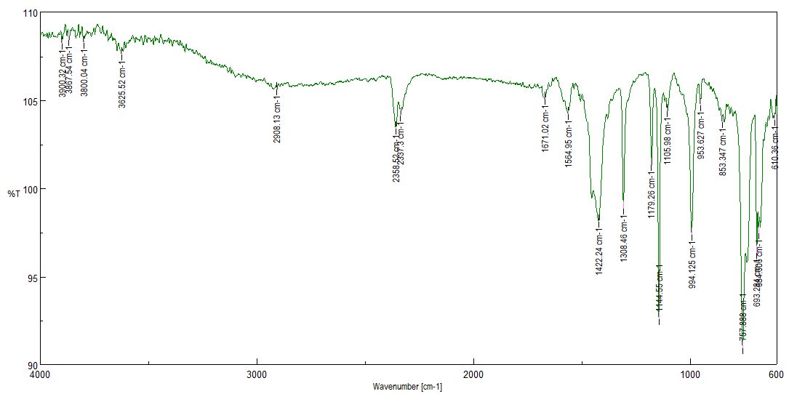
Supplementary Figure S2: FT-IR Spectra of [Zn-Im] nanocomposite.

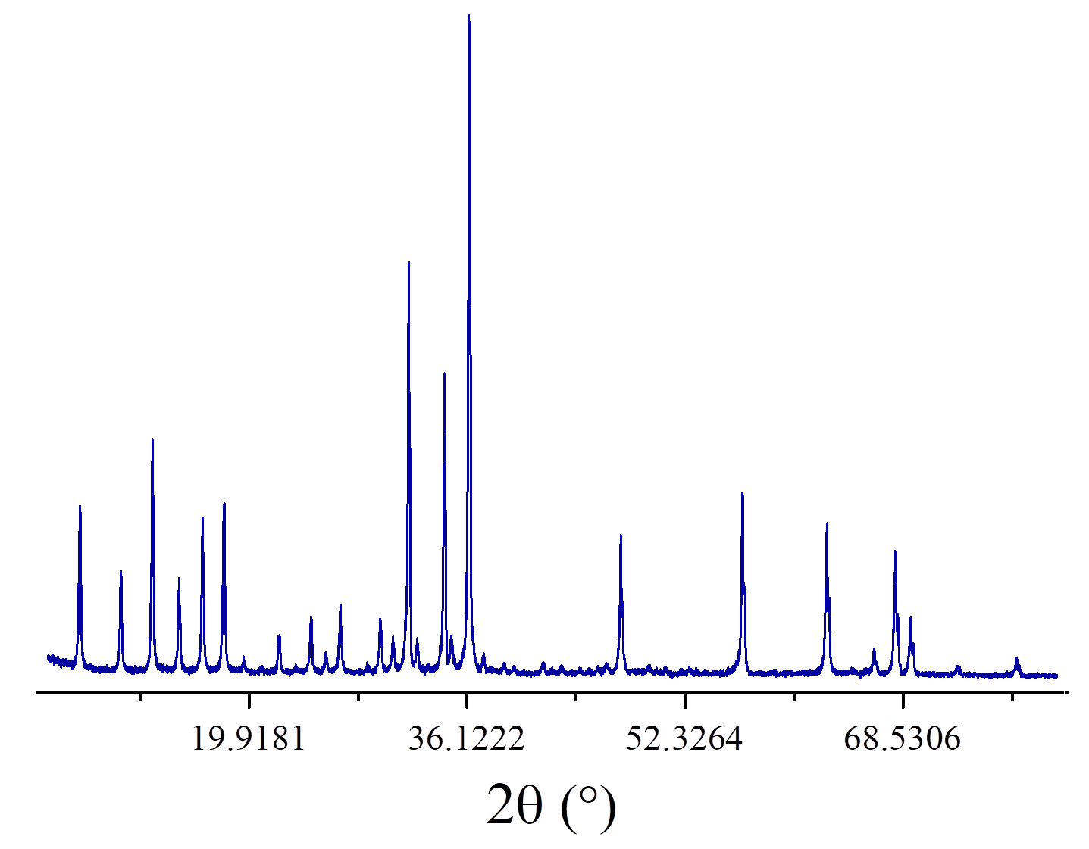
Supplementary Figure S3: Powder XRD of nano-composite [Zn-Im].

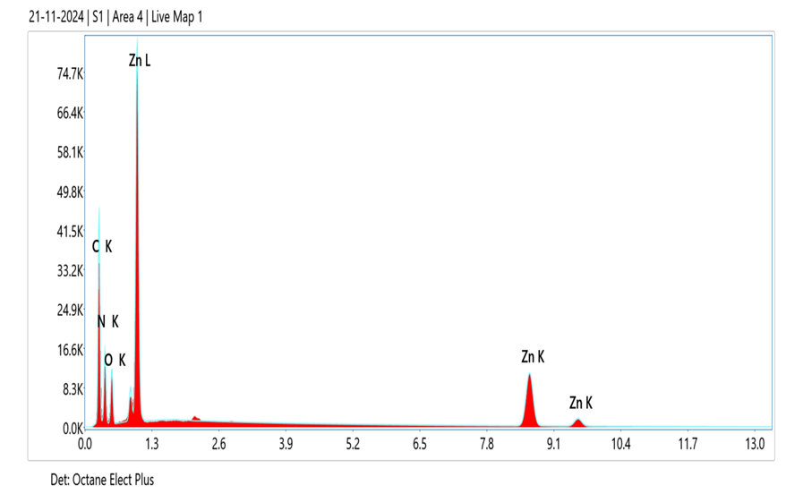

Supplementary Figure S4: EDX image of [Zn-Im] nanocomposite.

Supplementary Table S1: Elemental percentages data of [Zn-Im] nanocomposite.

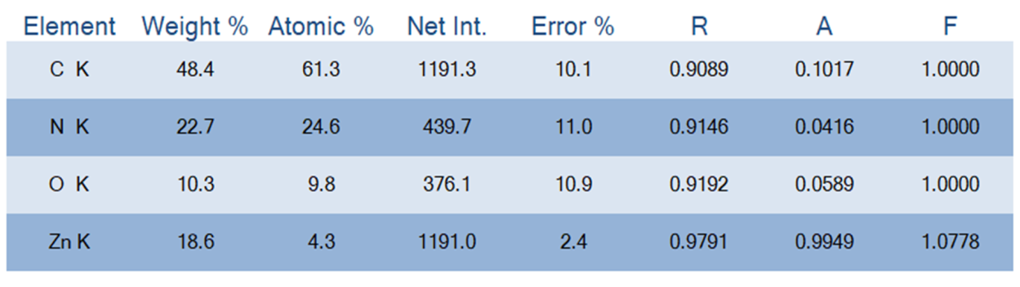
Supplementary Table S2: Comparison of maximum adsorption capacity of CV onto different Adsorbents
Authors | CV (mg/L) | Year | Used Materials | Efficiency (mg/g) | Time (hr) | Temp. (°C) | pH | Ref.
Ogata et al., 2024 | 100 | 2024 | Waste Fabric Polyster (VCP1000) | 74.80 | 24 | 25 | ̴5.0 | [1]
Ogata et al., 2024 | 100 | 2024 | Waste Fabric Polyster (VC1000) | 92.8 | 24 | 25 | ̴5.0 | [1]
Teoh et al., 2025 | 30 | 2025 | Immobilized Spent Coffee Powder | 97.09 | 6 | 40 | 7 | [2]
Sen et al., 2024 | 100 | 2024 | Ball milled Royal Palm Leaf Sheath | 454.5 | 1 | 25 | 6 | [3]
Homagai et al., 2022 | 50 | 2022 | Charred Rice Husks | 62.85 | 24 | 20-25 | - | [4]
Sultana et al., 2022 | 400 | 2022 | Coconut Husk | 454.54 | 3 | 20-25 | 5.0 | [5]
Ayuba, Idoko., 2021 | 50 | 2021 | Cowpea Husk | 153.85 | 1.5 | 25 | 6 | [6]
Wu et al., 2023 | 300 | 2023 | Fe modified sponge structure peanut shell carbon | 143.25 | 2 | 500 | 7 | [7]
Benamar et al., 2025 | - | 2025 | Olea Oleaster Leaf biomass | 66.28 | 70 | - | 5.4 | [8]
Rozi et al., 2025 | - | 2025 | lemon peel waste (LPW) | 71.2 | - | - | - | [9]
Naifar et al., 2024 | - | 2024 | Activated Bamboo Fiber Powder (ABFP) | 1403.13 | - | 25 | - | [10]
Tiar et al., 2025 | - | 2025 | Raw Oil mill waste (Olive Cake) | 399.8 | - | 30 | 6.54 | [11]
Elsherif et al., 2021 | 50 | 2021 | Olive Leaves Powder | 181.1 | 20 min | - | 7.54 | [12]

Adsorption Isotherm Study:
Determining the amount of solute adsorbed at a constant temperature on a defined quantity of sorbent is essential for understanding adsorption characteristics. In this study, the adsorption behaviors of ZIF-8 towards Crystal Violet (CV) was investigated using three isotherm models Langmuir, Freundlich, and Dubinin Radushkevich (D–R) at approximately 25 ± 2 °C. The experiments were conducted with varying sorbent doses ranging from 1.0 to 7.0 g/L, while maintaining a fixed CV concentration of 10 mg/L. The linearized Langmuir isotherm (Figure 5A) was plotted using the relation between 1/qₑ and 1/Cₑ, as expressed by the following equation.
… 1
where Cₑ represents the equilibrium concentration (mg/L), Qₘₐₓ denotes the maximum adsorption capacity (mg/g), b is a constant associated with the adsorption system’s energy (L/mg), and qₑ indicates the amount of adsorbate adsorbed per unit mass of adsorbent at equilibrium (mg/g). Based on the linearized Langmuir equation, expressed as 1/qₑ = 0.0784(1/Cₑ) + 0.14771, the correlation coefficient (R²) was determined to be 0.98, confirming a good fit of the experimental data to the Langmuir model. The maximum adsorption capacity (Qₘₐₓ) was calculated as 6.77 mg of CV per g of ZIF-8. Subsequently, the linearized Freundlich isotherm (Figure 5B) was obtained by plotting ln qₑ against ln Cₑ, according to the following equation:
$\ln{q_{e}}=\ln{k_{f}}+\frac{1}{n}(\ln{C_{e}})$ …2
where K_{f} is the Freundlich constant representing the adsorption capacity, and n denotes the adsorption intensity. The linearized form of the equation was obtained as ln qₑ = 0.09657 (ln Cₑ) + 1.63844. From this relation, the maximum adsorption capacity (K_{f}) was determined to be 5.147 mg of CV per g of ZIF-8, with a correlation coefficient (R²) of 0.93, and an adsorption intensity (n) of 10.35. The relatively high n value (n > 1) indicates a strong affinity of CV molecules towards the ZIF-8 surface. Based on the R² values, the Freundlich model provided a slightly better fit than the Langmuir model (Table S3).
The dimensionless equilibrium parameter (R_{ᴸ}) was further calculated using the following equation to assess the favourability of CV adsorption on the synthesized precursor.
…3
The symbol C_{o} denotes the initial concentration of crystal violet (CV) in mg/L, while b represents the Langmuir isotherm constant (refer to Table S3). An R_{L} value below 1 suggests that the adsorption process is favourable, whereas an R_{L} value exceeding 1 means that the process is unfavourable. For an initial CV concentration of 10 mg/L, the R_{L} was calculated to be 0.05, confirming the suitable nature of the adsorption. The standard Gibbs free energy change (ΔG_{o}) related with the adsorption is found out using the equation given below:
…4
Here, b (as shown in Table S3) refers to the Langmuir isotherm constant, R denotes the universal gas constant with a value of 8.3145 J mol⁻¹ K⁻¹, and T stands for the absolute temperature. A positive ∆Gº value (1.5638 kJ/mol) suggests that the adsorption of crystal violet (CV) onto TNT is not a spontaneous process. To investigate the adsorption mechanism whether it involves physisorption or chemisorption on ZIF-8, the Dubinin Radushkevich (D–R) isotherm was studied. This was done by plotting lnQ against ε² (as shown in Figure 5C), using the following linear equation.
….5
In the above equation, ε (the Polanyi potential) is defined as, ε = RT ln [1 + (1/Ce)], where Q represents the amount of crystal violet (CV) adsorbed per gram of adsorbent (mg/g), Q_{m} denotes the highest adsorption capacity (~5.80 mg CV/g of ZIF-8), and k is a constant that resonates to the adsorption energy. R is the universal gas constant, and T refers to the absolute temperature in Kelvin. The mean free energy of adsorption (E) which is described as the energy differs when one mole of ions moves from an undefined distance in solution to the solid's surface, was found using the k-value through the given equation:
…6
The estimated E value (approximately 0.1345 kJ/mol) denotes that the adsorption of crystal violet (CV) onto ZIF-8 surface occurs via physisorption, as this value falls below the threshold of 1.5638 kJ/mol.
Supplementary Table S3: Values of Langmuir Isotherm, Freundlich and D-R Isotherm constant.
 |  | Langmuir Isotherm |  |  |  | Freundlich Isotherm |  |  |  |  | D-R Isotherm
Spiked sample | Temp.  (K) | Q_{max}  (mgg⁻¹) | b  (Lmg⁻¹) |  | R² | n | k_{f} | R² | R_{L} | ΔGº (kJ mol⁻¹) | Q_{m} (mgg⁻¹) | E (kJmol⁻¹) | R²
[CV]= 10 mgL⁻¹ | 298 | 6.77 |  | 1.88 | 0.98 | 10.35 | 5.14 | 0.93 | 0.05 | 1.56 | 5.80 | 0.134 | 0.97

Supplementary Figure S5: Reusability of [Zn-Im] nanocomposite.
Supplementary Table S4: Bonding parameters of [Zn-Im] nanocomposite with crystal violet.
Molecule name | Binding energy (kcal/mol) | Binding atoms | Bond type | Bond length (Å)
Crystal violet | -2.48 | π orbital---π orbital  π orbital---π orbital  π orbital---C  π orbital---C  π orbital---C  π orbital---C | π - π interaction  π - π interaction  π -Alkyl bond  π -Alkyl bond  π -Alkyl bond  π -Alkyl bond | 4.00  5.11  5.02  3.62  4.38  3.92
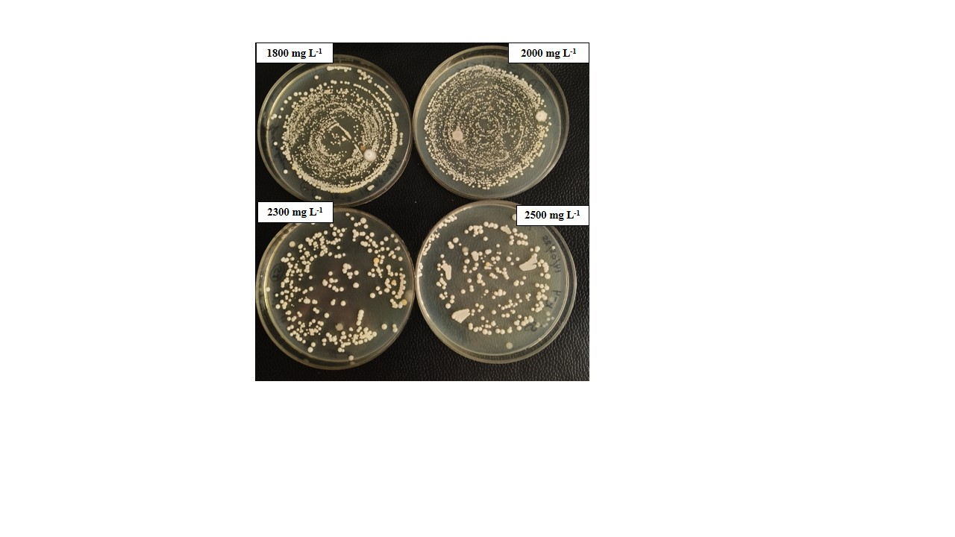Supplementary Figure S6: Growth tolerance of Burkholderia cepacia strains at different concentrations of [Zn-Im] nanocomposite.

