Eco-friendly Al-Bi₂WO₆ nanosheets for effective elimination of crystal violet and methylene blue dyes
Diwakar Malla^{1,4}, Bishal Hamal^{1,4}, Rakshya Mulmi², Neel Kamal Koju³, Rishi Ram Ghimire⁴, and Deependra Das Mulmi^{1*}
¹Nanomaterials Research Laboratory, Nepal Academy of Science and Technology (NAST), Lalitpur, 44700, Nepal

²KIST Medical College and Teaching Hospital, Lalitpur, 44705, Nepal

³Goldengate International College, Trikuti Colony, Kathmandu, 44600, Nepal
⁴ Racah Institute of Physics and the Harvey M. Kruger Family Center for Nanoscience and Nanotechnology, the Hebrew University of Jerusalem, Jerusalem 919040, Israel.
*Corresponding author: dmulmi@gmail.com
S1. Schematic diagram of synthesis
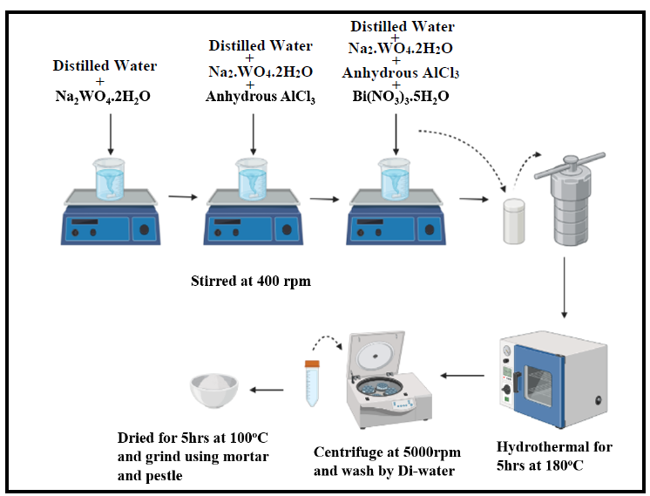
S2. FE-SEM analysis
S2 (a-c) depict FE-SEM images of Al-Bi₂WO₆ at different magnification scales. S2 (d-f) illustrate histograms of the dimension of nanosheets following the Gaussian distribution.
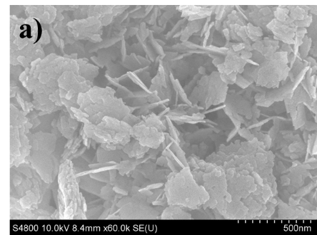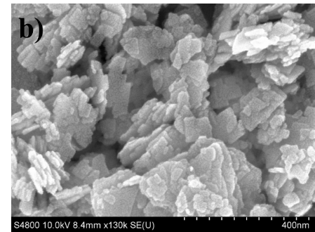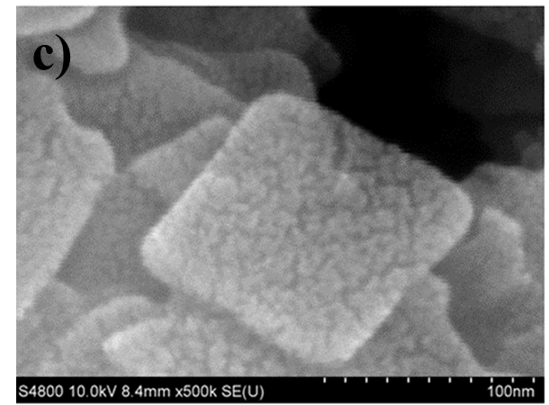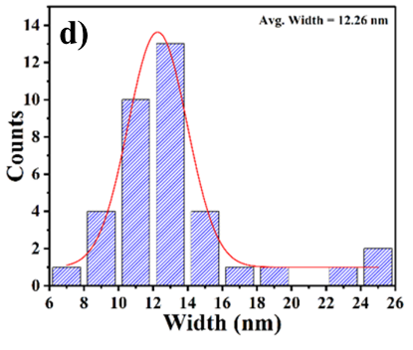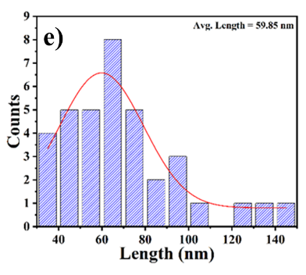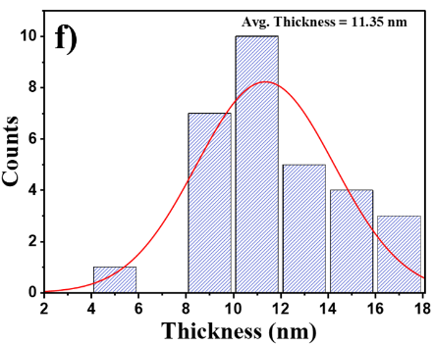
S2 (a-c) FE-SEM images of Al-Bi₂WO₆ at different magnification scales. S2 (d-f) are histograms of the count of the width, length, and thickness of Al-Bi₂WO₆, respectively.
S3. Schematic diagram of Adsorption experiment
