Supplemental materials for:
An analysis of growth rates, seasonal cycles, and meridional gradients of atmospheric CO₂ and δ¹³C using an atmospheric transport model (1948-2021)
U. Chakraborty (ceha1867@chiba-u.jp), N. Saitoh, and D A. Belikov
Center for Environmental Remote Sensing, Chiba University, Chiba, 263-8522, Japan

N. Chandra, P. K. Patra
Research Institute for Global Change, JAMSTEC, Yokohama, 236-0001, Japan

A. Ito
Graduate School of Agricultural and Life Sciences Department of Forest Science, The University of Tokyo, Tokyo, 113-8657, Japan

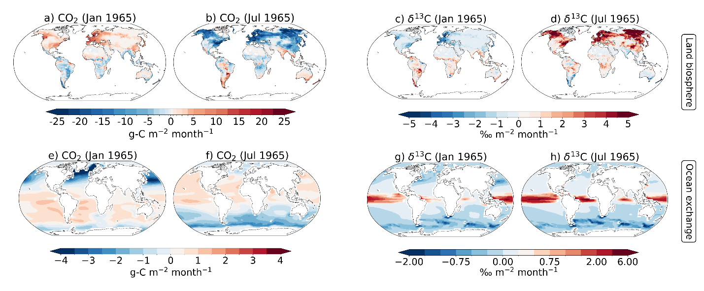Figure S1: Same as Figure 1, but for 1965.

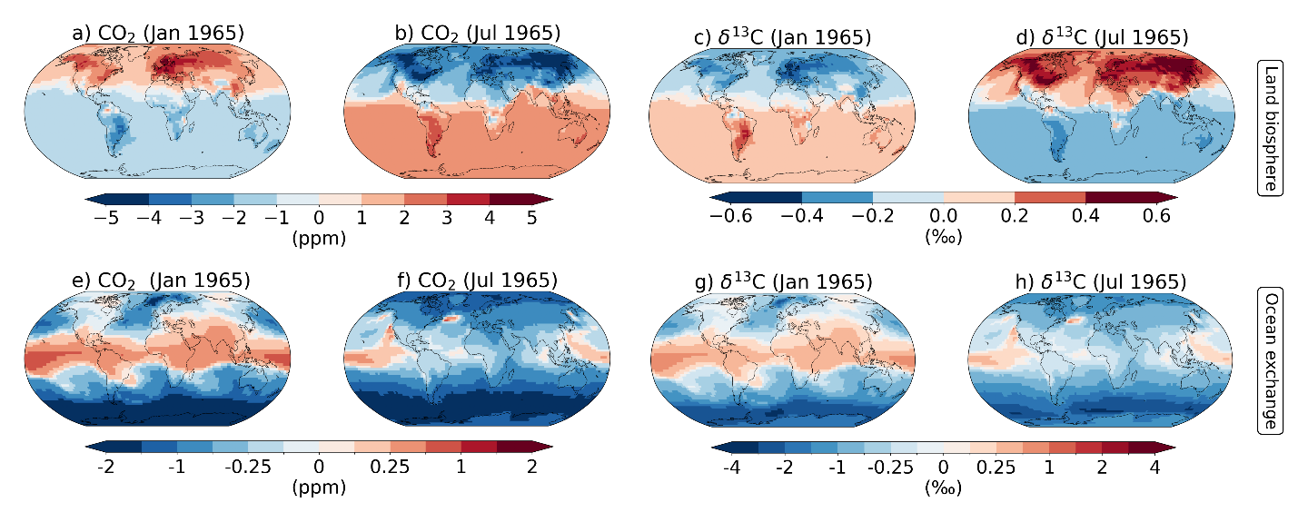
Figure S2: Same as Figure 4, but for 1965.

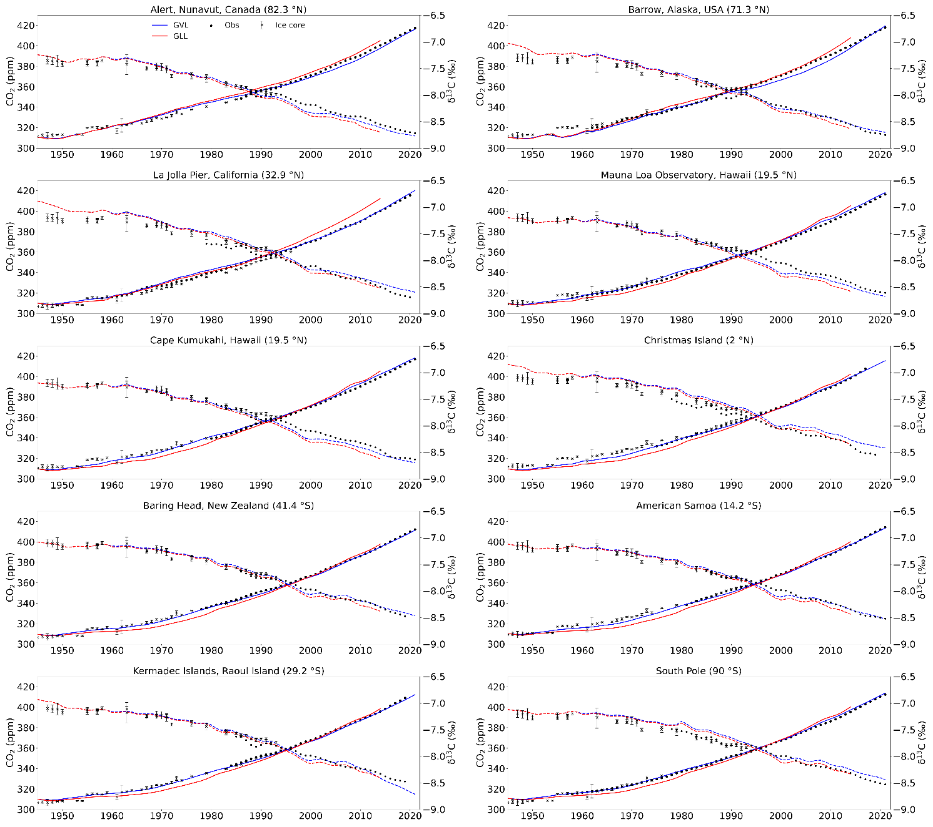
Figure S3 : Same as Figure 5, but for all 10 SIO sites
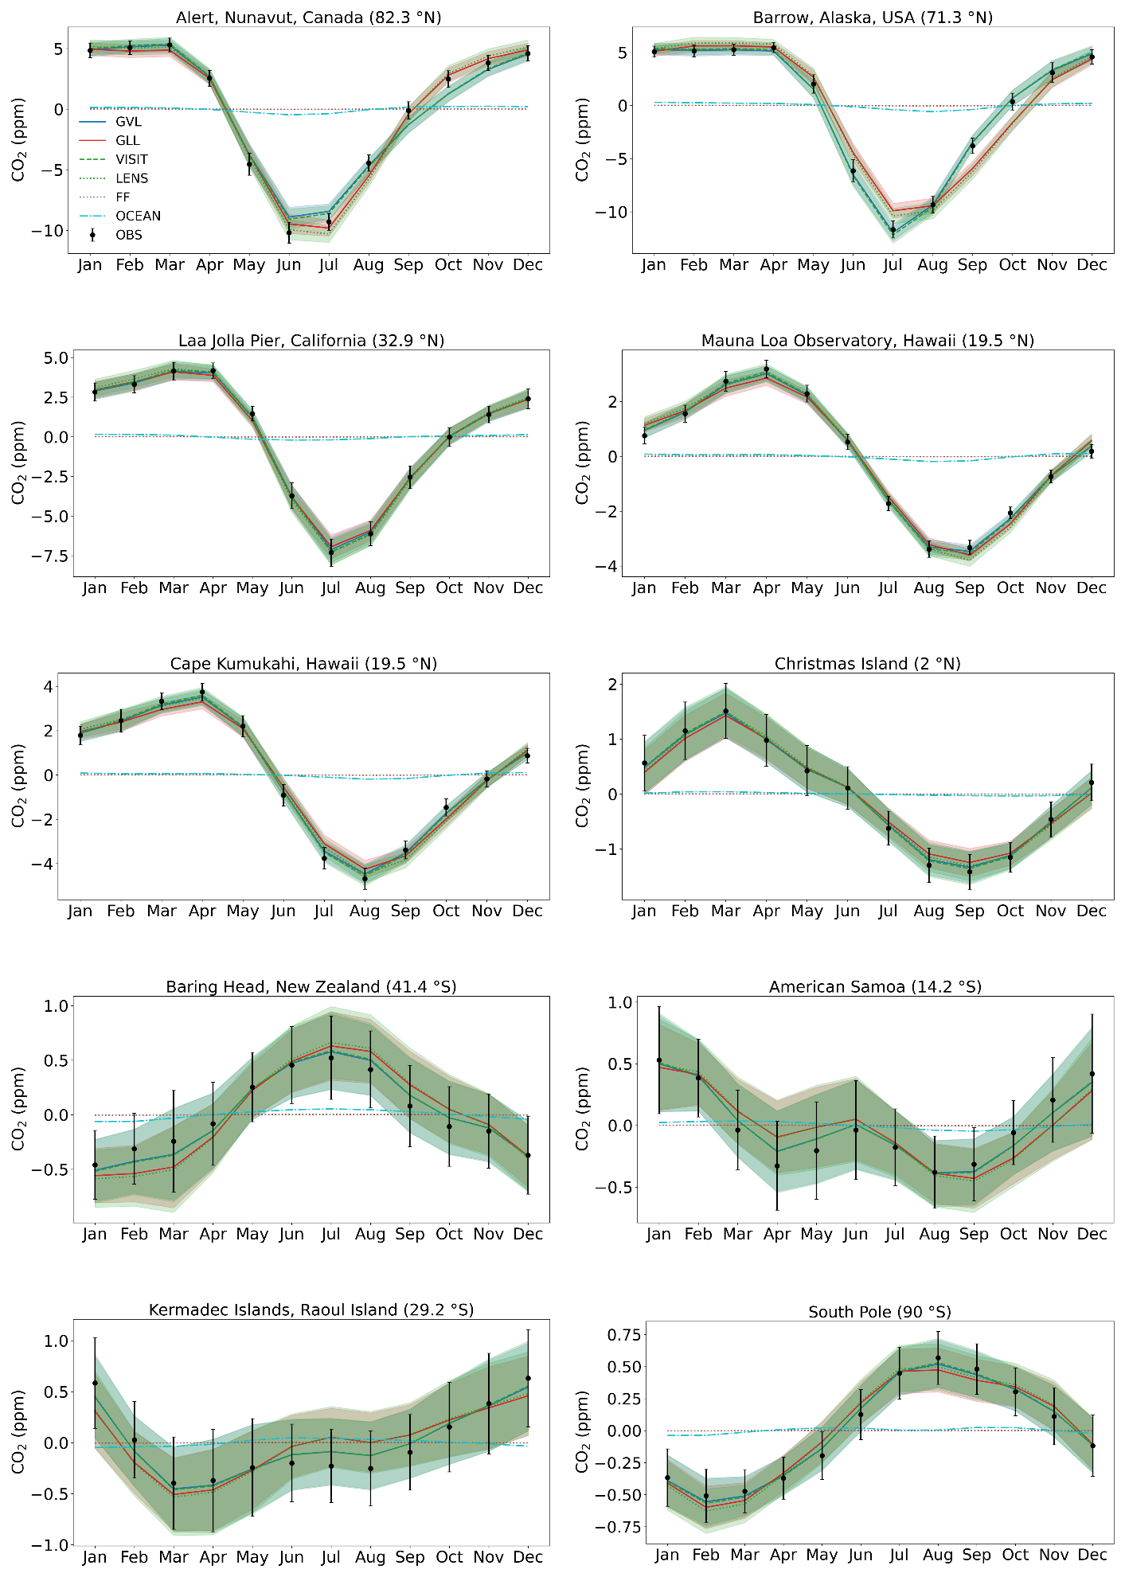
Figure S4: Same as Figure 6, but for all 10 SIO sites for CO2.
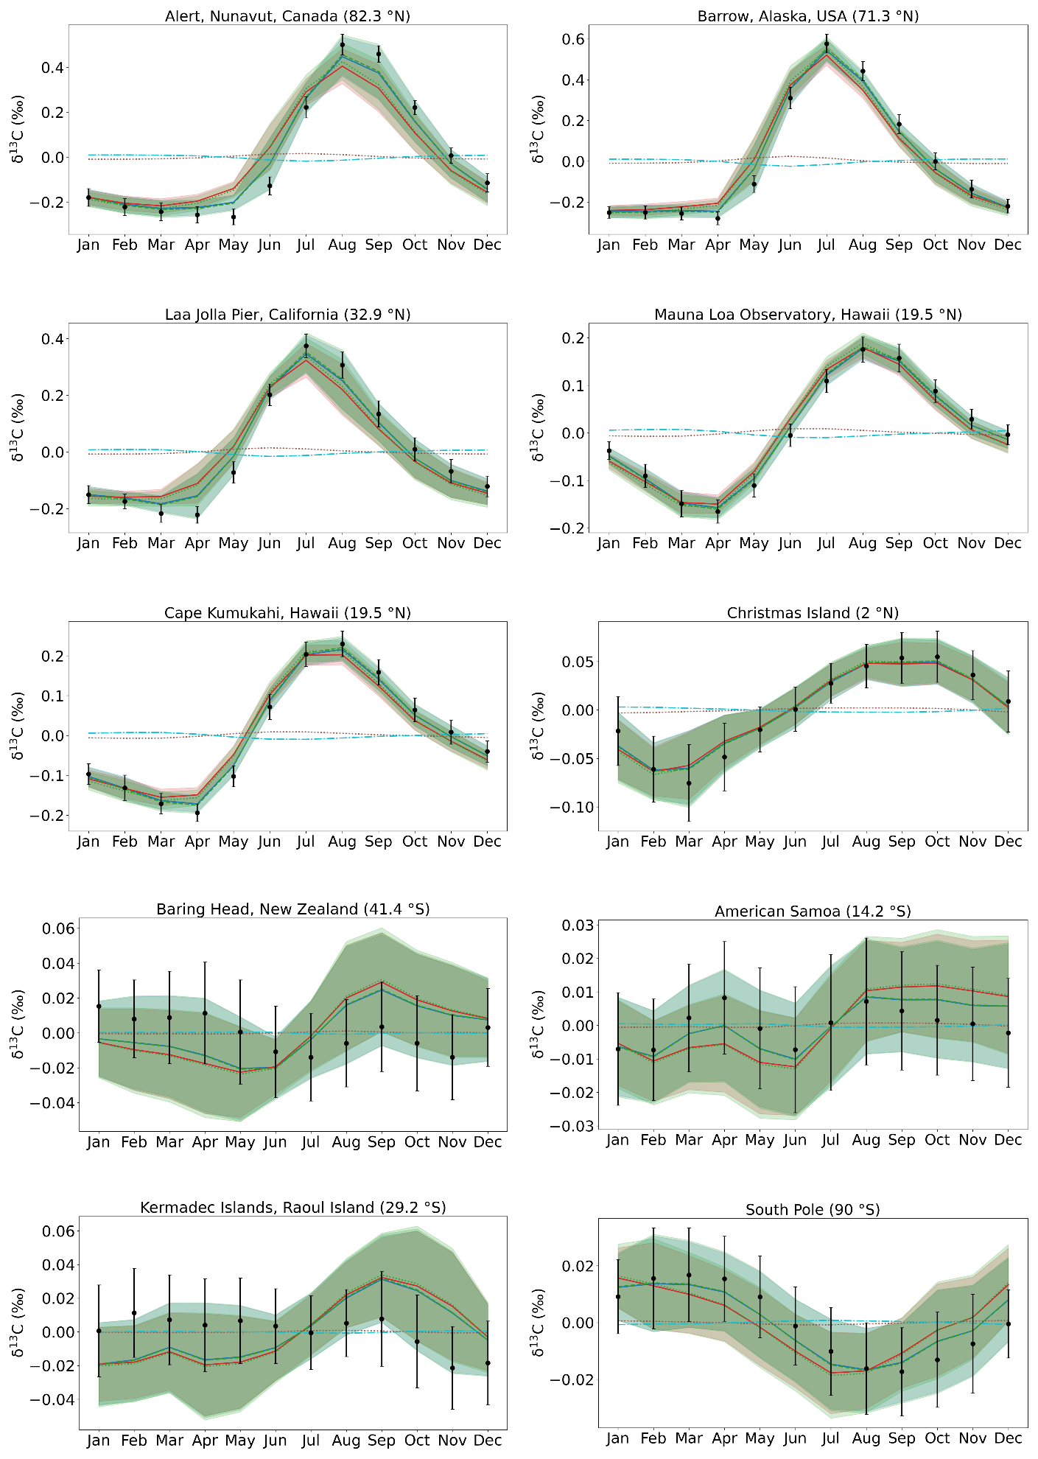Figure S5: Same as Figure 6, but for all 10 SIO sites for δ¹³C.
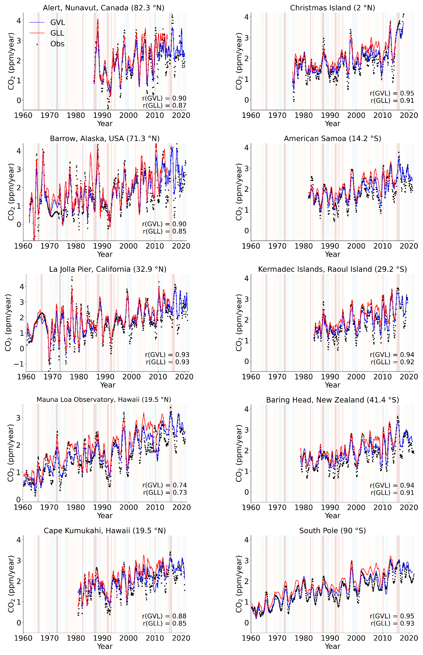
Figure S6: Same as Figure 7, but for all 10 SIO sites for CO₂.
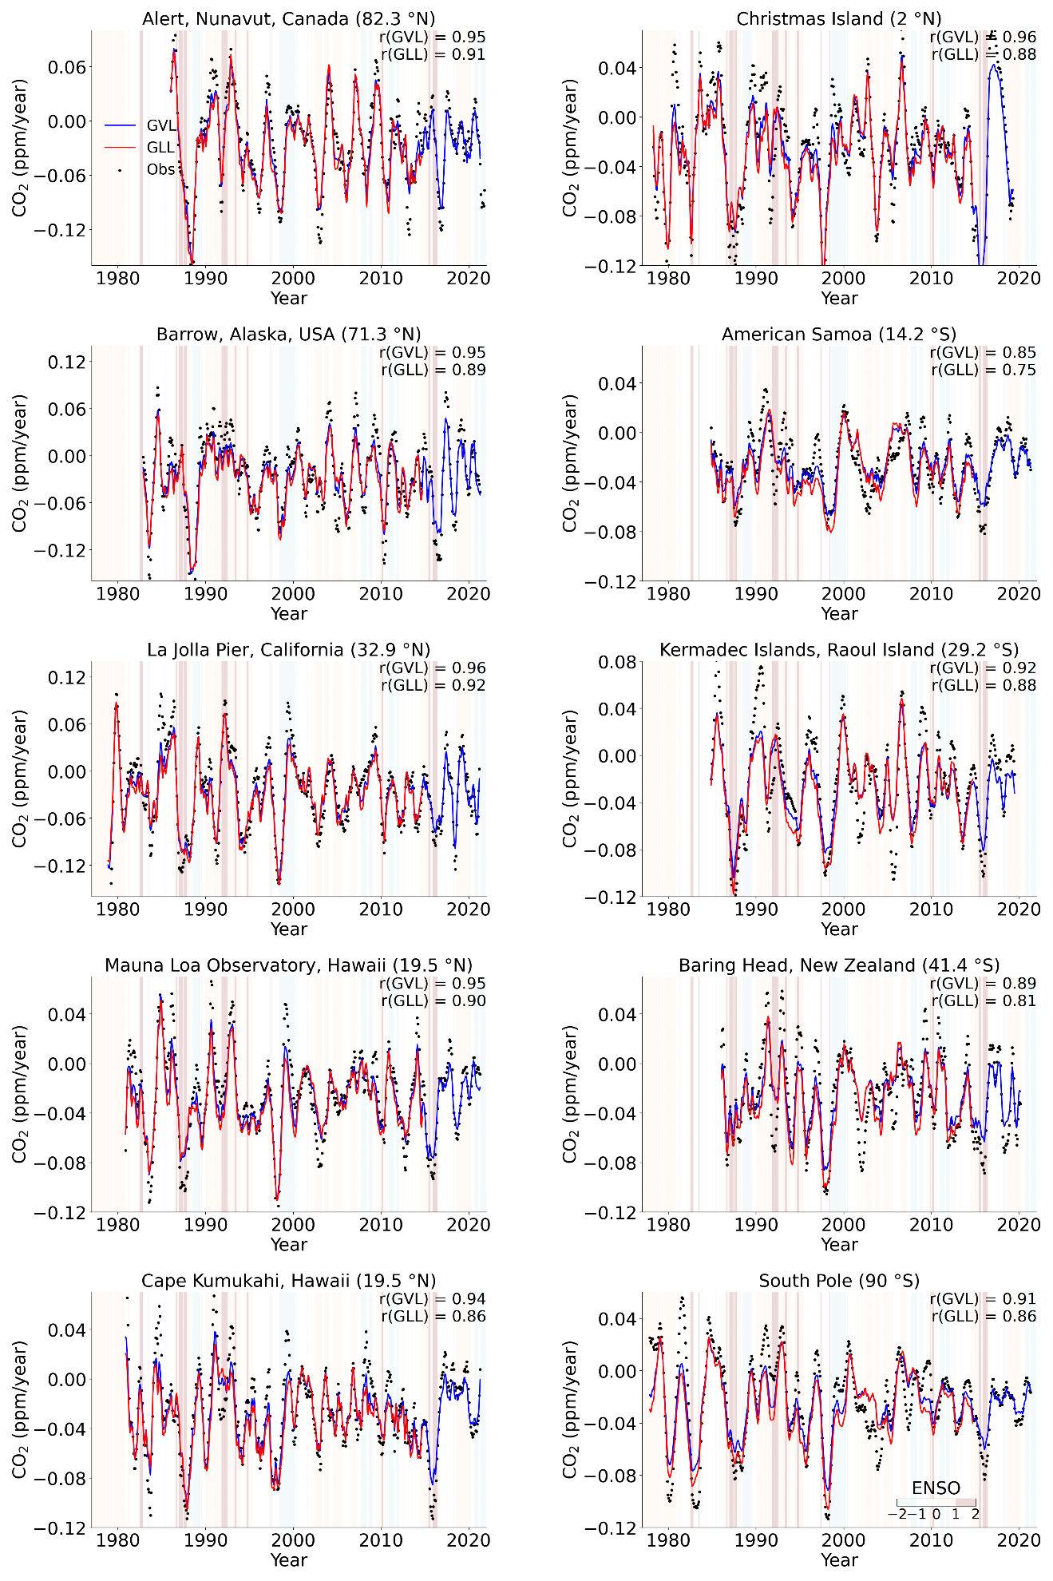
Figure S7: Same as Figure 7, but for all 10 SIO sites for δ¹³C.
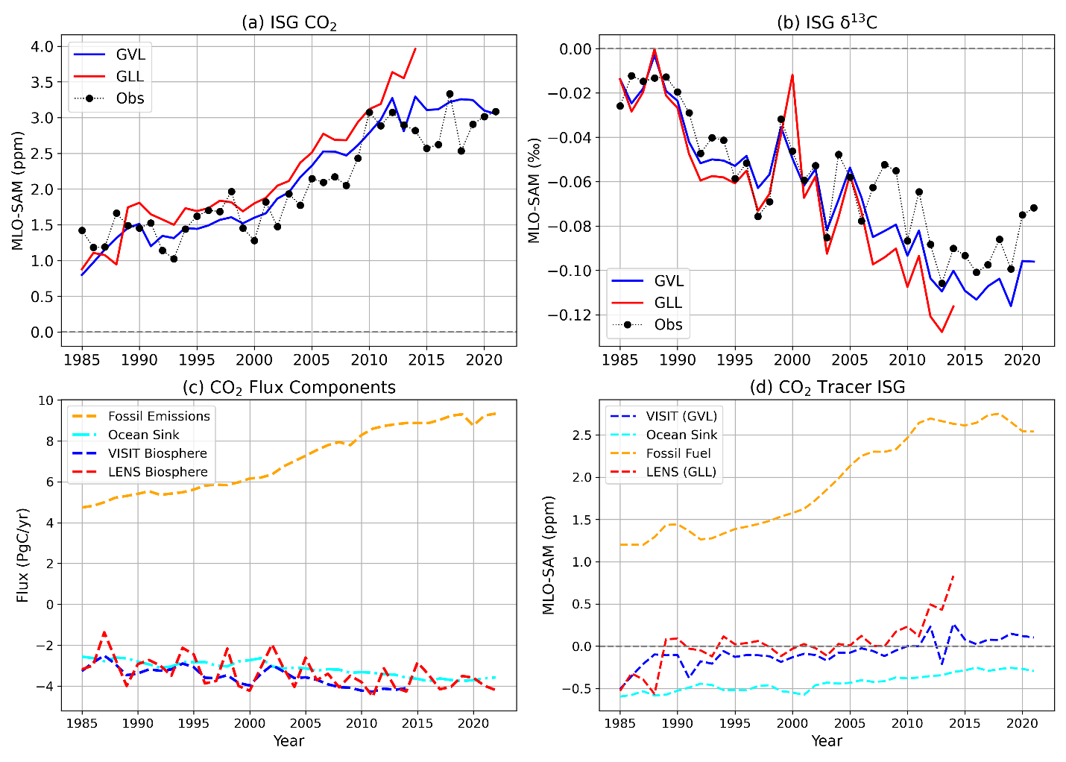
Figure S8: Same as Figure 8, but for MLO-SAM.

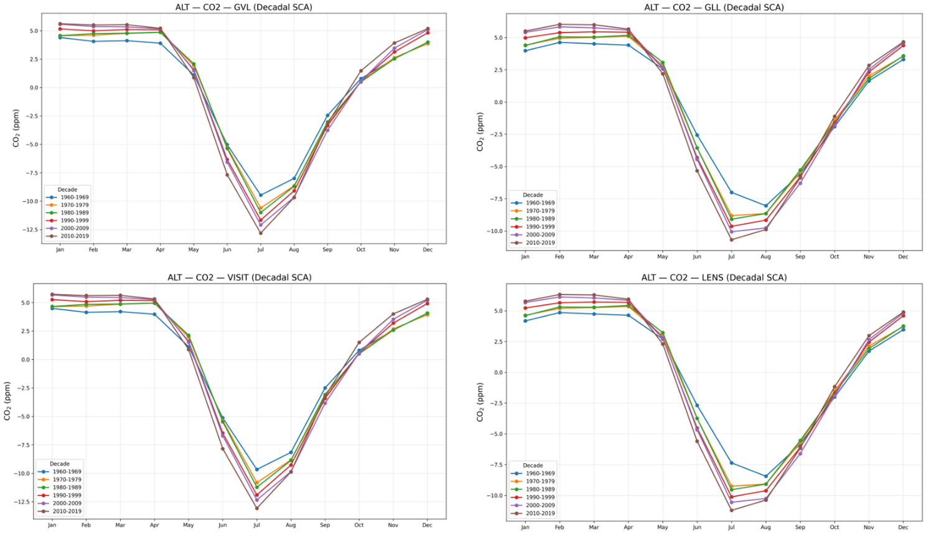

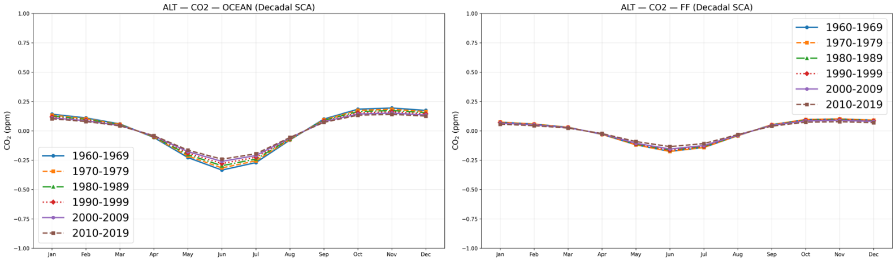
Figure S9: Same as Fig.6 but decadal CO₂ SCA for ALT for showing the change in SCA decade wise.

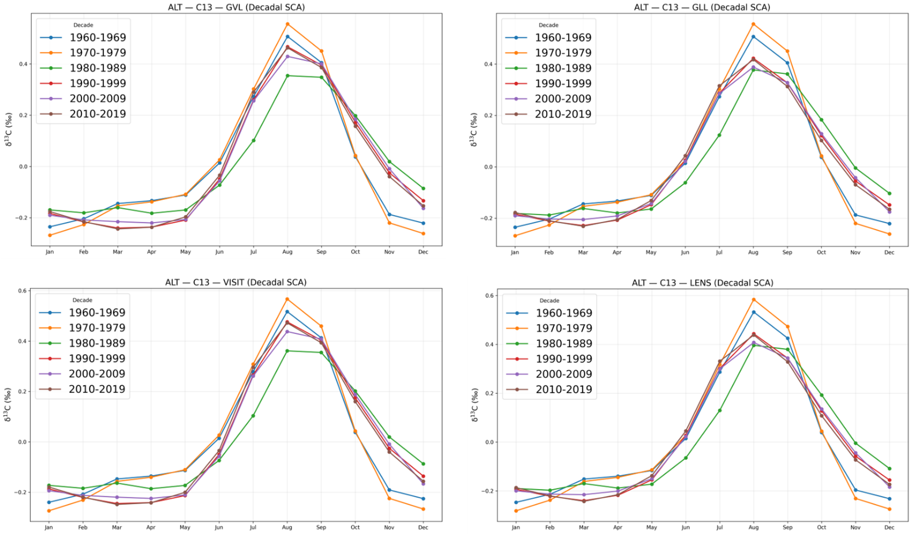
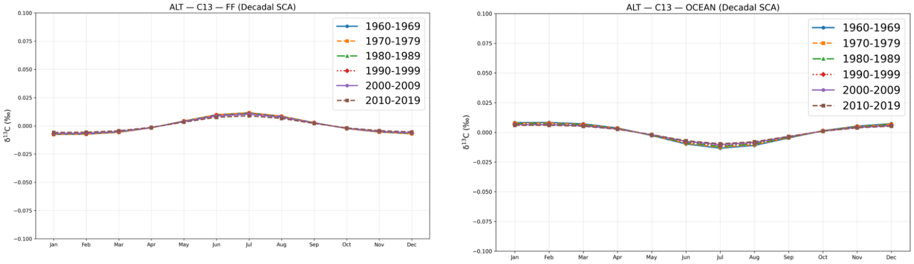
Figure S10: Same as Fig.6 but decadal δ¹³C SCA for ALT for showing the change in SCA decade wise.

Table S1: Same as Table 3, but for all the stations.

SCA of CO₂ (ppm)
Observed |  |  |  | ACTM-GLL |  |  | ACTM-GVL
Period | PTB | KUM | BHD | PTB | KUM | BHD | PTB | KUM | BHD
1950-59 | - | - | - | 14.82 | 6.77 | 3.58 | 14.36 | 6.57 | 2.96
1960-69 | - | - | - | 15.02 | 7.03 | 3.71 | 14.68 | 6.69 | 3.47
1970-79 | - | - | - | 15.89 | 7.18 | 4.03 | 15.04 | 6.86 | 3.68
1980-89 | 14.31 | 6.52 | 3.83 | 16.72 | 7.57 | 4.12 | 14.22 | 6.41 | 3.82
1990-99 | 14.91 | 6.73 | 3.95 | 17.03 | 7.88 | 4.14 | 15.69 | 6.38 | 4.04
2000-09 | 15.96 | 6.44 | 4.02 | 17.12 | 7.61 | 4.23 | 16.71 | 6.34 | 4.07
2010-19 | 16.88 | 6.99 | 4.08 | 17.76 | 7.95 | 4.24 | 16.47 | 6.84 | 4.12

SCA of CO₂ (ppm)
Observed |  |  |  | ACTM-GLL |  |  |  | ACTM-GVL
Period | LJO | CHR | KER | LJO | CHR | KER | LJO |  | CHR |  | KER
1950-59 | - | - | - | 14.87 | 6.81 | 3.63 | 14.39 |  | 6.54 |  | 3.02
1960-69 | - | - | - | 15.09 | 7.07 | 3.76 | 14.62 |  | 6.74 |  | 3.44
1970-79 | - | - | - | 15.83 | 7.22 | 4.08 | 15.01 |  | 6.91 |  | 3.66
1980-89 | 13.37 | 6.58 | 3.86 | 15.78 | 7.52 | 4.19 | 13.14 |  | 6.45 |  | 3.79
1990-99 | 14.94 | 6.76 | 3.98 | 16.99 | 7.91 | 4.18 | 15.66 |  | 6.36 |  | 4.07
2000-09 | 15.93 | 6.47 | 4.06 | 17.19 | 7.64 | 4.29 | 16.76 |  | 6.37 |  | 4.01
2010-19 | 16.88 | 6.99 | 4.08 | 17.76 | 7.95 | 4.24 |  | 16.47 |  | 6.84 |  | 4.12

SCA of δ¹³C (‰); x 10*
Observed |  |  |  | ACTM-GLL |  |  | ACTM-GVL
Period | PTB | KUM | BHD | PTB | KUM | BHD | PTB | KUM | BHD
1950-59 | - | - | - | 5.68 | 2.79 | 0.38 | 5.47 | 2.7 | 0.35
1960-69 | - | - | - | 5.77 | 3.12 | 0.41 | 5.6 | 2.88 | 0.36
1970-79 | - | - | - | 6.59 | 3.33 | 0.46 | 6.31 | 3.11 | 0.4
1980-89 | 6.9 | 3.45 | 0.4 | 6.96 | 3.52 | 0.51 | 6.73 | 3.42 | 0.41
1990-99 | 7.85 | 3.46 | 0.49 | 7.92 | 3.53 | 0.54 | 7.77 | 3.41 | 0.46
2000-09 | 7.88 | 3.3 | 0.48 | 8.07 | 3.35 | 0.51 | 7.83 | 3.26 | 0.46
2010-19 | 7.89 | 3.5 | 0.5 | 8.08 | 3.56 | 0.54 | 7.84 | 3.47 | 0.48
* values multiplied by 10 to reveal more significant digits

Observed |  |  |  | ACTM-GLL |  |  | ACTM-GVL
Period | LJO | CHR | KER | LJO | CHR | KER | LJO | CHR | KER
1950-59 | - | - | - | 5.71 | 2.83 | 0.39 | 5.44 | 2.68 | 0.34
1960-69 | - | - | - | 5.81 | 3.09 | 0.43 | 5.58 | 2.92 | 0.35
1970-79 | - | - | - | 6.63 | 3.29 | 0.47 | 6.28 | 3.14 | 0.39
1980-89 | 6.92 | 3.47 | 0.41 | 6.99 | 3.55 | 0.53 | 6.7 | 3.39 | 0.4
1990-99 | 7.87 | 3.48 | 0.55 | 7.95 | 3.56 | 0.56 | 7.74 | 3.39 | 0.45
2000-09 | 7.91 | 3.32 | 0.49 | 8.1 | 3.38 | 0.53 | 7.81 | 3.24 | 0.45
2010-19 | 7.92 | 3.52 | 0.51 | 8.11 | 3.59 | 0.56 | 7.82 | 3.45 | 0.47
* values multiplied by 10 to reveal more significant digits

Table S2: Same as Table 4, but for all the stations.

Growth Rate of CO₂ (ppm yr⁻¹)
Observed |  |  |  | ACTM-GLL |  |  | ACTM-GVL
Period | PTB | KUM | BHD | PTB | KUM | BHD | PTB | KUM | BHD
1950-59 | - | - | - | 1.14 | 0.72 | 0.63 | 1.16 | 0.76 | 0.66
1960-69 | - | - | - | 1.27 | 0.93 | 0.86 | 1.22 | 0.88 | 0.84
1970-79 | - | - | - | 1.82 | 1.34 | 1.27 | 1.59 | 1.29 | 1.16
1980-89 | 1.96 | 1.57 | 1.29 | 2.01 | 1.6 | 1.53 | 1.94 | 1.56 | 1.28
1990-99 | 1.87 | 1.54 | 1.33 | 1.9 | 1.56 | 1.35 | 1.85 | 1.52 | 1.3
2000-09 | 2.13 | 2.03 | 2.01 | 2.25 | 2.14 | 2.06 | 2.17 | 2.08 | 1.98
2010-19 | 2.52 | 2.43 | 2.37 | 2.64 | 2.49 | 2.46 | 2.51 | 2.42 | 2.35

Growth Rate of CO₂ (ppm yr⁻¹)
Observed |  |  |  | ACTM-GLL |  |  | ACTM-GVL
Period | LJO | CHR | KER | LJO | CHR | KER | LJO | CHR | KER
1950-59 | - | - | - | 1.13 | 0.71 | 0.63 | 1.18 | 0.75 | 0.66
1960-69 | - | - | - | 1.28 | 0.92 | 0.84 | 1.23 | 0.88 | 0.86
1970-79 | - | - | - | 1.81 | 1.34 | 1.26 | 1.6 | 1.29 | 1.17
1980-89 | 1.95 | 1.55 | 1.27 | 2.01 | 1.6 | 1.34 | 1.93 | 1.53 | 1.25
1990-99 | 1.88 | 1.53 | 1.31 | 1.95 | 1.58 | 1.36 | 1.83 | 1.49 | 1.28
2000-09 | 2.12 | 2.01 | 1.99 | 2.18 | 2.07 | 2.05 | 2.1 | 1.98 | 1.96
2010-19 | 2.5 | 2.41 | 2.39 | 2.58 | 2.49 | 2.46 | 2.47 | 2.38 | 2.35

Growth Rate of δ¹³C (‰ year⁻¹) × 100 *
Observed |  |  |  | ACTM-GLL |  |  | ACTM-GVL
Period | PTB | KUM | BHD | PTB | KUM | BHD |  | PTB | KUM | BHD
1950-59 | - | - | - | -4.12 | -2.19 | -2.04 |  | -3.11 | -2.15 | -2.12
1960-69 | - | - | - | -4.14 | -3.22 | -3.25 |  | -4.05 | -3.46 | -2.28
1970-79 | - | - | - | -5.11 | -3.39 | -3.21 |  | -4.19 | -3.58 | -3.13
1980-89 | -4.02 | -3.41 | -3.04 | -3.96 | -3.35 | -2.98 |  | -4.11 | -3.48 | -3.12
1990-99 | -3.07 | -2.56 | -2.44 | -2.99 | -2.49 | -2.39 |  | -3.15 | -2.63 | -2.51
2000-09 | -4.06 | -3.41 | -3.09 | -3.98 | -3.34 | -3.01 |  | -4.14 | -3.49 | -3.17
2010-19 | -5.08 | -4.12 | -3.41 | -4.99 | -4.05 | -3.34 |  | -5.16 | -4.20 | -3.49
* values multiplied by 100 to reveal more significant digits

Growth Rate of δ¹³C (‰ year⁻¹) × 100 *
Observed |  |  |  | ACTM-GLL |  |  | ACTM-GVL
Period | LJO | CHR | KER | LJO | CHR | KER | LJO | CHR | KER
1950-59 | - | - | - | -4.18 | -2.23 | -2.09 | -3.07 | -2.11 | -2.17
1960-69 | - | - | - | -4.17 | -3.26 | -3.18 | -4.09 | -3.44 | -2.31
1970-79 | - | - | - | -5.08 | -3.43 | -3.27 | -4.22 | -3.55 | -3.11
1980-89 | -4.03 | -3.38 | -3.07 | -3.92 | -3.31 | -2.97 | -4.15 | -3.52 | -3.18
1990-99 | -3.05 | -2.59 | -2.46 | -2.98 | -2.49 | -2.39 | -3.18 | -2.64 | -2.51
2000-09 | -4.08 | -3.38 | -3.12 | -3.99 | -3.31 | -3.04 | -4.19 | -3.47 | -3.21
2010-19 | -5.06 | -4.15 | -3.39 | -4.97 | -4.07 | -3.33 | -5.18 | -4.22 | -3.47
* values multiplied by 100 to reveal more significant digits

Table S3: This table shows the decadal mean interhemispheric gradients (Northern Hemisphere minus Southern Hemisphere) of atmospheric CO₂ concentrations (in ppm) and δ¹³C (in ‰), derived from GLL and GVL model simulations. Positive CO₂ gradients and negative δ¹³C gradients reflect the stronger influence of Northern Hemisphere fossil fuel emissions and land-based biospheric activity relative to the Southern Hemisphere.

Period | CO₂ (in ppm) |  | δ¹³C (in ‰)
Period | GLL (NH-SH) | GVL (NH-SH) | GLL (NH-SH) | GVL (NH-SH)
1940-49 | 1.69 | 1.73 | -0.10 | -0.07
1950-59 | 1.73 | 1.75 | -0.11 | -0.08
1960-69 | 2.27 | 2.32 | -0.12 | -0.09
1970-79 | 3.19 | 3.28 | -0.17 | -0.13
1980-89 | 3.64 | 3.76 | -0.18 | -0.14
1990-99 | 3.92 | 4.00 | -0.19 | -0.15
2000-09 | 4.15 | 3.95 | -0.22 | -0.18
2010-19 | 4.21 | 4.18 | -0.25 | -0.21

