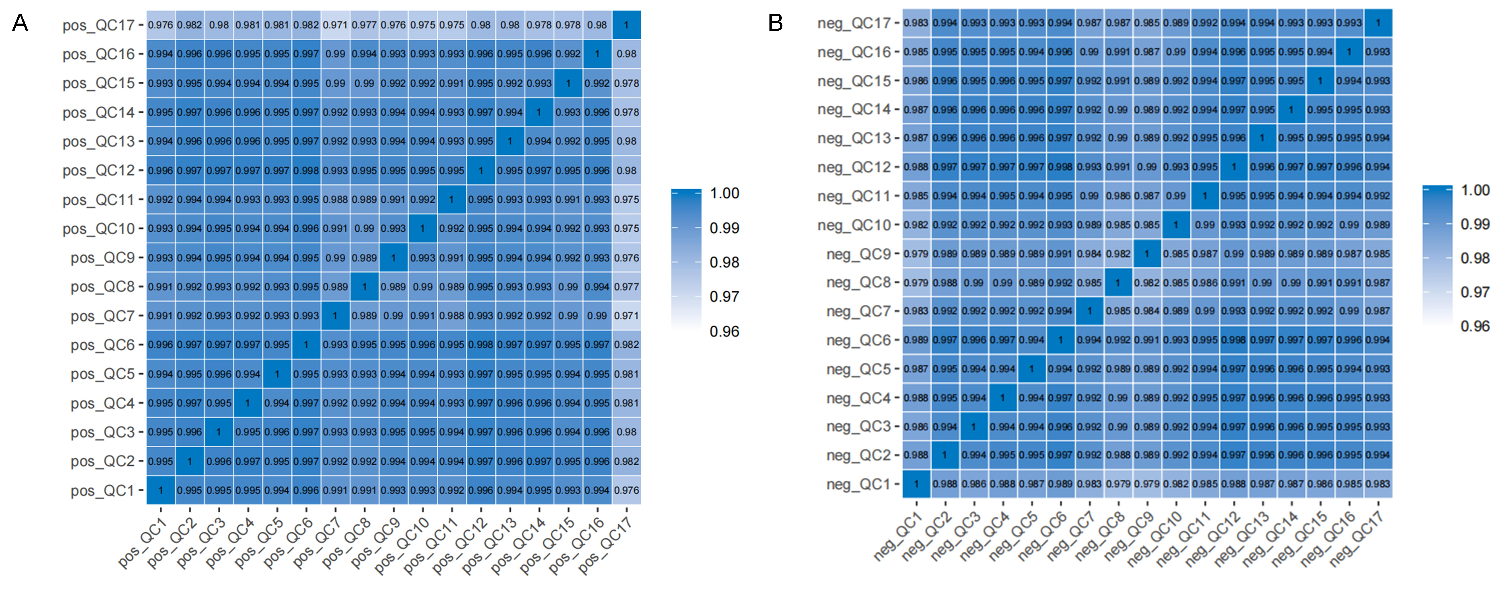
Figure S1. Pearson correlation coefficients of fecal untargeted metabolomic profiles in quality control (QC) samples. High correlation coefficients indicate strong consistency and reliability of the metabolomics data, reflecting stable instrument performance and reproducibility throughout the analytical process.

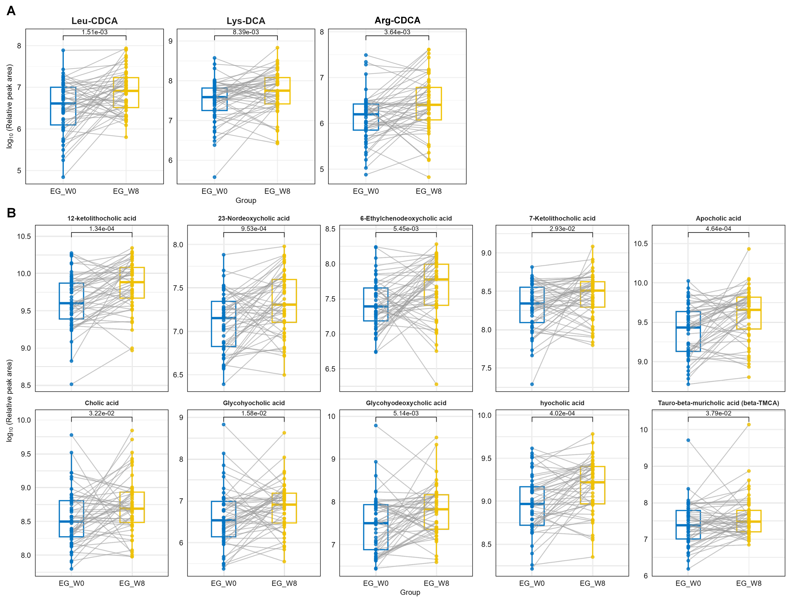
Figure S2. Differential bile acids (BAs) identified through paired Wilcoxon tests in untargeted and targeted metabolomics datasets. A. The remaining three differential BA-related metabolites.
B. Ten novel differential BAs identified in this study, highlighting metabolic changes in the EG group at W8.

Table S1. Baseline characteristics of the recruited patients with functional constipation
 | CG (n=50) | EG (n=51) | P value
Female, n (%) | 48 (96.0%) | 48 (94.1%)
Age (years) | 48.80 ± 21.93 | 44.12 ± 11.20 | 0.182
Duration (years) | 8.56 ± 6.23 | 9.46 ± 6.95 | 0.495
Height (m) | 1.59 ± 0.05 | 1.59 ± 0.05 | 0.848
Body weight (kg) | 56.10 ± 7.00 | 55.61 ± 7.18 | 0.728
BMI (kg/m²) | 22.23 ± 2.57 | 21.96 ± 2.53 | 0.613
ROME score | 3.74 ± 1.08 | 3.85 ± 1.04 | 0.608
CSBM score | 2.28 ± 0.90 | 2.35 ± 1.04 | 0.707
HAMD score | 6.40 ± 5.50 | 5.85 ± 5.58 | 0.627
PAC-QOL score | 51.48 ± 22.34 | 50.49 ± 22.59 | 0.825

Table S2. Paired Comparison of PBAs in the EG Group Between W0 and W8
Full Name | Abbreviation | Metabolomics Type | FC (W8/W0) | P value
Cholic acid | CA | Untargeted | 1.53 | 0.028
Glycocholic acid | GCA | Targeted | 2.30 | 0.015
Glycochenodeoxycholic acid | GCDCA | Untargeted | 2.28 | 0.008
Glycochenodeoxycholic acid | GCDCA | Targeted | 2.91 | 0.005

