Appendices

Appendix 1: Location, habitat type, home range, tracking duration, age class and sex of platypuses from six tracking studies across their distribution
Paper | Lat | Habitat | Home Range (m) | Tracking Duration (days) | Age Class | Sex
Boulton et al., 2022 | -37.68411 | Urban | 604 | 60 | Adult | F
 | -37.68411 | Urban | 822 | 75 | Adult | F
 | -37.68411 | Urban | 1331 | 79 | Adult | F
Crane et al., 2022 | -36.481275 | Rural | 505 | 75 | Adult | F
 | -36.481397 | Rural | 746 | 71 | Adult | F
 | -36.481144 | Rural | 1373 | 70 | Adult | F
 | -36.48485 | Rural | 2016 | 58 | Adult | F
 | -36.483283 | Rural | 1745 | 67 | Adult | F
 | -36.482722 | Rural | 814 | 69 | Adult | F
 | -36.481056 | Rural | 634 | 17 | Adult | F
 | -36.479647 | Rural | 502 | 41 | Adult | F
Gardner & Serena, 1995 | -37.657666 | Rural | 1300 | 116 | Adult | M
 | -37.648078 | Rural | 2900 | 79 | Adult | M
 | -37.648078 | Rural | 3300 | 68 | Adult | M
 | -37.640065 | Rural | 4100 | 116 | Adult | M
 | -37.694948 | Rural | 7000 | 69 | Adult | M
Gust & Handasyde, 1995 | -37.258432 | Rural | 350 | 36 | Adult | M
 | -37.258432 | Rural | 1400 | 36 | Adult | M
 | -37.258432 | Rural | 1350 | 36 | Adult | M
 | -37.258432 | Rural | 450 | 46 | Adult | M
 | -37.258432 | Rural | 2575 | 46 | Adult | M
 | -37.258432 | Rural | 1275 | 46 | Adult | M
 | -37.258432 | Rural | 475 | 46 | Adult | M
 | -37.258432 | Rural | 500 | 46 | Adult | M
 | -37.258432 | Rural | 1875 | 43 | Adult | M
 | -37.258432 | Rural | 450 | 43 | Adult | M
 | -37.258432 | Rural | 500 | 43 | Adult | M
 | -37.258432 | Rural | 955 | 43 | Adult | M
 | -37.258432 | Rural | 2325 | 43 | Adult | M
Serena et al., 1998 | -37.911592 | Urban | 4100 | 43 | Adult | M
 | -37.906672 | Urban | 2500 | 22 | Adult | F
 | -37.903365 | Urban | 3800 | 11 | Adult | M
 | -37.911122 | Urban | 4500 | 43 | Adult | M
Serena, 1994 | -37.685261 | Rural | 1110 | 13 | Adult | F
 | -37.685261 | Rural | 1920 | 49 | Adult | F
 | -37.685261 | Rural | 1780 | 48 | Adult | M
 | -37.685261 | Rural | 1570 | 41 | Adult | M
 | -37.685261 | Rural | 2280 | 58 | Adult | M
 | -37.685261 | Rural | 330 | 19 | Adult | F
 | -37.685261 | Rural | 540 | 58 | Adult | F
 | -37.685261 | Rural | 1350 | 28 | Adult | F
 | -37.685261 | Rural | 840 | 18 | Adult | F
 | -37.685261 | Rural | 1240 | 16 | Adult | F
 | -37.685261 | Rural | 720 | 85 | Adult | F

Appendix 2: Source, habitat type, CPUE mesh, CPUE fyke and latitude of platypus trapping studies
Reference | Habitat | Net Type | Latitude | CPUE
Bethge 2002 | Rural | Mesh | -41.52 | 0.13
Bethge 2002 | Rural | Fyke | -41.52 | 0.02
Bethge et al. 2001 | Rural | Mesh | -42.75 | 0.23
Bethge et al. 2001 | Rural | Fyke | -42.75 | 0.04
Bino et al. 2015 | Rural | Mesh | -35.64 | 0.41
Bino et al., 2021 | Rural | Mesh | -31.53 | 0.25
Bino et al., 2021 | Rural | Fyke | -31.53 | 0.02
Boulton et al. 2022 | Urban | Fyke | -37.68 | 0.05
Brunt et al. 2022 | Urban | Fyke | -27.51 | 0.01
Connolly & Obendorf 1998 | Rural | Mesh | -41.75 | 0.08
Connolly & Obendorf 1998 | Rural | Mesh | -41.08 | 0.23
Connolly & Obendorf 1998 | Rural | Mesh | -41.67 | 0.14
Connolly & Obendorf 1998 | Rural | Mesh | -41.42 | 0.14
Connolly & Obendorf 1998 | Rural | Mesh | -41.16 | 0.25
Connolly et al. 2016 | Rural | Mesh | -34.98 | 0.10
Grant et al. 1992 | Rural | Mesh | -36.44 | 0.12
Grant, T. R. unpublished | Rural | Mesh | -33.99 | 0.15
Grant, T. R. unpublished | Rural | Mesh | -33.99 | 0.12
Grant, T. R. unpublished | Rural | Mesh | -34.47 | 0.42
Grant, T. R. unpublished | Rural | Mesh | -34.47 | 0.64
Gust & Griffiths 2011 | Rural | Fyke | -42.13 | 0.02
Hawke et al. 2021 | Rural | Fyke | -36.23 | 0.07
Hawke et al. 2021 | Rural | Mesh | -36.81 | 0.03
Hawke et al. 2021 | Rural | Fyke | -36.81 | 0.01
Hawke et al. 2021 | Rural | Mesh | -36.51 | 0.14
Hawke et al. 2021 | Rural | Fyke | -36.51 | 0.01
Hawke et al. 2021 | Rural | Mesh | -36.38 | 0.16
Hawke et al. 2021 | Rural | Fyke | -36.38 | 0.02
Hawke et al. 2021 | Rural | Mesh | -29.50 | 0.18
Hawke et al. 2021 | Rural | Fyke | -29.50 | 0.03
Hawke et al. 2021 | Rural | Mesh | -29.29 | 0.28
Hawke et al. 2021 | Rural | Mesh | -29.03 | 0.22
Hawke et al. 2021 | Rural | Fyke | -29.03 | 0.07
Hawke et al. 2021 | Rural | Mesh | -36.42 | 0.21
Hawke et al. 2021 | Rural | Fyke | -36.42 | 0.01
Hawke et al. 2021, Crane 2022, PCI | Rural | Mesh | -36.45 | 0.28
Kangaroo Island | Rural | Fyke | -35.95 | 0.04
Khurana et al., 2024, PCI | Rural | Mesh | -29.99 | 0.06
Khurana et al., 2024, PCI | Rural | Mesh | -31.31 | 0.13
Khurana et al., 2024, PCI | Rural | Mesh | -28.99 | 0.07
Khurana et al., 2024, PCI | Rural | Mesh | -29.48 | 0.20
Lunney et al. 2004 | Rural | Mesh | -30.42 | 0.22
Lunney et al. 2004 | Rural | Mesh | -30.47 | 0.23
McLachlan-Troup 2007 | Rural | Mesh | -34.72 | 0.30
Melbourne Water | Rural | Fyke | -38.27 | 0.05
Melbourne Water | Rural | Fyke | -37.67 | 0.05
Melbourne Water | Urban | Fyke | -37.98 | 0.03
Melbourne Water | Urban | Fyke | -37.77 | 0.05
Melbourne Water | Urban | Fyke | -37.90 | 0.01
Melbourne Water | Urban | Fyke | -37.73 | 0.04
Serena & Williams 2008 | Rural | Fyke | -37.78 | 0.02
Serena & Williams 2008 | Rural | Fyke | -37.47 | 0.10
Serena & Williams 2008 | Rural | Fyke | -37.74 | 0.04
Serena & Williams 2008 | Rural | Fyke | -37.42 | 0.02
Serena 1994 | Urban | Fyke | -37.68 | 0.03
Serena et al. 1998 | Urban | Fyke | -37.71 | 0.02
Serena et al. 1998 | Urban | Fyke | -37.77 | 0.02
Williams & Serena 2000 | Rural | Fyke | -37.06 | 0.42
Williams & Serena 2002 | Rural | Fyke | -36.55 | 0.03
Williams 2004 | Rural | Fyke | -33.99 | 0.14
Young | Rural | Fyke | -27.49 | 0.00
Young | Rural | Mesh | -27.49 | 0.06
Young | Rural | Fyke | -27.49 | 0.04
Young | Urban | Mesh | -27.49 | 0.17
Young | Urban | Fyke | -27.49 | 0.01

Appendix 3: Simper invertebrate order contribution comparison
Comparison | Order | Average Contribution | Cumulative Contribution | P
Moggill DS vs Gold Creek | Amphipoda | 0.0344 | 0.0849 | 0.0105
Moggill DS vs Gold Creek | Hemiptera | 0.027 | 0.1514 | 0.2445
Moggill DS vs Gold Creek | Lepidoptera | 0.0249 | 0.2127 | 0.6778
Moggill DS vs Gold Creek | Coleoptera | 0.0243 | 0.2725 | 0.356
Moggill DS vs Gold Creek | Megaloptera | 0.0243 | 0.3324 | 0.0491
Moggill DS vs Gold Creek | Anthoathecata | 0.0218 | 0.386 | 0.0165
Moggill DS vs Gold Creek | Odonata | 0.0209 | 0.4376 | 0.0143
Moggill DS vs Gold Creek | Ephemeroptera | 0.0185 | 0.4832 | 0.9961
Moggill DS vs Gold Creek | Monostilifera | 0.0181 | 0.5278 | 0.6518
Moggill DS vs Gold Creek | Littorinimorpha | 0.0166 | 0.5688 | 0.3265
Moggill DS vs Gold Creek | Hymenoptera | 0.0163 | 0.609 | 0.2975
Moggill DS vs Gold Creek | Calanoida | 0.0152 | 0.6464 | 0.0053
Moggill DS vs Gold Creek | Lumbriculida | 0.0146 | 0.6823 | 0.9959
Moggill DS vs Gold Creek | Araneae | 0.0145 | 0.718 | 0.6197
Moggill DS vs Gold Creek | Cyclopoida | 0.0119 | 0.7474 | 0.0104
Moggill DS vs Gold Creek | Decapoda | 0.0119 | 0.7767 | 0.6288
Moggill DS vs Gold Creek | Heteronemertea | 0.0098 | 0.8008 | 0.3558
Moggill DS vs Gold Creek | Poduromorpha | 0.0097 | 0.8248 | 0.9654
Moggill DS vs Gold Creek | Neuroptera | 0.0092 | 0.8475 | 0.9285
Moggill DS vs Gold Creek | Psocoptera | 0.0088 | 0.8691 | 0.7479
Moggill DS vs Gold Creek | Sarcoptiformes | 0.0088 | 0.8907 | 0.4065
Moggill DS vs Gold Creek | Crassiclitellata | 0.0074 | 0.9089 | 0.0263
Moggill DS vs Gold Creek | Diplostraca | 0.0058 | 0.9232 | 1
Moggill DS vs Gold Creek | Rhizostomeae | 0.0055 | 0.9368 | 0.5338
Moggill DS vs Gold Creek | Tricladida | 0.0054 | 0.9501 | 0.0369
Moggill DS vs Gold Creek | Unionida | 0.0054 | 0.9635 | 0.0369
Moggill DS vs Gold Creek | Limnomedusae | 0.0049 | 0.9757 | 0.9977
Moggill DS vs Gold Creek | Phyllodocida | 0.0049 | 0.9878 | 0.5666
Moggill DS vs Gold Creek | Trichoptera | 0.0049 | 1 | 0.5666
Moggill DS vs Gold Creek | Diptera | 0 | 1 | 0.9124
Moggill DS vs Gold Creek | Entomobryomorpha | 0 | 1 | 0.6868
Moggill DS vs Gold Creek | Tubificida | 0 | 1 | 0.0001
Moggill DS vs Gold Creek | Diplostraca | 0.0419 | 0.0897 | 0.0002
Moggill DS vs Gold Creek | Lumbriculida | 0.0308 | 0.1558 | 0.0233
Gold_Creek vs Moggill US | Limnomedusae | 0.0295 | 0.2191 | 0.0042
Gold_Creek vs Moggill US | Ephemeroptera | 0.0288 | 0.2808 | 0.0633
Gold_Creek vs Moggill US | Hemiptera | 0.0247 | 0.3338 | 0.6936
Gold_Creek vs Moggill US | Lepidoptera | 0.0245 | 0.3864 | 0.7377
Gold_Creek vs Moggill US | Coleoptera | 0.0238 | 0.4374 | 0.4749
Gold_Creek vs Moggill US | Megaloptera | 0.0227 | 0.486 | 0.1851
Gold_Creek vs Moggill US | Poduromorpha | 0.0218 | 0.5327 | 0.0987
Gold_Creek vs Moggill US | Monostilifera | 0.0212 | 0.5781 | 0.2438
Gold_Creek vs Moggill US | Anthoathecata | 0.0188 | 0.6183 | 0.1801
Gold_Creek vs Moggill US | Odonata | 0.018 | 0.6568 | 0.1762
Gold_Creek vs Moggill US | Amphipoda | 0.0177 | 0.6947 | 0.999
Gold_Creek vs Moggill US | Araneae | 0.0166 | 0.7302 | 0.4056
Gold_Creek vs Moggill US | Decapoda | 0.0166 | 0.7657 | 0.1603
Gold_Creek vs Moggill US | Neuroptera | 0.0162 | 0.8005 | 0.4022
Gold_Creek vs Moggill US | Diptera | 0.0144 | 0.8314 | 0.0889
Gold_Creek vs Moggill US | Calanoida | 0.0137 | 0.8609 | 0.1312
Gold_Creek vs Moggill US | Littorinimorpha | 0.0136 | 0.89 | 0.7146
Gold_Creek vs Moggill US | Hymenoptera | 0.0131 | 0.9181 | 0.7239
Gold_Creek vs Moggill US | Cyclopoida | 0.0109 | 0.9416 | 0.1441
Gold_Creek vs Moggill US | Crassiclitellata | 0.0067 | 0.9559 | 0.4926
Gold_Creek vs Moggill US | Psocoptera | 0.0056 | 0.9679 | 0.8514
Gold_Creek vs Moggill US | Tricladida | 0.005 | 0.9787 | 0.553
Gold_Creek vs Moggill US | Unionida | 0.005 | 0.9894 | 0.553
Gold_Creek vs Moggill US | Entomobryomorpha | 0.0049 | 1 | 0.4555
Gold_Creek vs Moggill US | Heteronemertea | 0 | 1 | 0.8585
Gold_Creek vs Moggill US | Phyllodocida | 0 | 1 | 0.617
Gold_Creek vs Moggill US | Rhizostomeae | 0 | 1 | 0.6213
Gold_Creek vs Moggill US | Sarcoptiformes | 0 | 1 | 0.8633
Gold_Creek vs Moggill US | Trichoptera | 0 | 1 | 0.617
Gold_Creek vs Moggill US | Tubificida | 0 | 1 | 0.0001
Gold_Creek vs Moggill US | Amphipoda | 0.0454 | 0.0954 | 0.0002
Gold_Creek vs Moggill US | Diplostraca | 0.0403 | 0.1802 | 0.0001
Gold_Creek vs Moggill US | Ephemeroptera | 0.0385 | 0.261 | 0.0014
Gold_Creek vs Moggill US | Lumbriculida | 0.0366 | 0.338 | 0.0017
Moggill DS_vs Moggill US | Limnomedusae | 0.0303 | 0.4017 | 0.0028
Moggill DS_vs Moggill US | Coleoptera | 0.0284 | 0.4613 | 0.0442
Moggill DS_vs Moggill US | Lepidoptera | 0.0277 | 0.5194 | 0.1651
Moggill DS_vs Moggill US | Hemiptera | 0.0246 | 0.5711 | 0.7607
Moggill DS_vs Moggill US | Poduromorpha | 0.023 | 0.6194 | 0.041
Moggill DS_vs Moggill US | Neuroptera | 0.02 | 0.6615 | 0.0411
Moggill DS_vs Moggill US | Monostilifera | 0.0192 | 0.7018 | 0.4589
Moggill DS_vs Moggill US | Diptera | 0.0156 | 0.7345 | 0.0035
Moggill DS_vs Moggill US | Araneae | 0.0149 | 0.7658 | 0.5915
Moggill DS_vs Moggill US | Megaloptera | 0.014 | 0.7953 | 0.9282
Moggill DS_vs Moggill US | Littorinimorpha | 0.013 | 0.8225 | 0.7502
Moggill DS_vs Moggill US | Psocoptera | 0.0125 | 0.8487 | 0.2366
Moggill DS_vs Moggill US | Hymenoptera | 0.0125 | 0.8749 | 0.7708
Moggill DS_vs Moggill US | Decapoda | 0.0111 | 0.8983 | 0.6688
Moggill DS_vs Moggill US | Heteronemertea | 0.0095 | 0.9183 | 0.4381
Moggill DS_vs Moggill US | Sarcoptiformes | 0.0086 | 0.9363 | 0.4425
Moggill DS_vs Moggill US | Anthoathecata | 0.0053 | 0.9476 | 0.9765
Moggill DS_vs Moggill US | Rhizostomeae | 0.0053 | 0.9588 | 0.6222
Moggill DS_vs Moggill US | Entomobryomorpha | 0.0052 | 0.9697 | 0.035
Moggill DS_vs Moggill US | Odonata | 0.0048 | 0.9798 | 0.9776
Moggill DS_vs Moggill US | Phyllodocida | 0.0048 | 0.9899 | 0.6286
Moggill DS_vs Moggill US | Trichoptera | 0.0048 | 1 | 0.6286
Moggill DS_vs Moggill US | Calanoida | 0 | 1 | 0.9097
Moggill DS_vs Moggill US | Crassiclitellata | 0 | 1 | 0.6822
Moggill DS_vs Moggill US | Cyclopoida | 0 | 1 | 0.9125
Moggill DS_vs Moggill US | Tricladida | 0 | 1 | 0.685
Moggill DS_vs Moggill US | Tubificida | 0 | 1 | 0.0001
Moggill DS_vs Moggill US | Unionida | 0 | 1 | 0.685
Moggill DS_vs Moggill US | Amphipoda | 0.0344 | 0.0849 | 0.0105
Moggill DS_vs Moggill US | Hemiptera | 0.027 | 0.1514 | 0.2445
Moggill DS_vs Moggill US | Lepidoptera | 0.0249 | 0.2127 | 0.6778
Moggill DS_vs Moggill US | Coleoptera | 0.0243 | 0.2725 | 0.356
Moggill DS_vs Moggill US | Megaloptera | 0.0243 | 0.3324 | 0.0491
Moggill DS_vs Moggill US | Anthoathecata | 0.0218 | 0.386 | 0.0165

Appendix 4: Predicted response of invertebrate orders to woody riparian vegetation
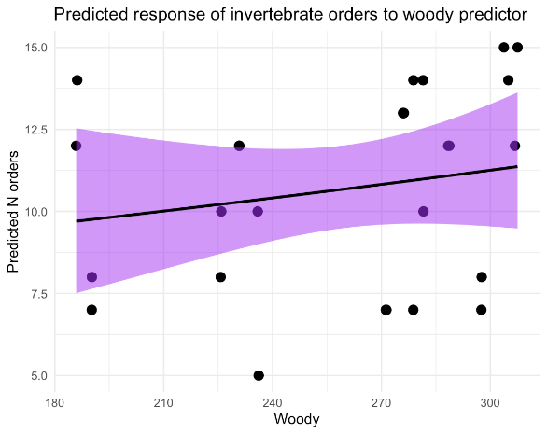

Appendix 5. Observed and predicted invertebrate signal across elevation
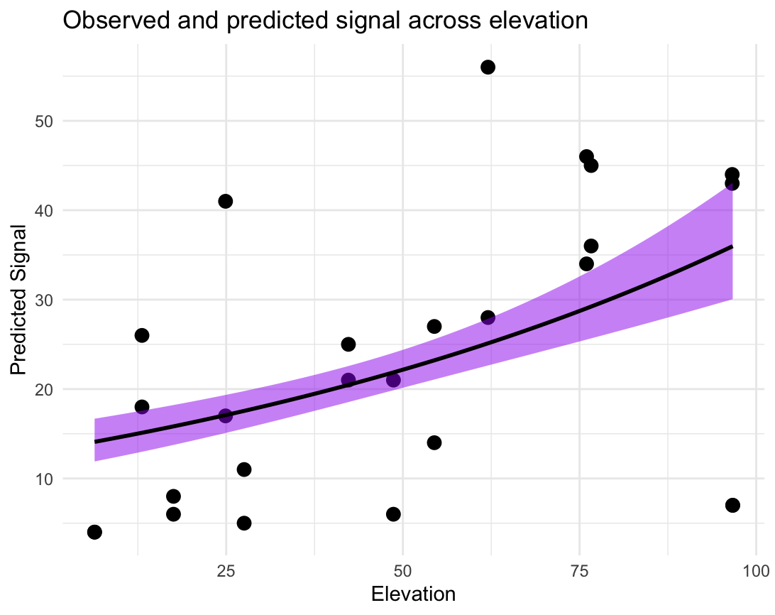

Appendix 6: Multivariate GLM coefficient plot for band1, conserved and elevation