Reduced enteric methane emissions alters carbon isotope ratio of animal derived products
Francesca A. McInerney¹, Gonzalo Martinez Fernandez², Stuart Denman², Jody McNally³, Ruth Gómez Expósito¹, Christoph Gerber⁴, Sonja Dominik² and Nina Welti¹
¹CSIRO, Agriculture and Food, Urrbrae, 5064, Australia
²CSIRO, Agriculture and Food, St. Lucia, 4067, Australia
³CSIRO, Agriculture and Food, Armidale, 2350, Australia
⁴CSIRO, Environment, Urrbrae, 5064, Australia

Supplementary Information
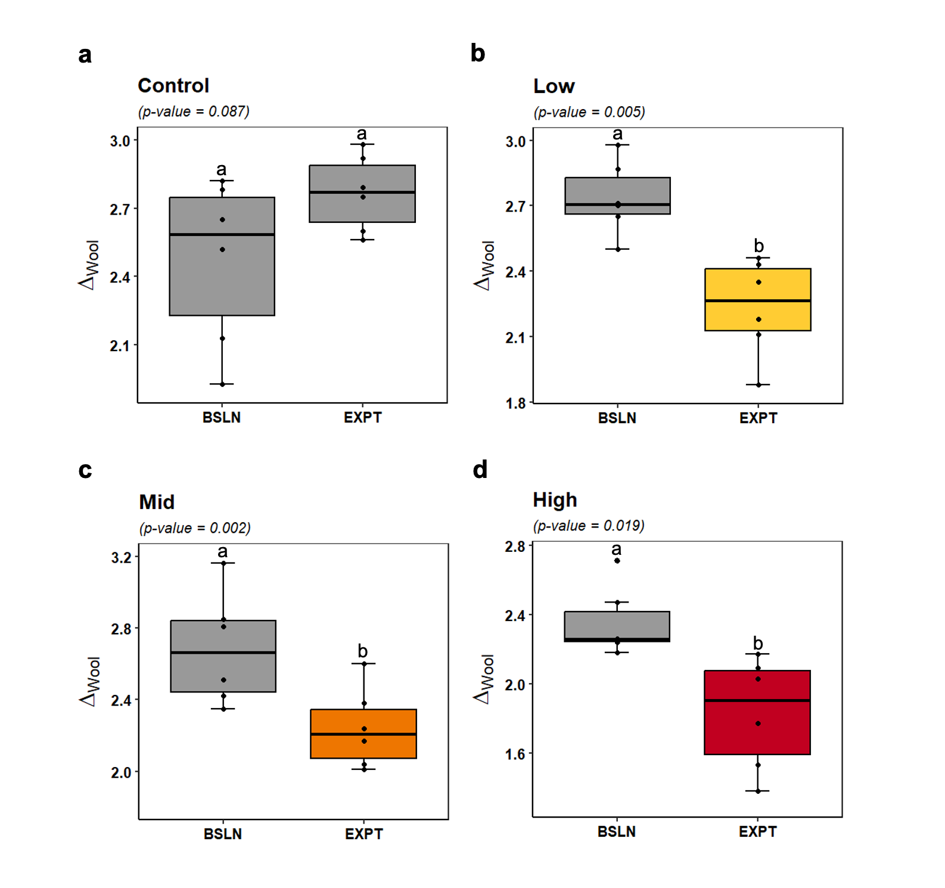

Supplementary Figure S1: Comparisons of the wool-diet offsets (Δ_{wool}) from the baseline and experimental periods for each experimental group. Adjusted p-value from paired t-test shown, with whiskers representing the maximum and minimum for each group with outliers shown as points, and results of Tukey-Kramer post-hoc pairwise comparisons indicated with different letters for groups that differ significantly (p < 0.05). Treatments: Control, Low, Mid and High (0, 55, 130 and 256 mg 3-NOP/kg DM, respectively).

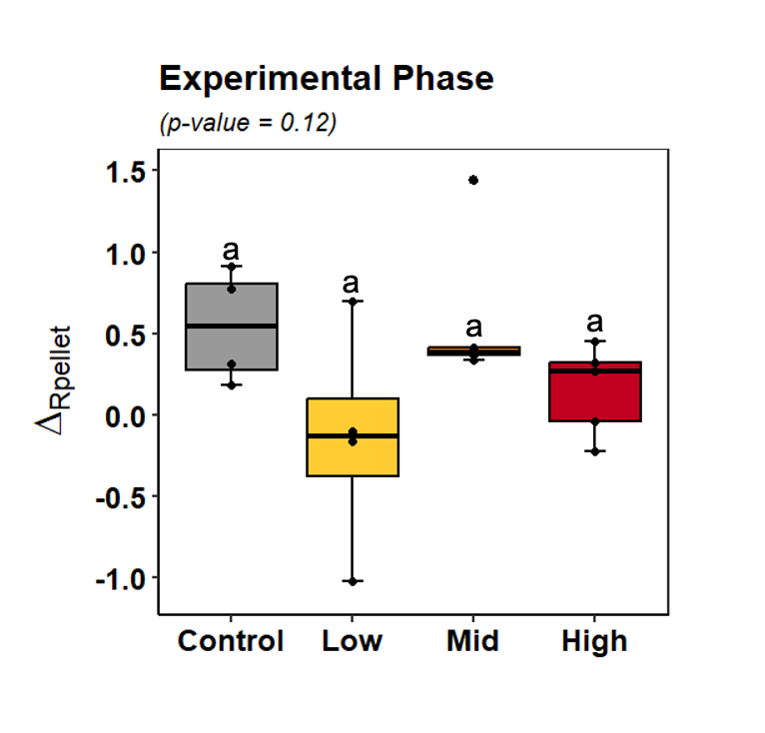
Supplementary Figure S2: Rumen pellet offsets from diet (Δ_{pellet}) by group for the experimental period. Adjusted p-value from Anova shown, with whiskers representing the maximum and minimum for each group with outliers shown as points for each group, and results of Tukey-Kramer post-hoc pairwise comparisons indicated with different letters for groups that differ significantly (p < 0.05). Treatments: Control, Low, Mid and High (0, 55, 130 and 256 mg 3-NOP/kg DM, respectively).
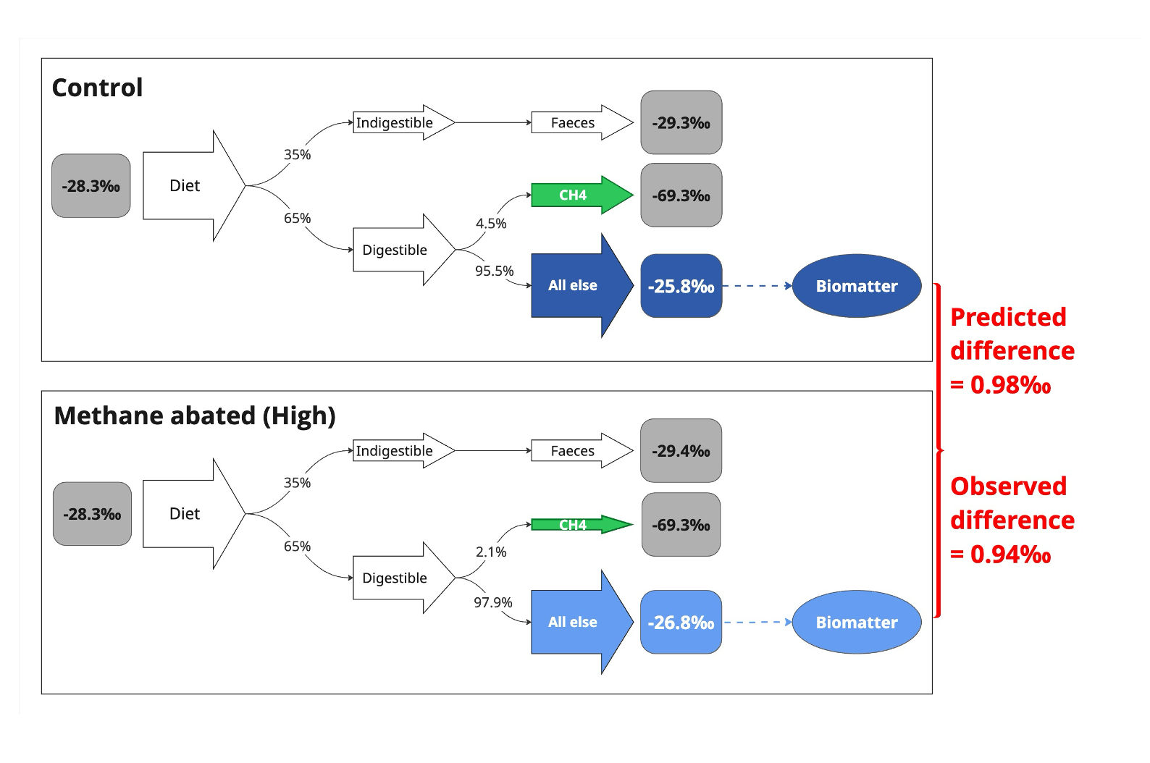
Supplementary Figure S3: Schematic of mass balance model with values from this trial for the control and high treatment groups during the experimental phase. All carbon isotope values were measured in this trial except for the δ¹³C of methane that was calculated from the δ¹³C of diet following Chang et al. 2019¹¹. The resultant predicted isotopic effect is compared to the observed isotopic difference in wool-diet offsets (Δ_{wool}).

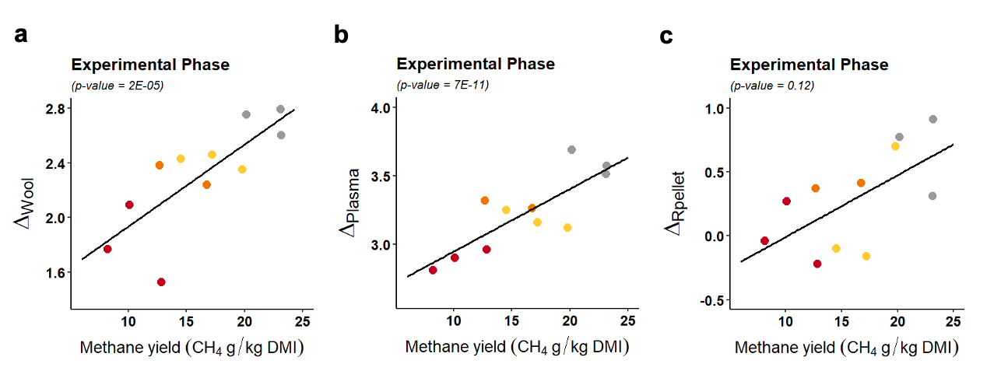
Figure S4. Experimental phase methane yield (g CH₄/kg DMI) for all animals that consumed >60% DMI while in chambers versus carbon isotope offsets relative to diet (Δ_{biomatter}) for wool (a), plasma (b) and rumen fluid pellet (c). Colour coded by treatment group: control = gray, low = yellow, mid = orange, high = red. Linear regression for all data shown as black line, with p-value for non-zero slope indicated in title.

Supplementary Table S1: Mass balance calculation available as an excel file.

Supplementary Table S2. Feed nutritional analysis.

 | Baseline fodder cubes | Experimental fodder cubes
Dry Matter % | 90.5 | 90.3
Organic Matter % | 92.8 | 92.3
Total Crude Protein % | 10.5 | 11.7
Neutral Detergent Fibre % | 53.0 | 49.2
Acid Detergent Fibre % | 35.9 | 32.0
Ether Extract % | 1.7 | 1.5
Ash % | 7.2 | 7.8
Dry Matter Digestibility (DMD) | 60.1 | 65.1
Dry Organic Matter Digestibility (DOMD) | 57.7 | 62.0
Metabolisable Energy, MJ/kg DM | 8.7 | 9.6

Supplementary Table S3. Methane production, DMI and BW of sheep fed fodder cubes for the baseline period prior to inclusion of 3-NOP treatments. Results reported as a group mean ± standard error of the mean.
 | Control | Low | Mid | High | p-value
BW (kg) start | 57.2 ± 0.72 | 56.2 ± 0.94 | 58.6 ± 1.28 | 57.4 ± 1.40 | 0.518
BW (kg) 70 days on fodder cubes | 61.5 ± 1.17 | 60.6 ± 1.36 | 61.0 ± 2.18 | 60.5 ± 1.04 | 0.963
DMI (Kg) individual pen | 1.79 ± 0.08 | 1.86 ± 0.11 | 1.89 ± 0.10 | 1.84 ± 0.08 | 0.908
DMI (Kg) chamber | 1.42 ± 0.09 | 1.39 ± 0.09 | 1.33 ± 0.12 | 1.42 ± 0.08 | 0.891
CH₄ g/day | 26.7 ± 2.92 | 27.0 ± 2.43 | 26.5 ± 1.67 | 28.2 ± 2.12 | 0.950
CH₄ g/kg DMI | 18.7 ± 1.34 | 19.4 ± 0.67 | 20.3 ± 1.13 | 19.8 ± 0.97 | 0.759
Treatments: Control, Low, Mid and High (0, 55, 130 and 256 mg 3-NOP/kg DM, respectively).

Supplementary Table S4. Treatment effect on rumen fermentation metabolites of sheep fed with fodder cubes containing different levels of 3-NOP. Results reported as a group mean ± standard error of the mean.
 | Control | Low | Mid | High | p-value | Polynomial contrast
pH | 6.58 ± 0.12 | 6.35 ± 0.04 | 6.56 ± 0.06 | 6.44 ± 0.07 | 0.150 | n.s.
Lactate (mM) | 0.03 ± 0.02 | 1.44 ± 1.36 | 0.18 ± 0.09 | 0.10 ± 0.02 | 0.355 | n.s.
Formate (mM) | 0.00 ± 0.00 | 0.22 ± 0.19 | 0.49 ± 0.21 | 0.83 ± 0.33 | 0.124 | L
Ammonia-N (mg /100 mL) | 3.25± 0.69 | 4.93 ± 0.50 | 4.79 ± 0.75 | 4.00 ± 0.37 | 0.244 | n.s.
Total VFA mM | 98.2± 6.62 | 93.0 ± 1.98 | 92.4 ± 4.83 | 89.5 ± 6.65 | 0.741 | n.s.
Individual VFA (%)
iso-Butyrate | 0.19 ± 0.04 | 0.17 ± 0.06 | 0.21 ± 0.04 | 0.20 ± 0.03 | 0.939 | n.s.
n-Butyrate | 8.64 ± 0.76 | 10.3 ± 0.93 | 8.80 ± 0.45 | 10.1 ± 0.79 | 0.303 | n.s.
n-Caproate | 0.17 ± 0.04 | 0.23 ± 0.05 | 0.23 ± 0.03 | 0.29 ± 0.05 | 0.311 | n.s.

^{abc}Within each row, treatment mean values with different superscript letters indicate a significant difference (p < 0.05).
Contrast: Significant (P < 0.05) linear (L), Cubic (C), or quadratic (Q) effects of the response to incremental dose of 3-NOP estimated by polynomial contrast. n.s.: not significant.
Treatments: Control, Low, Mid and High (0, 55, 130 and 256 mg 3-NOP/kg DM, respectively).

Supplementary Table S5. Carbon isotope ratios of fodder cubes during baseline and experimental phases of the trial.
 | Mean δ¹³C ± SEM (‰) | Weight % C | Subsamples | Replicate measurement of subsamples
Baseline diet | -29.00 ± 0.02 | 43% | 1 | 3
Experimental diets | -28.33 ± 0.06 | 43% | 28 | 2 to 3

Supplementary Table S6: Isotope and methane emissions data for all animals for all trial phases available as an Excel file.

Supplementary Table S7: Carbon isotope ratios (δ¹³C) for wool, plasma and rumen fluid and pellet and for each treatment group for the baseline and experimental phases. All values in ‰.
 | Control | Low | Mid | High | p-value
Baseline
δ¹³C_{wool} | -26.54 ± 0.15 | -26.28 ± 0.07 | -26.33 ± 0.13 | -26.66 ± 0.08 | 0.08
δ¹³C_{plasma} | -25.28 ± 0.04 | -25.27 ± 0.04 | -25.30 ± 0.03 | -25.33 ± 0.05 | 0.70
δ¹³C_{faeces} | -28.57ª ± 0.05 | -28.81^{b} ± 0.07 | -28.78^{ab} ± 0.05 | -28.85^{b} ± 0.05 | 0.01
Experimental
δ¹³C_{wool} | -25.56ª ± 0.07 | -26.10^{b} ± 0.09 | -26.09^{b} ± 0.09 | -26.50^{c} ± 0.13 | 2E-05
δ¹³C_{plasma} | -24.75ª ± 0.03 | -25.17^{b} ± 0.04 | -25.02^{c} ± 0.02 | -25.39^{d} ± 0.03 | 3E-11
δ¹³C_{faeces} | -29.34 ± 0.08 | -29.39 ± 0.03 | -29.36 ± 0.03 | 29.44 ± 0.02 | 0.44
δ¹³C_{fluid} | -28.05 ± 0.15 | -28.65 ± 0.15 | -28.65 ± 0.20 | -28.71 ± 0.14 | 0.05
δ¹³C_{pellet} | -27.79 ± 0.18 | -28.48 ± 0.35 | -27.74 ± 0.21 | -28.17 ± 0.12 | 0.12
^{abcd}Within each row, treatment mean values with different superscript letters indicate a significant difference (p < 0.05).
Treatments: Control, Low, Mid and High (0, 55, 130 and 256 mg 3-NOP/kg DM, respectively).

