Supplementary Materials
Supplementary Table 1. Regression coefficients in the two marker status models
Predictors | Sertraline Marker Model |  |  | Bupropion Marker Model
Predictors | Log-Odds | CI | p | Log-Odds | CI | p
Interference Flanker | -3.69 | -8.32 – 0.57 | 0.101 | - | - | -
Employment Status | 1.54 | 0.63 – 2.53 | 0.001 | - | - | -
Neuroticism | 0.03 | -0.04 – 0.11 | 0.397 | - | - | -
HRSD total | 0.03 | -0.08 – 0.14 | 0.641 | - | - | -
Response Bias | - | - | - | 7.14 | -0.94 – 18.51 | 0.129
Reward Sensitivity | - | - | - | 3.19 | -0.46 – 8.01 | 0.125
NAcc-rACC rsFC | -3.17 | -7.25 – 0.60 | 0.11 | 21.64 | 7.63 – 48.59 | 0.03
Note. Nacc: nucleus accumbens, rACC: rostral anterior cingulate cortex, rsFC: resting state functional connectivity

Supplementary Table 2. Distribution of different marker status in the EMBARC phase 2 data
 | BUP+ | BUP-
SER+ | 8 (10.8%) | 31 (41.9%)
SER- | 14 (18.9%) | 21 (28.4%)

Supplementary Table 3. Estimated regression coefficients from the LMM in which participant groups were defined by their BUP and SER markers. The reference group was BUP-/SER-
Predictors | Estimates | CI | p
sex | -1.49 | -5.46 – 2.48 | 0.462
age | -0.1 | -0.33 – 0.14 | 0.421
Time | -1.18 | -2.10 – -0.25 | 0.013
BUP-/SER+ | 2.84 | -3.92 – 9.60 | 0.409
BUP+/SER- | 3.89 | -2.36 – 10.13 | 0.222
BUP+/SER+ | 4.41 | -2.18 – 11.00 | 0.188
Time:[BUP-/SER+] | -1.35 | -2.56 – -0.14 | 0.029
Time:[BUP+/SER-] | -1.26 | -2.38 – -0.15 | 0.026
Time:[BUP+/SER+] | -1.04 | -2.17 – 0.10 | 0.073

Supplementary Figure 1. Trajectories of depression scores (A) and response rates (B) for participants who were assigned a drug consistent vs. inconsistent with their biomarker indication. MADRS: Montgomery-Asberg Depression Rating Scale. n.s.: not significant
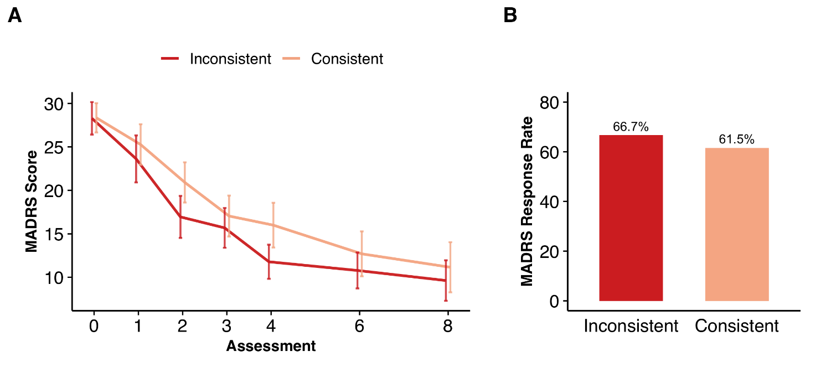

Supplementary Figure 2. Trajectories of depression scores (A) and response rates (B) for participants who received sertraline vs bupropion. MADRS: Montgomery-Asberg Depression Rating Scale. n.s.: not significant 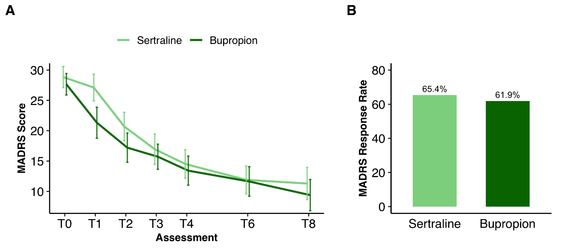

Supplementary Figure 3. Trajectories of depression scores (A) and response rates (B) for participants across four different marker groups. MADRS: Montgomery-Asberg Depression Rating Scale

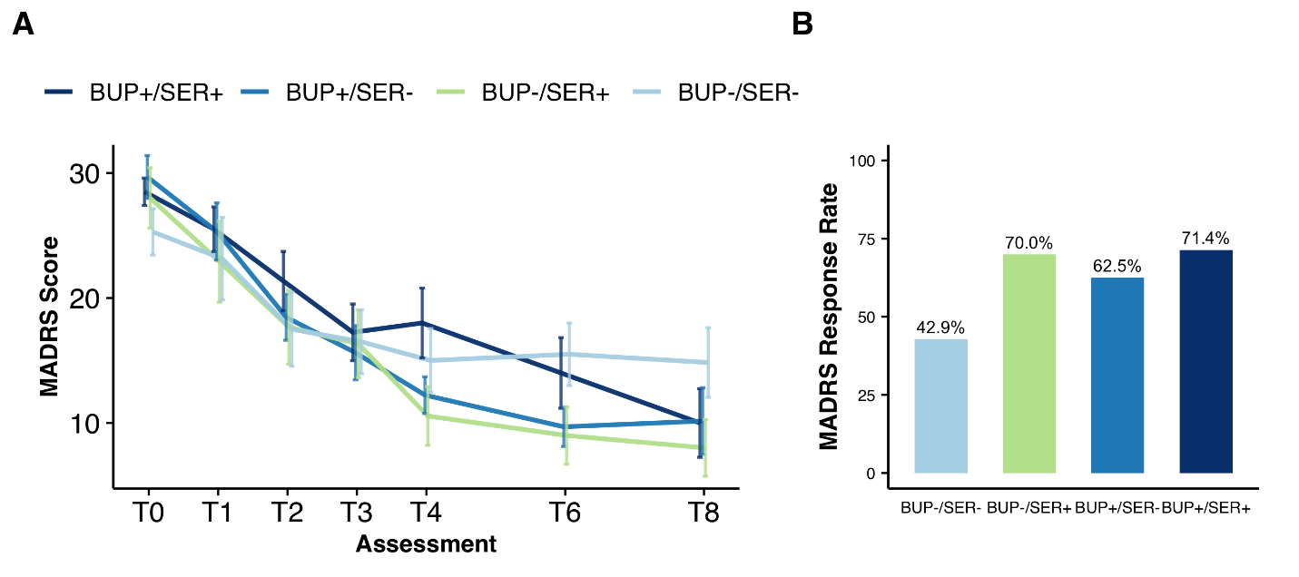

REFERENCES

