Table 1
Examples of AI-Generated Alt Text and Faculty Feedback
Image | AI-Generated Alt Text | Faculty Feedback
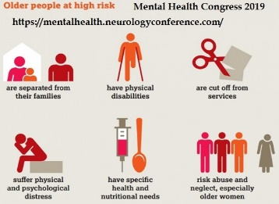 | Infographic titled “Older people at high risk” with the heading “Mental Health Congress 2019” and a web link: https://mentalhealth.neurologyconference.com/. It lists six risks older adults face, each illustrated with icons: 1. Separated from their families – icon of two people inside a house with one outside. 2. Have physical disabilities – icon of a person with a cane. 3. Cut off from services – icon of scissors cutting a line. 4. Suffer physical and psychological distress – icon of a person sitting with head in hands. 5. Have specific health and nutritional needs – icon of a test tube and a spoon. 6. Risk abuse and neglect, especially older women – icon of a group of figures with one female highlighted. The infographic highlights the vulnerabilities and support needs of elderly populations. | Accuracy: 2  Meaningfulness: 3  Usefulness: 3  The description of the images do not have meaningful information that would be helpful to students. As far as accuracy, all are accurate except #5 which has a syringe and a spoon - not a test tube.
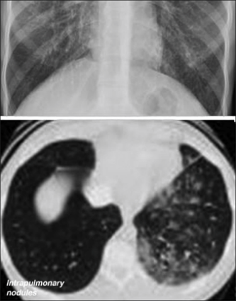 | Composite medical image showing two different views of the lungs: Top image: Chest X-ray showing a diffuse pattern of increased opacities throughout the lung fields, consistent with a nodular or interstitial pattern. The lung markings are dense, suggesting an abnormal parenchymal process. Bottom image: CT scan (axial view) of the lungs displaying multiple small intrapulmonary nodules, predominantly in the right lung, with heterogeneous distribution. The left lung appears clearer with fewer nodules and more aerated spaces. The combined images suggest a diagnosis involving intrapulmonary nodules, potentially indicative of metastatic disease, granulomatous infection, or a diffuse inflammatory condition. | Accuracy: 3  Meaningfulness: 2  Usefulness: 2  The AI-generated text is accurate but misses the purpose of this slide. The purpose is to present the radiographic imaging associated with hepatopulmonary disease related to AV shunting.
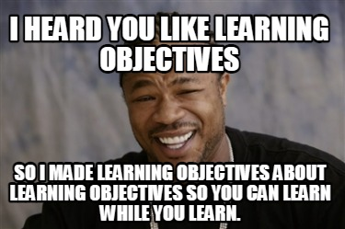 | Meme featuring a man smiling with a squint, overlaid with bold white text in all caps. Top text: "I HEARD YOU LIKE LEARNING OBJECTIVES". Bottom text: "SO I MADE LEARNING OBJECTIVES ABOUT LEARNING OBJECTIVES SO YOU CAN LEARN WHILE YOU LEARN." The meme humorously exaggerates the concept of meta-learning, poking fun at the repetitive and layered nature of instructional design. | Accuracy: 5  Meaningfulness: 2  Usefulness: 2  While it accurately describes the image (though I'd probably use normal sentence-case for alt-text), the joke here is about how we have objectives learning about making learning objectives. The joke, in this case, applies to this specific course, rather than instructional design more broadly.

