Storylines of summer streamflow droughts in western Canadian watersheds: historical attribution and future projections

Rajesh R. Shrestha, Alex J. Cannon
Climate Research Division, Environment and Climate Change Canada, Victoria, BC, Canada.
Email: rajesh.shrestha@ec.gc.ca

Contents of this file
Tables SI1 to SI3
Figure SI1 to SI11
Additional References

Table SI1. Goodness-of-fit metrics for CWatM simulated streamflow results for the calibration (1990-2000) and validation (2001-2007) periods.
Basin | Station | Calibration |  |  | Validation
Basin | Station | NSE | KGE | RMSE | NSE | KGE | RMSE
Fraser | Fraser River at Hope | 0.88 | 0.89 | 811 | 0.83 | 0.83 | 886
Upper Columbia | Columbia River below Murphy Creek | 0.80 | 0.90 | 902 | 0.81 | 0.90 | 826
Summarized metrics include Nash-Sutcliffe coefficient of efficiency (NSE), Kling-Gupta coefficient (KGE) and root mean square error (RMSE, m³/s) for the stations shown to Fig. 1.

Table SI2. Goodness-of-fit metrics for CWatM simulated SWE results.
Basin | Station | NSE | KGE | RMSE
Fraser | BCE-1B01P | 0.55 | 0.61 | 145.8
Fraser | BCE-1B02P | 0.90 | 0.86 | 167.6
Fraser | BCE-1B08P | 0.68 | 0.77 | 259.2
Upper Columbia | BCE-0B06P | 0.51 | 0.60 | 147.8
Upper Columbia | BCE-2C10P | 0.71 | 0.60 | 92.7
Upper Columbia | BCE-2D06 | 0.80 | 0.89 | 75.9

Summarized metrics include Nash-Sutcliffe coefficient of efficiency (NSE), Kling-Gupta coefficient (KGE) and root mean square error (RMSE, mm) for the stations shown to Fig. SI10.

Table SI3. List of CMIP6 GCMs together with the time periods SSP5-85 scenario runs of each GCM reach 1.5 to 4.0 °C global warming level (GWL) above the preindustrial period 1850-1900.

GCM name | Primary reference | GWL 1.5 | GWL 2.0 | GWL 3.0 | GWL 4.0
Australian Community Climate and Earth System Simulator coupled model version 2, (ACCESS-CM2) | Bi et al ¹ | 2008-2027 | 2020-2039 | 2040-2059 | 2055-2074
Geophysical Fluid Dynamics Laboratory Earth System Model, version 4 (GFDL-ESM4) | Dunne et al ² | 2019-2038 | 2034-2055 | 2059-2078 | 2080-2099
Hadley Centre Global Environmental Model 3—Global Coupled configuration 3.1 (HadGEM3-GC3.1-LL) | Jones et al ³ | 2004-2023 | 2014-2033 | 2032-2051 | 2049-2068
Institut Pierre-Simon Laplace, Climate Model version 6 - low resolution (IPSL-CM6A-LR) | Boucher et al ⁴ | 2014-2033 | 2027-2046 | 2043-2062 | 2058-2077
Korea Meteorological Administration Advanced Community Earth-system model (KACE-1-0-G) | Lee et al ⁵ | 2007-2026 | 2016-2035 | 2036-2055 | 2055-2074
Model for Interdisciplinary Research on Climate, Earth System version 2 for Long-term simulations (MIROC-ES2L) | Hajuma et al ⁶ | 2016-2035 | 2029-2048 | 2051-2070 | 2073-2092
Model for Interdisciplinary Research on Climate version 6 (MIROC6) | Tatebe et al ⁷ | 2020-2039 | 2035-2054 | 2059-2078 | 2077-2096
Max Planck Institute Earth System Model version 1.2 - low resolution (MPI-ESM1.2-LR) | Mauritsen ⁸ | 2024-2043 | 2039-2058 | 2060-2079 | 2080-2099
Meteorological Research Institute Earth System Model version 2.0 (MRI-ESM2.0) | Yukimoto et al ⁹ | 2011-2030 | 2023-2042 | 2050-2069 | 2070-2089
Norwegian Earth System Model version 2 - medium resolution (NorESM2-MM) | Seland et al ¹⁰ | 2018-2037 | 2030-2049 | 2056-2075 | 2075-2094
U.K. Earth System Model (UKESM1-0-LL) | Sellar et al ¹¹ | 2005-2024 | 2014-2033 | 2030-2049 | 2044-2063
GWL calculations are performed with respect to 1990-2010 by considering +0.7 °C warming between 1850-1900 to 1981-2010.

Fig. SI1. April–August hydroclimatic variability in the upper Columbia River Basin. (a) daily mean temperature, (b) cumulative daily precipitation, (c) daily SWE, and (d) daily streamflow.

Fig. SI2. Quantile-quantile plots of the GEV fits compared with the data used to fit to the distributions. The p-values indicates results of the Anderson-Darling (AD) test of the goodness of fits of the GEV distributions, and Shapiro-Wilks (SW) test of the normality of the drought indicates. Both tests involved 1000 bootstrap resamples and test scores represent average values, with p-value > 0.05 indicates the validity of GEV fit and normality for the AD test and SW test, respectively.
Fig. SI3. El Niño Southern Oscillation (ENSO) index and drought indices for the upper Columbia River Basin. (a) Niño 3.4 index, (b) Standardized Precipitation–Evaporation Index (SPEI), (c) Standardized SWE Index (SWEI), and (d) Standardized Streamflow Index (SSI). Numbers in the top-right corner of (a–c) indicate Spearman rank correlations of each index with SSI, with bold numbers indicating statistically significant correlations (p < 0.05). The years 2023 and 2024 are highlighted with grey bands.

Fig. SI4. Comparison of hydroclimatology between factual and counterfactual climates. (a–b) mean April–August temperature, (c–d) total April–August precipitation, (e–f) April 1 SWE, and (g–h) July–August streamflow.
Fig. SI5. AMJJA Pr-PET from the factual and counterfactual simulations, partitioned with respects to the ENSO-states. a) 1985-2023 ENSO -ve state results for the Fraser basin corresponding to the 2023 streamflow drought event. b) 1987-2024 ENSO +ve state results for Fraser basin corresponding to the 2024 streamflow drought event. c) and d) same as a) and b), respectively, but for the upper Columbia basin.

Fig. SI6. Mean annual and seasonal (a, c) temperature and (b, d) precipitation changes at 1.5 to 4.0 °C global warming levels (GWLs) relative to the 1985–2014 reference period.

Fig. SI7. Reference (1985–2014) and projected SWE [mm] at 1.5 to 4.0 °C GWLs obtained from the GCM ensemble. All SWE results are simulated, basin-averaged values from CWatM simulations: (a) monthly SWE and (b) April 1 SWE for Fraser Basin. (c) monthly SWE and (d) April 1 SWE for upper Columbia Basin. Median change [%] at four GWLs relative to 1985–2014, along with the agreement of ensemble members [%] with the direction of median change, is shown at the top of each panel.
Fig. SI8. Reference (1985–2014) and projected streamflow at 1.5 to 4.0 °C GWLs obtained from the GCM ensemble–driven CWatM simulations. (a) monthly flows and (b) June–August flow at Fraser–Hope station. (c) monthly flow and (d) June–August flow at upper Columbia Murphy Creek station. Median change [%] at four GWLs relative to 1985–2014, along with the agreement of ensemble members [%] with the direction of median change, is shown at the top of each panel.

Fig. SI9. Projected changes in cumulative distribution and drought severity of AMJJA Pr-PET compared to the 1985–2014 reference period. Panels (a–b) show exceedance probabilities, with vertical dashed and solid lines representing thresholds for moderate and extreme droughts, respectively, based on Fig. 3. The bars in panels (c–d) show median drought frequencies, and the whiskers depict the maximum–minimum range from the GCM ensemble.

a)
BCE-1B01P
BCE-1B02P
BCE-1B08P

b)
BCE-0B06P
B CE-2D06
B CE-2C10P
Fig. SI10. Observed vs. simulated SWE from CWatM model for three stations each from the a) Fraser and b) upper Columbia Basins.
a)
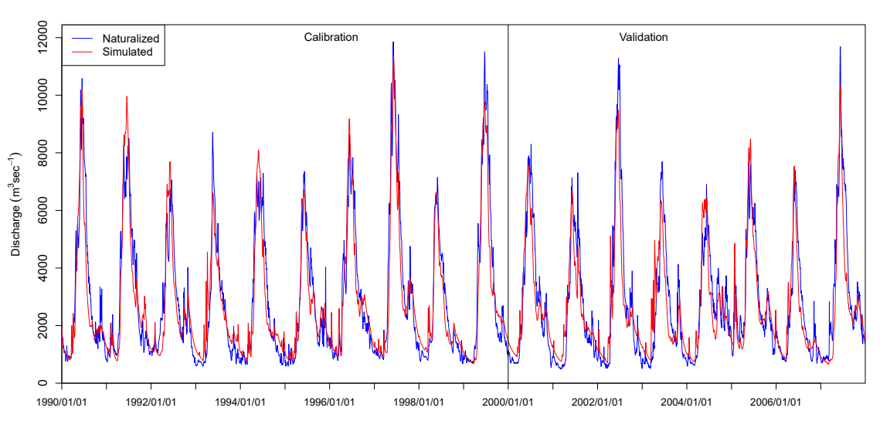
b)
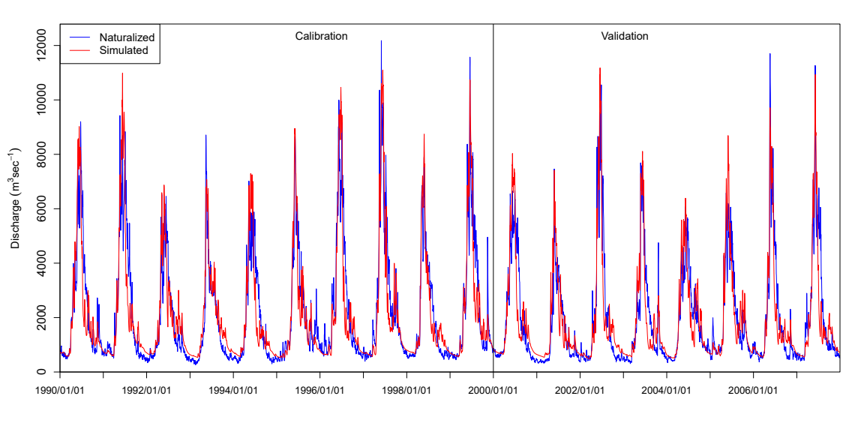
Fig. SI11. Naturalized vs. CWatM-simulated flows from for calibration (1990–2000) and validation (2001–2007) periods. (a) Fraser River at Hope station and (b) Columbia River below Murphy Creek station.

Additional References
1. Bi, D. et al. Configuration and spin-up of ACCESS-CM2, the new generation Australian Community Climate and Earth System Simulator Coupled Model. JSHESS 70, 225–251 (2020).
2. Dunne, J. P. et al. The GFDL Earth System Model Version 4.1 (GFDL-ESM 4.1): Overall Coupled Model Description and Simulation Characteristics. Journal of Advances in Modeling Earth Systems 12, e2019MS002015 (2020).
3. Jones, G. S. et al. The HadGEM3-GC3.1 Contribution to the CMIP6 Detection and Attribution Model Intercomparison Project. Journal of Advances in Modeling Earth Systems 16, e2023MS004135 (2024).
4. Boucher, O. et al. Presentation and Evaluation of the IPSL-CM6A-LR Climate Model. Journal of Advances in Modeling Earth Systems 12, e2019MS002010 (2020).
5. Lee, J. et al. Evaluation of the Korea Meteorological Administration Advanced Community Earth-System model (K-ACE). Asia-Pacific J Atmos Sci 56, 381–395 (2020).
6. Hajima, T. et al. Development of the MIROC-ES2L Earth system model and the evaluation of biogeochemical processes and feedbacks. Geoscientific Model Development 13, 2197–2244 (2020).
7. Tatebe, H. et al. Description and basic evaluation of simulated mean state, internal variability, and climate sensitivity in MIROC6. Geoscientific Model Development 12, 2727–2765 (2019).
8. Mauritsen, T. et al. Developments in the MPI-M Earth System Model version 1.2 (MPI-ESM1.2) and Its Response to Increasing CO2. Journal of Advances in Modeling Earth Systems 11, 998–1038 (2019).
9. Yukimoto, S. et al. The Meteorological Research Institute Earth System Model Version 2.0, MRI-ESM2.0: Description and Basic Evaluation of the Physical Component. Journal of the Meteorological Society of Japan. Ser. II advpub, (2019).
10. Seland, Ø. et al. Overview of the Norwegian Earth System Model (NorESM2) and key climate response of CMIP6 DECK, historical, and scenario simulations. Geoscientific Model Development 13, 6165–6200 (2020).
11. Sellar, A. A. et al. UKESM1: Description and Evaluation of the U.K. Earth System Model. Journal of Advances in Modeling Earth Systems 11, 4513–4558 (2019).

