Supplemental Information
Unlocking the Circular Potential of Construction and Demolition Waste: A Pathway for Texas’ Construction Industry
Julie Ann Hartell Ph.D., Billy L. Jones, Ashrant Aryal Ph.D.

Department of Construction Science, Texas A&M University
789 Ross Street, College Station, TX

Corresponding Author: Dr. Julie Ann Hartell, julie.hartell@tamu.edu

TCEQ Regional Results for 500tpd, 1000 tpd and 1500 tpd scenarios.
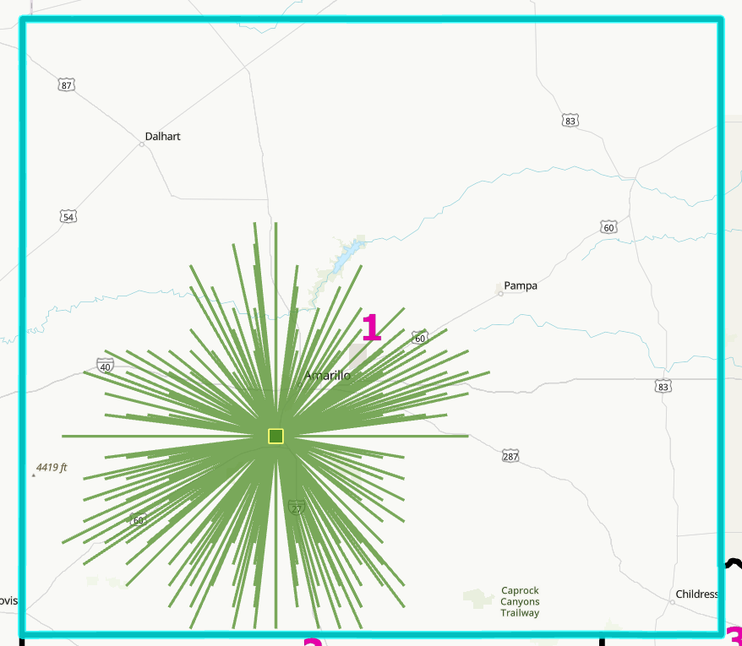
Figure A-1: TCEQ Region 1, 500/1,000/1,500 tpd facility scenarios, 1 candidate
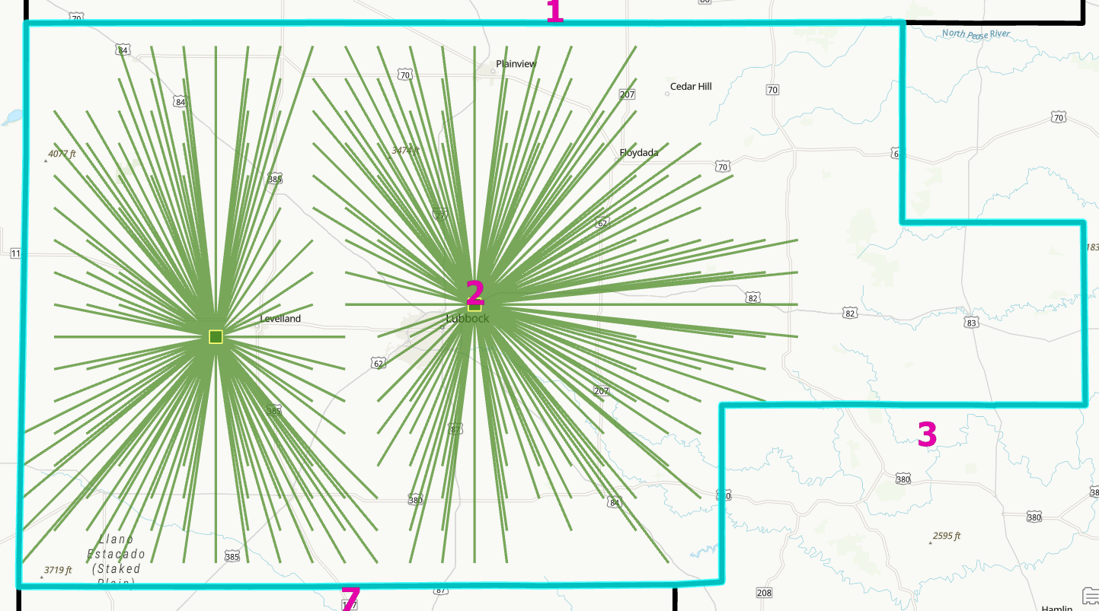
Figure A-2a: TCEQ region 2, 500 tpd facility scenario, 2 candidates

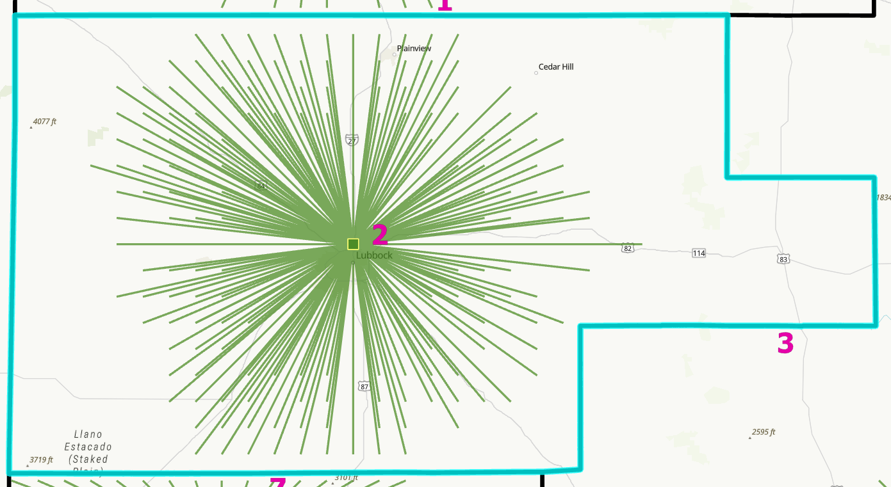
Figure A-2b: TCEQ region 2, 1,000/1,500 tpd facility scenario, 1 candidate

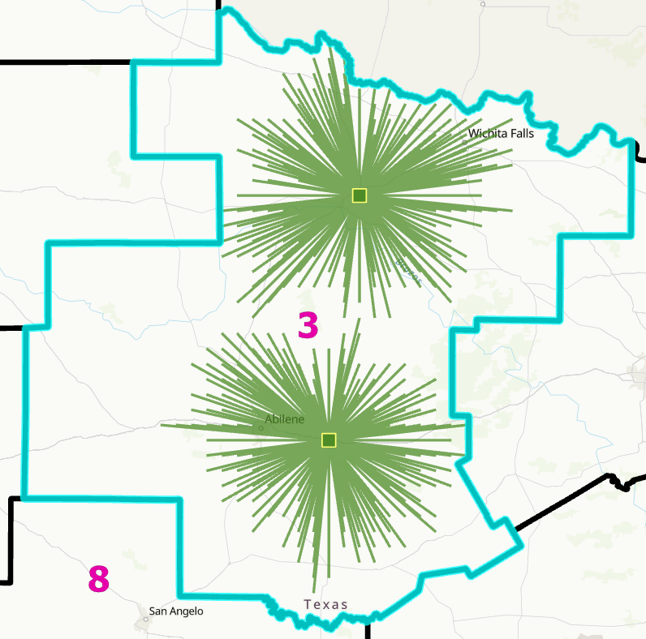
Figure A-3a: TCEQ region 3, 500 tpd facility scenario, 2 candidates
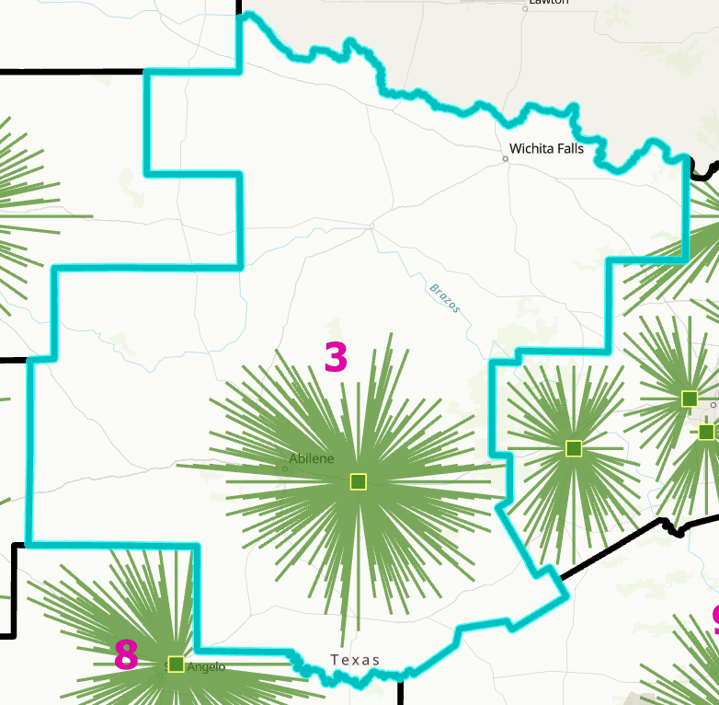
Figure A-3b: TCEQ region 3, 1,000/1,500 tpd facility scenario, 1 candidate

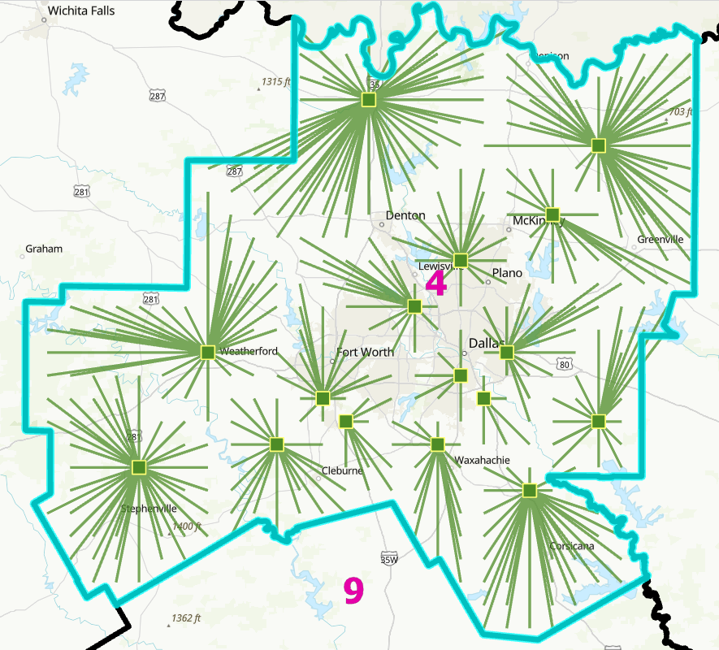
Figure A-4a: TCEQ region 4, 500 tpd facility scenario, 16 candidates

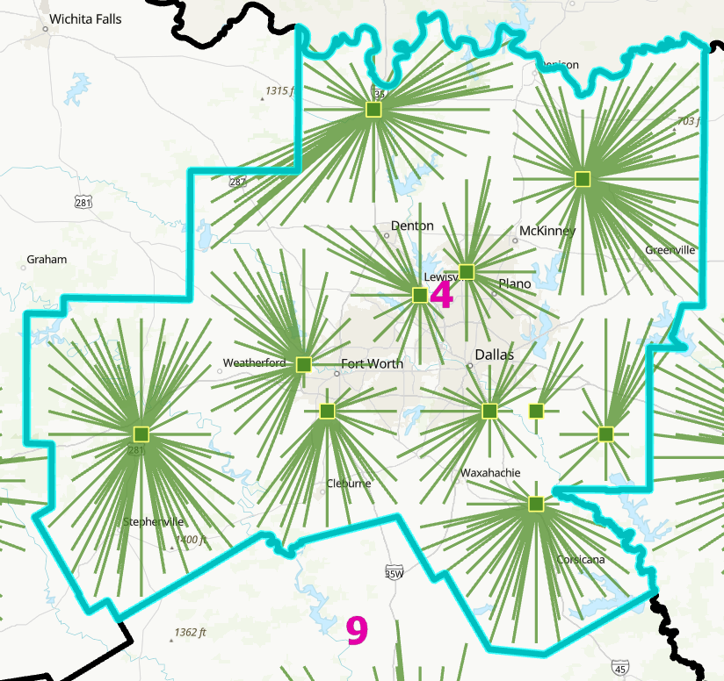
Figure A-4b: TCEQ region 4, 1,000 tpd facility scenario, 11 candidates
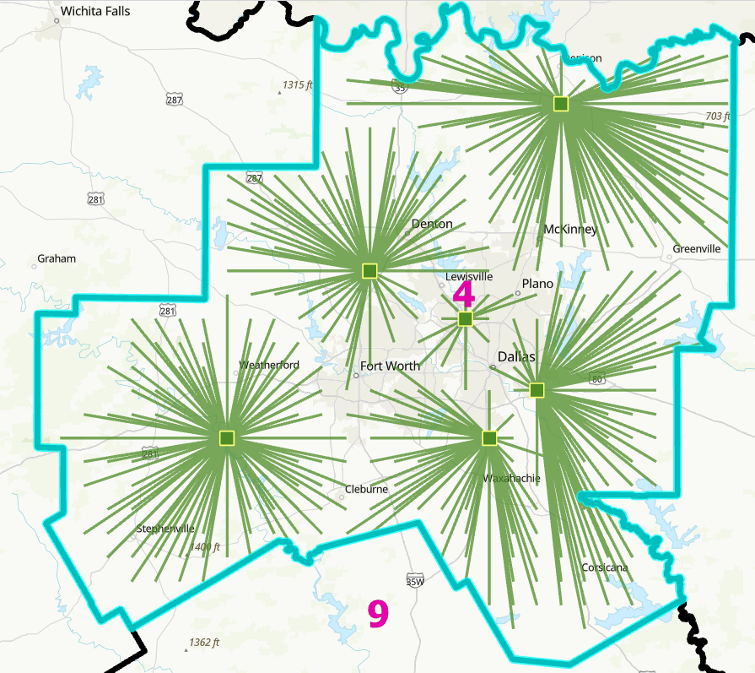
Figure A-4c: TCEQ region 4, 1,500 tpd facility scenario, 6 candidates

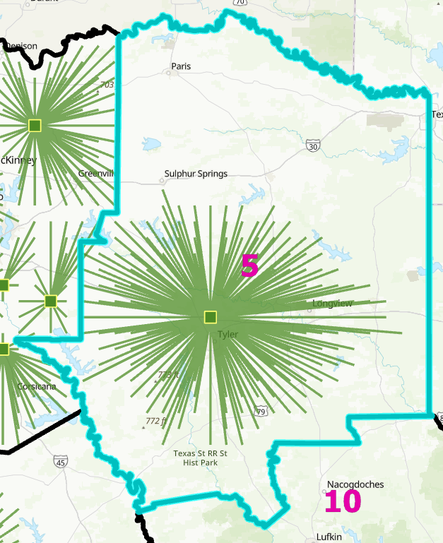
Figure A-5: TCEQ region 5, 500/1,000/1,500 tpd facility scenarios, 1 candidate
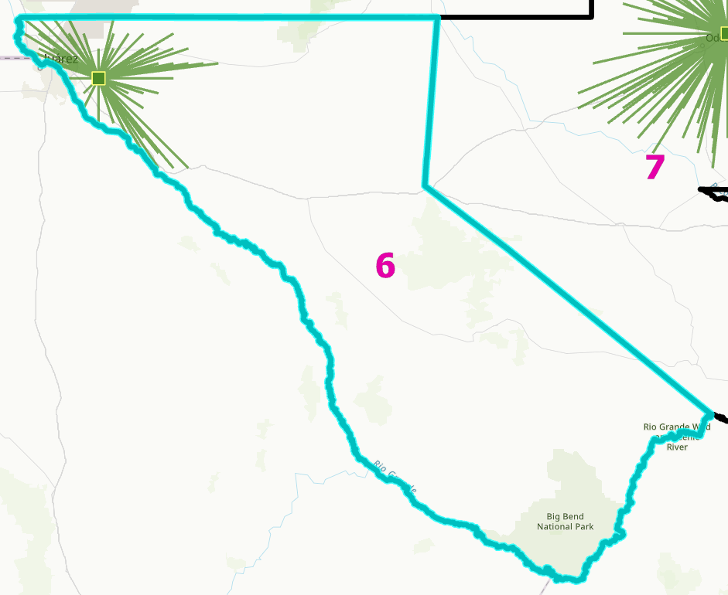
Figure A-6: TCEQ region 6, 500/1,000/1,500 tpd facility scenarios, 1 candidate

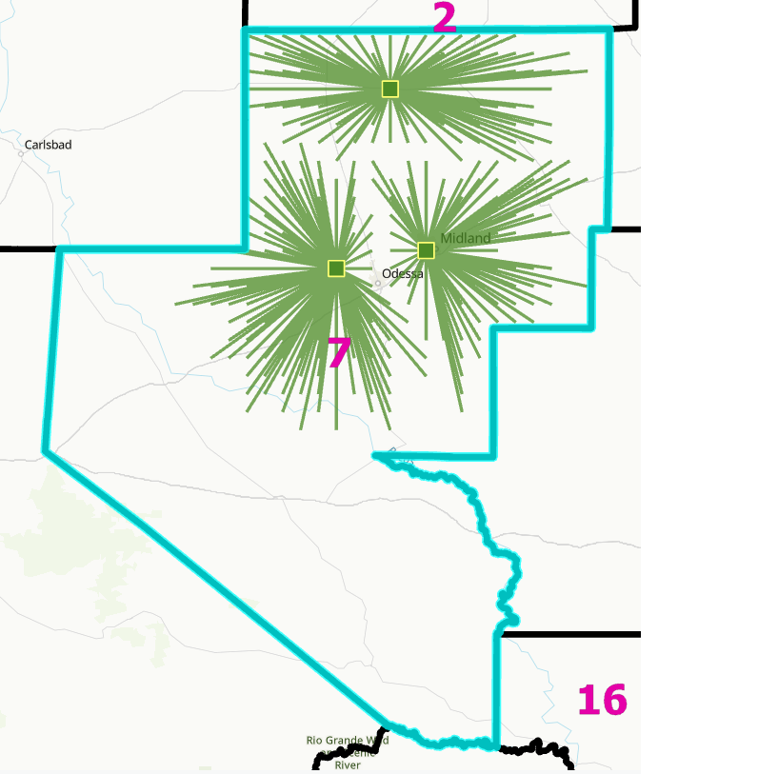
Figure A-7a: TCEQ region 7, 500 tpd facility scenario, 3 candidates

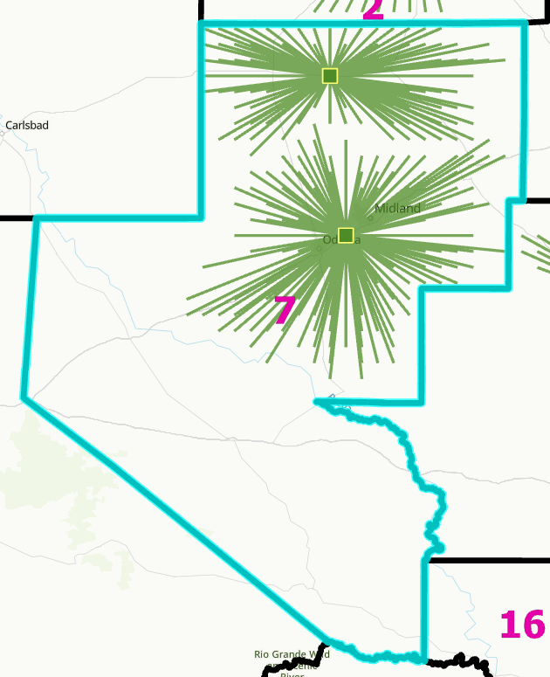
Figure A-7b: TCEQ region 7, 1,000 tpd facility scenario, 2 candidates
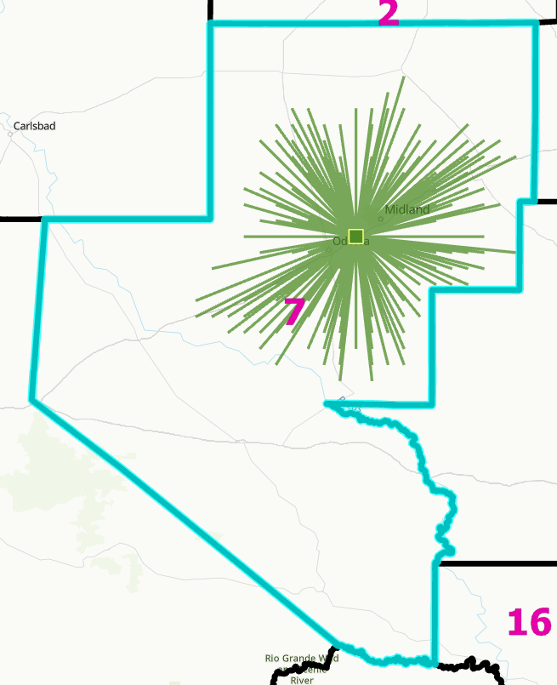
Figure A-7c: TCEQ region 7, 1,500 tpd facility scenario, 1 candidate

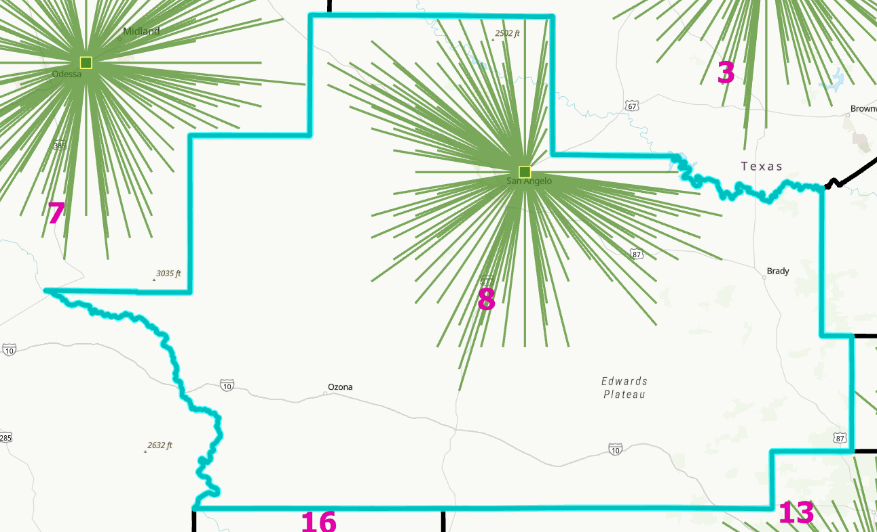
Figure A-8: TCEQ region 8, 500/1,000/1,500 tpd facility scenarios, 1 candidate

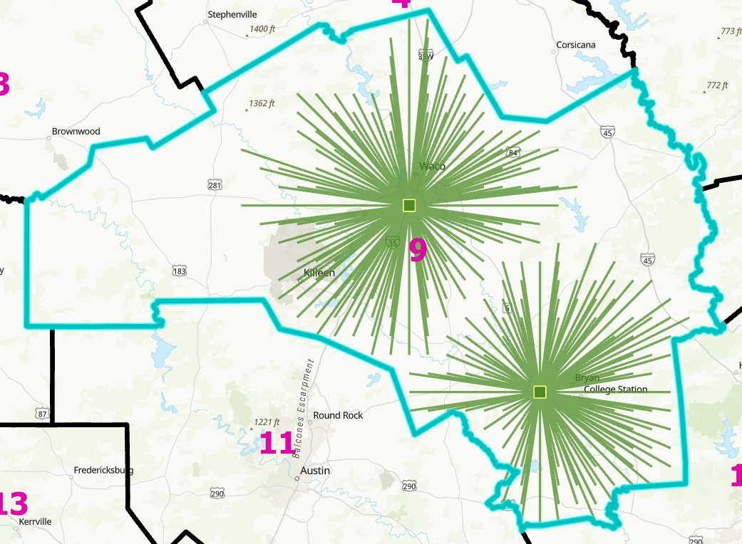
Figure A-9a: TCEQ region 9, 500 ton per day facility scenario, 2 candidates

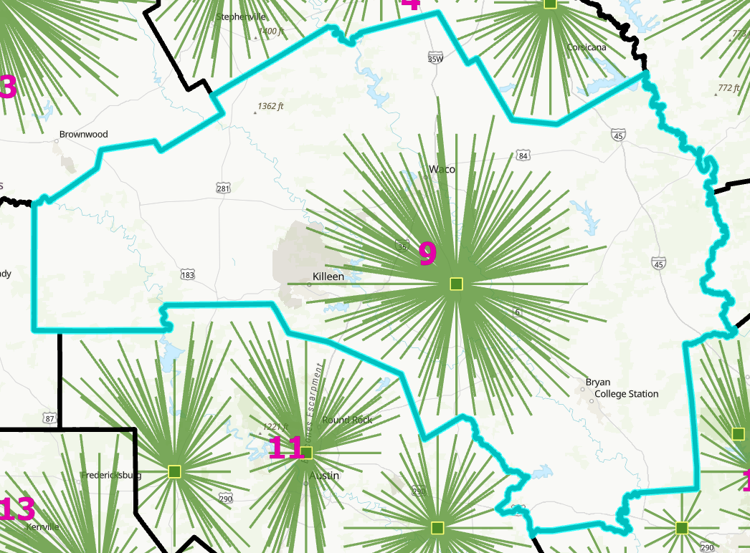
Figure A-9b: TCEQ region 9, 1,000/1,500 tpd facility scenarios, 1 candidate

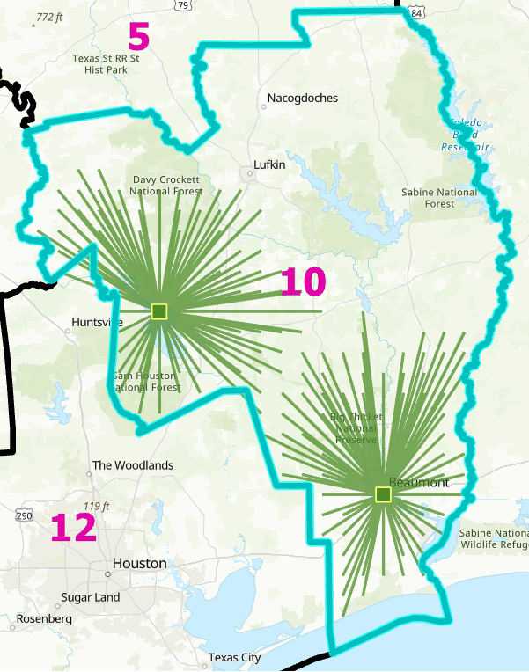
Figure A-10a: TCEQ region 10, 500 tpd facility scenario, 2 candidates

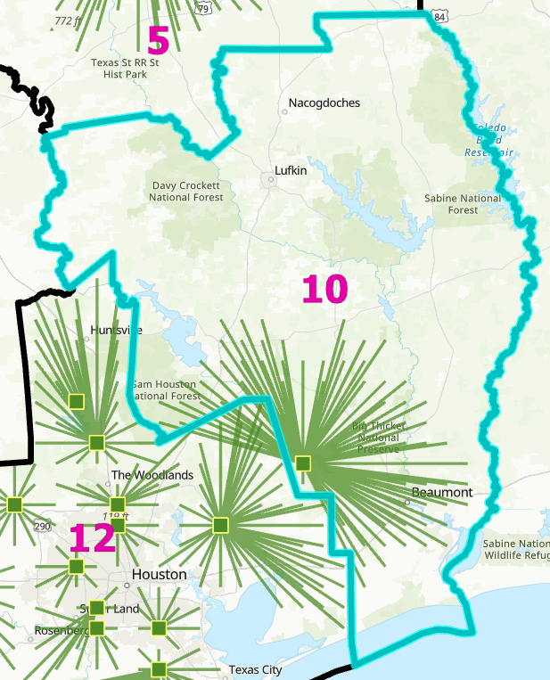
Figure A-10b: TCEQ region 10, 1,000/1,500 tpd facility scenarios, 1 candidate

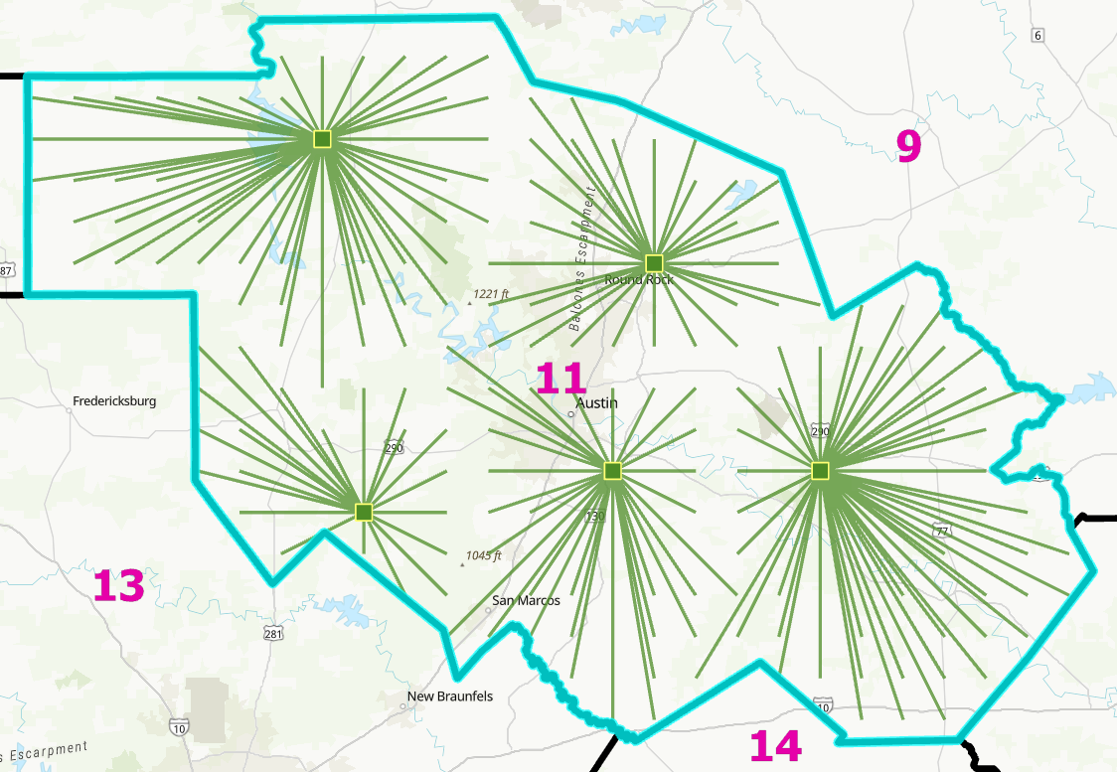
Figure A-11a: TCEQ region 11, 500 tpd facility scenario, 5 candidates

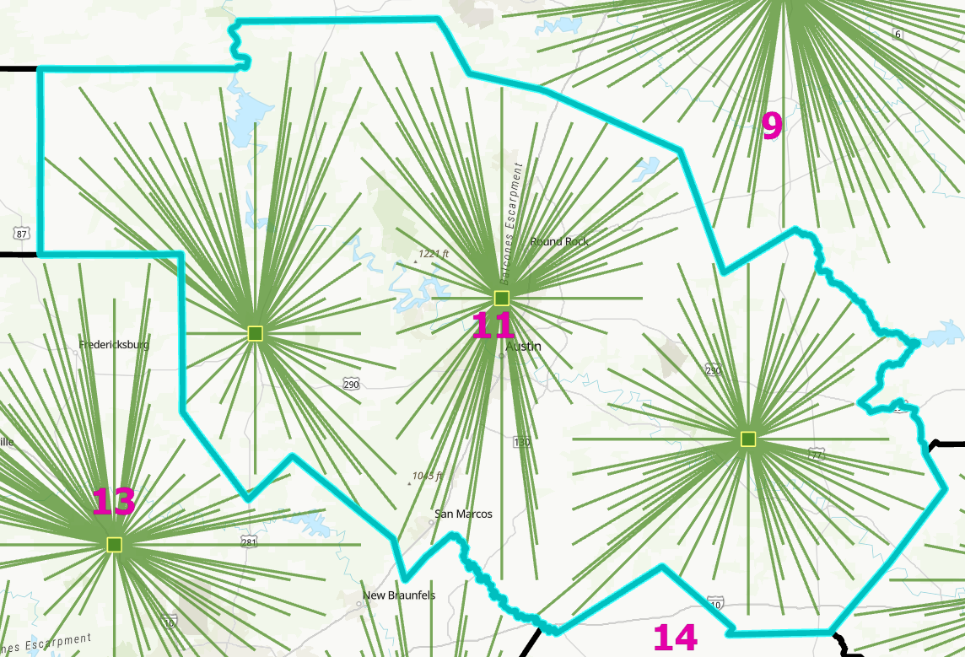
Figure A-11b: TCEQ region 11, 1,000 tpd facility scenario, 3 candidates

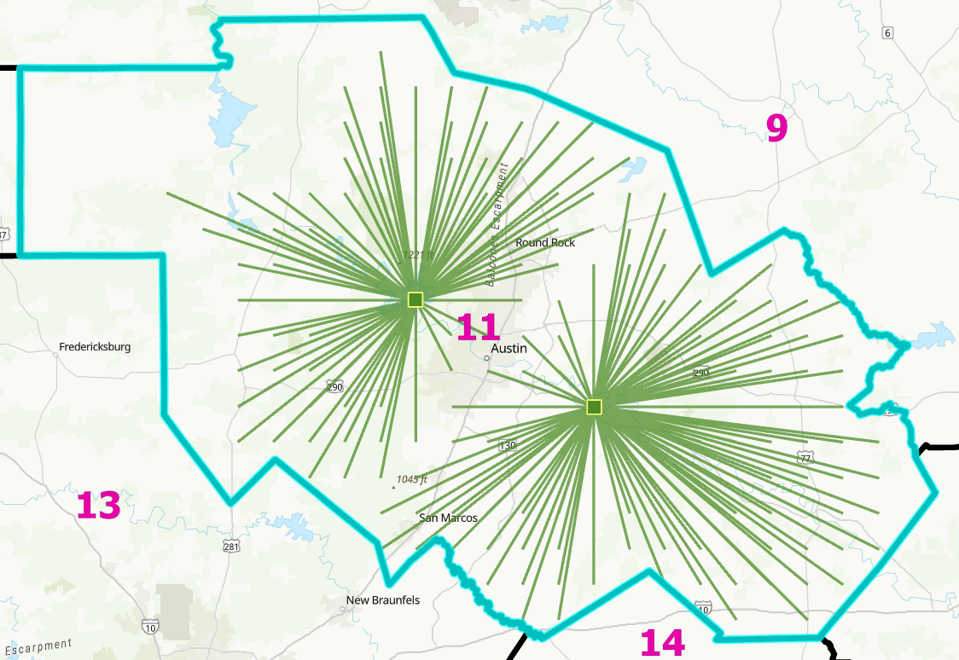
Figure A-11c: TCEQ region 11, 1,500 tpd facility scenario, 2 candidates

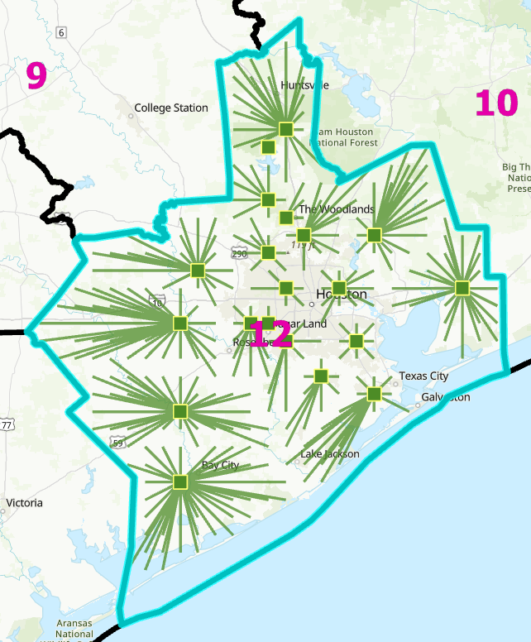
Figure A-12a: TCEQ region 12, 500 tpd facility scenario, 20 candidates

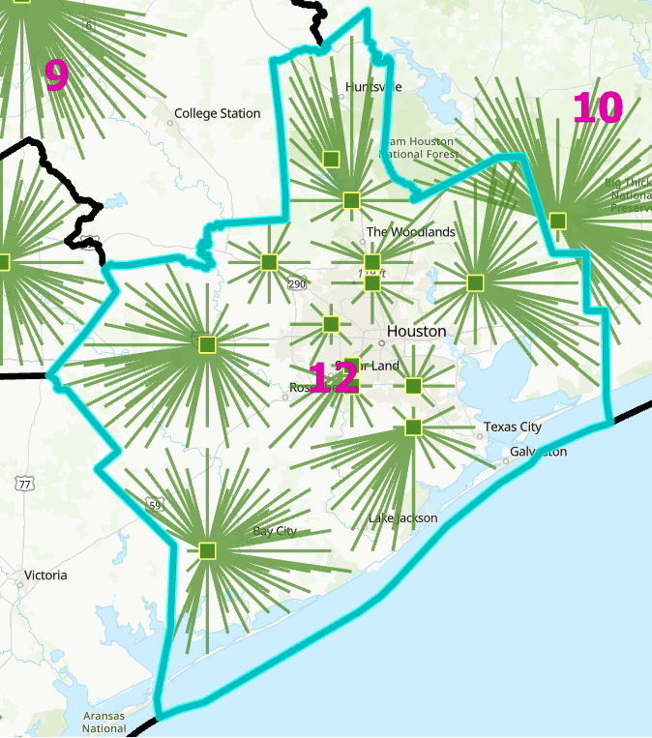
Figure A-12b: TCEQ region 12, 1,000 tpd facility scenario, 13 candidates

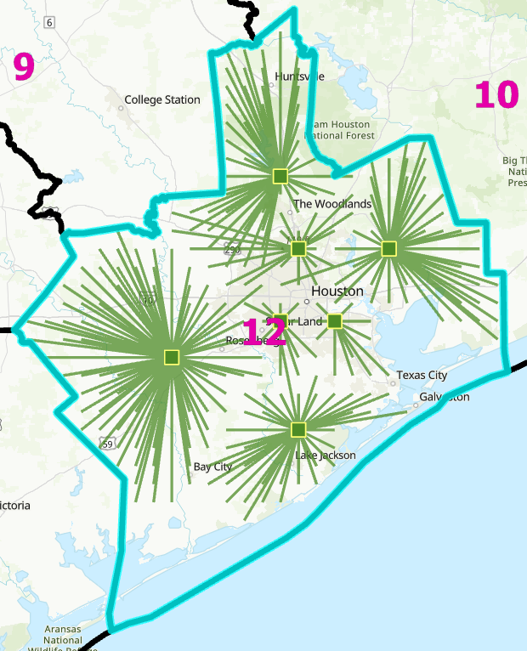
Figure A-12c: TCEQ region 12, 1,500 tpd facility scenario, 7 candidates

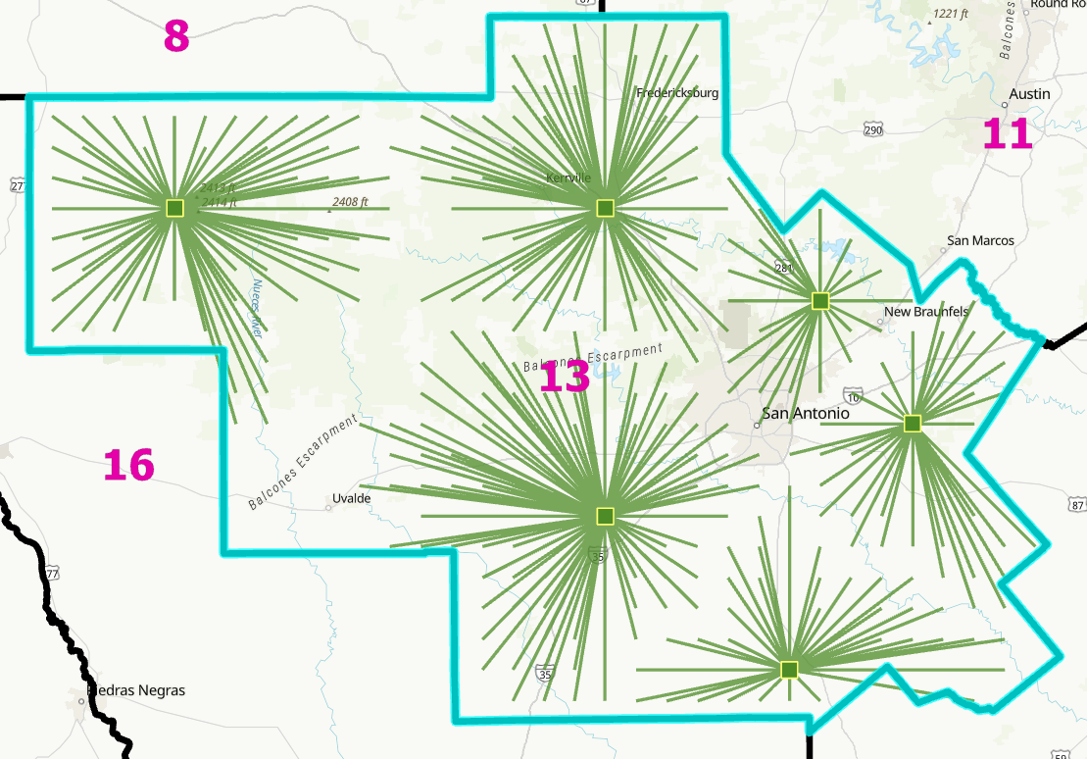
Figure A-13a: TCEQ region 13, 500 tpd facility scenario, 6 candidates

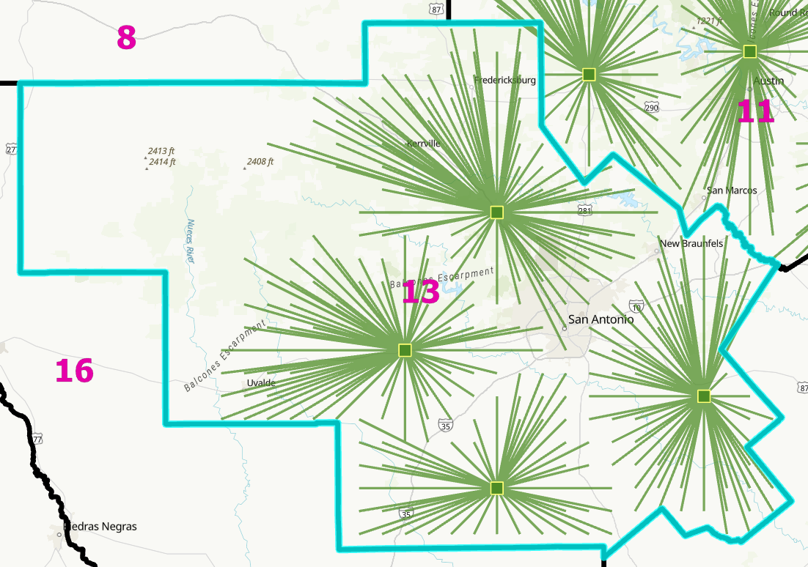
Figure A-13b: TCEQ region 13, 1,000 tpd facility scenario, 4 candidates

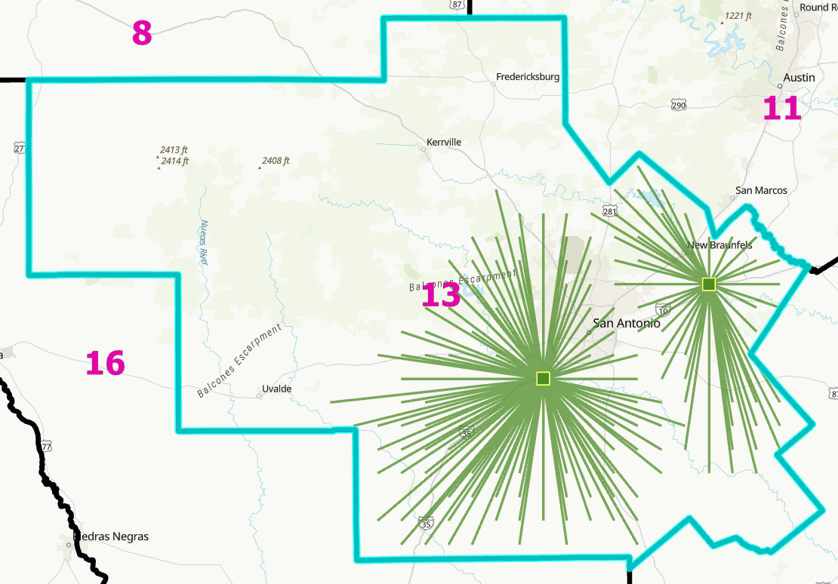
Figure A-13c: TCEQ region 13, 1,500 tpd facility scenario, 2 candidates

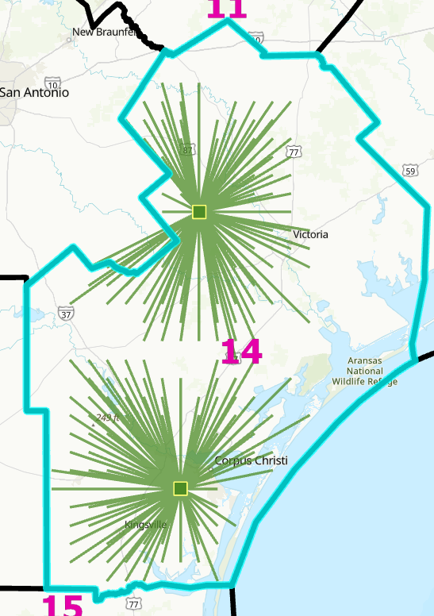
Figure A-14a: TCEQ region 14, 500 tpd facility scenario, 2 candidates

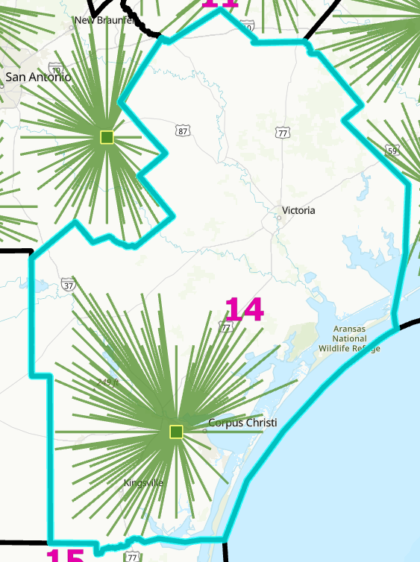
Figure A-14b: TCEQ region 14, 1,000/1,500 tpd facility scenarios, 1 candidate

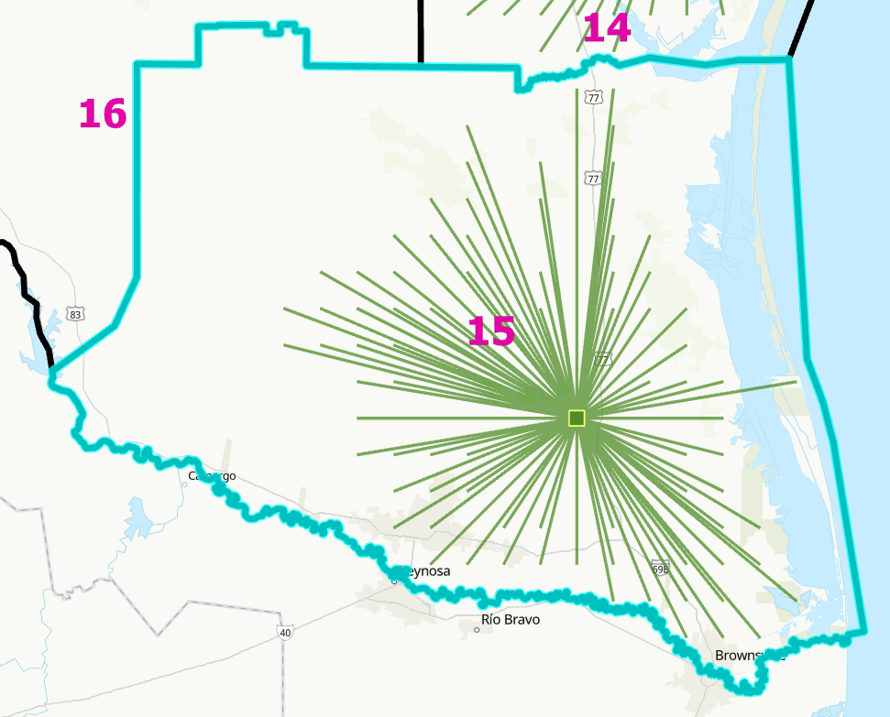
Figure A-15: TCEQ region 15, 500/1,000/1,500 tpd facility scenarios, 1 candidate
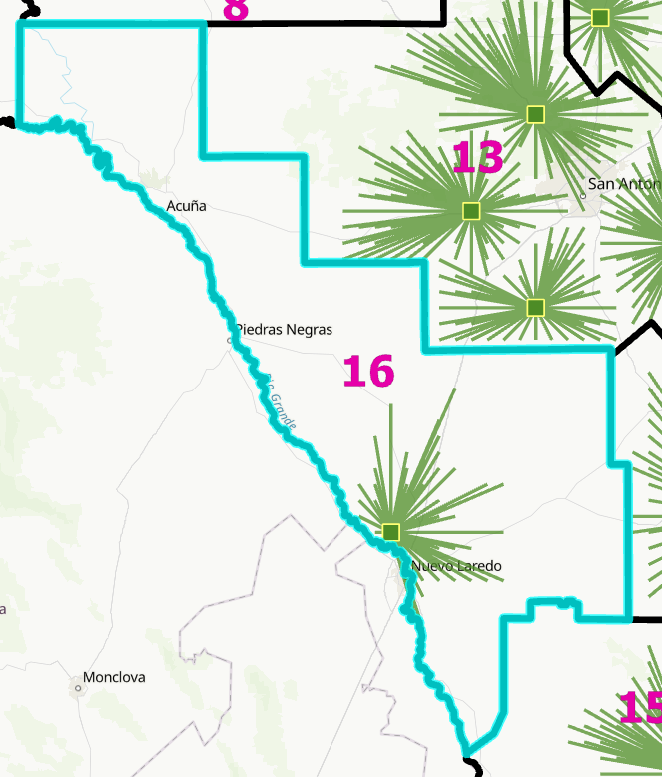
Figure A-16: TCEQ region 16, 500/1,000/1,500 tpd facility scenarios, 1 candidate

Table A1: Proposed scenario facility capacity and coordinates (in decimal degree WGS 1984)
Region | Proposed Number of Recycling Facility | Facility Capacity (stpd/mtpd) | X coordinate | Y coordinate
02 | 1 | 1,000/907.2 | -101.84459 | 33.639
04 | 1 | 1,500/1,360.8 | -97.836401 | 32.54631
04 | 2 | 1,500/1,360.8 | -96.81017 | 32.54615
04 | 3 | 1,500/1,360.8 | -96.623322 | 32.70252
04 | 4 | 1,500/1,360.8 | -96.90333 | 32.93795
04 | 5 | 1,500/1,360.8 | -97.27351 | 33.09307
04 | 6 | 1,500/1,360.8 | -96.530938 | 33.63698
07 | 1 | 1,000/907.2 | -102.21749 | 31.91525
09 | 1 | 1,000/907.2 | -96.993523 | 31.12208
10 | 1 | 500/453.6 | -94.106658 | 30.07685
10 | 2 | 500/453.6 | -95.135052 | 30.80789
11 | 1 | 1,500/1,360.8 | -94.106658 | 30.07685
11 | 2 | 1,500/1,360.8 | -95.135052 | 30.80789
12 | 1 | 1,500/1,360.8 | -95.411765 | 29.18504
12 | 2 | 1,500/1,360.8 | -96.06531 | 29.50845
12 | 3 | 1,500/1,360.8 | -95.504997 | 29.67247
12 | 4 | 1,500/1,360.8 | -95.225319 | 29.67254
12 | 5 | 1,500/1,360.8 | -95.411773 | 29.99655
12 | 6 | 1,500/1,360.8 | -94.948951 | 30.00037
12 | 7 | 1,500/1,360.8 | -95.505024 | 30.31835
13 | 1 | 1,000/907.2 | -98.68034 | 29.26971
13 | 2 | 1,000/907.2 | -98.022125 | 29.59026
14 | 1 | 500/453.6 | -97.555884 | 27.7844

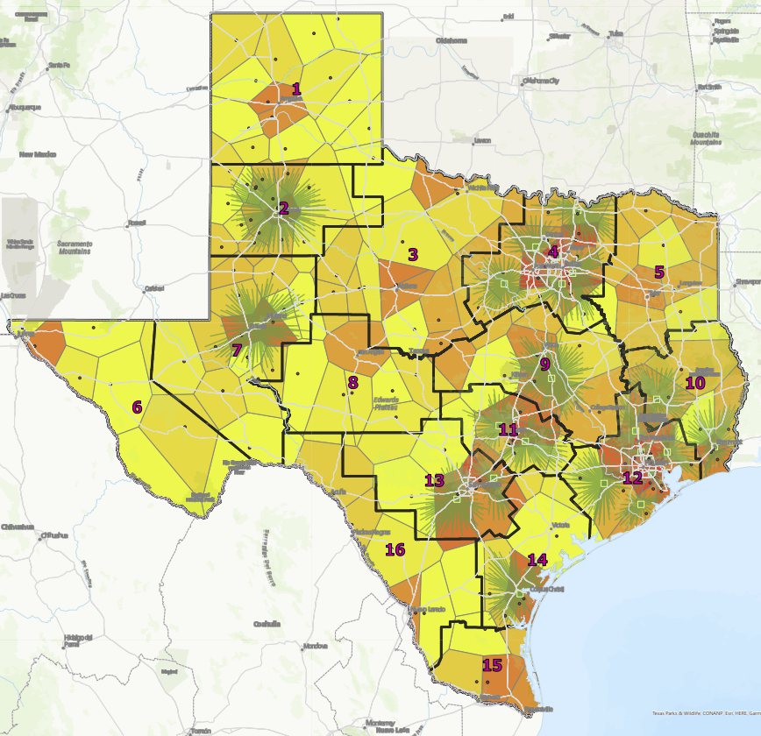
Figure 9: The optimized 23-facility siting scenario, showing facility placement and service areas. Waste density depicted by Thiessen polygon coloration from pale (low density) to dark (high density). Facility location matches estimated regional waste availability.

