Supplementary Figure – Full Uncropped Gels and Blots

Uncropped western blot membranes used to prepare Fig. 4A.
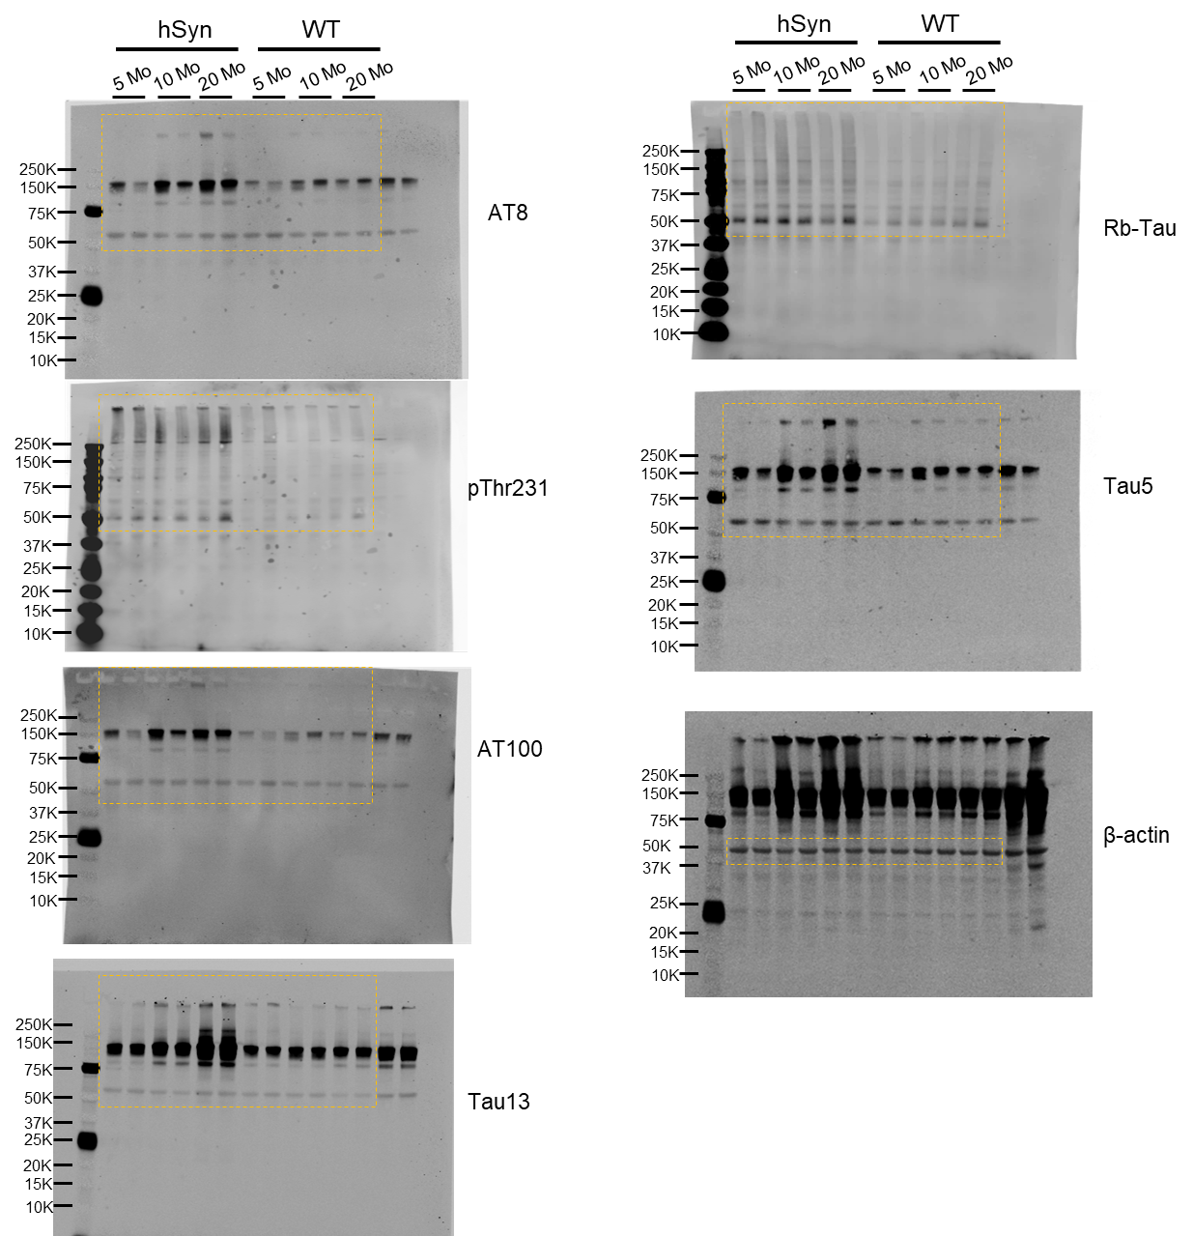

Uncropped western blot membranes used to prepare Fig. 5B.
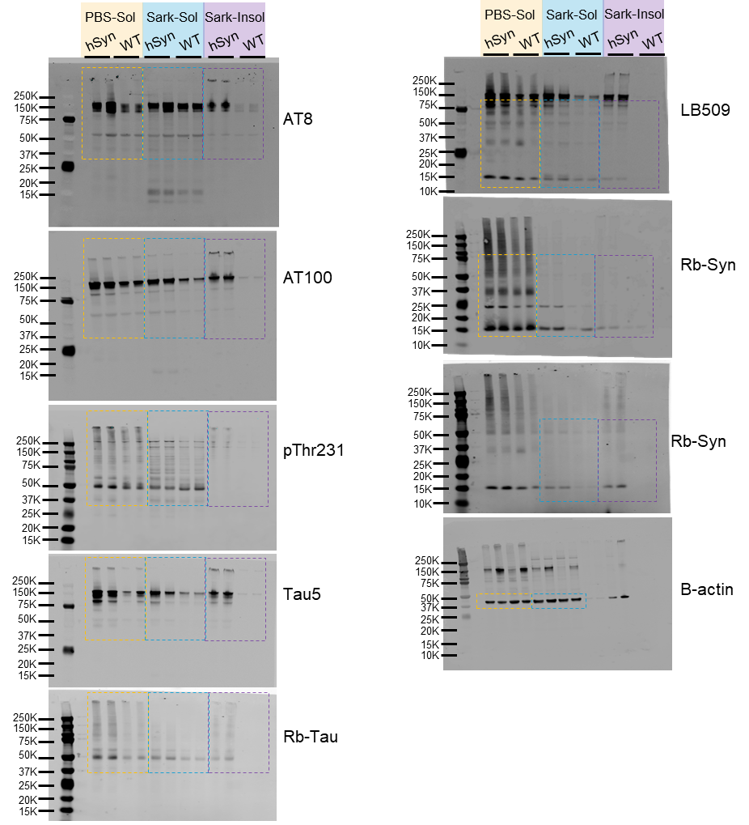

Uncropped Filter trap membranes used to prepare Fig. 5C.
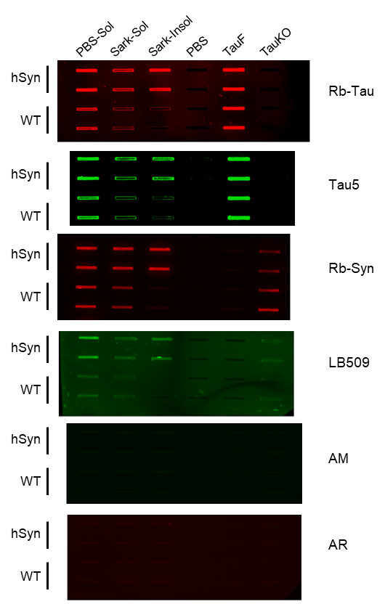

Uncropped Western blot membranes used to prepare supplementary Fig. S1A.
