Supplementary Information

Human Wild-Type α-Synuclein Drives Progressive Tau Pathology in a Disease-Relevant Mouse Model of Synucleinopathy.

Sudipta Senapati^{1,2}, Alessia Sciortino^{1,2}, Madison Samples^{1,2}, Nikita Shchankin^{1,2}, Yingxin Zhao³, Mauro Montalbano^{1,2} and Rakez Kayed^{1,2}*

¹Mitchell Center for Neurodegenerative Diseases, University of Texas Medical Branch, Galveston, Texas, USA; ²Departments of Neurology, Neuroscience and Cell Biology, University of Texas Medical Branch, Galveston, Texas, USA; ³Sealy Center for Molecular Medicine, University of Texas Medical Branch, Galveston, Texas, USA

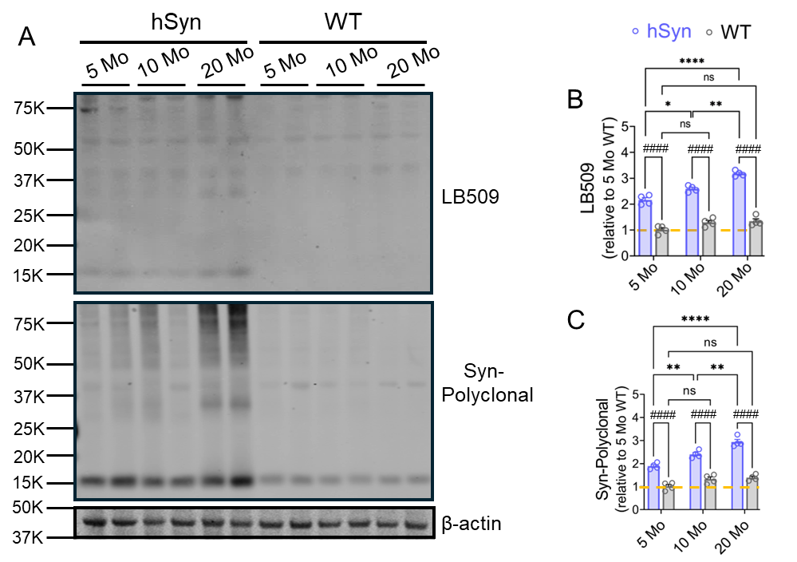

Fig. S1: hSyn transgenic mice expressing WT human α-Syn under the direction of the Thy-1 promoter exhibit α-Syn pathology. (A) Western blot analysis of PBS-soluble brain homogenates from 5-, 10- and 20-month-old hSyn Tg and WT littermates with LB509, and rabbit polyclonal α-Syn antibodies. (B-C) Quantification of α-Syn levels using LB509 and Rb-polyclonal synuclein antibodies. Bar graphs represent mean ± SEM. Statistical analyses were performed using two-way ANOVA with Tukey's post-hoc test (*p < 0.05, **p < 0.01, ***p < 0.001, ***p < 0.0001 for age-dependent comparisons within the same group; ####p < 0.0001 for comparisons between hSyn and WT littermates).

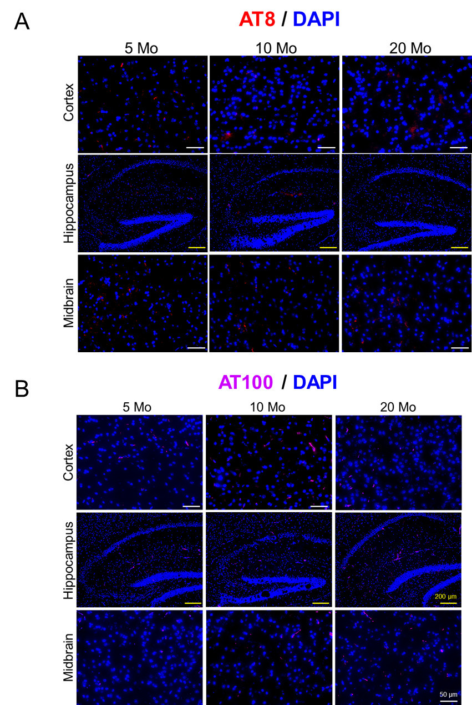
Figure S2: Representative immunofluorescence images of AT8 and AT100 immunoreactivities in 5-, 10- and 20-month-old WT controls in cortex, hippocampus, and midbrain.

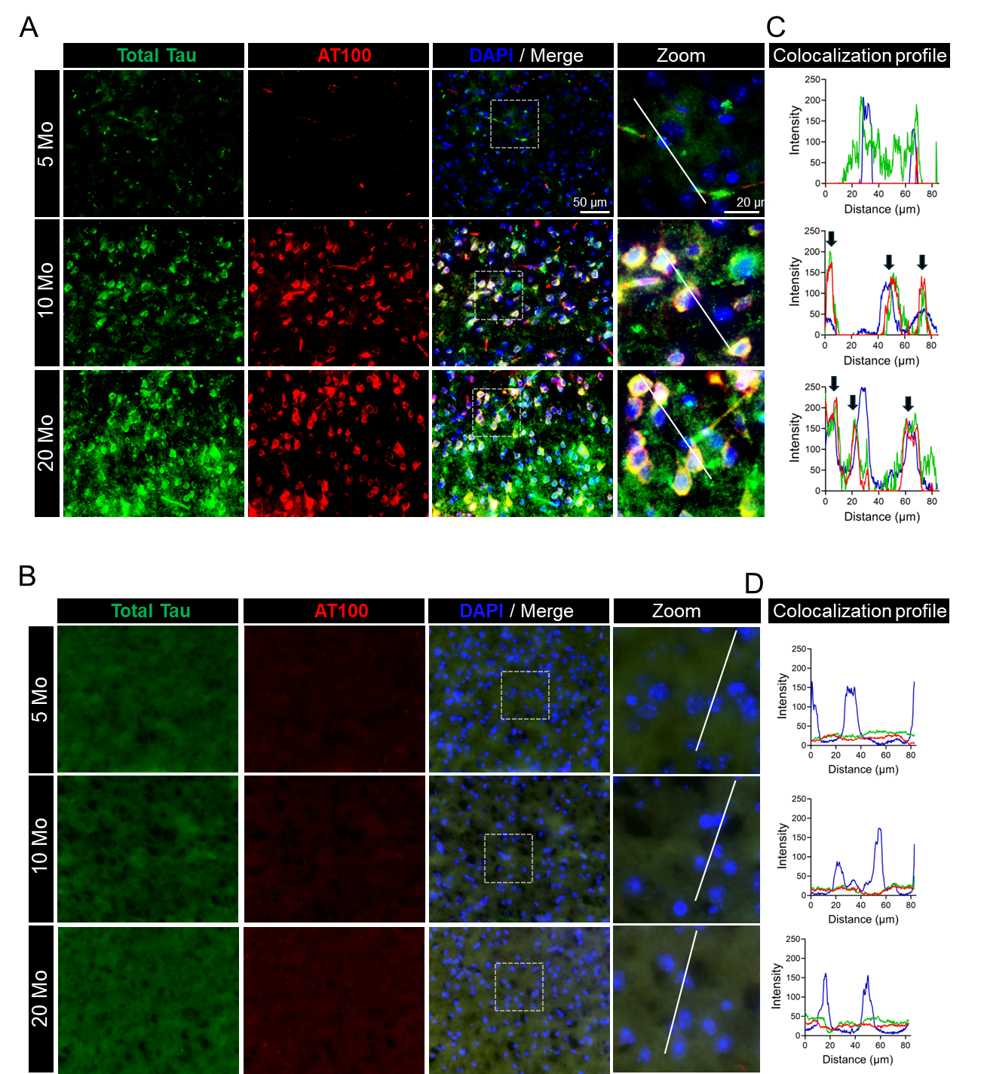
Fig. S3: Colocalization of hyperphosphorylated tau with total tau in hSyn mice. (A, B) Representative co-immunofluorescence images of hSyn and WT mice cortex showing hyperphosphorylated tau (AT100, red) colocalize with total tau (chicken-polyclonal tau, green), with DAPI staining for nuclei (blue). Scale bars: 50 μm; 20 μm for zoomed-in images. (C, D) Intensity profiles of colocalization of AT100 (red), chicken-polyclonal tau (green) and DAPI (blue) along an 82 μm segment (indicated by white lines), analyzed using ImageJ software. Significant colocalization of hyperphosphorylated tau (AT100, red) with chicken polyclonal tau (green) is evident in 10- and 20-month-old hSyn mice (black arrows), compared to younger (5-month-old) mice and age-matched WT controls, which show minimal colocalization and lack substantial hyperphosphorylated tau.
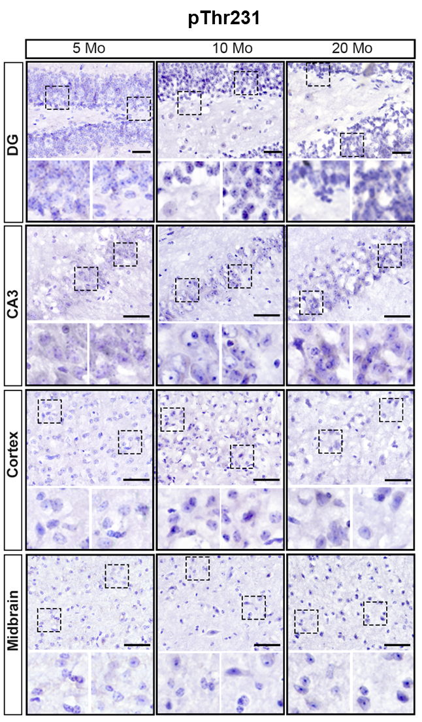
Fig. S4: Representative images of immunohistochemistry staining for hyperphosphorylated tau (pThr231) in different brain regions of 5-, 10- and 20-month-old WT animals.

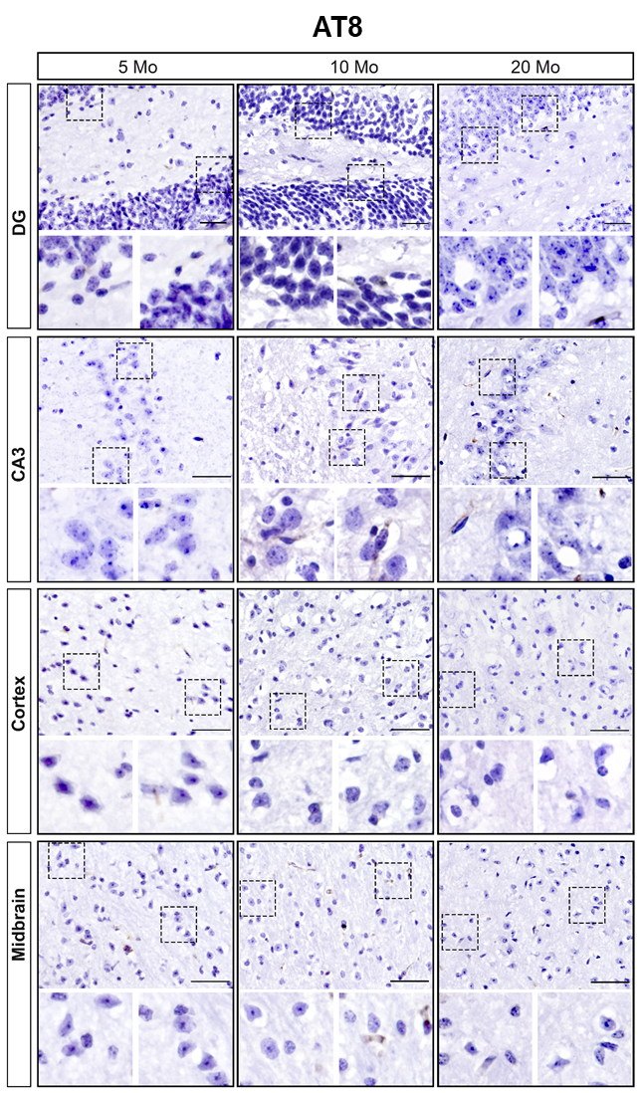
Fig. S5: Representative images of immunohistochemistry staining for hyperphosphorylated tau (AT8) in different brain regions of 5-, 10- and 20-month-old WT animals.

