SUPPLEMENTARY INFORMATION FOR:
“Improving maternal bonding through Real-time fMRI Neurofeedback in Mothers with Postpartum Bonding Problems”

SUPPLEMENTARY RESULTS

Neural activation in target regions during the three rt-fMRI-NFB sessions
Across the three neurofeedback (NFB) sessions (mean activity in ROI analyses) on a descriptive level, participants in the VS group showed stronger activation in the target VS region compared to the ACC group, while the ACC group exhibited stronger activation in the ACC region. However, these group differences did not reach any statistical significance (see Fig. S1 and Table S1, only for visualization purpose). Not interpretation should be drawn from these results.

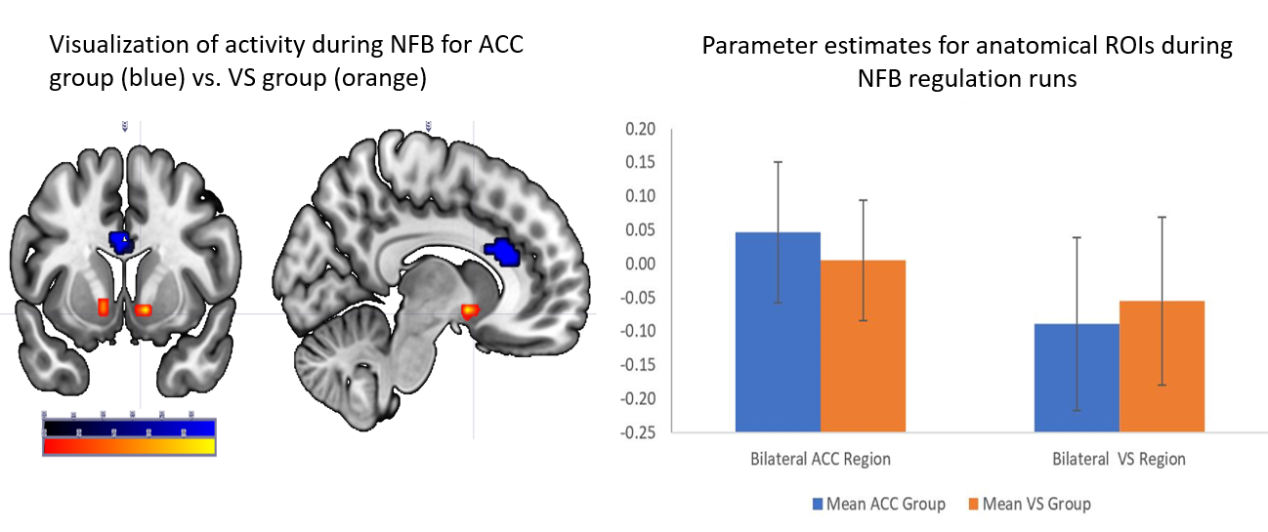
Supplementary Figure S1. Visualization of brain activity during NFB training (mean of activity during NFB 1, NFB 2 and NFB 3; regulation phase > baseline) using anatomical ROI analyses for ACC and VS region, ACC > VS blue, VS > ACC orange.

Supplementary Table S1
Table S1 Descriptive pattern of neural activity during NFB
Mean activity in ACC ROI during all NFB Sessions for ACC group > VS group
Cluster p (FWE-corr) | Cluster size (voxels) | Cluster p (uncorr) | Peak p (FWE-corr) | T-value | Z-value | Peak p (uncorr) | x (MNI) | y (MNI) | z (MNI) | Hemisphere
0,999 | 34 | 1 | 1,000 | 0,40 | 0,54 | 0,294 | -3 | 29 | -3 | L
 |  |  | 1,000 | 0,39 | 0,54 | 0,296 | 9 | 29 | 9 | R
0,999 | 1 | 1 | 1,000 | 0,04 | 0,30 | 0,383 | -9 | 32 | 20 | L
Mean activity in VS ROI during all NFB Sessions for VS group > ACC group

Cluster p (FWE-corr) | Cluster size (voxels) | Cluster p (uncorr) | Peak p (FWE-corr) | T-value | Z-value | Peak p (uncorr) | x (MNI) | y (MNI) | z (MNI) | Hemisphere
0,999 | 24 | 1 | 1,000 | 2,07 | 1,99 | 0,023 | 12 | 5 | -10 | R
 |  |  | 1,000 | 0,72 | 0,80 | 0,213 | 6 | 14 | -1 | R
0,999 | 40 | 1 | 1 | 1,79 | 1,74 | 0,041 | -12 | 5 | -10 | L
 |  |  | 1,000 | 0,14 | 0,36 | 0,359 | -18 | 17 | -7 | L
Notes: FWE, family-wise error; uncorr, uncorrected. Coordinates are in MNI space (mm). Cluster-level significance assessed at FWE-corrected p<0.05; peak-level p-values reported for local maxima. Hemisphere: L = left, R = right.
Statistical parametric maps for the contrast mean [NFB regulation blocks > baseline] comparing the VS and ACC groups.

