Therapeutic-scale CAR-NK microrobots with programmable swarm navigation for targeted solid tumour therapy

Authors
Zhiguang Wu^{1,2,#,*}, Yalin Wang^{1,2,#}, Hongyue Zhang^{1,3,#}, Xinjian Fan^{4,#}, Mingtong Li^{5,#}, Zesheng Li^{1,3}, Gongzi Zhang⁶, Jialin Wang⁷, Yumeng Lu¹, Hongda Wang¹, Yuxin Jia⁸, Hongri Gu⁹, Tan He¹⁰, Jiawei Tian¹¹, Ximing Sun¹¹, Hui Xie^{2*}, Lihai Zhang^{6*}, Metin Sitti^{5,12*}, Jie Zhao^{2,*}

Affiliations
¹ School of School of Medicine and Health, Harbin Institute of Technology, Harbin 150001, China
² State Key Laboratory of Robotics and System, Harbin Institute of Technology, Harbin 150001, China
³ Laboratory for Space Environment and Physical Sciences, Harbin Institute of Technology, Harbin 150001, China
⁴ School of Mechanical and Electrical Engineering, Soochow University, Suzhou 215131, China
⁵ Physical Intelligence Department, Max Planck Institute for Intelligent Systems, Stuttgart 70569, Germany
⁶ China Department of Orthopedics, Chinese PLA General Hospital, Beijing 100141, China
⁷ Department of Science, Computer Science, University of Alberta, Edmonton T6G 2R3, Canada
⁸ Department of Mathematics, Imperial College London, London SW7 2AZ United Kingdom
⁹ Division of Integrated System and Design, Hong Kong University of Science and Technology, Hong Kong 999077, China
¹⁰ Comprehensive Cancer Centre, Denmark Hill Campus, King’s College London, London SE5 9NU, United Kingdom
¹¹ School of Future Technology, Harbin Institute of Technology, Harbin 150001, China
¹² School of Medicine and College of Engineering, Koç University, 34450 Istanbul, Turkey

#These authors contributed equally.
†Correspondence: zhiguangwu@hit.edu.cn; xiehui@hit.edu.cn; zhanglihai74@qq.com; sitti@is.mpg.de; jzhao@hit.edu.cn

SUPPLEMENTARY MATERIALS

Fig. S1. Design of CAR DNA plasmid for the CAR NK microrobots.
Fig. S2. Design and assembly of the hybrid magnetic actuation system
Fig. S3. Safety evaluation of CAR-NK microrobots
Movie S1. Chemotactic motion of CAR-NK microrobots
Movie S2. Tracking and cytotoxicity of CAR-NK microrobots toward tumor cells
Movie S3. Motion of CAR-NK microrobots upon gradient magnetic field, rotating magnetic field with uniform intensity, and rotating gradient magnetic field in 8 s
Movie S4. Controllable motion of CAR-NK microrobots though manipulation of magnetic field
Movie S5. Vortex-like and ribbon-like swarm of CAR-NK microrobots upon rotating gradient magnetic field
Movie S6. Transformation of multimode swarm of CAR-NK microrobots
Movie S7. Long distance swarm migration of CAR-NK microrobots upon robotic-arm-assisted rotating gradient magnetic field input of vortex swarm
Movie S8. Large area coverage of CAR-NK microrobots upon robotic-arm-assisted rotating gradient magnetic field input of ribbon swarm

SUPPLEMENTARY METHODS

Establishment of the magnetic actuation system
The magnetic actuation system tailored for multi-modal control over a substantial ensemble of microrobots. This system capitalizes on a synergistic integration of permanent magnets and electromagnetic coils, culminating in a design that is both compact and eﬃcient. Furthermore, the configuration includes a semi-open workspace, which enhances the ease of integration for experimental samples, as shown in Fig. S2.
The magnetic actuation platform incorporates a quartet of electromagnetic coils, strategically positioned at a 45-degree angular orientation with an upward inclination of 35.3 degrees. The axes of these coils converge at the nucleus of a spherical magnetic object, which possesses a diameter of 25 mm, situated centrally. This sphere is housed within a three-dimensional printed, concave support structure, ingeniously designed to confine the sphere’s rotational mobility exclusively along a predetermined axis. A layer comprising spherical copper elements, each with a diameter of 2 mm, is tactically deployed within the support structure to diminish frictional resistance and augment responsiveness to the induced magnetic fields.
A sophisticated control unit comprises a personal computer (PC) equipped with an Intel Core i7 processor and 16 GB of RAM. The control mechanism is orchestrated via a LabVIEW-based application, which serves as the user interface, translates input from a joystick into actionable control signals, and oversees data interchange with the data acquisition module (DAQ). Dual direct current (DC) power supplies, each capable of outputting 10 A and up to 500 W, furnish the requisite energy for the operation of the coils. Additionally, four bespoke power amplifiers, capable of reaching a peak voltage of 65 V and sustaining a load current of 4 A, enhance the control signals emanating from the DAQ module prior to their transmission to the coils. To broaden the operational domain and refine the system’s proficiency in precise attitude and trajectory modulation, an open source AR4 robotic arm is integrated into the assembly.

Control methods of the magnetic field
The fundamental principle underpinning the hybrid magnetic actuation system is the intrinsic propensity of a magnetic sphere to align its magnetization direction with an externally applied magnetic field. This alignment, driven by magnetic torque, ensures that the sphere follows the dynamic rotations of the external magnetic field, maintaining a constant angular displacement that does not exceed 90◦ within the operational workspace. Precise programming of the current profiles in the four electromagnetic coils facilitates the generation of an overlapping magnetic field. This configuration permits extensive and indirect control over the rotational dynamics of the magnetic sphere across any plane within the workspace, thereby enabling a fully controllable rotating magnetic field environment.
Considering a static configuration of electromagnets, each unit contributes a magnetic field that permeates the entire workspace and can be predetermined[1]. At any given point $P$ within this space, the resultant magnetic field from a particular electromagnet's activation is represented by the vector $B(P)$, where the field intensity is directly proportional to the current traversing the electromagnet. Besides, for air-core electromagnets, the contribution from each field is independent, permitting a total magnetic field calculation at point $P$ through the principle of linear superposition. Given the current matrix $i={\left[i_{1},i_{2},i_{3},i_{4}\right]}^{T}$ flowing through each coil (where $i_{k}$ represents the current in the k-th coil), the magnetic flux density at any point in the workspace $B(P)$ can be expressed by the equation:
$B(P)=β(P){\left[i_{1},i_{2},i_{3},i_{4}\right]}^{T}$ (1)
Where $β(P)={\left[\begin{matrix}B_{1}(P) & B_{2}(P) & B_{3}(P) & B_{4}(P)\end{matrix}\right]}^{T}$. Next, to synthesize a specified magnetic field at an arbitrary spatial location, the requisite currents for each coil are deduced by first inverting the contribution matrix $β(P)$, followed by its subsequent multiplication with the vector representing the target magnetic field. Consequently, the requisite current vector $i$ necessary to establish the desired magnetic field configuration is expressed as:
$i=β(P)^{†}B(P)$ (2)
Here, the superscript $^{†}$ denotes the pseudo-inverse of the matrix in the context of this application. In our apparatus, the movement of the magnetic ball is confined by a concave support, which restrictively minimizes any deviations from the center, thereby maintaining the ball centrally within the quartet of coils. Accordingly, the magnetic influence of each coil on the ball is primarily a function of their respective spatial alignments, culminating in the matrix formulation:
$β(P)=k[[1,-1,-1,1],[1,1,-1,-1],[-1,-1,-1,-1]]$ (3)
where $k$ signifies the proportionality coefficient, determinable through empirical means. Under these operational conditions, the magnetic ball can be maneuvered along a predetermined trajectory with remarkable precision, in addition to being maintained in a specific position and orientation.

Dynamic modeling methods of microrobots
To elucidate the dynamics within swarms of microrobots, we conducted a series of theoretical simulations under certain simplifying premises. We disregarded forces induced by coils and inertial effects, and represented each microrobot as a point mass. The array of forces acting upon each microrobot encompasses: the magnetic force $F_{m}$ emanating from the stationary magnetic sphere, the resultant gravitational force $F_{G}$, the forces due to inter-robot interactions and boundary constraints $F_{s}$ and $F_{\text{rep }}$, the viscous drag $F_{d}$, and the magnetic interaction force $F_{mi}$ among the microrobots.
In alignment with the principles of the scallop theorem [2], within environments characterized by low Reynolds numbers, the viscous drag $F_{d}=6πr_{0}μv$-where $v$ is the velocity vector of the microrobot, and $μ$ is the dynamic viscosity of the medium (e.g., water)-counterbalances all other acting forces, rendering the microrobot in a state of dynamic equilibrium with zero net force. Consequently, the equation of motion for the microrobots is formalized as:
$\sum_{i=1,j≠i}^{N}{ }\left\{F_{m}(i,j)+F_{\text{rep }}(i,j)\right\}+F_{mi}+F_{G}+F_{s}=F_{d}$ (4)
Here, indices $i$ and $j$ denote distinct microrobots within the assembly, with $N$ representing the total number in the swarm. The net gravitational force is defined as $F_{G}=\frac{4πr_{0}^{3}}{3}gΔρ$, where $Δρ$ denotes the density differential between the microrobot and its ambient medium. The repulsive forces $F_{\text{rep }}$ and $F_{s}$, resulting from collisions between robots and interactions with substrates respectively, are depicted utilizing an ideal elastomer model: $F_{\text{rep }}=-K\left(d_{i,j}-2r_{0}\right),F_{s}=-K\left(z_{i}-r_{0}\right)$, where $z_{i}$ represents the vertical displacement of the microrobot from the substrate, $di,j$ is the inter-robot separation at contact, and $K$ denotes the robotic stiffness coefficient. Moreover, the force $F_{m}$ exerted on a magnetic dipole $m_{1}$ by another dipole $m_{2}$ is articulated as follows[3]:
$F_{m}=\frac{3μ_{0}}{4πr^{5}}\left[\left(m_{1}⋅r\right)m_{2}+\left(m_{2}⋅r\right)m_{1}+\left(m_{1}⋅m_{2}\right)r-\frac{5\left(m_{1}⋅r\right)\left(m_{2}⋅r\right)}{r^{2}}r\right]$ (5)
where $μ_{0}$ is the magnetic permeability of free space, and $r$ is the vector delineating the spatial distance between the robot.

Modeling methods of the magnetic field and force
The magnetic dipole approximation is frequently employed to simulate the magnetic fields generated by diminutive coils or permanent magnets. This model facilitates the evaluation of the intensity and orientation of the magnetic field or its gradient as engendered by a magnetic entity. Utilizing the dipole moment approximation, the magnetic field $B_{d}$ attributed to a dipole is quantified as follows[3]:
$B(r)_{d}=\frac{μ_{0}}{4π}\left(\frac{3m⋅r}{r^{5}}r-\frac{m}{r^{3}}\right)$ (6)
Moreover, when magnetic micro-robots are subjected to an external magnetic field, they typically experience both magnetic forces $F_{m}$ and torques $τ_{m}$. These vectors are extensively documented within the scholarly literature and are expressed by the following equations:
$\begin{matrix}F_{m}=\left[\begin{matrix}\frac{∂B_{x}}{∂x} & \frac{∂B_{x}}{∂y} & \frac{∂B_{x}}{∂z} \\ \frac{∂B_{x}}{∂y} & \frac{∂B_{y}}{∂y} & \frac{∂B_{y}}{∂z} \\ \frac{∂B_{x}}{∂z} & \frac{∂B_{F}}{∂z} & -\left(\frac{∂B_{x}}{∂x}+\frac{∂B_{y}}{∂y}\right)\end{matrix}\right]\left[\begin{matrix}m_{x} \\ m_{y} \\ m_{z}\end{matrix}\right] \\ \end{matrix}$ (7)
$τ_{m}=m×B=\left[\begin{matrix}0 & B_{z} & -B_{y} \\ -B_{z} & 0 & B_{x} \\ B_{y} & -B_{x} & 0\end{matrix}\right]\left[\begin{matrix}m_{x} \\ m_{y} \\ m_{z}\end{matrix}\right]$ (8)

Modeling methods of the fluidic field
To conduct a rigorous analysis of the flow field generated by the rotational dynamics of a microrobot, we employ the classical imaging technique. The velocity field $v$, resultant from a microrobot with radius $a$ rotating at an angular velocity $Ω$ in proximity to a stationary planar boundary, is quantified through the application of the tensorial formulation devised by Blake and Chwang[4]:
$$v=a^{3}\left[\frac{ϵ_{ijk}Ω_{j}{\overset{ˆ}{r}}_{k}}{|\overset{ˆ}{r}|^{3}}-\frac{γ_{ijk}Ω_{j}R_{k}}{|R|^{3}}+2hϵ_{kjz}Ω_{j}\left(\frac{δ_{ik}}{|R|^{3}}-\frac{3R_{i}R_{k}}{|R|^{5}}\right)+6ϵ_{kjz}\frac{Ω_{j}R_{i}R_{k}R_{z}}{|R|^{5}}\right]$$
Here, $\overset{ˆ}{r}=\sqrt{{\left(x-x_{1}\right)}^{2}+{\left(y-y_{1}\right)}^{2}+{\left(z-z_{1}\right)}^{2}}$ signifies the vector denoting the position relative to the center of the microrobot, $R=\sqrt{{\left(x-x_{1}\right)}^{2}+{\left(y-y_{1}\right)}^{2}+{\left(z+z_{1}\right)}^{2}}$ delineates the position vector of its image, with $\left(x_{1},y_{1},z_{1}\right)$ and ( $x,y,z$ ) representing the coordinates of the microrobot's center and the target location respectively. The symbol $ϵ$ represents the Levi-Civita tensor. In the regime where the Reynolds number $Re≪1$, the Stokes equations simplify to a linear form, thereby facilitating the utilization of the superposition principle. As a result, the aggregate fluid field engendered by an ensemble of microrobots can be expressed as the sum of individual vectorial contributions: $v_{\text{sum }}=∑_{i=1}^{N} v_{i}$.

References
- M. P. Kummer, J. J. Abbott, B. E. Kratochvil, R. Borer, A. Sengul, B. J. Nelson, OctoMag: An electromagnetic system for 5-DOF wireless micromanipulation. IEEE T. Robot. 26, 1006-1017, (2010).
- E. M. Purcell, Life at low Reynolds number, Amer. J. Phys., 45, 3-11, (1977).
- J. J. Abbott, E. Diller, A. J. Petruska, Magnetic methods in robotics. Annu. Rev. Control Robot. Autom. Syst. 3, 57-90, (2020).

SUPPLEMENTARY FIGURES

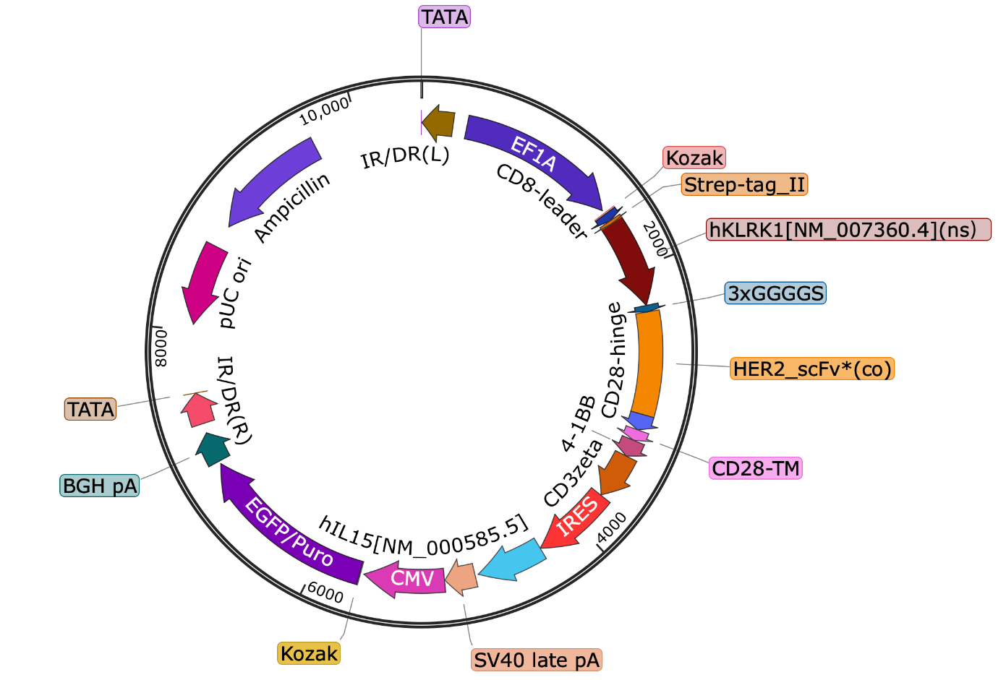
Fig. S1. Design of CAR DNA plasmid for CAR-NK microrobots.

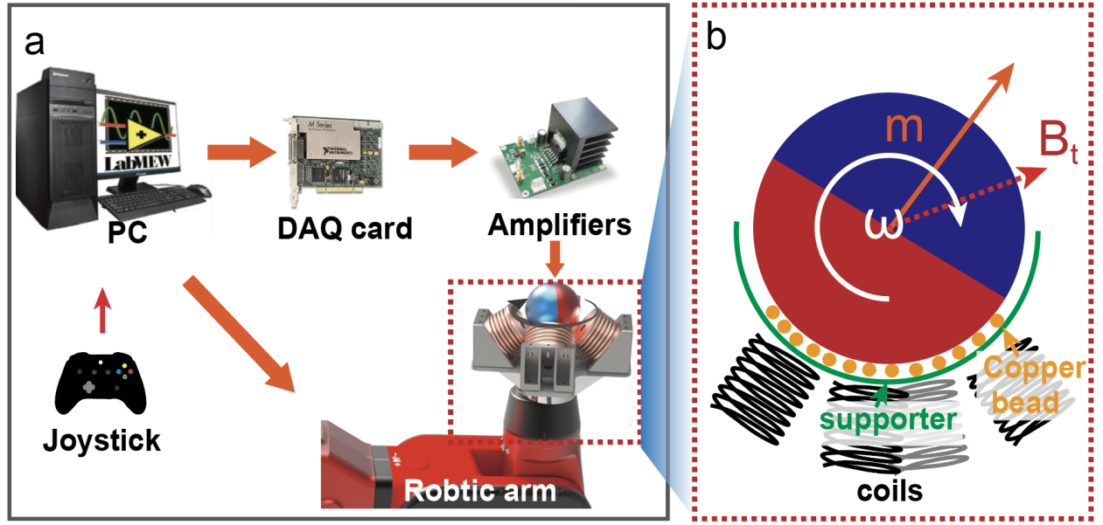

Fig. S2. Design and assembly of the hybrid magnetic actuation system. (a) Hardware configuration and operational principle: This sub-figure delineates the compositional elements and operational ethos of the hybrid magnetic actuation system. (b) Structure and assembly scheme of the magnetic field generation module: This sub-figure elucidates the intricate structure and systematic assembly protocol of the magnetic field generation module. The red dotted arrow indicates the background magnetic field produced by the coil, while the red solid arrow denotes the magnetization direction of the magnetic ball. The white arrow illustrates the rotational direction of the magnetic ball, as induced by the dynamic magnetic field.

Fig. S3. Safety evaluation of CAR-NK microrobots though the histology analysis for brain, heart, liver, spleen, lung, and kidney, which were collected from tumor mice treated with different formulations. These organs were separated from the treated tumor-bearing mice after intracranial injection of tumour cells for 25 days. Scale bar, 50 μm.

