SUPPLEMENTARY MATERIALS
The following Supporting Information is available for this article:
Supplementary Table S1, S2, S3; Figure S1, S2, S3, S4, S5, S6, S7

Table S1. The spring and summer biases were calculated for correlations between daily, weekly, and biweekly GPP and NIR_{v}P, SIF, and PRI in 2020.

Proxies |  | Spring biases |  |  |  | Summer biases
 |  |  | Daily | Weekly | Biweekly | Daily | Weekly | Biweekly
NIR_{v}P  SIF  PRI |  | 0.411 |  | 0.318 | 0.398 | -0.514 | -0.454 | -0.401
 |  | 0.622 |  | 0.153 | -0.008 | -0.602 | -0.165 | 0
 |  | 0.579 |  | 0.480 | 0.453 | -0.496 | -0.387 | -0.297

Table S2. The spring and summer biases were calculated for correlations between daily, weekly, and biweekly GPP and NIR_{v}P, SIF, and PRI in 2019.

Proxies |  | Spring biases |  |  |  | Summer biases
 |  |  | Daily | Weekly | Biweekly | Daily | Weekly | Biweekly
NIR_{v}P  SIF  PRI |  | -0.07 |  | -0.14 | -0.21 | 0.06 | -0.04 | -0.05
 |  | -1.88 |  | -1.20 | -0.85 | 2.12 | 1.03 | 0.87
 |  | -2.09 |  | -1.91 | -1.99 | 3.24 | 3.12 | 2.84

Table S3. The spring and summer biases were calculated for correlations between daily, weekly and biweekly LUE and NIR_{v}P, SIF_{r}, and PRI in 2020.

Proxies |  | Spring biases |  |  |  | Summer biases
 |  |  | Daily | Weekly | Biweekly | Daily | Weekly | Biweekly
NIR_{v}P  SIF_{r}  PRI |  | 8.8e-05 |  | 1.69e-04 | 2.12e-04 | -1.63e-04 | -2.52e-04 | -2.08e-04
 |  | 3.95e-04 |  | 1.53e-04 | 8.3e-05 | -3.98e-04 | -1.01e-04 | -2.1e-05
 |  | 2.46e-04 |  | 2.28e-04 | 2.17e-04 | -1.88e-04 | -1.93e-04 | -1.34e-04

Fig. S1 The monthly (A) mean Tair (air temperature) over April to October, and (B) mean precipitation over April to October in 2019 (green) and 2020 (red), as well as overall monthly means in the period of 2010-2020 (black) at US-Wkg site.
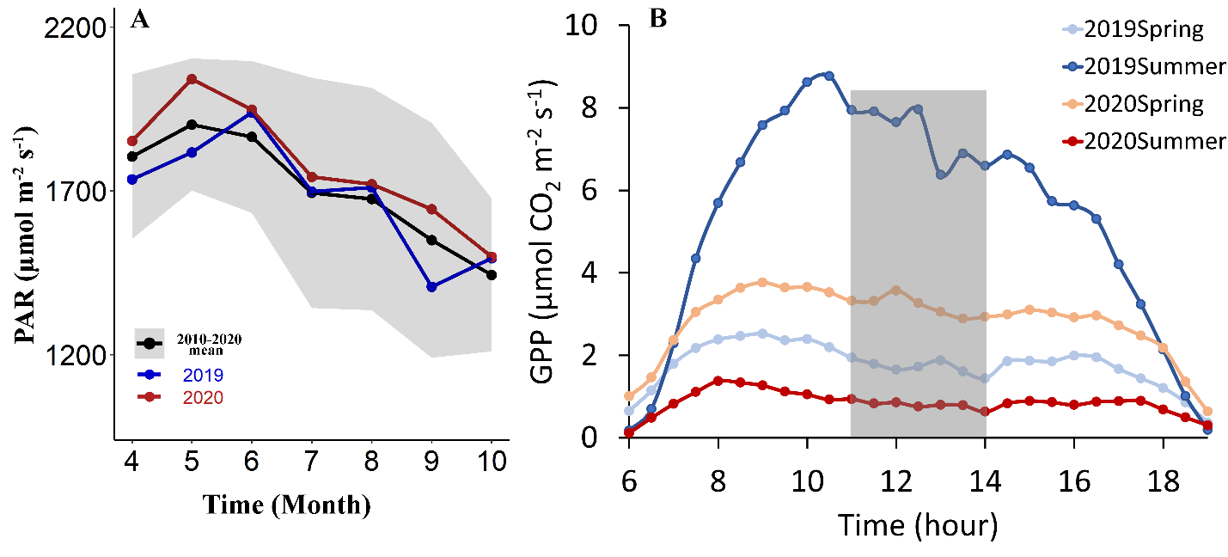

Fig. S2 (A) Monthly PAR (photosynthetically active radiation) over two growing seasons (April to October) in 2019 (blue) and 2020 (red), as well as overall monthly means during 2010-2020 (black) at US-Wkg. The shaded area represents the mean ± one standard deviation. (B) Diurnal GPP dynamics from 6:00 to 19:00 for spring and summer of both 2019 and 2020.
Fig. S3 The number of days with no or low-quality data from 11:00 to 14:00 in each month from April to October of 2019 and 2020.
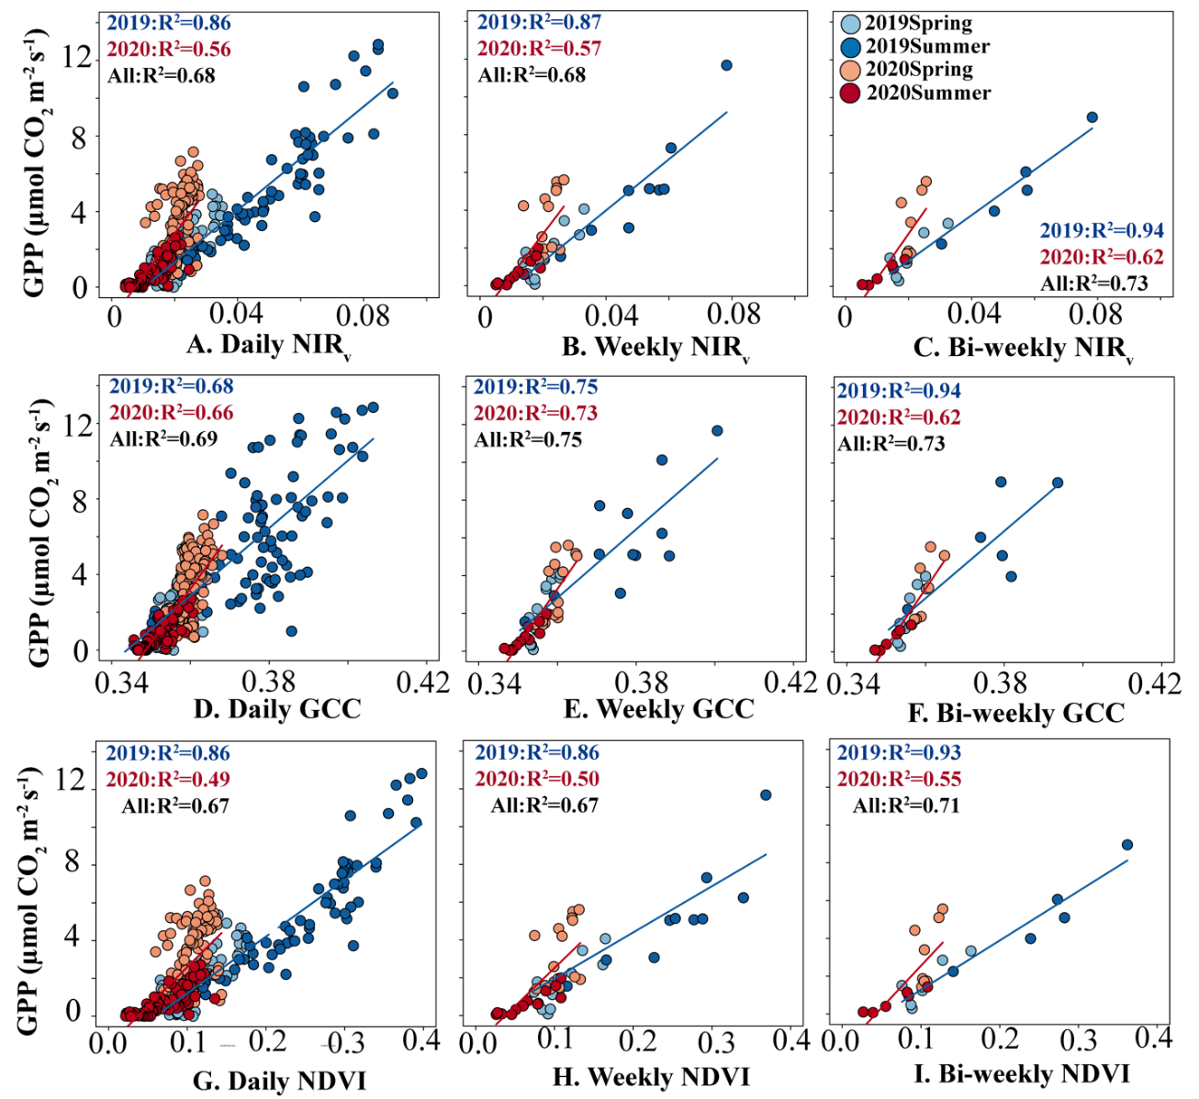

Fig. S4. Comparisons between EC GPP (µmol CO₂ m⁻² s⁻¹) and (A-C) NIR_{v} (µmol m⁻² s⁻¹), (D-F) GCC, (G-I) NDVI at daily, weekly, and biweekly scales over two growing seasons (April to October) in 2019 spring (April to July, light blue), 2019 summer (August to October, dark blue) and 2020 spring (April to July, light red), 2020 summer (August to October, dark red). The blue lines are the fitted linear regression models between GPP and the two indices in 2019, and the red lines are the fitted models in 2020.
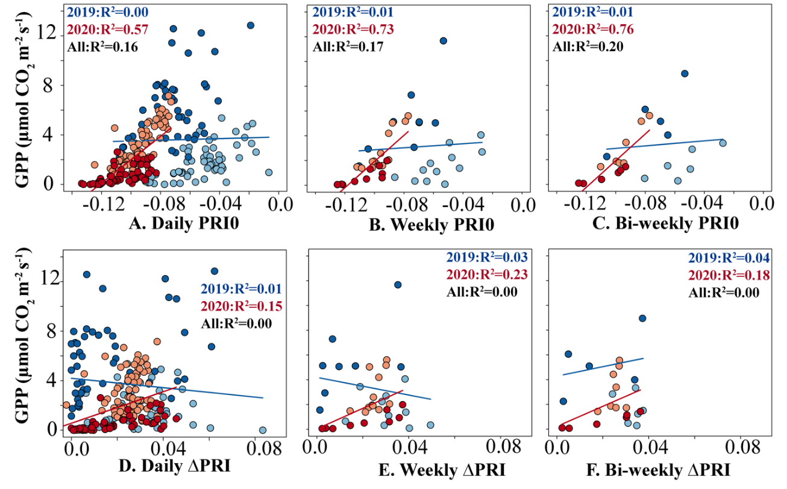

Fig. S5. Comparisons between EC GPP (µmol CO₂ m⁻² s⁻¹) and (A-C) PRI₀, and (D-F) ∆PRI at daily, weekly, and biweekly scales over two growing seasons (April to October) in 2019 spring (April to July, light blue), 2019 summer (August to October, dark blue) and 2020 spring (April to July, light red), 2020 summer (August to October, dark red). The blue lines are the fitted linear regression models between GPP and the two indices in 2019, and the red lines are the fitted models in 2020

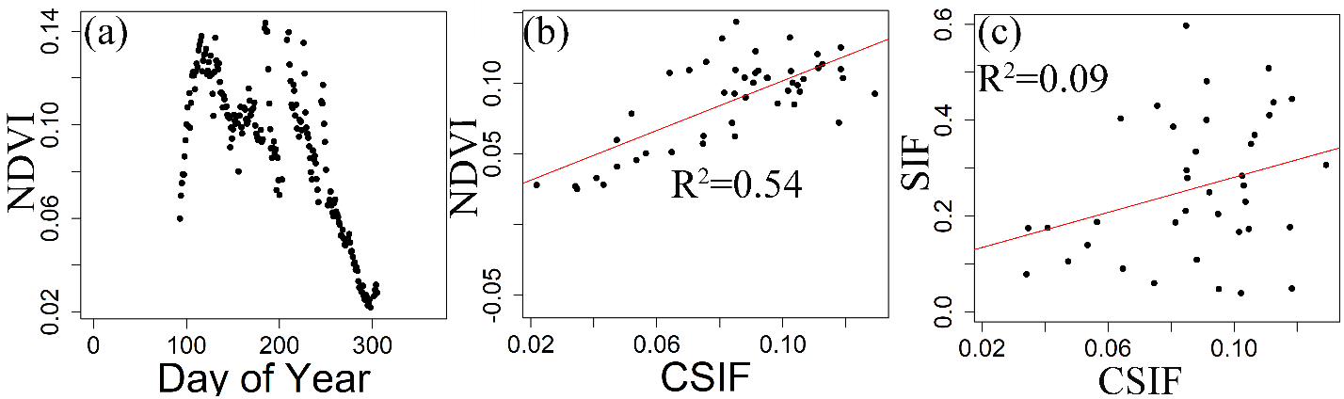

Fig. S6. CSIF is more correlated to NDIV than SIF at US-Wkg. (a) is the time series of NDVI in 2020, (b-c) suggests the correlations between CSIF and NDVI/tower SIF in 2020. The red lines in (b-c) are the fitted linear regressions between CSIF and the two indices, labeled with R2 values.
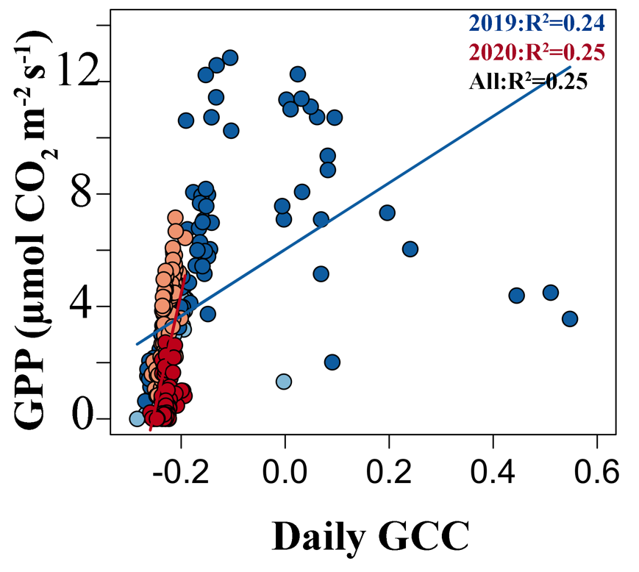

Fig. S7. Comparison between daily EC GPP (µmol CO₂ m⁻² s⁻¹) and CCI over two growing seasons (April to October) in 2019 spring (April to July, light blue), 2019 summer (August to October, dark blue) and 2020 spring (April to July, light red), 2020 summer (August to October, dark red). The blue lines are the fitted linear regression models between GPP and the two indices in 2019, and the red lines are the fitted models in 2020.

