Can salt-tolerant sludge mitigate the salt inhibition to acidogenic fermentation of food waste? Insight into volatile fatty acid production microbial community

Jun Yin^{1,2}, Xiaozheng He^{1,2}, Ting Chen^{1,2,3 *}

¹ School of Environmental Science and Engineering, Zhejiang Gongshang University, Hangzhou 310012, P.R. China
² Zhejiang Provincial Key Laboratory of Solid Waste Treatment and Recycling, Hangzhou 310012, P.R. China
³ Instrumental Analysis Center of Zhejiang Gongshang University, Hangzhou 310018, China

*Corresponding author. E-mail address: chenting_15@mail.zjgsu.edu.cn

Table S1. Characteristics of the food waste, non-acclimated sludge and acclimated sludge used in this study.
Parameter | Food waste | Non-acclimated sludge | Acclimated sludge
TS（%） | 23.4 | 8.6 | 8.2
VS（%） | 98 | 84.5 | 83.5
TCOD (%) | 1.4 | 1.1 | 1.1
TN (%) | 3.1 | 6.3 | 7.2
Cellulose and hemicellulose (%) | 34.9 | - | -
T-lipids (%) | 10 | - | -
T-sugar (%) | 65.4 | 19.9 | 11.8

Table S2 Ammonia nitrogen generation model at different NaCl concentrations during acidogenic fermentation
Group | Linear Equation | R²
non-AS_0 | y = 13.451x - 17.909 | 0.8949
non-AS_30 | y =17.295x - 73.564 | 0.8611
non-AS_70 | y = 15.645x - 61.076 | 0.8518
AS_30 | y = 31.507x - 164.99 | 0.9282
AS_70 | y = 30.571x - 98.479 | 0.9065

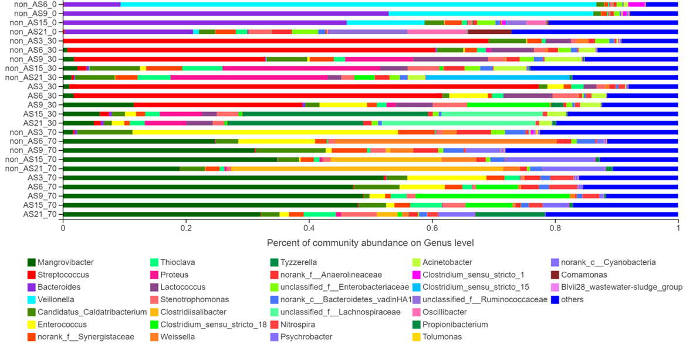
Figure S1 Taxonomic classification of MiSeq sequencing from bacterial community of non-AS and AS groups at genus level under 0 g/L, 30 g/L and 70 g/L NaCl. The genera with relative abundance less than 5% are classified as ‘‘others”).
(Note: non_AS and AS stand for non-acclimated and acclimated anaerobic sludge, respectively. The number 3,6,9,15 and 21 stands for the day of sampling. The number 0, 30 and 70 stands for the NaCl concentrations.)

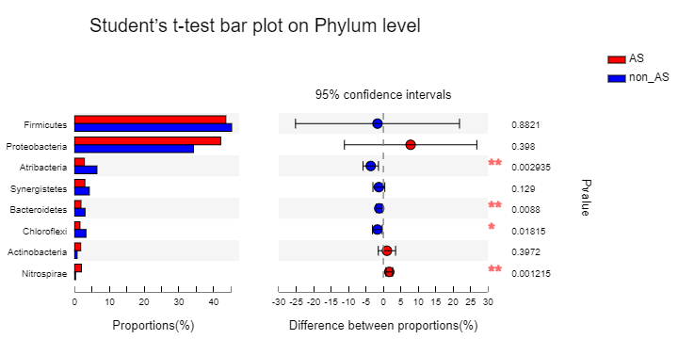
Figure S2 Microbial analysis of the differences in the bacterial communities between non-AS and AS groups at high salt concentrations (30 g/L and 70 g/L NaCl) at the phylum level.

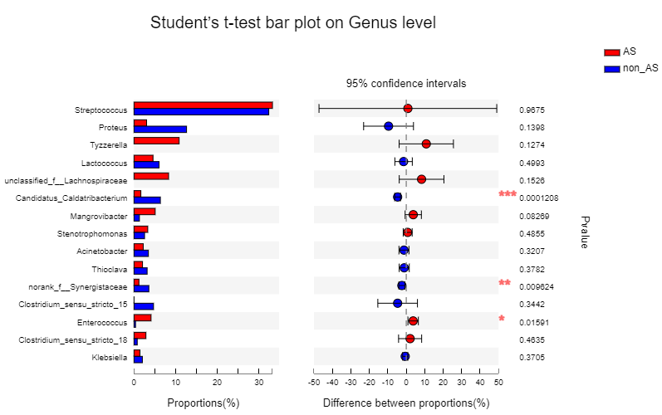
Figure S3 Microbial composition difference between the AS and non-AS groups at 30g/L NaCl.
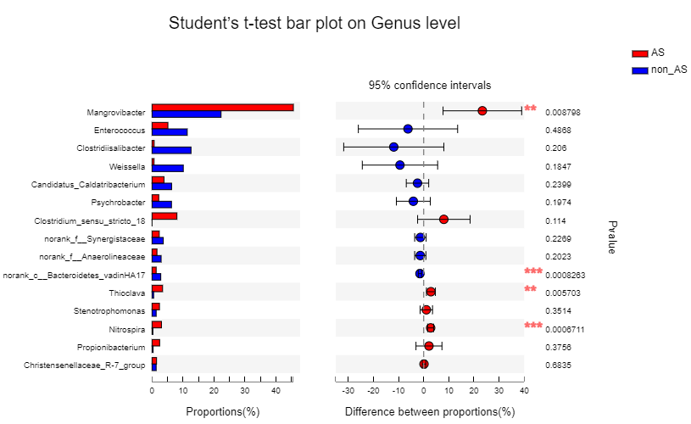
Figure S4 Microbial composition difference between the AS and non-AS groups at 70g/L NaCl.

